

JPII 5 (2) (2016) 247-255

JurnalPendidikan IPA Indonesia

http://journal.unnes.ac.id/index.php/jpii

Problem Based Learning with Argumentation as A Hypothetical Model to Improve Critical Thinking Skills of Junior High School Students

Raden Wakhid Akhdinirwanto¹⁾, Rudiana Agustini²⁾, Budi Jatmiko²⁾
¹⁾University of Muhammadiyah Purworejo, Indonesia
²⁾State University of Surabaya, Indonesia
R_wakhid_a@yahoo.com

Abstract: Problem Based Learning with Argumentation (PBLA) model is designed to improve the thinking skills of junior high school students. This study aims to formulate a hypothetical PBLA model through stages, namely: preliminary studies, theoretical studies, relevant research results, and frame of mind. The hypothetical PBLA model is based on the problem-based learning model (PBL) which is supported by argumentation preparation according to the Toulmin Argumentation Pattern (TAP). The results of the PBLA hypothetical model formulation have 5 phases, namely:(1) identification of problem and motivation, (2) organization and investigation, (3) argumentation building, (4) argumentationsessions, and (5) evaluation-reflection. Research result shows that validity, practicality and effectiveness of teaching using PBLA model to improve students’ critical thinking skills are based on: (1) The developed validity of PBLA model is 3.5 with reliability of 77.10% for content validity and 3.3 with reliability of 77.67% for construct validity. (2) Practicality with the average reliability for the first meeting was 96.36%, for the second meeting was 96%, and for the third meeting was 94.4%, so that the total reliability was 95.59% (very good category). (3) The effectiveness with an increase in critical thinking skills before and after the implementation of the PBLA model significantly at α = 5%, where the average value of critical thinking skills is in the medium category, and there is no difference in the increase in students' critical thinking skills (there is no difference in the average n -gain) or consistent for both groups.

Keywords: PBLA model, critical thinking skills, junior high school.

INTRODUCTION

One of the thinking skills that students must have in school in the Industrial Revolution 4.0 era is critical thinking skills. This is in accordance with the achievement of learning in the framework of the 21st century, namely: Critical thinking and problem solving; Creativity and Innovation; Communication and collaboration (Wagner, 2010). According to Walker (2005), critical thinking skills are a learning process to gain new knowledge through problem solving and collaboration. According to Bloom (1956), critical thinking skills are the highest level of cognitive thinking, which includes: analysis (C4), synthesis (C5), and evaluation (C6). Analysis is a thinking skill in describing an object of problem into smaller elements to obtain a broader understanding of these elements; synthesis is the skill to rearrange various components to get a new structure; while evaluation is the skill of giving an assessment of an object with certain norms or standards to ensure its effectiveness, both in terms of its urgency and usefulness. Therefore, Candy in Phillips & Bond (2004) states that one of the main goals in the learning process is to bring up critical thinking skills. This is because critical thinking skills are believed to be able to help someone in solving complex problems faced by everyone in the era of the Industrial Revolution 4.0. Based on the importance of critical thinking skills in that era, the Government of the Republic of Indonesia through the Regulation of the Minister of Education and Culture of the Republic of Indonesia No. 68 of 2013 concerning the curriculum structure of junior high schools, mentioning that the competencies that must be achieved by junior high school / Madrasah Tsanawiyah through science learning include critical thinking skills.
One of the learning models in schools that have been believed to be able to teach critical thinking skills to students, namely by using the Problem Based Learning (PBL) model, which has been developed by Arends (2012). However, the reality in the field shows that PBL models still have weaknesses, especially students are still weak in giving argumentation (Thobroni & Arif, 2013; Semerci & Batdi, 2014).
Therefore, it is necessary to formulate a new model formulation that can teach the critical thinking skills of junior high school students, namely by incorporating the components of argumentation in the PBL model and known as the Problem-Based Learning with Argumentation (PBLA) model. So, the PBLA model is a formulation of the learning model which is the result of the development of the Problem-Based Learning (PBL) model which is intervened with Toulmin’s Argumentation Pattern (TAP). TAP consists of as-phase: (1) data, (2) warrant, (3) backing, (4) qualifier, (5) rebuttal, and (6) claim.
PBLA Model
PBLA is a Problem-Based Learning (PBL) model that is intervened with Toulmin’s Argumentation Pattern (TAP). This is intended to reflect the demands of learning that want maximum improvement of critical thinking skills.
PBL is a student-centered teaching method that involves learning through unclear but original and constructivist problem solving, namely a student-focused approach that promotes reflection, skills in communication and collaboration, raises motivation, and requires reflection from various perspectives (Etherington, 2011). PBL consists of small groups that involve the use of higher cognitive functions to complete tasks that are directly meaningful to students (Akhdinirwanto, Agustini, & Jatmiko, 2015).
PBL starts from the problem that the authentic that require students to undertake an investigation authentic to resolving the real problems. Students must analyze and define problems, collect and analyze information, conduct experiments, and formulate conclusions. Students able to grow problem-solving skills, acting as problem solvers and learning built in the process of thinking, teamwork, communication and exchanging information. In addition problem based learning can provide opportunities for students to explore to collect and analyze data to problem solving, so that students are able to think critically, analytically, systematically and logically in finding alternative solutions to problems (Sanjaya, 2009).
However, PBL still has weaknesses still has weaknesses in argumentation (Thobroni & Arif, 2013; Semerci & Batdi, 2014), so that it needs to be intervened by argumentation. Toulmin defines the argumentation as an expression along with the reasons and the components which data, warrants, backing, qualifier, rebuttal, and claim called Toulmin’s Argumentation Pattern (TAP) (Tippett, 2009). Argumentation are classified in three terms: the rhetorical, dialectical and analytical (Tippett, 2009). Rhetorical or didactic argumentation used to persuade others by presenting one sense to make this statement, which is often called one-sided argumentation; Dialogic called dialectical argumentation or multiple argumentation, involving the examination of perspective during the debate over different; analytical argumentation follow the rules of logic that allows inductive or deductive. Inductive argumentation is propose a conclusion based on some evidences, while deductive argumentation using the universal truth to case to support a truth (Murtadho, 2013).
Argumentation is a skill that is needed both by teachers and students to build conceptual understanding, develop research skills, understand the benefits of science, understand the values of social interaction and improve students' critical thinking skills. Therefore, teachers need to integrate argumentation in the implementation of learning, so that students who have argumentative skills can build explanations to produce new knowledge (Wardani, Yuliati, & Taufiq, 2016). Based on the description above, a Problem-Based Learning with Argumentation (PBLA) model was created as a hypothetical model to maximize the critical thinking skills of junior high school students maximally, with syntax (1) problem identification and motivation, (2) organization and investigation, (3) argumentationbuilding, (4) argumentation sessions, and (5) evaluation - reflection.
The novelty of this PBLA model when compared to the PBL model in improving critical thinking skills is the argumentation. This occurs in the phase of building argumentation and argumentation sessions. This phase is specifically designed so that students prepare arguments in depth by compiling arguments through TAP, namely by compiling data, warrant, backing, qualifier, rebuttal, and claim. The preparation of these arguments requires analyzing, synthesizing, and evaluating skills, where analysis, synthesis, and evaluation are indicators of critical thinking skills according to Bloom's Taxonomy (Choy & Oo, 2012). Students will implement argumentation skills to practice critical thinking skills. They are required to present the results of constructing arguments as a means to explore communication skills (Mercier & Higgins, 2014), strengthen the concepts they have, so that the scope of information obtained will be greater (Celik, Onder, & Silay, 2011), and increase responsibility, cooperation and student confidence (Rosen, 2014).
The PBLA model has a problem characteristic of authentic (real in everyday life) that makes the confrontation to the students, the form of ill-structured, ill-defined, or open-ended through a stimulus to learning, in which claim answers along with the support of evidence and justification. The PBLA model device include syllabus, lesson plan (LP), Master Books, Students Book, Student Activity Sheet (worksheets), Sheets competence assessment to measure attitudes, knowledge and psychomotor as well as evaluation sheets to measure critical thinking skills. Learning tools were developed by teachers either individually or in groups.

Supporting Theory
Supporting theories of the PBLA model include cognitive theory, behavioral learning theory, constructivist learning theory, and motivation theory. Cognitive theory says that learning is a process of perception change and understanding that can be measured and observed (Moreno, 2010). This model is oriented to how students learn to think, so that for the teacher the most important thing is how to influence the development of thinking and how the teacher can adjust his teaching to the level of cognitive development of students. Teachers who have cognitive views in carrying out learning will tend to adapt to the needs of each student, such as providing various scaffolds according to the students 'prior knowledge, and training students' thinking processes using open questions that require students to explain using their own reasoning and strategies. . Based on cognitive views, the problem identification and motivation phases, and the phase of compiling arguments in the PBLA model is a process that can help develop conceptual understanding (Sadler & Fowler, 2006) and support the occurrence of cognitive processes (Jimenez & Erduran, 2007). For this reason, Duschl (2008) suggests that students need to develop some important insights in order to be able to argue scientifically. Students must be able to use important conceptual structures (i.e. theories, models, and laws or a combination of several concepts) and cognitive processes when they argue about a problem. Students also need to know the epistemic framework of science to develop and evaluate recognition. And finally, students must be involved in scientific arguments and social processes about how that knowledge is communicated, displayed, discussed, and debated in science.
Constructivism is a learning approach where students actively build or create knowledge independently (Thobroni, 2015). Constructivist theories have two constructivist individuals and social constructivists. Constructivist individuals called cognitive constructivists are explaining how students build knowledge in their minds (Moreno, 2010). According to this view, students have a natural tendency to seek understanding when interacting with the environment. Meanwhile, social interaction is not emphasized and is considered to be only one mechanism that facilitates cognitive growth (Moreno, 2010). When there is interaction between students and teachers or other students there will be cognitive conflict, motivating students to try to resolve imbalances in themselves to reconstruct the structure of knowledge. While Vygotsky's constructivist social / constructivist theory / sociocultural theory holds that students' cognitive development is a result of their interactions with their environment and society (Utami, 2016). This view emphasizes the importance of collaboration in learning, one of which is through cooperative learning. Cooperative learning occurs when students work in small groups to help each other in learning (Santrock, 2011), which has 4-5 students in each group) to study certain topics such as the organizational phase and investigation, the phase of building arguments, and the phase of argumentation sessions on the model This PBLA.
Behavioral learning theory (modeling) is also called the socio-cognitive theory of Bandura related to cognitive, affective, and behavioral changes that result from observing the behavior and explanation of others (Laila, 2015). Behavior likely to be emulated later depends on student involvement in four processes, namely: (1) Attention is the process of allocating cognitive resources to existing stimulus or tasks and is a condition needed to transfer information that must be learned into working memory. In learning, students must direct their attention to relevant information from the model to be able to learn from the model. In the PBLA model in the organizational phase and investigation the teacher prepares a handout that students can use to focus on relevant information before carrying out learning / experimentation. (2) Retention is students need to remember the observed behavior in order to be able to imitate the behavior in the future. Relevant information is modeled, considered, and transferred to working memory, students need to encode this information by creating verbal and / or visual representations of that experience in long-term memory. In the PBLA model in the orientation and motivation phases, the teachers can motivate students with images or events that motivate students to ask questions. (3) Production is the process of converting mental representations made during encoding into motor activities. In learning, students need to convert mental representations created during encoding to motor activities. In the PBLA model the phase of building argumentation, students try to produce the behavior that has been done that is solving problems by building argumentation. It is possible for students to experience difficulties. Therefore, at this stage the most important thing is to break down the procedures being studied into smaller steps and provide many training opportunities to compose arguments. (4) Motivation is the process of encouraging students to learn from the model and to reproduce what they learn. According to sociocognitive theory, students can learn something from observation but decide not to apply what they have learned. In the PBLA model in (1) the problem identification and motivation phase, the teachers can motivate students with images or events so as to motivate students to ask questions. (2) Then in the phase of the argumentation session, motivating students to convey ideas or ideas that have been obtained during the phase of building arguments to other groups. And (3) the phase of reflection, which is to motivate students to make conclusions in following learning.

Components of PBLA
The PBLA component consists of syntax, social system, reaction system, support system, and instructional impact and sender impact. The syntax of the PBLA model has five phases that are equally important and sequential, namely: (1) problem identification and motivation, (2) organization and investigation, (3) building arguments, 4) argumentation sessions, and 5) evaluation - reflection.
The first phase is Identification of Problems and Motivation. This phase is designed so that students arouse curiosity and explore students' interest in the materials to be learned. One way to stimulate students' interest and curiosity is through teacher behavior, namely linking old experiences and those to be learned, informing lesson objectives and describing learning needs to build student argumentation; and motivate students to get involved in problem solving activities. The teacher gives everyday problems (authentic) to be studied and solved. In this way, students will be curious and interested in learning so students must pay attention (Cheng & Yeh, 2009). Students think and try to find answers to the problems given by the teacher.
The second phase is Organization and Investigation. The second phase is designed to encourage students to gather the right information for the implementation of learning, trying to find explanations and solutions to build critical thinking skills. The teacher provides hand-outs and mainds on the preparation of arguments. The combination of hands-out and main-oni in learning activities will be able to provide motivation, make learning fun and meaningful, and have an impact on learning outcomes (Kurniawan, Ertikanto, & Suana, 2016). The teacher organizes students to form groups, each group of 4-5 students, and informs the learning objectives. Students in small groups try to define and organize learning tasks that relate to the problem, collect the right information for the implementation of learning, try to find explanations and solutions through experiments to obtain data.
The third phase is Argumentation Building. This phase aims to compile arguments. The supporting theory is that many students have a tendency to rush to make conclusions and these students fail in drawing conclusions (Moreno, 2010). Guided by the teacher, students try to analyze the data and interpret the results of data analysis, then build answers through argumentation to get claim with data, warrant, backing, qualifier, and rebuttal (Villata, Boella & Torre, 2014). Claim can be in the form of guesswork or an explanation used by students to answer the problem. Warrant can be the results of laboratory measurements or the results of literature studies that can be used to support recognition. Empirical data shows that with argumentation, students have shown changes in addressing science (Qhobela, 2012). With argumentation skills students are expected to have critical thinking skills.
The fourth phase is the Argumentation Session. This phase aims to provide opportunities for students to convey their ideas / answers that have been prepared through argumentation, respond to questions, submit evidence to the idea, evaluate the benefits of exchanging ideas, and share views or alternative ideas. With the guidance of the teacher, students convey the material that has been compiled at the session to build an argument. Students learn to use various scientific criteria such as conformity of evidence or consistency with theory, law or alternative explanations (Murtadho, 2013). This argumentation session is a means for students to explore communication skills (Mercier & Higgins, 2014), strengthen the concept that they have, so that the scope of information obtained will be more (Celik, Onder & Silay, 2011), and increase responsibility, cooperation and trust student self (Rosen, 2014).
The fifth phase is Evaluation - Reflection. This phase aims to have students the opportunity to provide feedback on the entire learning process. This is in line with the theory that without feedback there is little knowledge (Arends, 2012). With the guidance of the teacher, students try to analyze, evaluate, and deduce the knowledge gained in the previous session. At the end of this session the teacher provides feedback by giving corrections and reinforcement to the results of solving problems and arguments so that students are able to think critically. Students must understand and analyze physical (scientific) concepts, principles, laws and theories and are interrelated and apply them to specific fields (Permendikbud No. 64 of 2013).
The design of syntax of development model, theoretical and empirical support, behavior of teachers and students and the learning environment for each phase in the PBLA model is briefly described in Table 1.

Table 1. Syntax of PBLA Model
Fase 1: The Problem Identification and Motivation
Purpose | Teacher Behaviors | Student Behaviors | Learning Environment
Grow the students' curiosity and explore students' interest towards the materials that will be studied. | - Link long experience and will be studied,  - Inform describe the learning objectives and purposes of learning to develop students' argumentation.  - Motivate students to get involved in problem-solving activities | - Students thinking and trying to find answers to the problems set by the teacher. | - Allow students explore prior knowledge on the issues to be solved.  - Allows students to improve their attention on the problem and motivated to finish it.

Fase 2: The Organization and Investigation
Purpose | Teacher Behaviors | Student Behaviors | Learning Environment
Motivating students to gather the appropriate information for the implementation of learning, trying to find explanations and solutions to build critical thinking skills. | - Theteacher gives handouts and worksheets as well as information about preparation of the argumentation.  - Teaches organize students to form groups, each group of 4-5 students, and inform the learning objectives. | - Students in small groups trying to define and organize learning tasks related to the problem, collect the appropriate information for the implementation of learning, trying to find explanations and solutions through experimentation to get the data | - Allow students to integrate all the information necessary to perform tasks effectivel.  - Allow students to develop social attitudes and the ability to apply information gathering through experiments.  - Allow students to develop communication skills.

Fase 3: The Build of argumentation
Purpose | Teacher Behaviors | Student Behaviors | Learning Environment
Develop/construct argumentation with Toulmin’s Argumentation Pattern (TAP) | - Guiding the student to analyze the data  - Guiding students to develop/construct argumentation | - Students are trying to analyze the data and interpret the results of data analysis,  - Students construct an answer by argumentation for claims as a form of problem solution along with data (supporting evidence), warrant (details on the relationship between recognition and data), backing (basic assumptions supporting evidence), qualifier (a condition that acknowledgment is right), and rebuttal (condition that renders the recognition). | - Allow students to analyze the data to construct an answer to the problems posed.  - Allow students to construct argumentation.  - Allow students to develop communication skills.

Fase 4: The Argumentation Session
Purpose | Teacher Behaviors | Student Behaviors | Learning Environment
Providing opportunities for students to express ideas/ answers have been compiled through TAP, respond to inquiries, submit evidence to ideas, evaluating the benefits of exchanging ideas and sharing views or alternative ideas. | - Guiding students presenting ideas through the session of argumentation. | - Students presenting the material that has been prepared at the session of construct argumentation.  - Students learn to use a variety of criteria such as the of science conformity of evidence or consistency with the theory, legal or alternative explanations. | - Allow students to discuss the results construct argumentation.  - Allow students to use verbal argumentation to defend the claim that has been made.  - Allow students to develop an attitude of social and communication skills.

Fase 5: The Evaluation - Reflection
Purpose | Teacher Behaviors | Student Behaviors | Learning Environment
So that students have the opportunity to provide feedback of the entire the learning process. | - Guiding students to analyze, evaluate, and collect the knowledge gained in the previous session | - Students are trying to analyze, evaluate, and collect the knowledge gained in the previous session | - Allow students to develop skills of analysis and evaluation.  - Allow students to make conclusions based on the discussion at the session of argumentation.  - Allow students to develop social attitudes and appreciate the critical thinking.
Social system of PBLA models describe the role of students and teachers, student interaction, interaction between teachers and students as well as the expected target. In the PBLA model, learning activities is students centered. Teacher is facilitators, mentors, and mediators (Santrock, 2011). As a facilitator, the teacher must provide sources of learning, motivate students to enthusiasm in learning, organize and motivate their students to learning activities can be done well. As counselor, teacher is a place to ask when students are having difficulty, teachers can provide assistance, guidance and direction for students to construct knowledge claims optimally and make sure that students carry out activities assigned well. As a mediator, the teacher must give a number of activities that can stimulate to construct an argument along with the support of data, warrants and justification, the teacher lead and organize the discussion and the teacher is a mediator when there is a dispute when the process of debate.
Reaction principle of PBLAmodel is a reference the teacher in response performance of students. Reaction principle relates to how teachers appreciate and respond, including how teachers asking questions, answering and responding to what students can do. In a model that is characterized by PBLA, students are a source of activities and information so that the teacher's role is more consultative and decision determined student. Therefore, teachers must often provide the opportunity for students to ask questions if students have difficulty in constructing scientific knowledge or solve problems. So, the role of the teacher is very important in facilitating student responsibility for successful learning (Mulyasa, 2013).
Support system of PBLA models is an additional requirement of a model other than the skill, strength and ability a regular. Additional terms may be physical or nonphysical. Physical Terms include learning tools and learning resources needed to implement the PBLA model. There are: (1) Syllabus; (2) Learning Implementation Plan; (3) student book; (4) worksheets; (5) learning appropriate media including media such as computer assisted learning program Phet, Crocodile, and so forth; and (6) Assessment instruments to measure critical thinking skills. Non-physical condition, among others psychologically ready to accept the students' learning, students are in a conducive environment, teachers are able to manage learning, and there is good communication between teachers and students (Kurt, 2011).
The instructional impact or direct impact in the PBLA model is the impact that drives students on the desired learning goals (Miller & Anderson, 2007). The direct impact is that the PBLA Model is expected to improve the critical thinking skills of junior high school students. Moderate impact or indirect impact, namely the impact obtained due to experiencing the environment created by the model. The expected impact in the PBLA model is: (1) students have high motivation in following the learning process; (2) students have the ability to work together with other students; (3) students have mutual respect for the opinions of other students; (4) students have communication skills; and (5) students have an independent attitude and responsibility in completing tasks (Joice, Weil, & Calhoun, 2009; Sukartono, 2018).

METHOD
Research was done in the even semester of 2016/2017 academic year, in 18 weeks using temperature and its alteration and heat and its displacement as the topics. This research was emphasizing the validity and effectiveness of PBLA by analyzing the effect of teaching using PBLA model in improving students’ critical thinking skills.
In this research, validity and reliability of PBLA model were calculated based on assessment result given by validators who have the expertise in science learning. Meanwhile, the effectiveness of students’ critical thinking skills was analyzed based on: (a) the difference score of pre-test and post-tes in α=5%, (b) n-gain average, and (c) the similarity of several n-gain average.

Sample of Research
This research was done in science learning in Junior High School using PBLA model. The amount of samples in this study were 52 students from 130 students’ population of SMPN 1 Galur, Kulon Progo, DIJ, Indonesia. Amount of sample was determined by cluster random sampling technique. This technique was done because of easy to be applied in groups, so it did not take much times (Fraenkel, Wallen, & Hyun 2012). From five groups of students in grade VII, there were: VII A, VII B, VII C, VII D, and VII E; two homogeny groups were selected as the research samples, VII A and VII C with 26 students in each group.

Instrument and Procedures
This research learning using PBLA model to improve students’ critical thinking skills was done to two groups of homogeny students; which were classified as pre-experiment research using pre-test and post-test design: O1XO2 (Fraenkel, Wallen, & Hyun, 2012). This research was done by conducting critical thinking skills test to the students before the group of students were given the material about temperature and its alteration and heat and its displacement, it was called as pre-test (O1). Next, these group of students were given the lessons using PBLA model (X) with learning instrument which had the standards of validity and reliability, as follows: lesson plan (LP), student textbooks (ST), student activity sheets (SAS). After all of the learning processes over, group of students were given the test with the same subject and problem, so called post-test (O2).

RESEARCH RESULT
After the PBLA model as a hypothetical model to improve the critical thinking skills of junior high school students is completed, the next step is to carry out a model trial. The trial was conducted at SMP N 1 Galur in the even semester of the 2016/2017 school year within 18 weeks for junior high school science subjects on the topic of temperature and measurement as well as heat and changes. This study emphasizes the analysis of the validity, practicality and effectiveness of the PBLA model, namely by analyzing the impact of teaching using the PBLA model to improve students' critical thinking skills.
The validation process by three validators who are experts in science education towards the PBLA model is carried out with discussion in the Focus Group Discussion (FGD). The FGD discussed the draft PBLA model that was supplemented with supporting learning tools in the form of: Syllabus, Lesson Plan (LP), Student Textbooks (ST), and Student Activity Sheets (SAS). Details of the validity and reliability scores for each component of the PBLA model and the supporting learning tools are shown in Table 2.
Table 2. The validity and reliability of the PBLA model.
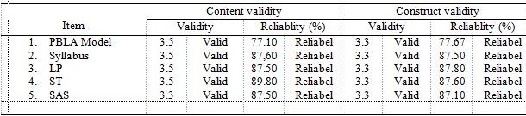
(LP: Lesson Plan; ST: Student Textbooks; SAS: Student Activity Sheets)
Table 2 shows that the PBLA model is valid and reliable in terms of content and construction, as well as the learning tools supporting the PBLA model, which include: Syllabus, SIP, ST, and SAS, each of which is valid and reliable both in content, and construct. Next, a PBLA model was tested to see the model's viability. The implementation of the PBLA model is seen from observers observing the implementation of learning in each lesson plan by the model teacher. The model teacher in the study was a teacher in the field of science studies from the school of research and was observed by 2 observers who had been trained and involved in discussions about how to implement the PBLA model. Observer is in charge of observing the implementation of lesson plans, student activities, and constraints during the learning process. The implementation of the SIP includes the introduction, core and conclusions, as well as classroom atmosphere and time management. Observation of the implementation of the lesson plan is done by giving a score oneach object of observation with a minimum score of 1 and a maximum score of 4 (Ratumanan & Laurens, 2011). Discussions between researchers and the model teacher are conducted after learning is finished to receive input from the observer. The clarity of the PBLA model is presented in Figure 1.
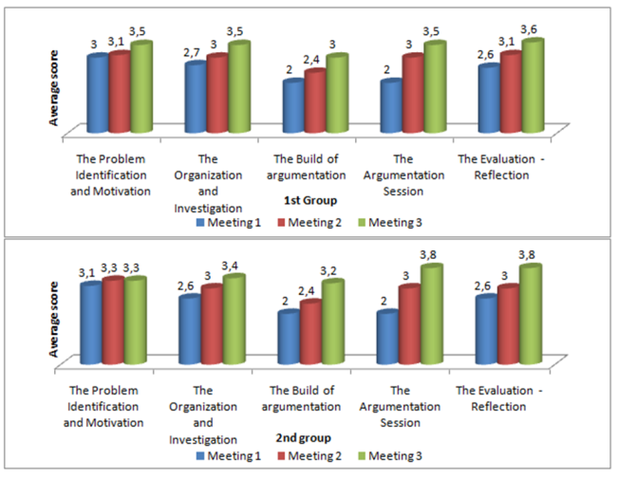

Figure 1. Mean score of PBLA model feasibility

Figure 1 shows that the implementation of the PBLA model showed an increase at each meeting. The argumentation building phase and the argumentation session have the lowest score at the first meeting. These phases have increased at the second and third meetings, but the phase of building an argument has difficulty in the learning process. The average reliability for the first meeting was 96.36%, for the second meeting 96%, and for the third meeting 94.4%, so that the total reliability was 95.59% (very good category).
Furthermore, to see the effectiveness of learning done with the PBLA model in group 1 and group 2, each meeting six times in each meeting is preceded by a pre-test and ended with a post test. Pre-test and post-test scores during the study for group 1 and group 2 are shown in Figure 2 and Figure 3.
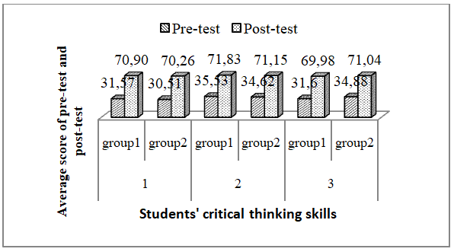
Figure 2. Average pre-test and post-test scores of students' critical thinking skills for the 1st and 2nd groups at the 1st to 3rd meetings.

Figure 2 shows that the average score between students' pre-test and post-test critical thinking skills for the 1st and 2nd groups at the 1st to 3rd meeting increased. The average pre-test, post-test, and n-gain scores on the Indicators of critical thinking skills of students according to Bloom's taxonomy are shown in Table 3.

Table 3. Average Score of ofPre-test, Post-test, and n-gainStudents’ Critical Thinking Skills Indicator of Group 1 and Group 2 from the 1st until 3rd Meeting.
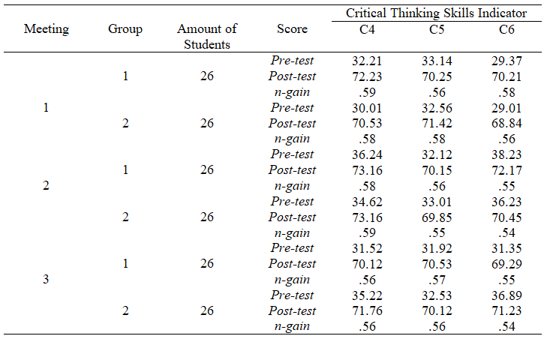

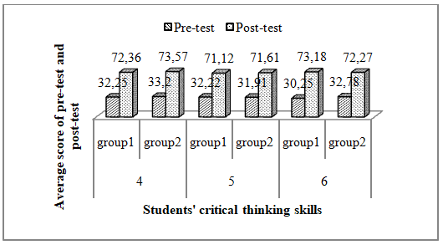
Figure 3. Average pre-test and post-test scores of students' critical thinking skills for groups 1 and 2 at the 4th to 6^{t}h meeting

Figure 2 shows that the average score of pre-test andpost-testof students’ critical thinking skills for the group 1 and group 2 in the 4th until 6th is improving. Average score of pre-test, post-test and n-gainin students’ critical thinking skills indicator based on Bloom Taxonomy is shown in Table 4.

Table 4. Average Score of Pre-test, Post-test and n-gain of Students’ Critical Thinking Skills for Group 1 and Group 2 in the 4th until 6th Meeting
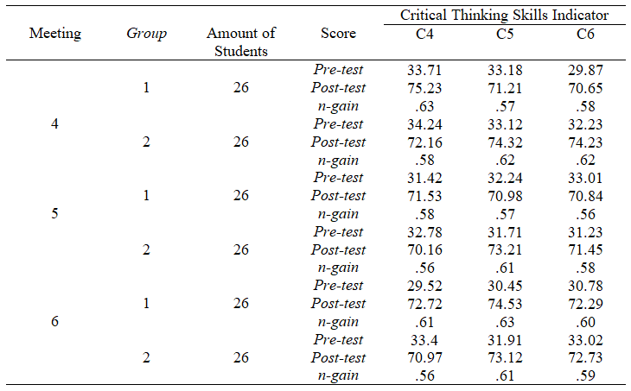

Furthermore, the normality of the pre-test and post-test scores with the Kolmogorov-Smirnov test, the results are obtained that all are normally distributed. To analyze the increase in students' critical thinking skills taught using the PBLA model a paired t-test was performed. Table 5 shows the results obtained from the paired t-test after fulfilling the pre-test and post-test normality tests.

Table 5. Pair t-test Result for Students Critical Thinking Skills.
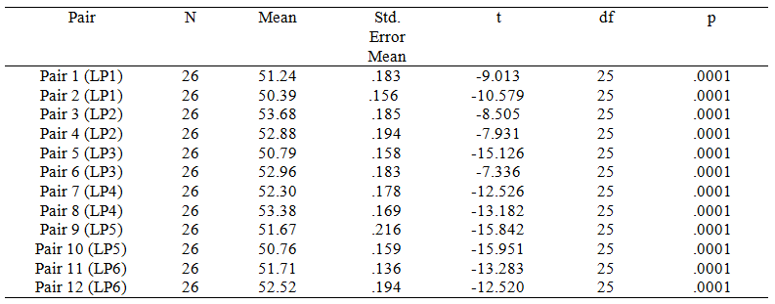

Table 5 shows that all of the meetings in group 1 and group 2 produce negative-t value with the value of p less than .05 (p < .05), this means that the score of post-test is bigger than pre-test; or students’ critical thinking skills is greater after they were given learning using PBLA model than before using it. In other words, there is a raising score of students’ critical thinking skills statistically after they were given learning using PBLA model at level of significance α = 5%.
The consistency of students’ critical thinking skills after fulfilling the assumption of normal and homogeny is later analyzed using equality test of two means with dependent t-test, as it is shown in Table 6.

Tabel 6. Result of t dependent test of Students Critical Thinking Skills
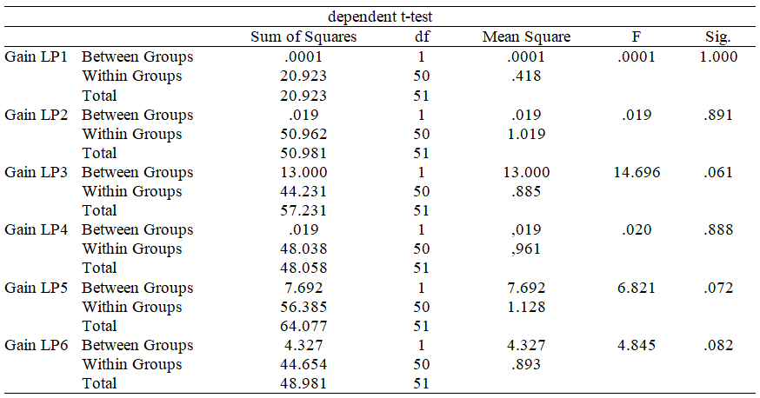

Table 6 shows that the significance value for group 1 and group 2 in all of meetings is greater than .05 (sig. > .05), means that there is no different average score of students’ critical thinking skills improvement between group 1 and group 2 (consistent) significantly at the level of 5% after they were given learning using PBLA model.

CONCLUSION
According to the previous research result and discussion, the application of Junior High School science learning using PBLA model in temperature and its alteration and heat and its displacement materials has been considered as valid, practical, and effective in completing requirement to improve students’ critical thinking skills. Validity, practicality and effectiveness of teaching using PBLA model to improve students’ critical thinking skills are based on: (1) The developed validity of PBLA model is 3.5 with reliability of 77.10% for content validity and 3.3 with reliability of 77.67% for construct validity. (2) Practicality with the average reliability for the first meeting was 96.36%, for the second meeting was 96%, and for the third meeting was 94.4%, so that the total reliability was 95.59% (very good category). (3) The effectiveness with an increase in critical thinking skills before and after the implementation of the PBLA model significantly at α = 5%, where the average value of critical thinking skills is in the medium category, and there is no difference in the increase in students' critical thinking skills (there is no difference in the average n -gain) or consistent for both groups.

ACKNOWLEDGEMENTS (OPTIONAL)

I hope that good deeds are accepted by God and that this research can produce a new learning model that is a problem-based learning model with argementation (PBLA), which is beneficial for the development and development of education in our country. This research was conducted with the help of several parties. Therefore, researchers would like to thank:
- Director of Postgraduate State University of Surabaya.
- Chair of the Science Education Study Program, Postgraduate State University of Surabaya.
- Head of Department of Education of Kulon Progo, Yogyakarta.
- Headmaster of SMPN 1Galur.
- All 7th grade students of SMPN 1 Galur.

REFERENCES
Ahuna, K.H., Tinnesz, C. G., and Kiener, M. (2014). A New Era of Critical Thinking in Professional Programs. Transformative Dialogues: Teaching & Learning Journal.7(3), November 2014
Akhdinirwanto, R. W., Agustini, R., & Jatmiko, B. (2015). A study of critical thinking skills in junior high school. Semarang: Proceeding International Converence on Mathematics, Science, and Education (ICMSE) 2015,Semarang State University, 5 September 2015, SE-18-24.
Arends, R. I. (2012). Learning to teach; 9th edition. New York: McGraw–Hill.
Bloom, B.S. (1956) Taxonomy of Educational Objectives, Handbook: The Cognitive Domain. David McKay, New York.
Celik, P., Onder, F., &Silay, I. (2011).The effects of problem-based learning on the students’ success in physics course.Procedia-Social and Behavioral Sciences.28, 656-600.
Cheng, C. Y. &Yeh, T. H. (2009). From concepts of motivation to its application in instructional design: Reconsidering motivation from an instructional design perspective. British Journal of Educational Technology,40(4), 597–605.
Choy, S. C. & Oo, Pou San. (2012). Reflective thinking and teaching practices: A precursor for incorporating critical thinking into the classroom. International Journal of Instruction, 5(1), 167–182. https://doi.org/e-ISSN:1308-1470.
Duschl, R. A. & Osborne, J. (2008). Supporting and promoting argumentation discourse in science education. London: King’s College.
Etherington, M. (2011). Investigative primary science: A problem-based learning approach. Australian Journal of Teacher Education, 36(9), 36–57.
Fisher, Alec. (2009). Critical Thinking: An Introduction. Translated by Hadinata, B. Jakarta: Erlangga Publisher.
Fraenkel, J., Wallen, N., & Hyun, H. (2012). How to design and evaluate research in education (8th edt.). New York: McGram-Hill Companies: Inc.
Jacobsen, D. A. Eggen, P., & Kauchak, D. (2009). Methods for teaching, teaching methods improve learning of kindergarten - high school students. Yogyakarta: Pustaka Pelajar.
Jim’enez-Aleixandre, M. P. & Erduran, S. (2007). Argumentation in science education: An Overview. In S. Erduran & M. P. Jim’enez-Aleixandre (Eds), Argumentation in science education: Perspectives from classroom-based research (3-28). Dordrecht, Netherlands: Springer.
Joyce, B., Weil M., & Calhoun Emily. (2009). Models of Teaching, New Jersey, Prentice Hall, Inc.
Kurniawan, W., Ertikanto, C., & Suana, W. (2016). Effects of Hands On Minds On Activity on Learning Outcomes through Guided Inquiry. FKIP Universitas Lampung. 105-116.
Kurt, S. (2011). Use of Constructivist Approach in Architectural Education. Cyprus International University. Department of Architecture, Nicosia, Cyprus.
Laila, Q. N. (2015). Albert Bandura's Moral Education Thought. STITNU Al Hikmaah Mojokerto. III(01), 21 – 36.
Mercier, E. & Higgins, S. (2014). Creating joint representations of collaborative problem solving with multi-touch technology. Journal of Computer Assisted Learning. 30(6), 497–510.
Miller, A. V., & Anderson, S. E. (2007). Development of a matrix of teaching models based on instructional and nurturant effects.Texas: The University of Texas at Brownsville/Texas Woman’s University.
Moreno, R. 2010. Educational Psychology. New York: John Weley & Sons Inc.
Mulyasa, E. (2013). Character Education Management.Jakarta :BumiAksara.
Murtadho, F. (2013). Critical Thinking and Metacognition Strategy: Alternative Means Optimization Writing Exercise Argumentation. 2nd International Seminar on Quality and Affordable Education (ISQAE 2013), 2(2013), 142-152.
Permendikbud Nomor 65 Year 2013. CONCERNING STANDARDS OF THE BASIC EDUCATION PROCESS AND INTERPRETING THE GRACE OF THE ALMIGHTY GOD THE MINISTER OF EDUCATION AND CULTURE OF THE REPUBLIC OF INDONESIA. Jakarta: Kemendikbud.
Permendikbud Nomor 68 Year 2013. ABOUT THE BASIC FRAMEWORK AND STRUCTURE OF THE FIRST MIDDLE SCHOOL / MADRASAH TSANAWIYAH CURRICULUM. Jakarta: Kemendikbud.
Phillips, V., & Bond, C. (2004). Undergraduates’ Experiences of Critical Thinking. Higher Education Research & Development, 23, 277-294.
Prasetyo, Z. K. (2013a). Strengthening the mastery of natural science teacher professional education materials (teaching materials).FPMIPA- UNY.
Qhobela, M. (2012). Using argumentation as a strategy of promotion of talking science in a physics classroom: What are some of the challenges?, 2(2012), 163–172.
Ratumanan, G. T. dan Laurens. (2011). Evaluate Relevant Results by Solving Learning and Teaching Problematics. Bandung: Alfabeta.
Redhana, I W. (2012). Improve student critical thinking skills through cooperative learning with problem solving strategies. Journals Education and State Teacher Training Institute of Singaraja,3(33), 11-23.
Regulation of the minister of education and culture. No. 65 years 2013. Standard Process of Primary and Secondary Education by The Grace of God Almighty The Minister of Education and Culture of The Republic of Indonesia. Jakarta: The Ministry of Education and Culture.
Regulation of the minister of education and culture. (2013). Attachment Regulation of The Minister of Education and Culture Number 64 of 2013 Concerning The Framework and Basic Structure of Curriculum Junior High School. Jakarta: The Ministry of Education and Culture.
Rosen, Y. (2014). Comparability of conflict opportunities in human-to-human and human-to-agent online collaborative problem solving.Technology, Knowledge and Learning.18 (3).
Sadler, T. D. & Fowler, S. R. (2006). A threshold model of content knowledge transfer for socioscientific argumentation. Scientific Education, 90(6), (986-1004).
Sanjaya, W. (2009). Learning Strategy EducationStandard Process Oriented. Jakarta: Kencana Prenada Group.
Santrock, John W. (2011). Educational Psycology: 5th Edition. New York: McGraw-Hill.
Semerci, Ç &Batdi, V. (2014). The effects of problem based learning approach on students’ attitude levels: A meta-analysis. Educational Research and Reviews.9(9), 272-276.
Sukartono. (2018). Industrial Revolution 4.0 and Its Impact on Education in Indonesian. FIP PGSD Universitas Muhammadiyah Surakarta, 1-22.
Thobroni, M. (2015). Learning and Learning: Theory and Practice. Yogjakarta: Arr-Ruzz Media.
Tippett, C. (2009). Argumentation: The language of science. Journal of Elementary Science Education,21(1), 17-25.
Utami, I.G.A.L.P. (2016). Constructivism Theory and Sociocultural Theory: Applications in Teaching English. PRASI. 11(01), 4 – 11.
Villata, S., Boella, G. & Torre, L. V. D. (2014). Argumentation Patterns. University of Turin.
Wagner, T. 2010. Overcoming The Global Achievement Gap (online).Cambridge, Mass., Harvard University.
Walker, R. (2005). Social Security and Welfare: Concepts and Comparisons. Journal of Social Policy.35(4). 705-722.
Wardani, A. D., Yliati, Lia. dan Taufiq, A. (2016). Ability of Scientific Argumentation and Solving Physics Problems of High School Students in Style and Motion Material. Prosiding Seminar Pendidikan IPA Pascasarjana UM. Vol. 1, 2016, ISBN: 978-602-928621-2.

Raden Wakhid Akhdinirwanto  (Corresponding author) | Associate Professor. Researcher, Faculty of Matematics and Science Education, University of Muhammadiyah Purworejo, Indonesia,  Jalan KHA Dahlan 3 Purworejo, Indonesia, 54111  E-mail: r_wakhid_a@yahoo.com  Website: http://www.ump.ac.id/
Rudiana Agustini | Professor, Researcher, Postgraduate School, State University of Surabaya, Jalan Ketintang, Surabaya, Indonesia 60231  E-mail: rudianaagustini@unesa.ac.id  Website: http://pasca.unesa.ac.id/
Budi Jatmiko | Professor, Researcher, Postgraduate School, State University of Surabaya, Jalan Ketintang, Surabaya, Indonesia 60231  E-mail: budijatmiko@unesa.ac.id  Website: http://pasca.unesa.ac.id/

