THE EFFECT OF BLENDED LEARNING PROBLEM-BASED INSTRUCTION MODEL ON STUDENTS’ CRITICAL THINKING ABILITY IN THERMODYNAMIC COURSE

DOI:
Accepted:... .Approved: ... . Published: ...

ABSTRACT
The course of thermodynamics is one of the subjects whose material content consists of real theory and practice and the use of formulas. Therefore, in the application of this course is a need to apply a learning model that is able to help students find and solve problems and be able to explain their findings in achieving the basic competencies of thermodynamics course. The learning model is a Problem Based Instruction learning model based on Blended Learning. This study aims to improve the critical thinking skills of pre-service physics teacher as a result of using Problem Based Instruction based on Blended Learning in the course of thermodynamics. Retrieval of data in this study was conducted on third semester students of physics education study programs that take Thermodynamics course. This research was conducted in September-October 2019. The research method used is quasi-experimental. Quasi-experiments are research carried out on a single group of students. Data analysis in this study used a one-party t-test. The results showed that (1) the application of the Problem Based Instruction learning model based on Blended Learning can improve students’ critical thinking skills, (2) Students’ responses to the application of the Problem Based Instruction learning model based on Blended Learning get a very happy category of ongoing learning.

Keywords: problem based instruction; blended learning; thermodynamic

INTRODUCTION

For an educator, teaching is an activity that must be able to change the behavior of their students and can show the results or effects of a learning process that is being carried out.Teaching activities carried out must be able to stimulate students’ stimuli, so that they have the opportunity to develop their thinking skills, especially high-level thinking.The ability to develop students’ thinking and developing abilities will only emerge if the learning process carried out is more Student center Learning (Hoskins et al., 2011; Kim et al., 2013; Macleod,2013). The teachers mustthink learning should be more 'How to Stimulate Learning', not just 'How to Teach' (Cetin, 2016). The teaching patterns of lecturers who generally dominate, in essence, will make students unable to develop their thinking abilities optimally. The same thing was conveyed by Ismet (2013), Schiefer et al. (2020), Vakilifard et al. (2020) that “in the learning process, forming thinking patterns is a very important and should be the main goal of learning, because thinking activities involve high mental activity”. Many solutions can be chosen by an educator including lecturers in certain courses to be able to present a learning atmosphere that is better able to explore students’ thinking abilities. The presence of various learning models, and current learning media will greatly help an educator to teach better and memorable.
The SCL grant program in the teaching and education faculties has a significant effecton the students of physics education study programs, especially in thermodynamics course, such as changing teaching and learning patterns by lecturers-students who were previously Teacher Centered Learning to student centered learning. Moreover, Teacher Centered Learning has shown that on average 78% of students achieved C grade in thermodynamics course. Thus, the teaching method of Problem Based Instruction based on Blended Learning is hoped that it will further trigger the activeness of students learning activities both in face-to-face sessions and through e-learning. Strong learning enthusiasm will be able to explore students’ thinking abilities and intellect. In this regard, Hakimet al. (2017) mentions that the thinking skills are one of the necessary intellectual potentials in many aspects of the daily life of students. Problem based learning is a learning activity that invites students to find a conclusion through an investigation of the problems that arise.This, of course, has the potential to develop the potential of thinking, acting actively seeking, solving and finding a concept or idea while providing conclusions from students (Khanafiyah&Yulianti, 2013; Okafor, 2019; Macleod, 2013).
Previous studies on Blended Learning and Problem Based Instruction have been carried out by Hasumah(2015),Khanafiyah&Yulianti(2013),Hermawanto et al.(2013),Anazifa&Djukri(2017). Those studies indicate that mastery of the concept of physics must be accompanied by a learning model that is centered on students and is able to explore students’ scientific creativity. So far, there is no information available on the implementation of Blended Learning-Problem Based Instruction for thermodynamics course; or the collaboration of those two methods. This is consistent with suggestions from Hermawantoet al. (2013) whose works on topic of “vectors” which suggests that Blended Learning should be implemented on other courses as well. Furthermore,Khanafiyah&Yulianti (2013)and Sitorus (2016) suggested that education should be able to develop learning that is able to awaken thinking skills and in accordance with regional character. While,Anazifa&Djukri (2017) stated that study activities that can hone students’ ability to solve science problems by giving them the opportunity to explore and use their problems in the thermodynamics course. Problem Based Instruction and Blended Learning Collaboration by utilizing the learning system face to face and online or e-learning is the focus of novelty in this research. The implementation of e-learning media that was packaged in this blended learning activitity was inspired on the research by Hakim etal. (2017), which showed that thermodynamic’s interactive multimedia was able to improve the creative thinking skills of pre-service teachers. Furthermore, the focus of novelty in this study is also the using of collaborative Problem Based Instruction and Blended Learning which were not reported previoulsy on some study referred here (Hasumah, 2015; Khanafiyah&Yulianti, 2013; Hermawanto et al., 2013; Anazifa&Djukri, 2017).
Problem Based Instruction is a series of learning activities that emphasize the process of problem solving through the process of thinking scientifically, critically, logically, and systematically (Khanafiyah&Yulianti. 2013). In the Problem Based Instruction learning model, students have the opportunity to explore and investigate. The data investigation and problem-solving activities will be able to generate a high-level thinking process for students, namely the ability to think critically. Thus, Problem Based Instruction can be said as a problem resolution through an investigation that begins with the emergence of a real meaningful problem (Ayse&Sertac, 2011).
Problem Based Instruction has several stages in learning, namely identifying and formulating problems, raising problems, proposing hypotheses, collecting data, testing hypotheses and making decisions (Khanafiyah&Yulianti, 2013). From the stages of learning passed by students, it shows that this learning will make students more active in the problem-based learning process (Okafor,2019). In this study, the lecturer uses the Problem Based Instruction model by combining problem-based instruction learning with the learning process using the web, or what is called Blended Learning. The use of the web or computer-based in learning will be very helpful to improve students’ understanding of concepts because web media will greatly facilitate lecturers and students (Husnietal., 2010). According to Hermawantoet al. (2013), Blended learning is a learning by combining face-to-face learning with online learning using the Moodle Learning Management System (LMS), so that with e-learning students will get the depth of material that students want.
The advantage gained by implementing Blended Learning is that the lecturer can observe directly and repeatedly the responses of each student through the discussion features or evaluation features provided in the e-learning media prepared by lecturers supporting thermodynamics course. Lecturers can also provide systematic and ongoing assessments of various questions or answers to the audience or students of e-learning web participants whether related to the material or not (Hermawantoetal., 2013). This results in students always trying to reason, think, and explore by using their critical thinking skills to get good comments from lecturers and other audiences in fellow members of e-learning learning groups in thermodynamics.The activeness of students to inquire and explore some information in each course presentation is the main reason for the researcher to implement Blended Learning in the thermodynamicscourse. According to Hakimet al. (2017), thermodynamics course has dynamic material content and require high creativity from students, so the web-based learning model will be able to facilitate students to develop their thinking skills in thermodynamics course.
However, the direct learning process also has a very positive effect on the development of student abilities. The Learning Process with the learning model "Problem Based Instruction" has also shown empirically been able to explore students’ thinking abilities, because students in this case are students faced with real situations that require them to conduct investigations and problem solving.High-level thinking skills, one of which is the ability to think critically, is a process experienced by someone to make decisions that are relevant to what is being learned (Sarwi et al., 2012; Setyorini et al.,2011). Critical thinking skills can be classified into several abilities, namely observing, focusing, analyzing, hypothesizing, assuming, drawing conclusions, reviewing, and reflecting back (Setyorini et al., 2011; Suter, 2012; Espinosa, 2014; Kwan & Wong, 2015; Cargas, 2017; Moseni et al., 2020).
Furthermore, as a whole Sarwi et al. (2012) group students’ critical thinking skills into five basic skills that are developed, namely; 1) provide a simple explanation (elementary clarification), 2) provide a further explanation (in-depth clarification), 3) make a decision or judge (judgment), 4) make conclusions or inferences, 5) perform strategic steps (strategies). Based on some of the reviews and opinions, the research objectives were formulated in this research, namely to improve the critical thinking skills of pre-service physics teacher as the effect of applying Blended Learning-based Problem Based Instruction in thermodynamics course.
Overall, the description of the problems in this study are the low student learning outcomes in the course of thermodynamics and the low active role of students in teaching and learning in class. Thus, the objectives of this study can be determined as follows: (1) To improve students’ critical thinking skills in thermodynamicscourse through the use of Blended Learning collaborated with Problem Based Instruction; (2) To determine students’ responses on the teaching and learning process by using Blended Learning collaborated with Problem Based Instruction.

METHODS

The subjects of this research are the third semester students in physics education study program, Faculty of Teacher Training and Education, in the academic year 2019/2020. This research is focused on increasing students’ critical thinking skills and observing the effect of applying Problem Based Instruction based on Blended Learning in thermodynamicscourse. A collaboration of Problem Based Instruction and BlendedLearning was implemented in teaching and learning process of thermodynamics. The researcher was prepared teaching materials before the lectures. The teaching materials was used for lectures in classrooms and online learning.
The research method used is quasi-experimental. Quasi-experiments are research carried out on a single group of students.The chosen group is the third semester students of the physics study program at the University of Almuslim. The group was given two tests, namely the initial test (pre-test), followed by treatment and after that the final test (post-test) was conducted again. The pre-test or initial test is carried out before the treatment in the form of the application of the Problem Based Instruction learning model carried out, then proceed with the post-test or final test.The questions used in the study are valid and reliable.The test design is to use a one-group pretest-posttest design (Sugiyono, 2010), namely:
O1 X O2

Where:
O1: Pretest to see students’ critical thinking skills before learning using the E-learning model.
X : Treatment, which is an E-learning model.
O2: Posttest to see the critical thinking ability of pre-service physics education teacher candidates on the application of Problem Based Instruction based on Blended Learning in thermodynamicscourse.
The category of improvement in learning outcomes in the form of critical thinking skills, measured using the gain index(Hake, 1998as cited in Parno, 2015), which mentions the following success criteria:

Range | Category
0,70 < g ≤ 1,00 | High
0,30 < g ≤ 0,70 | Moderate
g ≤ 0,30 | Low

Furthermore, the data obtained in this study were analyzed using several statistical tests as follows:
- Qualitative data were collected using a questionnaire instrument assessing student responses to the learning process. This qualitative data was analyzed using a percentage formula, namely:
Quantitative data were collected using critical thinking skills item test instrument. This quantitative data is analyzed based on the results of pre-test and post-test which have been conducted on a sample of students. The difference between the mean score of pre-test and post-test where the data distribution has been tested with the normality test stated to be normally distributed, tested with one-party t-test statistics.
Inferentialhypothesis in research:
H0 =The effect of using the blended learning-based problem-based instruction model to students’ critical thinking ability in thermodynamics course
H1 =Does not have the effect of using the blended learning-basedproblem-based instruction model to students’ critical thinking ability in thermodynamic course
With the following Criteria:

Ho is accepted ift_{count}<t _{table}
Ho is rejectedift_{count}>t_{table}
Furthermore, quantitative data that has been collected from the pretest and posttest scores, then the magnitude of the enhancements of the two tests are seen by using the gain index equation, namely:
with the following criteria:
Category Range
0.70 <g ≤ 1.00 Height
0.30 <g ≤ 0.70 Medium
g ≤ 0.30 Low (Hake, 1998 as cited in Parno, 2015)
Meanwhile, the completeness criteria for all items of the critical thinking skill test is set at 85% as a percentage of classical completeness.

RESULTS AND DISCUSSION

Analysis of Research Results
This research was conducted to determine the increase in critical thinking skills of pre-service physics teachers as a result of the application of Problem Based Instruction based on Blended Learning in the course of thermodynamics. The research data were obtained based on students’ pre-test and post-test data, namely before and after treatment was applied. Furthermore, qualitative data in the form of student responses were obtained based on observation questionnaires distributed to students after the pre-test activities were carried out. Lecturers or those who act as researchers on this thermodynamics course, perform and see the completeness criteria of student learning outcomes in the form of critical thinking skills. The completeness criteria of learning outcomes are carried out to ensure the acquisition of the results of tests of critical thinking ability of pre-service teachers individually. The completeness criteria for learning outcomes obtained are as follows:

pass
Fail

Figure 1. Percentage of Mastery in Critical Thinking Ability
The result of completeness data analysis of learning outcomes in the form of critical thinking skills of pre-service teachers shows that the average student has completed his study, 85% of student test results answer the questions correctly, so it can be said that the test results of the test from the post-test has succeeded in improving students’ critical thinking skills in the course of thermodynamics. The problem-based instruction learning model based on blended learning is one of the reasons for good achievement on students’ learning outcomes. Prior weakness observed on the students during learning activites arefeeling of shyness to ask questions and some students are bored with the teacher centered learning system.Furthermore, the success of learning with Blended Learning is also seen from the results of testing the value of N-Gain. N-Gain value calculation is done after all data have been declared normally distributed and homogeneous from the results of normality and validity test. The value of N-Gain is a dramatic calculation used to see the difference between the pre-test and post-test values, which is done to avoid bias towards the acquisition of research results. N-Gain values ​​have low, medium and high categories. Following are the results of the analysis of the pre-test and post-test data which have been calculated N-Gain values ​​and the average with a high category. The results of data analysis of N-Gain values ​​are as follows:

Tabel 1. Analysis of N-gain Value
No | Pretest Score | Post test Score | Gain | N-Gain | Category
1 | 8 | 16 | 7 | 0.66 | Moderate
2 | 7 | 17 | 10 | 0.76 | High
3 | 8 | 17 | 9 | 0.75 | High

The data show that there is a significant effect on the application of the Problem based Instruction learning model based on Blended learning, namely the average of all initial test items and final test items for pre-service teachers to obtain moderate and high N-Gain scores. Thus, this shows that face-to-face learning collaboration and on-line based learning or so-called Blended Learning have a very good influence on the motivation and enthusiasm of student teacher learning. Picture (2) shows students motivation and enthusiasms using blended learning.

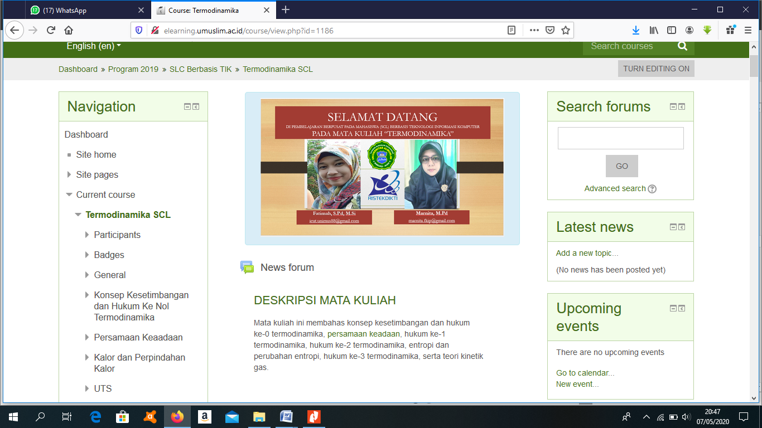
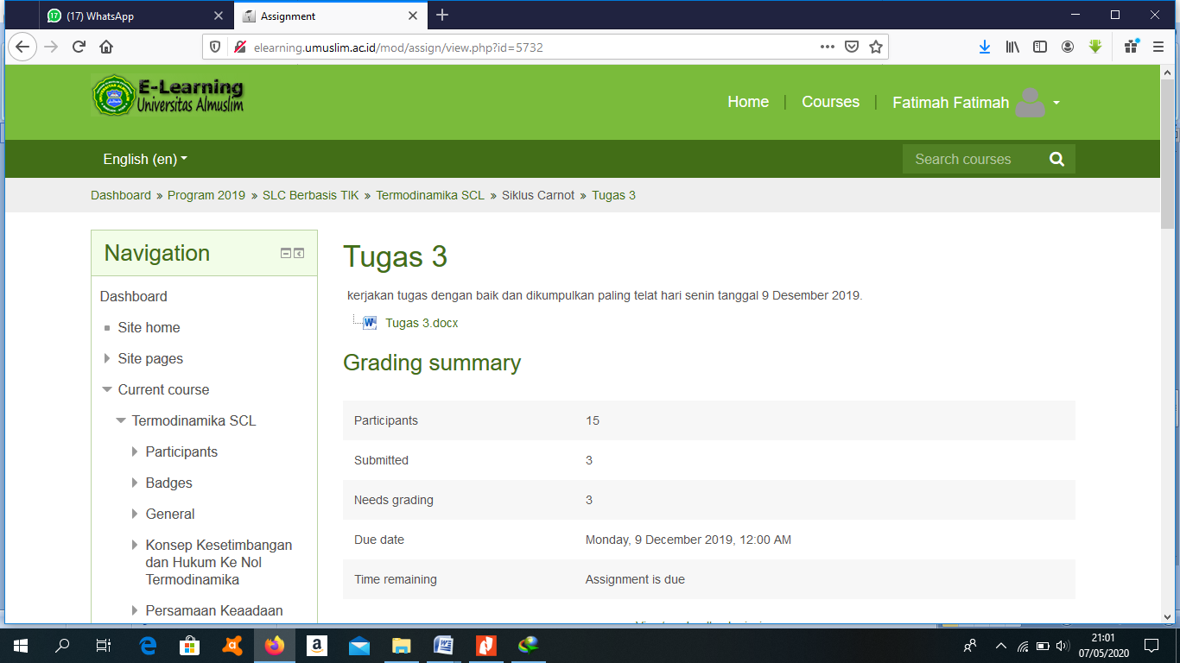
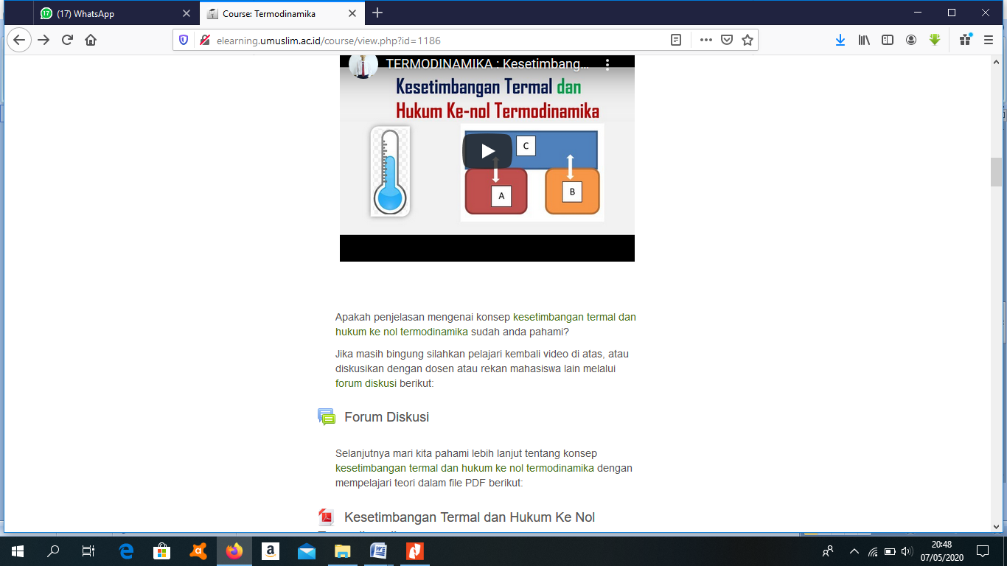

Figure 2. Students Motivation And Enthusiasms Using Blended Learning

Figure (2) demonstratesstudents enthusiasm and activity in each session by e-learning. This enthusiasm then further is utilized by the lecturer to invite the students to design anexperiment or investigation of the material being discussed in a face-to-face session directly in class and in the laboratory. This is considered as the point of success towards the application of problem-based instructional models based on blended learning, namely the high enthusiasm of students to learn either independently, in groups, directly or through e-learning.Researcher’s observations concludes that this situation occurs because students tend not to get bored and feel awkward or not confident with the lecturer or with fellow students, students find it easier to find the basic concepts of thermodynamics due to direct investigations and assisted with learning videos that support students’ understanding of concepts in every material on the thermodynamics course. A similar study was conducted by Laisema&Wannapiroon (2014), who found that “Students’ creative thinking skills are effective to improve with the use of information technology”.Furthermore, Cahyani&Hendrianim(2017) have also conducted research with a multimedia-based as well as E-learning media. Cahyani&Hendrianim (2017) found that learning based on multimedia can improve student final test results. The following is a presentation of data to improve the critical thinking skills of pre-service teachers on each indicator of critical thinking skills. Indicators of critical thinking that are used are as many as five indicators, namely giving a simple explanation (elementary clarification), 2) giving a further explanation (in-depth clarification), 3) making a decision or judging (judgment), 4) making conclusions or inferences, 5) performing strategic steps (strategies).

Figure 3.N-Gain of Critical thinking skills indicator
This data illustrates that the presence of learning videos, detailed explanations in each sub-material and direct discussion and investigation strongly supports the emergence of various indicators of critical thinking skills. More clearly in the following e-learning screen-shoot can be seen sub material that can be clicked on by students to get further explanation. Sub material is shown by arrows.
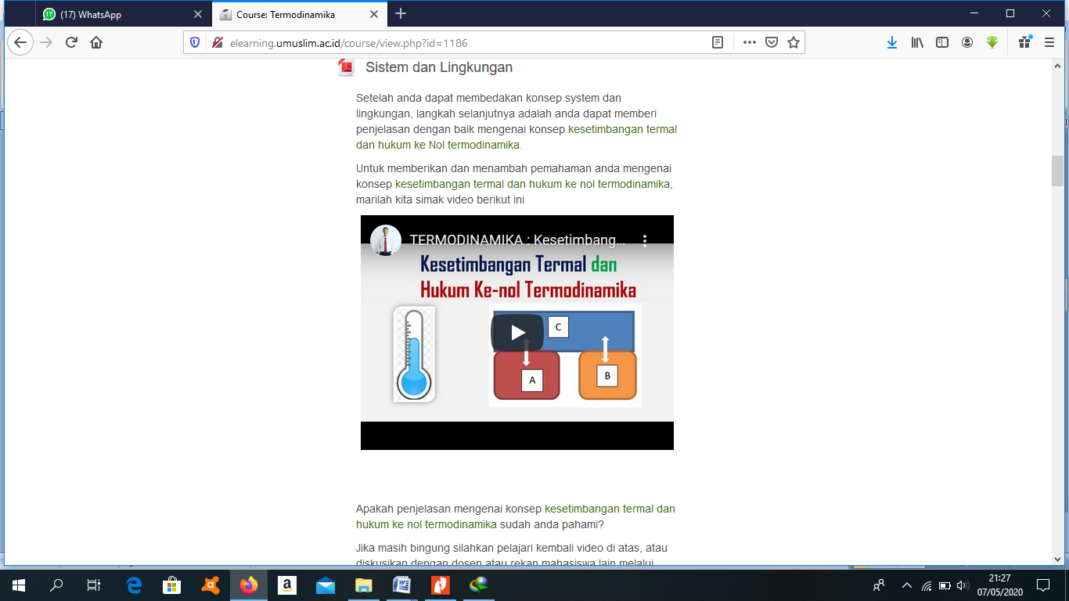

Furthermore, to ensure that research on pre-service teachers using the Problem Based Instruction learning model based on Blended Learning has succeeded in increasing students’ critical thinking skills, the lecturer who acts as a researcher conducts t-test statistical tests. Statistical analysis of the t-test was conducted to find out whether the results of the study were true or not. T-test using the t-test statistical formula with the test criteria obtained from the list of t distribution at a significant level α = 0.05 with degrees of freedom db = N-1. Thus, the Inferential hypothesisused is the acceptance and rejection criteria are accepted H₀, if t_{count}<t_{table} if H₀ if t_{count}>t_{table}. To obtain the value of t_{count}, it has been calculated the average gain of the pretest and posttest score, which obtain an Md value of 27 and the sum of the squares of deviations of ∑X²_{d} = 2871.So the next t-value is obtained by using the t-test statistics, namely the value of t_{count} = 8.3 and the value of t_{table} = 1.75 which is considered based on the degree of freedom (dk) = N-1 and a significant level α = 0.05. This test is done by using one-party t-test, namely the right hand side. Hypothesis testing is carried out at a significant level of 0.05 and dk is (N - 1) = 16 obtained t_{(1 - α)(db)} = 1.75. Thus, it means that the null hypothesis (H₀) is rejected and the working hypothesis (H₁) is accepted, which means that the Problem Based Instruction learning model based on Blended Learning can improve the critical thinking ability of students of physics education program in thermodynamics courses. Here is a presentation of the results of the t-test statistical test, namely:
Figure 4.t-test Statistical Testing
1,75
8,3
T_{count}
t_{table}

This picture shows that learning activities have succeeded in increasing students’ critical thinking skills with the Problem Based Instruction learning model based on Blended Learning. This success is greatly supported by learning activities that meet a number of active and creative learning criteria: (1) There is innovation in students’ critical thinking skills and problem solving abilities, communication and collaboration, creativity and innovation; (2) information, media, and technology skills; and (3) life and career skills (Anazifa&Djukri, 2017; Cetin,2016; Cibik&Yalcin,2012). The findings in this study are in accordance with Dwijananti&Yulianti’s (2010) study explaining that the application of PBI models in Environmental physics courses can develop critical thinking skills of students in Physics Education study programs.

Analysis of Student Responses
Analysis of student responses was conducted in order to see the level of acceptance of pre-service teachers to the application of the Problem Based Instruction learning model based on Blended Learning in the Thermodynamics course. Students are very pleased with the application of Problem Based Instruction based on Blended Learning. The results of the response analysis are as follows:

Very happy Happy a little happy not happy Very Unhappy

Figure 5. Percentage of Students’ responses
Data analysis and statistical test of research conducted in September-October 2019, which was funded on SCL grant won by FKIP Umuslim in the 2019, shown that the use of Problem Based Learning models based on Blended learning has answered one of question in this research, which is overcoming the boredom of student learning which stemmed from teacher centered learning center; which in this research shifted to student centered learning. This success is a teaching process with an appropriate pattern for physics lessons (Cetin, 2016; Cibik&Yalcin, 2012; Turgut et al., 2016).Thus, the research objectives have been achieved by the use of Problem Based Learning based on Blended learning, which proven to be able to improve the critical thinking skills of students of Physics education in thermodynamics course. Additionally, analysis on students’ responses to this learning showed that 81% of assessed students were very satisfied to learn with this learning model.
This is in line with research conducted by Hakimetal. (2017) who found that: 1) Interactive multimedia thermodynamics developed in thermodynamic learning can improve the creative thinking skills of pre-service physics teachers; (2) The highest increase in creative thinking skills occurs in the indicator of flexibility and the lowest in the indicator of originality; (3) Learning by using interactive multimedia thermodynamics is quite effective in increasing the creative thinking skills of pre-service physics teachers rather than regular learning, without interactive multimedia thermodynamics.

CONCLUSION
The conclusions of the research to students of Physics education study programs in thermodynamics are (1) The application of the Problem Based Instruction learning model based on Blended Learning can improve students’ critical thinking skills; (2) Students’ responses to the application of the Problem Based Instruction learning model based on Blended Learning obtained the category of very happy with the ongoing learning.

REFERENCES
Anazifa, R.D.,&Djukri. (2017). Project- Based Learning And Problem- Based Learning:Are They Effective To Improve tudent’s Thinking Skills? JurnalPendidikan IPA Indonesia,6(2), 346-355.
Ayse, O.,&Sertac, A. (2011). Overviews On Inquiry Based and Problem Based Learning Methods. Westerrn Anatolia Journal of Educational sience. Special Issue, 303-309.
Cahyani, R.,&Hendrianim, Y. (2017). Students’ Ability Of Scientific Inquiry With Mulitimedia Cell Reproduction Materials.JurnalPendidikan IPAIndonesia, 6(2), 265-270.
Cargas, S., Williams, S., & Rosenberg, M. (2017). An approach to teaching critical thinking across disciplines using performance tasks with a common rubric. Thinking Skills and Creativity, 26, 24-37.
Cetin, A. (2016). An Analysis of Metaphors Used by High School Students to Describe Physics, Physics Lesson and Physics Teacher. European Journal of Physics Education, 7(2), 1309-7202.
Çıbık, A.S.,&Yalçın, N. (2012). The effect of project based learning supported with analogies on attitudes of students towards physics. GaziEğitimFakültesiDergisi, 32 (1), 185–203.
Dwijananti, P.,&Yulianti, D. (2010). PengembanganKemampuanBerfikirKritisMahasiswaMelaluiPembelajaran Problem Based Instruction Pada Mata KuliahFisikaLingkungan. JurnalPendidikanFisikaIndonesia, 6(2), 108-114.
Espinosa, A. A. (2014). Modified Useful-Learning Approach: Effects on Students’critical Thinking Skills and Attitude Towards Chemistry. International Journal of Learning, Teaching and Educational Research, 1(1).
Hakim., Liliasari., Setiawan, A., &Saptawati, G.A.P. (2017). Interactive Multimedia Thermodynamics To Improve Creative Thinking Skill Of Physics Prospective Teachers. JurnalPendidikanFisikaIndonesia, 13(1), 33-40.
Hasumah (2015). Thinking Skills For Environmental Sustainability Perspective Of New Students Of Biology Education Department Through Blended Project Based LearningModel. JurnalPendidikan IPA Indonesia, 4(2), 110-119.
Hermawanto., Kusairi, S., &Wartono. (2013). Pengaruh Blended Learning terhadapPenguasaanKonsepdanPenalaranFisikaPesertaDidikKelas X. JurnalPendidikanFisikaIndonesia, 9 (1), 67-76.
Hoskins, S. G., Lopatto, D., & Stevens, L. M. (2011). The CREATE approach to primary literature shifts undergraduates’ self-assessed ability to read and analyze journal articles, attitudes about science, and epistemological beliefs. CBE—Life Sciences Education, 10(4), 368-378.
Husni, A., Juanda, E.A., &Hamidah, I. (2010). Model PembelajaranKooperatifBerbantuan Web PadaMateriFluidaStatisUntukMeningkatkanKonsepSiswa SMA. Prosiding SeminarNasionalFisika 2010, 451-458.
Ismet (2013). Impact Of Multiple Representations-Based Mechanics Learning On Prospective Physics Teachers’ Spatial Intelligence. JurnalPendidikanFisikaIndonesia, 9(1), 132-143.
Khanafiyah&Yulianti, D. (2013). Model Problem Based Instruction PadaPerkuliahanFisikaLingkunganUntukMengembangkanSikapKepedulianLingkungan. JurnalPendidikanFisikaIndonesia, 9 (2), 35-42.
Kim, K., Sharma, P., Land, S. M., & Furlong, K. P. (2013). Effects of active learning on enhancing student critical thinking in an undergraduate general science course. Innovative Higher Education, 38(3), 223-235.
Kwan, Y. W., & Wong, A. F. (2015). Effects of the constructivist learning environment on students’ critical thinking ability: Cognitive and motivational variables as mediators. International Journal of Educational Research, 70, 68-79.
Laisema, S.,&Wannapiroon, P. (2014). Design Of Collaborative Learning With Creative Problem-Solving Process Learning Activities In A Ubiquitous Learning Environment To Develop Creative Thinking Skills. Procedia-Social And Behavioral Sciences, 116, 3921-3926.
Macleod, K. (2013). Physics Education and STSE: Perspectives From the Literature. European Jounal of Physics Education, 4(4), 1-12.
Moseni, F., Seifoori, Z., &Ahangari, S. (2020). The impact of metacognitive strategy training and critical thinking awareness-raising on reading comprehension. Cogent Education, 7(1), 1-22.
Okafor, U.T. (2019). Effect Of Polya’s Problem Solving Technique On The Academic Achievement Of Senior Secondary School Student In Physics. European Journal of Physics Education, 10(1), 1309-7202.
Parno (2015). Effect of Guided discovery model with self-explanation learning strategiy toward students’ achievement on solid state physics. JurnalPendidikanFisika Indonesia, 11(1), 23-25
Sarwi, A., Rusilowati, A., &Khanafiyah, S. (2012). Implimentasi Model EksperimenGelombang Open-Inquiry UntukMengembangkanKemampuanBerpikirKritisMahasiswaFisika .JurnalPendidikanFisikaIndonesia, 8(1), 41-50
Setyorini, U., Sukisno, E.S., &Subali, B. (2011). PenerapanModel Problem Based Learning UntukMeningkatkankemampuanberpikirKritissiswa SMP. JurnalPendidikanFisikaIndonesia, 7(1), 52-56.
Schiefer, J., Golle, J., Tibus, M., Herbein, E., Gindele, V., Trautwein, U., &Oschatz, K. (2020). Effects of an extracurricular science intervention on elementary school children's epistemic beliefs: A randomized controlled trial. British Journal of Educational Psychology, 90(2), 382-402.
Sitorus, J. (2016). Students’ creative thinking process stages: Implementation of realistic mathematics education. Thinking Skills and Creativity, 22, 111-120.

Sugiyono. (2010). MetodePenelitianPendidikan. Bandung: Alfabeta.
Suter, W. N. (2012). Qualitative data, analysis, and design. Introduction to educational research: A critical thinking approach, 2, 342-86.
Turgut, U., Colak, A., &Salar, R. (2016). The Effect of 7E Model on Conceptual Success of Students in The Unit of Electromagnetism. European Jounal of Physics Education, 7(3),1-37.
Vakilifard, A., Bahramlou, K., &Mousavian, M. (2020). The Effect of Cooperative Learning Approach And Semantic Mapping Strategy on The Acquisition Of L2 Persian Vocabulary, Cogent Education 7(1),1-25.

