LETTER OF STATEMENT
No: 28/JPII/R.A./2020

I hereby declare that the article:
Ttle : The Effect Of Blended Learning Problem-Based Instruction Model On
Students’ Critical Thinking Ability In Thermodynamic Course

Authors : 1. Marnita, M.Pd
2. Drs, M. Taufiq, M.Pd.
3. Iskandar, S.Pdi.,MA.
4. Rahmi, M.Pd
is APPROVED to be published in JPII for September 2020 Issue.
Hereby this statement is made truthfully and to be used accordingly.

Bireuen, [21 September 2020]
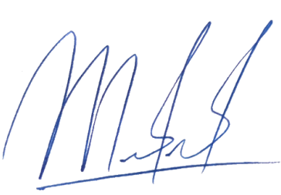
First Author,

[Marnita, M.Pd]

