Phys. Comm. 2 (2) (2018) 141-150
Physics Communication
http://journal.unnes.ac.id/nju/index.php/pc
Analytical Thinking Skills of Vocational Students in Circular Motion Cases

Isti Ikmah, Sunyoto Eko Nugroho, Sutikno

Pascasrjana, Universitas Negeri Semarang, Indonesia

Article Info  ________________  Article History:  Submitted:  June, 16 2018  Accepted:  August, 4 2018  Published:  August, 5 2018  ________________  Keywords:  Analytical thinking skills;  Circular motion;  Vocational students.  ____________________ |  | Abstract  ___________________________________________________________________  Physics as a basic subject of engineering department in vocational school need to equip students with analytical thinking skills. The purpose of this study is to describe the analytical thinking skills of vocational students on engineering department in solving cases of circular motion, to describe the obstacle, and to describe the factors that influence. This research use mixed method with written test instrument, questionnaire and interview. The average value of students' analytical thinking skills is 50.65. Students have been able to identify the variables in the case of circular motion, but they can’t understand the relationship between each other variables in the cases of specific problems. Physics lesson is less integrated with the field of expertise so that students are poorly trained in applying the physics concept in the field of expertise. Obstacles and factors that affect students' analytical thinking skills are known to vary by category.  © 2018 Universitas Negeri Semarang
Alamat korespondensi:  Physics Eduction Pascasarjana Universitas Negeri Semarang  E-mail: luph.isty@gmail.com |  |  | p-ISSN 2528-5971  e-ISSN 2528-598X

INTRODUCTION
In the 2013 curriculum for vocational school field of technology and engineering expertise, physics becomes one of the basic subjects in the department of expertise. Vocational schools are secondary schools that provide students with experience to be skilled and ready to work (Susilawati et al, 2014). The cases in the department of technology and engineering of vocational school have much to do with the concepts of physics such as mechanics, thermodynamics, fluids and others. Learning Physics circular motion material is closely related to daily cases.
In vocational school, circular motion is taught not only as conceptual understanding but more related to the application of tools or machines that used everyday. There are materials that specifically discussed in physics and there are not discussed again in machining classes. Circular motion is one of the physics material that its application most often relates to machining techniques because the machines mostly use the working principle of circular motion. Early interviews with physics teachers suggest that the average student reaches the level of the C1-C3 bloom taxonomy (knowing, understanding, and applying) and experiences constraints on the C4-C6 thinking level (analysis, synthesis, creation). The physics teacher conveyed that circular motion is one of essential matter on physics subject in vocational school. Through circular motion material, physics teachers are expected to provide learning that links the subject content and its application in life (Marnita, 2013). Implementation of the concept of circular motion is quite a lot on the field of expertise requires the analytical thinking skills. Vocational schools graduates of machining engineering skills program are expected to have analytical thinking skills, considering the various problems that will be faced by students in machining engineering field. Physics is one of the basic subjects of expertise in machining engineering courses, so that physics learning needs to emphasize aspects of analytical thinking.
High order thinking has a very important role in education. Thinking skills has a positive impact on education because the thinking skills had a direct impact on the learning process of students (Heong, 2011). The high order thinking skills consists of various kinds, one of them is analytical thinking skills. The analytical thinking skills allow students to know a specific phenomenon. Students can search for detailed information and relationships that occur from existing concepts so that later can draw conclusions and solutions of a problem encountered in a credible and valid (Sartika, 2016). The students' analytical thinking skills will foster other high-level thinking skills such as systematic, synthesis, critical and creative thinking skills (Susanti et al., 2012). Analytical thinking must be developed because analytical thinking skills is one of the three aspects of successful intelligence besides being creative (Anwar & Mumthas, 2014). It is very necessary to be prepared by vocational students in the world of work by providing various skills and expertise majoring as stock in overcoming problems encountered. Vocational students should be able to analyze every phenomenon that exists in general learning and skills (productive) that requires a lot of analysis in problem solving. Analytical thinking is best suited for vocational students because students are already in the maturity stage. In Piaget's cognitive development, vocational students are already in formal operational stage. Characteristics of the formal operational stage of having the ability to think abstractly and profoundly, the ability to reason logically from logical evidence and to draw conclusions from the information obtained.
Bloom's taxonomy revised by Krathwohl devided thinking skills into six levels of ability: remembering, understanding, applying, analyzing, evaluating and creating (Amer, 2006). The definition of analysis according to Krathwohl is the breakdown of matter until it becomes the smallest part and identifies the relationships formed from each part. After knowing the existing relationship so that the structure and its purpose is known. In line with Krathwohl, Winarti (2015) provided that analyzing is a process that involves the activity of breaking the information in a section and then looking for relationships that exist in every part and structure as a whole.
Analytical thinking skills is the ability to see the problem and then search for ideas and consequences to obtain the right solution (Marini, 2014). According to Areesophonpichet (2013), the ability to analyze and clarify parts of matter, to seek relationships between concepts and organize relationships into a principle. Analytical thinking skills according to Kao, C.Y. (2014) is the ability to break down parts of the problem and then understand each part. Understandable sections, look for relationships and reasoning that exist in each section or define a process of solving, then compare each part to evaluate the parts or solutions that have been done.
Lopez (2016) provided that the analytical thinking ability is divided into 7 areas, namely modeling ability, reasoning ability, symbolic ability, representation ability, problem solving ability, abstraction ability, and mathematical ability. In learning subjects that require analytical thinking skills, subject teachers should be careful that learning the subject requires and requires skills, methods, and techniques to motivate students to be interested in the subject they are studying. Analytical thinking skills is the ability to look at an idea or idea (Amer, 2005). This ability is used to know the advantages and disadvantages that can develop the ability to think to find solutions, analyze data and draw conclusions. This analytical thinking ability allows students to understand the parts of the structure, dividing the inside of important components and able to differentiate the function of each component.
Based on the description of analytical thinking skills, it can be divided into three indicators of analytical thinking skills, namely (1) skills to identify each element; (2) skills to sort parts into important elements; (3) skills to analyze relationships between elements and giving solutions. This is based on the type of test given in the form of written tests related to concrete problems in the workshop of machining techniques as well as real problems in the engineering world. Students are given the problem that is attempted as real as possible with the variables that can be used to solve the problem. This is in contrast to analytical thinking skills when students are directly on the real issues that require further analytical thinking skills.
Hartini (2011) provided the development of learning models of physics through the activities of vocational school automotive workshop. The results showed that physics learning activities through automotive workshop activities more effectively improve the soft skills of vocational students than practicum activities in physics laboratories. Purwandari (2015) provided the physics laboratory activities at vocational high schools in Purwokerto, Indonesia. The results stated that physics learning in vocational schools should be supported by practicum activities in physics laboratories. Practical topics can be developed and adapted from the competencies of the student's field of expertise so that students can apply the physics concepts in their field of expertise. Maghfiroh (2011) conducted a classroom action research on grade X high school. Based on the result, it is found that the application of physics learning with vision of SETS (science, environment, technology, and society) can improve students' analytical thinking skills. Physics learning with the vision of SETS can improve students' analytical thinking skills of class X significantly, although the value of significance is low. Rengganis and Yulianto (2018) asses the analysis of students’ analytical thinking skill in electromagnetic induction concept using props mini tesla coil for student of physics education program. The result of analytical thinking skills of students is known that the three indicators of analytical thinking obtained the highest result that is differentiating and the lowest result obtained on attributing indicator.
In the learning process, many students find it difficult to analyze something like science, history, and math. This is because students feel less information about how to analyze (Elder & Paul, 2007). These difficulties will inhibit the development of students' analytical thinking skills. This barrier creates different analytical thinking skills between one student and the other students.
Rauf (2009) defines obstacles as a condition that does not support, this causes an activity can not be done properly. In learning activities, students will experience obstacles. Wahyuni ​​(2017) expresses an internal obstacle that is something heavy that comes from within the learner, such as psychological conditions experienced by students when learning; student saturation during the learning process, displeasure with the subject being studied, not knowing the benefits gained from what is learned, and the level of intellectuality in each student. Based on the description of the obstacles experienced by students, student barriers in developing analytical thinking skills can be described as health, including health often disturbing; the learning skills include aspects of student learning habits and achievement motivation; the condition of the learning environment, covering aspects of association with friends and relationships with schools; how to deliver lessons, including teacher personal and analytical implementation activities; and lesson material is not in accordance with ability, covering the subjects delivered.
There are factors that affect students' analytical thinking skills. Slameto (2010) defines the factors that affect learning are divided into two namely internal and external factors. Internal factors are factors derived from the individual self, consisting of physical factors, psychological factors, and fatigue factor. External factors are factors that come from outside the individual, grouped into family factors, school factors, and community factors. Based on the description of factors that influence students in developing analytical thinking skills is obtained internal factors, including self-motivation, interests and experience and external factors, including teachers, learning situations and learning activities, others, subjects and the environment.
This study primarily investigated analytical thinking skills of vocational students in facing the problem of circular motion in the case of the field of expertise. It also examines factors are inhibiting and influencing the analytical thinking skills of vocational students. Little research has been done that focused on analytical thinking skills of the vocational students specifically. Some studies of analytical thinking skills are more likely to examine high school students who are projected to continue studying at higher levels of education, whereas vocational students projected as labor also require analytical thinking skills. Vocational students will encounter complex problems and demand the ability of analytical thinking according to their area of expertise. In addition, research on the analytical thinking skills of circular motion has not been much studied by previous researchers, where as in machining techniques the concept of circular motion is widely applied in the field of expertise. In addition, research needs to analyze the things that encourage and inhibit the ability of analytical thinking for vocational school students.This research is expected can evaluate the implementation plan of learning and implementation of learning in exploring students' analytical thinking skills and to evaluate the contextuality of the physics material given in relation to the field of student vocational skills.
METHOD
The research method combine between quantitative and qualitative method. Investigation of vocational student’s analytical thinking skills used written test with 5 problems, questionnaires and interviews. Analytical thinking skills is measured through a test of the subject matter of the application of the concept of circular motion. This research was conducted on X grade students of Engineering Department of vocational school state of Central Java, academic year 2017/2018 with the total population of 23 students. All members of the population are used as research samples. Hypothesis test in this research using one-party t test is left-t test. The null hypothesis (H₀) is the analytical thinking ability of the vocational students of medium category is greater or equal to 50%. The depth of the research was continued by looking for data related to the analytical thinking ability of the vocational school students through interview.
RESULTS AND DISCUSSION
The samples used in the first test of normality to find the samples used normal distribution or not. Based on Chi Square test conducted, the sample data has Chi Square value of 6,13 with Chi Square value 15,086 for dk 5 and α 1%. The value of Chi Square calculated obtained is smaller than Chi Square value of the table, this means the samples are normally distributed. If the sample used is normally distributed then the hypothesis test is done by using t test.
The result of left-t test for sample of 23 students obtained t count equal to 0,1625. The value of t table for dk 22 and α = 1% is 2,508. Results t arithmetic is then compared with the value of the table, seen t count value is much smaller than the value of t table. The value of t arithmetic is in the area of ​​acceptance Ha. This means the null hypothesis is rejected and the alternative hypothesis is accepted. Average Ability of analytical thinking of vocational students in solving physics cases related to the field of expertise is in the medium category.

Figure 1. Number of Students in Each Categories of Student Analytical Thinking Skills.
Students' analytical thinking skills are grouped into five categories: very low, low, medium, high, and very high shown at Figure 1. The written test of the subject of circular motion shows the sample is in the low, medium and high category. The number of students in the low category as many as 8 students, moderate category 8 students and high category as many as 7 students. Student learning outcomes in working out the five questions obtained the highest score 79 and the lowest score 23. Average student score of 50.65. If included in the minimal criteria of passing grade (KKM) of physics: 75, there are only three students who complete the KKM on the evaluation. This number is smaller than half number of students in the class.
The percentage of student worksheet is shown in Figure 2. The results show that students have difficulty in working out problems of number 2b questions about determining important elements and number 3 on selecting the important elements shown by the percentage of students who can work low.

Figure 2. Students scores in written for each questions

Problems in item 1a, 1b, and 2a are questions that measure students' skills to identify circular motion elements in gearboxes and motorcycles. Question 1a asks students to show any part of the gearbox showing kinds of the relation of pulley systems like Figure 3. The result of student's answer on item 1a can not differentiate students from low, medium, and high analytical thinking category. R4, R11, and R16 have not shown the correlation of the single axis wheelsthrough the answer sheets, but may indicate a september wheel ties during the interview.
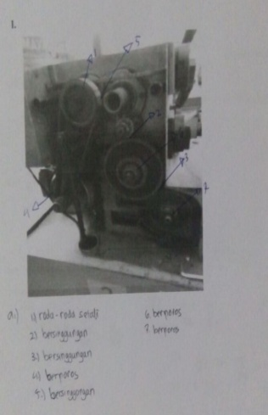
Figure 3. Gearbox on student questions and answers
Problem in item number 1b is a question that further measures the students' skills to identify the characteristics of each wheel relation on pulley systems in terms of the concept of the direction of rotation, frequency, period, angular velocity, and linear velocity of each wheel relation. Two students have not been able to identify the direction of turning two wheels touching each other. Seven students have not been able to identify the frequency and period of two wheels that are sigle axis, twisted, and tangent. A total of 10 students have not been able to identify linear velocity and angular velocity on the gearbox wheel relationship.
Based on interview, it is known R2 and R23 have not been able to distinguish between angular velocity and linear velocity. They claim that in the pulley systems of two wheels that connected with rope have the same angular velocity and different linear velocities. R23 on the result of the answer has been able to write the relationship formula correctly, but the explanation when confirmed through the interview shows a less precise understanding. Given the definition of Kao (2014) that analytical thinking skills is the ability to break down parts of the problem and then understand each part. Understandable sections, look for relationships and reasoning that exist in each section or define a process of solving, then compare each part to evaluate the parts or solutions that have been done. In relation to the definition, R2 and R23 are identified as having problems in identifying the elements of an issue. Misconceptions of angular velocity and linear velocity cause inaccuracy in solving the problems asked so that R2 scores 58 (medium category) and R23 scores 23 (low category).
Problem in item 2a measures students' skills in identifying pulley systems in motorcycle cases. Students are expected to be able to illustrate the wheel connection between the front gear, rear gear, and rear wheel based on the illustration of the problem. Most students (86.96%) have been able to identify the wheel relationships in the case of motorcycles. As many as 13.04% of students have not completed the image of wheel ties on motorcycles, but they’re able to explain correctly during the interview.
P : In answer 1b, you write the formula for a relationship is $v_{1}=v_{2}$, can you explain what it means?
R2 : Forsymbol $v$, my point is angular velocity, and$ω$ is linear velocity
P : Means you think, for the relation of the wheels, how about the angular velocity and the linear velocity?
R23 : In my opinion, on the wheels of the same axis, the angular velocity is the same, the linear velocity is different

One indicator of analytical thinking skills is the ability to choose an important element in the problem that can be used to solve the problem. Item number 2b is a question aimed at measuring the ability of students in choosing an important element in a matter of circular motion of a motorcycle. As many as 8.70% of students are able to choose the quantities that used to solve the problem, while 91.30% of students have difficulty in solving the problem due to lack of precise sorting out the important variables to solve the problem. Problem in item number 3 on written test measures students' skills in choosing an important element of an issue. Students are asked to calculate the output power generated by microhydro generator based on the known variables. A total of 17 students (73,91%) had difficult to select important elements of microhydro generator problem, 2 students cleared the answer, and 4 other students wrote all the data but had not sorted out the important part to solve the problem. Examples of comparison high and low analytical thinking skills showed on Figure 4.
Problem in item number 4 is a circular motion in the case of microhydro generator which is compiled more concisely than problem number 3. Students are expected to be able to connect the circular motion elements known in the matter to calculate turbine rotational speed. As many as 65,22% of students are able to analyze the relationship of wheel in the same scheme microhydro generator presented, so as to be able to solve the problem properly. A total of 34,78% of students had difficulties in analyzing the wheel relationships in the microhydro generator scheme presented so it was not appropriate in solving the problem.
Problem in item number 5 requires students to analyze the connection of parts of the salt pumping windmill in pumping up the seawater from the moat to the salt rice fields. Students are carefully expected to be able to analyze the circular motion variables needed to answer the problem. A total of 47,83% students are able to analyze the relationship of variables that exist and determine the type of wheel relationships that exist, so as to solve the problem properly. As many as 52,17% of students have not correctly analyzed the relationship between the known variables in the problem, some students are only able to identify the known variables in the problem, but have not analyzed the relationships among elements appropriately.

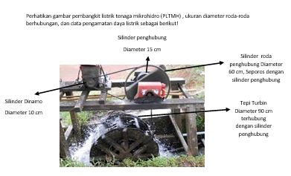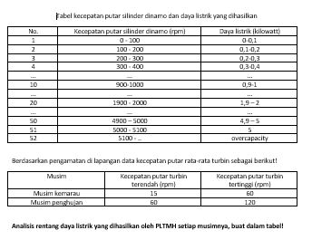
Problem 3 on written test (circular motion in microhydro generator)
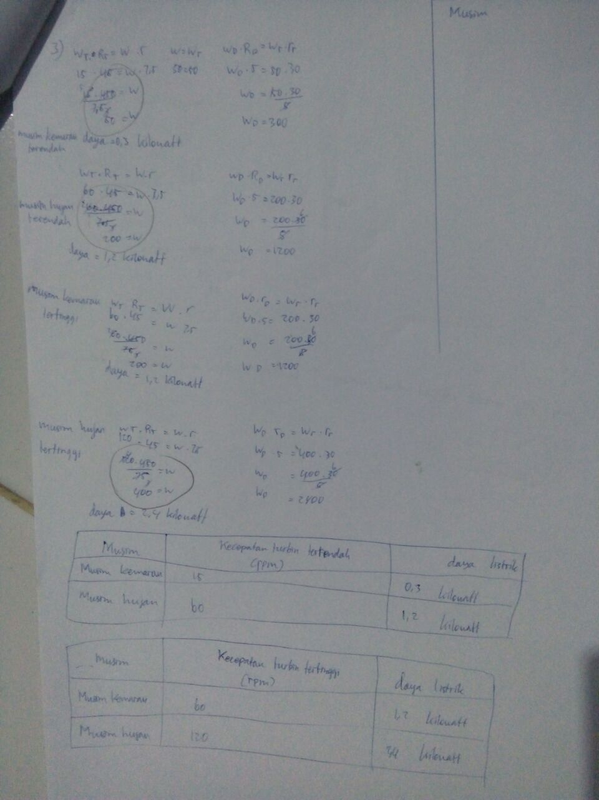 | 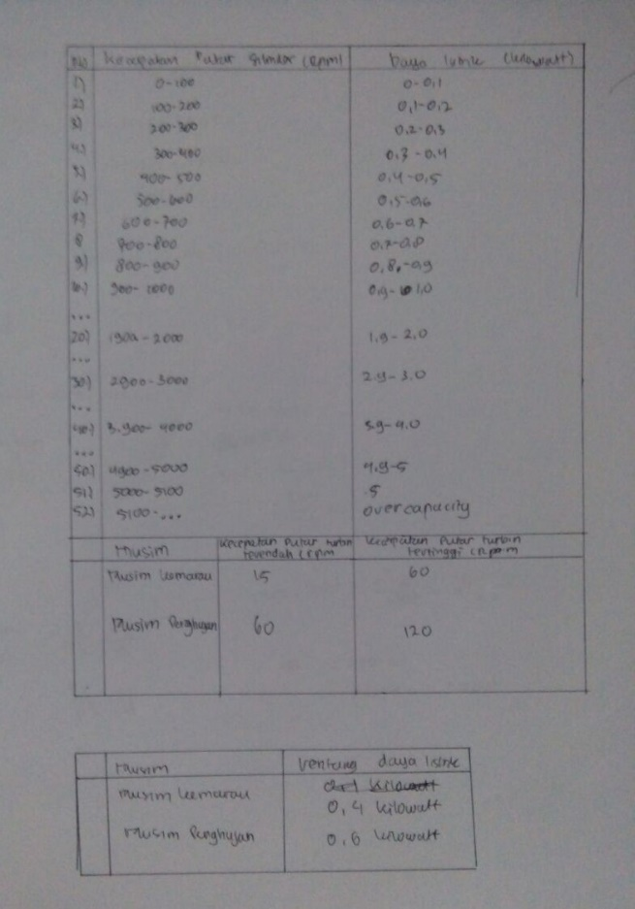
Analytical thinking skills R3 on written test at question no. 3 | Analytical thinking skills R19 on written test at question no. 3
- skills to identify each element;  - skills to sort parts into important elements;  - skills to analyze relationships between elements and giving solutions | - skills to identify each element;  - skills to sort parts into important elements;  - skills to analyze relationships between elements and giving solutions
Figure 4. Examples of Analytical thinking skills ratio on written test (R3 and R19)

The barriers described are grouped according to their own category of analytical thinking skills. Based on Table 1, it is known that the obstacles experienced by students are different. Given the students are in a dormitory environment that provides the same and scheduled activities in each student. Students are categorized as both academic and non academic achievers who have been previously screened. The obstacles experienced by these students follow each other's personal.

Table 1. Obstacles experienced by students based on each category of analytical thinking skills
Categories Analytical Thinking Skills | Aspects of Barriers
 | Health | Learning habits | Motivation to achieve goals | Interactions with friends | Relationships with schools | Personal teachers | Analytical Application Activities | Subjects taught
High | 72,86 | 80,86 | 55,29 | 66,43 | 48,57 | 84,57 | 76,57 | 73,14
Medium | 72,25 | 76 | 57,38 | 76 | 44,38 | 86,25 | 92,88 | 83,75
Low | 81,88 | 91,75 | 52,13 | 81,5 | 52,75 | 82,13 | 87,75 | 85,75

Students with low analytical thinking skills have the greatest obstacles to aspects of learning habits. Students in this category have not been able to adapt to the scheduled activities provided by the dormitory. Students can not abandon learning habits at the previous level, such as learning to eat. This can not be done in the dormitory given the eating and learning schedule is available at different times. Students with analytical thinking skills are experiencing the greatest obstacles to aspects of application activity analysis. Students in this category lack experience in analytical activities. Students feel they have not been told how to analyze so that in certain cases students often take answers or conclusions without being analyzed first.
Students with high analytical thinking skills have the greatest impediment to personal teachers. Personal teachers consist of five aspects, the aspect with the highest value experienced by students with high analytical thinking skills is the teacher gives a lot of homework. This makes students with high categories in learning must be good at sharing concentration to complete homework between subjects one with other subjects. This description is in line with Firmansyah (2017) which provided that learning barriers not only afflict students with low skills but also experienced by students with high skills.
Based on observations, observed physics learning has not used a scientific approach. Aspects of scientific learning are observed in the form of observing and asking, but not yet structured to form a scientific study. The question mostly comes from the practice after the teacher's explanation. The questions given by teachers are still simple questions of the subject matter, so that students are less accustomed to analyzing complex problems and beyond physics textbooks. Students' skills in analyzing a concept will train students to think in a complex way (Susilawati et al, 2015).
P : What do you think about the problem asked in the question?
R2 : I think it's difficult because it's not unusual with such a problem.
P : Is it a long question? How does it usually matter from the teacher?
R2 : Yes, the question asked long story, usually a matter given by the teacher brief and can be completed immediately.

Less students are given contextual questions that will train their thinking skills. The ability to think implies that thinking can be taught and requires exercises to be able to have it (Yuliati, 2013). Yet in solving the problem of contextual physics, students need a special process of thinking and different between the problems with each other (Syukri et al, 2012).

Figure 5. Internal Factors that Affect Students are based on The Category of Analytical Thinking Skills

The students' analytical thinking skills is influenced by external factors and factors within students. Based on Figure 5, the factors that affect the students are known that students who have high and low analytical thinking skills are driven by the motivating factors that exist within them. This looks the same but the percentage of motivation that exists in high and low category students is different. Unlike students who have analytical thinking skills are being influenced by an interest in doing analysis. Students of this category have an interest in knowing and detailing the elements in a section.
Table 2. External factors that affect students' analytical thinking skills
Categories Analytical Thinking Skills | External Factors Affecting Aspects
 | Teacher | Learning Situation and Learning Activities | Other people | Subjects | Learning environment
High | 75,89 | 85,71 | 55,95 | 77,38 | 67,86
Medium | 83,59 | 87,5 | 57,29 | 69,79 | 78,13
Low | 81,25 | 81,25 | 57,29 | 70,83 | 53,13

In addition to factors from within students, students' analytical thinking skills are influenced by external factors. Table 2 shows the external factors that affect students in each category of analytical thinking ability also vary. Students who have high analytical and moderate analytical thinking are strongly influenced by learning situations and learning activities. This external factor strongly supports them in developing their thinking skills directly.
Just as students with high analytical and moderate analytical thinking, students with low analytical thinking skills are also strongly influenced by learning situations and learning activities but with additional aspects of teachers. Students with low analytical thinking skills are not only supported with good learning situations and activities but must also be supported by the teacher's ability to bring the learning. The percentage owned by the situation and the learning activity with the teacher has the same value. This indicates that the students of this category have not had independence in learning and are still dependent on the teacher.
CONCLUSION
The average of analytical thinking skills of vocational students is 50,65. Students have been able to identify the variables of circular motion cases, remain difficult to find relationships between variables in the resolution of physics problems related to the case of the field of expertise. This is because the lesson of physics is less integrated with the field of expertise so that students are poorly trained in applying the physics concept in the field of expertise. Obstacles and factors that affect students in each category are different.
ACKNOWLEDGEMENT
Thanks to SMK Negeri Jawa Tengah who has given the research permission. Thanks to the Physics and Mechanical Engineering teachers who have provided assistance on reseach..

REFERENCES

Amer, A, 2005, Analytical Thinking, Cairo: Center of Advancement of Postgraduate Studies and Research In Engineering Science.

Amer, A, 2006, Reflections on Bloom’s Revised Taxonomy, Electronic Journal of Research in Educational Psychology. 4 (8): 213-230

Anwar, B & Mumthas NS, 2014, Taking Triachic Teaching to Classrooms: Giving Everybody a Fair Chance, International Journal of Advanced Research, 2 (5): 455-458

Areesophonpichet, S, 2013, A Development of Analytical Thinking Skills of Graduate Students by using Concept Mapping, The Asian Conference on Education, 1-15

Elder, L & Paul, R, 2007, Analytic Thinking How To Take Thinking Apart And What To Look For When You Do The Elements of Thinking and The Standards, The Foundation for Critical Thinking

Firmansyah M. A, 2017, Analisis Hambatan Belajar Mahasiswa pada Mata Kuliah Statistika, JPPM, 10 (2)

Hartini, P., 2011, Pengembangan Model Pembelajaran Fisika SMK Melalui Kegiatan Bengkel Otomotif untuk Menumbuhkan Soft skills Siswa, Jurnal Penelitian Pendidikan, 1 (2): 190-199

Heong, Y M., 2011, The Perception of The Level of Higher Order Thingking Skills Among Technical Education Students, International Conference on Social Science and Humanity IPEDR, 5: 281-285

Kao, C Y, 2014, Exploring The Relationships Between Analogical, Analytical, and Creative Thinking, Thinking Skills and Creativity, 13: 80–88

Lopez, J.E. & Tancinco, N. P., 2016, Student Analytical Thinking Skills and Teacher’s Instructional Practices in Algebra in Selected State Universities and Colleges in Region VIII, International Journal of Engineering Sciences & Research Technology, 5 (6) : 681-697

Maghfiroh, U., & Sugianto, 2011, Penerapan Pembelajaran Fisika Bervisi SETS untuk Meningkatkan Kemampuan Berpikir Analitis Peserta Didik Kelas X, Jurnal Pendidikan Fisika Indonesia, 7: 6-12

Marini, 2014, Analisis Kemampuan Berpikir Analitis Siswa dengan Gaya Belajar Tipe Investigatif dalam Pemecahan Masalah Matematika, Fakultas Keguruan dan Ilmu Pendidikan. Universitas Jambi.

Marnita, 2013, Peningkatan Keterampilan Proses Sains melalui Pembelajaran Kontekstual pada Mahasiswa Semester 1 Materi Dinamika, Jurnal Pendidikan Fisika Indonesia, 9 (1): 43-52

Purwandari, R.D., 2015, Physics Laboratory Investigation of Vocational High School Field Stone and Concrete Construction Techniques in Central Java Province (Indonesia), Journal of Education and Practice, 6 (11): 85-92

Rauf, A. W., 2009, Deskripsi tentang Hambatan Guru dalam Implementasi KurikulumTingkat Satuan Pendidikan (KTSP) di SMUN 4 Watampone, Jurnal MEDTEK, 1 (1)

Rengganis, A. M & Yulianto, A., 2018, Analysis of Students’ Analytical Thinking Skill in Electromagnetic Induction Concept Using Mini Tesla Coil, Physics Communication, 2 (2): 130-140

Sartika, S. B., 2016, Keterampilan Berpikir Analitik dalam Pembelajaran IPA di SMP, Prosiding Seminar Nasional, 783-789

Slameto. 2010, Belajar dan Faktor-faktor yang mempengaruhinya, Jakarta: RinekaCipta.

Susanti, R., Sunarno, W., & Haryono, 2012, Pembelajaran Kimia menggunakan Siklus Belajar 5E dan Inkuiri Bebas Dimodifikasi Ditinjau dari kemampuan Berpikir Analisis dan Kreativitas Siswa, Jurnal Inkuiri, 1 (1): 60-68

Susilawati., Idrus, H., Masturi., &Rusilowati, A., 2014, Analisis Content Concept FisikaKelas X SMK Pada Jurusan Teknik Kendaraan Ringan (TKR), Prosiding Semnas Sains dan Pendidikan Sains IX Fakultas Sains dan Matematika UKSW, 5 (1): 368-374

Susilawati., Ristanto, S., & Khoiri, N., 2015, Pembelajaran Real Laboratory dan Tugas Mandiri Fisika pada Siswa SMK sesuai dengan Keterampilan Abad 21, Jurnal Pendidikan Fisika Indonesia, 11 (1): 73-83

Syukri, M., Halim, L., & Meerah, T. S. M., 2012, Model Pendekatan Pakar Fisika dalam Menyelesaikan Masalah Fisika Kontekstual: Sebuah Studi Kasus, Jurnal Pendidikan Fisika Indonesia, 8(1): 61-67

Winarti, 2015, Profil Kemampuan Berpikir Analisis dan Evaluasi Mahasiswa dalam Mengerjakan Soal Konsep Kalor, Jurnal Inovasi dan Pembelajaran Fisika, 2 (1): 19-24

Yuliati, L., 2013, Efektivitas Bahan Ajar IPA Terpadu terhadap Kemampuan Berpikir Tingkat Tinggi Siswa SMP, Jurnal Pendidikan Fisika Indonesia, 9 (1):53-57

