 | Life Science 15 (1) (2026)  Life Science  https://journal.unnes.ac.id/journals/UnnesJLifeSci | 
Diversity of Dragonflies (Odonata) Across Different Ecosystem Types on Karimun–Kemujan Island, Karimunjawa Archipelago
Alfiah Maula Salsa Billa^{🖂 1)}, Fathurrahman Sidiq¹⁾, Jasmine Augi Nadifa¹⁾, Salsabilla Khairunnisa¹⁾, M. Ammar Ghirrid Muzakki¹⁾
¹⁾Green Community Biology, Faculty of Mathematics and Natural Sciences, Universitas Negeri Semarang, Indonesia
50229

Article Info |  | Abstract
_{Submitted: 08 March 2026}  _{Revised: 20 May 2026}  _{Accepted: 31 May 2026} |  | Dragonflies (Odonata) are members of the class Insecta that can be used as bioindicators to assess the quality of aquatic ecosystems. This study aims to evaluate the diversity of dragonfly species in the Karimunjawa area as an effort to assess the condition of aquatic ecosystems and their surrounding environments. Data collection was conducted in four habitat types: forest, rice fields, settlements, and mangroves. The method used was point count, with observations carried out in the morning from 08:00–11:00 WIB and from 15:00–17:00 WIB. The results showed that dragonfly diversity varied among habitat types, where the mangrove habitat had the highest species diversity (H’ = 2.23), while the settlement habitat showed the lowest richness (Dmg = 1.31). Several species recorded have the potential to serve as bioindicators of aquatic environmental quality in Karimunjawa. These findings indicate that the ecosystem conditions in the study area are still well preserved. However, further management and conservation efforts are required to ensure the sustainability of dragonfly habitats. This study provides one of the first habitat-based assessments of dragonfly diversity in Karimunjawa and contributes baseline information on species composition, habitat associations, and their potential use as bioindicators of aquatic ecosystem quality.
Keywords:
Dragonflies; Odonata; Species diversity; Bioindicator; Aquatic ecosystem; Karimunjawa
 |  | © 2026 Universitas Negeri Semarang
Correspondence address:  D6 Building, 1st Floor, Faculty of Mathematics and Natural Sciences, Universitas Negeri Semarang, Sekaran Campus, Gunungpati, Semarang 50229  E-mail: alfiahsalsa05@gmail.com |  |  | p-ISSN 2252-6277  e-ISSN 2528-5009

INTRODUCTION
Dragonflies (Odonata) are members of the class Insecta that can be used as bioindicators for assessing the quality of aquatic ecosystems. Their role as bioindicators is closely related to the nymphal stage, which can only survive in unpolluted water conditions and river ecosystems that still possess aquatic vegetation. Odonata nymphs are highly sensitive to changes in water quality; therefore, the presence and diversity of dragonflies are frequently used to evaluate the condition of aquatic environments. Recent studies have shown that dragonflies can serve as indicators of river water quality by analyzing species diversity in conjunction with the physicochemical characteristics of water, reflecting the status of aquatic ecosystems through biotic indices commonly applied in ecological assessments (Zunnikah et al., 2025). Compared with other aquatic organisms, Odonata were selected in this study because their biphasic life cycle, consisting of aquatic nymphs and terrestrial adults, enables them to reflect environmental conditions in both aquatic and terrestrial habitats (Corbet, 1999). In addition, Odonata respond rapidly to environmental changes and are relatively easier to observe and identify, making them effective organisms for biodiversity assessment and ecological monitoring (Corbet, 1999).
Karimunjawa National Park (TNKJ) contains limited freshwater habitats, including small streams, springs, and forest water channels that potentially support Odonata communities. These habitats provide important environmental features for dragonflies, such as aquatic vegetation, riparian cover, and suitable microhabitat conditions for both aquatic nymphs and adult stages. However, freshwater ecosystems on small islands are generally more vulnerable to environmental changes and anthropogenic pressures. Increasing tourism activities, land-use changes, and habitat disturbance may alter habitat quality and affect freshwater biodiversity. Given that Odonata are highly sensitive to environmental changes, understanding their diversity and distribution within Karimunjawa freshwater habitats is important for assessing ecosystem conditions and supporting conservation management. However, development activities, particularly resort construction, have the potential to cause environmental degradation through increased soil erosion, sedimentation, and coastal abrasion. Land-use conversion into resort areas has occurred in several parts of Karimunjawa, including the Bukit Karimunjawa area (Pristira, 2021), which may indirectly affect water quality and the presence of bioindicator organisms such as dragonflies (Zunnikah et al., 2025).
Previous studies on dragonflies in Indonesia have mainly focused on species diversity, community structure, and their role as bioindicators in freshwater ecosystems across various habitats such as rivers, waterfalls, forests, and mountainous areas. Research in the Mount Muria area showed that dragonfly diversity reflected water quality conditions and demonstrated the potential of Odonata as bioindicators (Hidayat et al., 2019). Other studies found that habitats with better vegetation structure and lower disturbance levels supported higher dragonfly diversity, indicating the importance of habitat quality in shaping Odonata communities (Oliveira-Junior & Juen, 2019). In addition, environmental factors have been reported to influence dragonfly species composition and diversity patterns across freshwater habitats (Wibowo et al., 2019). A review of dragonfly research in Indonesia further highlighted uneven research distribution and emphasized that many regions and ecological aspects remain poorly studied (Lupiyaningdyah, 2020).
Research on biodiversity in Karimunjawa has primarily focused on marine and coastal ecosystems, including coral reef diversity, reef fish communities, and other faunal groups. Previous studies have investigated reef fish diversity and community structure in the Karimunjawa National Park and surrounding waters, emphasizing marine ecosystem conditions and conservation values (Yuliana et al., 2017). Studies have also explored coral diversity and environmental factors affecting coral ecosystems in Karimunjawa (Nugroho et al., 2018). In terrestrial ecosystems, biodiversity studies have included butterfly diversity assessments in Karimunjawa National Park (Murti et al., 2017). More recent studies have additionally applied environmental DNA approaches to assess fish biodiversity in Karimunjawa ecosystems (Al Malik et al., 2024). However, despite these studies, information regarding Odonata diversity and community patterns in Karimunjawa remains very limited. In particular, studies evaluating the relationship between dragonfly diversity and environmental variables across habitat types in Karimunjawa are still lacking. Consequently, previous studies have not sufficiently addressed the scientific question of how habitat characteristics and environmental conditions influence Odonata diversity and distribution patterns within island ecosystems. This knowledge gap is important because Odonata are highly sensitive ecological indicators capable of reflecting environmental conditions in both aquatic and terrestrial habitats. Therefore, this study aims to provide baseline information on Odonata diversity and contribute to biodiversity monitoring and conservation strategies in Karimunjawa. Despite increasing development pressure and tourism activities in Karimunjawa, there is still insufficient information regarding dragonfly community patterns and their potential use as long-term ecological indicators.
This study aims to assess the diversity of dragonfly species (Odonata) in the Karimunjawa area as an effort to evaluate the condition of aquatic ecosystems and their surrounding environments. The research was conducted by identifying the composition of dragonfly species across different habitat types, including mangrove areas, residential areas, rice fields, and forest habitats, which are influenced by both natural and anthropogenic activities. This data is important because TNKJ is a conservation area experiencing increasing development pressure, particularly in Karimunjawa. Long-term monitoring using bioindicators can detect environmental degradation early, before irreversible impacts occur.

METHODS

Time and Location
This research was conducted on Karimunjawa Island and Kemujan Island, which are part of the Karimunjawa National Park area. Data collection was carried out across four habitat types, namely forest, rice field, residential area, and mangrove. The study was conducted from April to May 2024. Observations were performed in the morning and afternoon in accordance with the activity periods of dragonflies (Susanto & Arianti, 2021) from 09:00 to 11:00 WIB for morning observations and from 15:00 to 17:00 WIB for afternoon observations.

Table 1.

Locations and coordinates of study sites
Location | Coordinate point
Location | Latitude | Longitude
Forest | -5.858017 | 110.448474
Rice field | -5.833512 | 110.463370
Residential area | -5.835925 | 110.446943
Mangrove | -5.827898 | 110.467305

Tools and Materials
The tools and materials used in this research included an insect net, digital camera, tally sheet, watch, stationery, and identification guidebooks, such as Photographic Field Guide to the Dragonflies & Damselflies of Singapore, Dragonflies of Yogyakarta, and Naga Terbang Wendit: Keanekaragaman Capung Perairan Wendit, Malang, Jawa Timur. These references were used as the primary sources for recognizing morphological characteristics and determining the dragonfly species found at the study site.
Methods
Dragonfly data collection in this research employed the Point Count method (Carlton, 1990). Observations were conducted in each habitat by stopping at predetermined observation points for 20 minutes, with an observation radius of 20 meters from the observer’s position. The distance between observation points along each transect was set at 100 meters. Each habitat consisted of five observation points. The total transect length was 500 meters, with three replicates conducted in each habitat.
Data collection was conducted in May, which falls within the dry season, resulting in relatively stable environmental conditions and low rainfall. Study habitats were selected based on the presence of environments suitable for dragonfly breeding and foraging activities. A purposive–systematic approach was applied, where transects were established purposively within suitable habitats, and observation points were placed systematically at fixed intervals along each transect (Pujiastuti et al., 2017).
Environmental variables were measured at each observation point, including air temperature (°C), light intensity (lux), and relative humidity (%). These parameters were recorded to characterize microhabitat conditions that may influence dragonfly occurrence and activity patterns.
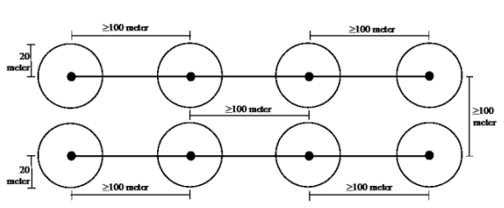
Figure 1.
Schematic diagram of the Point Count method showing observation points (black dots) spaced 100 meters apart along transect lines with a 20-meter observation radius (dashed circles) at each point (Murti et al., 2017)

All dragonflies encountered within the observation area were identified directly in the field and documented through photography. Individuals that could not be identified in the field were placed in paper envelopes (papilotes) for further identification in the laboratory. Information recorded on each tally sheet included the time of observation, behavior, and location of occurrence. To ensure accurate species identification, several specimens particularly those that could not be identified in the field were preserved and subsequently identified at the Animal Taxonomy Laboratory, Department of Biology, Faculty of Mathematics and Natural Sciences, Universitas Negeri Semarang (UNNES).
Data Analysis
Data analysis included the assessment of dragonfly species diversity using the following indices:
Shannon–Wiener Diversity Index (H′).
The Shannon–Wiener Diversity Index was used to determine the level of dragonfly species diversity (Shannon & Weaver, 1949)

Informations:
H′ = species diversity index
Pi = relative abundance index
Ni = number of individuals of species
N = total number of individuals
The value of H′ (dragonfly diversity index) ranges as follows:
- H′ < 1.50: low diversity
- 1.50 ≤ H′ < 3.50: moderate diversity
- H′ ≥ 3.50: high diversity

Species Richness Index (Margalef Index) (Margalef, 1958)

Informations:
Dmg = Margalef species richness index
S = total number of species recorded
N = total number of individuals

Evenness Index
The evenness index was used to determine the distribution uniformity of individuals among species within the community (Pielou, 1966),

Informations:
E′ = evenness index
H′ = Shannon–Wiener diversity index
S = number of species

The value of E′ (dragonfly evenness index) ranges from 0 to 1, with the following categories:
- E′ < 0.50: stressed community
- 0.50 ≤ E′ < 0.75: unstable community
- 0.75 ≤ E′ ≤ 1.00: stable community

RESULT AND DISCUSSION
Variation in Odonata assemblages was observed among sampling locations during the study period. Species presence differed across habitats, indicating potential differences in habitat suitability and environmental conditions. The study area map, species occurrence across sampling locations, and the results of diversity index analyses are presented in Figure 2 and Tables 2–3.

a)  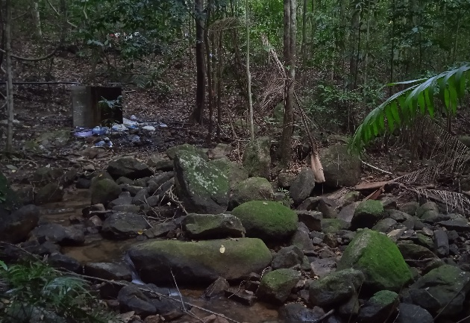 | b)  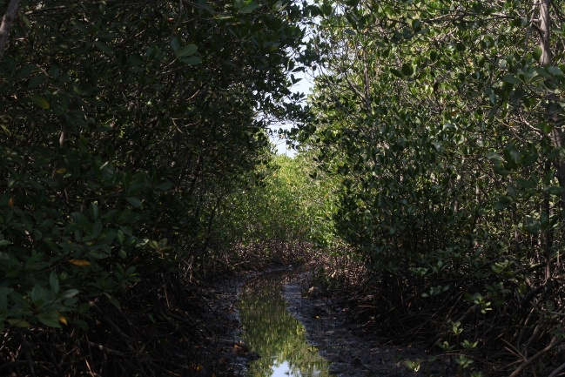
c)  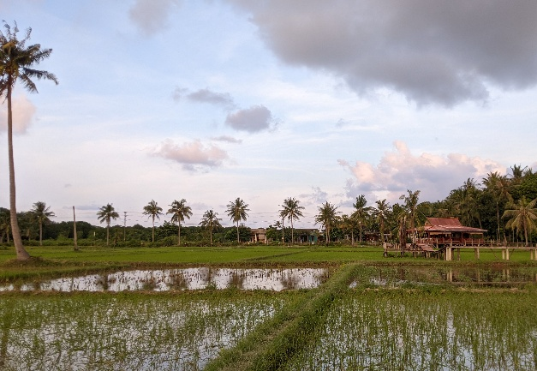 | d)  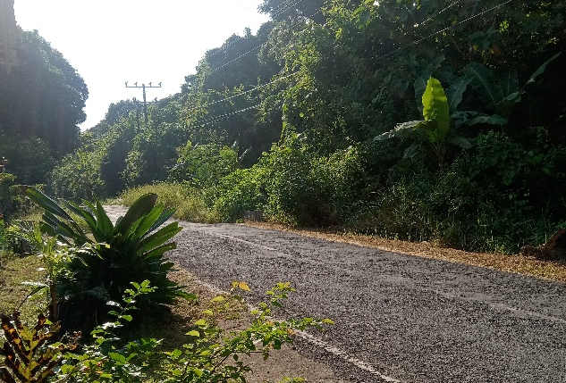
Figure 2.
Research location: Tropical Forest (a), Mangrove (b), Rice Fields (c), Residential area (d)

The results of this study across four habitat types on Karimunjawa Island, encompassing four habitat types: forest, rice fields, residential area, and mangrove, revealed clear variations in the composition and abundance of Odonata species among observation sites. A total of 22 Odonata species were identified across all sampling transects on Karimunjawa Island (Table 1). Species richness varied significantly among the four habitat types: mangrove areas had the highest richness (16 species), followed by rice fields (15 species), forest areas (10 species), and urban areas (8 species; Table 1). These differences in species richness reflect variations in environmental conditions, habitat heterogeneity, and anthropogenic disturbance intensity. The higher richness in mangrove and rice field habitats suggests that these ecosystems provide suitable aquatic breeding sites and vegetation structure for diverse Odonata communities.
At the family level, Libellulidae was the most frequently encountered family and exhibited the highest species richness, with a total of 13 species distributed across almost all habitat types. The presence and dominance of the family Libellulidae indicate its important role in shaping the structure of Odonata communities within the study area. Species belonging to this family are generally characterized by high dispersal ability, broad environmental tolerance, and strong adaptability to changing habitat conditions, including aquatic environments affected by human activities (Suárez-Tovar et al., 2022).

Table 2.

Result of Odonata in the Karimunjawa-Kemujan
No | Species Name | Family | Suborder | Forest | Rice Field | Residential area | Mangrove
1 | Agriocnemis femina | Coenagrionidae | Zygoptera | - | + | - | +
2 | Agriocnemis pygmaea | Coenagrionidae | Zygoptera | - | + | - | -
3 | Ceriagrion auranticum | Coenagrionidae | Zygoptera | - | - | + | +
4 | Ischnura senegalensis | Coenagrionidae | Zygoptera | + | + | - | +
5 | Mortonagrion falcatum | Coenagrionidae | Zygoptera | - | - | + | +
6 | Pseudagrion microcephalum | Coenagrionidae | Zygoptera | - | + | - | -
7 | Prodasineura autumnalis | Platycnemididae | Zygoptera | + | + | - | +
8 | Anax guttatus | Gomphidae | Anisoptera | - | - | - | +
9 | Acisoma panorpoides | Libellulidae | Anisoptera | - | - | - | +
10 | Agrionoptera insignis | Libellulidae | Anisoptera | + | - | - | +
11 | Brachydiplax chalybea | Libellulidae | Anisoptera | - | + | - | +
12 | Brachythemis contaminata | Libellulidae | Anisoptera | - | + | - | -
13 | Crocothemis servilia | Libellulidae | Anisoptera | - | + | - | -
14 | Diplacodes trivialis | Libellulidae | Anisoptera | + | + | + | +
15 | Neurothemis terminata | Libellulidae | Anisoptera | + | + | + | -
16 | Orthetrum chrysis | Libellulidae | Anisoptera | + | + | + | +
17 | Orthetrum sabina | Libellulidae | Anisoptera | + | + | + | +
18 | Pantala flavescens | Libellulidae | Anisoptera | + | + | + | +
19 | Raphismia bispina | Libellulidae | Anisoptera | + | - | - | +
20 | Rhyothemis Phyllis | Libellulidae | Anisoptera | + | + | + | +
21 | Tholymis tillarga | Libellulidae | Anisoptera | - | - | - | +
22 | Tramea transmarina | Libellulidae | Anisoptera | - | + | - | +

In the forest area, a total of 10 Odonata species were recorded, dominated by species that prefer relatively stable aquatic habitats and well-preserved vegetation. Diverse vegetation strata and the availability of various surface water bodies generally influence the occurrence of Odonata in tropical forest habitats. A study conducted in tropical forests (Nafisah & Soesilohadi, 2021) reported that Odonata communities in natural forest habitats comprise several families from both suborders Anisoptera and Zygoptera and exhibit diversity index values indicating that forest environmental structure effectively supports diverse Odonata communities. Observations in rice fields revealed the presence of 15 Odonata species, dominated by species tolerant of temporary standing water and human activities. The relatively high species richness in rice field habitats indicates that agroecosystems continue to function as important habitats for Odonata, particularly for species with high ecological flexibility. In transect B, the Odonata community consisted mainly of species commonly found in rice field environments, primarily belonging to the families Libellulidae and Coenagrionidae. Inventory studies of dragonflies in rice field areas have reported that species recorded in such habitats predominantly belong to these two families, reflecting their ecological association with rice field ecosystems (Rizal & Hadi, 2015).
In the residential area, species diversity was comparatively lower, with only 8 Odonata species recorded. The reduced diversity in this habitat is likely associated with high levels of anthropogenic pressure, limited natural vegetation, and alterations in water quality, which negatively affect Odonata, particularly species that are sensitive to environmental disturbance. Meanwhile, mangrove areas represented the habitat with the highest species richness, with 16 Odonata species recorded. Mangrove ecosystems are characterized by complex environmental conditions, including tidal influence, salinity variation, and heterogeneous vegetation structure, which collectively support the presence of various Odonata species with strong adaptive capacities to coastal aquatic environments. The high species diversity observed in mangrove habitats indicates that this ecosystem continues to function ecologically as an important habitat for Odonata on Karimunjawa Island. In contrast, the suborder Zygoptera was generally represented by fewer species compared to Anisoptera. The species from Zygoptera are typically more sensitive to environmental changes and are more strongly dependent on water quality and surrounding vegetation (Aprilia et al., 2025). The presence of several Zygoptera species at specific sites on Karimunjawa Island suggests that habitat conditions in these areas remain sufficiently suitable to support species with relatively lower environmental tolerance.

Table 3.

Diversity indices of dragonflies (Odonata) across habitat types in the Karimunjawa area
Description | Forest | Rice fields | Residential area | Mangrove/  Coastal area
S | 11 | 15 | 8 | 17
Dmg | 2.05 | 2.13 | 1.31 | 3.02
H’ | 1.99 | 2.09 | 1.17 | 2.23
E | 0.83 | 0.77 | 0.56 | 0.78

Odonata diversity in Karimunjawa Island was classified as moderate, based on the Shannon–Wiener diversity index (H’) values ranging from 1.17 to 2.23. According to Odum (1993), all observed H’ values fall within the moderate diversity category (1–3), indicating varying but generally moderate levels of Odonata diversity across habitats. However, differences in H’ values suggest a gradient of ecological conditions, with mangrove habitats (2.23) showing relatively higher diversity compared to residential areas (1.17), which exhibit lower diversity within the moderate range, likely reflecting higher levels of anthropogenic disturbance. These differences reflect variations in Odonata community structure associated with environmental conditions and the intensity of anthropogenic disturbance. Odonata diversity is generally higher in habitats with good vegetation cover and water quality, whereas it tends to decline in urban areas due to anthropogenic disturbance (Perron et al., 2021). Furthermore, the evenness index (E) values ranged from 0.56-0.83, indicating differences in the distribution of individuals among species across habitats. Higher evenness values suggest a more balanced community structure with relatively similar abundances among species, while lower values indicate dominance by certain species. Species richness based on the Margalef index ranged from 1.31-3.02, demonstrating variation in species richness among habitat types. Habitats with higher Margalef values supported greater species richness, likely due to more favorable habitat complexity and resource availability. Variations in Odonata diversity among habitat types were likely influenced by differences in environmental conditions and habitat characteristics.

Table 4.

Environmental parameters at research site
Parameters | Location
Parameters | Forest | Rice Field | Residential Area | Mangrove
Temperature (ºC) | 32,4 | 34,3 | 33 | 38,3
Light Intensity (Lux) | 3157 | 6404 | 2405 | 2119
Air humidity (%) | 43 | 74 | 73 | 45

Factors such as vegetation structure, habitat complexity, light intensity, temperature, humidity, and the availability of aquatic microhabitats may affect the distribution and composition of Odonata communities. Habitats with more favorable environmental conditions and greater vegetation cover tend to support higher species diversity by providing suitable breeding sites, shelter, and food resources. In contrast, habitats experiencing greater anthropogenic disturbance may reduce habitat quality and limit species occurrence, particularly for environmentally sensitive taxa (Hendriks et al., 2023).

a)  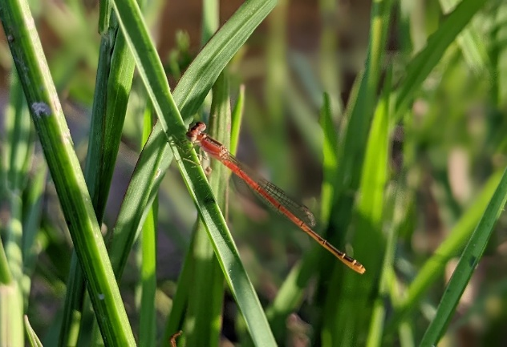 | b)  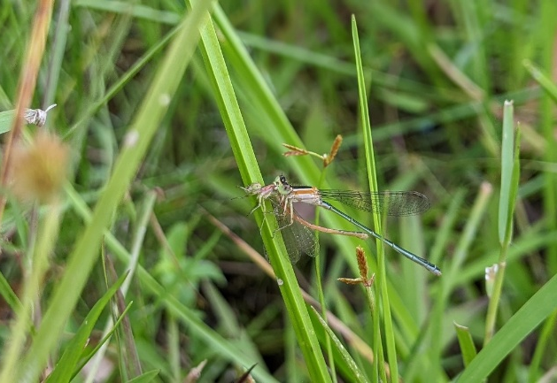
c)  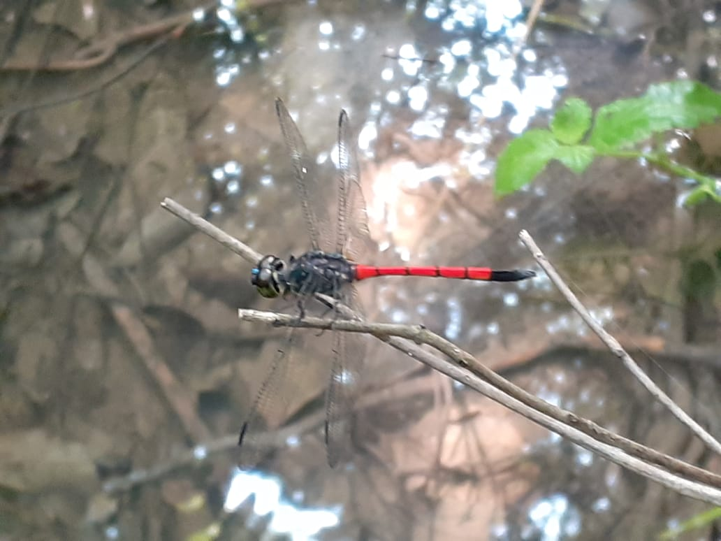 | d)  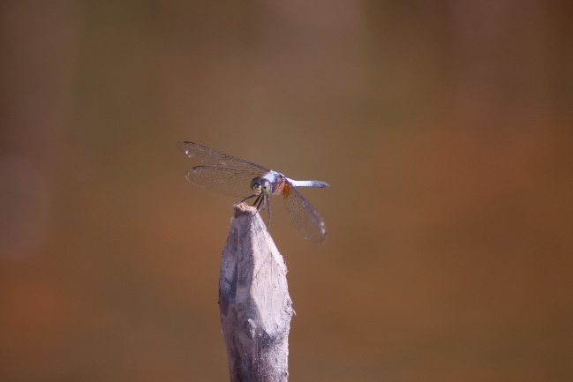
Figure 3.
Dragonflies found during observations Agriocnemis femina (a), Ishnura senegalensis (b), Agrionoptera insignis (c), Brachydiplax chalybea (d)

Mangrove, rice field, and forest habitats supported relatively more stable Odonata communities, characterized by higher diversity and a more even distribution of individuals. In contrast, the lower H’ value in residential areas indicates a community dominated by tolerant species. Under disturbed conditions, communities in habitats with higher diversity are expected to exhibit greater resilience than those in habitats with lower diversity. The findings of this study have important conservation implications for Karimunjawa National Park. Differences in Odonata diversity among habitats indicate that habitat conditions and anthropogenic disturbance influence community structure. As bioindicators of ecosystem health, Odonata can provide important baseline data for biodiversity monitoring and support habitat management and conservation planning within the national park.

CONCLUSION
This study highlights the influence of habitat characteristics and anthropogenic disturbance on Odonata community structure on Karimunjawa Island. Habitats with more suitable environmental conditions, such as mangroves, tended to support richer and more balanced Odonata communities, while disturbed habitats showed reduced diversity and altered community composition. These findings emphasize the importance of maintaining habitat quality and highlight the potential of Odonata as bioindicators for biodiversity monitoring and conservation planning in small island ecosystems.

ACKNOWLEDGEMENT
The authors would like to express their sincere gratitude to the Karimunjawa National Park Authority for granting research permission and providing field support during the study. Appreciation is also extended to the Institute for Research and Community Service (LPPM), Universitas Negeri Semarang (UNNES), for administrative and institutional support. Special thanks are given to Mr. Pri and his family, as local residents of Karimunjawa, for their hospitality and for providing accommodation throughout the research period.

REFERENCES
Aprilia, A., Pratama, S. F., Achyar, A., & Satria, R. (2025). Jenis-jenis capung (Odonata) pada beberapa tipe habitat di Korong Asam Pulau, Kabupaten Padang Pariaman, Sumatera Barat. Jurnal Pendidikan Tambusai, 9(1), 11188–11193. https://doi.org/10.31004/jptam.v9i1.26460
Carlton, C. (1990). Bird survey methods. National Parks Association.
Corbet, P. S. (1999). Dragonflies: Behavior and Ecology of Odonata. Cornell University Press.
Hedriansyah., Kamal, S., & Nuraisah. (2017). Keanekaragaman jenis teripang (Holothuroidea) di perairan Pantai Iboih Kota Sabang. Prosiding Seminar Nasional Biotik, 5(1), 260–265.
Hendriks, J. A., Mariaty, Maimunah, S., Anirudh, N. B., Holly, B.A., Erkens, R.H.J., Harrison, M.E. (2023). Odonata (Insecta) communities in a lowland mixed mosaic forest in Central Kalimantan, Indonesia. Ecologies. 4(1), 55-73. https://doi.org/10.3390/ecologies4010006
Hidayat, S., Husnia, F., Rohmah, E., & Mukhlishoh, S. (2019). Study on diversity of dragonfly (Odonata) as a bioindicator of water quality in Mount Muria Area, Central Java. Journal of Natural Sciences and Mathematics Research, 5(2), 53–61.
Lupiyahningdyah, P. (2020). The past, present and future of dragonfly research in Indonesia. BIO Web of Conferences. https://doi.org/10.1051/bioconf/20201900024
Malik, M. D. A., Ambariyanto, A., Hartati, R., Nursalim, N., Kholilah, N., Kurniasih, E. M., Anggoro, A. W., Prasetia, R., Syamsyuni, Y., Muh, F., & Cahyani, N. K. D. (2025). eDNA uncovers hidden fish diversity in the coral reef ecosystems of Karimunjawa National Park, Indonesia. Regional Studies in Marine Science, 81, Article 103945. https://doi.org/10.1016/j.rsma.2024.103945
Margalef, R. (1958). Information theory in ecology. General Systems, 3, 36–71.
Murti, W, B. Kartijono, N, E. Rahayuningsih, M. (2017). Diversity of butterflies in Karimunjawa National Park of Central Java. Biospecies, 10(2). https://doi.org/10.22437/biospecies.v10i2.3928
Nafisah, N. A., & Soesilohadi, R. C. H. (2021). Community structure of dragonfly (Ordo: Odonata) in natural forest and tourist sites Petungkriyono Forest, Central Java, Indonesia. Journal of Tropical Biodiversity and Biotechnology, 6(03), 1–9. https://jurnal.ugm.ac.id/jtbb/article/view/67328
Nugroho, F., Zamanni, N. P., Madduppa, H. (2018). The effect of organic sediment contnet on coral diversity in Karimunjawa Island, Indonesia. Jurnal Ilmu dan Teknologi Kelautan Tropis, 10(1), 79-86. https://doi.org/10.29244/jitkt.v10i1.21665
Oliveira-Junior, J. M. B., & Juen, L. (2019). Structuring of dragonfly communities (Insecta: Odonata) in eastern Amazon: Effects of environmental and spatial factors in preserved and altered streams. Insects, 10(10), 322. DOI: 10.3390/insects10100322
Perron, M. A. C., Richmond, I. C., & Pick, F. R. (2021). Plants, water quality and land cover as drivers of Odonata assemblages in urban ponds. Science of the Total Environment, 773, 145467. https://doi.org/10.1016/j.scitotenv.2021.145467
Pielou, E. C. (1966). The measurement of diversity in different types of biological collections. Journal of Theoretical Biology, 13, 131–144. https://doi.org/10.1016/0022-5193(66)90013-0
Pristira, A. L., Purwanti, F., & A’in, C. (2021). Indeks kepekaan lingkungan (IKL) ekosistem lamun berdasarkan pemanfaatan sumberdaya perikanan di Karimunjawa. Saintek Perikanan: Indonesian Journal of Fisheries Science and Technology, 17(1), 37–46.
Pujiastuti, P. Windusari, Y. Agus, M. (2017). The distribution and composition of Odonata (Dragonfly and damselfly) in Sriwijaya University, Inderalaya Campus South Sumatera. Journal of Biological Researcher, 23(1), 1-5. DOI:10.23869/bphjbr.23.1.20171.
Rizal, S., & Hadi, M. (2015). Inventarisasi jenis capung (Odonata) pada areal persawahan di Desa Pundenarum, Kecamatan Karangawen, Kabupaten Demak. Bioma: Berkala Ilmiah Biologi, 17(1), 16–20. https://doi.org/10.14710/bioma.17.1.16-20
Shannon, C. E., & Weaver, W. (1949). The mathematical theory of communication. Urbana: University of Illinois Press.
Suárez-Tovar, C. M., Castillo-Pérez, E. U., Sandoval-García, I. A., Schondube, J. E., Cano-Santana, Z., & Córdoba-Aguilar, A. (2022). Resilient dragons: Exploring Odonata communities in an urbanization gradient. Ecological Indicators, 141, 109134. https://doi.org/10.1016/j.ecolind.2022.109134
Susanto, M. A. D., & Arianti, O. F. (2021). Diversity and abundance of dragonfly (Anisoptera) and damselfly (Zygoptera) at Sabo Dam Complang, Kediri, East Java, Indonesia. Biosfer: Jurnal Tadris Biologi, 12(2), 110–122.
Wibowo, S. S., Basukriadi, A., & Winarni, N. L. (2019). Dragonfly species diversity (Odonata) in Three Telaga on the highland freshwater, West Java. IOP Conference Series: Earth and Environmental Science, 394 (1). https://doi.org/10.1088/1755-1315/394/1/012007
Yudiawati, E., & Oktavia, L. (2020). Keanekaragaman jenis capung (Odonata) pada areal persawahan di Kecamatan Tabir dan Kecamatan Pangkalan Jambu Kabupaten Merangin. Jurnal Sains Agro, 5(2).
Yuliana, E. Boer, M. Fahrudin, A. Kamal, M, M. (2017). Biodiversity of reef in marine protected area of Karimunjawa National Park. Biospecies, 10(2). https://doi.org/10.22437/biospecies.v10i2.3928
Zunnikah, Z., Hadisusanto, S., & Nurjani, E. (2025). Diversity of dragonflies (Odonata) as bioindicators of water quality in Mangkol River, Terak Village, Simpang Katis Subdistrict, Central Bangka Regency. Bioma: Berkala Ilmiah Biologi, 27(2), 60–67. https://doi.org/10.14710/bioma.2025.71005

