 | Life Science X (X) (202X)  Life Science  https://journal.unnes.ac.id/journals/UnnesJLifeSci  p-ISSN: 2252-6277 | e-ISSN: 2528-5009 | 
The Title (Concise, Direct, and Highlighting Key Findings)
Name of Author 1^{🖂 1)}, Name of Author 2 ²⁾, Name of Author 3 ³⁾
¹⁾ Author Affiliation (All of the authors’ institutional address(es))
🖂 Corresponding Author: xyz@mail.ac.id
Submitted: xx-yy-zzzz. Revised: xx-yy-zzzz. Accepted: xx-yy-zzzz
Abstract. Background/Objective: Provide a concise background and clearly state the primary objective of the study. Methods: Briefly describe the methodology, experimental design, or analytical approach utilized. Results: Summarize the main quantitative and key findings of the research concisely. Conclusion: State the broader significance, core takeaway, and main implications of the research. (Recommended length: 150–250 words).
Keywords: Keyword 1; Keyword 2; Keyword 3; Keyword 4; Keyword 5 (Choose 3–5 relevant terms for search engine optimization)
How to Cite:
DOI:
INTRODUCTION
The introduction should establish the scientific context, articulate a rigorous state-of-the-art literature review, identify research gaps, and clearly define the study's novel contribution and objectives. State of the Art Overview: Provide a comprehensive overview of recent and foundational developments in the field. Review relevant primary studies and emphasize recent progress to ground your research in current scientific discourse. Research gap & Justification of Novelty: Explicitly point out the critical gaps, limitations, or unanswered questions in the existing literature. Explain how this research addresses these limitations and highlight the theoretical or practical novelty of your proposed framework, methodology, or analysis. Research Objectives: State the specific aims and central hypothesis or research questions of this study clearly and concisely. Explain the research purpose and benefit for science or society.
METHODS
Describe the research design, methodologies, procedures, and analytical tools in sufficient detail to allow replication by other researchers.
Study Design & Sampling / Data Collection
Detail the overall framework, experimental setups, sampling strategy, data collection instruments, or dataset parameters.
Experimental / Analytical Procedure
Outline step-by-step procedures, algorithms, measurement tools, or intervention protocols implemented during the investigation.
Statistical & Analytical Methods
Specify software versions, analytical frameworks, and statistical test criteria (e.g., significance levels, confidence intervals) used to process and analyze data.
RESULTS AND DISCUSSIONS
Present the primary empirical findings logically and systematically using clear narrative text, tables, and structured outputs.
Summary of Findings
Provide a structured presentation of key measurements, data trends, and empirical outputs.
Table 1. Example for Table
Primer | Retention Time | Area
ILT1 | TTC AAC AAT TTA ATG TTT AAG | 5’ PCR Primer (+20bp) complementary to nucleotide +20 to 120 of 50S Ribosomal Gene of rplK S. aureus
ILT2 | TTG TAG TAC CCT AAG ACA TTT | 3’ PCR Primer (+120) complementary to nucleotide +20 to 120 of 50S Ribosomal Gene of rplK S. aureus
… | … | …
Notes: ........

Descriptive summary highlighting statistical significance and critical data observations from the table above. Provide an in-depth interpretation of the results, connect empirical findings with underlying mechanisms, and compare outcomes with previous studies in the scientific literature Interpretation of Key Results: Analyze the deeper meaning and broader theoretical/practical implications of the key findings. Explain the mechanisms or principles driving observed phenomena. Comparative Analysis with Prior Literature: Compare your findings directly with benchmark studies and existing scientific literature. Highlight agreements, discrepancies, or advancements over previous methodologies and outcomes. Study Limitations: Acknowledge potential constraints, assumptions, or methodological limitations of the study and discuss how they may impact generalizability.

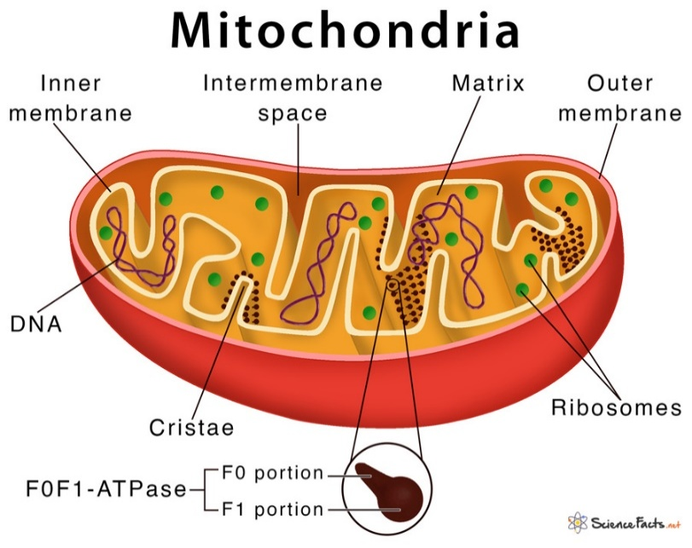
Figure 1. Example of Figure

CONCLUSION
Summarize the main conclusions of the research, direct responses to the original objectives, and provide actionable implications or recommendations for future work. Key Findings: Succinctly recap how the experimental outcomes satisfy the main objectives. Scientific & Practical Implications: Describe the broader theoretical contributions and practical applications of the work. Future Research Directions: Offer concrete recommendations for further studies to build upon these results.
ACKNOWLEDGEMENTS
This research was funded by [Name of Funding Agency], grant number [Grant/Project Number]. (If no external funding was received: This research received no specific grant from any funding agency in the public, commercial, or not-for-profit sectors).
AUTHOR CONTRIBUTION STATEMENT
Using the CRediT (Contributor Roles Taxonomy) framework:
Initial of Author Name A: Conceptualization, Methodology, Formal analysis, Writing original draft. Initial of Author Name B: Investigation, Data curation, Visualization, Validation. Initial of Author Name C: Supervision, Project administration, Writing, review & editing, Funding acquisition. All authors have read and agreed to the published version of the manuscript.

ETHICAL APPROVAL STATEMENT
If your research uses humans or animals, please include informed consent statement in your writing. For example: Informed consent was obtained from all subjects involved in the study. Prior to participation, each subject was provided with a detailed explanation of the study’s objectives, procedures, potential risks, and benefits. All participants voluntarily agreed to participate and signed a written informed consent form
DECLARATION OF GENERATIVE AI USE
During the preparation of this work, the author(s) used [Name Tool / Service] in order to [reason for use, e.g., improve readability and language editing]. After using this tool/service, the author(s) reviewed and edited the content as needed and take(s) full responsibility for the content of the published article.
DECLARATION OF COMPETING INTEREST
The authors declare that they have no known competing financial interests or personal relationships that could have appeared to influence the work reported in this paper.
REFERENCES
Written alphabetically, using the "APA" style, Used manager references such as Mendeley, Zotero, or Endnote. References contain at least 80% refers to the primary references /research journals and the latest sources (at least 5-10 years). The number of references is minimum 25 references.
Example:
Balouiri, M., Sadiki, M., & Ibnsouda, S. K. (2016). Methods for in Vitro Evaluating Antimicrobial Activity: A review. Journal of Pharmaceutical Analysis, 6(2), 71–79. https://doi.org/10.1016/j.jpha.2015.11.005
Donadio, G., Mensitieri, F., Santoro, V., Parisi, V., Bellone, M. L., De Tommasi, N., Izzo, V., & Piaz, F. D. (2021). Interactions with Microbial Proteins Driving the Antibacterial Activity of Flavonoids. Pharmaceutics, 13(5). https://doi.org/10.3390/pharmaceutics13050660

