 | Arty 14 (1) 2025  Arty: Jurnal Seni Rupa  http://journal.unnes.ac.id/sju/index.php/arty
REPRESENTATION OF MINANGKABAU CULTURAL VALUES IN THE DESIGN AND MOTIFS OF TAROMPA DATUAK

Irsyad, Muhammad; Bayu Anggara; Indra Irawan
Program Studi Pendidikan Kriya, Fakultas Seni Rupa dan Desain, Institut Seni Indonesia Padang Panjang.

Info Artikel  ________________  Article History:  Accepted :  Approved :  Published :  ________________  Keywords:  Tarompa Datuak, aesthetics, motifs, Minangkabau, cultural values.  ____________________ |  | Abstract  ___________________________________________________________________  This study examines how Minangkabau cultural values ​​are represented in the design and motifs of tarompa datuak, which are traditional footwear worn by traditional figures in traditional events. The problem discussed is how the visual symbols of tarompa datuak reflect the traditional wisdom and social values ​​of the Minangkabau people amidst the threat of modernization to their culture. This study uses qualitative methods and an ethnographic approach. This includes interviews with craftsmen and direct observation. The results of the study show that the traditional designs and motifs of tarompa datuak, such as variations of the tarompa datuak design and one of the motifs that is often used, namely the Itiak Pulang Patang motif, which philosophically symbolizes order, togetherness, and local wisdom, illustrate the importance of maintaining harmony and returning to the origin in community life. Not only to beautify, but also to symbolize courage, wisdom, and spirituality that reflect cultural identity. Tarompa datuak is a symbol of culture and a cultural education tool that shows the importance of tradition in the life of the Minangkabau people.  © 2025 Universitas Negeri Semarang
Address for correspondence: Institut Seni Indonesia Padang Panjang  Author's Address : Program Studi Pendidikan Kriya, Fakultas Seni Rupa dan Desain, Institut Seni Indonesia Padang Panjang, Jln. Bahder Johan Padang Panjang, Sumatera barat, 27128.  Email : |  |  | ISSN 2252-7516  E-ISSN 2721-8961

INTRODUCTION
Minangkabau culture is famous for its rich traditions and arts, which reflect local wisdom values such as togetherness, respect for customs, and balance with nature. One of the unique works of art is the tarompa datuak, which is a traditional footwear worn by traditional leaders or penghulu at official events and ceremonies. Behind the motifs and designs of tarompa datuak, there are philosophical messages and cultural values that have been passed down from generation to generation.
According to Koentjaraningrat (2009), culture consists not only of customs but also includes a system of values, norms and symbols used to express the identity of a particular group. Traditional art such as tarompa datuak represents these systems through visual patterns that have meaning. Each motif and design on these footwear - such as floral or geometric patterns - contains messages about harmony, cooperation, and respect for nature and ancestors.
Meanwhile, according to Soedarsono (2002), in traditional art, aesthetics is not only related to visual beauty, but also to meaning and social roles. Aesthetics in Minangkabau art, including in tarompa datuak, acts as a means to express traditional values such as togetherness and life balance. In addition, traditional motifs are used as a cultural education tool, to teach the younger generation about the philosophy of life and the importance of maintaining traditions.
In Minangkabau culture, the main principle applied in daily life is balance and harmony. This is in accordance with Abdullah's (2010) opinion that states that every traditional art contains a collective moral message, which directs people to live in accordance with nature and customs. Therefore, tarompa datuak is not only a work of art, but also a symbol of identity and identity of the Minangkabau people. Tarompa datuak is part of the Datuak's special clothing used during traditional ceremonies in the Minangkabau region. Tarompa datuak has ethical and aesthetic values attached to the Traditional Leaders/Pangulu who are usually called Datuk in everyday life in Minangkabau. As a Pangulu, the Datuak dress certainly has a distinctive regalia. The clothes reflect the behavior that is part of his personality governed by custom. Datuak clothing consists of: saluak (destar), baju gadang (large), sarawa galembong (field pants), cawek (belt), sampiang (cloth draped around the waist), sandang/salempang (sarong cloth draped over the shoulder), karih (kris) and tungkek (stick), and tarompa (sandals). (Manggis, Karim, & Saus Sutan Bagindo, 1976 15-22; Mutia, Munir, & Alwi, 1996: 19-61).

Anwar Datuak Rajo Pangulu (63 years old) stated that the tarompa datuak was originally considered a luxury item, used only by the rich. Datuak was one of the wealthy individuals in his community, who also used the tarompa (Amrizal & Yuliarni, 2016: 2).
The purpose of this study is to reveal how the visual elements in the design and motif of tarompa datuak represent Minangkabau cultural values. This study is important in an effort to document and preserve traditional Minangkabau art in the midst of the Covid-19 pandemic.
social changes that can threaten the philosophical meaning contained in the art.

RESEARCH METHODS
This research was conducted using qualitative methods and an ethnographic approach to examine the meaning of Minangkabau culture revealed in the motifs and designs of tarompa datuak. This approach allows researchers to understand cultural practices and symbolism through direct interaction with the social environment of the community. The research locations were chosen in several Minangkabau regions, such as Tanah Datar Regency and Bukittinggi City, which still maintain the tradition of making tarompa datuak.
The data used in this study came from primary and secondary data sources. Primary data was collected through in-depth interviews with tarompa artisans, traditional leaders, and tarompa datuak users to explore the cultural and philosophical values reflected in the motifs. In addition, participatory observation was conducted, where researchers were directly involved in the tarompa making process to understand the techniques, motif selection and social context that influenced the design. Secondary data was drawn from books, articles and documents related to symbolism and Minangkabau culture.
Data analysis was conducted through several stages, including data reduction, thematic analysis, and triangulation. The purpose of data reduction was to filter out information relevant to the research focus, namely the representation of cultural values in designs and motifs. The thematic analysis method was used to identify the main themes that emerged in tarompa datuak motifs, such as religious meaning, social status, and the value of gotong royong. To ensure validity, triangulation was conducted by comparing the results of interviews, observations, and documentation.

RESEARCH RESULTS AND DISCUSSION
Minangkabau Cultural Values in Tarompa Datuak
As the traditional footwear of the Minangkabau people, tarompa datuak not only has a practical function but also contains cultural and aesthetic values that reflect the life of the community. According to Hamka (2001), Minangkabau culture is strongly influenced by customary values that have an important role in daily life, including in the field of arts and crafts. The motifs and designs of tarompa datuak often contain symbols with deep meaning, such as floral patterns that symbolize life and the preservation of nature. In this context, Nasir (2022) states that the patterns on tarompa datuak reflect the harmonious relationship between humans and the environment, which is the core of the local wisdom of the Minangkabau people.

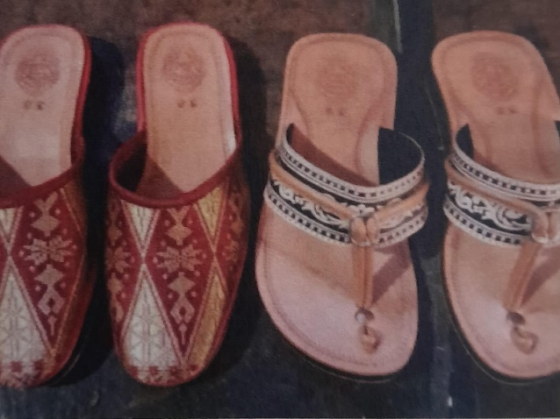
Figure 1. Shape of the Tarompa Datuak
(Source: Foto Irsyad, 2024)
The curved shape at the top shows the continuity of life and harmony in the Minangkabau custom. This design is not only aesthetically pleasing but also reflects the symbolic value of customary flexibility and firmness.
The colors used in the tarompa datuak design, such as red, yellow, and black, also have symbolic meanings. significant. Red symbolizes courage and passion, yellow indicates wisdom, and black hints at spiritual power (Iskandar, 2018). Through this color selection, the tarompa datuak not only functions as an art item, but also as a medium to express the social and spiritual values embraced by the community.
The aesthetics in tarompa datuak motifs and designs are not simply as traditional sandals, but also as works of art that contain rich aesthetic elements. The main elements that stand out in the design are: (1) geometric lines and patterns, tarompa datuak designs generally feature symmetrical patterns using curved or geometric lines. This symmetrical pattern symbolizes balance and harmony in social life and the relationship between humans and nature. In traditional aesthetics, harmony is considered an important aspect because art is not only to be enjoyed visually, but also as a representation of life values. (2) The selection of colors in tarompa datuak includes red, yellow, and black which have philosophical meanings namely: red depicts courage and passion, yellow symbolizes wisdom and honor, black symbolizes spiritual strength and firmness. These colors not only function for aesthetics, but also as indicators of social status in Minangkabau society.
Each element in the tarompa datuak has a deep aesthetic and philosophical meaning. Here are some of the Minangkabau cultural values represented: (1) togetherness and gotong royong, the interconnected and unbroken pattern symbolizes the spirit of togetherness and gotong royong in Minangkabau society. This value is reflected in the traditional proverb "Barek samo dipikua, ringan samo dijinjiang", which means that every job is done together so that it feels light. The use of tarompa datuak in traditional ceremonies shows respect for tradition and ancestors. Tarompa is a type of shoe used exclusively by traditional leaders or penghulu, as a symbol of significant status and social role in the Minangkabau community. (2) The balance between the material and spiritual worlds is reflected in certain motifs and patterns on the tarompa datuak, reflecting the relationship between man, nature and his creator. In Minangkabau culture, the balance between the material and spiritual worlds is considered important in achieving a harmonious life.

Desain Tarompa Datuak
Tarompa datuak is a traditional Minangkabau footwear that has a variety of designs, depending on its function and the social status of the wearer. Based on the shape of the tip, there are two main types. The pointed toe symbolizes aesthetics and elegance, so it is often used in formal occasions or worn by traditional rulers. In contrast, the square tip offers a simpler and more practical feel, making it more suitable for everyday use or casual activities.
In addition, these tarompa can come with or without heels. Designs with heels, which are usually decorated with traditional motifs such as Itiak Pulang Patang or Pucuak Rabuang, indicate the status and elegance of the wearer, especially traditional figures in big events. Whereas tarompa without heels offers greater comfort for use in informal situations.
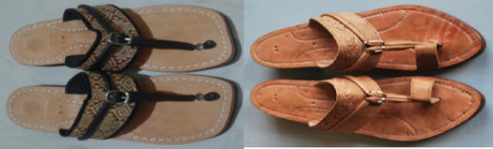
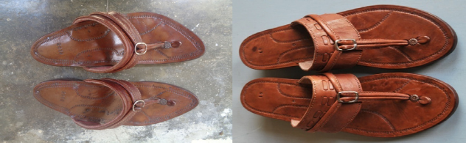
Figure 2. The Top of Tarompa Datuak and the Difference of Ujuang Tarompa Datuak
(Source: Foto Amrizal, 2017)
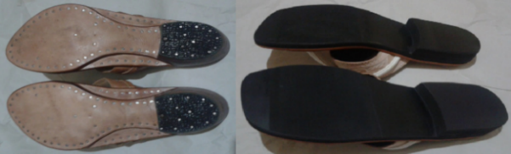
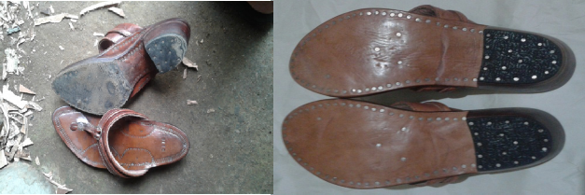

Figure 3. Sole Section l Tarompa Datuak and the Different Rights of Tarompa Datuak
(Source: Foto Amrizal, 2017)
In terms of materials, these tarompa are generally made from hardwoods such as suriyan wood decorated with Minangkabau carvings. Decorative elements such as Itiak Pulang Patang and Kaluak Paku add aesthetic value while reflecting cultural philosophy. The design not only prioritizes function, but also has a deep meaning that symbolizes the values of togetherness, harmony, and local wisdom in Minangkabau customs.
Research in Bukittinggi and surrounding areas found several models and sizes of tarompa datuak that served as inspiration in the development of the new design in this study. There are three models of tarompa datuak, namely the regular, classic and petak models. There are both plain and decorated tarompa datuak. stamp, embroidery, plaiting, as well as songket weaving. There are standard soles and classic soles with thicknesses between 1 to 1.5 cm and heels between 3 to 3.5 cm.
The materials used have varied, some use vegetable tanned leather in combination with Pandai Sikek songket for the original tarompa datuak and chroom tanned leather, and some use vegetable tanned leather in combination with oscar, vinyl and ati rubber for the transformed tarompa datuak. All the original soles and rights use vegetable tanned leather and nails for thickness. The transformed tarompa datuak soles use ati rubber and synthetic glue is added for additional thickness. In terms of product weight, the original and altered tarompa datuak are significantly different. The original tarompa weighs around 700 grams to 800 grams, while the altered tarompa only weighs 450 grams to 500 grams.
Once the exploration is deemed sufficient, the design begins by creating alternative sketches. The best sketches were selected and then turned into working drawings. On the working drawings, there are clear measurements and pattern fragments that correspond to the designed tarompa elements..

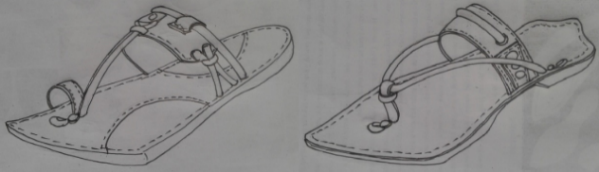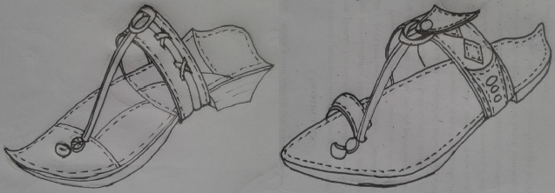
Figure 4. Sketch Shape Tarompa Datuak
(Source: Desain Amrizal, 2017)
Datuak Tarompa Motif
The motifs on the tarompa datuak play an important role in highlighting Minangkabau cultural identity as well as enhancing the appearance of this traditional footwear. The motifs applied, such as the carvings on the strap, usually contain philosophical values that are closely related to Minangkabau customs. The philosophies often reflected in these motifs include togetherness, harmony and local wisdom.
Generally, the motifs on datuak tarompa are carved manually using traditional tools and are made with high detail to indicate the social status of the wearer. In addition, these motifs often follow symmetrical or curvilinear patterns, which give an aesthetic impression while reinforcing the sacredness of the tarompa as part of a traditional ceremony.


Figure 5. Itiak Pulang Patang Motif in Sketch Form.
(Source:https://id.m.wikipedia.org/wiki/Itik_pula)
This motif depicts ducks returning home in neat lines in the afternoon, symbolizing social order and the importance of returning to their origins (identity). This motif contains a philosophical message about the importance of mutual cooperation and order in the lives of indigenous peoples.
The Itiak Pulang Patang motif is one of the typical Minangkabau motifs that is often found on various traditional objects, including tarompa datuak. This motif is inspired by the pattern of ducks walking back to the cage in the afternoon. Philosophically, this motif symbolizes order, togetherness, and local wisdom, illustrating the importance of maintaining harmony and returning to the origin in social life.
On the tarompa datuak, this motif is usually placed in several important parts. Firstly, on the top or instep cover, the motif is carved in detail as the center of attention due to its highly visible position. Secondly, the motif is often found on the sides of the tarompa frame, following the natural curved shape of the wood to reinforce its aesthetic value. In addition, although rare, some tarompa also have an additional motif on the back heel as a decorative accent.

The use of the Itiak Pulang Patang motif not only adds beauty, but also reflects the high regard for traditional Minangkabau carving. This motif also serves as a symbol of social status, considering that the tarompa datuak is only worn by traditional leaders at certain ceremonies.

The Philosophical Meaning of Tatrumpa Datuak
The datuak tôppos are not just traditional footwear, but a symbol of cultural identity that is full of philosophical values: 1) Order and Harmony: The motif of Itiak Pulang Patang reflects social discipline, order in customs, and the value of returning to the origin as a form of respect for ancestors. 2) Balance of the Material and Spiritual Worlds: The colors red (spirit), yellow (wisdom), and black (inner strength) indicate a balance between courage, wisdom, and spiritual strength.
3) Gotong Royong and Togetherness: The intertwined pattern of motifs illustrates the value of Minangkabau collectivity, as the traditional expression "barek samo dipikua, ringan samo dijinjiang".
Visual Design of Tarompa Datuak
The design of the datuak trumpet represents the symbolic system through shapes, colors, and motifs: 1) Shape: The pointed tip indicates splendor and high social status, while the tile shape is more popular. The presence of rights indicates the formality of the traditional event. 2) Color: Red: courage, leadership., Yellow: honor, customary policy, Black: customary constancy and spirituality. 3) Visual Motifs: Geometric motifs and flora are carved symmetrically, which aesthetically reinforces the value of harmony between humans, nature, and God.
The Social Role of Tarompa Datuak
Tarompa datuak functions as a social instrument and symbol of stratification in Minangkabau society: 1) Leadership Symbol: Worn by Datuak (traditional chief), this trumpet becomes an identity of one's social status and customary responsibility. 2) Cultural Heritage and Value Education: As a cultural object, tarompa datuak teaches noble values to the younger generation, such as respect for customs, manners, and social responsibility. 3) Rituals and Ceremonies: Worn in traditional processions, weddings, and inaugurations, reinforcing the legitimacy of the role of customary in the Minangkabau social structure.

CONCLUSION
Tarompa datuak is not just a footwear, but also a cultural symbol rich in aesthetic and philosophical values of the Minangkabau people. The motifs and designs reflect the relationship between man, nature, and social values, such as gotong royong and togetherness, which form the basis of community life. The geometric patterns and floral motifs used are not only for aesthetic purposes, but also symbolize harmony of life and continuity with nature. The choice of colors such as red, yellow and black adds spiritual meaning.
These colors symbolize courage, wisdom, and inner strength. Furthermore, the tarompa datuak acts as a symbol in a customary context, showing respect for ancestors and specific social status. Its participation in traditional ceremonies reinforces cultural identity and emphasizes the seriousness with which Minangkabau people preserve traditions. In the midst of the times, tarompa datuak survives as a traditional work of art and as a means of preserving and passing on local wisdom to future generations. Thus, the role of tarompa datuak becomes very significant in establishing a relationship between society and tradition

DAFTAR PUSTAKA
Abdullah, I. (2010). Konstruksi dan Reproduksi Kebudayaan. Yogyakarta: Pustaka Pelajar.
Abdullah, Taufik. (1988). Adat dan Kebudayaan Minangkabau. Jakarta: Balai Pustaka.
Amrizal & Yuliarni. (2016). Proses Produksi Kerajinan Tarompa Datuk. Padangpanjang: LPPMPP ISI Padangpanjang.
Arikunto. 2013. Prosedur Penelitian, Suatu Pendekatan Praktek, Edisi Kesambilan.Jakarta: Penerbit RINEKA CIPTA
Hamka. (2001). Adat Minangkabau: Refleksi Filosofis dan Praktis. Jakarta: Pustaka Mizan.
Iskandar, Z. (2018). Estetika dalam Seni Visual Nusantara. Padang: Andalas Press.
Koentjaraningrat. (2009). Pengantar Ilmu Antropologi. Jakarta: Rineka Cipta.
Mahmud, & Alfianto, E.A. (2014). Pengaruh Desain Produk dan Layanan Purna Jual Terhadap Keputusan Konsumen Membeli Sepeda Motor Yamaha Merek New V-IXION FI (Full Injection) (Studi pada Konsumen Sepeda Motor Yamaha Merek New V-IXION FI (Full Injection) di Adiguna Sakti Motor Pandaan). Jurnal Sketsa Bisnis, 1, 1130–1132.
Mulya, A.N. & Mutmainah, S. (2017). Pengembangan Desain Produk Anyam Bambu di Desa Sukolilo Kecamatan Sukodadi Kabupaten Lamongan. Jurnal Seni Rupa, 5 (2), 375–384. Mutia, R., Munir, D. & Alwi, N. (1996
Naim, Mochtar. (1979). Merantau: Pola Migrasi Suku Minangkabau. Yogyakarta: Gadjah Mada University Press.
Nasir, Y. (2022). Motif dan Makna dalam Karya Seni Tradisional Sumatera Barat. Padang: Penerbit Citra Budaya.
Nasroen, M. (1971). Falsafah Adat Minangkabau. Jakarta: Bulan Bintang.
Nuraini, T. (2020). Identitas Budaya dalam Produk Kerajinan Minangkabau. Yogyakarta: Penerbit Ombak.
Padang Expo. (2021). "Itiak Pulang Patang: Simbol Kehidupan Harmonis."
Soedarsono. (2002). Seni Pertunjukan dan Ritual di Indonesia. Yogyakarta: Gadjah Mada University Press.
Suwarno, D. (2015). Seni Tradisional dan Kebudayaan Indonesia. Bandung: Alfabeta.
Yoety, O.A. (2008). Ekonomi Pariwisata: Introduksi, Informasi dan Implementasi. Jakarta: Kompas.

