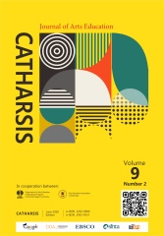

Catharsis 9 (2) (2020) halaman x-x

Catharsis: Journal of Arts Education

https://journal.unnes.ac.id/sju/index.php/catharsis

The title should be clear, brief, and informative. Abbreviations and formulas should be avoided. No place or year is included. Font Size 14 Calisto MT

Author Name¹, Author Name² and Author Name3
¹ Department, Institution, Cit, Country, Email address
^{2,3} Department, Institution, Cit, Country, Email address

Accepted:..., Approved: ..., Published: ...

Abstract
The abstract should be written briefly and factually in English. The abstract contains a clear elaboration of research purpose, result, and conclusion. The abstract should be written separately from the article. Reference should not be written in the abstract, but if it is indispensable, the authors' name and publication year should be cited. The nonstandard abbreviation should be avoided, but if it is indispensable, the full name should be specified in its initial mention.

Keywords: consist of 3-5 words or phrases.

© 2020 Universitas Negeri Semarang

INTRODUCTION

The introduction contains the purpose of article/research that is formulated and presented by an adequate introduction and avoids detail references and research result presentations. The research urgency, supporting facts, and data must be included. A preliminary research result should be explained as the basis of the research. Before mentioning the objective/s, a gap analysis must be elucidated. The gap analysis states the difference/s between the research and other previous studies.

At this point, the novelty will be apparent. The research stance must be included, whether it corrects, debates, or support the previous research. Please use the following table setup if you want to display the data

Table 1. Example of table display.
No | Activity | Description
1 | Management | Teks teks teks teks
2. | Education | Teks teks teks teks
3. | Publication and Brand Image | Teks teks teks teks

METHODS
The method used should be accompanied by references; the relevant modification should be explained. The procedure and data analysis technique should be emphasized. The stages and analysis of the research must be explained in detail.

RESULTS AND DISCUSSION
Section/Subsection
The results and discussion should be presented in the same part, clearly and briefly. The following is how to display image data.
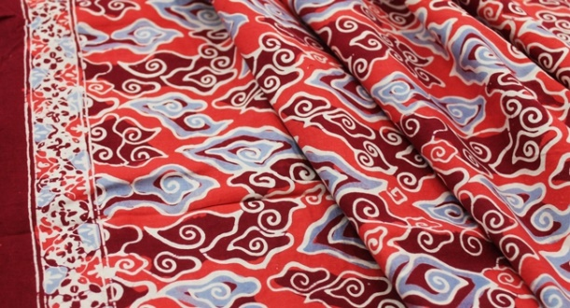

Figure 1. Example of picture or image display.

Section/Subsection
The discussion part should contain the benefit of the research result, not the repeat result part. The results and discussion part can be written in the same part to avoid the extensive quotation. The results of data analysis must be reliable in answering research problems. References to the discussion should not repeat the references in the introduction. Comparisons to the findings of previous studies must be included.

CONCLUSION
The conclusion of the research is presented briefly, declarative, non-bulleted, and conceptual. The research impact must be stated.

REFERENCES
Sugiarto, E. (2019). Kreativitas Seni dan Pembelajarannya. Yogyakarta: LKiS
Sugiarto, E., Othman, A. N., Triyanto, & Febriani, M. (2020). Regional Icon Motifs: Recent Trends in Indonesia's Batik Fabric Development. Vlakna a Textil, Vol 27(1) 93-98. http://vat.ft.tul.cz/
Rohidi, T. R. (2012). Metodologi Penelitian Seni. Semarang: Cipta Prima Nusantara

Reference written in 9pt font size. Reference in the article should be ordered based on the most recent reference. All of citation should be written in reference part. Every cited reference should be written completely in the reference part. An unpublished reference is not suggested to be quoted in the article. References should be written according to the APA style. Reference sould be written by reference management software (Mendeley). This journal requires 80% of the reference cited from the national and international journals.

