International Perspectives on Autism Therapy: Practices in Germany’s Die Lebensgemeinschaft and Indonesian Foundations

Alin Greenawati Cavelius¹, Franz Hessel², Vaibhavi Dargude³
^{1,2,3} SRH University of Applied Sciences, Berlin, Germany

DOI: https://doi.org/10.15294/ijeces.v14i1.22940
Submitted: 30/03/2025 Revised: 05/05/2025 Accepted: 03/07/2025

ABSTRACT
Global approaches to Autism Spectrum Disorder (ASD) vary, with increasing emphasis on inclusive practices and cross-cultural research for effective solutions. This study addresses the challenges surrounding the treatment and societal acceptance of children with ASD, particularly focusing on the transition from childhood to adulthood. It explores the initial emotional reactions of parents upon receiving an autism diagnosis and examines how foundations, schools, and clinics manage the care and treatment of children with ASD, emphasizing early and appropriate therapeutic interventions. The research compares the treatment of children with autism in Indonesia and adult individuals with autism in Germany. A mixed-methods approach, combining quantitative and qualitative methods, was employed, including a literature review on Indonesian autism research centers and in-depth interviews with experts from a special school and private therapy clinics in Indonesia. The study examines both beneficial and detrimental aspects of autism treatment, revealing societal misconceptions that perceive autism as a detriment, with therapeutic interventions viewed as the primary means of amelioration. Despite challenges, such as workforce limitations in educating children with autism, the study draws attention to the potential benefits of community-based initiatives in Germany, specifically the employment opportunities at Werkstätten (workshops), as a model for sustainable inclusion for individuals with autism in Indonesia. The research emphasizes the importance of such programs in enhancing autism literacy and preparing educators to foster better practices in young learners, ultimately contributing to the advancement of early childhood education across different cultural contexts.

Keywords: Autism Spectrum Disorder (ASD), Intellectual Disabilities, Educational Practices, Therapeutic Interventions
Copyright (c) 2025 Alin Greenawati Cavelius, et al

Corresponding Author:
Alin Greenawati Cavelius
SRH University of Applied Sciences, Berlin, Germany
Email: alin.cavelius@stud.srh-campus-berlin.de
- INTRODUCTION
Individuals are endowed with inalienable human rights and, notwithstanding the presence of disabilities, possess the intrinsic potential for autonomy, contingent upon the provision of appropriate support. This study aimed to explore the intricate relationship between healthcare systems, educational practices, and therapeutic interventions for individuals with intellectual disabilities, particularly those with Autism Spectrum Disorder (ASD). The focus was on two different models from Germany and Indonesia, showcasing distinct approaches to care and support for individuals with disabilities.
ASD is a neurodevelopmental disorder characterized by limited communication, both verbal and non-verbal, as well as restricted and repetitive behaviours. The World Health Organization (2023) describes ASD as a diverse group of conditions with difficulties in social interaction, communication, and atypical behaviour patterns. The term ‘autism’ was first introduced by Leo Kanner in 1943 to describe children with severe social disorders, communication issues, and repetitive behaviours. (Kanner, 1943). Over time, diagnostic criteria for ASD evolved, with the Diagnostic and Statistical (DSM) Manual-3 in 1980 marking a significant shift in the classification of mental disorders by introducing specific criteria and a multiaxial evaluation system. The DSM-5, (Grzadzinski et al., 2013) which outlines the latest definitions, identifies two primary symptoms of ASD: deficits in social communication and interaction, and restricted, repetitive behaviours, interests, or activities. Individuals diagnosed with ASD exhibit a range of characteristics that manifest variably across individuals, with differences in severity, intensity, and frequency. As outlined in the DSM-5, key features include impairments in social communication, deficits in speech and language, and the presence of restricted and repetitive patterns of behavior. Social communication difficulties often manifest as challenges in peer interaction, limited ability to interpret non-verbal cues such as tone and facial expressions, and a preference for using body language over verbal communication. Repetitive behaviors, such as hand-flapping, stereotyped speech, and intense focus on specific interests, are commonly observed in individuals with ASD. Furthermore, impairments in executive function, such as difficulties with task initiation, problem-solving, and organizing materials, are frequently present and contribute to challenges in daily functioning. Various therapies for ASD include Applied Behavior Analysis (ABA), which uses reinforcement to encourage positive behavior (Kamp-Becker & Bölte, 2021), and Treatment and Education of Autistic and related Communication Handicapped Children (TEACCH), which emphasizes structured environments and visual supports (Virues-Ortega et al., 2013). Other approaches like behavioral therapy aim to reduce unwanted behaviors, while physiotherapy focuses on motor skills (Sefen et al., 2020). Pharmacotherapy is used selectively for co-occurring conditions, and therapies such as visual, music, animal-assisted, and play therapy help improve communication, sensory processing, and social skills (Autism Research Institute, 2024; Lebensgemeinschaft e.V., 2008; Elbeltagi et al., 2023). These methods are tailored to the individual needs of children with ASD.
Recent studies (2020–2024) highlight the growing efficacy of integrated intervention models that combine educational, therapeutic, and social components to enhance developmental outcomes in children with ASD (e.g., Ratto et al., 2022; Kim & Park, 2023). In particular, inclusive education systems have shown promise in increasing social participation and academic outcomes when supported by teacher training and resource accessibility (Nguyen et al., 2021). Additionally, health economic studies underscore the long-term value of early intervention programs in reducing the cost burden on families and national healthcare systems (Wong et al., 2021). Despite these advancements, there has been limited research comparing therapeutic systems and support models for individuals with ASD across different cultural and socioeconomic contexts. Specifically, there is a lack of comprehensive comparative studies analysing community-based approaches, like Germany’s anthroposophical model, and more centralized systems, such as those developing in Indonesia. Moreover, the literature remains limited on the intersection of therapeutic systems and health economic management in the context of ASD, particularly in low- and middle-income countries.
In Germany, Die Lebensgemeinschaft e.V., operational since 1965, provides a comprehensive anthroposophical approach to the care and rehabilitation of individuals with intellectual disabilities, including ASD. Founded by Dr. Wilhelm zur Linden, Hanno Heckmann, and others influenced by Rudolf Steiner’s teachings on anthroposophy and curative education, the community model emphasizes therapeutic support, vocational training, curative education, and cultural activities. In 1968, the Lebensgemeinschaft Sassen und Richthof was established, offering a family-like environment where individuals could live, work, and participate in cultural and nature-based activities. This holistic model, guided by Steiner’s principles, promotes social participation, autonomy, and personal development for individuals with disabilities. By integrating various therapeutic and educational approaches, Die Lebensgemeinschaft e.V. ensures individuals with ASD receive the necessary support for rehabilitation, promoting their dignity and inclusion within society (Die Lebensgemeinschaft e.V., 2008; WVO, 1980).
In contrast, Indonesia’s approach to supporting children with ASD is still evolving, with increasing recognition of the need for inclusive education and therapeutic interventions. Special education schools and autism-focused programs are expanding to accommodate children with ASD, providing tailored support and individualized educational plans. Teachers' beliefs about inclusion and disability play a significant role in shaping the effectiveness of these interventions. The growing awareness of ASD in Indonesia is leading to improvements in both educational practices and therapeutic support, although challenges remain in providing consistent and specialized care for all individuals across the country (Budiyanto et al., 2020).
In developing and managing healthcare systems, an economic management approach is essential for making informed decisions. (Drummond et al., 2015) emphasized that healthcare decisions often raise profound questions about social choices, such as who should benefit from interventions and who may face life-shortening outcomes. These decisions require scrutiny from various stakeholders, including patients, clinicians, administrators, and policymakers, all of whom may have different perspectives on the costs and benefits of healthcare interventions. Drummond also discusses the value of healthy time, which can be measured in terms of improved health, leisure, or work productivity. He highlights the importance of capturing the value of healthy time in economic evaluations to ensure a comprehensive understanding of healthcare interventions' impact. The comparative analysis between these two models will highlight the importance of integrating healthcare, education, and social inclusion for individuals with ASD, emphasizing the need for individualized support, respect for autonomy, and the role of community-based models in enhancing social participation and dignity. This research study further explored how these diverse systems can inform each other to develop best practices for promoting the well-being and autonomy of individuals with intellectual disabilities globally.

- METHOD
The study conducted in 2024 focused on the treatment of individuals with ASD at Lebensgemeinschaft e.V. in the Sassen and Richthof areas of Germany, as well as at SLB Kusumo Asih and the Autistic Houses in Jakarta, Indonesia. The research adopted both qualitative and quantitative methodologies, incorporating expert interviews, questionnaires, and analysis of existing data. Additionally, a thorough literature review was conducted to supplement the primary research. The objective of research study was to compare the treatment approaches for individuals with ASD in Germany and Indonesia. The analysis centers on the workshops (Werkstätten) at Lebensgemeinschaft e.V. in Germany and the therapeutic practices for individuals with ASD at Sekolah Luar Biasa (SLB) (means a Special School) Kusumo Asih and the A – Klinik Intervensi Dini – Autisme (Early Intervention Clinic – Autism) (KID)-Autisme Clinic in Indonesia were included. Data from Lebensgemeinschaft e.V. was collected through interviews and questionnaires, with the managing director providing responses and supplementary information via a book, facilitating the literature review. Data from Indonesia was gathered through in-depth expert interviews conducted via video calls on WhatsApp, which were recorded and transcribed. Additionally, literature from the YPAC (Yayasan Pembinaan Anak Cacat) National website, a foundation dedicated to the development of disabled children, was incorporated for further analysis.
According to the scientific recommendations (American Psychological Association, 2001), interview subjects were chosen on the basis of their knowledge and background in the treatment, education, and therapy of ASD. Experts from KID-Autism Clinic, SLB Kusumo Asih, and YPAC, a well-known foundation with a wealth of ASD research, were included from Indonesia. The experts contributed to the data collection by offering qualitative insights through literature and interviews. The expert from managing department of Lebensgemeinschaft e.V. in Germany, was contacted who has an extensive experience working with therapeutic rehabilitation facilities. Direct interviews as well as the provided papers and research materials were used to gather information, which was centred on the Sassen and Richthof areas. This choice guaranteed a thorough understanding of ASD treatment in both institutions, backed by both theoretical and empirical evidence.
In order to evaluate the hypothesis about the effects of art treatments and cross-selling management on autistic patients, the data collected using both qualitative and quantitative methodologies. Questionnaires, expert interviews, and information from reliable sources such as Lebensgemeinschaft and YPAC are all part of the data collection process. Both methodologies offered a comprehensive analysis of ASD treatment. According to Edwards (2004), data interpretation involves applying a conceptual framework or interpretive questions to analyse the material. Ensuring reliability and validity is crucial, as it guarantees that the findings are consistent and accurate, thereby strengthening the research design and contributing to trustworthy insights. This mixed-method approach guarantees a thorough examination of ASD treatment methods in various settings. Reliability, validity, and pertinent frameworks are used to analyse the data, enabling an assessment of important elements including management techniques, therapy kind, and accessibility. The study involved five expert participants across both countries, utilized semi-structured interview guides and standardized questionnaires, and followed a thematic content analysis for qualitative data, while descriptive statistical techniques were applied to the quantitative responses, ensuring transparency and replicability of the analytical process.

- RESULTS AND DISCUSSION
The data for this study was collected from three sources in Indonesia: YPAC, SLB Kusumo Asih, and KID - Autism Therapy Clinic, and from Lebensgemeinschaft e.V. in Germany. Interviews and literature studies, along with statistical data from the Central Statistics Institute of Indonesia, are presented. The study highlighted the influence of socio-economic status, social support, education, and therapy on the treatment and care of individuals with ASD in Indonesia and Germany. This study presents a novel cross-cultural comparison of ASD support systems in Indonesia and Germany, integrating therapeutic models, inclusive education, and economic management practices an area previously underexplored in ASD literature. Socio-economic status plays a crucial role in shaping how parents approach ASD treatment. In Indonesia, lower-middle-class families often face societal stigma, associating autism with negative stereotypes. As of 2020, the Indonesian population stood at 270.2 million, with approximately 3.2 million children diagnosed with autism, and 144,102 autistic students were enrolled in special schools by 2019. Data on autism within the population has been categorized based on various levels of mental and physical disabilities, with classifications focusing on challenges such as concentration, learning difficulties, and communication barriers.
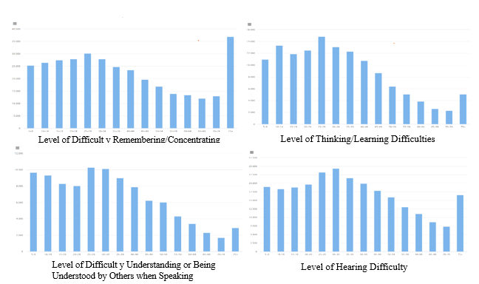
Fig. 1: Number of Population Aged 5 Years and Older by Age Group, Urban/Rural Area, and All Gender, and Level specified INDONESIA in 2022. (Source: BPS, 2022).

The first graph shows the total number of males and females aged 5 and above with difficulties in remembering and concentrating based on 2022 data. While not all individuals in this category have autism, the numbers are closely related to ASD characteristics. The graph second, third and fourth further illustrate these traits, offering an estimate of the therapy needed for individuals facing these difficulties. These graphs can also serve as projections to identify potential ASD tendencies, allowing for early rehabilitation preparations. The number of students with ASD attending special schools in Indonesia has increased from 133,826 in 2018 to 144,102 in 2020, indicating a growing need for support.
YPAC, established by Prof. Dr. Soeharso in 1953, is a prominent foundation in Indonesia providing comprehensive support for individuals with ASD. The organization, recognized by the Indonesian Ministry of Social Affairs, operates throughout the country with a mission to prevent disabilities early and develop the potential of children with disabilities toward independence. YPAC offers an integrated approach to rehabilitation, which includes medical, educational, social, and occupational rehabilitation. It provides services in 16 regions across Indonesia, with specialized facilities such as the “Mitra Ananda” Autism Centre in Karanganyar. YPAC emphasizes the importance of early detection, individualized therapy, and collaborative efforts between parents, teachers, and therapists to ensure the best outcomes for children with ASD. The foundation uses a structured teaching approach and provides a range of therapies, including educational, psychology, occupational therapy, and speech therapy, to support children with ASD. The interview with the pedagogic at SLB Kusumo Asih, highlighted the school’s approach to children with special needs, particularly those with ASD. The expert emphasized the school’s vision of developing the personalities of children through individualized mentoring, with each child receiving personalized attention from dedicated teachers, despite limited staff.
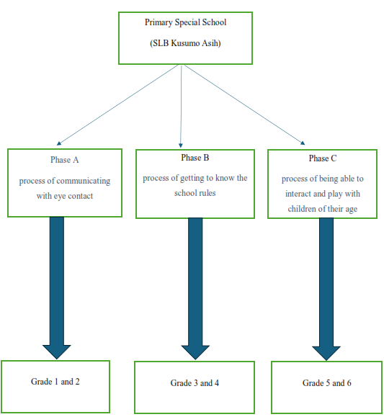
Fig 2. Flow Chart of Learning Process in every Phase at SLB Kusumo Asih
(source: own illustration based on information obtained by interviewee at SLB Kusumo Asih from Indonesia).

Another interview with the psychologist at A – Klinik Intervensi Dini – Autisme (Early Intervention Clinic – Autism) (KID-A) Clinic, detailed the clinic’s mission to provide early intervention therapy for children with ASD. Using the ABA method, KID-A prepares children for integration into regular schools. The psychologist emphasized the clinic’s focus on individualized therapy, parental support, and promoting societal acceptance of children with ASD. The clinic operates privately, offering therapy through direct sessions and home visits, with the goal of fostering independence and positive social integration for children with ASD. However, organizations like KID-A challenge these views through counselling and education. Conversely, upper-middle-class families are more likely to access private therapy services. Public insurance schemes such as Badan Pusat Statistik (Indonesian Central Statistics Institute) (BPJS) help lower-income families access free therapy at referral hospitals, illustrating the impact of socio-economic factors on care access. Social support is another critical factor. In Indonesia, institutions like YPAC provide a wide range of therapeutic services, while informal family support enhances the development of children with ASD. Correspondingly, in Germany, Lebensgemeinschaft e.V. offers integrated care, including housing, therapy, and financial support, regardless of socio-economic status. This comprehensive model emphasizes the importance of institutional structures in long-term care. The interview with management expert from Lebensgemeinschaft e.V., provided valuable insight into the community’s operations, particularly in the villages of Sassen and Richthof, which focus on supporting individuals with mental disabilities, especially those with ASD. Lebensgemeinschaft e.V. utilizes workshops, known as Werkstätten, to offer meaningful work opportunities for individuals with special needs. The interview, supplemented by a book titled Zusammenleben wollen and additional data, deepened the understanding of the community's approach to fostering inclusivity and providing practical support for its residents. The interview summarised the insightful information about the organization’s approach to supporting individuals with disabilities, particularly those with ASD. Lebensgemeinschaft e.V. is a community located in the villages of Sassen and Richthof, where approximately 250 individuals with intellectual disabilities, including ASD, live in a family-style environment. These individuals are integrated into 26 large families, each consisting of 8-10 individuals with special needs, as well as host families and workers who assist in their daily lives. The community operates on anthroposophical principles, which combine nature, art, and therapy. The daily routine of the residents includes communal meals and participation in workshops that offer various forms of work and therapy, such as vegetable gardening, carpentry, ceramics, and art therapies like Eurythmy. These activities are designed to foster independence and creativity while providing therapeutic benefits. According to the information obtained from the interviewee at Lebensgemeinschaft in Germany., many individuals with ASD in the community also have additional conditions, such as Down Syndrome or Schizophrenia.
Lebensgemeinschaft e.V. aims to create a nurturing, inclusive environment where individuals with special needs are treated with dignity and encouraged to live fulfilling, meaningful lives. The organization places great emphasis on togetherness, shared activities, and holistic care, following the teachings of Rudolf Steiner. Like Rudolf Steiner quoted, “wenn Menschen zusammen das Geistige in innerer Ehrlichkeit suchen, dann finden sie die Wege zueinander, von Seele zu Seele”, when people seek the spiritual together in inner honesty, then they find the ways to each other, from soul to soul” (Die Lebensgemeinschaft e.V., 2008). The answers received for some of the interview questions in the open questionnaire included responses that highlighted the challenges faced by parents of children with ASD in both Indonesia and Germany, such as the lack of accessible therapies and the stigma surrounding autism. Additionally, interviewees emphasized the importance of early intervention, individualized therapy approaches, and the need for more trained professionals and inclusive educational systems to support individuals with ASD effectively.
Some examples are:
How can the workshop of Lebensgemeinschaft e.V. help autist is disabled people to get through life well? “We have a differentiated range of manual activities in the workshops. We try to offer new participants a place that corresponds to their possibilities. Order, overview, many or few people in one room, perhaps a garden with fresh air. In particular, the recurring tasks, but necessary, are a help for orientation. Few staff change in the living area as well as in the workshop are particularly helpful for people with autistic disabilities in order to be able to orient themselves. The location of both villages is such that a free – but manageable living space with rhythmic repetitions is created. This covers a basic need for ‘security’.
Does Lebensgemeinschaft e.V. sell its products from the workshops and from the farms
to local supermarkets? “We distinguish between two areas of workshops: garden, agriculture and bakery primarily cover the needs of the village communities, there is free sales, but this is rather subordinate. The other workshops sell their products through markets, bazaars, a fixed customer base of buyers. Increasingly, the products are also offered and sold via an online shop.”
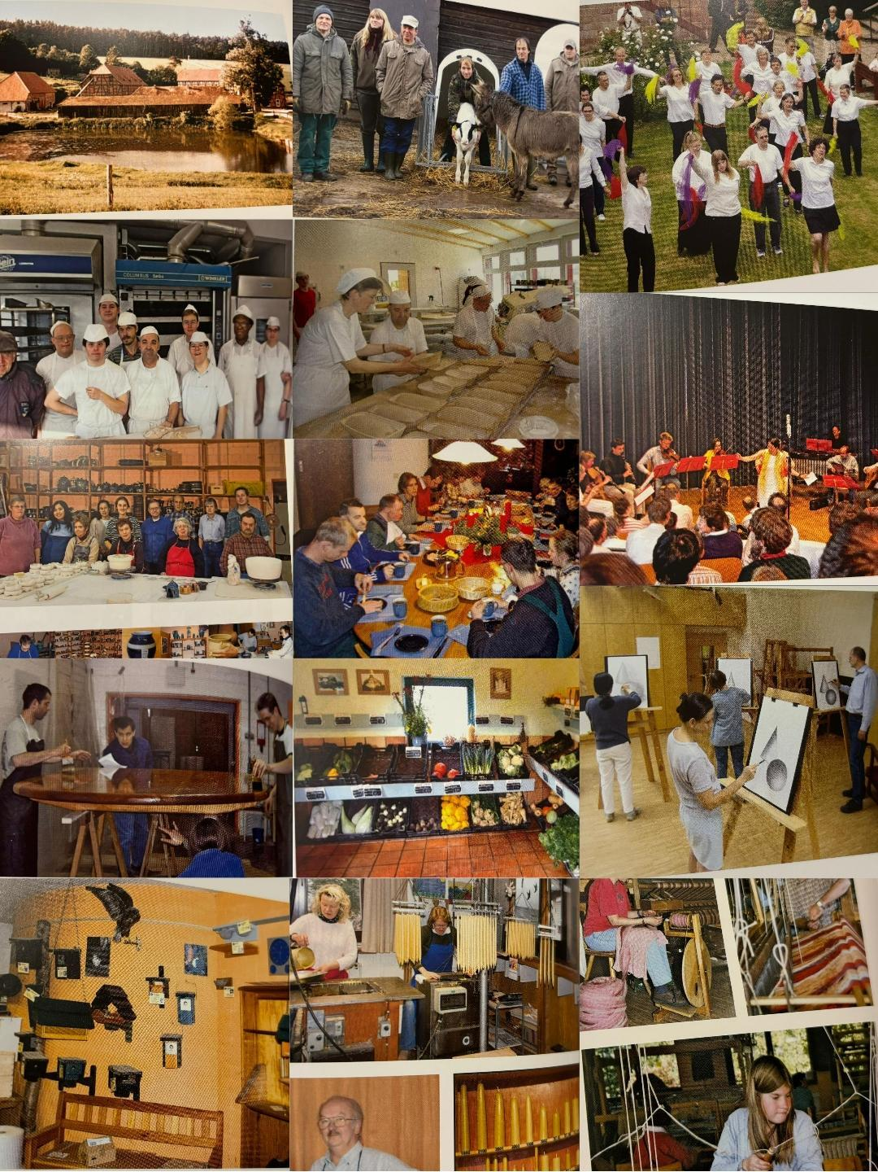
Fig. 3 Daily life activities in Lebensgemeinschaft e.V Sassen und Richthof (Lebensgemeinschaft e.V., 2018).
The evaluation of data interpretation explored various perspectives regarding the support for children with Autism Spectrum Disorder (ASD) in Indonesia and Germany, highlighting differences and similarities across socio-economic, educational, therapeutic, and institutional frameworks. Socio-economic status significantly influences the accessibility of support, with lower-income families in Indonesia facing social stigma and limited access to therapy, while upper-middle-class families seek private care. Social support, both formal (e.g., hospitals, schools) and informal (e.g., family), is pivotal in promoting child development, with institutions like YPAC in Indonesia and Lebensgemeinschaft in Germany providing essential therapy and educational services. Education for children with ASD in Indonesia focuses on preparing children for regular schools, as inclusive schools are scarce, offering shadow teachers and individualized plans, while special schools like SLB Kusumo Asih emphasize communication, emotional understanding, and social interaction. In contrast, Lebensgemeinschaft in Germany offers vocational workshops for adults with ASD, embodying a unique form of inclusive education. Therapeutic services are similarly diverse, with KID-A in Indonesia utilizing ABA and music therapy, SLB Kusumo Asih focusing on social and visual therapies, and YPAC providing a broad range of therapies. In Germany, Lebensgemeinschaft focuses on art, language, and physical therapies for adults. Both Indonesia and Germany provide insurance coverage for ASD treatments under ICD-10, facilitating financial accessibility. The workforce in each institution varies, with larger organizations like YPAC and Lebensgemeinschaft employing substantial staff, while smaller centers like KID-A have fewer therapists. Cross-selling management strategies are employed by YPAC and Lebensgemeinschaft, promoting economic sustainability and offering opportunities for individuals with ASD. In conclusion, the evaluation underscores the critical roles of socio-economic factors, education, therapy, and social support in enhancing the lives of individuals with ASD, with both YPAC and Lebensgemeinschaft playing pivotal roles in fostering inclusion and offering specialized therapies.
The educational approaches also differed between the two countries. In Indonesia, institutions like KID-A and SLB Kusumo Asih focus on integrating children with ASD into regular schools, using early intervention strategies like Applied Behaviour Analysis (ABA) therapy and shadow teaching. In contrast, Germany emphasizes community-based activities and workshops for adults with ASD, focusing on participation and independent living. Therapeutic methods also vary. Indonesia prioritizes early intervention, especially ABA therapy, while Germany offers a wider range of therapies, including music and art therapy. Both countries highlight the importance of cross-selling management and income-generating activities, as seen in YPAC and Lebensgemeinschaft’s workshops. Overall, the study underscores the significance of socio-economic factors, social support, education, and therapy in shaping the care and development of individuals with ASD in both countries.

- CONCLUSION
The research study provided a comprehensive analysis of the management and therapeutic approaches for individuals with ASD in both Indonesia and Germany, revealing both strengths and limitations. Institutions such as YPAC, SLB Kusumo Asih, KID-A, and Lebensgemeinschaft e.V. exhibit well-structured organizational frameworks that cater to the diverse needs of individuals with ASD, offering targeted therapeutic interventions, educational systems, and developmental opportunities. YPAC, with its extensive network of therapy centres and special education schools, demonstrates a multidisciplinary approach to ASD management, providing services from early intervention to lifelong support. SLB Kusumo Asih, despite limited resources, ensures individualized education plans and therapeutic interventions tailored to the developmental stage of each child. KID-A, under the leadership of a seasoned clinical psychologist, implements early intervention strategies, including ABA therapy, to support children in transitioning to inclusive educational settings. Lebensgemeinschaft e.V., located in Germany, addresses the needs of adult individuals with ASD by offering specialized therapies, including music therapy, art therapy, and vocational training, in addition to social inclusion programs within its workshop model. Nevertheless, significant challenges remain, particularly in Indonesia, where socio-economic barriers, stigma, and a shortage of qualified professionals impede the accessibility and quality of ASD care. The lack of inclusion schools, insufficient public awareness, and the predominance of privately funded therapy clinics exacerbate the disparities in access to care. Moreover, the absence of a national registry or census for individuals with ASD in Indonesia complicates the formulation of data-driven policies for ASD care and resource allocation.
The study recommends several strategic improvements for ASD management in Indonesia, including the establishment of a comprehensive national registry for individuals with ASD, the expansion of the workforce through targeted training programs in autism therapies and educational strategies, and the provision of government-subsidized therapeutic services to reduce the financial burden on families. Furthermore, the adoption of cross-selling management practices, as exemplified by YPAC and Lebensgemeinschaft, should be considered to ensure financial sustainability for therapeutic programs and enhance the capacity of institutions to provide high-quality services. In enveloping up, the findings underscore the need for a collaborative, multi-sectoral approach to ASD management, focusing on early diagnosis, comprehensive therapeutic interventions, inclusive education, and public awareness. By addressing these gaps, both Indonesia and Germany can enhance the long-term outcomes for individuals with ASD, ensuring better access to care and improving the quality of life for affected individuals and their families. In Lebensgemeinschaft e.V., workshops and agricultural activities are vital for fostering inclusion and meaningful participation for individuals with disabilities. These activities, rooted in biodynamic farming and creative production, allow individuals to contribute to the community while developing essential skills. The community emphasizes inclusion by dismantling social boundaries and promoting self-efficacy, ensuring every individual’s contribution is valued. Through work, therapy, and shared experiences like festivals, individuals feel connected and part of a larger social whole, empowering them to actively participate in the community’s life. Future research should investigate the long-term impact of integrated therapeutic and vocational programs on individuals with ASD, and assess how cross-selling management models like those used by YPAC and Lebensgemeinschaft can be adapted and scaled across different cultural and socio-economic settings.

REFERENCES

Autism Research Institute. (2024). What is Autism? San Diego: Author. https://autism.org/what-is autism

Badan Pusat Statistik. (2022). Jumlah Penduduk Berumur 5 Tahun ke Atas menurut Kelompok Umur, Daerah Perkotaan/Perdesaan, Jenis Kelamin, dan Tingkat Kesulitan Berpikir/Belajar, INDONESIA, Tahun 2022. Jakarta: BPS. https://sensus.bps.go.id/topik/tabular/sp2022/150/1/0

Badan Pusat Statistik. (2022). Jumlah Penduduk Berumur 5 Tahun ke Atas menurut Kelompok Umur, Daerah Perkotaan/Perdesaan, Jenis Kelamin, dan Tingkat Kesulitan Memahami atau Dipahami Orang Lain ketika Berbicara, INDONESIA, Tahun 2022. Jakarta: BPS. https://sensus.bps.go.id/topik/tabular/sp2022/146/1/0

Badan Pusat Statistik. (2022). Jumlah Penduduk Berumur 5 Tahun ke Atas menurut Kelompok Umur, Daerah Perkotaan/Perdesaan, Jenis Kelamin, dan Tingkat Kesulitan Mendengar, INDONESIA, Tahun 2022. Jakarta: BPS.

Badan Pusat Statistik. (2022). Jumlah Penduduk Berumur 5 Tahun ke Atas menurut Kelompok Umur, Daerah Perkotaan/Perdesaan, Jenis Kelamin, dan Tingkat Kesulitan Mengingat/ Berkonsentrasi, INDONESIA, Tahun 2022. Jakarta:BPS. https://sensus.bps.go.id/topik/tabular/sp2022/149/1/0

Bundesministerium für Justiz. (1980). WVO – Werstättenverordnung. Bonn: Author.https://www.gesetze-im-internet.de/schwbwv/BJNR013650980.html

Budiyanto, Sheehy, K., Kaye, H., Rofiah, K. (2020). Indonesian Educators’ Knowledge and Beliefs about Teaching Children with Autism. Athens Journal of Education Volume 7, Issue 1, February 2020 – P. 77–98. https://doi.org/10.30958/aje.7-1-4

Die Lebensgemeinschaft e.V. (2008). Eine Gemeinschaft entsteht: Ein Buch aus Anlass des 40-jährigen Bestehens der Lebensgemeinschaft e.V. Sassen and Richthof: Author.

Drummond, M. F., Sculpher, M. J., Claxton, K., Stoddart, G. L., & Torrance, G. W. (2015). Methods for the economic evaluation of health care programmes (4th ed.). Oxford University Press.

Elbeltagi, R., Al-Beltagi, M., Saeed, Nermin K., Alhawamdeh, R. (2023). Play therapy in children with autism: Its role, implications, and limitations. World J Clin Pediatr 12(1), 1-22 ISSN 2219-2808. http://doi:10.5409/wjcp.v12.i1.1

Grzadzinski R, Huerta M, Lord C. DSM-5 and autism spectrum disorders (ASDs): An opportunity for identifying ASD subtypes. Molecular Autism. 2013;4(1):1–6. http://doi:10.1186/2040-2392-4-12.

Indiyana, Anisa and Utami, Ratih D.P. (2022). Relationship between Parental Awareness and ADL (Activity Daily Living) Independence in Autistic Children in SLB YPAC Prof. Dr. Soeharsono Surakarta. Surakarta: Universitas Kusuma Husada. https://eprints.ukh.ac.id/id/eprint/3612/201.pdf

Kamp-Becker, Inge and Bölte, Sven. (2021). Autismus. Stuttgart: UTB – Uni-Taschenbücher.

Kanner L. Autistic disturbances of affective contact. Nervous Child. 1943;2(3):217–250.

Kemendikbud (Ministry of Education and Culture of Indonesia). (2020). Statistik PLB (Pendidikan Luar Biasa) 2019/2020. Jakarta: Sekretariat Jenderal Kementerian Pendidikan dan Kebudayaan. https://pustaka.kemdikbud.go.id/libdikbud/index.php?p=show_detail&id=47030

Kim, H., & Park, S. (2023). Integrated intervention models for children with autism: A meta-analysis of educational and therapeutic outcomes. Journal of Autism and Developmental Disorders, 53(1), 45–62.

Nguyen, L. T., Smith, J. A., & Rodriguez, M. (2021). Inclusive education for children with autism: A review of teacher preparedness and classroom outcomes. International Journal of Inclusive Education, 25(8), 912–930.

Ratto, A. B., Kenworthy, L., & Scarpa, A. (2022). Advances in autism intervention: Blending school, home, and clinical services. Autism Research, 15(4), 601–615.

Sefen, Jessica A.N., Al-Salmi, S., Shaikh, Z., AlMulhem J.T., Rajab, E., Fredericks, S. (2020). Beneficial Use and Potential Effectiveness of Physical Activity in Managing Autism Spectrum Disorder. Frontiers 14:587560. https://doi.org/10.3389/fnbeh.2020.587560

Virues-Ortega, J., Julio, Flavia M., Pastor-Barriuso, R. (2013). The TEACCH program for children and adults with autism: A meta-analysis of intervention studies. Elsevier 33 (2013) 940-953. https://doi.org/10.1016/j.cpr.2013.07.005

Wong, C. Y., Lin, C. H., & Goh, A. E. (2021). Cost-effectiveness of early intervention programs for autism spectrum disorder: A systematic review. Health Economics Review, 11(1), 10.

World Health Organization. (2023). Autism. WHO. https://www.who.int/news-room/fact-sheets/detail/autism-spectrum-disorders#YPAC Nasional. (2024). Statistik Global. Jakarta: Author. https://ypac-nasional.org/datin/

YPAC Nasional. (2024). Visi, Misi dan Falsafah. Jakarta: Author. https://ypac-nasional.org/visi-misi-dan-falsafah/

