Analysis of Students' Critical Thinking and Creativity Skills at SMP Negeri 2 Margoyoso

Leni Kurnia Sariᵃ

ªIntegrated Science Education Study Program, Faculty of Mathematics and Natural Sciences,Universitas Negeri Semarang, Indonesia

henykurniasari358@students.unnes.ac.id

Keywords |  | Abstract
Critical Thinking Skills, Creativity, Junior High School Students, Science Education. |  | This study aimed to examine the extent to which students' critical thinking and creativity skills at SMP Negeri 2 Margoyoso are developed through science learning activities. A survey method with a quantitative approach was employed to collect the data. A modified questionnaire was distributed to respondents to gather information regarding their critical thinking and creativity abilities. This approach was chosen to ensure objective data analysis and to provide a measurable description of the existing conditions. Data were collected through a Google Form distributed to 30 students from grades VII, VIII, and IX. The results indicated that students demonstrated relatively good abilities in understanding and processing information, presenting logical arguments, and generating ideas relevant to the learning context. The ANOVA test revealed no significant differences among grade levels (significance value = 0.208, greater than 0.05), indicating that their abilities were relatively similar. However, higher-order thinking skills, such as integrating information, conducting self-evaluation, and producing original ideas, still require further improvement. Therefore, the implementation of active learning models, such as Problem-Based Learning and Project-Based Learning, is highly recommended to optimize the development of students' critical thinking and creativity skills.

INTRODUCTION
Critical thinking ability is one of the fundamental competencies that students must master to navigate various challenges in the contemporary era. Through this competency, students are able to process information systematically, objectively, and comprehensively, leading to accurate conclusions. In the academic context, the ability to think critically encourages students to go beyond merely accepting information at face value and enables them to analyze, evaluate, and construct their own understanding independently.
Critical thinking can be defined as the ability to examine information through the processes of analysis, evaluation, and rational conclusion-drawing. This process involves identifying problems, assessing the accuracy of information, and constructing arguments systematically (Puling et al., 2024). Furthermore, critical thinking in science education involves the ability to evaluate various perspectives and revise one’s understanding based on scientific evidence (García-Carmona, 2025). Thus, this ability serves as a crucial foundation for helping students address various problems effectively.
Critical thinking skills must be supported by creativity, which is equally important in learning. Creativity is related to the ability to develop new, original, and valuable ideas to comprehensively solve a problem. Students with high creativity tend to be able to think flexibly, develop various alternative solutions, and find innovative and original solutions. Based on this description, fostering creativity is a crucial aspect of supporting students’ ability to adapt to various changes.
In the context of learning at Margoyoso Public Junior High School No. 2, critical thinking and creativity play a very important role. The learning process does not focus solely on mastering conceptual understanding, but also on the accompanying scientific processes such as observing, analyzing, and drawing conclusions. Based on this description, students are expected to be able to think logically while also developing creative ideas in understanding natural phenomena.
Critical thinking skills are crucial in science education. They equip students with the ability to analyze phenomena, review data, and draw conclusions supported by empirical findings. On the other hand, creativity provides students with the space to design experiments, generate fresh ideas, and explore original approaches to solving scientific problems. These two competencies are closely interrelated and play a vital role in deepening conceptual understanding (Octafianellis et al., 2021).
However, the situation on the ground indicates that critical thinking skills still need improvement and that the creativity of students at Margoyoso Public Junior High School No. 2 has not yet reached its full potential. During lessons, students tend to simply absorb information without delving deeper. Furthermore, the students’ habit of taking shortcuts when completing assignments such as copying answers without mastering the underlying methods further hinders the development of critical thinking and creativity. A lack of interest in reading and information literacy also contributes to the suboptimal development of these two skills.
Several studies also indicate that students’ levels of critical thinking and creativity are still on the decline. This situation is caused by a learning process that still emphasizes memorization and does not yet fully stimulate deep thinking or foster the development of new ideas. This situation indicates that the current learning process has not yet been fully effective in optimally developing students’ abilities and in fostering critical thinking and creativity.
From the explanation above, it is clear that there is a gap between the ideal expectation which calls for students to possess critical and innovative thinking skills and the reality on the ground, which shows that both of these aspects remain at a low level. Therefore, a well-designed plan for teaching methods particularly for science classes is needed to develop the critical thinking skills and creativity of students at Margoyoso Public Junior High School No. 2 so that they can face the various challenges they encounter.

METHODS
This study employed a quantitative survey method. It was conducted at Margoyoso Public Junior High School No. 2, involving students from grades 7, 8, and 9. A total of 30 students participated as respondents. Data were collected via a questionnaire distributed using Google Forms, which included indicators to assess students’ critical thinking skills and creativity. The questionnaire offered response options such as agree, strongly agree, disagree, and strongly disagree. Subsequently, the information obtained was analyzed descriptively using a quantitative approach by calculating the percentage for each indicator. This analysis aimed to demonstrate the level of critical thinking and creativity among the students.
In science class, critical thinking skills greatly help students analyze phenomena, evaluate information, and draw conclusions based on facts. On the other hand, creativity enables students to design experiments, generate new ideas, and create innovative solutions to scientific problems. These two skills complement each other and contribute significantly to deepening conceptual understanding (Sasson et al., 2018).

RESULTS AND DISCUSSIONS
This study examines students’ reasoning abilities in critical and creative thinking. The survey involved thirty students from grades 7 through 9 at Margoyoso Public Junior High School No. 2, whose abilities were tested in addressing 21st-century skills challenges. To collect data, an online questionnaire was distributed to measure the extent to which students develop their attitudes, analytical and evaluative abilities, as well as their critical and creative communication skills during the learning process. The questionnaire contained various statements related to the dimensions of critical and creative thinking.
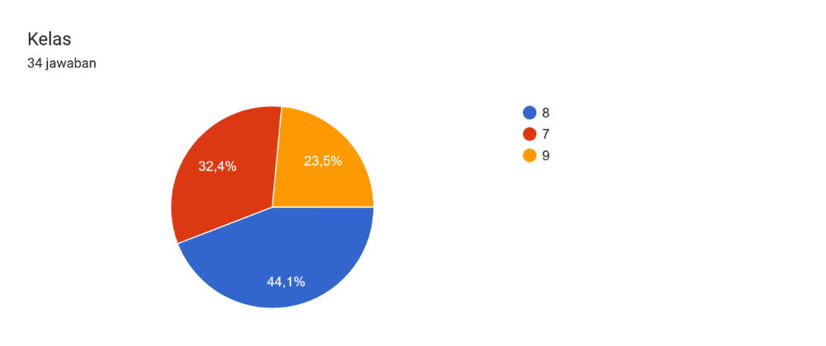
After all the data had been collected, an analysis was conducted on various aspects of critical thinking and creativity to gain a more comprehensive understanding of the students’ abilities. This pilot study was conducted to determine the extent to which students are prepared to apply critical thinking skills, both in educational settings and in their daily activities.
Figure 1. Pie chart showing the increase in conservation awareness among students.

The pie chart shows the distribution of respondents’ data by grade level, with a total of 30 responses. The majority of respondents were from 8th grade, which accounted for 44.1% of the chart. In second place is 7th grade, which accounts for 32.4% of the total population. Meanwhile, the smallest percentage is held by 9th grade, with a proportion of 23.5%. Overall, this data indicates that 8th-grade students are the group that participated most actively in completing this survey or data collection compared to other grades.

Table 1. Table showing percentages from the questionnaire or respondents
Number | Statement | 1 | 2 | 3 | 4
1 | Can correct assignments | 41,1% | 52,9%
2 | Asking follow-up questions | 14,7% | 79,4% | 59%
3 | Assessing the supporting evidence | 29,4% | 70,6%
4 | Understanding Critical Questions | 32,4% | 67,6%
5 | Explaining the reasons for the decision | 23,5% | 70,6%
6 | Gathering relevant information | 32,4% | 64,7% | 29%
7 | Generating unique ideas | 23,5% | 67,6%
8 | Ideas tailored to students' needs | 17,6% | 73,5%
9 | Combining various ideas | 29,4% | 58,8%
10 | Relevant information from various sources | 23,5% | 73,5% |  | 29%
11 | Be polite and respectful to your friends | 67,6% | 32,4%
12 | Respecting other points of view | 52,9% | 47,1%
13 | Following the discussion rules | 61,8% | 38,2%
14 | Valuing a friend’s ideas fairly | 64,7% | 35,3%
15 | Applying Knowledge in Daily Life | 29,4% | 67,6%
16 | Seeking inspiration on your own | 26,5% | 55,9%
17 | Helping to resolve conflicts | 32,4% | 64,7% | 29%
18 | Adapting communication | 26,5% | 70,6% | 29%
19 | Developing existing ideas | 29,4% | 64,7% | 59%
20 | determine the information needed to answer | 35,3% | 58,8%

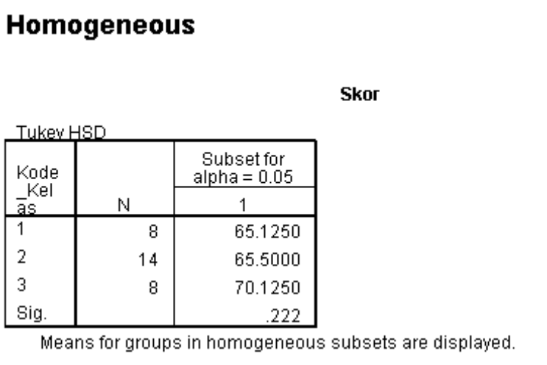

Figure 2: Distribution of Respondents by Grade Level.

The findings of the study indicate that the teaching methods used have provided students with opportunities to improve their analytical and creative skills relatively evenly across the board. However, these skills still need to be further optimized through the implementation of more dynamic, student-centered learning models, such as problem-based learning, project-based learning, and discussion-based learning.
Based on the results of the Homogeneous Subsets test using Tukey’s HSD method, the average scores for each class showed relatively small differences. Class 1 achieved an average score of 65.13 with 8 students, Class 2 achieved an average of 65.50 with 14 students, while Class 3 had the highest average score of 70.13 with a total of 8 students. However, a p-value of 0.222 (>0.05) indicates that these differences are not statistically significant.
The results indicate that the students’ abilities in all three classes fall into relatively similar categories. Although there are differences in average scores, these differences do not reflect a significant gap in ability among the classes. This situation may be influenced by similarities in teaching methods, student characteristics, instructional materials, and a relatively similar learning environment.
According to Sugiyono (2016), when the significance level is greater than 0.05, it can be concluded that there is no significant difference among the groups, and the null hypothesis can be accepted. This indicates that the observed differences in scores are still within a reasonable statistical range. This view is consistent with Ghozali’s perspective, which presents a more recent approach.
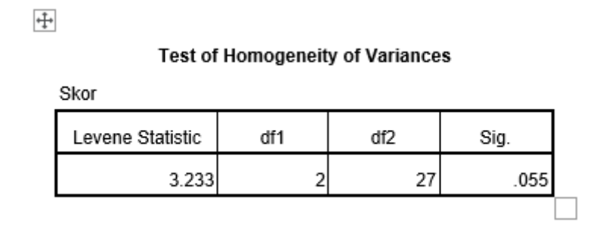
Thus, it can be concluded that the results of the analysis show that the three classes have relatively homogeneous levels of critical thinking and creativity. The absence of significant differences among the classes indicates that students’ analytical and creative thinking skills have developed fairly evenly. Nevertheless, further improvement in higher-order thinking skills is still needed so that students can meet the challenges of learning and life in the 21st century.

Figure 3 Results of the test for homogeneity of variances.

Based on the results of the homogeneity test using Levene’s test, the significance value was 0.055. Since this value is higher than 0.05, the data used in the study are considered homogeneous. This means that the variation in student ability within each group is relatively similar, indicating no significant difference in variance among the study groups.
This condition of homogeneity indicates that students’ critical thinking skills and creativity in each class are at a balanced level of diversity. With the assumption of homogeneity met, further statistical analysis can be conducted more accurately because the research results reflect the actual state of students’ abilities, rather than being influenced by differences in data variance across groups.
In addition, the homogeneity of variances strengthens the validity of the study in comparing students’ abilities in critical thinking and creativity. Thus, the research results can be interpreted more objectively and used as a basis for drawing conclusions about students’ abilities in 21st-century learning.
In the context of research on critical thinking skills and creativity, an analysis of variance (ANOVA) was conducted to ensure that each group of students had equal opportunities in the analysis process. This supports the validity of the research results when comparing students’ abilities in aspects of critical thinking such as analyzing information, evaluating arguments, and solving problems as well as in aspects of creativity, such as generating new ideas, developing solutions, and combining various ideas. With homogeneous variance, the analysis of differences in results between groups can be conducted in a more objective and scientifically grounded manner.
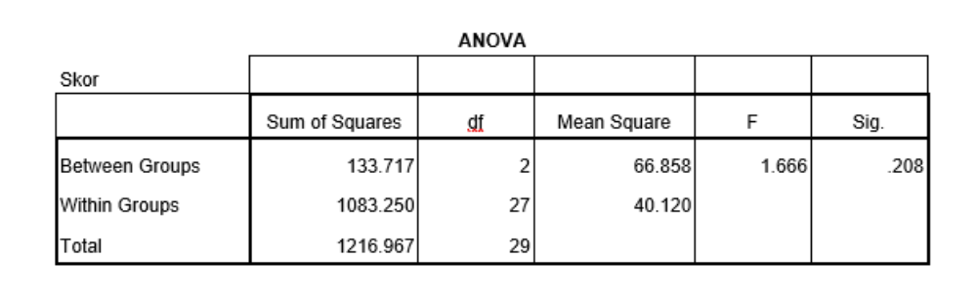
Figure 4 Results of the ANOVA test on students’ critical thinking skills and creativity.

The results of the ANOVA analysis showed a p-value of 0.208, which is higher than 0.05. Therefore, it can be concluded that there is no significant difference between grades VII, VIII, and IX in terms of students’ critical thinking skills and creativity. The differences in mean scores were only minor and did not indicate any meaningful differences in ability.
In the context of 21st-century education, critical thinking and creativity are essential components of higher-order thinking skills (HOTS). Science education not only requires students to understand concepts but also trains them to solve problems logically and systematically. Therefore, it is necessary to continue developing active learning models such as problem-based learning, project-based learning, and inquiry-based learning so that students’ critical thinking and creativity continue to improve in line with the needs of today’s educational landscape.
These results indicate that students’ levels of critical thinking and creativity are nearly the same across all grade levels. Students in grades VII, VIII, and IX demonstrate similar abilities in analyzing problems, expressing opinions, evaluating information, and generating creative ideas in science classes.
In this context, there is a connection to 20th-century education, which emphasized the importance of critical and creative thinking skills these are part of Higher Order Thinking Skills (HOTS). In the science learning process, students are not only expected to memorize existing concepts but must also be able to solve problems and think logically.
The absence of significant differences across grade levels indicates that efforts to develop students’ critical thinking and creativity skills have been implemented in a fairly balanced manner at each grade level. This may be influenced by science instruction that encourages active student engagement through discussions, observations, asking questions, and problem-solving within a student-centered learning process.
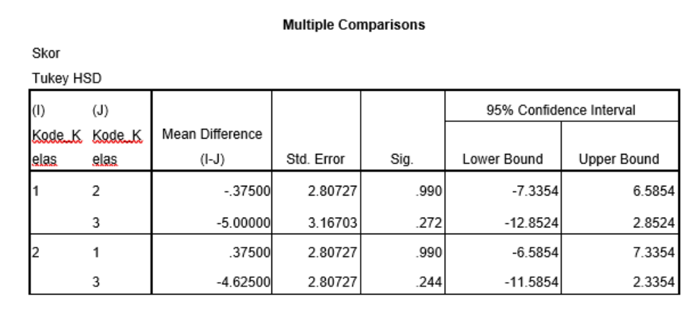
Figure 5: Results of the post hoc test of critical thinking skills and creativity across classes.

Based on the post hoc analysis shown in Figure 4, each pair of grades showed a significance value greater than 0.05. These findings support the conclusion that there are no significant differences in critical thinking skills and creativity among students in grades VII, VIII, and IX.
This indicates that students at every grade level have relatively similar abilities to understand information, solve problems, and generate innovative ideas in science learning. Critical thinking skills enable students to grasp concepts in a more rational and science-based manner, while creativity helps students generate new solutions and innovations.
Research findings also show that contextual learning and active learning activities can help students develop critical thinking skills and creativity more effectively. Through student-centered learning, students become more accustomed to expressing their opinions, evaluating information, and developing ideas in flexible and innovative ways.
Although the research results indicate a fairly good level of ability, this study still has limitations because the instrument used was only a questionnaire, so it does not fully capture the students’ cognitive abilities in depth.
In a 21st-century learning environment, critical thinking and creativity are key skills that need to be developed during the science learning process. Critical thinking helps students understand scientific phenomena logically and based on facts, while creativity enables students to generate new ideas, solutions, and innovations in addressing everyday challenges.
Learning that is relevant to everyday situations has been shown to strengthen the link between critical thinking and higher-order thinking skills. Kusuma & Rosyidah (2020) found that students accustomed to contextual problems are better able to evaluate arguments, synthesize information, and distinguish between facts and opinions. These findings are consistent with previous research, which indicates that interpersonal interaction. Students are doing well, but they still struggle to restate arguments in their own words. In terms of creativity, this approach also encourages students to develop ideas more flexibly and innovatively. Based on this discussion, context-based learning is essential for continuously strengthening both critical thinking and creativity.
To enhance critical thinking skills and creativity, active, participatory, and student-centered learning approaches such as PBL, PjBL, debates, and text analysis are necessary. Teachers also need to guide students in evaluating information, distinguishing between facts and opinions, and practicing paraphrasing. Furthermore, learning activities should encourage students to develop ideas, seek alternative solutions, and generate new concepts. In an open and supportive environment, students can grow to become more analytical and creative, in line with the demands of the 21st century.

CONCLUSION
Based on the findings of the study, it can be concluded that the levels of critical thinking and creativity among students at Margoyoso Public Junior High School No. 2 are relatively good. The majority of students have demonstrated the ability to process information, analyze issues, express their views logically, and generate creative ideas during the science learning process.
The results of the statistical analysis indicate that there are no significant differences among students in grades VII, VIII, and IX in terms of critical thinking skills and creativity. The significance value obtained was higher than 0.05, so the abilities of students in all three grade levels can be considered fairly uniform and balanced.
Nevertheless, some elements of critical thinking skills still need to be developed, particularly in terms of thoroughly evaluating information, formulating alternative solutions, and generating more original ideas. To that end, it is necessary to implement learning models that are more interactive, innovative, and student centered, such as problem-based learning, project based learning, and inquiry-based learning.
In addition, teachers also need to provide students with more opportunities to discuss, conduct experiments, and engage directly in problem-solving related to everyday life. In this way, students’ critical thinking skills and creativity can develop more fully in line with the demands of 21st-century learning.

REFERENCES
García-Carmona, A. (2025). Scientific thinking and critical thinking in science education: Two distinct but symbiotically related intellectual processes. Science & Education, 34(1), 227–245.
Halim, A. (2022). SIGNIFIKANSI DAN IMPLEMENTASI BERPIKIR KRITIS DALAM PROYEKSI DUNIA PENDIDIKAN ABAD 21 PADA TINGKAT SEKOLAH DASAR. Jurnal Indonesia Sosial Teknologi, 3(3).
Octafianellis, D. F., Sudarmin, S., Wijayanti, N., & Panca, H. (2021). Analysis of student's critical thinking skills and creativity after problem-based learning with STEM integration. Journal of Science Education Research, 5(1), 31–37.
Puling, H., Manilang, E., & Lawalata, M. (2024). Logika dan berpikir kritis: Hubungan dan dampak dalam pengambilan keputusan. Sinar Kasih: Jurnal Pendidikan Agama dan Filsafat, 2(2), 164–173.
Sasson, I., Yehuda, I., & Malkinson, N. (2018). Fostering the skills of critical thinking and question-posing in a project-based learning environment. Thinking Skills and Creativity, 29, 203–212.
Suryawati, E., & Osman, K. (2017). Contextual learning: Innovative approach towards the development of students' scientific attitude and natural science performance. Eurasia Journal of Mathematics, Science and Technology Education, 14(1), 61–76.
Sugiyono. (2016). Metode penelitian kuantitatif, kualitatif, dan R&D. Bandung: Alfabeta.

