 | Journal of economic Education … (…) (202…)  Journal of Economic Education  http://journal.unnes.ac.id/sju/index.php/jeec |  |  | 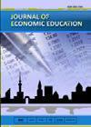
The Title consist of 12 up to 15 words, must be to the point (Times New Roman 12 pt)

First Author,¹ Second Author ², ThirdAuthor ³
The full names of the authors, Times New Roman 11 pt (2-6 authors/ not a single author)

DOI: leave it blank

¹ All the authors' institutional addresses should be inserted (Times New Roman 10 pt)
² …

History Article  ________________  Received: …  Accepted: …  Published: …  Keywords:  Xxx, Xxx Yyy, Xxx Yyy  Key words, 3-5 words or phrases, it represents the article content and should include words found in research database (Times New Roman 9 pt) |  | Abstract  ___________________________________________________________________ An effective abstract of 150–250 words should present a clear and concise overview of the entire research. It begins by stating the aim or objective of the study—what the research intends to investigate or achieve. Next, it briefly outlines the methods used, such as the research design, data collection techniques, and analytical approaches, without going into excessive detail. The abstract should then summarize the main results, highlighting the most important findings that emerged from the analysis. This is followed by the conclusion, which explains what the results mean in the context of the study. Additionally, the abstract must identify any new findings or significant contributions that the research offers, emphasizing how it advances existing knowledge. Finally, it should mention the benefits or implications of the research for scientific development or society, showing why the study is valuable and how its outcomes may be applied in real-world contexts. (Times New Roman 11 pt)  © 2025 Universitas Negeri Semarang
Correspondence address:  Write the full address of corresponding author  E-mail: email of corresponding author (Times New Roman 8 pt) |  |  | p-ISSN 2301-7341  e-ISSN 2502-4485

INTRODUCTION (Times New Roman 12 pt)

A strong Introduction, typically 1–1.5 pages with 1.15 line spacing, should open by presenting the general issues or challenges relevant to the research topic and then narrowing down to the specific problems that the study aims to address. It should also review previous research to show what has already been explored and to identify the research gap—the aspects that remain unclear, understudied, or unresolved. Based on this gap, the Introduction needs to explain the solution or approach that the present study offers, emphasizing the importance and relevance of conducting this research. It must clearly state the purposes or objectives of the study, so readers understand what the research intends to accomplish. Finally, the Introduction should highlight the benefits or contributions the research provides, either by advancing scientific knowledge or by offering value to society, industry, or practical applications. This structure ensures that the Introduction builds a logical foundation that leads readers into the main body of the research. (Times New Roman 12 pt)

METHODS (TIMES NEW ROMAN 12 PT)

The Methods section, usually about ½–1 page with 1.15 line spacing, should clearly and systematically describe how the research was carried out. It needs to explain the steps of the research process in a logical order, from the beginning to the end, so that others could understand or even replicate the study. This includes what was done, how it was done, and in what sequence.
The focus of this section is on the procedures and actions taken, not on explaining theories or concepts. Instead of discussing theoretical backgrounds, the Methods should emphasize the practical steps used to collect data, process it, and analyze it in order to achieve the research objectives. In short, the Methods section answers the question: “What exactly did the researcher do to obtain these results?” (Times New Roman 12 pt)

RESULT AND DISCUSSION (TIMES NEW ROMAN 12 PT)

The Results and Discussion section presents the findings of the research together in one integrated part. It should begin by clearly showing the results that directly address the research objectives, using tables, figures, or other visuals when necessary. Any visuals included must be easy to understand, properly labeled, and supported by concise and accurate descriptions.

The discussion should go beyond simply presenting data. It must provide an in-depth analysis of the results, explaining their meaning, implications, and how they relate to existing studies. This includes a critical comparison with recent and relevant references to show how the findings align with, extend, or differ from previous research.

Additionally, the section should highlight the novelty or unique contributions of the study—what makes the research original and how it advances knowledge in the field. Finally, it should explain the benefits and broader impacts of the findings, whether for scientific development, practical applications, or contributions to society. (Times New Roman 12 pt)

Sub Heading 1 (Times New Roman 12 pt)
The implementation of the teaching module ….(Times New Roman 12 pt)

Sub Heading 2 (Times New Roman 12 pt)
Development-based teaching modules in research …(Times New Roman 12 pt)

Table 1. Xxx Yyy Zzz (Times New Roman 12 pt)
Xxx | Xxx | Xxx |  | Xxx | Xxx | Xxx
1 | Xxx |  | 3 | 4 | 5 | 6
2 |  |  | 3 | 4 | 5 | 6
3 |  |  | 2 | 4 | 5 | 6
4 |  |  | 3 | 4 | 5 | 6
5 |  |  | 3 | 4 | 5 | 6
6 |  |  | 3 | 4 | 5 | 6
Source: …

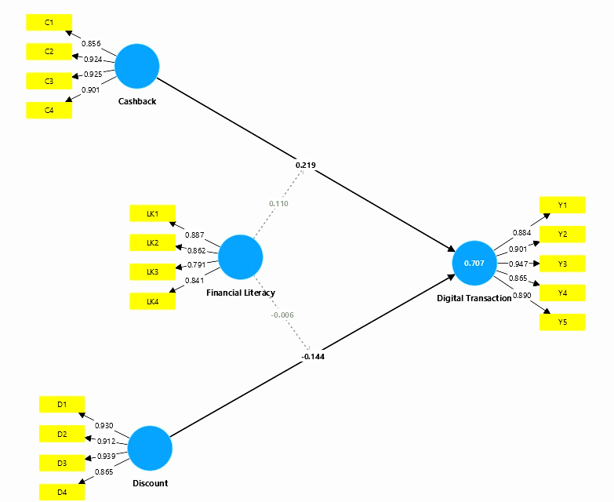

Figure 1. Research Model

CONCLUSION (TIMES NEW ROMAN 12 PT)

The Conclusion should be written as one unified paragraph without numbering. It must clearly and directly answer the research objectives, summarizing the key findings and showing how they fulfill the aims of the study. In addition, the conclusion should briefly acknowledge the limitations encountered during the research, such as constraints in data, methodology, or scope that may have affected the outcomes. Finally, it should propose a future research agenda, offering suggestions for further studies that could extend, refine, or improve upon the current work. Altogether, the conclusion provides a concise synthesis of the study’s contributions while guiding future scholarly exploration. (Times New Roman 12 pt)

ACKNOWLEDGMENTS (TIMES NEW ROMAN 12 PT)

The Acknowledgement section is dedicated to expressing gratitude to the individuals, groups, or organizations that contributed to the completion of the research. This may include funding agencies, academic institutions, supervisors, advisors, colleagues, research assistants, or any parties who provided support—whether financial, technical, or intellectual. The purpose of this section is to formally recognize their assistance and contributions to the success of the study. (Times New Roman 12 pt)

REFERENCES (TIMES NEW ROMAN 12 PT)

The References section must include a minimum of 25 sources and should be arranged alphabetically following the APA citation style. At least 80% of the references should come from primary sources, particularly research journal articles, and they must be recent publications, ideally from the last 10 years. The reference list must also include at least one citation from a journal article published in JEE and at least one publication authored by each supervisor. Every reference listed must correspond to a citation within the body of the text, ensuring consistency and proper scholarly acknowledgment. (Times New Roman 12 pt)

Examples:
Ahid, N., & Chamid, N. (2021). Implementation of Indonesian National Qualification Framework Based Curriculum in Higher Islamic Education. Jurnal Pendidikan Islam, 7(1), 109-122. http://journal.uinsgd.ac.id/index.php/jpi. (Times New Roman 12 pt)
Anggraini, et al. (2022). KKNI Curriculum Management at Islamic Education Management Study Program UIN Raden Fatah Palembang. Jurnal Pendidikan dan Konseling Volume 4 Nomor 4 Tahun 2022 E-ISSN: 2685-936X dan P-ISSN: 2685-9351.

Badan Nasional Sertifikasi Profesi. (2023). Skema Sertifikasi Okupasi Office Administrative.

Kosasih, E. (2021). Pengembangan bahan ajar. Jakarta : Bumi Aksara.

