 | JPES 14 (2) (2025)  Journal of Physical Education and Sports  http://journal.unnes.ac.id/sju/index.php/jpes | 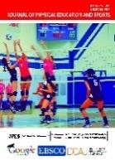
Contribution of Imagery and Consentration Training to the Passing Result of Bintang Kalinegoro Football Academy Athletes
Ilham Jaya Kusuma Dwi S¹, Soedjatmiko², Arif Setiawan³

^{1,2,3} Universitas Negeri Semarang
Article Info  History Articles Received:  April 2025 Accepted:  June 2025  Published:  June 2025  Keywords:  Imagery, Consentration, Passing, and Football | Abstract  Imagery training is rarely used by coaches to improve the quality of passing techniques in soccer. The purpose of this study was to analyze the interaction between imagery training and concentration on the results of passing training for players at the Bintang Kalinegoro soccer school. The research method in this study uses a quantitative approach with a quasi-experimental research method. Data collection uses concentration tests and passing tests. Data analysis in this study consists of normality tests, homogeneity tests, and hypothesis tests. The results of the study indicate that each group with different levels of concentration and different treatments will yield different passing test results. The discussion is that each group obtained different results because each group had different levels of concentration and each group received different treatments. The conclusion is that there is an interaction between imagery training and concentration on the passing performance of Bintang Kalinegoro school soccer players. The cognitive-specific training method is better applied to groups with high concentration, while the imagery motivational general mastery training method is better applied to groups with low concentration. The limitations of this study are that the research sample was not always present due to weather and school factors. It is recommended that the research be conducted on Sunday mornings because schools are closed and the weather is often sunny. If the research is conducted on Tuesdays and Thursdays, it should be done earlier to avoid extending into the evening.  Keywords: Imagery, concentration, passing, and football  © 2020 Universitas Negeri Semarang
 Address correspondence:  Author Correspondence Address  E-mail: (first author's email address) |  | p-ISSN 2252-648X e-ISSN 2502-4477

INTRODUCTION
Sport has now become an important thing in everyday life. Someone makes exercise an activity that is done during free time, considering the importance of fitness and health that must be maintained by every human being. Sport is a physical and psychological activity that a person does to maintain and improve physical and spiritual fitness (Salahudin & Rusdin, 2020).
Sports are systematic activities to develop physical and spiritual potential carried out by a person or group (Melyna & Setiawan, 2020). Exercise can improve physical fitness which is characterized by smooth blood flow, strengthening the heart muscle, respiratory system and increased metabolism and maintaining ideal body weight (“Olahraga Dan Kebugaran Jasmani (Physical Fitness) Pada Anak Usia Dini,” 2009).
In this modern era, technological developments are increasingly rapid, this causes sports to develop as well. One of the concerns is the sport of football which is increasingly undergoing changes, both in terms of coach methods, training processes, and ways of playing as well as facilities and infrastructure. Football is done with skillful movements with limited time, physically and mentally tired and faced with opponents (Setyaningum & Anwar, 2016).
Soccer is the most popular sport in the world today. This soccer game is often played by the community because it is useful for maintaining fitness, education, achievement and recreation, so it is not surprising that soccer is a sport that is favored and favored by many people (Mubarok et al., 2019). “Football is not just a game” (Şener & Karapolatgil, 2015). Football is more than just a game, it is about human activity around the world. Soccer is currently the most popular sport in the world.
There are many aspects that support the creation of good quality soccer, including technical, physical, mental, tactical, and so on (Guntoro et al., 2020). These aspects must be related to one another. Apart from being an obligation for every soccer athlete, it is also the responsibility of the coaches to provide the right training material. A quality coach is a coach who can produce quality achievements, but this is also obtained through quality training of course (Bangun, 2019).
Psychology is one of the supporters of athlete success, such as high self-confidence and motivation (Puspita, 2022). This imagery exercise is included in psychology because it can be used to increase self-confidence in athletes, because good athlete performance is when they have positive thoughts about themselves when athletes want to determine strategies in the match. This is an important factor to achieve success psychologically.
Imagery or visualization is a form of conscious and deliberate mental creation that aims to build a perception of something by forming a creative imagination in one's mind. In this process, a person can change their perception of something because they make imaginations about situations from various perceptions or see situations from various points of view (Festiawan, 2021).
Imagery is one of the effective techniques in improving athlete performance that is used regularly during training and competition. Imagery occurs when perceptual information is accessed from memory, giving rise to the experience of ‘seeing with the mind's eye’, ‘hearing with the mind's ear’ and so on (M.Kosslyn et al., 2019)
Imagery is a form of actual simulation. Imagery is derived from experiences gained by seeing, feeling and listening, but the whole experience takes place in the brain. In sports, imagery and athlete performance are closely related (Irmansyah et al., 2018). In doing imagery exercises athletes must be able to concentrate so that the exercise achieves good results. Imagery exercises can help athletes to be more confident, improve performance related to sports skills, and perform better sports activities (Lubis & Permadi, 2020).
In doing imagery exercises athletes must be able to concentrate so that the exercise achieves good results. Imagery training can help athletes to be more confident, improve performance related to sports skills, and perform better sports activities (Lubis & Permadi, 2020).
Psychological exercises that can be used by coaches and athletes to increase self-confidence and mentality, one of which is exercise (Nopiyanto et al., 2022). Everyone is capable of using imagery as a means to improve affective, cognitive, and behavioral outcomes. Everyone has the ability to generate and use imagery, but often we choose not to use it, even in situations that may be beneficial (Hall et al., 2016). In the realm of sports, athletes use imagery exercises in training, competition, and rehabilitation. Some sports teams use psychology to improve the quality of their players (Qader et al., 2017).
Not only in the realm of sports, the wide application of imagery training also reaches world musicians such as David Guetta and also martial artist Bruce Lee, which illustrates that imagery can be used in various sciences and for different functions (Munroe-Chandler & Guerrero, 2017).
Many factors affect the concentration of athletes when competing. One of them is psychological factors, where mental aspects are more influential than other aspects (Aguss & Yuliandra, 2021). Concentration is a person's ability to focus attention on an object within a certain time (Nusufi, 2016).
Based on the author's observations, it appears that concentration, confidence and also mentality in early age athletes at Bintang Kalinegoro soccer school are still too low. This can be seen when they compete. When mentally declining and losing concentration, what happens is that the techniques they have cannot be applied and the tactics of the coach cannot run.
An athlete with good concentration certainly makes him more confident. Self-confidence grows from within a person. This self-confidence will make someone comfortable and confident in their abilities. Without self-confidence an athlete will not achieve maximum performance, because there is an influence between self-confidence and maximum ability (Kurniawan, 2018).
The existence of imagery exercises can overcome passing problems at Bintang Kalinegoro soccer school. This can be proven from the imagery exercise itself because in passing with imagery a player is required to imagine himself (visualization) in his mind when passing, therefore a soccer player who will pass can see friends, opponents and the surrounding environment, then hear and feel so that the ball can be received easily by friends.
The purpose of this study is to analyze the interaction between imagery training and concentration on the results of passing training for Bintang Kalinegoro football school players.
METHOD
The research method is a scientific way to get data with a specific purpose. Research on the Effect of Imagery and Concentration Training on the Results of Football Passing Training in Kalinegoro Star Football School Athletes uses a quantitative research approach. Quantitative research is a research method used to research on populations or samples, sampling techniques are usually carried out randomly, data collection using research instruments, data analysis is quantitative, with the aim of testing predetermined hypotheses.
This research design is a factorial design. In this design there is a group that is given a pretest at the beginning of the meeting to find out the athlete's initial ability and a posttest at the end of the meeting to find out how influential the treatment is.
The population in this study were all athletes of Bintang Kalinegoro soccer school totaling 60 people who were divided into several age groups (U-15, U-13, U-12, U-11, U-10). The sample in this study were U-15 and U-13 athletes totaling 24 athletes. The sampling technique used in this study was purposive sampling.
The focus of this research is useful to limit the object of research that will be raised by the researcher. This study focused on how the interaction between imagery and concentration training on the results of passing training for Bintang Kalinegoro soccer school players.
The data collection techniques in this study used two kinds of tests, namely: a concentration test taken from a concentration test grid, this test is used to measure the concentration of athletes in the form of a table containing numbers 0-99, and giving a passing test which was carried out in the initial test (pre-test) and after getting the pre-test results, athletes will get treatment in the form of cognitive general mastery training and motivation. After being given treatment, at the end of the meeting athletes will be given a final test (post-test).
Data collection instruments in this study used 2 kinds of tests, namely: 1) Grid Concentration Test, is a form of measuring instrument that is already valid and has reliability, therefore researchers know the level of concentration by using the numbers in it. 2) Passing Test, namely by passing the ball using the inside leg (passing technique) to a predetermined target 3 times then the results are summed up.
Test Passing
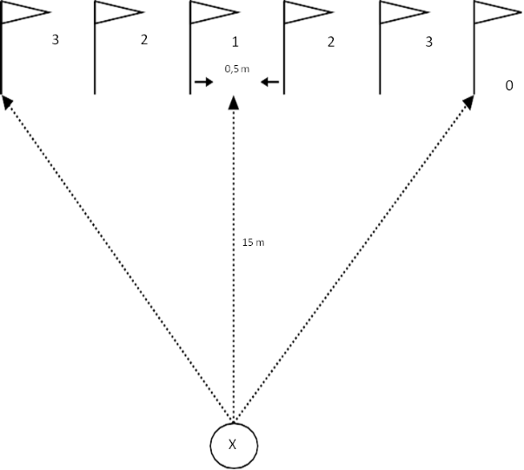

The initial test (pre test) was conducted with the aim of knowing the initial data of the research subject about passing training for each sample player. Treatment is carried out in accordance with the training program that has been prepared and has been expert judgment by experts. The process of giving treatment or treatment is carried out with 16 meetings where in one week 3 meetings are held. The implementation of the final test or post test in this study is the same as the implementation of the initial test, namely using a passing test, which aims for the final test (post test) to determine the difference in passing scores after being given treatment or training. The difference in passing scores can be seen from the comparison of scores between before (pre test) and after (post test).
Furthermore, for data analysis techniques using SPSS 26. This research was conducted using ANOVA, so before arriving at the use of TWO WAY ANOVA, prerequisite tests need to be carried out which include: (1) normality test and (2) variance homogeneity test and hypothesis testing.
RESULTS AND DISCUSSION
Results
Data from the pre-test and post-test results of the passing accuracy test on soccer athletes at Bintang Kalinegoro soccer school are presented as follows.
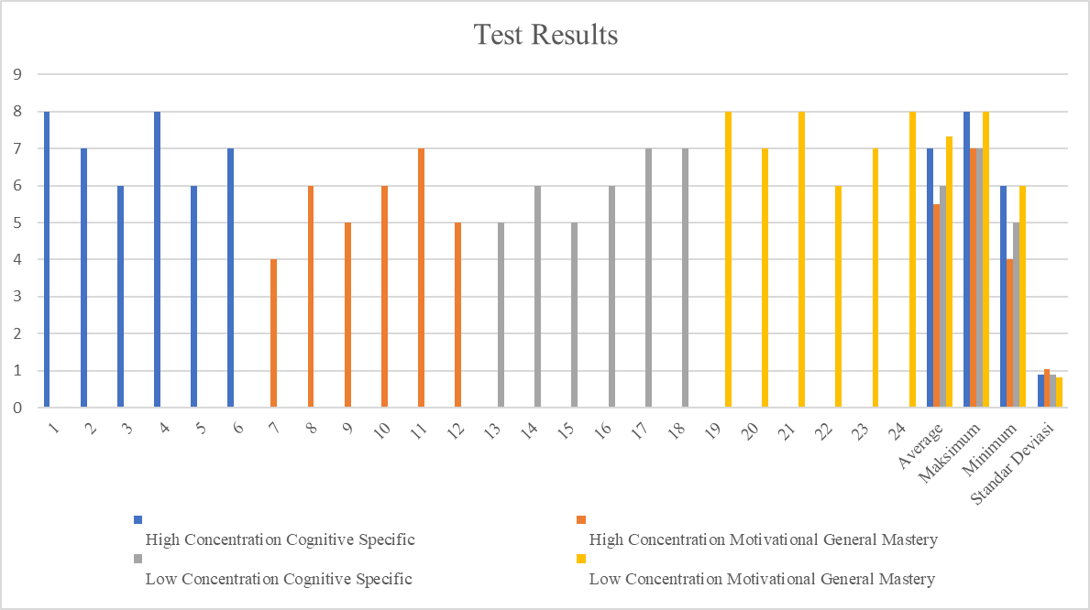

The data above is the result of the passing test of 24 players who are divided into 4 groups, each group consisting of 6 players.
The blue color is a high concentration group given treatment in the form of specific cognitive imagery training. The results of the six players in the group get the highest score of 8 and the lowest score is 6, the average value of the group is 7, the standard deviation is 0.89.
Orange color is a high concentration group given treatment in the form of general mastery motivational imagery training. The results of the six players in the group get the highest score of 7 and the lowest score is 4, the average value of the group is 5.5, the standard deviation is 1.04.
The gray color is a low concentration group given treatment in the form of cognitive specific imagery training. The results of the six players in the group got the highest score of 7 and the lowest score of 5, the average value of the group was 6, the standard deviation was 0.89.
The yellow color is a low concentration group given treatment in the form of general mastery motivational imagery training. The results of the six players in the group get the highest score of 8 and the lowest score is 6, the average value of the group is 7.3, the standard deviation is 0.81.
From the above results, it can be seen that imagery training and concentration have an interaction. Each group with different concentration and different treatment, the passing test results will also be different.
DISCUSSION
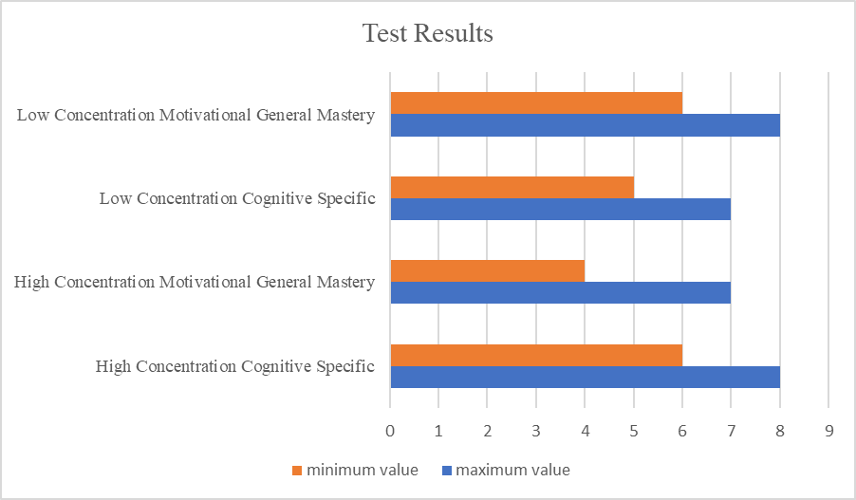
The diagram above shows that the high concentration group given cognitive specific imagery training produces a maximum value of 8 and a minimum value of 6.
The high concentration group given general mastery motivational imagery training produces a maximum value of 7 and a minimum value of 4.
The low concentration group given cognitive specific imagery training produces a maximum value of 7 and a minimum value of 5.
The low concentration group given general mastery motivational imagery training produces a maximum value of 8 and a minimum value of 6.
Each group gets different results because each group has a different level of concentration and each group gets different treatments.
From the results of this study, researchers found that a player with high concentration is better given cognitive specific imagery training. This imagery exercise requires the player to remember an activity and can be done if the player is focused. Meanwhile, a player with low concentration is better given general mastery motivational imagery training. This imagery exercise requires the player to perform a passing movement for a few moments and get distracted from the surrounding environment, this exercise does not really require high focus which is only needed not to be affected by external disturbances.
The advantage of this study compared to other studies is that general mastery motivational training juxtaposed with specific cognitive training and concentration to divide this group has never been done by others before.
The role of the coach in improving the passing ability of soccer athletes is very important, the coach can choose the right method, especially in providing imagery training according to the athlete's concentration level so that it will get maximum results.
CONCLUSION
Based on the discussion above, it can be concluded that there is an interaction between imagery training and concentration on the results of passing training for Bintang Kalinegoro soccer school players. The group with high concentration is better given cognitive specific imagery training, while the group with low concentration is better given general mastery motivational imagery training.
REFERENCES
Aguss, R. M., & Yuliandra, R. (2021). The effect of hypnotherapy and mental toughness on concentration when competing for futsal athletes. Medikora, 20(1), 53–64. https://doi.org/10.21831/medikora.v20i1.36050
Bangun, S. Y. (2019). Peran Pelatih Olahraga Ekstrakurikuler Dalam Mengembangkan Bakat Dan Minat Olahraga Pada Peserta Didik. Jurnal Prestasi, 2(4), 29. https://doi.org/10.24114/jp.v2i4.11913
Festiawan, R. (2021). The power of imagery: kajian tentang imagery dalam olahraga. Sport Psychology, January. https://doi.org/10.31219/osf.io/38wsq
Guntoro, T. S., Muhammad, J., & Qomarrullah, R. (2020). Faktor kemampuan fisik dan psikologis penunjang keterampilan atlet elit sepakbola Propinsi Papua. Jurnal SPORTIF : Jurnal Penelitian Pembelajaran, 6(2), 390–406. https://doi.org/10.29407/js_unpgri.v6i2.13768
Hall, C. R., Rodgers, W. M., & Barr, K. A. (2016). The Use of Imagery by Athletes in Selected Sports. The Sport Psychologist, 4(1), 1–10. https://doi.org/10.1123/tsp.4.1.1
Irmansyah, J., Ridwan, M., & Gilang, A. (2018). Model Latihan Imagery Terhadap Ketepatan Floating Service Atlet Voli Pantai Ntb. Energies, 4(1), 100. http://journals.sagepub.com/doi/10.1177/1120700020921110%0Ahttps://doi.org/10.1016/j.reuma.2018.06.001%0Ahttps://doi.org/10.1016/j.arth.2018.03.044%0Ahttps://reader.elsevier.com/reader/sd/pii/S1063458420300078?token=C039B8B13922A2079230DC9AF11A333E295FCD8
Kurniawan, R. (2018). Pengaruh Keseimbangan, Kecepatan, Dan Percaya Diri Terhadap Kemampuan Dribbling Dalam Permainan Sepakbola Pada Atlet Ssb Putra Wijaya Padang. Unes Journal of Education Scienties, 2(1), 062. https://doi.org/10.31933/ujes.2.1.062-070.2018
Lubis, M. R., & Permadi, A. G. (2020). Perbedaan Pengaruh Latihan Imagery Dan Tanpa Latihan Imagery Terhadap Peningkatan Kemampuan Shooting Game Atlet Petanque Undikma. Jurnal Ilmiah Mandala Education, 6(1), 101–106. https://doi.org/10.58258/jime.v6i1.1114
M.Kosslyn, S., Ganis, G., & Thompson, W. L. (2019). Prevalence and Psychological Correlates of Complicated. Journal of Interpersonal Violence, 20(1), 1689–1699. https://www.ncbi.nlm.nih.gov/pmc/articles/PMC2921311/%0Ahttp://www.ncbi.nlm.nih.gov/pubmed/20806028%0Ahttp://www.pubmedcentral.nih.gov/articlerender.fcgi?artid=PMC2921311%0Afile:///C:/Users/user/Downloads/YYY_2017_YYYYY_YYYY.pdf%0Ahttp://search.proquest.c
Melyna, M., & Setiawan, T. (2020). Gelanggang Remaja Tanjung Duren Sarana Penyaluran Minat Dan Bakat Untuk Meningkatkan Kesehatan. Jurnal Sains, Teknologi, Urban, Perancangan, Arsitektur (Stupa), 1(2), 1107. https://doi.org/10.24912/stupa.v1i2.4448
Mubarok, R. R. S., Narlan, A., & Millah, H. (2019). Pengaruh Latihan Long Passing Menggunakan Sasaran Berurutan Terhadap Ketepatan Long Passing Dalam Permainan Sepak Bola. Journal of SPORT (Sport, Physical Education, Organization, Recreation, and Training), 3(2), 98–103. https://doi.org/10.37058/sport.v3i2.1150
Munroe-Chandler, K. J., & Guerrero, M. D. (2017). Psychological Imagery in Sport and Performance. Oxford Research Encyclopedia of Psychology, March, 1–23. https://doi.org/10.1093/acrefore/9780190236557.013.228
Nopiyanto, Y. E., Alexon, A., Raibowo, S., Prabowo, A., Ilahi, B. R., & Widodo, L. (2022). Pengaruh Latihan Imagery terhadap Kepercayaan Diri Atlet. Jurnal Patriot, 4(1), 48–57. https://doi.org/10.24036/patriot.v4i1.834
Nusufi, M. (2016). Melatih Konsentrasi Dalam Olahraga. Jurnal Ilmu Keolahragaan, 15(2), 54–61. https://jurnal.unimed.ac.id/2012/index.php/JIK/article/view/6139/5439
Olahraga Dan Kebugaran Jasmani (Physical Fitness) Pada Anak Usia Dini. (2009). Jurnal Cakrawala Pendidikan, 3(3), 270–281. https://doi.org/10.21831/cp.v3i3.304
Puspita, M. D. (2022). Pengaruh Latihan Imagery Dan Konsentrasi Terhadap Hasil Shooting Atlet Polo Air Diy. Braz Dent J., 33(1), 1–12.
Qader, M. A., Zaidan, B. B., Zaidan, A. A., Ali, S. K., Kamaluddin, M. A., & Radzi, W. B. (2017). A methodology for football players selection problem based on multi-measurements criteria analysis. Measurement: Journal of the International Measurement Confederation, 111, 38–50. https://doi.org/10.1016/j.measurement.2017.07.024
Salahudin, S., & Rusdin, R. (2020). Olahraga Meneurut Pandangan Agama Islam. JISIP (Jurnal Ilmu Sosial Dan Pendidikan), 4(3), 457–464. https://doi.org/10.58258/jisip.v4i3.1236
Şener, İ., & Karapolatgil, A. A. (2015). Rules of the Game: Strategy in Football Industry. Procedia - Social and Behavioral Sciences, 207, 10–19. https://doi.org/10.1016/j.sbspro.2015.10.143
Setyaningum, R. K., & Anwar, K. (2016). Upaya Meningkatkan Prestasi Belajar Passing Dalam Bermain Sepakbola Dengan Menerapkan Pembelajaran Yang Inovatif. Journal of Chemical Information and Modeling, 3(2), 1–14. http://ejournal.utp.ac.id/index.php/JMSG/article/view/478

