 | SPECIAL EDITION 2026  Journal of Physical Education and Sports  http://journal.unnes.ac.id/sju/index.php/jpes |  |  | 
Development of Multi NetRing Tools for Elementary Students

Muhammad Yudistira Oktavian Putra¹ , Ipang Setiawan²

¹ Universitas Negeri Semarang, Indonesia
² Universitas Negeri Semarang, Indonesia

Article Info  ________________  History Articles  Received:  December 2025  Accepted:  December 2025  Published:  September 2026  ________________  Keywords:  media development, physical education, Multi NetRing, elementary schools, R&D.  ____________________ |  | Abstract  ___________________________________________________________________  Physical education learning activities in elementary schools are often hampered by limited facilities and infrastructure, especially game aids such as nets and rings. This condition results in low student participation and a less than optimal teaching and learning process. This study aims to develop and test the feasibility of the Multi NetRing learning aid as a solution to the limited physical education facilities in elementary schools. Multi NetRing is a portable and multifunctional tool that can be used in various games such as volleyball, badminton, and basketball. This study uses the Research and Development (R&D) method with reference to the Sugiyono development model. The results of expert validation show an Aiken's V value of 0.894 (very valid category), while the small-scale trial phase 1 showed an average feasibility percentage of 85% declared "very good". The second phase of the small-scale trial yielded an 89% "very good" rating. The large-scale trial yielded a 95% "very good" rating. Based on these results, the Multi NetRing device is considered highly suitable for use as a physical education learning medium in elementary schools, as it increases active participation, enhances learning efficiency, and provides a fun and safe learning experience for students.  © 2025 Universitas Negeri Semarang
Address correspondence:  Sekaran, Gunungpati, Semarang, Central Java, Indonesia, 50229.  Email : yudistiraoktavian17@gmail.com |  |  | p-ISSN 2252-648X  e-ISSN 2502-4477

INTRODUCTION

Physical education, sports, and health (PJOK) is a crucial component of the national education system, serving not only to develop students' physical abilities but also to support character development, social skills, and mental health (Arisandi et al., 2023). Physical education is an effective means of instilling the values of discipline, cooperation, and responsibility, as well as increasing motivation for an active and healthy lifestyle from an early age (Fernández-Espínola et al., 2020). In the elementary school context, PJOK serves as a medium for developing gross and fine motor skills through a variety of fun and educational physical activities.

Learning media is an integral part of the entire learning system and process. This means that learning media determine learning activities and are a crucial element in learning (Ani Daniyati et al., 2023). Media are tools or means used as intermediaries to convey learning material from educators to students (S, 2019).

In the context of physical education, learning media includes demonstration tools, training aids, and games that support the development of motor skills and mastery of basic sports techniques. According to (ACHMAD ABDUL GHOFUR, 2022), learning aids in physical education are defined as equipment or devices used to enhance students' movement learning experiences. Therefore, researchers believe that the Physical Education (PJOK) learning process will be more effective when using learning media, as the material becomes easier for each student to understand compared to learning conducted solely in the classroom. This is because sports movements are more easily imitated by students when presented through media.

Law of the Republic of Indonesia No. 3 (2005:5), concerning the National Sports Education System, states that "the development and development of sports education is carried out through a learning process conducted by qualified, certified sports teachers and supported by adequate sports facilities and infrastructure."

However, the implementation of physical education at the elementary school level still faces various challenges, particularly related to the availability of supporting learning facilities and infrastructure. One of the main obstacles encountered in the field is the lack of learning aids that can support the teaching and learning process, especially for games that require facilities such as nets and rings. Many elementary schools, especially those in rural areas or those with limited budgets, lack adequate learning media to support physical education lessons. As a result, the learning process is less than optimal and student participation in physical activities decreases. Meanwhile, large and small ball games such as volleyball, badminton, and basketball are core materials in physical education that directly involve the use of aids such as nets and rings. These games not only serve to practice playing techniques and skills, but also It serves as a tool for developing children's coordination, balance, teamwork, and motor dexterity (O. Candra et al., 2023). Therefore, flexible, easy-to-use learning media are needed that can be used in various types of games simultaneously.

In response to this need, this research developed an innovative learning aid called Multi NetRing. This portable and multifunctional tool is specifically designed for use in teaching net-and-ring-based games in elementary schools. Multi NetRing can be used for multiple sports simultaneously, such as volleyball, badminton, and basketball. Its detachable design simplifies storage, transportation, and installation in various field conditions, both indoors and outdoors. In addition to addressing facility limitations, the development of Multi NetRing is also expected to encourage more interactive and enjoyable learning, increasing student engagement and learning outcomes in both large and small ball games. Utilizing a research and development (R&D)-based product development approach, this research focuses on the design, validation, and testing of the practicality and feasibility of the Multi NetRing tool as a concrete solution for physical education (PJOK) learning at the elementary school level. Thus, this research not only contributes to the development of effective and efficient physical education learning media but also supports the implementation of quality physical education in elementary schools, especially in areas with limited resources. It is hoped that the Multi NetRing tool can be part of the solution to equitable access to inclusive, adaptive, and enjoyable physical education learning for all students.

METHODS

This research is a research and development (R&D) project aimed at producing a product in the form of the Multi NetRing learning aid, a portable, multifunctional tool designed to support the learning process of large and small ball games in elementary schools. The development model used in this study refers to the stages proposed by Sugiyono (2019), which consists of several systematic steps starting from 1) Potential Problems, 2) Data Collection, 3) Product Design, 4) Design Validation, 5) Design Revision, 6) Product Trial, 7) Product Revision, 8) Usage Trial, 9) Product Revision, and 10) Mass Production.

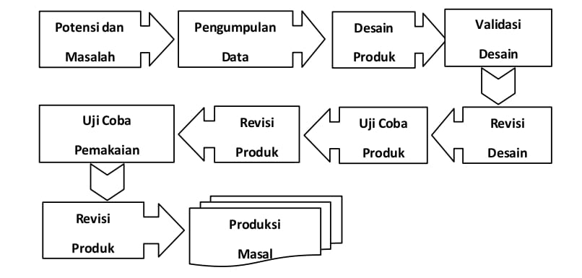
Figure 1 R&D Stages (Sugiyono, 2019).
Research Instrument
The instrument used in this study was a questionnaire. A questionnaire is a data collection technique that involves providing a statement/question to be answered in writing by respondents (Sugiyono, 2019). The expert questionnaire is intended for and must be completed by media experts, specifically in the field of sports game media; learning experts, specifically in the field of learning; and practitioners, specifically in the field of physical education tools; to determine the validity or feasibility of the developed product. This questionnaire must also be completed by the students themselves to assess the tool. The assessment range in this questionnaire uses a Likert scale: 1) very inappropriate, 2) inappropriate, 3) inappropriate, 4) very appropriate (Sugiyono, 2019).
Table 1 Assessment Questionnaire Outline
No | Aspect | Indicator | Items
1 | Functional | Used in various games, flexible and durable | 5
2 | Effectiveness and Efficiency | Make learning and techniques easier | 5
3 | Comfort and security | Safe and comfortable | 5
4 | Suitability | Increase cooperation and be age and curriculum appropriate | 5

Data Analysis Techniques
The data analysis techniques used in this study included quantitative and qualitative descriptive data analysis. Quantitative data were obtained from expert validation sheets and a product feasibility assessment questionnaire completed by students. Qualitative data were obtained from feedback or suggestions for product improvements, as well as deficiencies and weaknesses of the developed product. The obtained data were then calculated and converted into percentages. The formula used to process quantitative data, according to (Sugiyono, 2016) in (A. R. D. Candra et al., 2017), is as follows:

Note:
P = Presentation
Σxi = Total Scores from Respondents
Σxj = Maximum Score
100 % = Constant
The scores will then be classified into four categories as follows (Pranatawijaya et al., 2019):
Table 2 Percentage Classification
Presentation (%) | Classification
80 - 100 | Very Good
60 – 79 | Good
40 - 59 | Less Good
20 – 39 | Not Good
0 - 19 | Very Bad
Source: (Pranatawijaya et al., 2019)
Tool Design
The Multi NetRing tool is an innovative, portable, multifunctional learning aid designed to support various games that utilize nets and rings as the main components, such as volleyball, badminton, and basketball. This tool was developed to facilitate physical education learning, particularly in situations with limited field facilities, thereby increasing the flexibility and effectiveness of the teaching and learning process. The design is as follows:
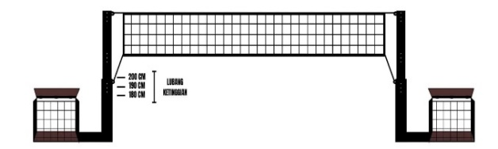
Net Design for Volleyball
Figure 2 Volleyball Net
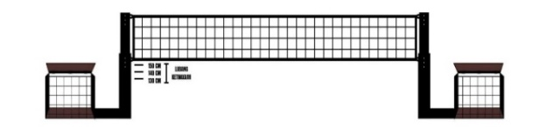
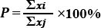
Net Design for Badminton
Figure 3 Badminton Net
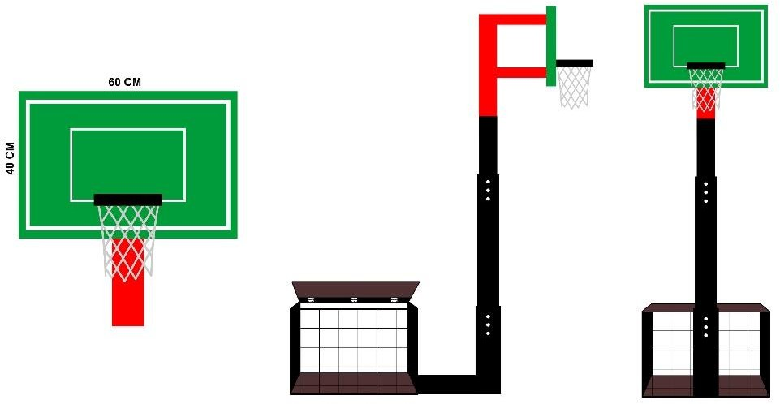
Basketball Ring Design
Figure 4 Basketball Rings

RESULTS AND DISCUSSION

Effective Physical Education (PE) learning in elementary schools can be achieved through systematic planning, implementation, and evaluation, supported by adequate media and learning aids. However, in its implementation, various obstacles often arise that can hinder the optimal achievement of learning objectives. To address these challenges, initial data collection through observation and preliminary studies are necessary as a basis for formulating solutions tailored to the actual needs of the school.

One focus of PE learning is providing learning experiences through large ball games. This material aims to encourage students' physical activity, foster a passion for exercise, and strengthen endurance from an early age. However, many elementary schools face limited resources, particularly in providing learning aids for large and small ball games such as soccer, volleyball, and basketball. This situation hinders what should be an active and enjoyable learning process.

Based on this preliminary study, researchers developed a multifunctional learning aid that can be used in three types of games. This innovation is expected to: (1) Increase active participation and student interest in learning, (2) Assist teachers in delivering learning materials efficiently, provide a solution to limited school facilities, and (3) create a learning process that is engaging, practical, and relevant to the needs of elementary school students.

Expert Validation of the Initial Product Draft

Before the initial product development of the Multi NetRing Tool was tested on a small scale, the product draft underwent a validation test by experts to assess its feasibility and potential shortcomings. This validation stage involved media experts, practitioner experts, and learning experts.

The product validation stage involved three experts with competencies in their respective fields. The media expert, Fajar Awang, M.Pd., Ph.D., is a lecturer at the Faculty of Sport Science, Semarang State University (FIK UNNES). The practitioner expert, Aflah Alamsah, S.T., M.T., is a Civil Engineering graduate with experience in tool design and construction. Meanwhile, the learning expert, Wildan Bagus, S.Pd., is an elementary school Physical Education teacher who understands the implementation of tools in the learning process. The three experts provided assessments and input to refine the product before the field trial.

To analyze the validation results, this study used the Aiken's V validity formula, developed by Aiken (1985), to measure the extent of expert agreement on the appropriateness of each statement item. The Aiken's V formula was chosen because it is suitable for assessing the level of agreement between experts on quantitative assessment scale items.

This V index assessment scale ranges from 0 to 1 (Retnawati, 2016).

a. An index value of ≤ 0.4 indicates poor validity,

b. 0.4-0.8 indicates moderate validity, and
c. >0.8 indicates very valid.
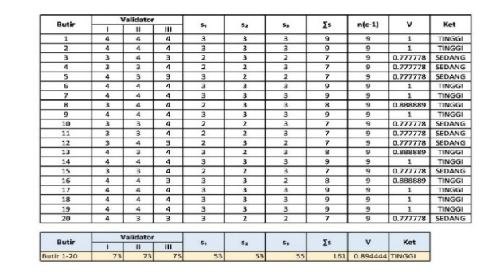
Table 3 Validity Results of Aikens'V

The results of the Aiken's V validity calculation for the 20 assessment items showed a total average score of 0.894, which falls into the "High" category. Therefore, the product was deemed suitable for further small-scale field trials with some minor improvements as recommended by the validator.
Table 4 Expert Suggestions and Input

No | Expert Name | Improvement Suggestions
1 | Fajar Awang, M.Pd., PhD. | The net posts were extended by 15–20 cm to allow for more flexible height adjustments depending on the type of game. Additionally, a manual was created detailing component installation instructions for ease of use.
2 | Aflah Alamsyah, S.T, M.T. | Adding a lock to the pole's height adjustment mechanism, such as a rotating bolt, to keep the pole stable during use. This addition supports the stability and safety of the tool during learning.
3 | Wildan Bagus, S.Pd. | It is necessary to add safety to the pole in the form of soft materials such as dense foam to provide a sense of safety and comfort.

Small-Scale Trial Phase 1
Table 5 Assessment Percentage
No | Aspect | Presentation Results
1 | Functional | 86%
2 | Effectiveness and Efficiency | 85%
3 | Comfort and Security | 84%
4 | Suitability | 86%
Average |  | 85%
Based on the results of a questionnaire completed by 23 sixth-grade students at Kaliwungu 1 Elementary School during the first small-scale trial, an average score of 85% was obtained. These results indicate that the multi-netring device falls into the very good category and is considered highly suitable for further trials.
During the first small-scale trial, several technical challenges were encountered in the use of the Multi-NetRing device by students. These issues require further action to ensure the product truly meets user needs and is suitable for use in learning. The problems and their solutions are as follows:
1. Students had difficulty lifting the weights, making it difficult to move and store the device. Solution: A special lifting tool was created to facilitate students' safe and efficient movement and storage.
2. The net was not securely installed, making it unstable during play. Solution: A net tightening tool was introduced to ensure the net was installed more securely and appropriately for play.
Small-Scale Trial Phase 2
Table 6 Assessment Percentage
No | Aspect | Presentation Results
1 | Functional | 90%
2 | Effectiveness and Efficiency | 89%
3 | Comfort and Security | 87%
4 | Suitability | 91%
Average |  | 89%

Based on the results of the questionnaire completed by students during the small-scale trial phase 2, the average percentage was 89%. These results indicate that the multinetting tool falls into the very good category and is considered very suitable for further large-scale trials.
Large-Scale Trial
Table 7 Assessment Percentage
No | Aspect | Presentation Results
1 | Functional | 97%
2 | Effectiveness and Efficiency | 96%
3 | Comfort and Security | 93%
4 | Suitability | 97%
Average |  | 95%

Based on the results of a questionnaire completed by 23 sixth-grade students at SDN 3 Mukiran during the large-scale trial phase, an average score of 95% was obtained. These results indicate that the multinetworking tool falls into the very good category and is considered very suitable for use in learning activities.
Description of the Final Product Draft
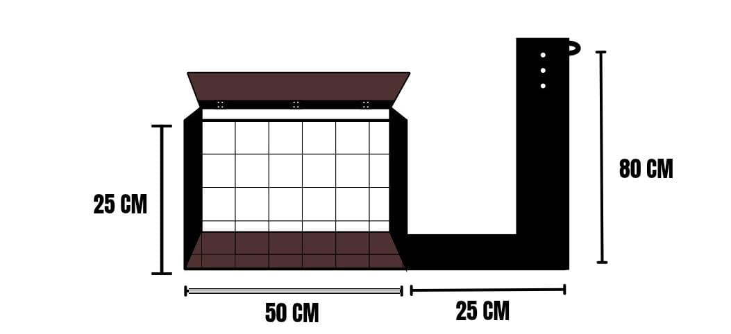
a. Ballast Part
The weights are in the form of a beam frame measuring 50 cm x 25 cm x 25 cm. The beam frame is made of thick zinc and welded together at each corner of the beam frame. This design makes the tool more efficient and practical, making it easy to carry anywhere and safe to move. This portability makes the tool more functional and supports flexible use in various learning situations or physical activities..
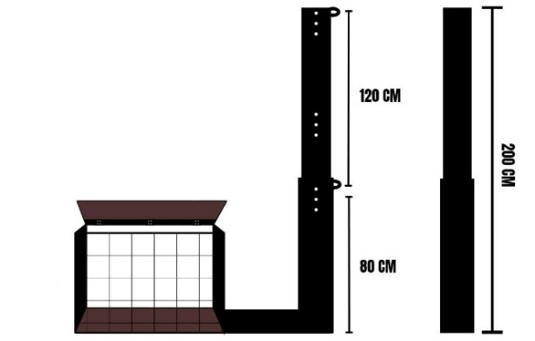
b. Pole Section

The pole on the Multi NetRing tool is made of iron pipe, consisting of two main segments, namely the bottom section with a height of 80 cm and the middle section with a maximum total height of 200 cm.
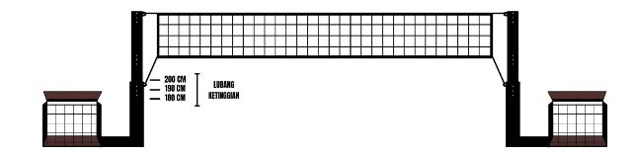
c. Volleyball Net

The net used for volleyball instruction on the Multi NetRing is 6 meters long and 0.7 meters wide. The net is mounted on poles at heights of 1.8 meters, 1.9 meters, and 2.0 meters, and can be adjusted to suit the height of the students.
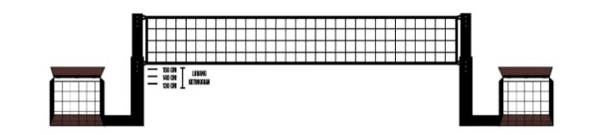
d. Badminton Net

When you want to use badminton learning, the net pole is lowered to a height setting of 1.5 m, 1.4, and 1.3 m which can be adjusted to the height as needed.
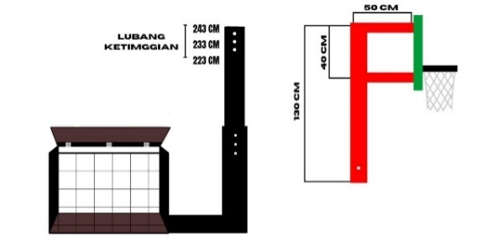
e. Basketball Rings

The net ring measures 60 cm x 40 cm and is 18 mm thick. It is supported by an "F"-shaped main iron bar.
Product Prototype
The Multi NetRing is a portable and multifunctional learning aid designed to support various net-based sports (such as volleyball and badminton) and basketball hoops in elementary school physical education. The tool is height-adjustable, easily assembled and disassembled, and can be used in various field conditions, making it easier for teachers to create effective, flexible, and enjoyable learning for students.
The Multi NetRing was developed to address the limited availability of sports facilities in elementary schools. With its practical and portable design, it is easily adapted for various games such as volleyball, badminton, and basketball. Its advantages lie in its flexibility, safety, and ease of use, thereby increasing student active engagement and motor skills.
Product Weaknesses
Based on trials conducted by researchers and input from several experts, the product has several weaknesses that need to be addressed and developed. The weaknesses of the Multi NetRing are:
- The Multi NetRing cannot play three types of games simultaneously.
- The paint is easily peeled off because the height adjustment mechanism uses a knock-down system between the poles.
Product Advantages
This tool is multifunctional, as it can be used for various games such as volleyball, badminton, and basketball. Its portable and flexible design allows for easy assembly and disassembly, and height adjustments to suit students' needs.
CONCLUSION
The final result of this development is a learning media product in the form of the Multi NetRing tool, designed as a portable tool for large and small ball games in elementary schools.
Based on the research results and data analysis, it can be concluded that the Multi NetRing tool was successfully developed through a Research and Development model and has been adapted to the needs of elementary school students in physical education learning. Expert validation results showed an Aiken's v value of 0.894 (highly valid), while the small-scale trial phase 1 showed an average feasibility percentage of 85%, classified as "very good." The small-scale trial phase 2 yielded an 89% "very good" rating. The large-scale trial yielded a 95% "very good" rating. Based on these results, the multi-netring tool is considered highly suitable for use as a physical education learning tool in elementary schools.
ACKNOWLEDGEMENT
The authors would like to thank the experts, teachers, and students who contributed to the validation and testing of the Multi-NetRing tool. We also extend our gratitude to the Faculty of Sport Science, Semarang State University, for their support and facilities. We hope this research will be beneficial for the development of physical education learning in elementary schools.
REFERENCES
Achmad Abdul Ghofur. (2022). Penggunaan Media Dalam Pembelajaran Pendidikan Jasmani Olahraga Dan Kesehatan (Pjok) Di Smp Se- Kecamatan Bantul. Eprints.Uny.Ac.Id, 248–253. https://eprints.uny.ac.id/73803/1/fulltext_artika novitasari_16604221072.pdf
Ani Daniyati, Ismy Bulqis Saputri, Ricken Wijaya, Siti Aqila Septiyani, & Usep Setiawan. (2023). Konsep Dasar Media Pembelajaran. Journal of Student Research, 1(1), 282–294. https://doi.org/10.55606/jsr.v1i1.993
Arisandi, Y., Neldi, H., Sepriandi, & Edwarsyah. (2023). Pelaksanaan Pembelajaran Pendidikan Jasmani Dan Olahraga Kesehatan di Sekolah Dasar. Jurnal Pendidikan Dan Olahraga, 6(1), 53–56.
Candra, A. R. D., Setyawati, H., & W, I. S. C. W. (2017). Alat Sensor Getaran Pendeteksi Kegagalan pada Papan Indikator Lompat Horizontal. Journal of Physical Education and Sports, 6(3), 1–7.
Candra, O., Pranoto, N. W., Ropitasari, R., Cahyono, D., Sukmawati, E., & CS, A. (2023). Peran Pendidikan Jasmani dalam Pengembangan Motorik Kasar pada Anak Usia Dini. Jurnal Obsesi : Jurnal Pendidikan Anak Usia Dini, 7(2), 2538–2546. https://doi.org/10.31004/obsesi.v7i2.4506
Fernández-Espínola, C., Robles, M. T. A., Collado-Mateo, D., Almagro, B. J., Viera, E. C., & Fuentes-Guerra, F. J. G. (2020). Effects of cooperative-learning interventions on physical education students’ intrinsic motivation: A systematic review and meta-analysis. International Journal of Environmental Research and Public Health, 17(12), 1–10. https://doi.org/10.3390/ijerph17124451
Pranatawijaya, V. H., Widiatry, W., Priskila, R., & Putra, P. B. A. A. (2019). Penerapan Skala Likert dan Skala Dikotomi Pada Kuesioner Online. Jurnal Sains Dan Informatika, 5(2), 128–137. https://doi.org/10.34128/jsi.v5i2.185
Retnawati, H. (2016). ANALISIS KUANTITATIF INSTRUMEN PENELITIAN.
S, I. R. K.-K. (2019). MANFAAT MEDIA DALAM PEMBELAJARAN. Sustainability (Switzerland), 11(1), 1–14. http://scioteca.caf.com/bitstream/handle/123456789/1091/RED2017-Eng-8ene.pdf?sequence=12&isAllowed=y%0Ahttp://dx.doi.org/10.1016/j.regsciurbeco.2008.06.005%0Ahttps://www.researchgate.net/publication/305320484_SISTEM_PEMBETUNGAN_TERPUSAT_STRATEGI_MELESTARI
Sugiyono. (2019). METODE PENELITIAN KUANTITATIF, KUALITATIF, DAN R&D (Sutopo (ed.); 2nd ed.). Alfabeta.

