The Title is Written Concisely in Less Than 15 Words and Presents Research Keywords

First Author Full Name^{1*}, Co-Author Full Name¹, and Co-Author Full Name ²

¹First Author Affiliation and Co-Author Affiliation
²Co-Author Affiliation (if different from First Author)

Correspondence should be addressed to Author: author@mail.com

Abstract
The abstract begins with sentences that describes the GAP of your research. Next, the abstract is continued with research objectives, research methods, results, and conclusions. At the end of the abstract, the implications of this research need to be stated. The abstract is written briefly in no more than 150 words for each Indonesian and English. Written in Corbel font size 10pt. Abstract in Bahasa is not necessary for an author from outside of Indonesia. Keywords are written after the abstract using English terms, consisting of 3-5 keywords. If you are author from abroad, ignore writing abstracts in Indonesian. You may leave the identity for blind review. At the end of the abstract, write 1 sentence explaining the implications of the research or what next or future research.

Keywords: Keyword; is written; in English

Abstrak
Abstrak dimulai dengan 2-3 kalimat yang menjelaskan GAP dari penelitian Anda. Selanjutnya, abstrak dilanjutkan dengan tujuan penelitian, metode penelitian, hasil, dan simpulan. Di akhir abstrak, implikasi dari penelitian ini perlu dituliskan. Abstrak dituliskan secara ringkas tidak lebih dari 150 kata untuk masing-masing Bahasa Indonesia dan Bahasa Inggris. Ditulis dengan font Corbel ukuran 10pt. Untuk Penulis yang berasal dari Indonesia, Abstrak dalam Bahasa Indonesia WAJIB ada. Keyword ditulis setelah abstrak menggunakan istilah berbahasa Inggris, terdiri dari 3-5 kata kunci. Di akhir abstrak tuliskan 1 kalimat yang menjelaskan implikasi penelitian atau what next atau future research.

Mathematics Clasification: ---- must be filled ----
Please check Mathematics Clasification here:
https://mathscinet.ams.org/msc/msc2010.html?t=97-XX&s=&btn=Search&ls=s

Metadata of Author
First author: SCOPUS ID: - optional - | ORCID ID: - mandatory - | Google Scholar : - optional -
Co-author: SCOPUS ID: - optional - | ORCID ID: - mandatory - | Google Scholar : - optional -

INTRODUCTION (SUBTITLE 1)
Subtitle 2
Subtitle 3
The manuscript must consist of Introduction, Method, Result and Discussion, also Conclussion. In Result and Discussion, at least there are sub-title Result, Discussion, Implication, and Limitation. The introduction contains the research background (the story of the phenomena or critical paradigm of the study), theoretical framework, GAP of the study, and ended with a problem statement. The theoretical framework must be justified with the research results. The introduction should be able to explain the contribution of this research in the field.
For theoretical framework references, the editor recommends using primary references, such as Brousseau, Bruner, Vygotsky, Thorndike, etc (Brousseau, 2002b, 2002a; Bruner, 1964; Thorndike, 1914; Vygotsky, 1978). To ensure the novelty of the study, you should compare your research with the research from recent years.
The introduction is as much as 35% of the total length of the text. 3 main things that must be present in the introduction, namely: (1) The ideal condition of learning outcomes in mathematics, or more general form is the dependent variable of a study. Scientific references are needed to strengthen the description of this ideal condition. Usually, government regulations can also be used as references; (2) The gap between reality and ideal conditions. In this section, it is better to convey the observation data and researcher's experience in the form of a description; and (3) Ideas for minimizing disparities, supplemented by the results of previous related studies.

The Length of Manuscript (Subtitle 3)
The length of the manuscript is 6000-7000 words for body of manuscript (Title, abstract, and references excluded). Manuscripts should have been written with Hyphenation rules in English. To use hyphenation, in Word-Processor application, you can use Page Layout, then Hyphenation.
The manuscript consists of 6 important parts, namely: 1) Title, abstract, and keywords; 2) Introduction; 3) Method; 4) Results and discussion, which include implications and limitations or the study; 5) Conclusions, acknowledgment; 6. References; and there can also be 7) Appendix. Manuscripts of Jurnal Kreano do not use numbering. All long manuscript is written in paragraph form.

How to Write Citation
In writing references, Kreano Journal uses the APA Format. The editor strongly recommends that the author use a reference manager, such as Mendeley, EndNote, or Zotero. In writing references, we suggest referring to the end of the statement. Example: Mathematical knowledge is obtained from the practice (Harel, 2011). The activity is obtained from a learning activity (Fink, 2003).
Important note: In the bibliography, there are at least 6 Primary references, those that are directly related to the dependent variable of this study. Example: Title Method A to improve B. Then in the references, there must be 6 references that directly refer to Methods A, and B, respectively. At least, there are 15 references from the Scientific Journal. At least, there are 20 references in the Bibliography. To move towards the internationalization of the Jurnal Kreano, the Editor strongly recommends that you refer to the International Journal.

Table(s) and Figure(s)
Table and images should not be written more than 3 pieces in each manuscript. Tables and figures need to be provided if referred to in the body of the article. If not referred, it is better not to write tables and figures. For general formulas and tables, there is no need to write them, just write the results. Make the table as simple as possible.
For example, in the SPSS application results table for the normality test, the homogeneity test, and the average difference test, the table does not need to be displayed, just write the results. For tables or figures, as far as possible write in one column as shown in Table 1 and Figure 1.

Table 1. Sample of Table 1
 |  | Levene Statistic | df1 | df2 | Sig.
Mid - test | Based on Mean | .449 | 6 | 211 | .845
 | Based on Median | .353 | 6 | 211 | .907

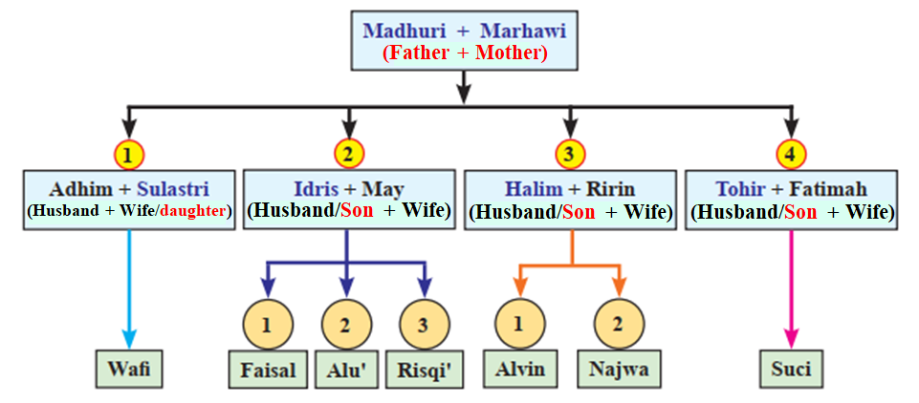
Figure 1. Family Diagram (As’ari, Tohir, Valentino, Imron, & Taufiq, 2017b)

If tables or figures do not allow one column to be written, please use the Text Box, set it to Square in the WRAP TEXT section, and no outline. Place the table at the top of the page, as shown in Table 2.
Table 2. Sample of Long Table
Basic Competence (KD) | Indicator of Achieving Competence (IPK)
Describe and state relationships and functions using various representations | Determine the definition of relation.  Present a relation with an arrow diagram.
Note: the number of KD based on School Curricula
METHOD
This section contains the research methods used. The maximum length of the method is 10% of the entire manuscript if it is quantitative research and a maximum of 15% if it is qualitative research. The writing method is very dependent on the type of research conducted. In qualitative research (this is highly recommended by the editor), the writer can describe the focus of the research carried out, whether looking for characteristics of the subject or describing phenomena. In this section, please write down the stages of your research so that the research questions are answered.
In development research or CAR, the author must write the steps of development and targets at each stage. For example, if your study uses the ADDIE method, you must explain the purpose of each step. If in the Analysis step your purpose is understanding the phenomena, then in the result, you must explain what phenomena happened. Presentation of research stages using a graphic organizer is highly recommended.
The Method is written in paragraphs and divided into 1) participants (and their characteristics such as location, people habit, environment, and culture); 2) instruments; 3) data collection; 4) data analysis. In qualitative research, Editor will ask the author to maintain what we call the trustworthiness of the qualitative data (Lemon & Hayes, 2020; Stahl & King, 2020).

RESULTS AND DISCUSSION
Results
In the Result, the author will ask to 1) provide a “big picture” perspective for readers to remind them of the importance of your study and 2) provide a critical analysis of your major finding(s).
The writing of research results depends on the type of research. For Development Research, write down all the results of each stage of the research, including if there is a flowchart, write in this section. Quantitative research results usually produce tables of statistical analysis results. This section is where the table is presented. The results of qualitative research are more flexible. Qualitative research writers can write data reduction, analysis results in each section of research, and findings.
For any findings, please compare them with findings in previous similar studies (references are recommended to scientific journals less than 5 years old), so that the findings of this study are clear, whether corroborating previous research or presenting new findings.

Discussion
This section is an elaboration of the findings written in the results section of the study. In qualitative research, this section describes the meaning of the findings of this study. In quantitative research, this section explains the inference from statistics presented in the results section. In CAR research, this section describes the process of research reflection and a summary of actions that illustrate learning success.
References from related research journals must exist, as part of the state of the art of this research. At the end of the discussion, the author should maintain the novelty of the research. By comparing with previous similar research, the author can place the research position.
The important rule of Discussion that author must discuss the result of research compared with theoretical GAP. For example, if author develop any media for mathematics teaching than connect it with how the student think when they use the media. Or author may consult with the theory of student respond. This discussion makes NOVELTY and State of art of the manuscript.

Implication of Research
Discuss the implications of your research for pertinent stakeholders (e.g., future research for other investigators, practice suggestions for practitioners, or policy considerations for administrators).
In addressing any of these elements, please make sure your discussion remains directly connected with the study you conducted.

Limitation
Discuss the limitations of the study. These limitations can be organized around simple distinctions of the choices you made in your study regarding who, what, where, when, why, and how.
Limitations of your study can be in the form of the number of research subjects that may not be representative, an unfavorable environmental situation, a sample that cannot be controlled properly, or anything that becomes an obstacle in your research. An explanation of this limitation can be a reason that strengthens your conclusion.

CONCLUSION
There are several rules of conclusion: 1) Conclusion must be drawn based on research questions and purposes of your study; 2) Conclusion must be a synthesis of key points; 3) Conclusions is written in 1 paragraph.
REFERENCES
- The references are written in APA Format, according to Mendeley, EndNote, or Zotero Standards.
- References are suggested to come from a Scientific Journal in recent years (Maximum 3 years for journal or doctoral dissertation or any research) but may the oldest year for primary theoretical references, such as Bruner, J. S. (1964); Thorndike, E. L. (1914); or Vygotsky (1978).
- Each keyword in the title, must be related to at least 6 references whose titles contain the keyword.
- REFERENCE must be minimum 60% from SCOPUS, with international author.

Below is sample of REFERENCE LIST

As’ari, A. R., Tohir, M., Valentino, E., Imron, Z., & Taufiq, I. (2017). Matematika, SMP Kelas VIII, Semester 1 (A. Lukito, A. Mahmudi, Turmudi, Y. Marpaung, Y. Satria, Widowati, & D. Hidayat, Eds.; 2 (revisi)). Kementerian Pendidikan dan Kebudayaan Republik Indonesia.
Brousseau, G. (2002a). Epistemological Obstacles, Problems, and Didactical Engineering. In N. Balacheff, M. Cooper, R. Sutherland, & V. Warfield (Eds.), Theory of Didactical Situations in Mathematics (Didactique des Mathématiques), 1970–1990 (pp. 79–117). Kluwer Academic Publishers. https://doi.org/10.1007/0-306-47211-2_6
Brousseau, G. (2002b). Theory of didactical situations in mathematics: Didactique des mathématiques, 1970–1990 (N. Balacheff, M. Cooper, R. Shutherland, & V. Warfiled, Eds.; Vol. 19). Kluwer Academic Publisher.
Bruner, J. S. (1964). The course of cognitive growth. American Psychologist, 19(1), 1.
Fink, L. D. (2003). A self-directed guide to designing courses for significant learning. University of Oklahoma, 27(11), 1–33.
Harel, G. (2011). What is Mathematics? A Pedagogical Answer to a Philosophical Question. In B. Gold & R. Simons (Eds.), Proof and other Dilemmas (pp. 265–290). Spectrum. https://doi.org/10.5948/upo9781614445050.018
Lemon, L. L., & Hayes, J. (2020). Enhancing trustworthiness of qualitative findings: Using leximancer for qualitative data analysis triangulation. Qualitative Report, 25(3). https://doi.org/10.46743/2160-3715/2020.4222
Stahl, N. A., & King, J. R. (2020). Expanding approaches for research: Understanding and using trustworthiness in qualitative research. Journal of Developmental Education, 44(1).
Thorndike, E. L. (1914). The influence of continuous mental work, special or general, upon general ability. In Educational psychology, Vol 3: Mental work and fatigue and individual differences and their causes. (pp. 79–110). Teachers College. https://doi.org/https://doi.org/10.1037/13796-000
Vygotsky, L. S. (1978). Mind and Society: The Development of Higher Psychological Processes. In M. Cole, V. John-Steiner, S. Scribner, & E. Souberman (Eds.), Harvard University Press. Harvard University Press. https://doi.org/(Original manuscripts [ca. 1930-1934])

Appendix A.

You are allowed to add attachments. Attachments in the form of images that are large enough (student work or research results tables) are placed after the bibliography in 1 column format. The appendix must be cited in the article.

Example:
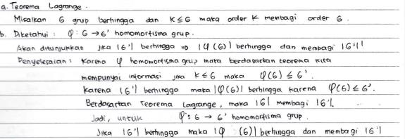
Figure 5. The Work of Problem 2 of the FN Subject

Table A1. Results of Analysis of Difficulties in the Level of Measurement of Students' Understanding, Application, and Reasoning for Multiple Choice Questions Mathematics at Madrasah Ibtidaiyah in South Sulawesi
NO | DIFFICULTY INDEX | CATEGORY | NO | DIFFICULTY INDEX | CATEGORY
1 | 0,43 | MEDIUM | 16 | 0,45 | MEDIUM
2 | 0,43 | MEDIUM | 17 | 0,45 | MEDIUM
3 | 0,50 | MEDIUM | 18 | 0,44 | MEDIUM
4 | 0,26 | HARD | 19 | 0,48 | MEDIUM
5 | 0,64 | MEDIUM | 20 | 0,48 | MEDIUM
6 | 0,61 | MEDIUM | 21 | 0,73 | EASY
7 | 0,38 | MEDIUM | 22 | 0,39 | MEDIUM

