
 | XX (X) (20XX) XX-XX  Journal of Physical Education, Sport,  Health and Recreations  http://journal.unnes.ac.id/journals/peshr |  |  | 
The title contains the themes and results of research, not more than 12 words, up to 2 Lines

Full name of the first author¹*, Second Author, writer of the third²

¹Affiliation and full address of the author(s), city, country
²Affiliation and full address of the author(s), city, country

Keywords  ___________________  Keywords 1; keywords 2; keywords 3  ___________________ |  | Abstract  _________________________________________________________________  Abstract as research or research problem must contain a statement of problem, objectives, approach, methodology, results and conclusions of the research. No more than 200 words. Directly written in this template to customize the font and its size, i.e. Fira Sans size 9.
Corresponding author :  E-mail: sekadarcontoh@gmail.ac.id |  |  | p-ISSN 2460-724X  e-ISSN 2252-6773

INTRODUCTION

The preface contains background research, corroborated with data, information, and trusted references (Subroto, 2013a). Writing systematics can be started from the things that are common or special, then the directed to things that are theoretical and conceptual (Zulfikar, 2009, h. 23-27). The introduction should contains the results of earlier research both from a scientific journal articles, books, and reference also news in mass media and a trusted website.

On the Systematics of the academic scientific articles in the English Journal of Physical Education, Sport, Health and Recreation (ACTIVE) there is not a chapter of its own containing theory and literature review. Therefore the theory and literature review were taken from previous research results can be included in the introduction to strengthen arguments regarding the urgency of research or study written and in the results and discussion as perspective and comparison in the analysis (Nugroho, 2009).

The writing take precedence in the form of paragraph, not numerical, i.e. write sequentially in paragraphs (1) and, (2), the next, and (4) consecutively. Except for those things that did have to be specified numerically. For instance as follows.

Explain the important things. Explains rank subsequent from the important thing. Explain things next in the form of additional information. Another form of elaboration for the purposes of explaining things that are relatively numerous and long, it is recommended to be written per paragraph or be-how many paragraphs, but not with the way numerik. But narrative, such as following.

The first, written using a the word "first", "second", and so on that you typed italics (italic). Both, however, for a brief explanation, other than written directly in a single paragraph, can also be written with a numerical way.

At the end of the preface written about specific issues will be examined at a particular place or context. His wish to the issue based on examination over previous research results that had already been reviewed also in the introduction. It can also come from the real problems that are found. The bottom line, pointed out that the research/study of so-called important done. If the case is examined carefully/nature comes from field research, the present problem at the venue, corroborated with data and information from observation or early research. It also pointed out the urgency of research is done, including theoretical and practical contributions.

Then proceed with the reference to support a theory that is listed. Both of the previous research publications, books, journals and articles or print/online that can be accounted for.

Outline, in the background loading results in field or problems or observations and findings data, theories that support earlier research, and explain whether or not there are similarities/differences with previous research, formulation the problem, objective research

METHODS

section of the method contains a research approaches, models and procedures of research, and his other (Wild, 1995). On qualitative research, for the '90s method things written, among others, approach, the paradigm used, focus research, time, place of study, subject/object of research, data mining techniques, techniques and principle improvement the accuracy of the data, and analysis. Quantitative research on the things that are written, among other approaches, the place of research, population, samples, variables, data collection techniques, data validity, measurement techniques and data analysis techniques. In addition, on the research of quantitative, no need to redundantly statistical formulas written in the section of the method.

If the article is written is the result of research the research development, it is necessary & added prototype created with description and how to use it. But for this kind of qualitative approach where necessary written description more detail, for example the approach phenomenology study, history, analysis of discourse, writers can still write research methods.
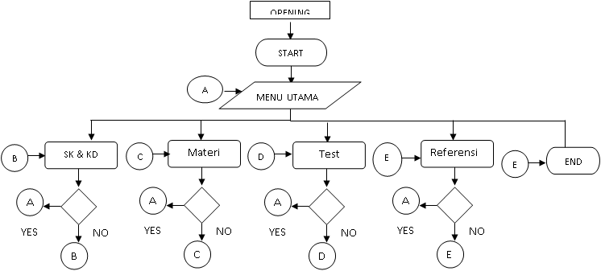
Figure 1. Flowchart learning Android-based mobile applications

RESULTS AND DISCUSSION

On the article written from research, then in the early part of the results and a discussion on research be preceded by a description of the implementation, namely (1) a description of the time of the research, (2) the duration of the implementation of the research, (3) the informant or respondence obtained, and (4) concludes with a description of the things that will be described in the following paragraphs afterwards.

Systematics of the writing section or sequence results and discussion can be written based on the research questions posed, the findings of the research, or according to the procedure of research done, especially when the research in the form of development, for example using a model Research & Development (R & D). Information in the form table without a direct number, preceded by a description of the table. As the following example.

Table 1. Description of table
Description | Description
Description | Description
.... | Description
.... | ....
.... | ....
.... | ....

Writing an explanation against the table and the figure do refer this enumeration, such as Table 1 and Figure 1. Instead of pointing to the table above and below this image, for example. The shape of the table the column line is omitted, only the gridlines are shown. It is conducted assuming the table is also a paragraph.

Further, the numbering and descriptions in the form of images is given after the image and written under the picture. In addition to photographic images, sketches, illustrations, diagrams, flow charts,-and the like also categorized as images. As a rule the same as images. For instance as follows.

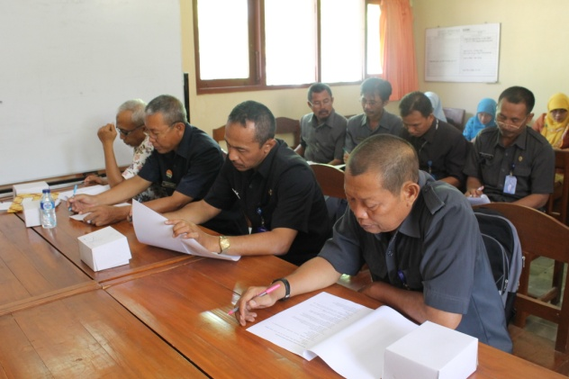
Figure 2. The atmosphere of FGD with the teachers school representatives in the Office-Office of education Rembang, Central Java.

Tables and images that are large and won't fit can be placed transversely to 2 columns, preferably placed in section top of the page or the bottom to make it easier to lay out. For example in Figure 2 flowchart on Android-based mobile learning application that formats such as JPEG. If the table is large, it is difficult to transverse arranged, then it must be changed in the first image format so they can be styled with ease.

The first section later

Allowed to also write a sub chapter beginning with A capital alphabet. Dilanjut next section later with alphabet B, C, and so on. The writing section later performed at the litian pene-type incremental or not. On the type of incremental research (e.g. research development) are written starting initial phase to the end. In other types of research, particularly the quantitative is written based on the proposed research questions and research findings.

In addition, pemerincian reviews and/or research results in the section later can be written using a numeric or numeric. For example, using Arabic numerals numbering 1, 2, 3, a dilanjut description of the sub-sub-chapter typed. Another way by writing without numbering figures Arabic (numerals), Roman, or alphabet, but rather a direct description of sub-section later, in italics and bold-type (bold).

The second section later writing of results and discussion are not separated in different section later, but rather directly each of the findings or results are discussed in depth. Direct excerpts and not direct ACTIVE using the reference style of the American psychological association (APA). Direct quotations are written into the overhanging with smaller font sizes to differentiate the with other paragraphs is not a direct quote.

Direct quotations are written with the font size of 9 MT Calisto and used for writes the results of the interviews, excerpts from documents and more. Quote speak language other than Indonesia did not need to be typed. (Iza, 2004, p. 5-8)

If quoted, either from wawan-way as well as certain documents not more da-ri 3 rows, then it should be written in the form of an indirect quote or paraphrase. Writer-sannya between quotes "..." .... "with mention of source citations. If the quoted sentence in addition to the language of Indonesia should be in italic-type.

CONCLUSION

The final section is a summary, it consists of a summary and suggestions or recommendations. But without any recommendation is enough. A summary of the written answer of question is research or research findings. The cover is written in paragraph form.

REFERENCES

ACARA. (2015) The Australian Curriculum. Di-unduh pada 12 April 2015

Apple, M.W., Gandin, L.A., & Hypolito, A.M. (2006) Paulo Freire (1921-1997). Dalam Palmer, J.A. (ed.). Fifty Modern Thinkers on Education: 50 Pemikir Paling Berpengaruh terhadap Dunia Pendidikan Modern. Terj. Farid Assifa. Yogyakarta: IRCiSoD.

As prices surge, Thailand pitches OPEC-style rice cartel (2008, 5 Mei) The Wall Street Journal, h. A9.

Darder, A., Baltodano, M.P., & Torres, R.D. (eds.) (2009) The Critical Pedagogy Reader. 2nd Edition. New York & London: Routledge.

Erawati, D. (2014, 1 April) Menengok Intelek-tualitas di Kota Malang. Diunduh 13 April 2015 dari Kompas.com

Kemdikbud. (2011) Panduan Penyelenggaraan Pe-latihan Pendidikan Karakter. Jakarta.

Postman, N. & Weingartner, C. (2001) Mengajar Sebagai Aktivitas Subversif. Terj. Siti Farida. Yogyakarta: Jendela.

Republik Indonesia (2012) Undang-undang Nomor 12 Tahun 2012 tentang Pendidikan Tinggi. Jakarta.

Subkhan, E. (2016) Sejarah & Paradigma Teknologi Pendidikan untuk Perubahan Sosial. Jakarta: Prenada Media Group.

Subkhan, E. (2011) Reposisi Tren ICT Bidang Kajian Teknologi Pendidikan. Masyarakat Telematika dan Informasi: Jurnal Penelitian Teknologi Informasi dan Komunikasi. 2(6), h. 89-113.

Unnes Jalin Kerja Sama dengan MSU. (2014, 2 April) Diunduh 14 April 2015 dari Su-aramerdeka.com.

Van Vugt, M., Hogan, R., & Kaiser, R. B. (2008) Leadership, followership, and evolution: Some lessons from the past. American Psychologist, 63(3), p. 182-196. doi: 10.1037/0003-066X.63.3.182.

For completeness the contents in its entirety, can be read on the Author Guidelines page

https://journal.unnes.ac.id/journals/peshr/about#authorGuidelines

