Implementation of the Term Frequency-Inverse Document Frequency Method for Mental Health Classification Using Algorithm Support Vector Machine

Ilfa Minatika, Riza Arifudin²
^{1,2}Department of Computer Science, Faculty of Mathematics and Natural Sciences,
Semarang State University, Indonesia

Abstract. Mental health is a person's emotional, social and psychological condition. A person's mental health level can be influenced by emotional experiences, behavior, environment and family educational background. A person's psychological well-being can be influenced by a person's behavior, where they live, the education they receive, and their emotional experiences. It is important not to underestimate the existence of mental health disorders because the number of cases is currently increasing.
Purpose: Using SVM algorithm and TF-IDF method can produce good accuracy for classification text. Therefore this research aims to determine the implementation of the use of the TF-IDF method and the SVM algorithm in mental health classification and to determine the accuracy results of using these methods.
Study Method/Design/Approach: The methods used in the research this for the mental health classification is Term Frequency-Inverse Document Frequency used in the vectorization process to convert text into a numerical representation, as well as using the Support Vector Machine algorithm in modeling. The dataset used is the Mental Health Corpus dataset obtained from the Kaggle website. This dataset consists of two classes containing text and labels totaling 27,977 data. Before applying the model, preprocessing is carried out first, namely cleaning the text using stopword removal and stemming. After cleaning the text, the next process is vectorization using CountVectorizer and TF-IDF.
Results/Findings: In this study the SVM algorithm was used four kernels, namely the linear kernel, the RBF kernel, the polynomial kernel, and the later sigmoid kernel get the best accuracy results on the RBF kernel if compared to with other kernels. Accuracy results obtained _ of 92.62%, value precision of 92.64%, value recall 92.62%, and value f1-score 92.62%.
Novelty/Originality/Value: So, it can be concluded that the application of the SVM algorithm and the TF-IDF method is possible used for classification mental health results mark high accuracy.

Keywords: Mental Health, Term Frequency-Inverse Document Frequency, Text Classification, Machine Learning, Support Vector Machines.

Received February 2024 / Revised September 2025 / Accepted September 2025

This work is licensed under the Creative Commons Attribution 4.0 International License .

INTRODUCTION
Mental health disorders are one of a person's syndromes or psychological behavior patterns that can result in inability to carry out tasks or work [1]. Disorders of the human brain's nervous tissue caused by various problems and difficulties that every person faces in their life can cause mental illness. A person's psychological well-being can be influenced by a person's behavior, where they live, the education they receive, and their emotional experiences [2]. The 2018 Basic Health Research Study said that the percentage of Indonesians with emotional mental problems increased from 6% in 2013 to 9.8% in 2018. When compared with other age groups, the age group over 75 years and the group without formal education shows the highest frequency [3].
Classification is a method for grouping objects based on the characteristics they have [4]. Classification can be carried out using various methods during the process, either manually by humans or by using technology [5]. Manual classification does not involve artificial intelligence algorithms, while classification that uses technology utilizes several algorithms such as Naïve Bayes, Support Vector Machine (SVM), Fuzzy , Artificial Neural Networks and Decision Trees [6]. Machine learning can be used to create models that can identify and understand patterns in data. Machine learning can group data into relevant categories or classes by applying classification algorithms [7].

Support Vector Machine and Term Frequency-Inverse Document Frequency are two key concepts in the fields of natural language processing and text analysis. The combination of SVM and TF-IDF is very important in text analysis, where SVM can be used to classify documents or text based on feature vectors [8]. Meanwhile, TF-IDF is a word weight measurement method that assigns importance values to words in a document based on the frequency of words in the document and how common the words are in the document collection [9]. These two ideas are critical to improving the understanding and classification of documents more accurately and effectively. This is useful for various applications, such as news categorization, analysis [10].

Related research was conducted by Wiyani et al in 2022 with the aim of classifying mental health texts on Twitter social media. This research uses the SVM method and for feature selection uses Information Gain. Testing was carried out using the K-Fold Cross Validation method with a value of k=5. The highest accuracy value is 59.11%, precision value of 29.99%, recall of 38.67%, and f-measure of 33.53% [11]. Similar research was conducted by Mahing et al in 2023 with the aim of text classification using SVM and Random Forest algorithms. The SVM algorithm model using the TF-IDF transformation method produces the best performance with an accuracy of 84%, precision of 80%, recall value of 89% and f1-score of 80%. Meanwhile, Random Forest has the best performance with accuracy results of 80%, precision value of 81%, recall value of 80% and f1-score value of 80%. From this research it can be seen that the use of the SVM algorithm is better than Random Forest with an accuracy difference of 3% [12].

METHOD
Study This applies SVM algorithm as a classification model, then for text cleaning use stopword removal and stemming. Meanwhile in vectorization use method CountVectorizer and TF-IDF for word weighting so can increase accuracy in classification mental health. As for the plot research to be done contained in the flowchart that has been provided made in Figure 1.

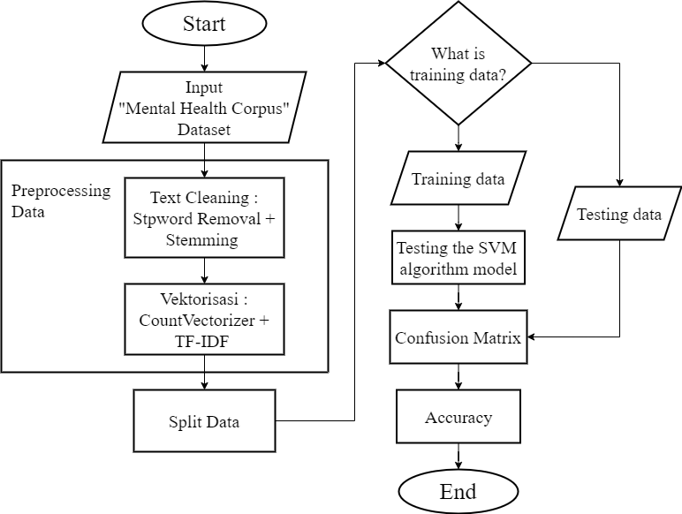

Figure 1. Research flowchart

Data Preprocessing
Initial step in preprocessing is data cleaning. On research This data cleaning is performed through 2 stages. Stage first is stopword removal used for delete words that don't add a meaning sentence [13]. With removing the word, text becomes easier analyze more carry on. Then the stage second that is stemming is used to change the word to basic word form [14]. The next step after data cleaning is vectorization used for changing text to become representation numeric [15]. As for vectorization using two stages that is CountVectorizer and TF-IDF. CountVectorizer and TF-IDF have different functions. CountVectorizer is used for count frequency or count how many times each word appears in text [16]. Meanwhile TF-IDF is used to give weights on each word based on how much the word is important for the collection document [17].

Split Data
After datasets through a data cleaning process step furthermore that is, data is shared into two parts main training data and test data. This matter is done to avoid overfitting. Test data is used to measure model performance independently, while the training data used to train the model [18]. Split train-test method used for dividing data in proportion certain. Research data this is shared into two parts, 80% as training data and 20% as test data.

Classification SVM algorithm
At this stage, classification of the training data will be carried out by applying the SVM algorithm. The goal of classification is to classify mental health texts. The classification algorithm will be called using the library in the Python programming language. The training data resulting from the split data in the next stage is classified to speed up the process and get more optimal results.

Confusion Matrix
After data modeling is carried out using a classification model, the performance model will be analyzed using a number of metrics Which determine the performance of the model in implementation in real time. At this stage, the Confusion Matrix is used to evaluate the model carefully [19]. Confusion matrix is used to carefully assess, test and check the performance of the classes in the model [20]. Evaluating the model with confusion matrix will get results accuracy, precision, recall, and f1-score. The confusion matrix table can be seen in Table 1.

Table 1. Confusion matrix
Actual |  | Negative (0) | Positive (1)
Actual | Negative (0) | TN  (True Negative) | FP  (False Positive)
Actual | Positive (1) | FN  (False Negative) | TP  (True Positive)

RESULTS AND DISCUSSION
In research this is the data used There are two labels, namely label 0 and label 1. The comparison of label 0 and label 1 is in Table 2. The number of labels 0 is 14138 or 50.53% of the total data. Meanwhile, the number of labels 1 is 13839 or 49,475 of the total data. Label 0 contains sentences that explain related to people who do not experience anxiety, depression, and other mental health problems. Meanwhile, label 1 contains sentences that explain people who are experiencing anxiety, depression and other mental health problems.
Table 2. Comparison number of labels
Label | Amount | Percentage
0 | 14138 | 50.53%
1 | 13839 | 49.47%
Total | 27977 | 100%

Evaluation model is used to know how good or bad Machine Learning model performance. This matter enough important Because can help know what model is used enough good. Model evaluation can be done with measure test data using a confusion matrix to get results accuracy, precision, recall, and f1-score. As for the results, the confusion matrix can be seen in Table 3. Based on Table 3 it is known that the TP value is 2450, then TN value is 2755, FP value 94 and FN value 297.

Table 3. The result of the confusion matrix
Actual |  | Negative (0) | Positive (1) | Amount
Actual | Negative (0) | 2755 | 94 | 2849
Actual | Positive (1) | 297 | 2450 | 2747
Actual | Amount | 3052 | 2544 | 5596

In the SVM algorithm model you can use multiple kernels for known results accuracy, precision, recall and f1-score for each kernel later Can compared to results finally and taken best value. The kernel used is the linear kernel, RBF kernel, polynomial kernel, and sigmoid kernel.

Table 4. Linear kernel
Linear Kernels
Accuracy | 0.9235
Precision | 0.9236
Recall | 0.9235
F1-Score | 0.9235

From Table 4. it is known that linear kernels produce mark accuracy of 0.9235, then for mark precision of 0.9236, value recall of 0.9235 and value F1-Score is 0.9235. Linear kernel is one of the types of kernel used in SVM algorithms for changing data to in room more features [21]. In addition, the SVM model uses a linear kernel more easily interpreted because the resulting decision boundary is a straight line or field easily flat understood.

Table 5. RBF kernel
RBF Kernel
Accuracy | 0.9262
Precision | 0.9264
Recall | 0.9262
F1-Score | 0.9262

In the kernel RBF generates mark accuracy of 0.9262, for mark precision of 0.9264, value recall 0.9262 and value f1-score 0.9262 is shown in Table 5. The RBF kernel is very effective in handling problem classification that can’t be separated linearly in space feature original. RBF basis functions allow data mapping to more dimensions large, which allows SVM to create complex and non-linear decision boundaries [22].

Table 6. Polynomial kernel
Polynomial Kernel
Accuracy | 0.8619
Precision | 0.874
Recall | 0.8619
F1-Score | 0.8607

In addition to linear kernels and RBF kernels can be known polynomial kernel with results accuracy of 0.8619, then for mark precision of 0.874, value recall of 0.8619, and value f1-score of 0.8607 can be obtained seen from Table 6. As for the polynomial kernel can used for handle problem involving classification polynomial tall or form a non-linear decision boundary [23]. Polynomial kernels can also handle the data it has non-linear pattern, but no as complex as does the RBF kernel.

Table 7. Sigmoid kernel
Sigmoid Kernel
Accuracy | 0.9232
Precision | 0.9232
Recall | 0.9232
F1-Score | 0.9232

From Table 7. you can use the sigmoid kernel to produce mark accuracy amounted to 0.9232, whereas mark precision of 0.9232, value recall of 0.9232, and value f1-score of 0.9232. The sigmoid kernel can help in data transformation to in room non-linear features, which SVM allows to handle problem classification that is not can be separated linearly in space feature original. Additionally, because the sigmoid kernel can handle various decision boundary forms, including non-linear ones as well as sigmoid kernels provide flexibility in modelling [24]. Based on the results of linear kernels, RBF kernels, polynomial kernels, and sigmoid kernels can be is known that's it accuracy best The obtained RBF kernels are compared with other kernels produces mark accuracy of 0.9262, value precision of 0.9264, value recall 0.9262 and value f1-score 0.9262. As for the comparison diagram results accuracy between kernels can be seen in Figure 2.

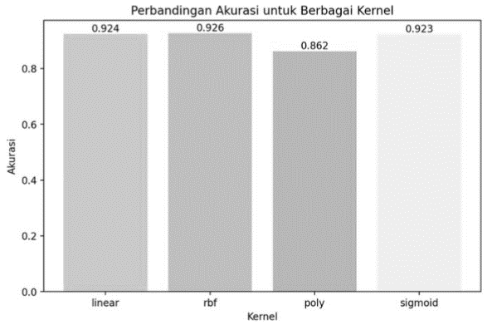
Figure 2. Comparison diagram between kernels

CONCLUSION
Based on results study about classification mental health use SVM algorithm with TF-IDF method can is known that it use SVM algorithm via three stage that is data retrieval, data preprocessing and model testing. Data collection is carried out with search mental health corpus dataset from Kaggle website. Stage furthermore that is data preprocessing started from cleaning text use stopword removal and stemming continued with the vectorization process for change text become representation numeric CountVectorizer and TF-IDF. Then the data is shared into two, namely training data and testing data. Stage final model testing using Support Vector machines with look for mark accuracy, precision, recall and f1-score. As for the results best on research This obtained RBF kernel with results accuracy of 92.62%, value precision of 92.64%, value recall 92.62%, and value f1-score 92.62%.

REFERENCE
[1] G. A. S. Prajaniti, K. E. Swedarma, and M. V. Manangkot, “Hubungan penggunaan media sosial dengan gejala depresi pada remaja di sman 3 denpasar,” Community Publ. Nurs., vol. 10, no. 1, p. 52, 2022, doi: 10.24843/coping.2022.v10.i01.p08.
[2] D. D. Kurnia, “Sistem pakar untuk mendiagnosa gangguan kesehatan mental menggunakan algoritma genetika,” JATISI (Jurnal Tek. Inform. dan Sist. Informasi), vol. 8, no. 3, pp. 1171–1187, 2021, doi: 10.35957/jatisi.v8i3.1079.
[3] T. Handayani, D. Ayubi, and D. Anshari, “Literasi kesehatan mental orang dewasa dan penggunaan pelayanan kesehatan mental,” Perilaku dan Promosi Kesehat. Indones. J. Heal. Promot. Behav., vol. 2, no. 1, p. 9, 2020, doi: 10.47034/ppk.v2i1.3905.
[4] S. Tang, A. Werner-Seidler, M. Torok, A. J. Mackinnon, and H. Christensen, “The relationship between screen time and mental health in young people: A systematic review of longitudinal studies,” J. Clin. Psychol. Rev., vol. 86, no. 2, pp. 1–15, 2021, doi: 10.1016/j.cpr.2021.102021.
[5] E. Retnoningsih and R. Pramudita, “Mengenal machine learning dengan teknik supervised dan unsupervised learning menggunakan python,” Bina Insa. Ict J., vol. 7, no. 2, p. 156, 2020, doi: 10.51211/biict.v7i2.1422.
[6] A. P. Wibawa, M. G. A. Purnama, M. F. Akbar, and F. A. Dwiyanto, “Metode-metode klasifikasi,” J. Ilmu Komput. dan Teknol. Inf., vol. 3, no. 1, p. 134, 2018.
[7] F. Riza, “Analisis dan prediksi data penjualan menggunakan machine learning dengan pendekatan ilmu data,” Data Sci. Indones., vol. 1, no. 2, pp. 62–68, 2022, doi: 10.47709/dsi.v1i2.1308.
[8] S. Khairunnisa, A. Adiwijaya, and S. Al Faraby, “Pengaruh text preprocessing terhadap analisis sentimen komentar masyarakat pada media sosial twitter (studi kasus pandemi covid-19),” J. Media Inform. Budidarma, vol. 5, no. 2, p. 406, 2021, doi: 10.30865/mib.v5i2.2835.
[9] S. H. Kusumahadi, H. Junaedi, and J. Santoso, “Klasifikasi helpdesk menggunakan metode support vector machine,” J. Inform. J. Pengemb. IT, vol. 4, no. 1, pp. 54–60, 2019, doi: 10.30591/jpit.v4i1.1125.
[10] M. Z. Naf’an, A. Burhanuddin, and A. Riyani, “Penerapan cosine similarity dan pembobotan TF-IDF untuk mendeteksi kemiripan dokumen,” J. Linguist. Komputasional, vol. 2, no. 1, pp. 23–27, 2019.
[11] J. R. Wiyani, Indriati, and Sutrisno, “Klasifikasi stres berdasarkan unggahan pada media sosial twitter menggunakan metode support vector machine dan seleksi fitur information gain,” J. Pengemb. Teknol. Inf. dan Ilmu Komput., vol. 6, no. 12, pp. 6003–6009, 2022.
[12] N. F. Mahing, A. L. Gunawan, A. F. A. Zen, F. A. Bachtiar, and S. A. Wicaksono, “Klasifikasi tingkat stress dari data berbentuk teks dengan menggunakan algoritma support vector machine (SVM) dan random forest,” J. Teknol. Inf. dan Ilmu Komput., vol. 10, no. 7, pp. 1527–1536, 2023, doi: 10.25126/jtiik.1078010.
[13] S. A. M. Vermeer, T. Araujo, S. F. Bernritter, and G. van Noort, “Seeing the wood for the trees: how machine learning can help firms in identifying relevant electronic word-of-mouth in social media,” Int. J. Res. Mark., vol. 36, no. 3, pp. 492–508, Sep. 2019, doi: 10.1016/j.ijresmar.2019.01.010.
[14] R. Kalaivani and R. Marivendan, “The effect of stop word removal and stemming in datapreprocessing,” Ann. R.S.C.B, vol. 25, no. 6, pp. 739–746, 2021.
[15] G. N. Aulia and E. Patriya, “Implementasi lexicon based dan naive bayes pada analisis sentimen pengguna twitter topik pemilihan presiden 2019,” J. Ilm. Inform. Komput., vol. 24, no. 2, pp. 140–153, Aug. 2019, doi: 10.35760/ik.2019.v24i2.2369.
[16] E. Hasibuan and E. A. Heriyanto, “Analisis sentimen pada ulasan aplikasi amazon shopping di google play store menggunakan naive bayes classifier,” JTS(Jurnal Tek. dan Sci., vol. 1, no. 3, pp. 13–24, 2022, doi: 10.56127/jts.v1i3.434.
[17] L. Yao, Z. Pengzhou, and Z. Chi, “Research on news keyword extraction technology based on TF-IDF and text rank,” in 2019 IEEE/ACIS 18th International Conference on Computer and Information Science (ICIS), IEEE, Jun. 2019, pp. 452–455. doi: 10.1109/ICIS46139.2019.8940293.
[18] Jimmy, E. H. Hermaliani, and L. Kurniawati, “Analisis klasifikasi sentimen pengguna media sosial twitter terhadap penundaan pemilu presiden tahun 2024,” J. Indones. Manaj. Inform. dan Komun., vol. 4, no. 2, pp. 570–579, May 2023, doi: 10.35870/jimik.v4i2.243.
[19] E. Muningsih, “Kombinasi metode k-means dan decision tree dengan perbandingan kriteria dan split data,” J. Teknoinfo, vol. 16, no. 1, p. 113, 2022, doi: 10.33365/jti.v16i1.1561.
[20] R. Rindiyani, A. Primadewi, M. Maimunah, and A. H. Purwantini, “Klasifikasi penjualan berdasarkan platform pada UMKM omah branded menggunakan random forest,” JURIKOM (Jurnal Ris. Komputer), vol. 9, no. 5, p. 1520, 2022, doi: 10.30865/jurikom.v9i5.4949.
[21] N. Fitriyah, B. Warsito, and D. A. I. Maruddani, “Analisis sentimen gojek pada media sosial twitter dengan klasifikasi support vector machine (SVM),” J. Gaussian, vol. 9, no. 3, pp. 376–390, 2020, doi: 10.14710/j.gauss.v9i3.28932.
[22] S. Rabbani, D. Safitri, N. Rahmadhani, A. A. F. Sani, and M. K. Anam, “Perbandingan evaluasi kernel SVM untuk klasifikasi sentimen dalam analisis kenaikan harga BBM,” MALCOM Indones. J. Mach. Learn. Comput. Sci., vol. 3, no. 2, pp. 153–160, 2023, doi: 10.57152/malcom.v3i2.897.
[23] S. A. Naufal, A. Adiwijaya, and W. Astuti, “Analisis perbandingan klasifikasi support vector machine (SVM) dan k-nearest neighbors (KNN) untuk deteksi kanker dengan data microarray,” JURIKOM (Jurnal Ris. Komputer), vol. 7, no. 1, p. 162, 2020, doi: 10.30865/jurikom.v7i1.2014.
[24] R. Thaniket, Kusrini, and E. T. Luthf, “Prediksi kelulusan mahasiswa tepat waktu menggunakan algoritma support vector machine,” J. FATEKSA J. Teknol. dan rekayasa, vol. 13, no. 2, pp. 69–83, 2019.

*Corresponding author. Email address: ilfamina1209@students.unnes.ac.id (Minatika) DOI: 10.15294/rji.v3i2.1921

