DIVERSITY OF SPECIES AND CONSERVATION PRIORITY OF BUTTERFLY
AT SURANADI NATURAL RESERVATION WEST LOMBOK
M. Liwa Ilhamdi, Agil Al Idrus, Didik Santoso
Biology Education – Faculty of Teacher Training and Education University of Mataram
^{Jl. Majapahit 62 Mataram 83125}
Email: liwa_ilhamdi@yahoo.co.id

Abstract
The present study aimed at analyzing the diversity and determining the priority of butterfly conservation at ​​Suranadi Natural Park of West Lombok. This is an explorative descriptive study conducted in April-May 2017. The data were collected through four-time repetition in the morning and in the afternoon for two months. The data collection instrument is survey with sweeping net technique following observation path (line left, line right, line central and line waterway). 40 species of butterflies belonging to 5 families were identified. The diversity index (H ') of butterflies ranges from 2.63 to 3.43 (medium-high). Of all the butterfly species found in TWA Suranadi, 2 species of the Papilionidae family, namely,Troides helena and Papilio memnon are the priority conservation.

Key Words: Diversity, Conservation Priority, Butterfly, Suranadi

INTRODUCTION

Lombok island is one of the islands in Indonesia in which a high level of animal diversity is found, one of which is the diversity of butterflies. Gradually, the making use of land for any purposes outside the forestry field increased. This makes the condition of the forest significantly depletedwhich leads to deforestation, so that, the existence is threatened and the habitat of butterflies is rarely found. One of the areas in Lombok island that is still well-preserved as a forest for biodiversity protection is the Suranadi Natural Tourism Park (hereafter SNTP).
SNTP was formerly recognized as Suranadi and Ranget Protected Forest based on the decision of Bali Resident-Lombok no. 1/4/3 and No. 1/4/4 of 2 February 1934 on the establishment of Suranadi and Ranget Protected Forests. The news event of the boundaries ofSuranandi forest area signed on September 10, 1941has been declared and a forest area that needs to be protected covers the area about 60 ha. The Minister of Agriculture Decree no. 646/Kpts/ Um/10/1976 dated October 15, 1976 jo no. 274/Kpts/Um/5/1977 dated May 30, 1977 Suranadi Natural Park covering 52 hectares has been designated as SNTP.
Its natural potency which is relatively maintained makesSNTP forest rich of various flora and fauna. Several studies have been conducted to discover the diversity of fauna species at SNTP. The fauna species found atSNTP include four species of amphibians of the anura order (Satyawan, 2009), mammals (Gray apes/Macaca Fascicularis), Black macaques (Presbytis cristata), Water civet (Cyngale benniti), jelarang (Ratufa bicolor), Birds (Eagle/Falchonidae), Honeybirds (Nectariniidae), Reptile Lizard (Varanus Salvator) and Snake Calobridae (BKSDA NTB, 2015).
One of the fauna that plays an important role in the ecosystem atSNTP is butterfly. Ariani et.al. (2013) found 28 species of butterflies in the SNTP region. Butterfly is a type of wildlife that plays an important role in the life cycle of flowering plants. Butterflies help preserve the existence and diversity of flora by facilitating the process of pollination.
The great variety of the butterfly species provides an interesting picturefor protection purposes as well as for the benefit of sustainable research and utilization. The number of the identified butterflies is about 17,000 species. The survival of the butterfly is strongly influenced by its adaptability to climate and its habitat state. Butterflies do not only play an important role as a pollinator or flower pollinator, but are also very vulnerable to environmental changes that can be used as bioindicators of environmental quality changes (Basset et al., 2012). Many butterflies are hunted by collectors for their collections, so that butterflies have a high selling value (Ngatimin et al., 2014). This condition triggers excessive and uncontrolled hunting and exploitation. In addition, clearing land and forest conversion for economic purposes is one of the major factors in the loss of butterfly habitats. If this continues, then negative impacts, such as the drop of the numbers even to extinction of species, poses a serious threat to the existence of butterfly populations.
Given the importance of the role of butterflies for the balance of the forest ecosystems, it is imperative that conservation efforts be undertaken to reduce the negative impacts of forest exploitation and conversions on the survival of the butterfly population. To determine the accurate strategy for the conservation of butterflies in the SNTP region, it is necessary to study the species diversity and prioritize the conservation of butterfly species at SNTP.

METHOD
The study was conducted from April to May 2017 at SNTP in West Lombok (Figure 1).
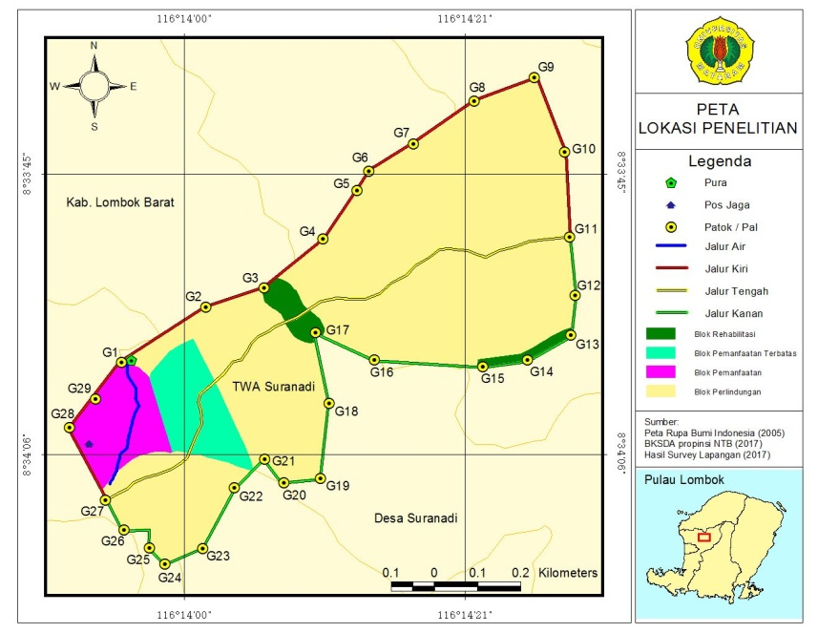
Figure 1 : Research Area

The process of data collection in this study employed direct survey method. Butterfly catching is done by sweeping net technique along observation lines that have been determined based on the observation. The butterfly samples taken in this study were adult butterflies. Sampling is taken along each path using insect net. Data collection was done through 4 repetitions within 2 months. Butterfly catching is done in the morning from 08.00 - 11.00 AM Central Indonesian Time and in the afternoon it starts at 30:00 – 5:00 PM Central Indonesian Time.
The sample butterflies caught in the field were preserved by injecting 4% formalin solution in their thoracic parts using syringes and then stored using papilot paper. The sample was then identified in the biology laboratory of FKIP Universitas Mataram and the number of individuals was counted. Butterfly samples were identified using the Practical Handbook of Butterflies at the Bogor Botanical Gardens (Peggie and Amir, 2006) and the Butterfly Field Guide at TWA Kerandangan (Wahyuni ​​and Fatahullah, 2015).
The data analysis used to calculate the Shannon-Wiener diversity index, as follows:
H'= -$\sum_{i=1}^{s}{pi}$ ln pi

Where: H ': Index of diversity andPi: Proportional abundance
The priority for conservation is determined by Minister of Forestry Regulation Number: P.57 / Menhut-II / 2008 on Strategic References for National Species Conservation 2008 - 2018.

RESULTS AND DISCUSSION
Diversity of Butterfly Species at SNTP
The results showed that in the SNTP area, 40 species of butterflies belonging to the 5 families of Papilionidae, Nymphalidae, Pieriidae, Lycaenidae and Hesperiidae were found. Table 1displays the species of butterfly found along with the diversity index (H ') on each observation path. The number of species found in this study is more than those found in the other sites such as those conducted by Ariani et.al. (2013) who found 28 species of butterflies, Koneri & Saroyo (2012) found 28 species of 4 families on Mount Manado Tua, Bunaken Marine National Park, North Sulawesi. The same number (40 species) classified in four families were found in the area of ​​Halimun Salak National Park of West Java (Murwitaningsih & Dharma, 2014). The different results obtained may be due to habitat conditions, precision factors and observation time.

Figure 2. The proportion of the number of butterfly species found in TWA Suranadi

The existence of butterfly species is strongly influenced by vegetation conditions, environmental factors and human disturbance. Changes in vegetation and the environment affect the composition of butterfly species. Figure 2 shows the proportion of butterfly species found in SNTP. Nymphalidae is a family with the highest proportion of species, 45%, followed by Pieridae 25%, Papilionidae 15%, Lycaenidae 13% and Hesperiidae 2%.
Table 1. Diversity of Butterfly Type on each observation line
No. | Family | No. | Species of butterflies | The number of individual species per line
 |  |  |  | line  Left | line  Right | line Central | line Waterway
1 | Hesperiidae | 1 | Ancisfroides nigrita | 2 | 2 | 1 | 0
2 | Lycaenidae | 2 | Leptotes sp | 7 | 3 | 0 | 0
 |  | 3 | Jamides alecto | 20 | 9 | 2 | 0
 |  | 4 | Floss annuela | 0 | 4 | 0 | 0
 |  | 5 | Jamides celeno | 38 | 7 | 0 | 2
 |  | 6 | Lambides boeticus | 4 | 0 | 0 | 5
3 | Nymphalidae | 7 | Euploea eunica | 6 | 5 | 1 | 2
 |  | 8 | Vindula dejone dorokusana | 3 | 11 | 3 | 4
 |  | 9 | Danaus genutia | 6 | 6 | 3 | 0
 |  | 10 | Melanitis leda | 6 | 4 | 4 | 0
 |  | 11 | Mycalesis janardana | 2 | 1 | 0 | 0
 |  | 12 | Doleschallia bisaltide | 1 | 7 | 0 | 2
 |  | 13 | Ideopsis juventa | 5 | 0 | 0 | 0
 |  | 14 | Euploea climena | 12 | 3 | 1 | 0
 |  | 15 | Pantoporia hardonia | 7 | 5 | 0 | 1
 |  | 16 | Elymnias hypermenestra | 2 | 11 | 0 | 1
 |  | 17 | Hypolimnas bolina | 4 | 1 | 2 | 0
 |  | 18 | Tirumala hamata | 10 | 2 | 0 | 0
 |  | 19 | Mycalesis horfieldi | 3 | 3 | 1 | 0
 |  | 20 | Polyura hebe | 7 | 4 | 0 | 1
 |  | 21 | Junonia sp | 6 | 5 | 1 | 0
 |  | 22 | Athyma nefte | 2 | 2 | 1 | 0
 |  | 23 | Nepthis hylas | 5 | 3 | 0 | 0
 |  | 24 | Melanitis phedipus | 9 | 4 | 2 | 0
4 | Papilionidae | 25 | Papilio memnon | 26 | 7 | 1 | 5
 |  | 26 | Papilio polytes | 2 | 3 | 1 | 0
 |  | 27 | Papilio peranthus | 8 | 4 | 0 | 1
 |  | 28 | Graphium doson | 2 | 14 | 0 | 1
 |  | 29 | Graphium Agamemnon | 2 | 6 | 0 | 6
 |  | 30 | Troides Helena | 0 | 0 | 0 | 1
5 | Pieridae | 31 | Catopsila sp | 4 | 4 | 1 | 0
 |  | 32 | Leptosia nina | 8 | 8 | 3 | 1
 |  | 33 | Eurema blanda | 13 | 6 | 0 | 2
 |  | 34 | Cepora iudith | 10 | 16 | 11 | 4
 |  | 35 | Cepora sp | 10 | 8 | 1 | 1
 |  | 36 | Delias sp | 7 | 5 | 0 | 0
 |  | 37 | Catopsila pamona | 5 | 13 | 7 | 0
 |  | 38 | Catopsila pyranthi | 2 | 5 | 1 | 0
 |  | 39 | Hebomoia glaucipe | 2 | 4 | 0 | 0
 |  | 40 | Eurema hecabe | 4 | 3 | 0 | 1
 |  | Amount |  | 272 | 208 | 48 | 41
 |  | H' |  | 3,29 | 3,43 | 2,63 | 2,65

The number of butterfly species found at SNTP is less than those identified from other locations outside Lombok island. Rahayu (2012) found 43 species (6 families) in the Sabjah City Forest of Jambi, 55 species (5 families) in Taman Kehati Unnes (Priyono & Abdullah, 2013), 60 species (5 families) in Hapanasan Rokan tourism area Upstream Riau (Febrita, 2014), 63 species of Papilionidae family in Banyuwindu, Limbangan Kendal (Oqtafiana, 2013), 42 species (8 families) in Tanjung Balai Karimun, Riau islands (Sutra et al., 2012) and 45 species were found in the North Coast of Manokwari West Papua (Hermawanto, 2016).
The number of species found in the SNTP area is also less than that found in other countries as reported by Lodh & Agarwala (2016) which found 53 species (5 families) in the Rowa Indian Natural Reservation, 63 species (5 families) on foot Itanagar hills India (Sarma et.al. 2012) and 74 species (6 families) in the Rema-Kalenga wildlife reserve of Bangladesh (Shihan & Prodhan, 2014). Majumder et.al. (2013) reports that in the South Asian Trishna Natural Reservation, it was found 59 species of butterflies belonging to 12 distinct species and 9 threatened species. In the Bangladeshi Forest, 125 species (6 families) and 23 threatened species are found, including Troides helena (Haidar et al. 2017).
Several species of dominant butterflies are found in the area of ​​SNTP (figure 3):
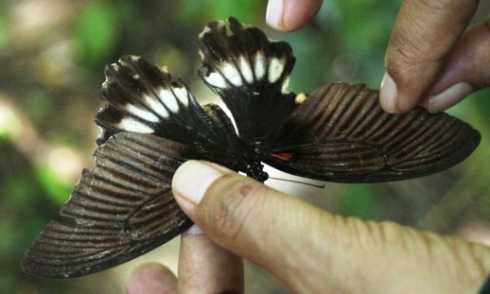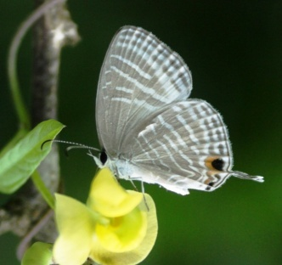
b.
a.
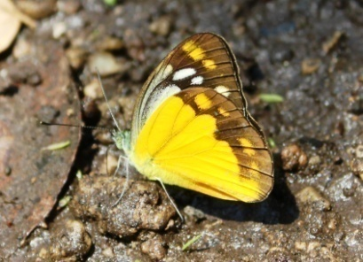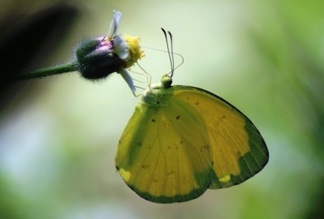
d.
c.
Figure 3. Dominant butterfly species found in TWA Suranadi
(a) Papilio polytes, b) Jamides celeno, c)cepora iudith, d) Eurema blanda)

Butterflies usually live in the terrestrial habitats but the composition of the species varies according to their habitat conditions. Butterfly habitat is characterized by the availability of host plants to feed the larvae, and the nectar-producing plants for their imaging. When these two plants are available in a habitat, they allow the butterflies to survive. If only one of them is available, butterfly cannot survive. In addition, it also needs a sufficient light factor, clean air, and water as the material needed to maintain the moisture of the environment where the butterflies live.
Figure 4 shows the proportion of the individual number of each butterfly family found at SNTP. The largest proportion of families is Nymphalidae (35%) followed by Pieridae (30%), Lycaenidae (18%), Papilionidae (16%) and Hesperiidae (1%). The dominance of the Nymphalidae family butterfly is a common pattern in many places. The Nymphalidae family not only have a high species diversity, but also has a wider range and higher abundance than other families. Nymphalidae generally prefer places like forests, bright areas and fields.

Figure 4. Proportion of Number of Individuals of each butterfly family found
at SNTP

The index of the diversity of butterflies at SNTP is 3.47 which is analyzed with Shannon-Wiener index, while each observation path has different value. Figure 4 displays the highest index value found on the right lane (H '= 3.43) followed by the left lane (H' = 3.29), the water line (H '= 2.65) and the middle lane (H' = 2 , 63). The differences in the index values ​​of the diversity of butterfly species in the SNTP region are influenced by the differences in vegetation structure of secondary forest composition in the form of tall trees and varied canopy.
The variety of canopies affects the difference of sunlight to each part of the forest, so that habitat conditions vary. The right and left lanes are the margins of the secondary forest that is directly adjacent to the community plantations, so that they have a fairly open canopy. The existence of community flower fields and fields provides an attractive source of food for butterflies, so that many species are concentrated in that location. Unlike the middle path that has a canopy, it is solid enough to block the penetration of sunlight that affects the less butterfly species found.
The index of the diversity of butterfly species at SNTP is greater compared to those found in other places. Nisa et. Al. (2013) find indices of diversity (H` = 2,199) in Malang City Green Open Space.

Figure 5. Shannon-Wiener Diversity Index on each observation path

Priority of Butterfly Conservation at SNTP
Table 2. Priority of butterfly conservation at SNTP
No | Family | No | Species | E | SP | KH | K | SPS | TOTAL
1 | Hesperiidae | 1 | Ancistroides nigrita | 5 | 20 | 5 | 10 | 10 | 50
2 | Lycaenidae | 2 | Leptotes sp | 5 | 20 | 5 | 10 | 10 | 50
 |  | 3 | Jamides alecto | 5 | 20 | 5 | 10 | 10 | 50
 |  | 4 | Floss annuela | 5 | 20 | 5 | 10 | 10 | 50
 |  | 5 | Jamides celeno | 5 | 20 | 5 | 10 | 10 | 50
 |  | 6 | Lambides boeticus | 5 | 20 | 5 | 10 | 10 | 50
3 | Nymphalidae | 7 | Euploea eunica | 5 | 20 | 5 | 10 | 10 | 50
 |  | 8 | Vindula dejone dorokusana | 5 | 20 | 5 | 10 | 10 | 50
 |  | 9 | Danaus genutia | 5 | 20 | 5 | 10 | 10 | 50
 |  | 10 | Melanitis leda | 5 | 20 | 5 | 10 | 10 | 50
 |  | 11 | Mycalesis janardana | 5 | 20 | 5 | 10 | 10 | 50
 |  | 12 | Doleschallia bisaltide | 5 | 20 | 5 | 10 | 10 | 50
 |  | 13 | Ideopsis juventa | 5 | 20 | 5 | 10 | 10 | 50
 |  | 14 | Euploea climena | 5 | 20 | 5 | 10 | 10 | 50
 |  | 15 | Pantoporia hardonia | 5 | 20 | 5 | 10 | 10 | 50
 |  | 16 | Elymnias hypermenestra | 5 | 20 | 5 | 10 | 10 | 50
 |  | 17 | Hypolimnas bolina | 5 | 20 | 5 | 10 | 10 | 50
 |  | 18 | Tirumala hamata | 5 | 20 | 5 | 10 | 10 | 50
 |  | 19 | Mycalesis horfieldi | 5 | 20 | 5 | 10 | 10 | 50
 |  | 20 | Polyura hebe | 5 | 20 | 5 | 10 | 10 | 50
 |  | 21 | Junonia sp | 5 | 20 | 5 | 10 | 10 | 50
 |  | 22 | Athyma nefte | 5 | 20 | 5 | 10 | 10 | 50
 |  | 23 | Nepthis hylas | 5 | 20 | 5 | 10 | 10 | 50
 |  | 24 | Melanitis phedipus | 5 | 20 | 5 | 10 | 10 | 50
4 | Papilionidae | 25 | Papilio memnon | 5 | 20 | 10 | 20 | 10 | 65
 |  | 26 | Papilio polytes | 5 | 20 | 5 | 10 | 10 | 50
 |  | 27 | Papilio peranthus | 5 | 20 | 5 | 10 | 10 | 50
 |  | 28 | Graphium doson | 5 | 20 | 5 | 10 | 10 | 50
 |  | 29 | Graphium agamemnon | 5 | 20 | 5 | 10 | 10 | 50
 |  | 30 | Troides helena | 20 | 15 | 10 | 20 | 10 | 75
5 | Pieridae | 31 | Catopsila sp | 5 | 20 | 5 | 10 | 10 | 50
 |  | 32 | Leptosia nina | 5 | 20 | 5 | 10 | 10 | 50
 |  | 33 | Eurema blanda | 5 | 20 | 5 | 10 | 10 | 50
 |  | 34 | Cepora iudith | 5 | 20 | 5 | 10 | 10 | 50
 |  | 35 | Cepora sp | 5 | 20 | 5 | 10 | 10 | 50
 |  | 36 | Delias sp | 5 | 20 | 5 | 10 | 10 | 50
 |  | 37 | Catopsila pamona | 5 | 20 | 5 | 10 | 10 | 50
 |  | 38 | Catopsila pyranthi | 5 | 20 | 5 | 10 | 10 | 50
 |  | 39 | Hebomoia glaucipe | 5 | 20 | 5 | 10 | 10 | 50
 |  | 40 | Eurema hecabe | 5 | 20 | 5 | 10 | 10 | 50

Where: E: Endemicity SP: Status of Population KH: Habitat Condition K: Risk SPS: Status of Species Management

Habitat is the result of interaction between the biotic and abiotic components, the components interact to form interrelated relationships. If only one of them is available, then the butterfly cannot survive, especially if there is no host plant. The butterfly habitat is a moist place with lots of flower vegetation, aquatic bodies and plenty of sunshine. Most species live in agricultural areas, orchards, primary and secondary forests. The highest frequency of butterflies flowering is at 09.00-13.00 and the colors of flowers have a positive effect on the number of butterflies that perceive it (Duara & Kalita, 2014).

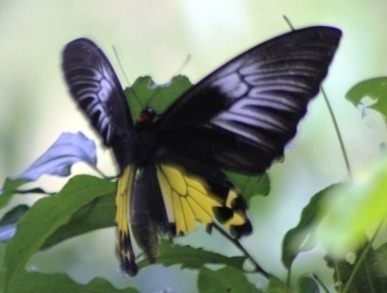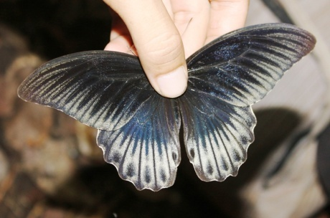
b.
a.
Figure 6. Species of butterflies being a conservation priority at SNTP (Troides helena, b.Papilio memnon)

Based on the conservation priority analysis, two species of the Papilionidae family are the main priority of butterfly conservation in TWA Suranadi namely Troides helena and Papilio memnon. This type of butterfly Troides helena (Common Birdwing) is one of the rare species found at SNTP. Troides helena is a type of butterfly protected by SK Mentan No.576/Kpts/Um/8/1980; PP. No. 7 Year 1999, Minister of Agriculture Decree No.716/Kpts/m1 /10/1980 and included in CITES Appendix II (Noerdjito and Aswari, 2003).
Butterflies from the Papilionoidea Family loveslight very much. Light is needed to dry butterfly's wings upon exit from the cocoon. Light provides heat energy to the body, so that body temperature increases and metabolism becomes faster. Increased body temperature accelerates the development of butterfly larvae. The existence of Troides helena and several other butterfly species, especially from the Papilionidae family, is threatened with extinction in nature, due to human hunting for trading, or due to the decline in the quality of butterfly habitats in nature. Type helen helides are much hunted for their beauty and rarity (Noerdjito and Aswari, 2003).
Pontororing et.al. (2016) reported that T. helena belonged to animals with high flying ability. His ability to fly high is used to alight, eat, breed, and play. The range of flight frequency of T. helena is 06.00 - 17.00. The highest flying frequency is found at 08.00-10.00 am. Flying high is done to increase body temperature and dry the wings. Pontororing et.al. (2016) also reported that the frequency of T. helenes during nectar sipping (food) begins at 07.00 - 16.00. Frequency increases at 07.00 - 09.00, and it decreased and then increased again at 12.00 - 15.00. Nectar is needed by the butterfly as a foodstuff and then converted into energy to fly.
The existence of Troides helena butterfly is influenced by the existence of feed and host plants. Aristolochia tagala from the family Aristolochiae is a host plant for the species. Troides helena was found in the waterway positioned between G1-G6 and only found at the third sampling. This relates to butterfly flying period and is likely close to the host plant. According to Peggie and Amir (2006), the observations at different times may show different types because they have different flying periods. This is obviously observable in the 4 seasons area. In Indonesia, there are also differences in the distribution and diversity of butterflies in the rainy season and in the dry season.
The population of Troides helena in the secondary forest of TWA Suranadi is small. This condition can threaten the survival of Troides helena because besides the rare host plants, the breeding ability of this type is low. Troides helena is large, eggs are produced a bit, and the reproduction time is long enough. Based on the Nurjannah (2010) study, Troides helena produces 35-150 eggs, and the success rate until imago phase is only 8-12%. This condition decreases the number of Troides helena and the frequency oftheir meeting with their ‘imago’ is rare. The phenomenon indicates that this natural tourism park area needs to be preserved. The population of butterflies is limited in nature, and its high sensitivity to potential disturbance due to the environmental imbalances threatens its survival, even causes the extinction of the butterflies in their habitat.

CONCLUSION
To sum up, 40 species of butterflies in 5 families are found: Hesperiidae (1 species), Lycaenidae (5 species), Nymphalidae (18 species), Papilionidae (6 species) and Pieridae (10 species). The index of the diversity of butterflies at SNTP is 3.47. The species diversity varies on each observation path. There are 2 Species of the Papilionidae family,Troides helena and Papilio memnon, at SNTP which must be the conservation priorities.

Acknowledgment
Thanks to the Directorate of Research and Community Service Kemenristek Dikti providing fund for the applied product research. Thanks also go to the "TIMBON" brothers who helped the research team during the field research.

REFERENCES
Ariani, L., Artayasa, Ilhamdi L., 2013, Keanekaragaman dan distribusi kupu-kupu di Hutan Suranadi sebagai media pembelajaran Biologi, Proseding Seminar Nasional, Pascasarjana Magister Pendidikan IPA, Universitas Mataram.
Basset. Y., R. Eastwood, L. Sam, D. J. Lohman, V. Novotny, T. Treuer, S. E. Miller, G. D. Weiblen, N. E. Pierce, S. Bunyavejchewin, W. Sakchoowong, P. Kongnoo dan M. A. Osorio-arenas. 2012. Cross-continental Comparisons of Butterfly Assemblages in Tropical Rainforests: Implications for Biological Monitoring. Insect Conservation and Diversity doi:10.1111/j.1752-4598.2012.00205: 1-10
Duara, P., Kalita, J. 2014. Butterfly as Pollinating Insects of Flowering Plants. Global Journal of Science Frontier Research (C), Vol. 14(1): 1 – 5
Febrita, E., Yustina, Dahmania. 2014. Keanekaragaman jenis kupu-kupu (subordo rhopalocera) di kawasan wisata hapanasan rokan hulu sebagai sumber belajar pada konsep keanekaragaman hayati. Jurnal biogenesis. Vol. 10 (2)
Haidar, IKA., Ahsan, MF., and Kabir, MT. 2017. Species diversity and habitat preference of butterflies (Insecta: Lepidoptera) in Inani Reserve Forest of Cox’s Bazar, Bangladesh. Journal of Insect Biodiversity and Systematics, Vol.3(1): 47–67
Hermawanto, R., Rawati, P., Sepus, F. 2015. Kupu-kupu (Papilionoidea) di Pantai Utara Manokwari, Papua Barat: Jenis, keanekaragaman dan pola distribusi. Prosiding Seminar Seminar Nasional Masyarakat Biodiversitas Indonesia. Vol 1(6): 1341 – 1347.
Koneri, R., dan Saroyo. 2012. Distribusi dan keanekaragaman kupu-kupu (lepidoptera) di gunung manado tua, kawasan taman nasional laut bunaken, sulawesi utara. Jurnal Bumi Lestari, Vol 12 (2): 357 – 365.
Lodh, R., Agarwala, BK. 2016. Rapid assessment of diversity and conservation of butterflies in Rowa Wildlife Sanctuary: An Indo-Burmese hotspot - Tripura, N.E. India. Tropical Ecology Vol. 57(2): 231-242
Majumder, J., Lodh, and R., Agarwala, BK. 2013. Butterfly species richness and diversity in the Trishna Wildlife Sanctuary in South Asia. Journal of Insect Science, Vol. 13 (79): 1 – 13
Murwitaningsih, S., and Dharma, AP. 2014. Species Diversity of Butterflies at Suaka Elang (Raptory Santuary) at Gunung Halimun Salak National Park in West Java. Asian Journal of Conservation Biology, Vol. 3(2): 159–163
Ngatimin. S. N. A., A. P. Saranga, N. Agus, A. Achmad dan I. Ridwan. 2014. Two Artificial Diet Formulations For Troides Helena Linne Larvae (Lepidoptera: Papilionidae) In Bantimurung-Bulusaraung National Park, South Sulawesi. International Journal of Scientific dan Technology Research volume 3, issue 7. Issn 2277-8616:170-173
Nisa, ARK., Mukti, M.,Hamzah, MF., Mustakim, A., Abidin, Z. 2013. Butterflies’ Diversity in Green Open Space of Malang City, East Java Province, Indonesia. The Journal Of Tropical Life Science, Vol 3(2):104 – 107.
Noerdjito WA, Aswari P. 2003. Metode Survei dan Pemantauan Populasi Satwa: Seri Keempat Kupu-kupu Papilionidae. Bogor: Pusat Penelitian dan Pengembangan Biologi-LIPI Cibinong.
Oqtafiana, R., Priyono, B., Rahayuningsing, M. 2013. Keanekaragaman Jenis Kupu-Kupu Superfamili Papilionoidae di Banyuwindu, Limbangan Kendal. Biosaintifika, Vol 5(1): 58 – 64.
Peggie D, Amir M. 2006. Practical Guide to the Butterflies of Bogor Botanic Garden – Panduan Praktis Kupu-kupu di Kebun Raya Bogor. Tokyo: Bidang Zoologi. Pusat Penelitian Biologi. LIPI Cibinong dan Nagao Natural Environment Foundation.
Pontororing, HH., Warouw, J., Maramis, RTD., Mamahit, JME. 2016. Conservation of Troides helena Linnaeus (Lepidoptera: Papilionidae) in Forest Park of Mount Tumpa, Manado, North Sulawesi. International Journal of Research in Engineering and Science, Vol. 4(9): 31-35
Priyono, B., Abdullah, M. 2013. Keanekaragaman Jenis Kupu-Kupu di Taman Kehati Unnes. Biosaintifika, Vol 5(2):100 – 105.
Rahayu, SE., Basukriadi, A. 2012. Kelimpahan dan Keanekaragaman Spesies Kupu-Kupu (Lepidoptera; Rhopalocera) Pada Berbagai Tipe Habitat di Hutan Kota Muhammad Sabki Kota Jambi. Biospecies. Vol. 5(2), hlm 40 – 48
Sarma, K., Kumar, A., Devi, A., Mazumdar, K., Krishna, M., Mudoi, P. And Das, N. 2012. Diversity And Habitat Association Of Butterfly Species In Foothills Of Itanagar, Arunachal Pradesh, India. Cibtech Journal of Zoology, Vol. 1(2): 67 – 77
Satyawan, NM, 2009. Keanekaragaman Jenis Amfibi (Ordo Anura) di Kawasan Taman Wisata Alam Suranadi - Lombok Barat .Prosiding Seminar Nasional Biologi XX Dan Kongres Perhimpunan Biologi Indonesia XIV
Shihan, TR., Prodhan, MAH. 2014. Butterflies of Rema-Kalenga Wildlife Sanctuary, Habiganj, Bangladesh. International Journal of Fauna and Biological Studies, Vol. 1 (6): 96-100
Sutra, NSM., Dahelmi, Salmah, S. 2012. Spesies Kupu-kupu (Rhopalocera) Di Tanjung Balai Kerimun Kabupaten Karimun, Kepulauan Riau. Jurnal Biologi Universitas Andalas, Vol 1(1):35 – 44.
Wahyuni, T.E dan Fatahullah. 2015. Panduan Lapangan Kupu-Kupu di TWA Kerandangan. Mataram: BKSDA NTB.

