In Vitro Propagation of Bambusa balcooa as Wood Alternative Material

Siti Nurhayani¹, Rita Megia², Ragapadmi Purnamaningsih³

¹Plant Biology Graduate Program, Bogor Agricultural University, Bogor
Indonesia, sitinurhayani38@gmail.com.
²Departement of Biology, Faculty of mathematics and Natural Sciences, Bogor Agricultural University, Bogor, Indonesia. Rmegia7@gmail.com
³ Indonesian Center for Agricultural Biotechnology and Genetic Resources Research and Development (ICABIOGRAD), Raga_padmi@yahoo.com

Abstract

Diversion to alternative material as a replacement of wood is necessary. One of alternative material that can be used to replace wood is Bambusa balcooa. This bamboo has not been not cultivated widely in Indonesia, therefore many efforts are needed to propagate the plant by tissue culture method. Plant materials used were the axilar shoots of bamboo which cultured on five different medium formulas: (1) MS0; MS containing: (2) 0.1 mg/l BAP, (3) 0.3 mg/l BAP, (4) 0.1 mg/l BAP + 0.1 mg/l TDZ and (5) 0.3 mg/l BAP + 0.1 mg/l TDZ. The results showed MS medium containing 0.1mg/l BAP + 0.1mg/l TDZ was the best medium for B. balcooa propagation. The shoots produced from aforementioned medium had better quality compared to the other media. The average number of shoots in this medium was 14.25 on 40 days after planted. MS medium containing 0.3 mg/l BAP + 0.1 mg/l TDZ produced the highest number of shoot but in lower quality. Rooting medium containing 10 mg/l IBA + 5 mg/l NAA produced 9-16 root in 8 weeks. For acclimatization of B. balcooa, vermicompost was a better fertilizer than compost.
Keywords: B. balcooa, In Vitro, Multiplication

Introduction
Indonesia is the third country in the world with the widest forest. It consists of huge forest which the area reached 130 million hectares. About 2% of the forest undergoes destruction every year due to several factors. The destruction of the forest results in erosion and flooding. Illegal logging is the biggest problem related to forest damages. Society needs woods for building materials, paper raw material and others cause the mass logging rapidly occurred.
Bamboo shoot can be used as a building material and raw material for paper. It is also functioned to overcome soil erosion, increase carbon dioxide absorption as well as produce biofuel (Ghosh et al.,, 2012). Therefore, bamboo can be used as an alternative material for wood.
Bamboo can be found in semi tropical region around the world (Rathaur 2013). In Indonesia, bamboo is planted in many areas especially Java, Bali, South Sulawesi, and Sumatra. There are at least 157 species of bamboo grown in Indonesia including introduction species which is planted in Bogor Botanical Garden and Cibodas Botanical Garden (Widjaja 2001). In general, the stem of bamboos found in Indonesia have small diameter and thin, such as that of Bambusa vulgaris is 6-15 mm (Widjaja 2001).
Bambusa balcooa is native plant of India (Widjaja 2001). The superior traits of this species are its strong stem and root as well as its large diameter of stem. This bamboo can reach 25 m in height and 15 cm in diameter of stem (Negi & Sanjay 2011). According to Gillis et al. (2007) B. balcooa is categorized as the best type of Bambusa genus.
Propagation of Bamboo is usually applied vegetatively. The propagation using bamboo seed is very difficult because flowering time of bamboo cannot be predicted easily and the flowering phase takes a long time which about 55-60 years (Negi & Sanjay 2011). Flowering type of bamboo is categorized as gregarious type, the plant will die after flowering without setting seeds (Brar et al. 2014).
B. balcooa has not widely distributed in Indonesia, allowing the needs to propagate this species in a large quantity. Tissue culture technique can be used to multiply plants rapidly and produce the clones of the plant. This method is expected to provide B. balcooa seedling that can be used immensely in Indonesia.

Methods
Sterilization. The material used was the axilar shoot of B. balcooa collected from the field as a collection of Balai Besar Biotechnology and Agricultural. The explants were first sterilized using detergent (30 minutes), agrep and banlate (two hours). Then the explant were disterilized using 70 % alcohol for five minutes, 30 % clorox for five minutes, and 20 % clorox for seven minutes. After that, the axilar shoots were then rinsed three times using sterilized aquades.
Shoots Induction. The sterilized explants were planted on MS (Murashige and Skoog) medium without plant growth regulator hormone (MS0). The explants were then incubated in culture room with 16 hours of light duration. Room temperature was set at 22ºC. After that, the explant was used on the next multiplication stage.
Shoots multiplication. The formulation of media used were MS basal media combined with (a) 0.1 mg/l BAP, (b) 0.3 mg/l BAP, (c) 0.1 mg/l BAP + 0.1mg/l TDZ, ( d ) 0.3mg/l BAP + 0.1mg/l TDZ, (e) MS0. The growth of bamboo was observed every 10 days for 40 days after planted. Parameters observed were the number of shoots, number of leaves, shoots height and culture visual. This experiment was designed using RAL with 10 replications for each treatment. Duncan test was used for advance analysis.
Roots induction. After assessing the best medium, the shoots were propagated in basal medium (MS) containing IBA 10mg / l + NAA 5mg / l as a rooting medium.
Acclimatization. Acclimatization was done on planlet one month after root induction. The media used were: 1) soil + sand + compost (1:1:1), 2) soil + sand + vermicompost (1:1:1).

Result and Discussion
The use of basal medium (MS0), without additional plant growth regulator (ZPT) was unable to support bud growth of B. balcooa. It can be seen from the number of shoots, the number of leaves and shoot height (Table 1). The shoot growing in MS medium without ZPT only survived until the 20th days after planted. The explant died due to the accumulation of high phenol production. Without ZPT, the explant began to produce phenol on the 3rd day which increasing gradually, causing the death of the explant.
A significant increase in the number of shoot and leaves, as well as shoot height was observed upon the addition of BAP and TDZ. The composition of MS0 basal medium is unsuitable for supporting explants growth. Explants growth required the addition of BAP and TDZ to grow intensively. The addition of ZPT of cytokinins group such as BAP and TDZ is necessary for shoots development (George & Sherrington, 1984). Without cytokinin, mitosis will be inhibited (Wattimena, 1992).
This study showed that bamboo shoot formation increased while planted in medium containing BAP and TDZ. It can be shown by the observed variables i.e. the number of shoot, the number of leaves as well as the shoot height compared to control. The MS basal medium containing BAP, TDZ as well as the combination of both were able to induced the growth of B. balcooa shoots. While the growth of bamboo explants planted in MS basal medium without any ZPT was interrupted, causing the explants died on the second week of observation.
The plant growth increased upon the addition of TDZ (Table 1). The number of shoots of explant that was planted on MS medium containing 0.1 mg/l BAP + 0.1 mg/l TDZ is significantly higher compared to those on MS medium containing 0.1 mg/l BAP. The same results was found on MS medium containing 0.3 mg/l BAP + 0.1 mg/l TDZ compared to those of MS medium with 0.3 mg/l BAP. The highest number of shoots was found in medium containing 0.3 mg/l BAP + 0.1 mg/l TDZ with 21 shoots, however the shoots appeared tinny with rosette formation. On the other hand, shoots planting in medium containing 0.1 mg/l BAP + 0.1 mg/l TDZ grew normally. TDZ is phenylurea cytokinin synthetic which is very effective to regulate the formation of Populus ciliata shoots (Aggarwal et al., 2012).

Table 1. B. balcooa growth on different medium formulation after 40 days.
Media Formulation (mg/l) | ƩShoot | ƩLeaf | Height(cm) | Shoot visual
MS | 4.37 ± 0.52ª | 3.00 ± 0.75ª | 1.03 ± 0.07ª | Dead
MS + BAP 0.1 | 11.50 ± 1.05^{b} | 12.17 ± 0.98^{c} | 1.58 ± 0.16^{b} | Rare
MS + BAP 0.3 | 15.00 ± 0.89^{c} | 9.33 ± 1.21^{b} | 1.65 ± 0.12^{b} | Roset
MS + BAP 0.1TDZ 0.1 | 14.25 ± 1.17^{c} | 13.75 ± 1.83^{c} | 1.56 ± 0.11^{b} | Normal
MS + BAP 0.3TDZ 0.1 | 21.00 ± 0.76^{d} | 16.50 ± 2.14^{d} | 1.79 ± 0.01^{b} | Roset

The means in the column with the same letter are not statistically significant (p=0.05) according to Duncans Multiple range test.

The growth of B. balcooa shoots was influenced by the addition of thidiazuron (TDZ). As shown in Table 1, the average number of B. balcooa shoot planted in media containing TDZ was higher than the shoot planted in media without TDZ. Thidiazuron induce the formation of adventitious bud and proliferation of axilar shoot (George & Sherrington, 1984). The number of shoot was increased as the effect of combination between BAP and TDZ due to their function in triggering bud formation.
Cytokinin such as BAP effectively increase the number of shoot by enhancing the cell proliferation (Wattimen, 1992). In this experiment, the function of BAP was to affect the growth of B. balcooa. Niranjan et al., (2010) found BAP increased the number of shoots of Lagerstroemia indica (L). The same result was found also in white turmeric shoots which produced shoots twice as much as the control planted in media containing BAP (Yulizar et al., 2014 ).
The production of B. balcooa leaves was significantly different in every treatment. BAP affect the growth of leaves compared to control. According to the Table 1, the highest number of leaves was found in medium containing 0.3 mg/l BAP + 0.1 mg/l TDZ while the lowest number of leaves occurred in medium 0.3 mg/l BAP without TDZ.
Different results was obtained from height shoots character (Table 1). There was significant difference observed upon the use of plant growth regulator such as BAP, TDZ, and the combination of them compared to the control. The average height of shoot from the explants planted on medium containing 0.3 mg/l BAP + 0.1 mg/l TDZ was 1.79 cm while the average height of shoot from medium 0.3 mg/l BAP was 1.65cm (Table 1).
Moreover, the growth pattern of shoot was found different among the five formulation medium. Shoots growth was significantly affected by medium formulation. Cytokinin of 0.3 mg/l or higher concentration on B. balcooa enhanced the number of shoots, however resulted in crumple, dwarft and rare shoots appearance. This condition occured while the explant that was planted in medium containing 0.3 mg/l BAP + 0.1 mg/l TDZ and in medium containing 0.3 mg/l BAP (Figure 1D, 1B). The induction of shoots formation could not occur without cytokinin such as on basal medium (MS0). On the other hand, shoot formation grew normally by the use of 0.1 mg/l BAP + 0.1 mg/l TDZ (Figure 1C).
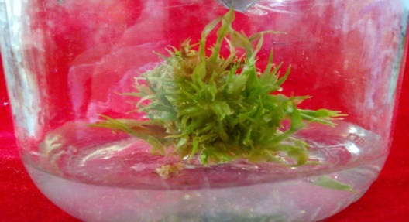
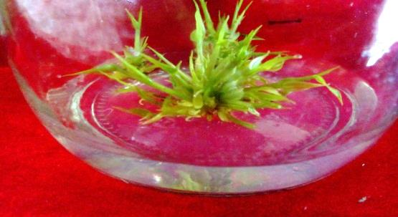
A
B
D
E
Figure 1. B. balcooa development on different medium formulations on the 40th day. (A) Rare, (B) Roset, (C) Normal, (D) Roset, (E) dead. White line :1cm.
C
On the basal medium (MS0) without ZPT, the growth of B. balcooa was hindered. This media was unable to induce the explant growth, causing the explants turning black (blackening) and died on the 20th day after planted (Figure 1E). ZPT especially cytokinin was required in planting B. balcooa explant. BAP and TDZ are cytokinin hormones which considered to be the most suitable hormone in increasing the formation of B. balcooa shoots.

Rooting induction
Rooting stage is required in supplying bamboo planlet from tissue culture technique. This stage is important because bamboo plant growing from tissue culture technique must survive on the field. Rooting induction was done on the planlet that was produced from the best propagation medium (0.1 mg/l BAP + 0.1 mg/l TDZ).
In this research, combination of 10 mg/l IBA + 5 mg/l NAA effectively induced roots formation. IBA is known weaker for rooting induction than that of NAA, therefore the NAA dosage (5mg/l) used in the medium was lower than that of IBA (10 mg/l). IBA 10 mg/l has been used also in rooting medium of Garcinia mangostana L. (Joni et al. 2015), mangosteen (Roostika et al. 2008), Bambusa vulgaris (Astuti, 2014) and Bambusa tulda (Sharma & Sarma 2013). The application of 5mg/l NAA concentration has been applied in Bambusa tulda (Sharma & Sarma 2013).
Auxin accumulation can induce the synthesis of ethylen. The accumulation of this hormone will degradating plant endogenous auxin and prevent root formation. However, synthetic auxin is difficult to be degraded, so that the use of auksin synthesis remains capable in inducing roots formation (George & Sherrington, 1998). Therefore shoot experience browning on rooting process, although it still could induced root due to syntetic auxin use (NAA & IBA).The roots started to grow on the 4th week after planting. The number of root produced on the 8th week range from 9-16 roots (Table 2). The roots colour was dominated by brown derived by the phenolic compound found in the shoots. As a result, browning was occurred frequently in the shoot when the root was started to emerge. In general, bamboo plantlet has to be moved to the new medium after four week.

Tabel 2. Number of Bambusa balcooa root during 8 week after planted using MS medium containing 10mg/l IBA + 5 mg/l NAA.
Repetition | Week after planted
 | 1 | 2 | 3 | 4 | 5 | 6 | 7 | 8
1 | 0 | 0 | 3 | 4 | 6 | 8 | 12 | 16
2 | 0 | 0 | 0 | 2 | 4 | 5 | 7 | 9
3 | 0 | 0 | 0 | 1 | 3 | 7 | 10 | 13
4 | 0 | 0 | 0 | 3 | 5 | 7 | 8 | 13
5 | 0 | 0 | 2 | 4 | 7 | 9 | 11 | 14

This study also showed that the roots grown on the same medium showed different diameter and length. Some plantlet produced longer root with smaller diameter (Figure 2A-B). However, mostly the planlet produced roots with bigger diameter (Figure 2C-D).
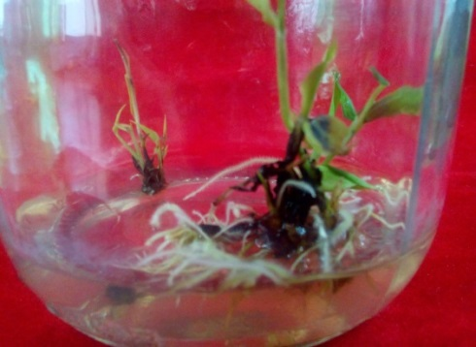
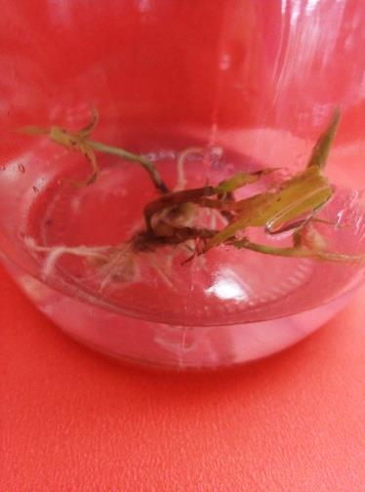
Roots condition was affected by the shoots condition. Shoots experiencing browning will produce brown roots. In Figure 2A-B, blackning was found on the base part of the shoots as a result of high accumulation of phenolic compound. This phenolic compound was transported to the roots causing the roots turning brown. The accumulation of phenolic compound is directly correlated with the activity of poliphenol oxidase (PPO) (Poudya et al., 2008).
Gambar 2. Pertumbuhanakar pada Bambusa balcooa
A
B
Figure 2. Roots of B. balcooa developed on MS medium containing 10mg/l IBA + 5mg/l NAA. (A) smaller diameter and browning roots, (B) blackning base shoot produced brown roots, (C) larger diameter and white roots, (D) browning shoots produced white roots. Black line: 2mm.

A
D
B
C

Tissue culture technique is a method for producing plants in a big mass. Tissue culture of axilar shoot produced more than 21 shoots on 40 days. Within 1-3 months, the bamboo is ready to be planted on the field. By using vegetative propagation through cutting, shoots having 4 nodes resulted in only 4 shoots in two month (Irvantia et al.,, 2014).

Acclimatization
Acclimatization is the last stage which is necessary to assured the ability of the plants produced from tissue culture method to survive in natural condition. Fertilizer with high nitrogen source is required for bamboo acclimatization. Vermicompost fertilizer contains various materials necessary for the plant growth like nutrient content such as N, P, K, Mg and Ca (Sinda et al.,, 2015). According to Hernandez et al.,, (2010) N, C, Ca Zn and Cu content in vermicompost is higher than that of compost.
According to the result, the use of compost fertilizer was unable to increased growth of B. balcooa. The planlet planted in soil medium with compost fertilizer were died at the first and the second week after planted. This condition was started by leaves senescences, followed by the stems, leading to the death of the plant (Figure 3B).
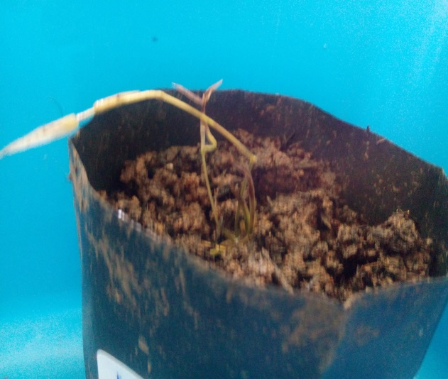
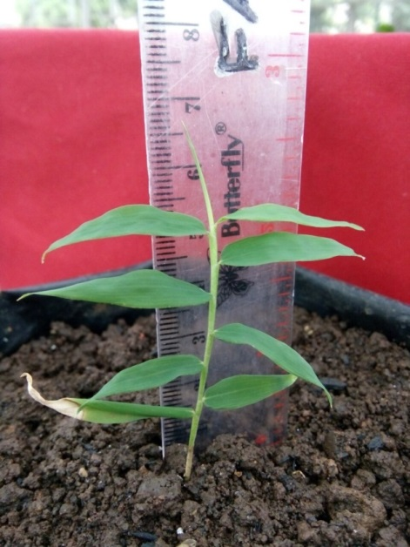
The planlet were acclimated one month after roots induction. One month after acclimatization in soil medium using vermicompost medium, the height of B. Balcooa can reach approximately up to 7 cm and the number of leaves was 8 leaves (Figure 3A).
Figure 3. Acclimatization of B. balcooa on the first month. (A) planted on vermicompost fertilizer, (B) planted on compost fertilizer. White line : 1 cm.
B
A

Conclusion
Combination of BAP and TDZ was significantly affecting the growth of B. balcooa shoots. The number of shoots in media containing BAP and TDZ is higher than that of control. Medium containing 0.3 mg/l BAP + 0.1 mg/l TDZ produced more shoots than those of other media, but shoot grew abnormally. Shoots which was planted on medium containing 0.1 mg/l BAP + 0.1 mg/l TDZ had the best quality of shoots which grew normally and uncrumpled. Medium containing 10 mg/l IBA + 5 mg/l NAA was capable to induce 9-16 root of B. balcooa planlet in 2 weeks. Vermicompost fertilizer was more suitable for B. balcooa growth under acclimatization compare to compost fertilizer.

Acknowledgement
This research was funded by the Indonesian Center for Agricultural Biotechnology and Genetic Resource Research and Development (ICABIOGRD), Bogor.

References
Aggarwal G, Sharma C, Srivastava DK. (2012). Thidiazuron: A Potent Cytokinin For Efficient Plant regeneration in Himalayan poplar (Populus ciliata Wall.) using leaf explants. Annal of Forest Research 55(2): 179-188.
Astuti Puji. (2014). induksi tunas dan perakaran bambu kuning Bambusa vulgaris Secara In Vitro. Biogenesis 2(2): 2302-1616.
Brar J, Shafi A, Sood P, Anand M, Sood A. (2014). In-vitro Propagation, Biochemical Studies and Assessment of Clonal Fidelity Through Molecular Markers in Bambusa balcooa. J Tropic Forest Sci 26(1):115–124.
Ghosh S, Somkuwar B, Sen MS, Talukdar C, Narayan. (2012). Genetic Variability and Phylogenetic Relationship Among Some Bamboo Species of North-East India by AFLP Analysis. Asian J Plant Sci and Res. 2(4):478-485
Gillis K, Gielis J, Peeter H, Dhooghe E, Oprins J. (2007). Somatic Embryogenesis From Mature Bambusa balcooa Roxburgh as Basis For Mass Production of Elite Forestry Bamboos. Springer. DOI 10.1007/s11240-007-9236-1
Goerge FE, Sherrington PD. (1984). Plant Propagationby Tissue Culture. Handbook and Directory of Commercial Laboratories. Britain: Exogetic Ltd
Guo B, Abbasi BH, Zeb A, Xu LL, Wei YH. (2011).Thidiazuron: A Multidimensional Plant Growth Regulator. African J Biotechnol. 10(45): 8984-9000.
Hernandez A, Castilo H, Ojeda D, Aras A, Lopez J, Sanchez E. (2010). Effect of Vermicompost and Compost on Lettuce Production. Chilean J Agric Res 70(4): 583-589.
Irvantia W, Indriyanto, Riniarti M. (2014). Pengaruh Jumlah Ruas Cabang Terhadap Pertumbuhan Setek Bambu Hitam (Gigantochloa atroviolacea). J Sylva Lestari 2 (1): 2339-0913.
Joni YZ, Efendi D, dan Roostika I. (2015). Induksi Perakaran Manggis (Garcinia mangostana L.) Secara In Vitro dan Ex Vitro. J Horticulural 25(2): 97-105.
Negi D, Saxena S. (2011). Micropropagation of Bambusa balcooa Roxb. Through Axillary Shoot Proliferation. In Vitro Cell Dev Biol. 47:604–610.
Niranjan MH, Sudarshana MS, Girisha ST. (2010). In vitro multiple shoot induction from excised shoot tips and nodal segment explants of - Lagerstroemia indica (L) - A medicinal Cum Ornamental Shrub. J Biomed Sci & Res. 2(3): 212-217
Poudyal BK, Du G Zhang Y, Liu J, Shi Q. (2008). Studies on browning problem and phenols content on shoots of yali, aikansui and abbe fetel pears for in vitro culture. Front. J Agric China. 2(3): 321–330.
Rahayu S, Adil WH. (2012). The effect of BAP and Thidiazuron on In vitro growth of Java Turmeric (Curcuma xanthorrhiza Roxb). ARPN J Agric & Biol Sci. 7: 10.
Rathaur AK. (2013). Bambusa arundinacea (Vanshlochan): An overview. Inter J Res in Pharmacology & Pharmacotherapeutics 2(1):248-255.
Roostika I, Sunarlim N, Mariska I. 2008. Micropropagation of Mangosteen. Indonesian J Agric 1(1): 28-33.
Sharma Pratibha, Sarma K P. (2013). In vitro propagation of Bambusa tulda : An Important Plant For Better Environment. J Environ Res. Dev 7: 3
Sinda KMNK, Kartini NL, Atmaja IWD. (2015). Pengaruh Dosis Pupuk Kascing Terhadap Hasil Tanaman Sawi (Brassica juncea L.), Sifat Kimia dan Biologi Pada Tanah Inceptisol Klungkung. J Agrotec Tropic 4(3): 2301-6515.
Wattimena GA. (1992). Bioteknologi Tanaman. Bogor: IPB
Widjaja, EA. (2001). Identikit Jenis-Jenis Bambu di Jawa. Pusat Penelitian dan Penembangan Biologi: Bogor.
Yulizar DR, Noli ZA, Idris M. (2014). Induksi Tunas Kunyit Putih (Curcuma zedoaria roscoe) Pada Media MS dengan Penambahan Berbagai Konsentrasi BAP dan Sukrosa Secara In Vitro. J Bioteknol 3(4): 2303-2162.

