The Effect of Red Fruit anointment (Pandanus Conoideus L) to the Histophysiology of Hepatic Rat (Rattus Norvegicus) Exposed by Cigarette Smoke

Albertina Dhiu Kio¹, Tyas Rini Saraswati², Enny Yusuf W. Yuniwarti³
Department of Biology, Faculty of Science and Mathematica, University of Diponegoro Semarang
E-mail: atin_dhiukio15@yahoo.com

Abstract
The smoke posed by cigarette as a free radical may interfere the balanced of body molecules and cause the damage of hepatic cell. The issues may be prevent using red fruit oil (Pandanus conoideus Lam) because it is antioxidant. This study aims to evaluate the structure and physiology conditions of liver when the red fruit oil (Pandanus conoideus Lam) given to the rat that exposed by cigarette smoke. This study carried out about 35 days with female white rats as the sample. The samples are 20 female white rats with the weight 180-220 grams, divided into four groups. Each treatment consists of P0 as negative control with standard feed and aquods P1 as positive control exposed by cigarette smoke, P2 exposed by cigarette smoke and red fruit oil with 0,1 ml/BB, P3 exposed by cigarette smoke and red fruit oil with 0,2 ml/BB. Each treatment was repeated five times repetition. The data ALT, AST, cell diameter, and hepatic weight were analysed using analysis of variants (ANOVA) with the study design use randomize complete design with four treatments and five repetitions. The results of the study showed that there are no significant differences between control and treatment both of ALT, AST, hepatocytes diameter, and hepatic weight. The conclusion is the use of red fruit oil to the rat exposed by cigarette smoke may help to protect the structure and the function of hepatic rat itself.
Keywords: cigarette smoke, hepatic, red fruit oil

Introduction
Based on data of World Health Organization (WHO), reported that in 2013 the number of death reach 6 million in the world as the results of smoking (Golli et al., 2016). The cigarette smoke contain more than 4.000 chemicals and hundreds of them were toxic substances for body. Any substantial finds in cigarette e.g. nicotine, tar, carbonmonoxy, formaldehyde, benzene, cadmium, timbale/lead, ammonia, PAH (Polynuclear Aromatic Hydrogen), phenol, carbonyl, chlorine dioxin, furan, and radical (Goniewicz et al., 2014). The entrance of cigarette smoke into the body through inhalation.
The compounds produced by cigarette smoke is free radical (Feitosa et al., 2016). Free radical of cigarette smoke derived from two different fractions, the first derived from tar phase of cigarette smoke and the second derived from gas phase of cigarette smoke. The gas phase of cigarette smoke produces the most reactive free radical such as oxygen and carbon. The effect of free radical caused the pathology conditions indicated with system injuries to the DNA injuries, Rahimah et al., (2009).
Hepatic includes the organs that vulnerable to the free radical (Pavlovic et al., 2007). The damages of hepatic caused by cigarette smoke can be recognized by check-up enzyme category transaminase, enzyme Aspartate Aminotransferase (AST) or well-known as Glutamate Oxaloacetate Transaminase (GOT) and enzyme Alanine Aminotransferase (ALT) or well-known as Glutamate Pyruvate Transaminase (GPT). Both of these enzymes will come out from hepatic cell if the hepatic cell damage, and as the results, increased the levels in blood serum (Hidayat et al., 2013).
The efforts made to prevent the damage of hepatic resulted by free radical of cigarette smoke with red fruit oil anointment (Pandanus conoideus Lam) which contain the antioxidant. Red fruit oil (Pandanus conoideus Lam), is the results of the extraction of red fruit plants which contain the active compounds of carotenoid 12.000 ppm, β-carotene 700 ppm, tocopherol 11.000 ppm, oleic acid 74,6%, linoleic acid 8%, linolenic acid 8,36% and some minerals such as Ca and Fe in suffice amount (Budi and Paimin, 2005). The mechanisms of antioxidant red fruit oil are to inhibit the formation of free radical, mediator in terms to neutralize the free radical that may had formed, reduce the potency of free radical in oxidase reaction, and inhibit the oxidative enzyme for example cytochrome P-450. The inhibit of free radical will protect normal hepatocyte from the damage and optimize the hepatic cells to regenerate. Based on the summary above, the study carried out to evaluate the potency of red fruit oil (Pandanus conoideus Lam) to the histophysiology hepatic rat (Rattus norvegicus) exposed by cigarette smoke.
Methods
The samples use in this study are female white rats type Rattus norvegicus (weight 150 ± 200 g.) with the age 2,5 months. The rats are placed in standard environment condition (temperature 26-28 ⁰ C, humidity 60-80%). Twenty female white rats were divide randomly into five trial groups as follows: (a) P0 (without cigarette smoke and red fruit oil), (b) P1 (cigarette smoke without red fruit oil), (c) P2 (cigarette smoke + red fruit oil 0,1 ml BB/days), (d) P3 (cigarette smoke + red fruit oil 0,2 ml BB/days).
The treatment exposed by cigarette smoke were carried out after the samples try to acclimate during a week. Cigarette use in this study was cigarette kretek with the amount one cigarette per days. Each treatment exposed by cigarette smoke conducted in treatment cage. The base of cigarette takes into the plastics bottle that has been modifications before burn the tip of cigarette. Then, the cigarette keeps into the treatment cage by placing in the modification place in each cage. The roof cage covered by gauze and glass, and also give a gap for air circulation. After the last cigarette burns out, the samples will take out from their treatment cage. Treatment exposed by cigarette smoke conducted every day during a week start at 10:00 PM till end.
Measurement activities ALT and AST for all groups conducted in last treatment. The bloods take through heart and accommodated in Eppendorf tube then centrifugate with the tempo reach 6500 rpm about 10-15 minutes. The content of ALT and AST determined by kinetic method UV International Federation of Clinical Chemistry (IFCC), use reagent ABX ALT and ABX AST with ABX Pentre. The activity of serum ALT and AST conducted as the biochemical signal of hepatocellular damage.
The making process of preparation conducted by the way rats dissected and took their hepatic organ. hepatic organ then takes into the BNF 10 %. The following steps is dehydrating use alcohol with high concentrate (70%, 80 %, 90%, and alcohol absolute). Clearing process use xylol, embedding and blocking process use paraffin, sectioning process in cutting paraffin block with the thickness about 5-6 millimicrons. Colouring process use Haematoxylin Eosin (HE). The check-up conducted under the light microscope with the magnification 10 x 40. The measurement of the diameter hepatocyte liver, determined by calculate the averages of the diameter with measurement results of the longest and the shortest part of the hepatocyte. The data as the results of the study were analysed by Analysis of Varian (ANOVA) on the level of original trust 95%.

Results and Discussion

The effect of red fruit anointment (Pandanus conoideus Lam) to the female white rats (R. norvegicus) influenced by the expose of cigarette smoke one cigarette each day during a week to the content activity of serum ALT and AST showed no significant change (P>0.05) between negative control (P0) which is, treatment to rats without cigarette smoke and red fruit oil and treatment to rats with cigarette smoke without red fruit oil (P1), and also there are no difference between the treatment groups with doses of red fruit oil 0.1ml (P2), treatment groups with doses of red fruit oil 0.2 ml (Pict. 1 and 2).
Table 1. The averages of content enzyme ALT and AST after the anointment of red fruit (Pandanus conoideus Lam) as the results of expose cigarette smoke
Variables | Treatments
Variables | P0 | P1 | P2 | P3
ALT (U/L) | 56.60ª±37.58 | 58.00ª±21.45 | 36.60ª±23.29 | 48.00ª±4.69
AST (U/L) | 115.40ª±33.73 | 172.40ª±71.60 | 116.80ª±23.71 | 127.60ª±20.63
Description: The effect of red fruit anointment to the activity of enzyme ALT and AST give to the rats showed no significant change (P>0.05)

The averages of content ALT and AST in group P0 assumed as normal content and used as the standard for comparison. According to Table 1, the averages of highest content of ALT find in group P1 and the lowest content of ALT find in group P2. The averages of highest content of AST find in group P1 and the lowest content of AST find in group P0. The use of cigarette smoke aims to increase free radical until the content of antioxidant endogenic unable to control free radical and body needs antioxidant exogenic.
Normal content of AST rats range 45,7-80,8 U/L. Normal content of ALT rats 17,5-30,2 U/L (Gad, 2007). AST value (115.40 U/L) and ALT value (56.60 U/L) of control groups gathered from this study find higher than normal content. This issue comes up because the use of cigarette smoke does not damage the necrosis of hepatocyte cells and the content of enzyme transaminase still secrecy in normal amount and does not increase. ALT is the more specific indicator damaged of hepatic cell, while AST is the indicator damaged of hepatic cell, muscle cells order, muscle cells heart, and kidney cell. The averages of lowest content both ALT and AST find in group P2 with red fruit anointment doses 0.1 ml. The characteristics of red fruit oil as antioxidant helps to muffled the effect of free radical produced by cigarette smoke.
Free radical produced by cigarette smoke will permeated by lung through the circulatory. Lung will pump up the blood over the bodies include liver. Through hepatic, the process of metabolism and dihedrals occur involves the cytochrome P-450 (Herliansyah, 2001). Free radical redundant on the bodies will affect the oxidative stress. Oxidative stress is condition where the free radical and the antioxidant defence system imbalance (Stevonson et al., 2005).
There are several ways of mechanism how antioxidant work in the body such as inhibit the formation of free radical, mediator in terms of neutralise the free radical that may had formed, reduce the potency of free radical in oxidase reaction, and inhibit the oxidative enzyme for example cytochrome P-450. The inhibit of free radical will protect normal hepatocyte from the damage and optimize the hepatic cells to regenerate.
Enzyme AST is parenchyma heart enzyme mostly finding in muscle, heart, kidney, and brain. Carl (2006) mentioned that big damage of hepatic with high content of AST and ALT generally show no increase. Even the content of both enzyme decreased because of the widely damage of hepatocyte cells, and the production of enzyme does not increase. The same idea was mentioned by Panjaitan et al. (2007), where in the level of widely damage, the availability of both enzyme become lower because the ability of hepatic cell to synthesize the enzyme decrease.
The measurement diameter of hepatocyte cells shows the result real unchanged (P>0.05). Treatment red fruit oil showed no significant change of diameter hepatocyte cells between negative control (P0) which is, treatment to rats without cigarette smoke and red fruit oil and treatment to rats with cigarette smoke without red fruit oil (P1), and also there are no difference between the treatment groups with doses of red fruit oil 0.1ml (P2), treatment groups with doses of red fruit oil 0.2 ml.

Table 2. The averages of content enzyme ALT and AST after the anointment of red fruit (Pandanus conoideus Lam) as the results of expose cigarette smoke
Variables | Treatments
Variables | P0 | P1 | P2 | P3
Diameter Hepatocyte Cells (µm) | 17.09ª±0.66 | 17.81ª ± 2.85 | 16.06ª ±3.27 | 16.86ª ±1.09
Hepatic Weight (g) | 8.15ª±1.14 | 8.49ª ±1.57 | 9.01ª ±1.62 | 8.49ª ±1.36
Description: The effect of red fruit anointment to the diameter hepatocyte cells give to the rats showed no significant change (P>0.05)
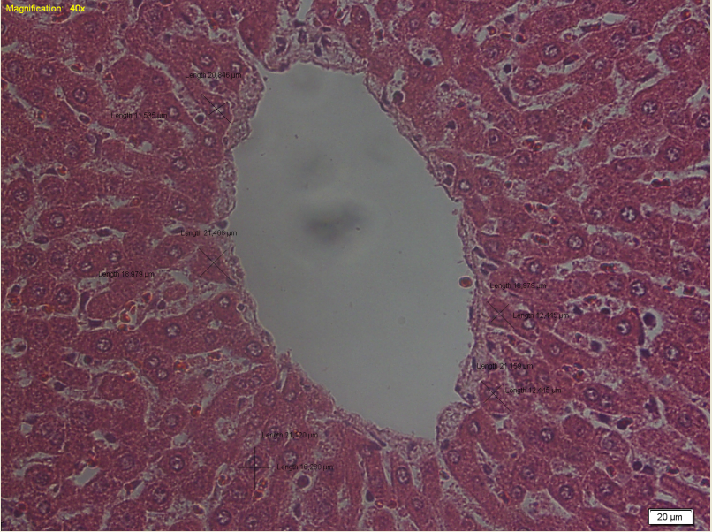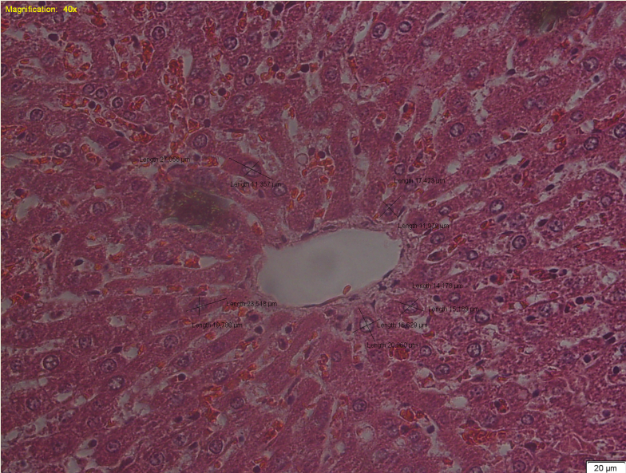
P1
P0
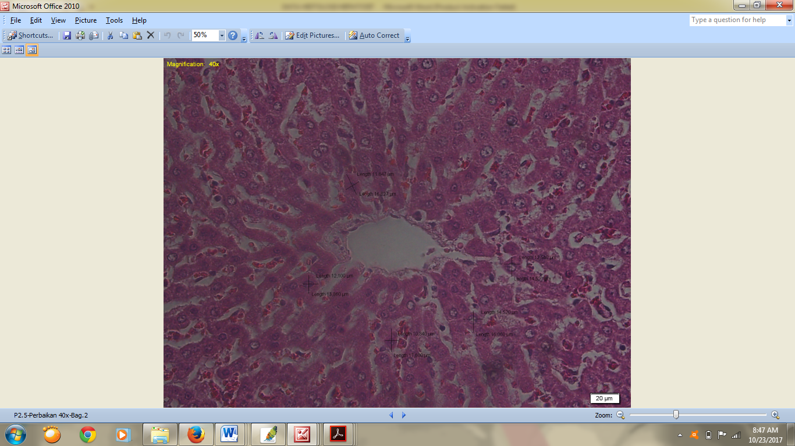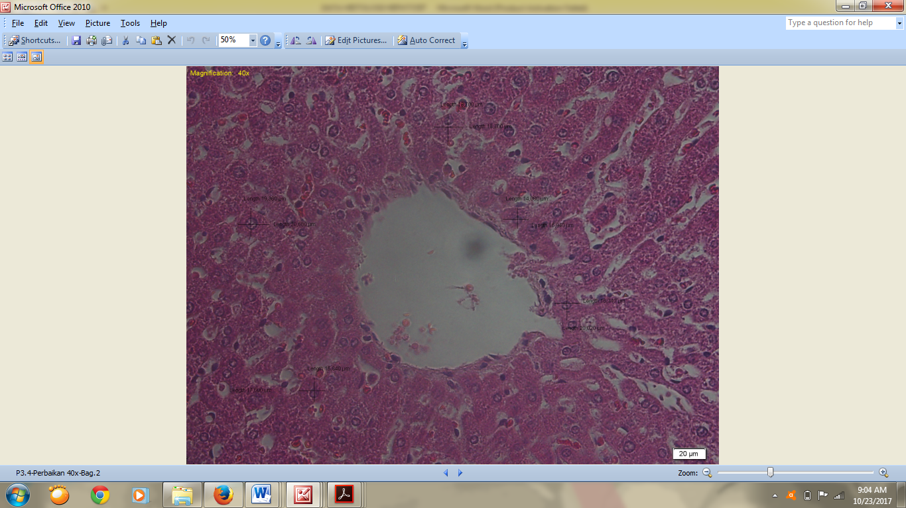
P3
P2
Picture 1. Diameter hepatocyte cells in the tretments real unchanged (P>0.05)
Diameter hepatocyte cells which real unchanged due to the high antioxidant contains in the red fruit oil. The tocopherol in red fruit oil helps to improve body immune system and the result is the mortality of body cells decrease. Tocopherol also helps to formed new cells to replace the broken cells (Clarke, 2006). Beta-carotene also has the role as antioxidant and use to catch the reactive compounds and prevent the occurring of chain reaction affect by free radical of cigarette smoke.
Hepatic is organs with fast regenerate. The disposal of any hepatic in case of dead or sick cells will replace with new hepatic cells (Wilson and Lester 1995). Hepatic contains intra hepatic stem cells precursor of the replication of hepatocyte cells. The replication of these hepatocyte cells will help regenerate the cells in order the growth and the development of hepatic damage by disorder resolved quickly (Fausto and Campbell, 2003). The affect of antioxidant on red fruit oil help regenerates the hepatic cells damage by disorder of cigarette smoke during a week.
The analyse of red fruit anointment (Pandanus conoideus Lam) to the female white rats (R. norvegicus) influenced by the expose of cigarette smoke one cigarette each day during a week to the hepatic weight showed no significant change (P>0.05). Treatment red fruit oil showed no real unchanged between the group of negative control, positive control, and treatment. This issue comes up because the expose of cigarette smoke still acute and unable to give toxics effect, because the ability of hepatocyte cells to regenerate fast to replace the broken hepatocyte due to the cigarette smoke with new hepatocyte cells.
In other hand, the replacement occurs in hepatocyte categorized as small disorder in normal condition, so the metabolism process of hepatic still continue normally. The organ in gastrointestinal tract still capable to fixed the damage caused by the expose of cigarette smoke, for example intestine. Intestine is the organ in which it cell has the capability to regenerate quickly, so the effects caused by the expose of cigarette smoke seem unreal. The condition of fast regeneration, impact on the absorption process which runs normally. The normal activity of gastrointestinal tract does not affect the replacement of real body weight.
Conclusion
Based on the research results, red fruit anointment (Pandanus conoideus Lam) has effects to protect the hepatic organ.
Acknowledgment
The writer thanks to Pemda Kab. Ngada, Flores, NTT and Dr. Enny Yusuf W. Yuniwarti, MP for financially support of this study.

Bibliography
Budi, I.M., dan Paimin, F.R. 2005. Buah Merah. Penebar Swadaya, Jakarta.
Carl A, Edward R, David E. 2006. Clinical Chemistry a Molecular Diagnostic II. Philadelphia (US): Elsevier.
Clarke, J. 2006. Omega-3 and Omega 9 Capital For Intelligence.http://id.wikipedia.org/wiki/asam-lemak[23 Januari 2006].
Fausto N. and J.S. Campbell. 2003. The Role of Hepatocytes and Oval Cells in Liver Regeneration and Repopulation. Mechanisms of Development 120 (2003) 117-130
Feitosa, E.M., Okuro, R.T., Ribeiro, V.P., Lanzetti M., Barroso, M.V., Zin, W.A., Porto, L.C., Gitirana, L.B., Valenca, S.S Eucalyptol Attenuates cigarette smoke-induced acute Lung Inflammation and Oxidative Stress in the Mouse. Pulmonary Pharmacology & Therapeutics Journal 2016 (41) 11-18.
Gad, S.C. 2007. Animal Models in Toxicology. Boca Raton: CRC Press.
Golli, N.E., Dkhili H., Dallagi Y., Rahali D., Lasram M., Dhouib, I.B., Lebret M., Rosa, J.P., Fazaa, S.E., Asmi, M.A.E. Comparison Between Electronic Cigarette Refil Liquid and Nicotine on Metabolic Parameters in Rats. Internasional Life Sciences Journal 2016 (146) 131-138.
Goniewicz, M.L, Knysak J., Gawron M., Kosmider L., Sobczak A., Kurek J., Prokopowicz A., Czapla M. J., Dulewska C.R., Havel C., Jacob P., Benowitz N., Tob. Control. 23 (2014) 133-139.
Guyton A.C., Hall JE. Buku Ajar Fisiologi Kedokteran. Edisi 11. Translation by Irawati et al., Jakarta: EGC; 2007.
Herliansyah. 2001. Chewing Haliah Sheds Disease. Journal of Malaysian Research.UKM Malaysia. 12:45-57.
Hidayat A., Christijanti W., Marianti A. Effect of Vitamin E Against SGPT and SGOT levels Strain Wistar Rats exposed to Lead. Unnes Journal Of Life Science 2 (1) (2013).
Panjaitan et al. 2007. Pengaruh Pemberian Karbon Tetraklorida Terhadap Fungsi Hati dan Ginjal Tikus. Majalah Kesehatan 11(1): 11-16
Pavlovic, V. Dusica, P.Gordana, K, Dusan, S, Tatjana, J,S, Snezana, C, Dragana, V. 2007. Effect of Monosodium Glutamate on Oxidative Stress and Apoptosis in Rat Thymus Mol Cell Biochem 303:161-166.
Rahimah, S.B, Sastramihardja, H.S, Sitorus, T.D, Antioxidant Effects Of White Oyster Mushroom At Malondialdehid Level And Lung Surface Density Of Rats Exposed to Cigarette Smoke. Bandung: Department of Pharmacology Faculty of Medicine Padjadjaran Bandung. 2009;42(4):195-202.
Stevonson CS, Koch LG, Britton SL. 2005. Aerobic capacity, oxidant stress and cronic obstructive pulmonary disease-a New take on an old hypothesis. Pharmakologi & Theurapeutics.pp. 71-82.
Wilson L.M and LB Lester. 1995. Liver, Bile ducts, and Pancreas. In: SA. Price and LM. Wilson. Pathophysiology, Clinical Concept of Disease Processes. 4th Edition. 1st Print. Translation: Peter Anugerah. EGC Medical Book Publishers. Jakarta. P: 426-427, 429-430.

