Sex Determination in Male and Female Parakeets (Melopsittacus undulatus) using
a Morphometric Method

Ibnu Baehaqi¹, Tyas Rini Saraswati², and Enny Yusuf Wachidah Yuniwarti²
^{1,2}Department of Biology, Faculty of Science and Mathematics, Diponegoro University,
Semarang, Indonesia
Ibnubaehaqi312@gmail.com

Abstract
This research was conducted to determine the sex of male and female parakeets (Melopsittacus undulatus). Sex identification is very important for breeding efforts to increase the parakeet population. External morphology was determined to identify males and females. Verification of Sex was verified by performing surgery to detect the parakeet male and female reproductive organs. This study used five male and five female parakeets aged 8 months and a quantitative and descriptive approach. The t-test results showed no significant differences in body length, upper bill length, lower bill length, wing length, tail length, femur length, tibial-tarsus length, tarsometatarsus length, length of digits, or body weight between male and female parakeets. The color of the cere was useful to accurately determine sex in parakeets (blue in males and white in females).
Keywords: parakeet, external morphology, reproductive organs.

Introduction
Parakeets (Melopsittacus undulatus) have a curved beak and consist of 350 species in the order Psittaciformes with a worldwide distribution (Hussain et al., 2017). Parakeets are often owned as pets in cages and are often praised for their songs and beautiful plumage colors, such as green, yellow, blue-white, and white-black (Adajar et al., 2011). The popularity of parakeets as pet birds has led to high commercial prices for these birds. Male parakeets are used in song contests, while female parakeets are used for breeding (Roldan-Clara et al., 2014).
Parakeet breeding is a promising business because of the ease of maintenance and the high commercial value of the birds. Parakeets are monomorphic, and the sexes are difficult to distinguish. Identifying the sex is very important for breeding efforts to increase the population. The morphological differences between males and females have been studied, as this basic information is necessary for selection and breeding programs (Yakubu, 2011). External morphology can be used to determine male and female parakeets. The morphometric method has been used for relatively small numbers of samples. The parameters measured for this method include body length, upper bill length, lower bill length, wing length, tail length, femur length, tibial-tarsus length, tarsometatarsus length, length of the digits, body weight, number of primary and secondary flight feathers on the wings, and tail feathers. The parameters useful to describe parakeets include cere color, eye color, chest color, mantle color, rump color, and wing color (Nugroho, 2015). This research was conducted to identify males and females based on external morphology.

Materials and Methods
This study used five male and five female parakeets (age 8 months) and a quantitative and descriptive approach. The quantitative morphometric data were analyzed using a t-test to determine the differences in the mean parameters between males and females. A p-value < 0.05 was considered significant. The statistical analysis was performed using SPSS version 16.0 software (SPSS Inc. Chicago, IL, USA).
The parameters measured for the quantitative morphometric approach included body length, upper bill length, lower bill length, wing length, tail length, femur length, tibial-tarsus length, tarsometatarsus length, length of digits, body weight, number of primary and secondary flight feather on the wings, and tail feathers. The descriptive parameters included cere color, eye color, chest color, mantle color, rump color, and wing color. A ruler with a 30-cm scale, calipers with 0.01 mm precision, and a digital scale were used to measure these parameters.
Body length was measured from the tip of the beak to the tip of the longest tail feather using a ruler. The length of the upper bill was measured with calipers from the tip of the beak to the culmen or edge of the cere border. The length of the lower bill was measured with calipers from the tip of the beak to the base end. Wing length was measured with a plastic ruler from the border of the humerus to the tip of the primary wings. Tail length was measured from the base of the tail to the tip of the longest tail feather using a ruler. Femoral length was measured with calipers from the base to the end of the tibial border. The length of the tibia-tarsus was measured with calipers from the femoral border to the tarsometatarsus. The length of the tarsometatarsus was measured with calipers from the border of the tibia to the tarsus. The length of digits I, II, III, and IV were each measured from the tip to the base of the tarsus with calipers (Nugroho, 2010). The number of primary flight feathers was counted from the tip of the phalanx to the ulna and the secondary flight feathers were counted from the border of the wing to the ulna and to the humerus border. Tail feathers were measured from the base of the tail to the tip of the longest tail feather (Pilastro, 1995).

Results and Discussion
Morphometrics of the Parakeets
The data and morphometric calculations for sex determination of male and female parakeets are shown in Table 1.
The t-test results revealed no significant differences in body height, body length, upper bill, lower bill, wing length, tail length, femur length, length of tarsometatarsus, length of tibia-tarsus, length of digits, or body weight between male and female parakeets.

Table 1. Male and female parakeet morphometric results
Parameters | Male |  | Female |  | P
Parameters | n | Mean ± St. Dev | n | Mean ± St. Dev | P
Body length (cm) | 5 | 17.32 ± 1.546 | 5 | 16.86 ± 0.944 | 0.581
Upper Bill length (cm) | 5 | 1.03 ± 0.115 | 5 | 1.01 ± 0.086 | 0.742
Lower Bill length (cm) | 5 | 0.86 ± 0.093 | 5 | 0.85 ± 0.088 | 0.973
Wings Length (cm) | 5 | 11.49 ± 0.900 | 5 | 11.63 ± 0.489 | 0.771
Tail Length (cm) | 5 | 9.48 ± 1.062 | 5 | 9.12 ± 0.701 | 0.538
Length of femur (cm) | 5 | 1.32 ± 0.258 | 5 | 1.26 ± 0.194 | 0.690
Length of tibia-tarsus (cm) | 5 | 3.52 ± 0.286 | 5 | 3.42 ± 0.420 | 0.672
Length tarsometatarsus (cm) | 5 | 1.12 ± 0.238 | 5 | 1.06 ± 0.089 | 0.613
Length of digit I (cm) | 5 | 0.76 ± 0.054 | 5 | 0.70 ± 0.100 | 0.273
Length of digit II (cm) | 5 | 1.34 ± 0.134 | 5 | 1.28 ± 0.228 | 0.626
Length of digit III (cm) | 5 | 1.96 ± 0.364 | 5 | 1.76 ± 0.288 | 0.464
Length of digit IV (cm) | 5 | 1.60 ± 0.282 | 5 | 1.40 ± 0.223 | 0.250
Body weight (g) | 5 | 36 ± 5.477 | 5 | 38 ± 4.472 | 0.545
Note: No significant differences were observed between males and females (P > 0.05).

The mean body length of male parakeets (17.32 cm) was higher than that of females (16.86 cm). The upper bill of males was 1.03 cm, whereas that of females was 1.01 cm. The lower bill of males was 0.86 cm, and that of females was 0.85 cm. The length of the wing feathers in males was 9.48 cm and that in females was 9.12 cm. Femur length in males was 1.32 cm and that in females was 1.26 cm. The length of the tibia-tarsus in males was 3.52 cm and that in females was 3.42 cm. The length of the tarsometatarsus in males was 1.32 cm and that in females was 1.06 cm. The lengths of digits I, II, III, and IV in males were 0.76, 1.34, 1.96, and 1.60 cm, respectively, whereas those in females were 0.70, 1.28, 1.76, and 1.40 cm.
Comparison of external morphological characteristics between males and females in parakeets is associated with the anatomical and physiological functions of the birds. Male parakeets have longer bodies than females. The male sings aggressive territorial bird songs compared to females (Conrad et al., 1993). Male songs are long and complex vocalizations, whereas female songs tend to be simpler. Male songs are used to attract females; they are used in sexual selection, male competition, and mate attraction (Podos et al., 2004). The shape and length of the beak is an adaptation for food, thermoregulation, and sound production functions (Calabuig et al., 2013). The shape of the beak is useful for peeling skin of grains that are eaten (Danner et al., 2016).The upper beak is longer than the bottom of the beak.
The wings of female parakeet are longer than those of males because female parakeets must incubate and protect eggs, as well as hide the eggs from predators. The wings of male parakeets are slimmer, due to the efficiency of flying in search of food (Adajar et al., 2011). Most birds have digits I to IV. The first finger is precisely at the back. The position of the radius is of taxonomic interest, as it is associated with the position of the birds when perching or not perching (Sinyo et al., 2014). Differences in body weight between males and females affect the sound frequency of the parakeets (Wallschlager, 1980). Body weight is also associated with metabolism, and body weights of females are larger more than those of males. This is because the female incubates eggs while the male spends time looking for food and feeding until the chicks fledge (Rose et al., 2016). Testosterone in female parakeets stimulates fat production and inhibits bone growth, whereas testosterone in males suppresses the production of body fat and bone. Testosterone affects the hippocampus in male parakeets, which is related to spatial learning and to developing and holding a large territory (Dewi et al., 2015).
No differences in primary or secondary flight feathers were found between males and females. Primary wings were lighter and predominantly black, whereas the secondary feathers were black with white stripes. Tail feathers in males and females are predominantly black. Pilastro (1995) reported that parakeet wings have the same shape and structure of axis components, so the number of feathers between males and females is the same. The numbers of primary and secondary flight feathers and tail feathers on male and female parakeets are shown in Table 2.

Table 2. Numbers of primary and secondary flight feathers and tail feathers.
Amount of feathers | Mean
Amount of feathers | Male | female
Primary flight feather | 9 | 9
Secondary flight feather | 9 | 9
Tails Feather | 6 | 6

Description of the parakeet morphology
The descriptive characteristics of male and female parakeets are shown in Table 3.
Table 3. Characteristics of parakeets
Characteristic | Sexes
Characteristic | Male | Female
cere color | Blue | White
eye color | Black-White | Black-White
chest color | Light Blue | Blue-White
mantle color | Black dominant | Black and blue
wings color | Light Black | Black-White
rump color | Light Blue | Blue-White

Cere Color and Eye Color
Based on observations of the color of the cere in parakeets, there were five blue and five white ceres. The cere is on top of the beak and works like a nose. Adajar (2001) distinguished parakeets by looking at the color of the cere; the male parakeet has a blue cere, whereas that of females is white or beige. The eyes of male and female parakeets are black in circles of white. Nogueira (2008) reported that white encircles the eyes of adult parakeets, which is a breeding indicator reflecting the age of the birds.
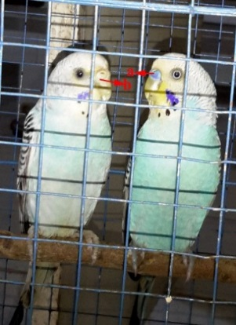
Figure 1.a. Blue colored cere in males and b. white colored cere in females

Chest, Mantle, Wing, and Rump-colored Feathers
The male chest feathers are a brighter blue than those of the female. The color of the mantle is predominantly black in males and blue in females. The rump feathers of males are a brighter blue than the females. The wings of males are predominantly black and light colored, whereas the wings of the female are black and white. Bendoy (2010) reported that the feathers on male parakeets are lighter and look more ornamental.
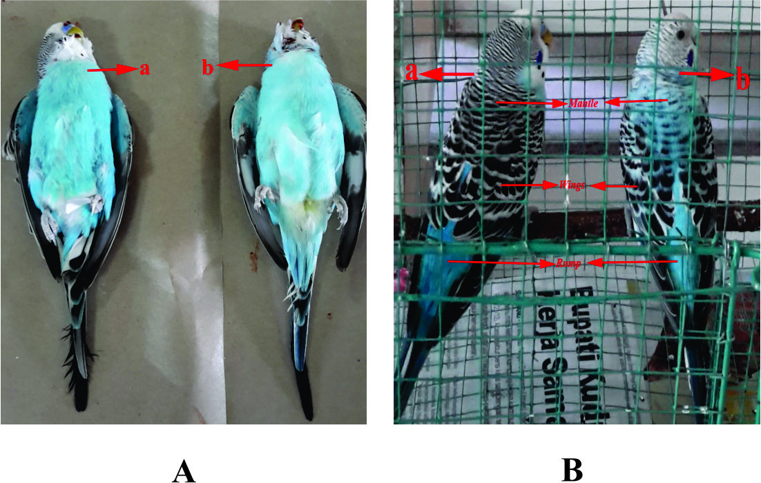
Figure 2. A. Color of the chest feather; B. color of the mantle, wings, and rump.

Verify Sex Determination in Male and Female Parakeets
We surgically identified five males and five females by their gonads (Figure 3).
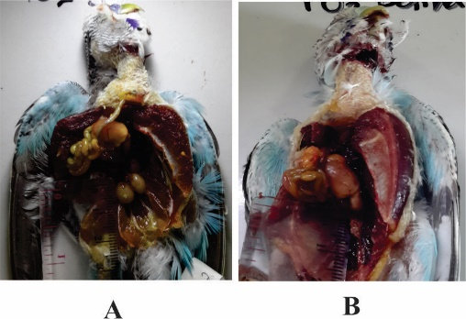
Figure 3. A. Testis and B. ovaries.

Conclusion
Parakeets (M. undulatus) can be identified as male and female based on the verification of sex. This is in accordance with the features contained in the cere, which is blue in males and white in females. The body of the male parakeet was longer than that of females, but body weight and length of the wings were larger and longer, respectively in females than males.

Acknowledgements
Authors thanks to Lembaga Penelitian dan Pengabdian kepada Masyarakat (LPPM), Diponegoro University for assisting with the English version of the manuscript.

References
Adajar, A., Torres, M. Demayo, C. 2011. Sexual Dimorphism in The Shape of The Primary Flight Feathers of Parakeet Budgerigar, Melopsittacus undulatus Shaw (1805). IPCBEE. 6: 333-337.
Bendoy, C.P., Torre, M.A., Tabugo, S.R., Demayo, C.G. 2010. Sexual Dimorphism in The Shape of The Primary Wing and Tail Feathers of The Sky Blue Parakeet (Budgerigar), Melopsittacus undulatus (Shaw, 1805) (Psittaciformes: Psittacidae). Egypt. Acad. J. biology. Sci. 2 (1): 51-58.
Calabuig, P.C., Green, A.J. Muriel, R., Katzenberger, M., Martines, J.P. and Moreira, H.M. 2013. Allometry as Evidence of Sexual Selection in Monochromatic Bird the Case of Coscoroba Swan (Anseriformes: Antidae). Zoologia. 30 (4) 424- 429.
Conrad, K.F. and Robertson, R.J. 1993. Relationship of Age and Sex to Size and Color of Eastern Phoebes. Wilson. Bull. 105 (4): 597-603.
Danner, R. and Luther, D. 2016. Males with Larger Bill Song at Higher Rates in a Hot and Dry Environment. American Ornithology. 133: 770-778.
Dewi, D.S., Kurtini, T. dan Riyanti, R. 2015. Characteritics and Behaviour of Males and Females Lovebird Species Agapornis Fishceri of Standard Green Variant. Jurnal Ilmiah Peternakan Terpadu. 3 (4): 228-233.
Hussain, M., Qasim, M., Ali, A., Syah, A., Aziz, S. and Mustafa, G. 2017. Breeding Rate and Mortality in Australian Parrot (Melopsittacus undulatus) in Captivity at Bahawal Pur, Pakistan. Pure App Biol. 6 (2): 511-515.
Nogueira, D.M. and Alves, M.A. 2008. Iris Color as An Indicator of Age Feature in female Brazilian Teenagers (Psseriformes: Emberizidae) Confirmed by A Molecular sexing Technique. Rev Biol. Trop. (Int. J. Trop. Biology). 56 (4): 1629-1633.
Nugroho, H.A. dan Zein, M.S. 2015. Evaluation Sexing Method on Black Caped Lory (Lorius lorry, Linnaeus 1758). Zoo Indonesia. 24 (2): 83-93.
Podos, J., Huber, S.K. and Taft, B. 2004. Bird Song: The interface of evolution and Mechanism. Annu.Rev.Ecol.Syst. 35: 55-57.
Pilastro, A., Farronoto, I. and Fracasso, G. The Use of Feather as a Method for Measuring the Wing Shape of Passerines. Avocetta. 19 (2): 213-218.
Roldan-Clara, B., Lopez-Medelin, X., Espejel, I. and Arellano E. 2014. Literature Review of the Use of Birds as Pets in Latin America, with a Detailed Perspective on Mexico. Ethnobiology and Conservation. 3 (5): 1-18.
Rose, K.A., Cod, J.R. and Nudds, R.L. 2016. Differential Sex-Specific Walking Kinematics in Leghorn Chickens (Gallus domesticus) Selectively Breed for Different Body Size. Journal of Experimental Biology. 219: 2525-2533.
Sinyo, B.A., Lambey, L., Kairupan, F., and Keintjem, J. (2014). Study on Feather Pattern and Colors of “Weris” Birds in City of Kotamobagu Sulawesi Utara. Jurnal Zootek. 34 (1): 124-139.
Yakubu, A. 2011. Discriminant Analysis of Sexual Dimorphism in Morphological Traits of African Muscovy Ducks. Arch. Zootec. 60 (232): 1115-1123.
Wallschlager, D. 1980. Correlate of song Frequency and Body Weight in Passerine Bird. Cellular and Molecular Life Sciences CMLS. 412.

