Utilization of Quercetin Flavonoid Compounds in Red Onion (Allium cepa L.) as Inhibitor of Spike Sars-Cov-2 Protein against ACE2 Receptors

Syifa Zahara Kultsum Azmi¹, Sunarno^{2*}, Sinta Aulia Rahmah³, Melisa Andriani⁴, Azlya Reza Lailul Farobi⁵, Luke Nur Ahlina⁶

^{1,2,3,4,5}Fakultas Sains dan Matematika, Universitas Diponegoro, Kampus Tembalang Semarang, 50275 – Indonesia
⁶Fakultas Teknik Universitas Diponegoro, Kampus Tembalang Semarang, 50275 – Indonesia
*Corresponding E-mail: sunarno@lecturer.undip.ac.id
ABSTRACT
The world is facing the challenge of the COVID-19 disease spreading, which is now statued as a pandemic. The main problem that causes this disease is the corona virus which attacks the respiratory system. The virus is a type of SARS-CoV-2 which belongs to the Betacoronavirus family, similar to the RNA sequences of SARS-CoV and MERS-CoV. Inside the host cell, the spike envelope protein (spike) of SARS-CoV-2 can interact with the Angiotensin-converting Enzyme 2 (ACE2) receptor. The penetration of SARS-CoV-2 into the human body can be inhibited by bioactive compounds such as flavonoids which have anti-viral effects. It is known that red onion (Allium cepa L.) contains an active compound which is classified as a flavonoid, namely quercetin which has a very broad pharmacological effect. This study aims to determine the spike protein inhibitory activity by quercetin against the ACE2 receptor using the molecular docking method. In this study, the flavonoid compound quercetin was extracted from onions using the maceration method to obtain flavonoid extracts. Furthermore, to prove the presence of quercetin content, quantitative analysis was carried out using a UV-Vis spectrophotometer. The absorbance was determined based on the measurement results on the UV-Vis spectrophotometer. The results of the quantitative analysis on the sample that onions contain a fairly high quercetin content. Furthermore, molecular docking simulations were carried out to look for the binding affinity between the spike protein and quercetin. Docking is carried out using the Autodock application, PyRx, and visualization using Discovery Studio. Indicators which prove that quercetin forms binding affinity and protein complexes with spikes are the Vina Score and RMSD values. Supported by ADME analysis and conformity to Lipinski's rules of five. That matter become a success indicator of the spike activity inhibition by quercetin, that makes it possible to be used as an anti-SARS-CoV-2 drug development agent.

Keywords: SARS-CoV-2, quercetin, maceration, docking, anti-SARS

INTRODUCTION
Acute respiratory infection, also known as SARS (Severe Acute Respiratory Syndrome), is an infectious disease that causes the respiratory system failure. This disease has basically never been identified in humans, but in certain animals as reservoirs. The case of COVID-19 appeared and attacked humans for the first time in Wuhan Province, China and entered Indonesia in mid-March 2020. The cause of COVID-19 is the SARS-CoV-2 virus or commonly called the corona virus, the virus will attack the respiratory system. Judging from many cases that have occurred, the virus can cause severe respiratory infections such as lung infections (pneumonia). Based on the grouping, SARS-CoV-2 belongs to the Coronaviridae family and the Betacoronavirus genus. Corona virus transmission starts from the respiratory route in the form of droplets and in many cases are caused by physical contact with sufferers (Xu et al., 2020). Inside the host cell, the spike envelope (S) protein of SARS-CoV-2 can interact with the Angiotensin-converting Enzyme 2 (ACE2) receptor (Zheng et al., 2020). Homolog of Angiotensin-converting Enzyme (ACE), name ly ACE2 can balance the function of ACE itself. The similarity of the nucleotide base sequence of the ACE2 receptor with the Angiotensin-converting Enzyme (ACE) is 42% (Zheng et al., 2020). In almost all tissues in the human body, ACE2 contained in type-1 membranes is expressed and activated (Long et al., 2020). The highest content of ACE2 is found in the respiratory, digestive, and heart tracts. Thus, an important role in the susceptibility and resistance to SARS-CoV-2 infection is held by genetic variations in the ACE2 receptor (Ikawaty, 2020; Magrone et al., 2020)
The interaction between ACE2 and the SARS-CoV-2 spike protein will be inhibited by using ARBs or Angiotensin Receptor Blockers. The role of ACE2 as a SARS-CoV-2 receptor has led many researchers to develop ways to inhibit the interaction between the S protein in SARS-CoV-2 and ACE2 (Bourgonje et al., 2020). Therefore, through this research, we are trying to develop the use of natural ingredients that could be used as a solution by utilizing the flavonoid compound quercetin in red onion to inhibit the interaction of the SARS-CoV-2 spike protein with ACE2 in the human body (Xu et al., 2020). This bioactive compound is believed to have anti-viral properties and based on its abundant availability it has the potential to be developed as an anti-SARS drug agent (Fischer et al., 1997; Parthasarathy et al., 2021). High levels of quercetin can be found in red onion plants (Schwartz and Sontag, 2011). Quercetin is classified as an antioxidant compound, so it could act as an inhibitor of the oxidation of other molecules (Spencer and Evans, 2004). With the chemical substructure of polyphenols, quercetin can take free radicals in the oxidative chain reaction so that the oxidation reaction could be stopped. In addition, it was reported that quercetin could change the activity of a number of proteins to be active or inhibited (Bao and Fenwick, 2004).
The main objective of this study is to analyze the inhibition process of the SARS-CoV-2 spike protein by quercetin in red onion (Allium cepa L.). This is a new innovation related to the supplements/drugs making based on natural ingredients from red onion as a preventive and therapeutic effort for SARS-CoV-2 in handling the pandemic. With this research, we expected to be able to provide information regarding on the use of quercetin compounds in red onion as an inhibitor of the SARS-CoV-2 protein S which has high affinity for the ACE2 receptor in the human body. The expected implication is the benefits that could be felt by community, such as disclose opportunities for the use of natural materials as a preventive action against corona virus infection in humans and encouraging creations that could be developed for further research.

MATERIALS AND METHODS

Equipment and Material Research
The tools used in this research include laptops, scientific journals, laboratory tools, spectrophotometers, AutoDock applications, Vina Wizard, PyRx, PyMol, and the Discovery Visualizer 2021 application. The materials used are 98% methanol solvent, 96% ethanol, 2% aluminum chloride , potassium acetate, yield of onion quercetin extract, 3D structure of protein S (GDP-ID: 6VSB), and quercetin (CID: 5320844).

Research Procedure
The research model which used is a blended research model that combines virtual and laboratory research models. Virtual research using the in silico method, namely molecular docking and laboratory research conducted at the Diponegoro University Integrated Laboratory. The time required for this research is 4 months.

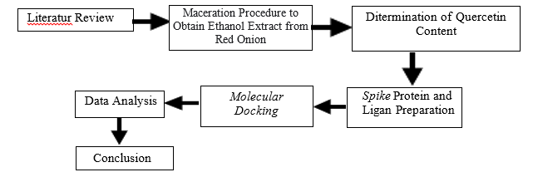
Figure 1. Research stages procedure

Literature Review
Literature review or literature studies in this research are carried out on references from journals, both national and international journals that support research needs. The literature taken is a literature which related to the interaction of quercetin compounds with spike proteins in SARS-CoV-2. This literature study is a source of support for laboratory research activities.

Maceration Procedure to Obtain Ethanol Extract from Red Onion
The red onion maceration process uses 96% methanol and 98% ethanol as solvents. This process aims to extract the quercetin contained in red onion using the solvent without a heating process. A total of 1 kg of red onions were roughly chopped using a chopper and then dehydrated using an oven at 46 degrees Celsius for 16 hours to maintain the flavonoid content in it. The simplicia powder obtained was filtered using a 100 mesh sieve and a dry powder with 300 grams net weight was obtained. The simplicia powder was soaked in a solvent and stirred periodically for 5 days. The liquid extract was collected and then concentrated using a rotary evaporator to obtain a thick extract (Aminah et al., 2017).

Ditermination of Quercetin Content of Methanol Extract of Red Onion Samples
The measurement of quercetin levels used a quercetin standard solution with concentration series of 6, 8, 10, 12, and 14 ppm. The absorbance was determined by the measurement results on a UV-Vis spectrophotometer. The standard curve is made to obtain a linear equation that will be used to determine the percent content. The wavelength absorption measurement uses a wavelength of 435 nm. This wavelength is used to measure the absorption of the ethanol extract of the red onion samples.

Spike and Ligand Protein Preparation
The 3D structure of the ligands was downloaded from the PubChem database page in .sdf format and converted to .pdb format with the PyMol application. The ligand used is quercetin (quercetin 4'-O-beta-glucoside) with CID code: 5320844. The receptor structure of SARS-CoV-2, namely glycoprotein spike protein or protein S, was taken from the 3D structure from the Protein Data Bank page with the code PDB- ID: 6VSB. The preparation of protein receptors and ligands was carried out with the AutoDock application by removing residues in the polypeptide chain, removing water, adding polar hydrogen along with gasteiger charges. The protein strand used is the A strand which is the active site of SARS-CoV-2 binding. After that, through the same application, the receptor proteins and ligands are converted into pdbqt extensions for docking.
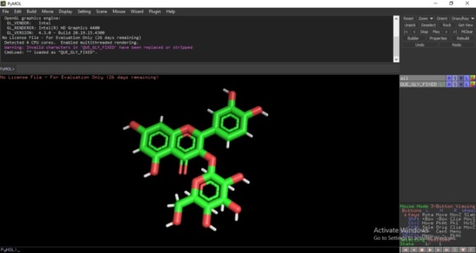

Figure 2. Quercetin visualitation

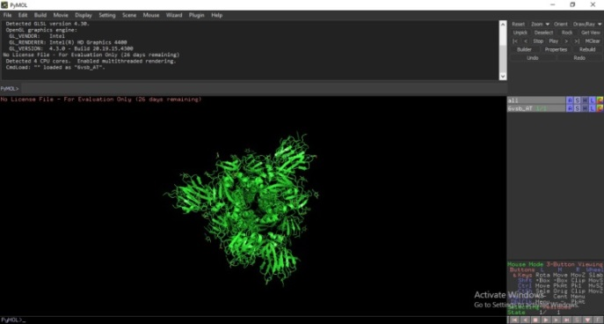

Figure 3. Spike protein visualitation

Molecular Docking
This study used a flavonoid class of phytochemicals, namely quercetin which was selected as a ligand to investigate its binding affinity to the SARS-CoV-2 spike protein A chain as a target receptor protein (Ge et al., 2013). The preparation of ligands and receptors was carried out using the AutoDock application, both the ligand and the receptor were removed from the water and then the polar poles and gasteiger charge were added. The docking process is carried out using the PyRx application which is integrated with the Vina Wizard. Grid set automatically by app with grid dimensions 82.89 Å , 79.91 Å , 168.06 Å (Kiran et al., 2020; Pandey et al., 2020).
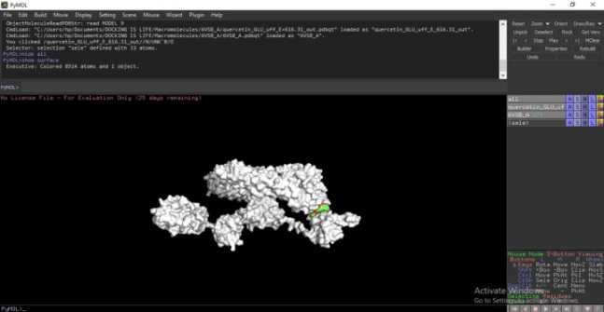

Figure 4. Visualitation of spike proteins with ligands

Data Analysis
Data analysis was carried out by reviewing the results of quantitative analysis of red onion flavonoid extracts that had been tested through the spectrophotometric stage. The indicators we analyze are wavelength, absorbance and standard curves. Analysis of molecular docking data was carried out by reviewing the docking results in the form of Vina Score and RMSD values. The Vina Score value states the binding affinity value between protein S and ligand interactions. The lower the bond energy, the greater the bond affinity. In this case, it could be concluded that the bond energy is inversely proportional to the bond affinity. Another thing that is also become a success indicator of molecular docking is by looking at the RMSD value. The RMSD value indicates the accuracy or validity of the molecular docking results (Kiran et al., 2020; Pandey et al., 2020). If the RMSD value is less than 2.0, then the docking result is declared valid.
The rules that define a bioactive can be categorized as having the opportunity to be developed as a drug development agent, namely in the form of absorption, distribution, metabolism, and excretion (ADME). In order to ensure the results of the docking analysis between protein S and quercetin that have been carried out have potential as an anti-SARS drug development, it must be ensured that the results meet Lipinski's five rules, namely; (a) molecular mass < 500 daltons, (b) degree of liposilicity expressed as LogP ≤ 5, (c) less than 5 hydrogen bond donors, (d) less than 10 hydrogen bond acceptors, (e) molar refractivity between 40 and 130. These parameters match the results of the ADME analysis (Pandey et al., 2020).

RESULT AND DISCUSSION

Literature studies or narrative studies are carried out by reviewing articles from journals and references that are related to the interaction of quercetin compounds with protein S in SARS-CoV-2. This literature study is a source of support for laboratory research activities. The results of our narrative study showed findings in the form of facts and secondary data, that quercetin is capable and potentially useful as an anti-SARS drug development agent because of its inhibitory properties. To prove this, we conducted a molecular docking study and laboratory experiments to collect primary data.
In the maceration process, which is processing the main ingredient in the form of 1 kg of red onions to be extracted with the help of methanol and ethanol extracting fluids, get results in the form of thick extracts. From the results of the maceration process that has been carried out, the next step is to measure the quercetin content in the thick methanol extract using a standard solution of quercetin with concentration series of 6, 8, 10, 12, 14 ppm. Those process obtained results as presented in Table 1.

Table 1. Quercetin content in thick methanol extract
Parameter analysis | Score | Unit
Total flavonoid | 4.245 | mg QE/g
 | 4.268

The liquid extract from the maceration was collected and then concentrated using a rotary evaporator to obtain a thick methanol extract. The results of maceration in the form of 30 grams of red onion quercetin extract then analyzed quantitatively using a spectrophotometer. The results are shown in Table 2.

Table 2. Results of quantitative analysis of quercetin samples with spectrophotometer.
Absorba nsi | Penimban gan (g) | Volume  add (mL) | Konsentra  si QE (ug/mL) | FP  (Pengen ceran) | ug QE/g | mg QE/g | Rata-rata
0.265 | 0.106 | 1 | 45.0 | 10 | 4245.283 | 4.245283 | 4.257075
0.267 | 0.106 | 1 | 45.3 | 10 | 4268.868 | 4.268868 | 4.257075

Quercetin chemically has the name 2-(3,4-dihydroxy phenyl)-3,5,7-trihydroxy4H-chromen-4-on Quercetin, which is a flavonol compound or is a flavonoid derived from plants, such as red onions (Patil et al., 2012). Based on Table 2 shows that quercetin obeys Beer Lambert's law, which is in the concentration range between 45.0-45.3 g/ml at a wavelength of 435 nm. Quercetin showed good linearity between concentration and absorbance. From these data it is evident that the UV Spectrophotometry method used for the determination of quercetin in shallot samples is simple, precise, and accurate.
Quercetin has been known to have various biological activities, such as antioxidant, anti-inflammatory, antiulcer, and neuroprotective effects. Shallots are a major source of quercetin and other flavonoid compounds. Quercetin is mostly bound to the sugar moiety in the form of quercetin glycosides, and its presence will increase when hydrolysis occurs by acidic compounds (Pandey et al., 2020). When the time used for the hydrolysis process is increased, there will be an increase in the total quercetin obtained. Acid hydrolysis was carried out in this study to convert the glycosidic form of quercetin into aglycone form. The total amount of quercetin increased in the extract after acid hydrolysis.
Molecular docking simulations used quercetin derived from the PubChem database with CID: 5320844, while the receptor was downloaded from the Protein Data Bank with PDB-ID: 6VSB. Both receptors and ligands were then prepared using the AutoDock application and their binding energy values ​​were measured using the Vina Wizard. Our visualization is carried out in the Discovery Studio Visualizer 2021 application.

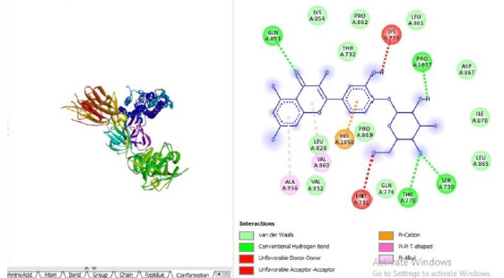

Figure 5. Molecular docking results visualization

Docking is carried out by the PyRx application and 9 conformations are formed automatically by the Vina Wizard. Quercetin showed the lowest and identical binding energy yield of -7.5 kcal/mol. According to this, quercetin forms hydrogen bonds with amino acids PRO 1057, SER 730, THR 778, GLN 853. In addition, it forms Pi-Alkyl bonds with amino acids VAL 860 and ALA 956. Pi-cation bonds are also found in amino acids HIS 1058. on the active group of the A strand of the SARS-CoV-2 spike protein.

Table 3. Vina score
Ligand | Binding Affinity (kcal/mol) | Mode | RMSD  Lower Bound | RMSD  Upper Bound
6VSB_A_Quercetin_GLU_uff_E_1 | -7.7 | 0 | 0.0 | 0.0
6VSB_A_Quercetin_GLU_uff_E_2 | -7.6 | 1 | 3.04 | 5.167
6VSB_A_Quercetin_GLU_uff_E_3 | -7.6 | 2 | 53.459 | 56.784
6VSB_A_Quercetin_GLU_uff_E_4 | -7.6 | 3 | 51.061 | 54.975
6VSB_A_Quercetin_GLU_uff_E_5 | -7.5 | 4 | 1.896 | 10.009
6VSB_A_Quercetin_GLU_uff_E_6 | -7.4 | 5 | 66.8 | 68.356
6VSB_A_Quercetin_GLU_uff_E_7 | -7.4 | 6 | 1.602 | 10.019
6VSB_A_Quercetin_GLU_uff_E_8 | -7.3 | 7 | 46.83 | 48.736
6VSB_A_Quercetin_GLU_uff_E_9 | -7.3 | 8 | 52.977 | 55.64

Molecular docking analysis in tracing the bioactive compound quercetin shows promising activity against the ligand-protein S protein complex. Thus, in order to get a better understanding about the conformational stability of ligand binding and the contribution of the active site in terms of binding free energy, we performed molecular docking simulations in the dissolved state at physiological temperature for 100 ns. The mediated interactions and the contribution of the binding energy of the amino acids were calculated using MM-PBSA. To investigate the overall conformational dynamics and stability of the S-ligand protein complex, we calculated the RMSD value relative to the initial structure as the basis for all residues. The RMSD value obtained is 1.896, so it can be concluded that the results of the molecular docking are valid. The bioactive compound selected as the ligand, namely quercetin, is found to meet the criteria required by Lipinski's five rules based on the results of ADME analysis; (a) a molecular mass of 302 daltons, (b) a degree of liposilicity expressed as LogP 2, (c) 5 hydrogen bond donors, (d) 7 hydrogen bond acceptors, and (e) a molar refractivity of 74.

CONCLUSION
Research which carried out in a new system and model, namely blended research, is a solution to the limitations for researchers during a pandemic. Through this method we were able to search, find, and analyze candidate of bioactive compounds that have the potential to develop as anti-SARS-CoV-2 drugs. This study describes the fact that red onions contain quercetin compounds seen from the results of maceration and spectrophotometric quantitative analysis. It was proven and supported by the results of molecular docking analysis which showed a good binding affinity between spike protein and quercetin. Our result from the research are supported by other analyzes such as analysis of RMSD values, ADME, and Lipinski's five rule reference. Furthermore, our results from the research show that this bioactive fulfills Lipinski's five rule criteria so that it is evident that quercetin has the opportunity to be used as an anti-SARS-CoV-2 drug development agent. Therefore, it is need to conduct a further in vitro studies to verify our findings.

KNOWLEDGEMENT

We would like to thank the Directorate General of Learning and Student Affairs, Ministry of Research, Technology and Higher Education of the Republic of Indonesia for funding the 2021 Research Student Creativity Program so that the results of this research can be published.
REFERENCE

Aminah, A., Tomayahu, N., and Abidin, Z. 2017. Penetapan kadar flavonoid total ekstrak etanol kulit buah alpukat (Persea americana Mill.) dengan metode spektrofotometri UV-Vis. Jurnal Fitofarmaka Indonesia, 4(2): 226-230.
Bao, Y., and Fenwick, R. 2004. Phytochemicals in Health and Disease. CRC Press, New York.
Bourgonje, A. R., Abdulle, A. E., Timens., and Hillebrands, W. J. 2020. Angiotensin-converting enzyme-2 (ACE2), SARS-CoV-2 and pathophysiology of coronavirus disease 2019 (Covid-19). J Pathol, 251(3): 228-248. doi: 10.1002/path.5471.
Fischer, C., Speth, V, Fleig-Eberenz, S., and Neuhaus, G. 2017. Induction of zygotic polyembryos in wheat: influence of auxin polar transport.’, The Plant Cell, 9(10): 1767-1780.
Ge, X. Y., Li, J., Yang, X. L., Chmura, A., Zhu, G., Epstein, J. H., Mazet, J. K., Hu, B., Zhang W., and Peng C., 2013. Isolation and characterization of a bat SARS-like coronavirus that uses the ACE2 receptor. Nature, 503: 535-538. doi: 10.1038/nature12711. Ikawaty, R. 2020. Dinamika interaksi reseptor ACE2 dan SARS-CoV-2 terhadap manifestasi klinis Covid19. Keluwih: Jurnal Kesehatan dan Kedokteran, 1(2): 70-76. doi: 10.24123/kesdok.v1i2.2869.
Kiran, G., Karthik, L., Devi, M. S. S., Sathiyarajeswaran, P., Kanakavalli, K., Kumar, K. M., and Kumar, D. R. 2020. In silico computational screening of Kabasura Kudineer-official Siddha formulation and JACOM against SARS-CoV-2 spike protein. Journal of Ayurveda and Integrative Medicine, S0975-9476(20): 30023-30024. doi: 10.1016/j.jaim.2020.05.009.
Long, B., Brady, W. J., Koyfman, A., and Gottlieb, M. 2020. Cardiovascular complications in COVID-19. Am J Emerg Med, 38(7): 1504-1507. https://doi.org/10.1016/j.ajem.2020.04.048.
Magrone, T., Magrone, M., and Jirillo, E. 2020. Focus on receptors for coronaviruses with special reference to angiotensin-converting enzyme 2 as a potential drug target a perspective. Endocr Metab Immune Disord Drug Targets, 20(00): 1-5.

Pandey, J., Bastola, T., Tripathi, J., Tripathi, M., Rokaya, R. K., Dhakal, B., Rabin, D. C., Bhandari, R., and Poudel, A. 2020. Estimation of total quercetin and rutin content in malus domestica of nepalese origin by hplc method and determination of their antioxidative activity. Journal of Food Quality, Article ID 8853426, https://doi.org/10.1155/2020/8853426.
Pandey, P., Rane, J. S., Chatterjee, A., Kumar, A., Khan, R., and Prakash, A. 2020. Targeting SARS-CoV-2 spike protein of COVID-19 with naturally occurring phytochemicals: an in silico study for drug development. Journal of Biomolecular Structure and Dynamics, pp. 1-11. https://doi.org/10.1080/07391102.2020.1796811.
Parthasaranthy, R., Mathew, M., Koshy, P., Babu, M., and Abraham, G. 2021. Traditional medicines prescribed for prevention of COVID-19: Use with caution. Nephrology (Carlton), 10.1111/nep.13947. doi: 10.1111/nep.13947.
Patil, S. J., Salunkhe, V. R., and Alai, M. H. 2012. Estimation of quercetin in ayurvedic proprietary medicine by uvspectrophotometry. International Journal of Pharmacy and Pharmaceutical Sciences, 4(3): 1-3.
Petrus, K., Schwartz, H., and Sontag, G. 2011. Analysis of flavonoids in honey by HPLC coupled with coulometric electrode array detection and electrospray ionization mass spectrometry. Analytical and Bioanalytical Chemistry, 400(8): 2555-2563.
Williams, R. J., Spencer, J. P. E., and Evans, R. C. 2004. Flavonoids: antioxidants or signalling molecules?. Free Radical Biology and Medicine, 36(7): 838-849.
Xu, J., Zhao, S., Teng, T., Elgaili, A., Zhu, W., Xie, L., Wang, Y., and Guo, X. 2020. Systematic comparison of two animal-to-human transmitted human coronaviruses: SARS-CoV-2 and SARS-CoV’, Viruses, 12(2): 244. doi: 10.3390/v12020244.
Xu, X., Chen, P., Wang, J., Feng, J., Zhou, H., and Li, X. 2020. Evolution of the novel coronavirus from the ongoing Wuhan outbreak and modeling of its spike protein for risk of human transmission. Sci China Life Sci, 63(3): 457-60.
Zheng, Y. Y., Ma, Y. T., Zhang, J. Y., Xie, X. 2020. Reply to: Interaction between RAAS inhibitors and ACE2 in the context of COVID-19. Nature Reviews Cardiology, 17(5): 313–314.

