Types of Rats and Their Parasites That Potential to Transmit Disease in Tugu District, Semarang City
Ning Setiati*, Rusyda Auliya, Partaya, F Putut Martin H B, Dyah Rini Indiyanti, Priyantini Widiyaningrum
Biology Department, Faculty of Mathematics and Natural Science, State University of Semarang, Indonesia
*Corresponding Author: ningsetiati@mail.unnes.ac.id

Abstract. Rats are known as vectors and reservoirs for various types of ecto- and endoparasites. The existence of rats as cosmopolitan animals allows for complex parasitic transmission due to the relationship between humans, animals, and the environment. This study aimed to provide informative data on the types of rat along with their ecto- and endoparasites. This research is a qualitative descriptive study. Data collection was carried out by random sampling survey with a point time approach. Data collection was carried out in 4 villages, namely Tugurejo, Mangkang Wetan, Mangunharjo, and Mangkang Kulon Villages, Tugu District, Semarang City. A total of 89 rats were obtained, the species obtained were R. norvegicus, R. argentiventer, R. exulans, R. tiomanicus, R. surifer, R. tanezumi, B indica, and S. murinus. Ectoparasite infestation was found in all types of rats except S. murinus. The ectoparasites found were, Xenopsylla cheopis and Laelaps echidninus which were reported as the main vectors of murine typhus, epidemic typhus, bartonellosis as well as scrub typhus and Q-fever disease. Endoparasite infestation was found in the intestinal organs, namely Diphyllobothrium sp. and two species of worm eggs Hymnoepis sp. and Trichuris trichiura which were reported as the cause of Diphyllobothriasis which cause anemia, diarrhea, and iron deficiency, that leads to malnutrition. Diphyllobothriasis is not transmitted from person to person, more than one family member can be infected by sharing common meals and having similar eating habits. This study can be used as an early warning for community against the potential of infectious diseases from rats as vectors in Tugu District, Semarang, related to rats density, their ectoparasites, and endoparasites.
Key words: Ectoparasite; Endoparasite; Parasite; Rat

INTRODUCTION

Rats are the order Rodentia which belongs to the group of small mammals that act as vital components in various ecosystems, that play a role as prey or predators as well as carriers and reservoirs of disease. Rats are known as a source of disease due to the interactions of rats with pathogenic organisms, and their physicochemical environment. They are also known to harbor a number of ecto- and endoparasites. Ectoparasites such as fleas, ticks, and mites can be pathogenic to humans and animals. Parasite eggs in rodents are also responsible for the spread of disease (Sharma et al., 2013). There are several reasons why humans can be involved in the cycle of disease transmission from rats, including, humans by chance entering the area where the disease is transmitted, the migration of infective wild rats from outside the house (forest, gardens/fields, sewers) into the residential environment, and the contact between an infected human with healthy humans (Ristiyanto et al., 2014).
The presence of rats either inside or around the house has a statistical relationship with the incidence of zoonotic cases (Ahmad et al., 2014). Transmission of disease from rat can be caused by contact between humans and rats, either through feces, urine, or rat bites. The interaction between rats and humans either directly or indirectly is when there is an increase in population which results in a decrease in the proportion of land that was previously a habitat for wild animals to become residential areas (Hamidi et al., 2015). This is supported by the fact that rats are cosmopolitan animals with high adaptability that can live in all places. Rats also have a high breeding power and are known as omnivorous animals that eat all kinds of food, including all food eaten by humans (Ahmad et al., 2014).
Urban areas can be a habitat for wild rats (Kusuma et al., 2021). This is related to the phenomenon of slum settlements that arise due to the increasing demand for land in urban areas along with an increase in the number of people living in cities (Hanifah & Widiyastuti, 2015). Slums with poor sanitation and large piles of garbage due to a lack of public awareness of cleanliness make it a place favored by rats (Dewi et al., 2020).
Tugu District is located at the western end of Semarang City which is growing rapidly as a potential area for industrial, trading, and service activities. A study on rats in Tugu District needs to be carried out to minimize the risk of disease transmission to humans, taking into account several aspects based on the Semarang City SPPIP including fairly dense settlements, quite large amount of waste generated, an inadequate quantity of waste facilities, and the waste disposal system is incomplete and not managed properly. This study aimed to provide informative data on the types of rats and ecto- and endoparasites found in the Tugu District, Semarang City.
The findings of the study are intended to aid Semarang Health Office in rat eradication efforts, which include both therapeutic and preventive measures. Curative activity in form of community socialization in order to maintain environmental health and prevent the spread of disease caused by rats. To lower the number of rats in Semarang, particulary in Tugu District, preventive measures such as employing live traps, poison, and rat glue have been implemented.

METHODS

The type of this research is descriptive qualitative research. This study does not have a hypothesis, but only describes an object as it is systematically by emphasizing factual data. Data collection was carried out by random sampling survey with a point time approach. The data studied were data from samples of rats caught in Tugu District, Semarang City.

Sampling location
The study was conducted in July – August 2021. The rats were caught using a single live trap in four villages, namely Tugurejo, Mangkang Wetan, Mangunharjo, and Mangkang Kulon. The installation of rat traps using area sampling technique in one district, was only carried out in one area (Rukun Warga/RW) (Dewi et al., 2020). The bait used was grilled coconut or salted fish. The use of both types of bait is based on a study conducted by (Siswandeni, 2020), which stated that there was no significant difference in the use of grilled coconut or salted fish in the success of rat capture. So that the use of grilled coconut and salted fish was adjusted to the information obtained from the local community about the bait that is preferred by rats. Trap installation was carried out in the afternoon and then was taken on the next day starting at 06.00 Western Indonesian Time (WIB). In capturing the rats in houses, two traps used were placed in the warehouse, kitchen, or places that were thought to be frequented by the rats. For catching the rats outside the house area, one trap was installed in an area of 10m² (Astuti, 2013).

Animal identification
The captured rats were anesthetized with ketamine at a dose of 100 mg/KgBW (Musterman, 2016; Yuliadi et al., 2016). Identification of rats was carried out by measuring body morphometry and physical observations. The measurements taken were the measurement of body weight, body length, tail length, ear length, and hind foot length. The process of identifying rats was carried out at the Laboratory of Animal Taxonomy, Department of Biology, State University of Semarang, referring to the “Rodent in Java” book (Suyanto, 2006)

Examination and identification of ectoparasites
Ectoparasites in rat were collected by combing the body hair with a brush in opposite directions. The inner ear was scraped with a cotton swab to collect mite larvae if present. The ectoparasites obtained were put in a vial containing 70% alcohol accompanied by an identity label. The ectoparasites were then observed with a stereo microscope to distinguish between soft-skinned ectoparasites such as ticks, mites, and ticks with hard-skinned ectoparasites such as fleas (Yuliadi et al., 2016). Examination of ectoparasites was based on Ristiyanto method, the method of study was by wire trap and ectoparasite processing by combing the hair (Ristiyanto et al., 2014). Soft-skinned ectoparasites were immersed in 95% alcohol for 3 minutes, then the abdomen was pierced. The specimens were washed with distilled water for 2 repetitions and then immersed in 50%, 80%, 95%, and absolute alcohol for 10 minutes each. The specimen was placed on a microscope slide and carefully covered with a cover glass using a needle. Meanwhile, hard-skinned ectoparasites were immersed in 10% KOH solution for 24 hours. The specimens were then transferred to distilled water for 5 minutes, then placed in acetic acid solution for 30 minutes. Specimens were observed by placing them on a microscope slide with a binocular microscope. Identification of ectoparasites referred to the book titled “Rodentia Infectious Diseases” (Ristiyanto et al., 2014).

Examination and identification of endoparasites
Endoparasites were collected surgically, by cutting along the stomach and then the liver, intestines, and stomach of the rats. They were then taken and put in a vial containing 70% alcohol and brought to the laboratory for further examination. Examination of adult endoparasites was carried out with a stereo microscope. The endoparasites found were put into 70% glycerin alcohol solution for 2 hours to dissolve the cuticle then transferred to semichon’s carmine dye solution for 20 minutes, then clarified in 70%, 80%, 90%, and absolute alcohol. The well-stained specimens were placed on a microscope slide to be observed under a binocular microscope (Ristiyanto et al., 2014; Yuliadi et al., 2016).
Examination of worm eggs was carried out by the floating method (Sheather's sugar solution) (Yang & Liang, 2015). Feces from the digestive tract were taken and then homogenized in a saturated sugar solution. The faecal solution was then filtered and poured into a test tube until it was full and formed a convex above it. The cover glass was affixed to the convex and waited for 10 minutes, then the cover glass was attached to the microscope slide so that the sample can be observed.

RESULTS AND DISCUSSION

A total of 89 rats caught in this study were from 7 species of rats and 1 species of shrew. The species identified were including Rattus norvegicus, Bandicota indica, Rattus argentiventer, Rattus exulans, Rattus tiomanicus, Rattus surifer, Rattus tanezumi, and Suncus murinus. The most commonly found species was Rattus norvegicus or known as the sewer rat because it is often found in drains / sewers in urban residential areas and markets (Ristiyanto et al., 2014).

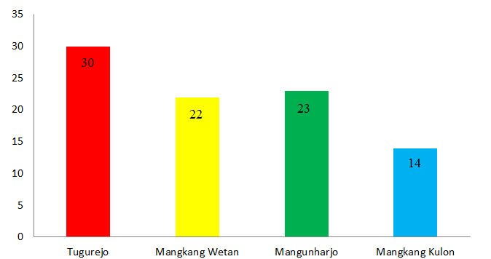
Figur 1. Number of rats caught in 4 villages.

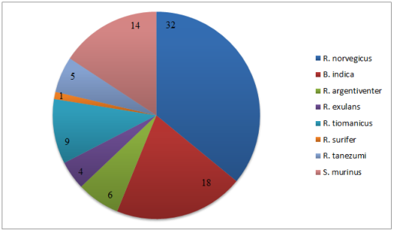
Figure 2. Total species of rats caught in 4 villages.

Based on the location of the trap, more rats were trapped in the trap outside the house. Even though the condition of the houses at the research site was dense and close to each other, the facts show that the existing houses are in moderate condition. The condition of the feasibility of the building is said to be moderate when the roof is made of tile, the house has cement floors, walls, the division of space in the house is quite clear, and the lighting is relatively moderate – good (Hanifah & Widiyastuti, 2015). The physical condition of the building is quite good as evidenced by the small number of Rattus tanezumi species caught. In several similar studies Rattus tanezumi was found more than the other species. This species is known as the house mouse which is often found on roofs, rooms, and warehouses. The poor and dense housing conditions greatly facilitate the mobilization of these rats (Juhairiyah et al., 2021).
Another cause of the presence of rats is the lack of public awareness of the cleanliness of the surrounding environment, causing a lot of piles of garbage such as along roadsides and in the corners of bush areas. This condition is getting worse due to the waste system that is not managed properly. Garbage that accumulates can cause clogged drains. The resulting damp and dirty conditions can be used as a habitat for wild rats.

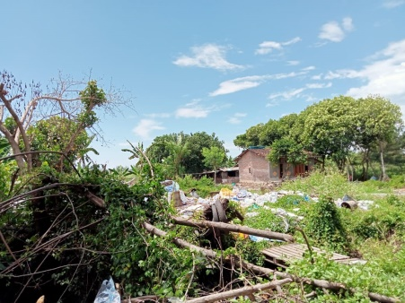
(a)

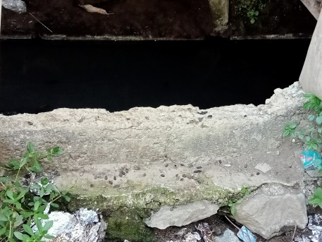
(b)
Figure 3. (a) Conditions around the house that have a lot of garbage piles (b) Flooded gutters and traces of rat droppings.

The results of the calculation of the Shannon-Wiener diversity index showed that the value of 1 ≤ H’ ≤ 3 is moderate diversity. Based on this interpretation, it can be seen that the diversity of rats caught in Tugu District, Semarang City is moderate, with the highest value was obtained from Tugurejo Village while the lowest value was from Mangkang Wetan Village. The results of the calculation of the evenness index showed that there is no significant difference in the four villages. This result shows that the evenness index value of the species is quite stable.
The diversity of rat species is strongly influenced by habitat characteristics, such as vegetation cover, the availability of food and safe shelter, and the level of human intervention. Based on several previous studies, rat caught in the area tends to have a low - medium diversity index value with a stable evenness value. Rat can adapt to the human environment because of the abundant and easily available food source (Chaudhary et al., 2017).
(a)
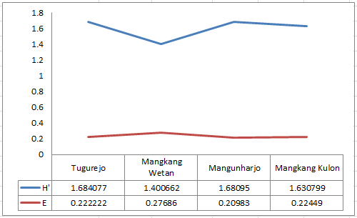

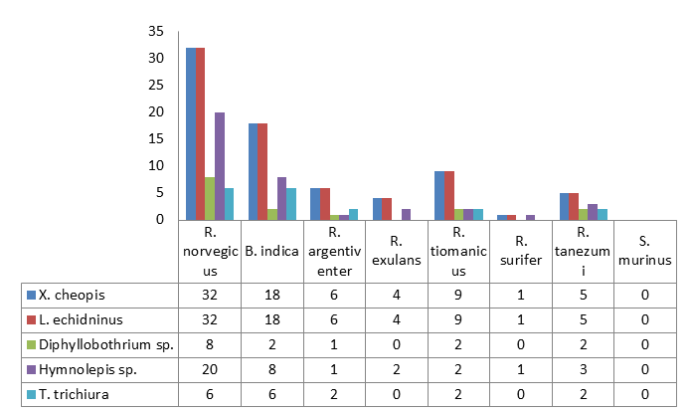
(b)
Figure 4. (a) Diversity index and evenness index of rats in Tugu District, Semarang City (b) Infestation of ecto- and endoparasites in rats.

Two species of ectoparasites found were fleas (Xenopsylla cheopis) and rat mites (Laelaps echidninus). Ectoparasite infestation was found in all types of rats caught except Suncus murinus. Rats different from shrews based on the shape of the snout, body size, and tooth structure (Suyanto, 2006). The hair structure of shrews is shorter, finer, and quite dense compared to rat, which is the cause of the absence of ectoparasites in shrews (Dewi et al., 2020).
(c)
(b)
(a)
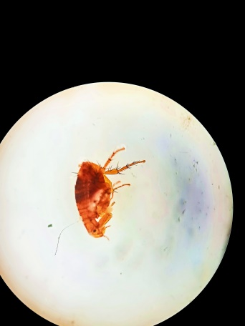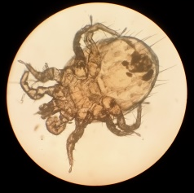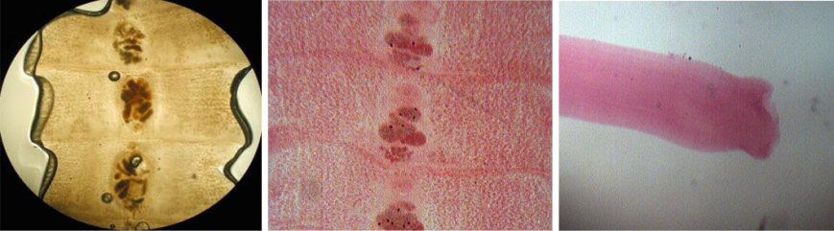
(e)
(d)
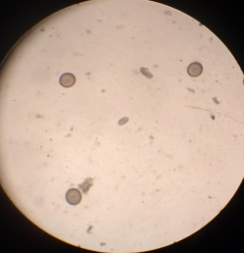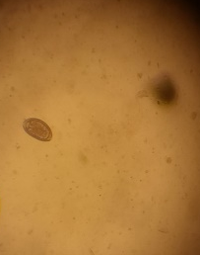
Figure 5. Ecto- and endoparasites found (a) Xenopsylla cheopis (b) Laelaps echidninus (c) Diphyllobothrium sp. (d) Hymenolepis sp. (e) Trichuris trichiura.

Fleas are holometabolous insects that go through 4 stages in their life development, i.e. egg – larva – pupa - adult. It has a body size of 2-10 mm and is not winged. Fleas can jump using their powerful hind legs up to 150 times their body length (Wells & Elston, 2020).
The relationship between rat and fleas is classified as an obligate (temporary) ectoparasite interaction (Ristiyanto et al., 2014), where the adult fleas always live attached to the surface of the host's body, while the immature stage lives independently from the host. Fleas like mammals living in nests, holes, or caves and away from direct sunlight. So it is very possible for rat to become the hosts of fleas.
Several studies in the health sector reveal that not all fleas have an important role in transmitting disease to humans. The flea species Xenopsylla cheopis has been reported as the main vector of murine typhus, epidemic typhus, and bartonellosis. Xenopsylla cheopis is also the most commonly found species as a vector in the world, including Indonesia. Murine typhus is transmitted from flea feces containing R. typhi bacteria through breathing or entering through bite wounds (Joharina et al., 2016).
Rat mites are cosmopolitan so it is possible for all types of rat to be infested with mites. Mites in rat are most often found swarming between the hairs, especially on the posterior back and thighs. Laelaps echidninus acts as a vector for murine typhus and a potential reservoir of other rickettsial diseases such as scrub typhus and Q-fever disease (Annashr et al., 2011).
The species of endoparasites (adult worms) found from intestinal organs were Diphyllobothrium sp. and two species of endoparasites found in faecal samples including Hymnolepis sp. and Trichuris trichiura based on the 2019 Atlas of Medical Parasitology (Surja & Wijaya, 2019). Diphyllobothrium sp. belongs to the Cestoda class which can cause Diphyllobothriasis. Rats can be infected with this type of worm by eating fish or crustaceans that have been infected with Diphyllobothrium sp. so that later it will grow up in the intestines of rat. Several studies have shown that this worm can be found in other animals such as fish (Gustinelli et al., 2016) and cats (Yudhana & Praja, 2017).
The tapeworm that is often found in rats is the small tapeworm Hymenolepis sp.This parasitic worm is an inhabitant of the intestine with a ribbon shaped and transverse stripes. Mature proglottids will break down in the intestine and free eggs, then come out with feces which when swallowed by a new host, the oncosphere will grow into cysticercoid larvae and adhere to the mucosa, then grow into adult worms (Widiastuti et al., 2016). These worms can cause internal autoinfection, i.e. eggs that are free in the intestine can hatch and become worms in the same host (Ristiyanto et al., 2014).
Trichuris trichiura is a nematode also known as whipworm that lives in cecum, large intestine, and rectum. The eggs are elongated or spherical in shape with an operculum at both ends, and are higly resistant to environmental conditions. This nematode commonly seen in tropical climates and in area where sanitation is pooor (Waugh et al., 2006). This worm infection in humans, especially children affects digestion, absorption, and food metabolism which can result in the loss of large amounts of protein, carbohydrates, fat, and blood (Siregar, 2016).
This study showed that the presence of rats in the house environment indicates a close relationship between rats and humans, so that there is a potential for disease transmission through rats to humans. Although previously there were no reports of disease transmission to humans, the facts show that some local people are sometimes bitten by rats. Although it does not show significant symptoms, there is a need for further studies on parasites in rats in urban areas. The number of ectoparasites and endoparasites detected based on rats type seized in Tugu District has potential to cause zoonotic diseases. The surrounding community must work to reduce rat population by trapping rats on regular basis and placing rat traps in areas where rats are likely to congregate.

CONCLUSION

The rat species caught in this study were R. norvegicus, R. argentiventer, R. exulans, R. tiomanicus, R. surifer, R. tanezumi, B. indica, and S. murinus. Ectoparasite (Xenopsylla cheopis and Laelaps echidninus) infestation was found in all types of rats except S. murinus. Endoparasite (Diphyllobothrium sp., Hymnolepis sp., and Trichuris trichiura) infestation was found in rats’ intestinal organs.

REFERENCES

Ahmad, M. S., Maqbool, A., Anjum, A. A., Ahmad, N., Khan, M. R., Sultana, R., & Ali, M. A. (2014). Occurance of Hymenolepis Diminuta in rats and mice captured from urban localities of Lahore, Pakistan. Journal of Animal and Plant Sciences, 24(2), 392–396.
Annashr, N. N., Santoso, L., & Hestiningsih, R. (2011). Study of Rats and Ectoparasites Density in the Village Jomblang, Candisari District, Semarang City, 2011. Academia, 3(2), 2087 - 2095.
Astuti, D. R. (2013). Keefektifan Rodentisida Racun Kronis Generasi Ii Terhadap Keberhasilan Penangkapan Tikus. KEMAS: Jurnal Kesehatan Masyarakat, 8(2), 183–189. https://doi.org/10.15294/kemas.v8i2.2820
Chaudhary, V., Tripathi, R. S., Koodi, H. L., & Singh, L. (2017). Diversity and distribution of rodent community in cold arid ecosystem of Leh, Jammu & Kashmir, India. Journal of Experimental Zoology of India, 20, 1371–1376.
Dewi, W. M., Partaya, P., & Susanti, S. (2020). Prevalensi Ektoparasit Pada Tikus Sebagai Upaya Pemetaan Risiko Zoonosis Di Kawasan Rob Kota Semarang. Jurnal Ekologi Kesehatan, 18(3), 171–182. https://doi.org/10.22435/jek.v3i18.2133
Gustinelli, A., Menconi, V., Prearo, M., Caffara, M., Righetti, M., Scanzio, T., Raglio, A., & Fioravanti, M. L. (2016). Prevalence of Diphyllobothrium latum (Cestoda: Diphyllobothriidae) plerocercoids in fish species from four Italian lakes and risk for the consumers. International Journal of Food Microbiology, 235, 109–112. https://doi.org/10.1016/j.ijfoodmicro.2016.06.033
Hamidi, K., Nourani, L., & Moravvej, G. (2015). The relationship of ectoparasite prevalence to the capturing season, locality and species of the murin rodent hosts in Iran. Persian Journal of Acarology, 4(40023), 409–423. https://doi.org/10.22073/pja.v4i4.13759
Hanifah, W., & Widiyastuti, D. (2015). Penilaian Lingkungan Fisik Permukiman Kumuh di Kawasan Pesisir Kota Semarang. Jurnal Bumi Indonesia, 5(1), 1–10.
Joharina, A. S., Mulyono, A., Sari, T. F., Rahardianingtyas, E., Wicaksonoputro, D. B., Pracoyo, N. E., & Ristiyanto, R. (2016). Rickettsia pada Pinjal Tikus (Xenopsylla Cheopis) di Daerah Pelabuhan Semarang, Kupang dan Maumere. Buletin Penelitian Kesehatan, 44(4). https://doi.org/10.22435/bpk.v44i4.4920.237-244
Juhairiyah, J., Hairani, B., Annida, A., & Fakhrizal, D. (2021). Keberadaan Ektoparasit Dan Endoparasit Pada Tikus Di Daerah Pesisir Pantai Desa Juku Eja. Prosiding Seminar Nasional Kesehatan Masyarakat Universitas Muhammadiyah Surakarta 2015. https://publikasiilmiah.ums.ac.id/xmlui/handle/11617/12488
Kusuma, S., Yesica, R., Bagus Gde Rama Wisesa, I., Hermanto, J., Nurholizah, Y., & Widyaneni Trinastuti, M. (2021). Preliminary Study: Detection of Ecto and Endoparasites Among Wild Rats From Urban Area in Blimbing, Malang, East Java. Acta VETERINARIA Indonesiana, May, 95–101. https://doi.org/10.29244/avi...95-101
Manyullei, S., Natsir, MF., Batkunda, A., (2020). Identification of Rat Density and Ectoparasites in Seaport Area of Manokwari, Papua Province. Macedonian Journal of Medical Sciences. 8(E), 204 - 208 https://doi.org/10.3889/oamjms.2020.4234. 204-208
Marbawati, D & Ismanto, H (2011). Pengawetan Tikus (Hasil Pelatihan di Laboratorium Mamalia Lembaga Pengetahuan Indonesia Jakarta) BALABA : 7(2). https://doi.org/10.22435/blb.v7i2.1333 49-52

Musterman, M. (2016). Rat and mouse anasthesia and analgesia formulary and general drug information. 1–14. https://animalcare.ubc.ca/sites/default/files/documents/Guideline - Rodent Anesthesia Analgesia Formulary %282016%29.pdf
Nugroho, R. A., Manurung, H., Saraswati, D., Deasy, L. D., & Nur, F. M. (2016). The Effect of Terminalia catappa L. Leaves Extract on the Water Quality Properties, Survival ana Blood Profile of Ornamental Fish (Betta sp.) Cultured. Biosaintifika, 8(2), 240 - 247
Prasetio, A., & Setiati, N. (2016). Keanekaragaman Jenis Tikus dan Cecurut di Gunung Ungaran Jawa Tengah. Unnes Journal of Life Science 4(1) 54-59
Ristiyanto, Mulyono, A., Agustina, M., Yuliadi, B., Muhidin ( 2009) Indeks Keragaman Ektoparasit pada Tikus Rumah Rattus Tanezumi Temminck, 1844 dan Tikus Polinesia R. Exulans (Peal, 1848) di Daerah Enzootik Pes Lereng Gunung Merapi, Jawa Tengah. Jurnal Vektora 1 (2) 74-84
Ristiyanto, Handayani, F. D., Boewono, D. T., & Heriyanto, B. (2014). Penyakit Tular Rodensia. Yogyakarta: Gadjah Mada University Press.
Sharma, D., Joshi, S., Vatsya, S., & Yadav, C. L. (2013). Prevalence of gastrointestinal helminth infections in rodents of Tarai region of Uttarakhand. Journal of Parasitic Diseases, 37(2), 181–184. https://doi.org/10.1007/s12639-012-0158-4
Siregar, C. D. (2016). Pengaruh Infeksi Cacing Usus yang Ditularkan Melalui Tanah pada Pertumbuhan Fisik Anak Usia Sekolah Dasar. Sari Pediatri, 8(2), 112. https://doi.org/10.14238/sp8.2.2006.112-7
Siswandeni, B. (2020). Perbedaan Umpan Kelapa Bakar Dan Ikan Asin Bulu Ayam Dalam Penangkapan Tikus. Jurnal Penelitian Kesehatan (JPK), 18(2), 8–11. https://doi.org/10.35882/jpk.v18i2.3
Suyanto, A. (2006). LIPI- Seri Panduan Lapangan, Rodent di Jawa. Bogor: Pusat Penelitian Biologi Lembaga Ilmu Pengetahuan Indonesia.
Waugh, C. A., Lindo, J. F., Foronda, P., Santana, M. A., Morales, J. L. & Robinson, R. D. (2006). Population Distribution and Zoonotic Potential of Gastrointestinal Helminths of Wild Rats R. rattus and R. norvegicus from Jamaica. Journal of Parasitology, 92(5), 1014 - 18
Wells, L. E., & Elston, D. M. (2020). What's Eating You? Oriental Rat Flea (Xenopsylla cheopis). Close Encounters with The Environment, 106(3), 124 - 126. https://doi.org/10.12788/cutis.0072
Widiastuti, D., Pramestuti, N., Astuti, N. T., & Tika Fiona Sari, T. F. (2016). Infeksi Cacing Hymenolepis nana dan Hymenolepis diminuta pada Tikus dan Cecurut di Area Pemukiman Kabupaten Bnayumas. Vektora, 8(2), 81 - 90. https://doi.org/10.22435/vk.v8i2.5319
Yang, Y., & Liang, H. (2015). Prevalence and risk factors of intestinal parasites in cats from china. BioMed Research International, 2015, 1–6. https://doi.org/10.1155/2015/967238
Yudhana, A., & Praja, R. N. (2017). Prevalence of Gastrointestinal Helminth Parasite in Stray Cat in Banyuwangi City. Jurnal Medik Veteriner, 1(1), 1–5.
Yuliadi, B., Muhidin, & Indriyani, S. (Ed.). (2016). Tikus Jawa, Teknik Survei Di Bidang Kesehatan. Jakarta: Lembaga Penerbit Badan Penelitian dan Pengembangan Kesehatan, Kementerian Kesehatan RI.

