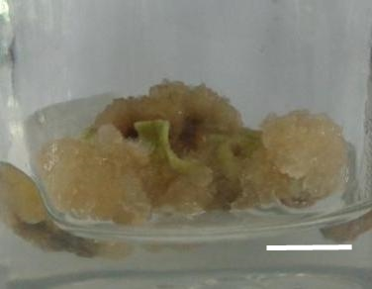 | 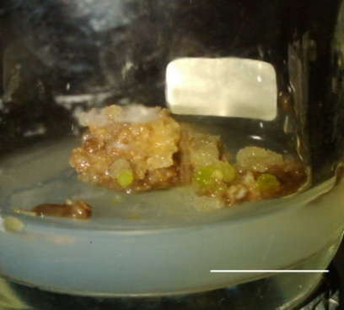
A  A | C
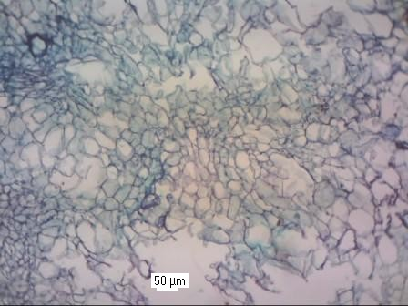 | 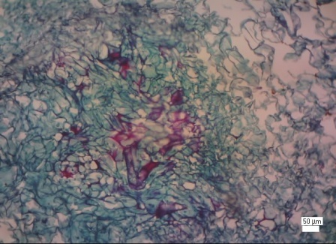
B | D

Figure 2. Callus of D. metel in (A-B) MS+NAA+Kin and in (C-D) MS+NAA+Kin+Cu10μM
bar (A,C) = 1 cm

