 | Volume XX. Issue X. Year 2021. Pages XX-XX  Edukasi  https://journal.unnes.ac.id/nju/index.php/edukasi |  |  | 
Implementation of the Use of Daily Journals in PAUD Institutions
Zahrina Amelia, Nurfadilah, Fitria Farhani Pansuri
Universitas Al Azhar Indonesia
DOI: https://doi.org/10.15294/edukasi.vXXiX.X

Info Articles  ____________________  History Article  Submitted XX  Revised XX  Accepted XX  ____________________  Keywords:  Daily Journal, Early Literacy skill, Early Childhood Education _________________________ |  | Abstract  ____________________________________________________________  One strategy to encourage children's early literacy skills, especially those aged 3-5 years, is to keep a daily journal so that children can communicate their thoughts, feelings and record their ideas through scribbles or pictures. Furthermore, scientific studies show that expressing what a person thinks and feels in a journal can have a positive impact on the author's physical and mental health. Based on the previous research, the researcher was interested in seeing how the "Implementation of the Use of Daily Journals in PAUD Institutions" using qualitative research methods and data collection methods using interviews and observations. The research was conducted in Jakarta and Depok, with a total number of respondents 12 teachers from four different kindergartens. The results showed that this daily journal was considered by most teachers to be able to support early literacy development even though the duration of work, writing equipment used and the form of support provided by teachers and parents are varied. In addition, most respondents also revealed that making daily journals can facilitate children to develop the ability to regulate their emotions in the morning, develop creativity, and help smooth daily teaching and learning activities. Therefore it can be say that a daily journal is a tool to expose children's social emotional problems, which always can help help to recognize and overcome the problems that faced with children, which can also help them to identify and overcome new problems, such as “new normal situation” when pandemi covid19 is over.
*Alamat Korespondensi:  E-mail: novanurfadilah@uai.ac.id |  |  | p-ISSN 0852-0240  e-ISSN 2746-4016

Introduction

One of the main keys to the successful implementation of education is the teacher. Therefore, teachers are required to have good teaching and learning competencies as stated in the Regulation of the Minister of Education and Culture Number 137 of 2014 concerning National Education Standards, namely, PAUD teachers must have four competencies as teachers, namely: personal, social, pedagogical and professional competence. Teacher competence can be seen from their ability to process teaching and learning, namely when teachers plan to learn, carry out learning, and evaluate children's learning outcomes.

Pedagogic competence is a very important competence in teaching and learning activities in PAUD because this competency includes the mastery of knowledge and skills in educating early childhood according to aspects of development and the child's age. If this pedagogical competence is low, then the child will experience obstacles to displaying developmental achievements as stated in the Regulation of the Minister of Education and Culture Number 146 of 2014 concerning the Early Childhood Education Curriculum.

Teachers have a very important role in developing children's early reading skills, whose activities seem like they are not related to writing and reading but in the form of behavior imitating writing with scribbles, pretending to read from pictures. Research shows that the ability of literacy is the basis that both help children to more easily learn to read and increase the level of success of children in school (S. J. a. D. w. R. Wilson, 2015). Furthermore, disclosed that the teacher can encourage children, especially the aged 3-5 years, to communicate ideas and record the ideas they are, but in some classes of children aged early, the ability to read the beginning of the child is not visible.

Through the book, a daily child can express thoughts and feelings about learning, through graffiti or images. the format of writing a journal can vary depending on the needs of children and the purpose of the teacher (https://korankaltim.com, 2017). Based on explanation above, researchers are interested in knowing how to implement the use of daily journal in PAUD Institutions who have implemented it for several years.

Methods

This research was conducted using qualitative methods because researchers want to get a clear and accurate picture of the material or phenomenon being investigated scientifically. Sugiyono said that the study was qualitative (qualitative research) is research which was shown to describe and analyze the phenomena, events, activities of social, attitudes, beliefs, same perception, thinking people in individual or group (Sugiyono, 2016). By way in the study of qualitative researchers will describe and analyze the activities are carried out subject research either as an individual. This research also uses the descriptive method. According to Nawawi " Methods Descriptive is a procedure solving a problem which was investigated by depicting/describe the state of the subject/object of the study (a person, institution, community, etc.) at the time is now based on facts which seem, or as any." Through methods of descriptive were used in the study, the researchers intend to describe the implementation of the use journals daily at the PAUD Institutions.

Results and Discussion
1. Observation

This research was conducted in four PAUD institution in Jakarta and Depok, namely Al-Bayan Islamic Kindergarten, Alif Islamic Kindergarten, Nur Sa'adah TKIT and An Nash Islamic Kindergarten. The covid 19 pandemic occurred when data collection was taking place, therefore, the observations made were limited to photos of the results of journaling activities that had been done by children, such as follows:

Al Bayan Islamic Kindergarten
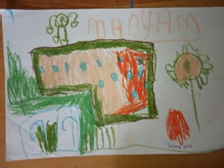 | 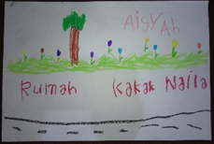 | 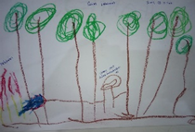
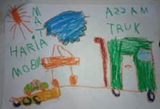 | 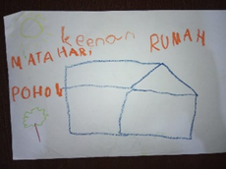 | 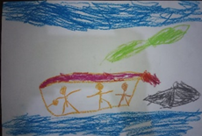

Picture 1. Samples of journal of Al Bayan’s students

Alif Islamic Kindergarten
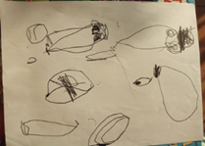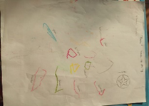

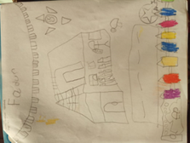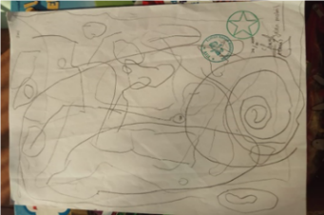

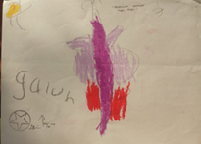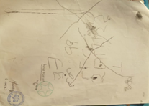

Picture 2. Samples of journal of Alif’s students

Nur Sa’adah Integrated Islamic Kindergarten
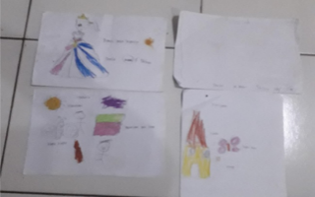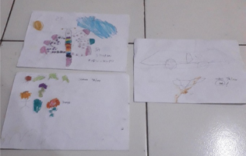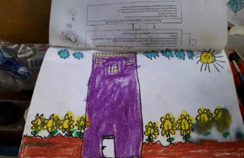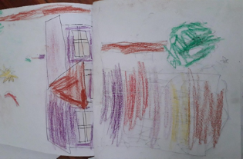

Picture 3. Samples of journal of Nur Sa’adah’s students

An Nash Islamic Kindergarten
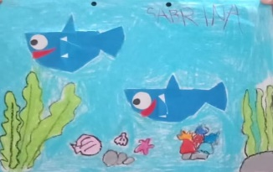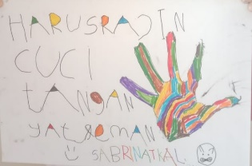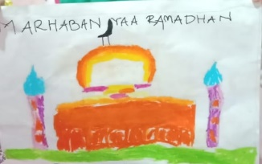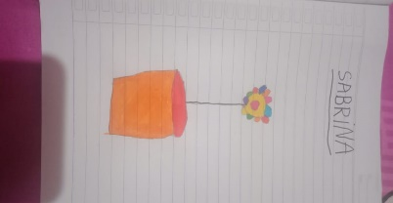

Picture 4. Samples of journal of Alif’s students

2. FIELD FINDINGS

The research was conducted by interviewing the 12 teacher respondents from 4 different PAUD Institution. Here are the data that can be collected:

2.1 Learning Strategy

All the respondents did the following things in different procentages:
No. | Component | % | Description of teacher’s activity
1 | Learning Goal | 100 | - Train writing skills, fine motor skills, and develop children's language skills.  - Means for children to express their ideas or thought, to neutralize children's emotions in the morning, pre-reading and pre-writing exercises with the no drilling method, train children's confidence through storytelling, and train children to communicate.  - Train children's creativity.  - The transition between the atmosphere at home and at school.  - Helping the flow running of daily teaching and learning activities
2 | Instructions | 100 | - in the form of open questions to children  - telling stories, writing ideas/activities that children interested in
3 | Setting rules | 100 | write down identity sitting arrangement, duration, express the idea on a paper which have provided by teacher
4 | Learning encouragement | 91,7 | Giving reward and feedback.  If a child is found has difficulty in making a daily journal, the teacher will direct the child to tell stories and write it down in the journal, provide open-ended questions, provide examples of expected journal making, so that the child can make a journal according to their own interests.
5 | Tell the ideas about what have been expressed in journal | 91,7 | Ask children about the stories in their journals
6 | Evaluation | 91,7 | Include : 1) the stage of children's writing and drawing skills, 2) child discipline/ability to follow the teacher's instructions, 3) the way children retell the contents of their daily journal, 4) Children's creativity
Table 1 Learning Strategy

Description above showed that by making a daily journal, teacher trying to stimulate or support early literacy, helped the children to be more creative and develop their ability to regulate their emotion.

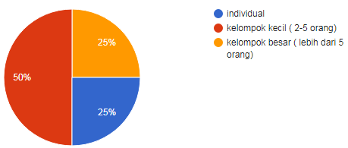
2.2 Classroom Managements

When carrying out daily journals, teachers do classroom arrangement, such as a sitting arrangement. In this study, 6 out of 12 respondents answered that the children's sitting position was arranged, where the children were in small groups consisting of 2-5 children. In addition, 3 other respondents answered that they arranged the sitting position of the child in a large group consisting of more than 5 children, and the remaining 3 respondents answered that they arranged the sitting position of the child individually. The percentage of children's sitting position arrangement in this research can be seen in the diagram below.
Diagram 1 sitting arrangement

The number of teachers involved in daily journal activities in this study was also have variety answers. It is found that, 10 respondents answered that they were only 1 teacher involved in daily journal activities, and 2 other respondents answered that they involved 2 teachers. The percentage can be seen in the diagram below.
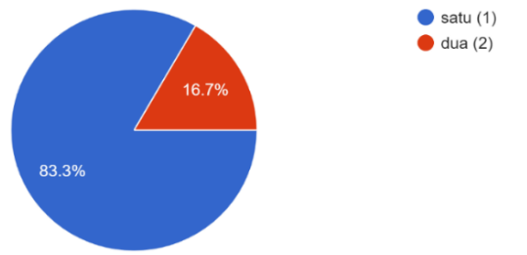

Diagram 2 the number of teachers who are involved in

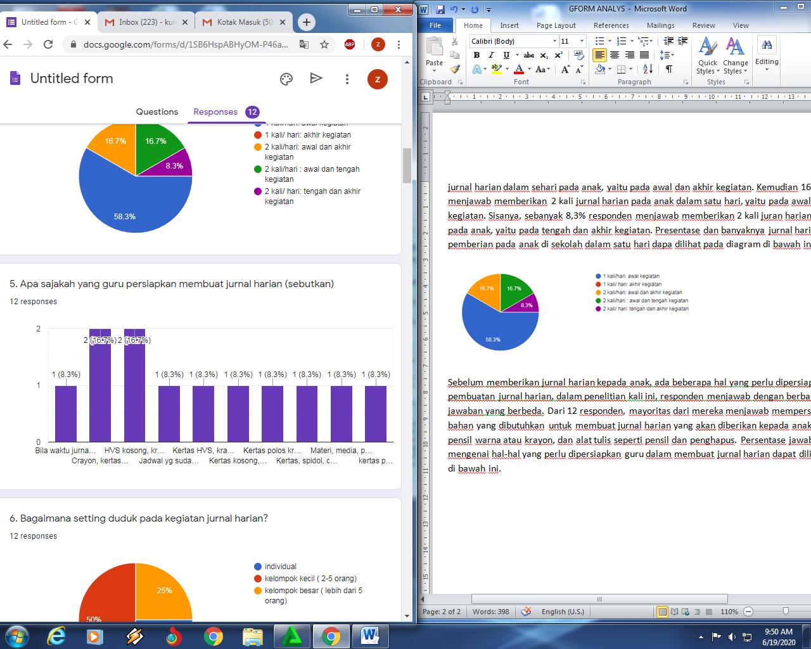
Before children are assigned to make a daily journal, there are several materials that need to be prepared by the teacher. The majority of respondents answered that they provided paper, colored pencils or crayons, and writing tools such as pencils and erasers. The percentage of respondents' answers regarding the things the teacher needs to prepare in doing a daily journal can be seen in the diagram below.

Diagram 1 Materials Provided by Teachers

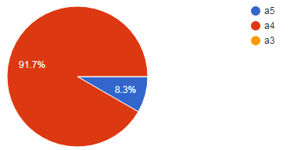
These PAUD institution carry out daily journals for their students using blank sheets (11 people) and one other person using worksheets.There are also 6 categories of daily journal forms used by teachers in this study, namely blank/plain sheets, lined sheets, lined notebooks, plain picture books, worksheets, and worksheet books.

The paper sizes which was used in the daily journals were also quite diverse. There are 11 respondents who were using A4 size paper in the daily journal and the remaining 1 respondent used A5 size paper in the daily journal at their institution. The paper sizes in making the daily journals was divided into 3 categories, namely A5, A4, and A3.
Diagram 3 The size of daily journal paper
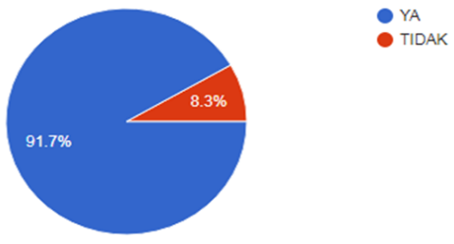

Even though the teacher has made these rules, the responses shown by the children are some who refuse to do the activity nor not following the instruction while some other are not.When the child refuses to make the journal given by the teacher, teacher try to manage the situastion by asking the reason why the children refused to do it, re-explain the instructions, encourage the child to find their interest, and give rewards if the child come up with ideas for making it. There were 11 teachers who did the support and 1 teacher were not.
Diagram 4 Teachers’s support

2.3 Time, frequency and location

The times and frequency of daily journals given by respondents also varied. There were 7 respondents who said they gave the opportunity to children to make a journal once a day, which was done at the beginning of the activity and 6 other people gave the opportunity 2 times a day with 3 variations of time. The time variations of the 6 people are 2 people at the beginning and end of the activity, 2 people at the beginning and middle of the activity, and the other people at the middle and end of the activity. The percentage of time and frequency of making children's daily journals in one day can be seen in the diagram below:
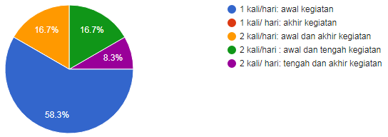

Diagram 5 Times and frequency of daily journal

Daily journal activities in PAUD can also be in various places. According to 12 teacher respondents, 11 teachers stated that children doing journals activity in their classroom, and the remaining 1 teacher stated that children doing it outside of the classroom. The precentage is shown in the diagram below.
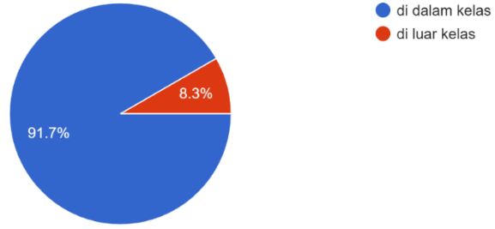

Diagram 6 Daily journal’s location

The duration of time in making daily journals varies according to the lesson plans made by the teacher beforehand. According to 12 teacher respondents, 6 teachers answered that they gave 15-20 minutes in making daily journals, then 5 other teachers answered that they gave 25-30 minutes for making daily journals, and the remaining 1 teacher gave 35-45 minutes for making daily journals. The precentage can be seen in the diagram below.
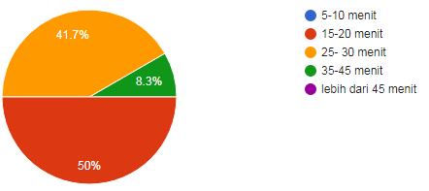

Diagram 7 Duration of daily journal activities

2.4 Evaluation

According to 11 out of 12 respondents, the teacher made an assessment and 1 other teacher did not make an assessment of the journal that was made by the child. The teacher's assessment of the results of children's daily journal work can be done in different ways. The components that are assessed from children's daily journals are related to:

The stage of children's writing and drawing skills.

Child discipline, follow the teacher's instructions or not.

The child's way of retelling the contents of their daily journal.

Children's creativity in keeping a daily journal.

2.5 Parent’s involvement

Saat pembuatan jurnal harian tersebut, terdapat orang tua yang dilibatkan oleh guru (50%) dan ada juga yang tidak dilibatkan (50%). The involvement of parents in the daily journals made by children according to the teachers as respondents is as follows:

Notification of child development assessment

reading stories or giving insights to children so that children have more ideas and vocabulary in writing daily journals.

Discussion about journals made by children.

DISCUSSION

Early literacy development is influenced by the ability of teachers to facilitate the learning environment, learning materials, experiences gained by children, and social support. These related to teacher’s pedagogic competence. Based on the results of the research, it shown most of PAUD institutions doing daily journal for one time a day. At the time of executing the daily journal to four schools is not using the book, will but use paper HVS. Kids in the work of the daily journal use crayon, pencil color, the other. Every day children do journals daily for 15-20 minutes and are done in one table that can accommodate 2-5 people and supervised by one teacher. Event daily journal at 3 schools in the classroom, and one school again beyond the classroom. At the time of the start of the daily journal teachers usually start with a sentence open. Children make according to their wishes and feelings on that day. After completion of the children provide the name, date, and tell what that drew on the day of the. In making the daily journal teacher not only helps with the sentence open, would be but the teacher also helps children when they are confused to be what is in for him on the day of the. Journal newspaper that made children every day rated teachers in terms of how to draw, create, communicating back. Daily journal given to the parents at the time of making the portfolio.

Daily Journals that carried the teachers every day in school is not directly facilitated time-sensitive children in the development of language. According to Purce, basic literacy components include phonemic awareness, writing, and story concepts, reading styles, and literacy as socio-cultural activities (V. Purcell-Gates, 2011). Things that can be done at the time the child tells the back of they are made. Through the daily journal children also begin to recognize letters by way of writing it, things are similar to the opinion of Snow in Mc Cartney & Philips in children preschool, ability literacy base is capacity for mentioning the name of the letter and write, spell the word simple, recognize letters and signs at around, identify the book from the title and do activities that relate to the book (V. Purcell-Gates, 2011). In line with the opinion above Writing a story is like going down a path in the woogs. You follow the path. You don’t worry abaout getting lost. (Kochenderfer, 2021). Fleck says writing You can be grateful for somethings small, like a flower, or something big, like you best friend. Once you strat filling out the pages in this book, you will be amazed by how may things you habe to be grateful for (Almee fleck, 2019).

This can be done when the child recounts the daily journal he has made. Through daily journals children can also begin to recognize letters by writing them down, this is similar to Snow's opinion in Mc Cartney & Philips for preschool children, basic literacy skills are the capacity to name letters and write them down, spell simple words, recognize letters and signs. around, identify books by title as well as perform book-related activities (K. &. P. D. McCartney, 2008). Daily Journals that made by the child at all four PAUD institutions can bridge the child to express feelings, helping the child to tell to others and as a means of communication of children, teachers and parents. The thing that needs to be considered is that teachers should only help children to be able to express what they want or feel in a daily journal.
Daily journals deal with Literacy and students' capacity to apply knowledge and skills in key subjects and analyze, consider and communicate effectively as they identify, interpret and solve problems in a variety of problems. Clay in primarni describes that literacy consists of early literacy, basic literacy, library literacy, media literacy, technological literacy, visual literacy (Primamie, 2021). In the daily journal children can also learn to read. Reading is essentially a complex thing that involves many things, not only reciting written texts, but also involving visual, thinking, psycholinguistic, and metacognitive activities. As a visual process, reading is a process of translating written symbols (letters) into spoken words (Amitya Kumara, 2014) . The purpose of the process of reading is to receive or understand the message contained in the text, and the initial level of learning is the level of the process of learning to read to master the writing system as a written representation (Farida, 2018).

Conclusion

All four PAUD institution implement a daily journal every day by using paper and stationery. At the time of executing the daily journal to four schools is not using the book, will but use paper HVS. Daily journal activity can be done in and outside the classroom, children seated in a small group that consist of 2-5 person, within 15-20 minutes.

What most respondents have done in implementing daily journal activities is in accordance with the theory, such as learning strategy, classroom managements, time, frequency, location, evaluation and parent’s involvement. Besides, the benefits have been seen in children's development through an evaluation in accordance to level of achievement of child development. But unfortunately, the teacher needs more support in giving the guidance that can be triggered children to do this journal-making activity closer to what is happening around the child. Even so, the use of the activity of keeping a daily journal not only for early literacy but also can be an alternative tool that can be used by the teachers in helping children facing the “new normal situation” when pandemi covid19 is over because they have chances to express their thoughts and feelings.

Acknowledgement
Aise God Almighty, for the presence of plenty of mercy and his grace, so that the writer can complete the research with the title: Implementation of the Use of Daily Journals in PAUD Institutions. thanks the author gave our team, respondens and "Lembaga Penelitian dan pengabdian masyarakat" LP2M Al-Azhar University. The final word the author realized that in the writing of this research is still far from perfection. Therefore, the authors invoke suggestions and criticisms which is build for the sake of perfection and may be useful for all of us. Amin

References

.

Almee fleck, katy brown. My First gratitude journal. United state: Penguin random house LLC. 2019.

Amitya Kumara, A. Jayanti Wulansari & L. Gayatri Yosef. Kesulitan Berbahasa pada Anak. Yogyakarta: PT. Kanisius. 2014.

Farida, Rahim. Pengajaran membaca di Sekolah Dasar. Jakarta: Bumi Aksara. 2018

D. M. S. B. K. Weigel. "Pathway to literacy: connections between family assets and preschool children’s emergent literacy skills.,". Journal of Early Childhood Research, p. 8, 2015.

H. H. E. L. M. W. H. Rosenberg, " Resource guide for Family Engagement Across the Developmental Pathway," Harvard Family Research Project, 2010.

H. Inna, "Hanafiah Inna. (2012) studi Tentang Peran buku Penghubung Terhadap Anak Tunagrahita Sedang di SLB Total System," 2012.

https://korankaltim.com," 02 Februari 2017. [Online]. Available: https://korankaltim.com/arsip/menulis-buku-harian-tingkatkan-daya-ingat-anak. [Accessed 01 Februari 2020].

J. A. Brewer. Introduction to Early Childhood Education: Preschool Through Primary Grades. USA: Pearson , 2016.

K. &. P. D. McCartney. Blackwell Handbook of Early Childhood Development. Singapore: C.O.S Printers Pte.Ltd, 2008.

Kochenderfer, MaryAnne. Question a day journal for kids. California: Rockridge.2021.

M. Syah., Psikologi Pendidikan.Bandung: PT. Remaja Rosda Karya., Bandung : PT. Remaja Rosda Karya., 2015.

Primamie, Amie. Penguatan Literasi Alam Kampung Ilmu Purwakarta. El-Mujtama: Jurnal Pengabdian Masyarakat. 2021.

S. J. a. D. w. R. Wilson, "Development of a Descriptive of Earlly Childhood Writing" Resu;t From the write start," Journal of Literacy Research, vol. 47, pp. 245-249, 2015.

S. J. H. C. Kuder. Enhancing Literacy For All Student. USA: Pearson Education Inc, 2002.

Sugiyono. Metode Penelitian Pendidikan, Pendekatan Kuantitatif, Kualitatif, dan R&D. Bandung: Alfabeta, 2016.

V. Purcell-Gates. Emergent literacy is emerging knowledge of written, not oral, language.New Directions for Child Adolescment development. 2011, p. 2

