MALANG MASK PUPPET IN ERA OF GLOBALIZATION: SOCIAL AND CULTURAL IMPACT

Arining Wibowo, Aquarini Priyatna.
Faculty of Cultural Sciences, Universitas Padjadjaran, Indonesia
Awardee LPDP-BUDI DN
cacamarisa90@yahoo.com, aquarini@unpad.ac.id

Abstract
This article discusses socio and cultural impact as an effect of commercialization of Malang mask puppet in the era of globalization. Padepokan Seni Asmoro Bangun located at Kedungmonggo Hamlet Malang Regency modifies the art of Malang mask puppet in order to turn the function of traditional art from ritual to the commodity. This research method is qualitative by using observation, interview, and documetary study for data collection. The result shows that modification creates three impacts, social and cultural impacts, also occurence of new senses in terms of Malang mask puppet includes creativity, prosperity, education, aesthetic, conservation, and identity sense.
Keywords: commercialization, socio, profane, cultural, impact, Malang mask puppet.

.

INTRODUCTION
According to Suparlan as cited by Prasetyo (2017) cultural change is the turn of idea system of society which consist rules, norms, values, and technology. The cultural change is the impact of modernism. The flow of modern life influences surrounding society of Kedungmonggo Hamlet, Malang regency as well. The art of Malang mask puppet which was once precious and sacred art turns to be old fashioned and ignored local art. Malang mask puppet was once oral tradition and sacred art which was being considered as tie between human and god and human and relatives and his/her surrounding society as well. As explained by Sibarani (2014: 54) that oral tradition encourages human to socialize both with their family and society environment. Oral tradition was being considered as communication medium. The impacts of oral tradition for society and their environment simply happens by watching, listening, and enjoying art performances.
Oral tradition alongside its content includes meaning, values, cultural norm, and local wisdom which is being stated by Sibarani (2014: 1) is about “remembering the past, understanding the present, and preparing the future”. Malang mask puppet as oral tradition of Kedungmonggo Hamlet was functioned as bonding of solidarity of its surrounding society. According to Kayam cited by Safarudin (2014: 169) that society will understand their values and behaviour pattern form traditional show.
But, Globalization and development brings society to the various side of reality such as comfort, pleasure, appearance, and freedom of desire. On the other side, Gildens (2001) predicts the existence of “huge threat in form of private meaning emptiness” as the impact of the lost of values and wisdoms of the past (Ritzer & Goodman, 2012: 610-611). Moreover, development of modern art in form of new amusement of television and internet which caught the attention of the young generation influences oral tradition, Malang mask puppet as well. Malang mask puppet once was forgotten. But then, nowadays Malang mask puppet tries to exist and survive in the era of globalization due to the effort of several art studios (padepokan) and artists.
Eventhough Malang mask puppet is being revitalized, according to Pratisto (2017) mask dance nowadays is being held in order to entertain audiences, whereas at the ancient ages it functioned as sacred procession. The values of this oral tradition to worship god and anchestor fade away. Malang mask puppet has been out of its real context. Moreover, the aim of the Malang mask puppet performance as entertainment medium is to make profit. Malang mask puppet has become a commodity and traded product. The high frequency of tourism promotion of the government of Malang turn the art to the assets for development of the regency. According to Brandt T (1997) the centralized administration, better infrastructure, and better lifestyle is preferable in order to operate larger cities. Factors such as education, transportation, mass media, communication and other sectors as well are related to the change of socio-cultural aspects of the society. As revealed by Pitana (2015: 115) that tourism influences the socio-cultural life of society, but other factors takes part in changing the condition of the socio-cultural as well. The change of Malang mask puppet brings several both positive and negative impacts include sosial, profane, and cultural impacts.
Picture 1. Malang Mask Puppet Show Performance
The art of Malang mask puppet includes dance and story preformed by various masked figures. Based on Javanese ethnic society, this art is considered as an old traditional art due to the occurrence since IX century (Timoer, 1980). In the show of Malang mask puppet, the dancers wear masks or kedok which cover their faces. Dancers play their characters by the guidance of narrator (dalang). According to Kartodiharjo dance of Malang mask puppet formerly functioned as religious ceremony for Hinduism at the era of Majapahit emperor and tradition such as animism, samanism, and the worship of achestors (Timoer, 1980: 11)
The tradition of masked dance functions as worshipping was being considered as medium to free human form danger and get protection from their anchestor. The arrangement of this ceremony was being considered as prevention of disaster and obstacle in man’s life. The importance of masks and the role of puppet was viewed as absolute element of their life. At that time, Malang mask puppet grew and was considerd as approriate art of the era. Malang mask puppet was admitted as tradition to worship anchestors spirit. But then according to Timoer (1980: 13) the realization of anchestors spirit changes. Alonngside the revitalization, simplicity shape of the mask turned to the smoothen and more beautiful shape. Function of mask changes as well, formerly as medium of religious ceremony to the medium of art show (Timoer, 1980: 14).
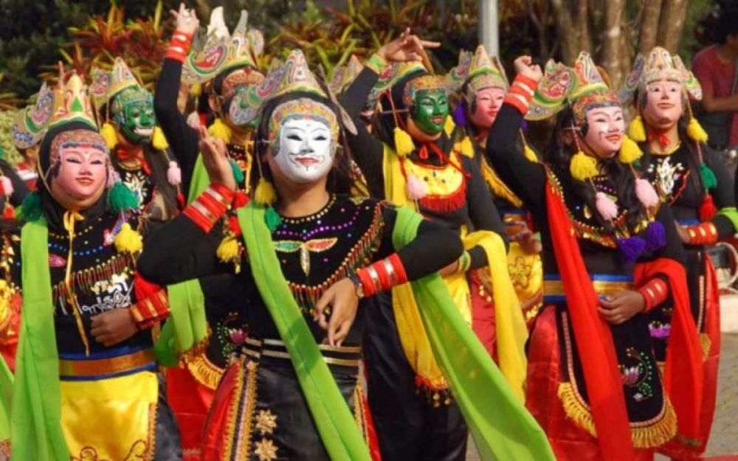
The growth of moderate Islam and development of modernism influence the changing function of Malang mask puppet. Padepokan Seni Asmoro Bangun, is located at Kedungmonggo Hamlet, Pakisaji, Malang regency, one of art studio which still maintains Malang mask puppet. Malang mask puppet is succeeded to change its function from sacred to the profane art. Thus, Malang mask puppet regains its position at the society and spreads its popularity. Growth and development of Malang mask puppet in Kedungmonggo Hamlet is started by Mbah Karimun and inherited by Kek Serun, a great grandchild of Mbah Karimun. According to Hidayat (2008: 29) Kek Serun and other grandchild of Mbah Karimun participate to develop the art of Malang mask puppet at Kedungmonngo Hamlet. They gathers and becomes dancers, players of gamelan, mask crafter. They have been faced various and dynamic condition, up and down during 25 years.
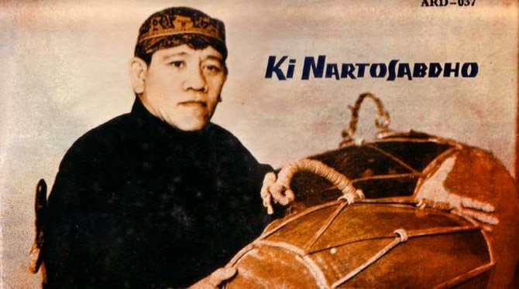
The rise of Malang mask puppet began in the middle of 1970. Both old and young generation participated and held many shows in several big cities of Indonesia. At 1978, dancers of Kedungmonggo Hamlet held performance in presidential palace at the era of President Suharto. In 1980, Kedungmonggo Hamlet renovated Malang mask puppet. They renewed quality of movement, performance, and products of Malang mask puppet. The result of this effort succeeded to brings Malang mask puppet to get predicate as local asset of Malang tributed by Government of Malang. As admitted superior local asset, government of Malang usually ask Kedungmonggo mask puppet to participate in several festival and cultural event in order to promote their local tourism (Hidayat, 2008: 42). Thus, because of the growth of Kedungmonggo mask puppet, the member changed its name to be Padepokan Asmoro Bangun. Asmoro Bangun is named after a main figure of Malang mask puppet, Panji Asmoro Bangun (Safarudin, 2003: 36). Now, Padepokan Asmoro Bangun is under the lead of Handoyo, as the heir of his pioneer.
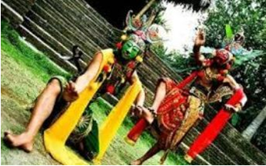
In performance of Malang mask puppet, there are several equipments needed to create high quality of art. Supporting equipments owned by Padepokan Seni Asmoro Bangun includes: Javanese Narrator called as dalang, puppet child, gamelan (Javanese music instruments), gamelan player, stage, and costume.
The meaning of Javanese narrator or dalang is a particular person who has special talent in playing puppets. Dalang is the main artist in the mask puppet performance. Dalang functions as director, the writer, narrator, singer, music arranger, stage arranger, and dancer as well. As a narrator, dalang must have skills in controlling janturan (description about king or empire which is being narrated in form of poetry or specific monolog), cariyos or kanda (story), gunem or pocapan (the figures of dialog), suluk (Javanese poetry with special rhythm), dhodhogan (controller of musical composition of gamelan), and kepyekan or kepyakan (Supriayanto, 1997: 79). The main dalang of Padepokan Seni Asmoro Bangun is Kasnam who has been trusted as the best Javanese narrator of mask puppet because of his acknowledge of pakem of Malang mask puppet. Dalang has an important role because the success of Malang mask puppet performance depends on him.
Picture 2. The Apperance of Javanese Narrator (Dalang)
The puppet child is team of actor who has good skill in mask dance. They have double roles because the costume arrangement of Malang mask puppet is possible to wear by double roles characters. The change of character needs only change of mask (Supriyanto, 1997: 81-82). The number of puppet child depends on the story and the price of the show. The story of Walang Sumirang Walangwati, for example has eight persons as puppet child.
Picture 3. Puppet Child
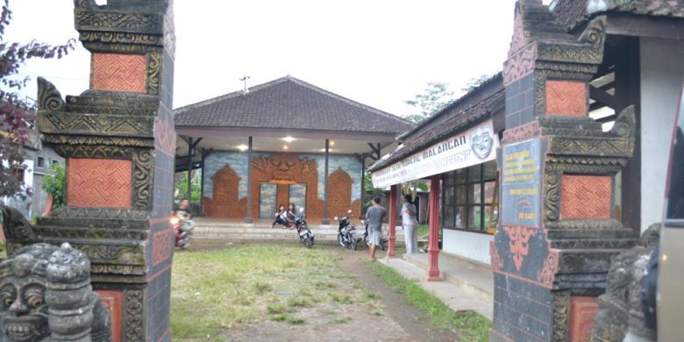
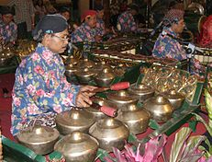
Panjak or gamelan music player is a group of gamelan player accompanied by the choir in the show of Malang mask puppet. Panjak of Padepokan Seni Asmoro Bangun is group of local people of Kedungmonggo Hamlet who have known the art of Malang mask puppet.
Picture 4. Panjak or Gamelan Players

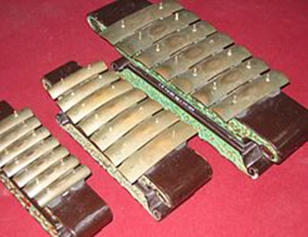
Gamelan is the intruments of music. In the performance of Malang mask puppet usually includes laras slendro or laras pelog. While for East Javanese puppet, laras slendro is usually preferable. The series of gamelan are: bonang balok, bonang penerus, demung, saron, peking, gender balok, gender penerus, gambang, kendang, kethuk, kenong, kempul, and gong (Supriyanto, 1997: 88-89). Whereas, gamelan which is usually used at Padepokan Seni Asmoro Bangun is more simple includes kenong, ketuk, gong,bonang penerus, bonang babon, kendang, saron, peking, and demung. The arrangement of musical instrument and stage is aimed to make dalang easier to manage the flow of the show because dalang needs to unite panjak and dancers of Malang mask puppet.
Picture 5. Gamelan (Music Instrument)
Stage is a part of important equipment to support the success of show performance. In Malang mask puppet, the stage can be in form of permanent or temporary stage. The arrangement of stage depends on the demand of audiences. Setting of the show influences type of stage, while the show holds in a building and appropriate place available to arrange gamelan, other properties, and decoration, crew does not need to prepare a stage (Timoer, 1980: 73). Oppositely, if the show holds at yard, crew need to prepare temporary stage which is usuaaly called as terop. The model of the stage usually prepared for Malang mask puppet performance by Padepokan Asmoro Bangun is in form of pendapa.
Picture 6. Stage of Malang mask puppet performance
Padepokan Seni Asmoro Bangun provides costumes for puppet child for the show of Malang mask puppet. Supriyanto (1997: 89) divides custome of Malang mask puppet into seven parts, include 1) head embellishment such as jamang, udeng, fabrik to cover head, and wig 2) ear embellishment such as sumping, 3) masks as face embellishment 4) neck embellishment includes kace necklace and sampur, 5) hand embellishment includes klat bahu and dekes, 6) body embellishment such as kace, stagen, timang, keris ladrangan, and 7) foot embellishment, pants, rapek, socks and gongseng. Mask functions as main complement of Malang mask puppet. The shape and color of the mask shows characteristic of the figures.
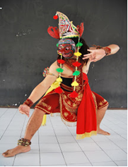
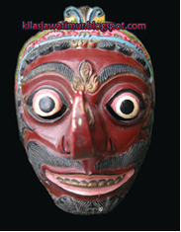
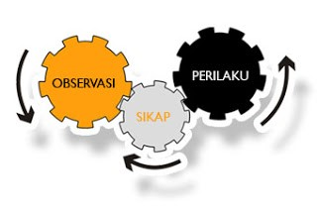

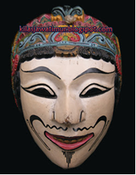
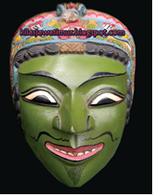

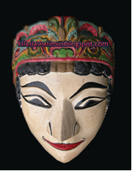

Picture 7. Costume and Masks of Malang mask puppet

METHODS
Qualitative method is used in this research. The study focuses on the worker, artist, and society of Kedungmonggo Hamlet in terms of their effort to modify Malang mask puppet as an oral tradition to the art product which can be traded. In qualitative research, the approach of the researcher does not have refer to the dichotomy of true or false, but rather stressing on the approach of the researcher itself (Ida, R. 2016)
Techniques of data collection are including: observation, interview, and documentary study. Observation is aimed to see and observe the changes of the growth social phenomena, thus the change of assesments needed, for the observer to observes certain moment, then separates necessary data (Margono, 2007: 159).
According to Kurnia (2007) information taken from observation includes the doer, location, activity, object, action, incident, and time. The use of observation technique is aimed to displays the realistic description of the action and event, to answers question, helps human behaviour, and to evaluates and measures certain aspects and gives feedback to the measurement. The use of observation is conducted by directly observe the activity and process in the field especially at the time of Malang mask puppet performance show. Observation is conducted also at the time when there is no performance show to obtain the situation and information in terms of skill of the Malang mask puppet doer.
Interview is conducted by researcher in the next step. The aim of interview according to Nazir (1988) is a process of getting information in research by giving question and asking answer face to face among the interviewer and informant. Interviewer as technique of data collection uses tools named as interview guide. Interview is conducted by communicating to the data source. Communication is conducted by question-answer orally whether direct or not (I. Djumhur & Surya, 1985). While according to Walgito (1987) interview is one of the methods to collect data both from child and adult by holding direct relation to the informant. Sukardi (1983) stated that interview is a tool to get data or facts or information from student orally. Interview is conducted to get data needed (Winkel, 1995).
Interview is conducted by researcher to the several respondent, they are Handoyo (owner, manager, doer, and crafter of Malang mask puppet at Padepokan Seni Asmoro Bangun), Tombro (doer and dancer of Malang mask puppet), Sunari (doer and art observer of Malang mask puppet), and Balok (art observer and researcher of Malang mask puppet).
Documentary study is tehnique of data collection which is conducted by researcher to get data based on the historical dan developmental process of Malang mask puppet. Definition of document according to Gottschalk (1986: 38) is the autnthentication process based on written, oral, description and archeology. According to Bungin (2007) documentary study is on of the methods conducted in qualitative approacch to tract historical data. Documentary study helps researcher to decide the level of credibility of the researcher based on the existed documents. Documentary study is conducted by researcher by finding and seeing directly to the show of Malang mask puppet and the production of skill art of Malang mask puppet. Documentary study is also conducted to find the change and shape of Malang mask puppet at Padepokan Seni Asmoro Bangun and at several places such as Inggil restaurant where display of various faces of Malang mask puppet can be found. Documentary study is conducted to find several references in form of books and information related to the Malang mask puppet in Malang public library, bookstore, and internet.

RESULT AND FINDING
The result and finding of this research is divided into three clusters, first explains the social impact of the modification of Malang mask puppet, second is the cultural impact, and third explains the senses of Malang mask puppet.

Social Impact of The Modification of Malang Mask Puppet
The positive impact which can be considered as social aspect of the modification process of Malang Mask Puppet is the increase of income and living standard. The surrounding society of Kedungmonggo Hamlet uses Malang Mask Puppet as their choice of daily occupation. The Society including children, teenager, and eldery learn to dance dan carve the mask. These people live nearly to the Kedungmonggo Hamlet compete each other to sell their product. As a show which is being performed once a month usually in Monday-Legi (based on Javanese calendar) and called as gebyak senin legian, Malang mask puppet attracts the society to participate . Tombro, one of the data resources said:
After Handoyo handle Seni Asmoro Bangun (name of the one of traditional dance art studio in Malang), mask becomes not only art but also resource of job. The job to product masks is now considered as job, no longer becomes only part time job [Tombro, Age].
Moreover, the decrease of unemployment is another positive impact. The bonding of togetherness and awarness to help each other event and performance of Malang Mask Puppet can be considered also as other social impact of the modification. After Handoyo succeed on bringing Malang mask puppet to perform internationally, the people of Kedungmonggo including eldery, children, and teenager compete to participate. They assume that they can be productive by selling the assets through creation of traditional art. After Kedungmoggo Hamlet is signed as Kampoeng Topeng by JTv, many visitors come to enjoy the show performance, to study and research. This means that the modification process of Malang Mask Puppet gives positive impact whether in economic, education, and mass media sector of Malang.
The development and the improvement of Malang Mask Puppet which gives good and positive impact, certainly is being followed by negative and decreasing aspect. Modification process of Mask Puppet creates two management systems, the organization and juragan (master) system. The organization system assume to have members but the juragan system assume to have workers. This system of management indicates the social and economical gap among the members of Padepokan Seni Asmoro Bangun. The gap includes position on organization setting, income, and job vacancy. According to Piliang (2011: 429) the disegmentation based on their taste, so it creates the social contrasts. The contrast and segmentation system is really complicated, and difference from a person to another. It also has another difference level: the difference level of person, class, society, nation amd race. The gap among the members of organization decrease solidarity and affect the development of Malang Mask Puppet. As stated by Suroso:
If Padepokan Seni Asmoro Bangun applicates these two system of management (organization and juragan system), the gap among members is hard to be avoided [Suroso, Age].
The art of Malang mask puppet which is rooted from the oral tradition, has deep aesthetical and sacred values. Malang mask puppet is being considered as the medium to worship and respect the ancestor’s spirit. People held this ritual continously and concerned to the faith values. But, the art of Malang mask puppet faces the change of culture time to time. Before becoming the art of castle which was performed by and for the noblemen, mask puppet was formly performed by and for civil society. The puppet was even made from stone at that time. The sacred values of the Malang mask puppet as a custom ceremony created many calculations. The calculation includes the electing day of the ceremonial show or called as naga dina, fasting three days continously before the show, and choosing lakon which is important to approriate the representation of the hopes and goals of the ceremony. According to Kusmayati cited by Safarudin (2014) the ceremony is aimed to worships the anchestors, express gratitudes , ties to the life cycle, and relates to the appeal. But then, Malang mask puppet changes the role of the art from medium of ceremony and ritual to the enjoyable performance.
The turn to the aspect of entertainment of Malang mask puppet is being signed by the deleting of some sacred values. Sunari, one of the data resources stated on the interview at July, 2016:
The dissapearance of the sacred values of Malang mask puppet is being influenced by the inability of the old generation to transform and the young generation to absord the religion context as well. As the medium of praying, the performance of Malang mask puppet contains the worship symbol of God as its basic philosophy. But, in nowadays show, the focus turn to the visualization aspect. Religion values no longer becomes the main purpose of the ceremony [Sunari, Age].
The modification process of Malang mask puppet brings profane impacts. The increase of the market demand to turn Malang mask puppet to be commodity indicates the goal of profit. Padepokan Asmoro Bangun commercializes and gets the profit as the impact of the modification of Malang mask puppet performance. Tombro, is interviewed at December, 2016 revealed:
The show of Malang mask puppet nowadays is different. The show follows the market taste. The limitation of duration and dancer compress the performance [Tombro, Age].
Tombro mentions the compression of Malang mask puppet as pethilan. Pethilan is the impact of modification which signs the profanization process of Malang mask puppet. According to Salim cited by Balok (2014: 172) the turn of cultural things to the commodity creates larger production process, imitation, and reduces the quality. In the performance of art, the show is being packaged and modified in its several aspect which causes the lose of important philosophical values.

The Cultural Impact of Modification of Malang Mask Puppet
As an oral tradition, Malang mask puppet is being considered as one of cultural asset and heritage of Malang. Thus, the origin values of Malang mask puppet must be conserved and maintained. Eventhough this traditional art faces the transferring and inheritance process, the artist of Malang mask puppet must be able to create the strategy of inheritance to keep the existence of this art. In the globalization era, the modification process of Malang mask puppet at Padepokan Seni Asmoro Bangun indicates the desire and market taste to turn the art to the commodity. According to Piliang (2004: 197) the openness to the other culture, interaction and exchange process which is possible must be completed with the critical thinking. There must be a mechanism of cultural filter which possibly minimalize the culture to the other.
The packaging show of traditional art is considered as the needed to approriate customer demand. This modification process is the big factor to the lose of the origin values and meaning of Malang mask puppet. First, the influence of the modification process impact the limitation duration of the show. Malang mask puppet performance which has to be held during all night changes to only two hours. The philosophical values changes the economical values as well. Moreover, the development of technology put the art of Malang mask puppet easier to enjoy. People do not need to attend directly to the show performance and possible to re-watch repeatedly via television, radio, internet, and other digital media. Malang mask puppet which has been medium of praying and worship to the ancestors changes its function as the commodity to fulfill the need of artist and worker. Malang mask puppet support the surrounding society as well.
Based on the history, the rising of Malang mask puppet at Kedungmoggo Hamlet is in the era of preaching of Hindu. Eventhough many hindu temples can be found as the proof of the preaching, these historical sites change to be an organization nowadays. The preservation of the traditional art such as dance, karawitan, and skill art occurs.

The Senses of Malang Mask Puppet
The creativity sense
The turn of the function of Malang mask puppet from medium of ritual to the public theather creates new important role for the surrounding society of Kedungmonggo Hamlet. Malang mask puppet solves problems which are happened in this region over years. According to Kasim cited by Iswantara (2000) that since the ancients ages, public theather is functioned as the facilities to ask society participation directly. As a public theahter, Malang mask puppet performance gives simple and easy-accepted communication. Thus, Malang mask puppet becomes the medium to solve developmental problems of surrounding society. This oral tradition nowadays creates welfare and prosperity for people of Kedungmonggo Hamlet. According to Wardana (1984: 40) the function of oral tradition can be slaved on the society importance and being part of the society life from time to time. According to Piliang (2003: 249) the change of meaning is caused by the process of encoding which reproduces meaning by standard of other text as its reference. The rules such as “similitide” and “resemblance” are applicated without considering deeper semiotical dimension such as consept, content, idea, meaning, myth, or ideology.
Moreover, during long period of time, Malang mask puppet faces various kind of changes whether in term of its form and function. The changes of Malang mask puppet effect its represented meaning. According to Piliang (2003: 249) the changes of meaning occur because of the encoding process. Beskalan Putri dance is one part of Malang mask puppet whose meaning changed. The prior function of this dance is to represent fertility ceremony and welcome the anchestor’s spirit. This dance is originally held at the ceremony such as opening new area or buliding house.But, due to the inheritance pattern, this dance is being modified as the guest welcoming dance performance and functions as the entertainment. Beskalan Putri dance becomes an object of tourism.
Considering the iconic character of Beskalan Putri dance, the modification shows the lose of ideological values and the rise of beautification of art. In the name of creativity, Padepokan Asmoro Bangun creates new pattern and renovates this dance. The amount of dancers, limitation of duration, choreography arrangement, briefing story plot, janturan, kandha, antawacana, and sulukan/lagon and stage adaptation become focus to modify. Malang mask puppet function changes to commercialize and creates jobs for the people of Kedungmonggo Hamlet. Various kind of creativity occurs and creates new art of Malang mask puppet show, its dances and handicrafts.
The prosperity sense
In terms of modification process of Malang mask puppet, Padepokan Asmoro Bangun has specific strategy and plan to support surrounding society. One significant purpose of this art modification is to increase the prosperity of local people of Kedungmonggo Hamlet. The increase of income which possibly helps surrounding society to fulfill their daily needed becomes the concern of modification. Development of tourism in Malang influences the growth of Malang mask puppet. Padepokan Asmoro Bangun formulates three basic patterns to support the development of tourism in Malang. First, the place as destination tourism has to be beautiful and unique. Second, people who live around tourism site characterize as kindly residence, friendly, give secure, comfort and prime services to the visitors. Third, parcel as products which represents culture and uniqueness of the place. Parcel which functions as handricraft is portable and represents memories. Thus, parcel gives the visitors vibe to remember or desire to comeback to this tourism site.
Revitalization of Malang mask puppet as the local culture of Malang extends profit for its society. Increasing number of visitors and tourist whether from other region of Indonesia or even other country establish productivity related to the Malang mask puppet. This art is being commercialized in order to open new job vacancies and creates prosperous society. As stated by Sutarto (2004: 58) that the function of local and cultural product which is still in process could support the growth of tourism industry and produce many devizen.
But this shows that the changing meaning of Malang mask puppet turns from sacred to profane. Due to the perspective of Padepokan Asmoro Bangun which considers Malang mask puppet as the medium to support its surrounding society to fulfil their daily needed. Malang mask puppet then becomes the playground to get jobs and occupation. This condition is unavoidable due to the change of socio-cultural background as well. Globalization flow brings influences to the Padepokan Asmoro Bangun to change the function of Malang mask puppet.
Education sense
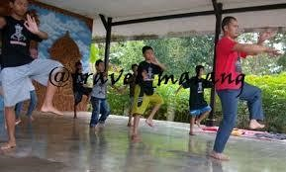
Malang mask puppet takes important role to build and teach manner toward children. Fun learning media such as Malang mask puppet contributes to the education aspect through story. The story contain moral messages to guide children to choose better way of life. As revealed by Sutarto (2004: 35) that Malang mask puppet as the cultural identity has potency to be developed, whether in terms of aesthetic of art or educational sense. Panji, as the main figure of Malang mask puppet is the one significant example of hero who could possibly becomes role model.
Picture 8. Children learn dance at Pendapa
Beside moral messages, education for children is being applicated through the dance training and practice. Pendapa (studio) of Padepokan Asmoro Bangun becomes the place for children to learn and dance. Learning process creates togetherness and respect without consider one’s social degree. Children are being taught about solidarity, helping each other, and peace.
The aesthetic sense
Aesthetic sense of Malang mask puppet is being represented through artist, dancer, and audience. These stakeholder have role to express values of Malang mask puppet itself. That’s why the change of generation influences the aesthetic sense of Malang mask puppet. At Kedungmonggo Hamlet, the change of the meaning of mask puppet itself begins from the change of pakem especially in terms of dance choreography. The old generation considers Malang mask puppet as a guidance due to the representation of philosophy of life. Malang mask puppet contains the balance of nature and human alongside with their religious aspect. Oppositely for nowadays society, Malang mask puppet is being considered as entertaining dance which attracts people. Malang mask puppet becomes product whose dance movement and custom is modified. Bapang dance for example, originally potrays a figure with the firm character who is marked by wide hand movement, moves left to the right, wide eyes, long nose, and red coloured mask. Bapang dance potrays bad character as the enemy of Panji. Whereas at this time, Bapang dance is simply being understood as the icon of Malang.
The understanding of audience toward the aesthetic values of Malang mask puppet is limited only from two hours show performance include dance and story. While dance and story have been packaged to match the demand of more enjoyable performance. As stated by Rusyana (1999: 2) that tradition could be a part of culture which is being common reflection of the whole culture, then it has certain meaning for the supporting society. Malang mask puppet as an oral tradition has dynamic characteristic to change its structure and function. The existence of Malang mask puppet in the era globalization follows its social context.
The conservation sense
Eventhough Malang mask puppet has been existed in various places of Malang, Padepokan Asmoro Bangun strongly conserves and maintains traditional art. Located at Kedungmoggo Hamlet, Pakisaji as one subdistrict of Malang, this art studio has been tried several effort to maintain Malang mask puppet from the extinction. The renewal of inheritance system is significantly being chose. The inheritance system of Malang mask puppet is called ngabdi for the very first time. Ngabdi which means one has to be student who follows particular ritual to be accepted and had chance to learn the art of Malang mask puppet. While nowadays, Padepokan Asmoro Bangun changes its system and allows every person to learn and practice dance at Sunday. The schedule is even possibly being approriated to the demand of participants. Moreover, the permission of girl participation adds the number of students.
The conservation effort of Malang mask puppet succeed to add amount of participant in dance training because it attracts not only adult but also teenagers and children. The result of this training brings children to show their talent at the event of Gebyak Topeng Senin Legian. This proves the effort of Padepokan Asmoro Bangun to develop the next generation in order to maintain the art of Malang mask puppet.
The identity sense
As an oral tradition which has developed at Malang, the art of Malang mask puppet becomes reflection of cultural identity of this regency. Thus, Malang mask puppet attracts the heirs, artist, and its supporting society because of its important role to build up the identity of Malang. The function of Malang mask puppet is important for the life of its surrounding society, as revealed by Koendjaraningrat (1984: 286) due to the ability of Malang mask puppet to spread and functioned as social medium. As traditional show which turn to be public (popular) art, Malang mask puppet reach each layer of society of Malang. Moreover, it becomes the identity of certain group of people. Including students, such as student of State University of Malang (UM), Kanjuruhan University of Malang, or Santo Yosep Senior High School who come to Padepokan Asmoro Bangun for studying and researching about Malang mask puppet. Even researcher comes both from other local region of Indonesia and other country such as Japan. The existence and meaning of Malang mask puppet attracts certain group of people to own infromation and collect data about it. According to Piliang (2011) cultural identity is the process of becoming. It does not mean only an existence which has passed time, place, history, or culture, but also the existence of learning and assosiation process of it.

Conclusion
The turn of Malang mask puppet form the sacred and traditional art to the profane and popular show at Kedungmonggo Hamlet indicates the influence of globalization flow. Once an art enter the globalization flow, it must follow the rule of global. As a local asset of Malang, Malang mask puppet is being considered to have roles to support the development of Malang, whether in terms of economic or cultural assest. Some art studio (padepokan) include Asmoro Bangun then modify Malang mask puppet and turn its functions as commodity and product. Modification process on the other side is indeed the effort of Padepokan Seni Asmoro Bangun to maintain dan conserve Malang mask puppet. Modification process of Malang mask puppet creates not only job vacancies, but also awareness of the heirs and surrounding society to work harder in order to revitalize and develop their traditional art. Whereas, while an art is being modified, several loss follows. Sacred and philosophical art is simply turned to be entertaining show. Sacred and philosophical side of Malang mask puppet contains local wisdom and continual guidance of life. Meanwhile, the entertaining show creates occurrence of several aspects such as prosperity, identity, creativity, education, etc. This signs ambivalence of the modification process, because positive and negative impact are equally occurred.
Acknowledgements
This research was supported or partially supported by Lembaga Pengelola Dana Pendidikan (LPDP) RI as one of the funding agencies and credible scholarship in Indonesia. I am also grateful, thanks to Aquarini Priyatna for her assistance with a brilliant guidance, Cece Sobarna and Sutiyono Mahdi who moderated this paper and in that line improved the manuscript significantly.
References
Balok, S. d. (2014). Dampak Komoditas in Seni Budaya. Surakarta: ISI Press.
Brandt, T. (1997). "Kunci Budaya" Business in Indonesia The cultural keys to success. Jakarta: PT Intermasa, Jakarta.
Bungin, M. B. (2008). Penelitian Kualitatif; Komunikasi, Ekonomi, Kebijakan Publik dan Ilmu Sosial Lainnya. Jakarta: Kencana.
Giddens, A. R. (2001). Bagaimana Globalisasi Merombak Kehidupan Kita. Jakarta: Gramedia.
Gottschalk, L. (1986). Understanding History; A Primer of Histirical Method. Jakarta: UI Press.
Hidayat, R. (2008). Malang Mask Puppet Presentation Structure. Harmonia: Journal of Arts Research and Education .
Ida, R. (2016). Metode Penelitian Studi Media dan Kajian Budaya. Jakarta: Prenada Media Group.
Koentjaraningrat. (1984). Pengantar Ilmu Antropologi. Jakarta: Aksara Baru.
Kurnia, A. (2014). Penelitian Kualitatif. Dunia Penelitian .
Margono, S. D. (2007). Metodologi Penelitian Pendidikan Komponen MKDK. Jakarta: PT. Rineka Cipta.
Piliang. (2003). Hipersemiotika (Tafsir Cultural Studies atas Matinya Makna). Yogyakarta: Jalasutra.
Piliang. (2007). Proses dan Interaksi Budaya. Jakarta: Estetika.
Pratisto, C. (2017). Padepokan Seni asmoro Bangun. Bukti Hidupnya Malang mask puppet. Jurnal Resital .
Prawitasari, F. (2017). Padepokan Asmoro Bangun. Bukti Hidupnya Malang mask puppet. Jurnal Resital dan Kompas.com .
Ritzer, G. d. (2012). Teori Sosiologi Modern. Jakarta: Kencana.
Rusyana. (199). Penggalian dan Penggarapan Karya Sastra. repository.upi.edu .
Safarudin, K. d. (2014). Komodifikasi Pertunjukan Malang mask puppet in Era Globalisasi. Harmonia .
Safarudin, K. d. (2014). Nilai-nilai Sakral in Pertunjukan. Jurnal Humaniora , 169.
Sibarani, R. (2014). Kearifan Lokal (Hakikat, Peran dan Metode Tradisi Lisan). Jakarta: Asosiasi Tradisi Lisan.
Suanda, E. (2005). Topeng. Jakarta: Pendidikan Seni Nusantara.
Supriyanto. (1997). Struktur, Simbol dan Makna Malang mask puppet. academia.edu .
Surya, I. D. (n.d.). Dunia Penelitian: Pengertian Teknik Wawancara. dunia penelitian. blokspot.com .
Surya, I. D. (1985). Dunia Penelitian: Pengertian Teknik Wawancara. Dunia Pendidikan .
Sutarto. (2004). Pariwisata dan Pengembangan Sumber Daya Manusia. JUR_PEND_GEOGRAFI .
Timoer. (1980). mask puppet Malang: Lakon Lahire Panji. jurnal-online.um.ac.id .
Walgito, B. (1987). Pengertian Teknik Wawancara. Dunia Penelitian blokspot.com.
Wardhana. (1984). Pelatihan dan Penelitian Tradisi Lisan. repository@UPI. Bandung.
Yanuartuti, S. (2016). Building Creative Art Product in Jombang Regency by Conserving Mask Puppet. HARMONIA .

