Mimicry and Hybridity of “Congrock Musik 17”

in Semarang
        
 Sunarto *
          Irfanda Rizki Harmono Sejati**
Udi Utomo***

*Faculty of Language and Art, Universitas Negeri Semarang, Sekaran, Gunungpati, Semarang
E-mail: sunartofbs@mail.unnes.ac.id
**Faculty of Language and Art, Universitas Negeri Semarang, Sekaran, Gunungpati, Semarang
E-mail: irfandasejati@mail.unnes.ac.id
3Faculty of Language and Art, Universitas Negeri Semarang, Sekaran, Gunungpati, Semarang
E-mail: udiutomo@mail.unnes.ac.id

Abstract

Keroncong, a slow and crooning music, serves as the art and culture that reflects Indonesian identities. This music style still exists today, particularly in Semarang that is widely known as an urban area. The resistance of such music is actualized with the process of mimicry and hybridity of keroncong and rock music, causing pros and cons that lead to a crisis. The performed mimicry and hybridity is a negotiation in identity construction that takes place in ambivalent behavior as a strategy to survive from the crisis. Building an identity of Congrock (keroncong and rock) is carried out to explore the mediation form in the third space, enabling the outlining of the position of Congrock identity in Semarang. A case study, an art research method, and historical reading were employed to interpret the existing phenomenon. The result indicated that the Congrock identity was the result of mimicry and hybridity that was formed due to the hegemony in Indonesia. Mimicry and hybridity had become the most important point because they took place in an urban area, such as Semarang. The integration of local and global cultures in Congrock generated a new identity in society as the third space and created a gray zone in Congrock, i.e., the area between the form of imitation and cross-cultural music integration. The position of Congrock in Semarang became a symbol of freedom in negotiating locality while partially articulating modernity.

Keywords: Congrock, Mimicry, Hybridity, Urban Area, Semarang

INTRODUCTION

As written in a book entitled Indonesia Heritage: Seni Pertunjukan [Indonesian Heritage: Performing Arts] (Sedyawati, 2002), Semarang includes in the area of the keroncong music spreading map in Indonesia. This city is also considered one of the barometers for keroncong development in the homeland. The rapid development of this music in Semarang is proven by the existence of several communities of keroncong music that still last until today, and are given media of preservation by the local government. Nevertheless, due to the consumerism of western cultures and the power of dominant cultures that cause an identity crisis, the art of keroncong has increasingly developed. The impact of such identity politics urges local artists to create innovations in keroncong music to develop its identity, one of which is by combining keroncong and rock genres to become a new contemporary genre called congrock (Rachman & Utomo, 2018).
Congrock is derived from the words keroncong and rock. The mixed genres of music between keroncong and rock rhythms in Semarang came into an identity of a student community in Universitas 17 Agustus 1945 on March 17th, 1983. There were mutual agreement and mission to create innovations towards keroncong music to maintain the existence of this music as local culture. The innovations were seen by a variety of instruments, tone, tempo, and harmonization played by a group called “Congrock Musik 17” (Rachmawati, Rohidi, & Tarwiyah, 2016, p. 10).
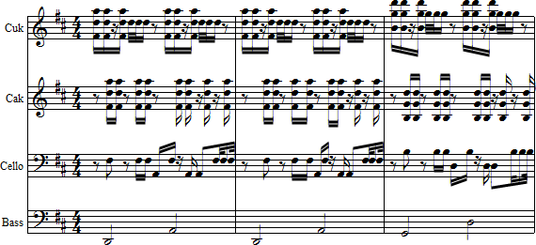
According to Kartika (2015, p. 36), Indonesian society as a post-colonial society, which referred to the historical period of post-independence at that time, had empiricism towards the practices of fascist colonialism or the racist administration. This issue also affects the existence of “Congrock 17” group that invites the pros and cons of its genre of music. The works created by “Congrock 17” is considered to be out of the keroncong music, in terms of the standard rhythm patterns and musical instruments.

Figure 1. Double rhythms of cak (four-stringed instrument) cuk (three-stringed instrument), cello, and bass of keroncong (Source: Giza Abel, 2019)

Standard keroncong rhythm patterns are characterized by recognizable patterns, although they are varied. Nonetheless, the basic rhythmic form does not change; only does the tempo, accentuation, and tone color (Utomo & Rachman, 2019).
Based on the above idea, Purwanto (2015) opines that a crisis of identities causes a shift in identities in cultural politics as a result of the hegemony of the dominant group until an agreement comes from a marginalized minority to show/build their identities. Building identities in cultural diversity is now a problem occurring in the ex-colonized nation, including Indonesia. This is a sign of colonialism in the modern era, which its agreement raises an ambivalence; such a phenomenon is known as identity politics (Dini, Utomo, & Triyanto, 2018).
On that ground, the phenomenon of identity politics is utilized to see the factors influencing the “Congrock 17” group in choosing the rock genre. Further, the analysis of the works and performances of the group is used to answer the question regarding the position of congrock identity in “Congrock 17 Semarang” with mimicry and hybridity in a postcolonial study.
In this context, keroncong has become an in-depth study in finding out the issue of the diversity of values in the process of forming the art itself. Along with technological advancements, the phenomenon serves as the montage of time-image that relates to the complexity of social relations that starts looking for new identities amidst the authority, politics, and ideology (Aryandari, 2018). This paper is devoted to the understanding of the art formulation, and determining the correlation between mimicry and hybridity in urban cultures. Keroncong is a type of music that goes through an integration, mixing, and re-interpretation of a culture (Lestari & Rachman, 2012). The mimicry and hybridity of keroncong are essential, considering their never-ending existence and consistency. Interestingly, when mimicry and hybridity take place in keroncong, the development is never-ceasing, leading to some innovations to the music itself.
Congrock has been the most-requested music by society. The diversity and continuous development of keroncong make this type of music more attractive. This paper will mix and match the concepts of mimicry and hybridity in explaining the congrock music, specifically in the “Congrock 17” group in the level of urban society in Semarang. Congrock has become very interesting with its diversity, particularly its existence which has been continually exposed and becoming public consumption of Indonesian people in the past few years.
Grounding from the above discussion, the problem of this research is the concepts of mimicry and hybridity in the “Congrock 17” group in the phenomenon of identity politics. This study is theoretically significant in terms of finding out the forms of identities in a postcolonial study. Practically, this study is useful for opening up the view of the society, local musicians, and government that the hybrid identity of congrock can be an icon for its group in the context of arts in Semarang, so that it will become a sustainable local art.

Method

This study relied on a case study, historical, and art research methods in interpreting the process of keroncong mimicry and hybridity. To make it easier, an in-depth reading of the existing problem could be done with this method. A qualitative data collection was the best choice in collecting the research data. Moreover, reading historical events also served as valid data in figuring out the existence of a congrock in Semarang that could be specifically seen in the group of “Congrock 17 Semarang”. The reading of art, which was devoted to the notation correlation, was considered to be able to respond to the art explicitly. The findings would become a reflection in seeing urban mimicry and hybridity in perceiving arts as a cultural manifesto.

Result and Discussion
Postcolonialism
Speaking of postcolonialism, being traditional and modern is the same two sides, and it is almost impossible to speak of it without involving the western and eastern countries, especially those with a history of colonialism. One of the strategies to deal with the dominance of colonizing culture is through mimicry and hybridity that is usually called a process of imitating and integrating cultures. There are also any other strategies that can be applied in media that look for innovations to vocalize equality and self-identity in the dominance of the interest of western-style companies. Among the innovations is exploring Indonesian local culture as an icon (Laksono, Purba, & Hapsari, 2015, p. 5) and (Widiastuti, 2015, p. 20).
The part of postcolonial identity complexities is related to the process of how the colonized society or culture absorbs the meaning for themselves by the creation and coercion of the colonizers’ power (Easton, 1964, p.108). When colonized countries become independent politically and militarily from colonialism, their new sovereign status is usually the integration between elements and forms of previous identities (pre-colonial times) which are created during the colonization (Clayton & Gregory [eds.], 1996, p. 148).
Postcolonialism, in its turn, refers to the situation of a society or culture after being colonized by those who intend to conquer, control, exploit, and even fix the society or culture itself. Although the use of postcolonialism normally refers to the aftermath of colonialism as mentioned earlier, this term has urged analytic values regarding the condition of the subject, society, or culture immediately after the initial colonial contact came about (Chatterjee, 1993, p. 10).
Urban Area and Popularity
Every developing region desires an establishment of becoming an urban area, especially when the regional development is carried out massively. The advancement and concept of urban areas are what the society has been dreaming of, and its value has become a stigma. The society craves for a concept of urban areas, i.e., borderline of values in the society. Clark (2003, p.4) states:
Seeing urban areas as spaces that have been conceptualized, and more importantly, signified in particular ways towards particular ends, can provide insight into the manner in which old, new and fluid cultural identities emerge, are negotiated or contested within and between these urban spaces.
Urban spaces become a negotiation place in building old, new, and emerging identities with mixing and integration that is introduced as hybridity. Urban areas become the level of an arena in the occurrence of the hybridity. Looking at the previous concept of urban areas, Weirtheim (1964, p. 170) claims “cities used to be the center of the kingdom, religious activities, or harbor". It is implied that cities are the place of power over something, such as suzerainty in a kingdom, God’s power in religion, and trade power in a harbor. There come values that are referred to and controlled, causing a new concept that is different from rural areas in general.
Urban arts have more quantities in forming a performance with a strong existence, and quantities with high frequency create values of popularity. Turner (1984, p. 4) indicates that the culture of popularity acts as a domain of production, and come a negotiation with the consent of the society. Turner also asserts that popularity is mass and the other way around. Popularity has a huge power on the demand of the society.
Popular things come from conscious or unconscious habituation. A popular understanding of a culture is expressed as the biggest demand and desire of people in negotiating social and cultural aspects. There are many collaborative concepts in their application, which can be concluded as hybridity efforts. In the art domain, Hauser (1982, p. 580) points out, “boredom is what underlies the presence of popular arts, and such boredom raises restlessness”. The boredom of the previous art has triggered people to look away to popular arts, and even initiate new arts that come from the regional or global scope. The categorization of arts is stated in popular music.
Usman (2000, p. 154) argues that from the perspective of social aspect, three important factors influence people’s appreciation to popular music, including 1) Introduction refers to a contact with certain popular music products; 2) Habituation is the frequency of the contact; and 3) Intensity of Association with the popular music. More basic knowledge about the aspects and involvement in activities that use popular music is one of its main means.
Usman’s theory strengthens the idea that the popularity of arts is based on its introduction, frequency, contact, and association. If applied to keroncong, the popularity of this music has been of a certain object. Keroncong is created as a natural reflection of the society over the resistance to the type of music coming from outside; this is the counterwork to the new culture. People make an interpretation by mixing and matching all developing cultures.

Keroncong
According to Paeni (2009), in the book Sejarah Kebudayaan Indonesia: Seni Pertunjukan dan Seni Media (History of Indonesian Culture: Performing and Media Arts), in the 1970s, keroncong music had been regarded as modern music because it played pop music. This type of music was considered the first pop music in Indonesia that always involved in a music competition held by RRI and TVRI (Indonesian TV channels). Keroncong, in the 1990s, already had a huge position in its event (Darini, 2012). Moreover, keroncong community began to raise that brought hybrid keroncong or combining keroncong with other types of music to create new types of keroncong music, such as congdut (keroncong and dangdut/melodious genre of music in Indonesia), congpop (keroncong and pop), and congrock (keroncong and rock).
As opined by Ganap (2006), keroncong is a hybrid music, a genre resulted from the accumulation of western elements (from Portuguese and Netherlands) and non-western elements (from Saudi Arabia, Africa, India, China, Oceania, Betawi, and Java). In this case, keroncong turns into neutral and multicultural music due to its strong relation with various local and even global cultures. As seen in its development, keroncong music has proven that it has characteristics different from other genres of music (Alfian, 2013). Keroncong has currently grown and developed, showing Indonesian identities and personalities, so that this music may be proposed to be the world heritage (Alfian, 2013).
In addition, Darini (2012) mentions that the development of keroncong music in Indonesia can be periodized into before independence, independence, and the present time. Keroncong still stands with more creative innovations, music compositions and arrangements. Keroncong community still grows in some cities, such as Semarang, Solo, and Yogyakarta.
According to Mintargo (2017), keroncong also serves as a form of acculturation between western and eastern cultures. This is characterized by the unique acculturation process of keroncong with functional transfer from gamelan musical instrument (traditional music of Javanese, Sundanese, and Balinese) to a western musical instrument. The process of acculturation takes place during the play of keroncong in the form of the philharmonic, indicating that this form is the acculturation model developed by the NIROM (privately funded territorial broadcaster in the Netherlands) and Jos Cleber in the Cosmopolitan orchestra. The conventional form and way developed in this type of keroncong orchestra are that all the instrumentalists use block notation with the western music system (Mintargo, 2017). The development of technological media makes keroncong music still acceptable by and more popular in society until today.

Construction of Keroncong and Rock (Congrock) Genre
The formation of the congrock genre in Semarang as the urban area is seen by the identity of the “Congrock 17 Semarang” group which is formed through two theoretical approaches, i.e., primordialism and constructivism. As stated by Susanto ( 2003), the perspective of primordialism describes that identities are formed naturally from generation to generation, which are also personally handed down by some of the parents of the “Congrock 17” members in Semarang. This becomes the strong factor causing some members to be familiar with keroncong genre since childhood, and have more personal ties with this music. The constructivism approach views identities as a product that is produced by a thorough social process seen in the selection of rock genre by “Congrock 17 Semarang”. This selection is through continuous social interaction with the society, as well as media exposure that massively popularizes rock music at the time.
“Congrock 17” group inevitably brings forth inspiration for the presence of groups of keroncong derivatives, e.g., congjazz (keroncong and jazz), congdut (keroncong and dangdut), and congyang (keroncong and goyang/ shaking). For this reason, the Music Committee in Semarang Arts Council immediately creates an appreciation place named “Warung Keroncong” (Keroncong Shop). The shop is open every Wednesday in Cultural Park of Raden Saleh, Semarang, where the youth gathers and has a small talk while listening to keroncong music. Besides Indonesia, “Congrock 17” is also sometimes invited overseas, such as Malaysia, and attends several international keroncong festivals (Wikipedia, n.d.).
“Congrock 17” itself was chosen as the name of the music group because the members studied at the Universitas 17 Agustus 1945 (Untag), Semarang. However, an audience who watched one of their performances stated that their keroncong music mixed with the rock genre. Marco and other members indeed combine two genres of music, i.e., keroncong and rock, in their performances as a form of freedom of expression without binding standards. The rock genre does not necessarily refer to producing loud, blaring, and thumping sounds from electric musical instruments, yet bringing up some unique parts of the rhythm, gesture, intonation, and sometimes humor.
The emergence of the “Congrock 17” group on the music scene in Semarang was initially unacceptable because many people thought that their performance broke up the standards of classical keroncong. Among the standards was seven musical instruments, in which more or less than this number must not be called as keroncong; that was stated by the audience. Nevertheless, the keroncong music community finally started enjoying the performance of this group. There are now 15 members of this group by adding musical instruments of brass, saxophone, trumpet, trombone, drum, and keyboard (Wikipedia, n.d.).
The effect of media in building rock identity in “Congrock 17 Semarang” lasts for quite a long time. The continuous spread of keroncong by the media has become one of the strong factors in forming the genre of rock in the group. Further, social interaction between group members and the society who likes rock also plays a big role in building rock identities until it reaches popularity at this time (Nasional Kompas, 2008; Metro Semarang, 2015).

Identities of Keroncong and Rock (Congrock) Genre in Postcolonial Study
A postcolonial theory put forward by Homi k. Bhabha (1984) elaborates that building identities is inseparable from cultural hybridity and mimicry; contemporary products provide and create an “intermediate”/”third” space to actualize marginalized local cultures (Wirawan, 2017). The construction of the congrock identity in Semarang is viewed through the process of mimicry and hybridity done by the “Congrock 17 Semarang” group.

Mimicry
The process of composing music with keroncong and rock (congrock) genres by the “Congrock 17 Semarang” group is regarded as a form of mimicry. The mimicry, in this context, is viewed as an action (performance) that shows the artificiality of all forms of symbolic expressions of power.
“Congrock 17 Semarang” group shows ambivalence because, on the one hand, they want to build an identity similarity by maintaining keroncong, but on the other hand, they want to show a difference by including rock genre. Colonialism, in this context, is defined as a role of a dominant group that employs globalization strategies to spread a culture, or rock music in this case. The imbalance in disseminating information or discourse by the media affects the position of local cultures, or in this case, keroncong music being marginalized. This is different from what has happened to rock music brought by the dominant group that is massively spread by the media over a long period of time in order that it has a major impact on society. One of the mimicries undertaken by the “Congrock 17 Semarang” group is the adoption of rhythm patterns in rock music, which then inserted with keroncong rhythm as the local culture until it brings up new music known as congrock.
“Congrock 17 Semarang” group did mimicry in the process of imitating rock music style spread by the media, particularly in terms of its rhythm patterns. Nonetheless, by carrying out the mimicry, this group had also mocked/made game of rock music at that time. Although this group is now also mocked by some groups of keroncong, yet the music of the congrock they have brought has become sarcasm for global music trends that are not completely able to conquer the attitude towards the music of local musicians. “Congrock 17 Semarang” group also shows that they can create a new ‘market’. Congrock music presented by this group has vaguely removed cultural boundaries between rock as a global culture and keroncong as a local culture. The action of mimicry or imitation in the congrock identity done by the “Congrock 17 Semarang” group further brings forth hybridity.

Hybridity
Hybridity is not only about mixing culture, but it also has cultural politics issues that underlie its presence. The identity of the congrock genre is the hybridity that is formed due to the media hegemony in Indonesia. Congrock as hybrid music is inextricable from identity politics that has a big effect on the creation of the works by the “Congrock 17 Semarang” group. There is also a process of imitation and mimicry in the process of congrock hybridity.

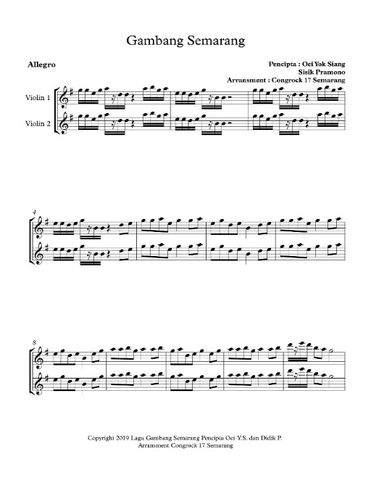

Figure 2. Sheet Music of Block Notation of the Intro in “Gambang Semarang” Song (Source: Copyright Giza Abel, 2019)

Hybridity in the congrock can be clearly seen in the performance and music in the works of the “Congrock 17 Semarang” group. However, the hybridity is not only about the combination of local and modern elements, but also the subject formed by the dominant group through the media that can apply and play modernity in discourse or daily life without losing their cultures or traditions entirely. When the subordinate group has become modern people, they are, in fact, not taking, adopting, and applying completely the truth of modern knowledge ideology that is massively disseminated through programs of readings on popular media (H. Bhabha, 1984)
“Congrock 17 Semarang” also comes up with a different reality, so that it creates a gray zone contained in the congrock music. A zone between exoticism and modernity, a form of imitation and shrewdness in integrating cross-cultural music, self-awareness of bringing local wisdom, and creating cross-cultural entertainment appears in the congrock music of the group. The group does not place rock music as a symbol of capitalist power; rather it is a symbol of freedom to negotiate locality along with partially articulating modernity.

Third Space
Rock music is a cultural product owned by the dominant group in a long period, and popularized by the media (Tolah & Utomo, 2014). “Congrock 17 Semarang” group as this research subject unwittingly gets the consequences of media exposure that spread rock music continuously. Rock music, which has become a trend among adolescents, has influenced the “Congrock 17 Semarang” group in imitating the cloth, style, and gesture that are shown on the stage.

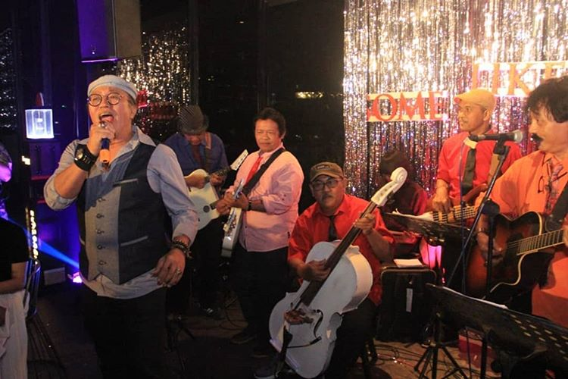

Figure 3. The performance of “Congrock 17 Semarang” (Source: “Congrock 17 Semarang” Group)
“Congrock 17 Semarang” group also carries out mimicry by adopting rock genre in stage performances. The group decides to keep preserving the local culture, specifically keroncong music as a cultural strategy to oppose capitalists in employing globalization strategies through the media.

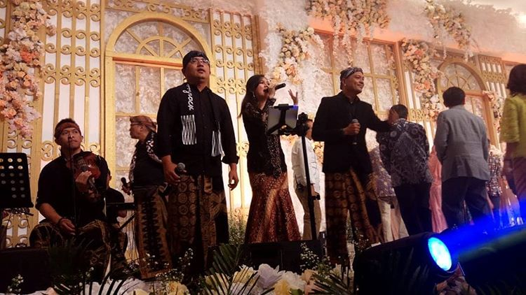
Figure 4. The performance of “Congrock 17 Semarang” (Source: “Congrock 17 Semarang” Group)

Congrock identity of the “Congrock 17 Semarang” group is then regarded as the third space or ‘intermediate’ space, in which there is a negotiation in congrock hybridity. The group members do not refuse identities or cultures brought up by the dominant group through the media. Instead, they show the dynamics of building an identity that continues to change, as well as a strategy to ‘survive’ from the rock genre exposure as the dominant culture. Congrock genre of the group serves as the form of negotiation of cultural identities in the third space mediation.
The negotiation between rock and keroncong is a hybridity discourse taking place in ambivalence, i.e., imitating and mocking, and is not completely subdued in cultural discrimination that occurs in globalization strategies done by the media. The performances and works of the “Congrock 17 Semarang” group presented on the stage show a negotiation of cultural identities between rock and keroncong music that encompasses continuous cross-cultural encounters.

CONCLUSIONS
Keroncong music has existed since the Independence Day of Indonesia and continued to develop until today; this proves the resistance of the music. From time to time, the existence and success of keroncong music, including keroncong pop, dangdut, bossa nova, and rock, can undeniably accept any kinds of cultures and developments. The integration of culture and development of new things becomes the key to the popularity of keroncong music. Music that emerges and develops with urban contours forms its own distinctive values, in which hybridity is increasingly occurring in the contours of urban society. Urban areas are the place of cross-cultural encounters, and the hybridity is applied in keroncong as a type of music. Hybridity, in its formation process, utilizes the elements of mimicry. Mimicry in hybridity, however, does not happen that easily because habitus also plays a role in the mimicry process. Hence, the elements of habitus, mimicry, and hybridity become a unity in its formation. The formation of mimicry and hybridity in keroncong mixes global values, along with local values as the strong element in hybridity. Global and local values integrate forming new values that do not remove, yet enrich both integrated values. The existence of keroncong is due to the strength of mimicry and hybridity.
Keroncong and rock (congrock) is a mimicry and hybridity behavior that is shaped in cultural identity politics. The relation of this phenomenon in the congrock genre used by the “Congrock 17 Semarang” group is seen by the huge impact of media hegemony that strongly contributes to the choice of rock genre by the group. The unification between keroncong and rock genres in the group’s works is due to identity formation in the concept of primordialism and media hegemony as the primary factors of the genre selection. Nevertheless, the group does not completely realize that the factors behind choosing rock genre are the consequences of media influence in carrying out globalization strategies. The establishment of the congrock is analyzed by using mimicry and hybridity to find out the gap in the third space, i.e., the society that becomes a space of integration, mixing, and re-interpretation of a culture. What has been done by this group is a form of keroncong actualization that is risen with new meaning. The group shows ambivalence between imitating the performance styles and rhythm patterns of the rock genre and disobeying the standard to play akin keroncong accompaniment music.
Choosing congrock music as the identity of the “Congrock 17 Semarang” group is a form of negotiation of the local cultures that are clearly seen in their works and performances on stage. The group members do not refuse the identities or cultures brought up by the dominant group through the media. Instead, they show the dynamics of building an identity that continues to change, as well as a strategy to ‘survive’ from the dominant culture exposure. This study finally concludes that congrock music in Semarang serves as the cultural identity that is formed in society as the third space, along with comprising continuous cross-cultural encounters. Congrock, as free music, refers to how one’s creativity is used in processing keroncong music, not a selection of a particular type of music.

REFERENCES
Alfian, M. (2013). Keroncong Music Reflects the Identity of Indonesia. Tawarikh-International Journal for Historical Studies.
Aryandari, C. (2018). “Ora Minggir Tabrak”: Electronic Dance Music (EDM), a Montage of The Time-Image. Journal of Urban Society’s Art, 5 No.2, 87–93.
Bhabha, H. (1984). Of Mimicry and Man: The Ambivalence of Colonial Discourse. Spring, 28, 125–133. https://doi.org/10.2307/778467
Bhabha, Homi k. (1984). The Location of Culture. London: Routledge.
Chatterjee, P. (1993). The Nation and its Fragments: Colonial and Postcolonial Histories.Princeton: Princeton University Press.
Clark, J. (2003). Introduction: Urban Culture: Representations and Experiences in/of Urban Space and Culture. Urban Culture, 1(57), 3–10.
Clayton, D. and D. Gregory (eds.). (1996). Colonialism, Postcolonialism and the Production of Space. Massachusetts: Blackwell.
Darini. (2012). Keroncong Dulu dan Kini [Keroncong in the Past and Present Time]. Jurnal Mozaik, 6 No.1, 19–31.
Dini, T., Utomo, U., & Triyanto, T. (2018). The Reflection of Cultural Identity of Gayo Society, Central Aceh Regency in Tawar Sedenge Song. Catharsis, 7(2), 189198.
Easton, S. C. (1964). The Rise and Fall of Western Colonialism: A Historical Survey from the Early Nineteenth Century. Connecticut: Praeger.
Ganap, V. (2006). Pengaruh Portugis pada Musik Keroncong [The Influence of Portuguese on Keroncong Music]. Harmonia.
Hauser, A. (1982). The Sociology of Art. Terj. Kenneth J. Northcott. London: University of Chicago Press.
Kartika, B. A. (2015). Mengapa Selalu Harus Perempuan: Suatu Konstruksi Urban Pemenjaraan Seksual Hingga Hegemoni Maskulinitas dalam Film Soekarno [Why Always Women: An Urban Construction of Sexual Restraint and Masculinitiy Hegemony in the Movie of Soekarno]. Journal of Urban Society’s Art, 2 No.1, 35–54.
Laksono, K., Purba, S. A., & Hapsari, D. (2015). Musik Hip-Hop sebagai Bentuk Hybrid Culture dalam Tinjauan Estetika [Hip-Hop Music as a Form of Hybrid Culture in the Perspective of Aesthetics] . Jurnal Resital, 16(2), 75–83.
Lestari, W., & Rachman, A. (2012). Bentuk Aransemen Musik Keroncong Asli Karya Kelly Puspito dan Relevansinya Bagi Remaja dalam Mengembangkan Musik Keroncong Asli [Music Arrangements of Original Keroncong by Kelly Puspito and Its Relevance to Adolescents in Developing Original Keroncong] . Catharsis, 1(2), 15–30.
Metro Semarang. 2015. “Congrock 1 Kolaborasi dengan Rock dengan Sentuhan Modern [The Collaboration between Congrock 1 and Rock Music with Modern Touch]. Retrieved from https://metrosemarang.com/congrock-17-kolaborasi-keroncong-dan-rock-dengan-sentuhan-modern-13657 on 6 March 2017.

Mintargo, W. (2017). Akulturasi Budaya Dalam Musik Keroncong di Indonesia [Cultural Acculturation in Keroncong Music in Indonesia]. Nuansa Journal of Arts and Design, 1(1), 10–22.
Nasional Kompas. 2008. “Congrock Kebebasan dalam Berkesenian” [Congrock as A Freedom in Art]. Retrieved from https://nasional.kompas.com/read/2008/12/13/15153116/~Oase~Cakrawala on 6 March 2017.
Paeni, M. (2009). Sejarah Kebudayaan Indonesia: Seni Pertunjukan dan Seni Media [History of Indonesian Cultures: Performing and Media Arts]. Jakarta: Raja Grafindo Persada.
Purwanto. (2015). Politik Identitas Dan Resolusi Konflik Transformatif [Identity Politics and Transformative Conflict Resolution]. Jurnal Review Politik, 5(01), 11–30.
Rachman, A., & Utomo, U. (2018). “sing penting keroncong”: sebuah inovasi petunjukkan musik keroncong di semarang ["sing penting keroncong": an innovation of keroncong music performances in semarang]. Jurnal Pendidikan Dan Kajian Seni, 3(1), 47–63.
Rachmawati, L., Rohidi, T., & Tarwiyah, T. (2016). Yen Ing Tawang Ana Lintang Kasus Bentuk Musik Keroncong Group Congrock 17 Di Semarang [Yen Ing Tawang Ana Lintang: A Case of Forms of Keroncong Music of Congrock 17 Semarang Group]. Catharsis, 5(2), 79–83.
Sedyawati, E. (2002). Indonesia Heritage Seni Pertunjukan [Indonesian Heritage: Performing Arts]. Jakarta: Buku Antar Bangsa.
Susanto, B. (2003). Identitas dan Poskolonialitas di Indonesia [Identities and Posrcolonialisms in Indonesia]. Yogyakarta: Kanisius.
Tolah, A., & Utomo, U. (2014). Proses Berkarya Grup Musik Distorsi Akustik [The Work Process of Acoustic Distortion Music Group]. Catharsis, 3(2), 10–25.
Turner, K. (1984). Mass Media and Popular Culture. Chicago: Science Research Association.
Usman, S. (2000). “Apresiasi Masyarakat terhadap Musik Populer” [Community Appreciation to Popular Music] In Ketika Orang Jawa Nyeni [When the Javanese does Arts], Ahimsa-Putra (Ed). Yogyakarta: Galangpress.
Utomo, U., & Rachman, A. (2019). The Rhythm Pattern Adaption of Langgam Jawa in Keroncong. In iconarc 2018.
Weirtheim, W. F. (1964). Indonesian Society in Transition: A Study of Social Change. The Hague: W. van Hoewe. Bandung: Sumur Bandung.
Widiastuti, T. (2015). Wacana Poskolonial dalam Desain Komunikasi Visual Kemasan Jamu Tradisional Indonesia [A Postcolonial Dicourse in Visual Communication Design of the Package of Indonesian Traditional Herbal Medicine]. Jurnal Ilmu Komunikasi, 12(1), 1–15.
Wikipedia. n.d. "Congrock 17". Retrieved from https://id.wikipedia.org/wiki/Congrock_17.
Wirawan, S. (2017). Krisis Identitas Budaya: Studi Poskolonial Pada Produk Desain Kontemporer [Crisis of Cultural Identities: A Postcolonial Study on Contemporary Design Products]. Jurnal Desain, 04(03), 311–324.

