Table
Table 1 : Data on pitch distances in Bariolage( B1a) - (B8a) / (Bars 113-120),violin
Bar | 113 | 114 | 115 | 116 | 117 | 118 | 119 | 120
Time in demisemiquaver units | B1a | B2a | B3a | B4a | B5a | B6a | B7a | B8a
0.08 | 0 | 6 | 4 | 2 | 0 | -2 | -4 | -6
0.17 | 0 | 0 | 0 | 0 | 0 | 0 | 0 | 0
0.25 | 24 | 24 | 22 | 20 | 16 | 0 | 12 | 12
0.33 | 24 | 24 | 22 | 20 | 16 | 14 | 12 | 12
0.42 | 0 | 0 | 0 | 0 | 0 | 0 | 0 | 0
0.5 | 0 | 6 | 4 | 2 | 0 | 0 | -4 | -6
0.58 | 0 | 6 | 4 | 2 | 0 | 0 | -4 | -6
0.66 | 0 | 0 | 0 | 0 | 0 | 0 | 0 | 0
0.75 | 24 | 24 | 22 | 20 | 16 | 14 | 12 | 12
0.83 | 24 | 24 | 22 | 20 | 16 | 14 | 12 | 12
0.91 | 0 | 0 | 0 | 0 | 0 | 0 | 0 | 0
1 | 0 | 6 | 4 | 2 | 0 | 0 | -4 | -6
1.08 | 8 | 7 | 5 | 3 | -5 | -7 | -4 | -5
1.16 | 0 | 0 | 0 | 0 | 0 | 0 | 0 | 0
1.25 | 24 | 23 | 21 | 19 | 15 | 13 | 12 | 12
1.33 | 24 | 23 | 21 | 19 | 0 | 13 | 12 | 12
1.41 | 0 | 0 | 0 | 0 | 0 | 0 | 0 | 0
1.49 | 8 | 7 | 5 | 3 | 0 | -7 | -4 | -5
1.58 | 8 | 7 | 5 | 3 | 0 | -7 | -4 | -5
1.660 | 0 | 0 | 0 | 0 | 0 | 0 | 0 | 0
1.74 | 24 | 23 | 21 | 19 | 15 | 13 | 12 | 12
1.83 | 24 | 23 | 21 | 19 | 15 | 13 | 12 | 12
1.91 | 0 | 0 | 0 | 0 | 0 | 0 | 0 | 0
1.99 | 8 | 7 | 5 | 3 | 0 | -7 | -4 | -5
2.08 | 7 | 5 | 3 | 2 | -3 | -5 | -5 | -5
2.16 | 0 | 0 | 0 | 0 | 0 | 0 | 0 | 0
2.24 | 24 | 23 | 21 | 17 | 15 | 13 | 12 | 11
2.32 | 24 | 23 | 21 | 17 | 0 | 13 | 12 | 11
2.41 | 0 | 0 | 0 | 0 | 0 | 0 | 0 | 0
2.490 | 7 | 5 | 3 | 2 | 0 | -5 | -5 | -5
2.57 | 7 | 5 | 3 | 2 | 0 | -5 | -5 | -5
2.66 | 0 | 0 | 0 | 0 | 0 | 0 | 0 | 0
2.74 | 24 | 23 | 21 | 17 | 15 | 13 | 12 | 11
2.82 | 24 | 23 | 21 | 17 | 15 | 13 | 12 | 11
2.91 | 0 | 0 | 0 | 0 | 0 | 0 | 0 | 0
3.000 | 7 | 5 | 3 | 2 | 0 | -5 | -5 | -5

Table 2: Data on pitch distances in Bariolage,Piano Transcription (Bars 118-125)

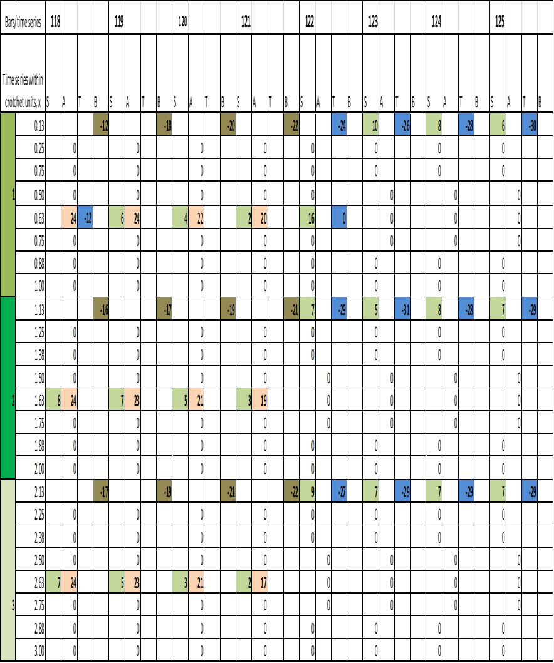

Figures
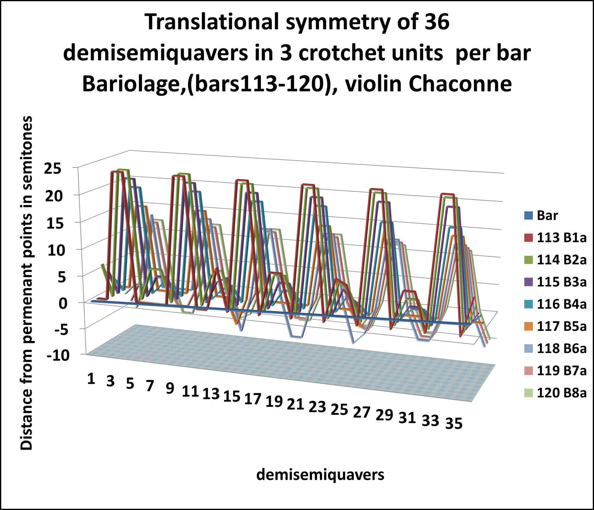
Figure 1: Bariolage (Bars113-120),Violin
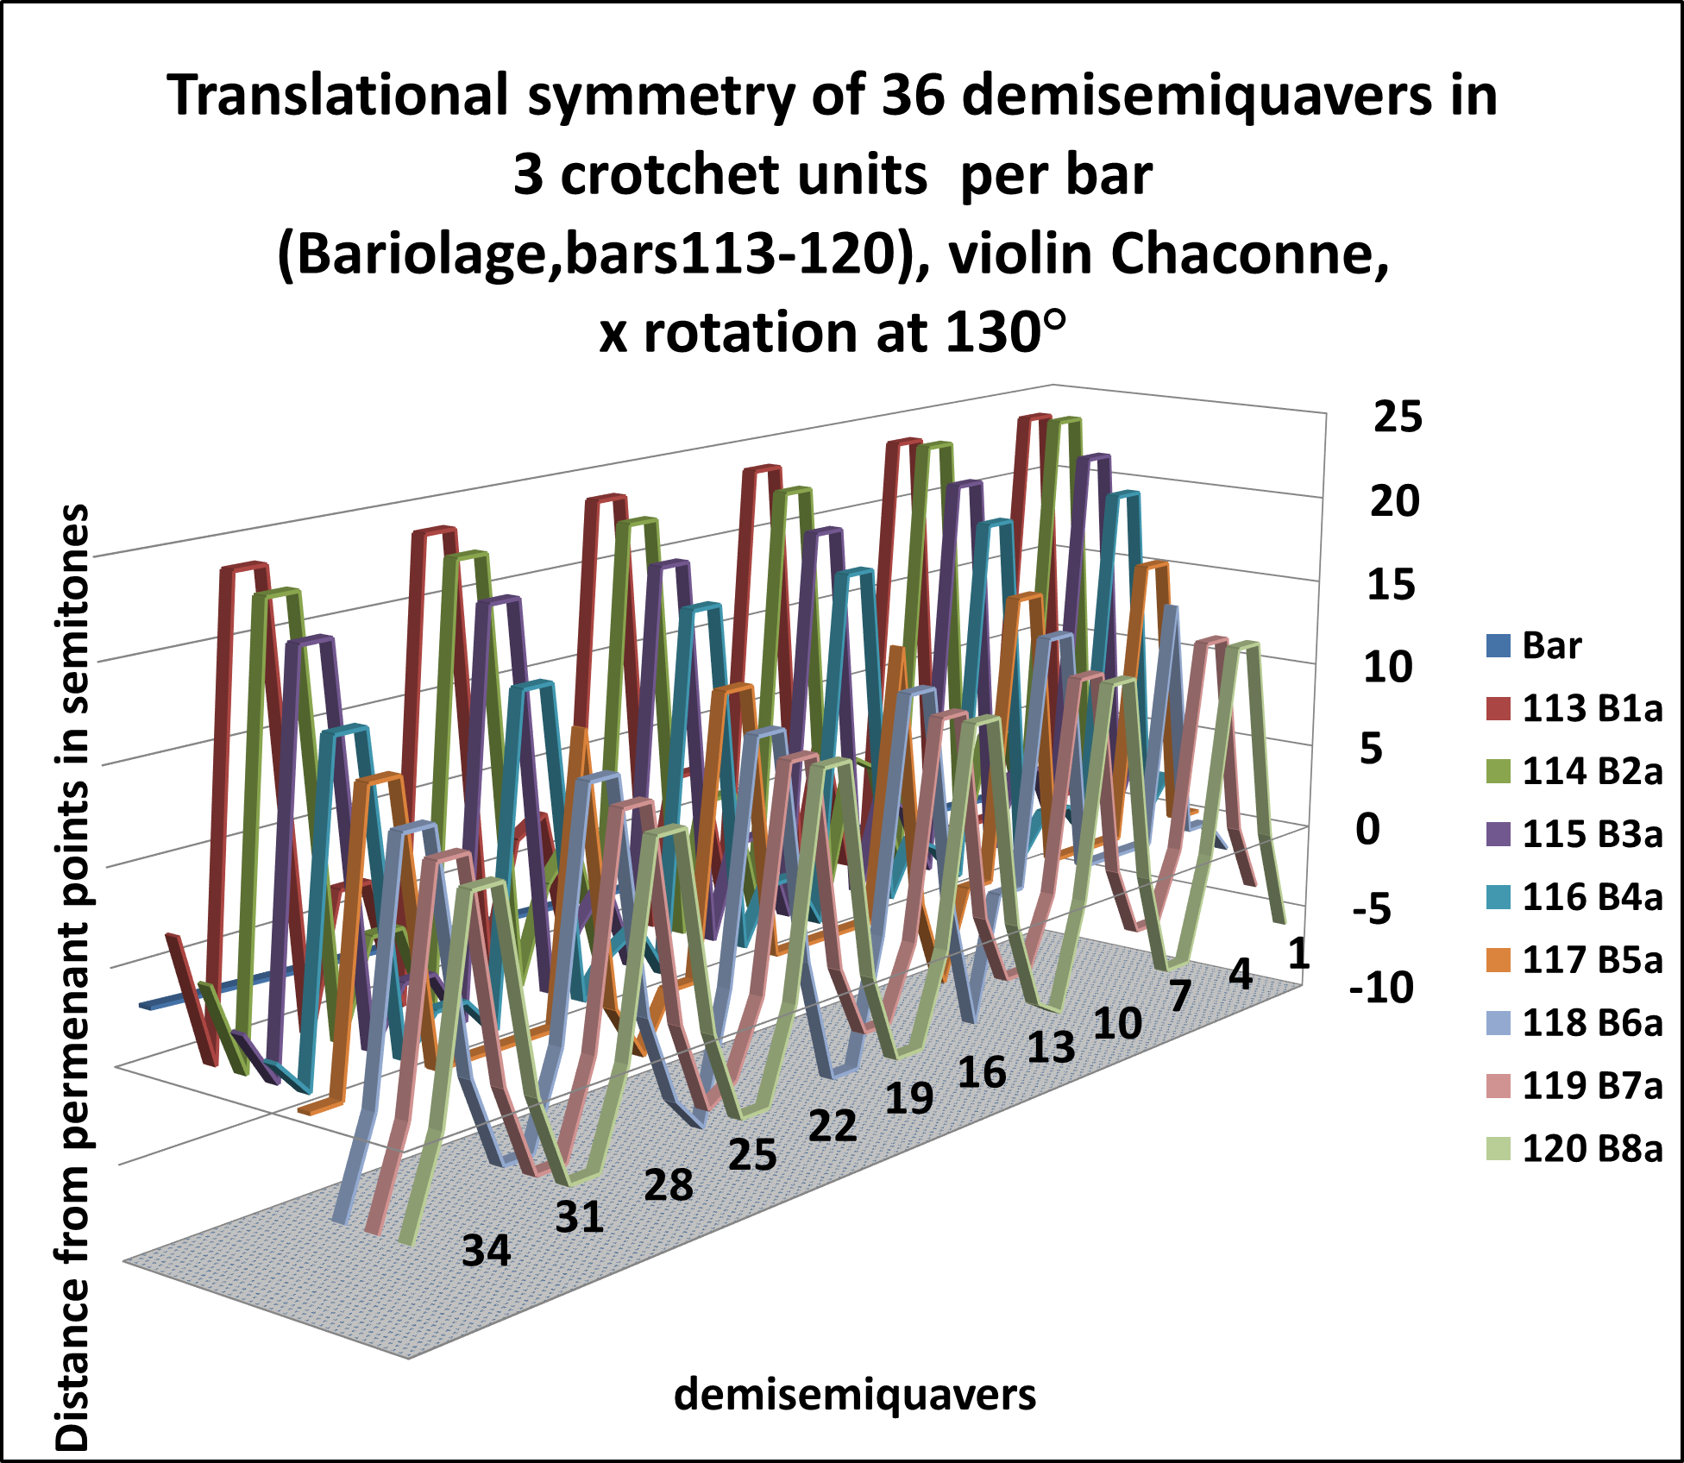
Figure 2 :Bariolage (Bars113-120),Violin, x rotation at 130°

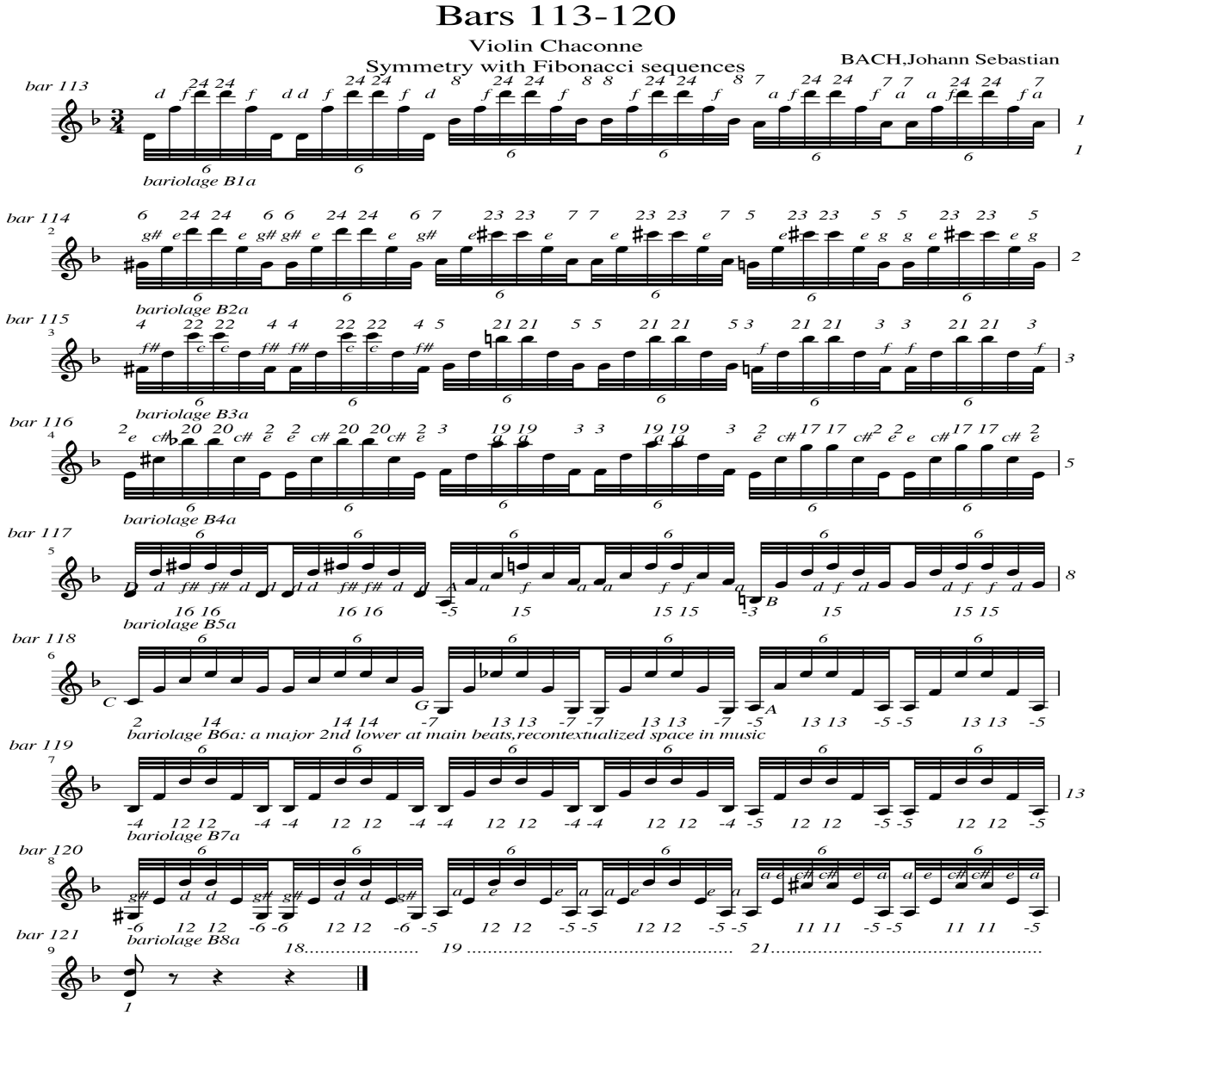
Figure 3: Bariolage (Bars113-120),Violin: Pitch distances in semitones

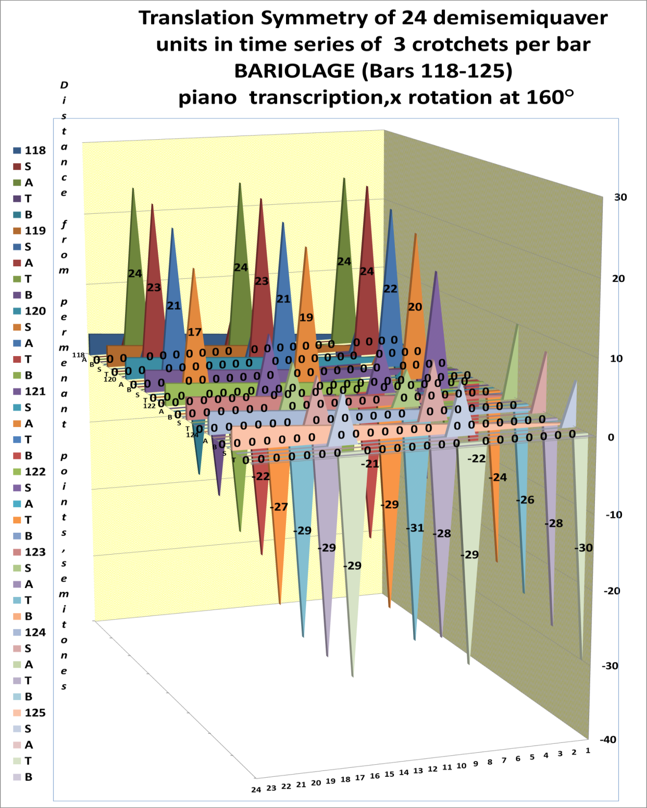
Figure 4: Bariolage (bars 118-125,piano transcription)
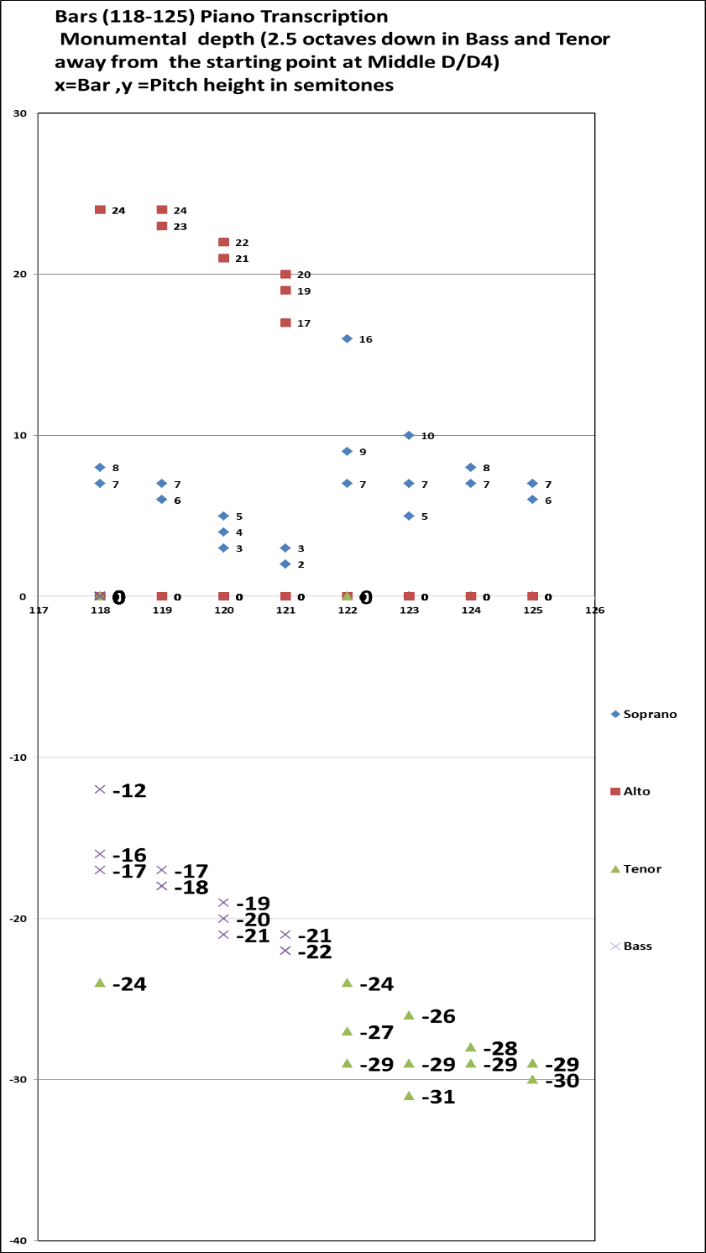
Figure 5: The signature of depth from Bariolage (bars 118-125, piano transcription)
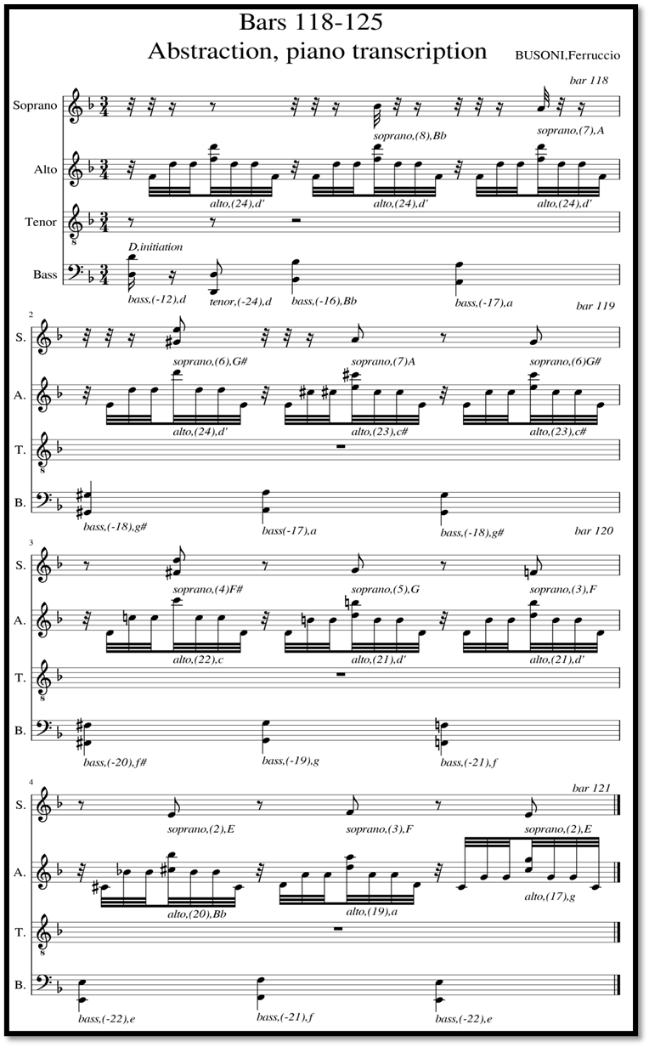
Figure 6: Abstraction from bars (118-125):Soprano, Alto, Tenor, Bass: SATB
Chaconne piano transcription, Busoni

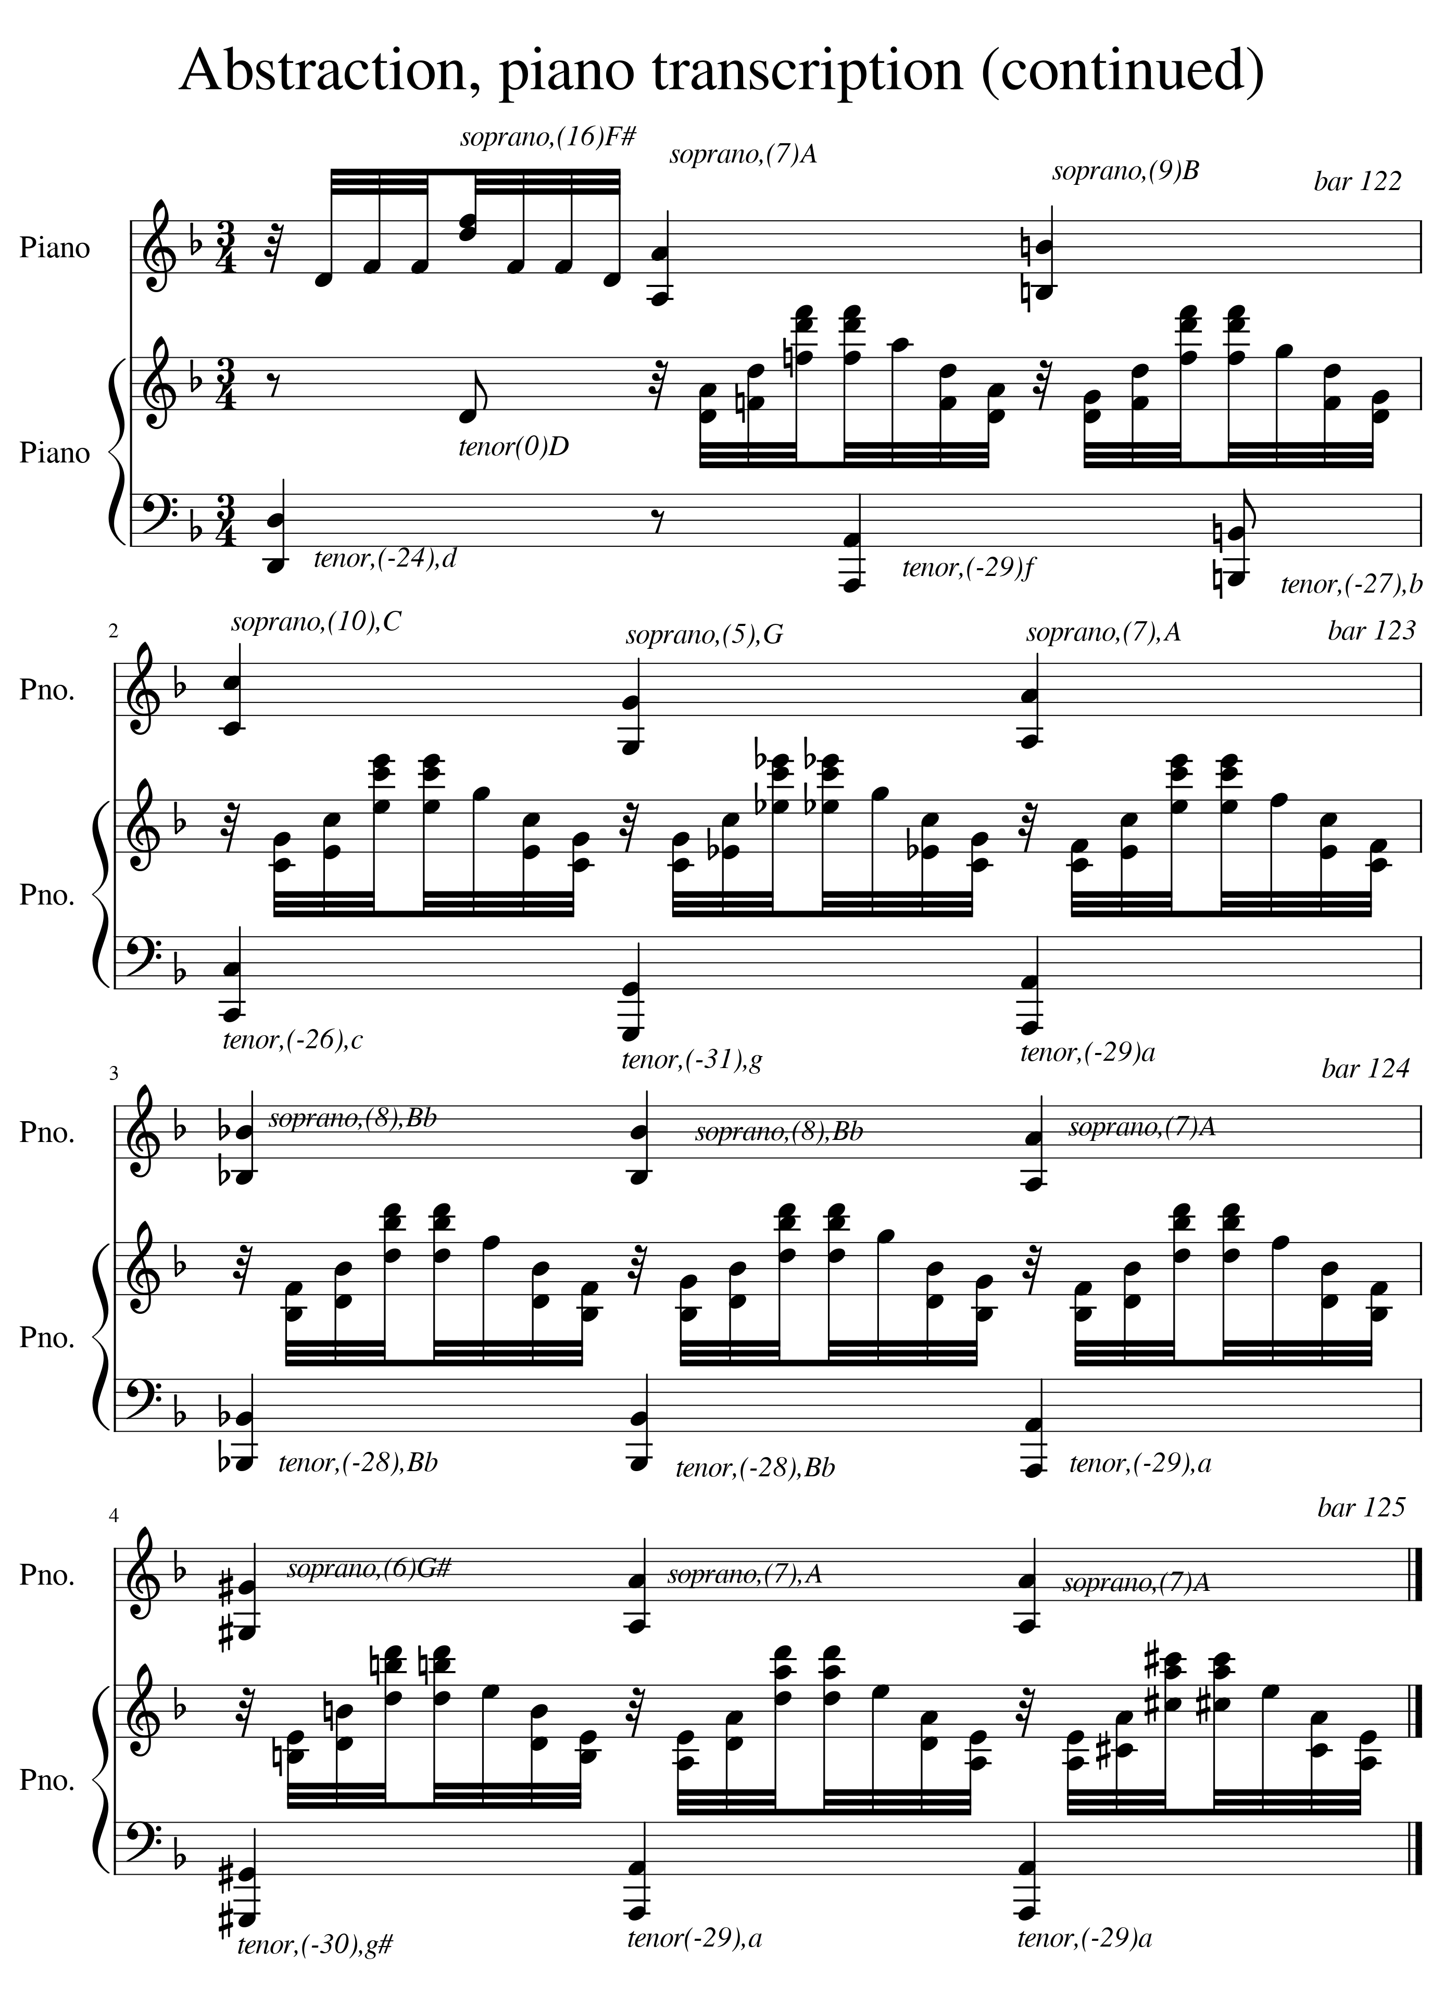
Figure 6 cont.: Abstraction from bars (118-125):Soprano, Alto, Tenor, Bass: SATB Chaconne piano transcription, Busoni

