**The Extraction of Natural Dyes from Jackfruit Wood Waste (*Artocarpus heterophyllus* *Lamk)* with Water Solvent Using by The Microwave Method**

Selfina Gala*, Mahfud Mahfud, Sumarno Sumarno, Lailatul Qadariyah

Department of Chemical Engineering, Institut Teknologi Sepuluh Nopember, Surabaya, Indonesia, 60111

*email: [selfinagala90@gmail.com](mailto:selfinagala90@gmail.com)

**Abstract**

*Currently, exploration of natural dyes is increasingly being activated and developed, especially to find natural sources of dyes from different plant species and also to develop natural dyestuff extraction process technology for textile applications. During this natural dye extraction process is done by conventional methods that require a long time and a large amount of solvent. Therefore, it is a necessary alternative to the use of "green techniques" are economical in its use. In this research, extraction of Jackfruit wood waste with the microwave by studying the extraction time required to produce the optimum yield and comparing with the conventional method (heat-reflux extraction). Both of these methods use water solvent. On the microwave-assisted extraction, the optimum extraction time at 30 minutes with the acquisition yield of 3.14% (microwave power 400 watt, the ratio of material to solvent 0.02 g/mL). whereas extraction with heat-reflux method showed the optimum extraction time of 180 minutes with a yield of 3.50%. Identification of groups of pigments contained in the Jackfruit wood waste is known categories tannins, flavonoids, and quinones. Fourier Transform Infrared Spectroscopy was used to identify the major chemical groups in the extracted dye. Description of the effects of extraction with microwave and conventional, structural damage shown in a solid surface material using by Scanning Electron Microscopy. Further, to test the application on the fabric dyeing.*

*Keywords:* Jackfruit wood waste, Microwave assisted extraction, Natural dyes, Reflux extraction.

**INTRODUCTION**

Interest and demand for natural products have increased significantly in recent years. The increasing demand for natural dyes is due to an awareness of the negative impact on the use of synthetic dyes that are both toxic and carcinogenic that can be harmful to the health and the environment. Therefore, in developed and developing countries are starting to using natural dyes that are non-toxic, non-carcinogenic, renewable sources, environmentally friendly and non-allergic reaction on the skin. Some natural sources in producing a dye which is truly beautiful and economical price compared to synthetic dye (Leitner et al., 2012; Sinha et al., 2012; Ali et al., 2009). Besides, dye textiles sourced from plants functioned as an antimicrobial because it contains tannin that is spatially antimicrobial (Selvam et al., 1993).

Currently, exploration of various types of plants that are the largest source of natural dyes has begun to be developed. Part of the plants that can be extracted to be used as a natural dye one of which is part of the bark and wood. Jackfruit is one of the plants that contain natural dyes (pigment). Jackfruit is widely found in Indonesia. Jackfruit wood is widely used as the material for furniture and building. In the processing, the wood waste produces sawdust. The waste is generally not used optimally when jackfruit wood contains some kind of pigment. Jackfruit wood contains tannin with morin types that can cause yellowing of thetextile material (Rosyida and Zulfiya, 2013; Qadariyah et al., 2017).

Natural dyes derived from plants can be obtained by extraction. They are still used in some industries since in the past till nowadays, especially the textile industry batik obtained by boiling the raw material with water as a solvent (traditional method). For the laboratory scale, it is usually performed by conventional methods such as reflux and Soxhlet extraction. This method requires a long time and a relatively large amount of solvent with a low yield (Vazquez et al., 2014; Sinha et al., 2013; Umale and Mahanwar, 2012; Sinha et al., 2012; Karabegovic et al. 2012; Xiao et al., 2008). Therefore, it encourages technology innovation in extraction process by utilizing microwaves as an energy source with more optimal results in a relatively short time. Also, the method includes "green techniques" in the process of extraction of natural dyes.

Basically, the work of microwave method or so-called Microwave-assisted Extraction (MAE) occurs when the microwaves heat the material and solvent directly which produces localized heating that drives the outbreak of plant cell walls and triggers the release of the dye more into the solvent (Ali et al., 2009). Therefore, MAE is an alternative method of considerable potential, especially when the material is extracted plant (Chen et al., 2007; Gala et al., 2018).

The various previous studies illustrate the need for the development of the process of extracting natural dyes with a variety of plant species which is a source of raw materials that can be updated, safe for health and the environment. Therefore, the extraction process which utilizes microwaves as alternative energy sources and is an environmentally friendly technology, so this study will be carried out to discover the source of natural dyes by methods Microwave-assisted Extraction (MAE) through the study of the parameter influencing the product produced. With this new technique used tools and environmentally friendly materials effectively and efficiently.

.This research aims to study the effect of the acquisition the extraction time on extraction yield with microwave assisted extraction (MAE) and reflux extraction, know the characterization extract natural dyes with phytochemical screening (identification of the type of pigment in extracts) and using Fourier Transform Infrared Spectroscopy (identification of functional groups of compounds). Knowing the morphological changes in the surface structure of the material after extracted by heat reflux method and MAE. Furthermore, apply the dyeing of cotton cloth and compare it with synthetic dyes Next, apply the dyeing of cotton cloth and compare it with synthetic dyes.

MATERIALS AND METHODS

Materials and reagents

The raw material jackfruit wood used were obtained from the District Wagir, Malang Regency in powder form results in sawmills, distilled water as a solvent, sodium hydroxide (NaOH 1%) as a regulator of alkaline pH, acetic acid (CH3COOH) 5% as a regulator of acid pH and alum [Al2 (SO4)3] as a mordant on the application staining. Hydrochloric acid 1%, Ferric chloride 1%, Sodium chloride 10% and Mg powders is used for phytochemical test (All chemicals used are technical and obtained from chemical distributors in Indonesia).

Apparatus

The tools used are models Electrolux Microwave Oven Magnetron EMM2007X with frequency 2450 MHz (2.45 GHz) and a power of 100-800 W, the voltage of 220 V, the dimensions of the microwave with a length of 46.1 cm, width 28 cm, and height 37.3 cm. The extraction process is done in the extractor glass three-neck round bottom flask which is equipped with a condenser. Thermocouple temperature on the extraction of pumpkin measured by type K 1/16 inc installed in the microwave.

Microwave-assisted extraction (MAE) and Heat reflux extraction (HRE)

The raw material is reduced in size, sieved to 30-60 mesh size. The raw material in sawdust form of 4 g and solvent distilled water of 200 mL were put into the extractor flask. The process is done with variable extraction time at 10, 20, 30, 40, 50, 60 minutes respectively. The operating conditions at the microwave power of 400 Watt, ratio of material to solvent 0.02, the temperature of approximately 100°C. The extraction results are filtered by vacuum filtration, evaporated and dried of approximately 80oC.

The reflux extraction was performed by the time variable extraction at 30, 60, 90, 120, 150, 180 minutes respectively (4 g of material in 200 mL of water solvent).

Analysis method for extracts of dyes

The results of extracts of natural dyes obtained were analyzed using FTIR (Fourier Transform Infrared Spectrometry) Prestige-21 Shimadzu and SEM (Scanning Electron Microscopy) TESCAN VEGA 3SB.

Fourier Transform Infrared Spectrometry aims to identify the identification functional groups of compound extracted dye.analysis by SEM was conducted to determine the morphological changes in the surface structure of the material after extraction with heat reflux and MAE methods.

RESULTS AND DISCUSSION

This study is using a water solvent that is based on the nature of polarity and has a high dielectric coefficient of around 80.4 (Metaxas, 1996), so it is excellent in the absorption of microwaves.

The dielectric constant plays a crucial role in determining the interaction between the electric field with a solid matrix, the higher the coefficient of dielectric owned the solvent, the better to absorb the microwave energy.

Effect of extraction time on extraction yield

The extraction time is one of the important factors that affect the acquisition of the extraction. The extraction time is closely related to the length of time the solvent contact with the material. In general, the length of time of extraction will increase its yield advantage.

Fig 1. shows the effect of extraction time on the yield (microwave power of 400 watt, the ratio of material to solvent of 0.02 g/mL). The optimum extraction time of 30 minutes with the acquisition yield of 3.14%. At about 30 minutes the diffusion phase where the rate of extraction run slowly to yield ideally obtained relatively constant. But because there is no control of the temperature in the extractor (temperature of about 100-103oC), resulting in decreased yield began in temperature after 30 minutes. At this boundary, allegedly already started to occur degradation of bioactive components including a pigment component contained in the material.

At the plant material, the longer extracted, the decline in yield since the components to be extracted in particular the natural pigment will be degraded because it is thermolabile (Mandal et al., 2007). After a time of 30-40 minutes noticeable decrease in percent yield. Further changes are insignificant and tend to yield constant until minutes into 60. While the reflux extraction (Fig.2) shows the optimum time for 180 minutes with the acquisition at the optimum yield of 3.50%. When compared MAE with HRE method, its duration of extraction at MAE very short of 10 minutes and the difference was very significant in comparison with the reflux method (120 min) to obtain optimum yield.

**Figure 1.** Effect of extraction time on the extraction yield of jackfruit wood waste (Microwave power of 400 watt, Feed to solvent of 0.02 g/mL)

**Figure 2.** Effect of extraction time on extraction yield with heat-reflux extraction method

**Qualitative analysis extracted dyes**

This research is conducted qualitative test pigment component which is found in extracts by phytochemical test (pigment identification) and Fourier Transform Infrared Spectrometry (the identification functional groups of extracted dye).

1. **Phytochemical test**

Qualitative analysis of flavonoid, tannin and quinone pigments is performed because these three types of pigments are indicated to be dominant in raw materials. The phytochemical test is one of the qualitative tests of pigment classes contained in the material (Marka et al., 2013). The tested material was extracted without heat treatment (cold maceration for 48 hours) and the MAE (The temperature in the extractor is controlled at about 100°C. The result of the phytochemical test can be shown in Table 1.

**Table 1.** Pigment identification of the test qualitative phytochemical screening

**Table 1.** Pigment identification of the test qualitative phytochemical

screening

|  |  |  |  |  |  |  |
| --- | --- | --- | --- | --- | --- | --- |
| **Types** | **Types** | **Reagents** | **Observation** | **Test results** | | |
| **of material** | **of pigment** |  |  | **Maceration** | **MAE** |
| Jackfruit wood | Flavonoid | Mg powder + HCl | Orange | + | ++ |
|  | Tannin | NaCl + FeCl3 | Blackish green | + | ++ |
|  | Quinone | NaOH | Red | + | ++ |

Note: + = Strong

++ = Stronger



Phytochemical test materials and the product extracted with MAE slightly different in terms of color density. In general, the color of the extract with MAE is more concentrated than the extract by maceration. The color concentration by phytochemical test also can be obtained quantitively for extraction by microwave with 10 min of reaction time. The result is greater than extraction by maceration with soaking time for 48 hours.

1. **Characterization of the extracted dye with FTIR Spectrometer (Fourier Transform Infra Red)**

Qualitative analysis of functional groups on the raw material and extract the dye after extraction with MAE is done by interpreting the absorption peaks of the infrared spectrum. Figure 3. shows the FTIR spectra of raw materials and extract, where the results of these spectra are used to observe changes in the structure or functional group of substances after extraction with microwave. The results show a ribbon stretching extract (vibration strain) -OH, but the -OH group on raw materials (Figure 3a) indicate the presence of free -OH groups (provide absorption with greater frequency with sharp intensity). While in Figure 3b shows the formation of the group -OH bound (the hydrogen bonds) are on the uptake with lower frequency and width and a shift in the absorption band.

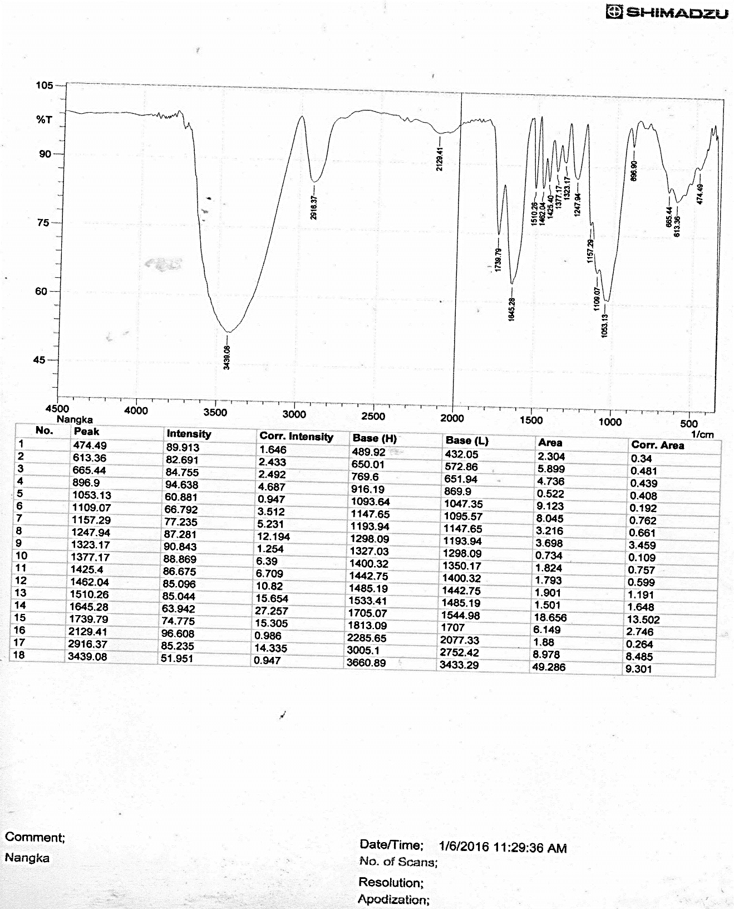

**(a)**

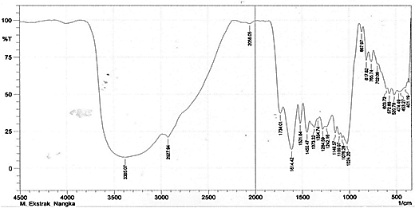

**(b)**

**Figure 3.** FTIR spectra of Jackfruit wood: (a) before the extraction,

(b) After the extraction with MAE (power of 400 watt, extraction time for 10 min)

The FTIR spectra analysis of the extracted dye after the extraction with MAE show distinct peaks at 3385, 2927, 2058, 1734, 1614, 1521 cm-1 respectively (Fig 3). The broad and strong band at 3385 cm-1 can be attributed to bonded –OH groups. The peak at 2927-1 is indicative of C-H stretching vibration, -C  N stretching of 2058 cm-1, C=O stretching of 1734 cm-1, C=C stretching of 1614 cm-1, N-H bending of 1521 cm-1.

In FTIR spectrometry analysis, it is identified that there are functional groups of the chromophore such as carbonyl groups (C=O) and ethylene groups (C=C). Functional groups of auxochrome, hydroxyl groups (-OH) ( Supratman, 2010).

**Structure surface morphology analysis by SEM**

To describe the effect of the use of MAE (Microwave Assisted Extraction) and extraction by means of reflux heat on the surface morphology of jackfruit wood powder made by SEM (Scanning Electron Microscopy) at 1.00 kx magnification.

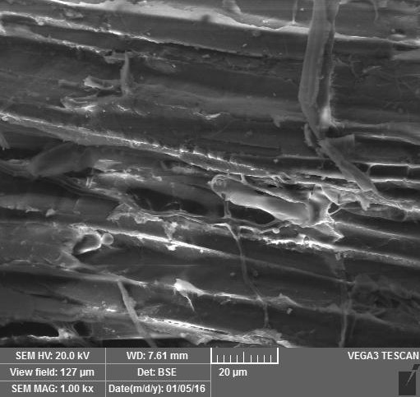

**(a)**

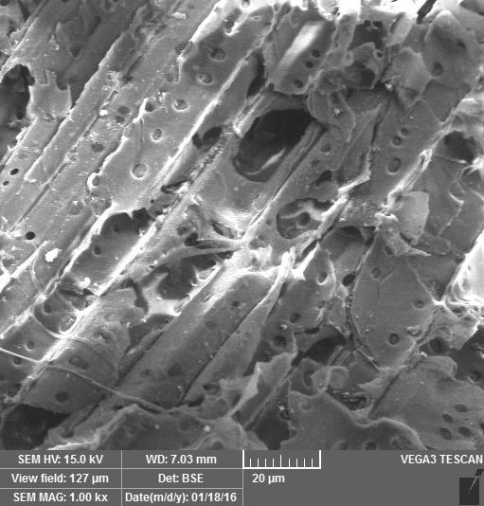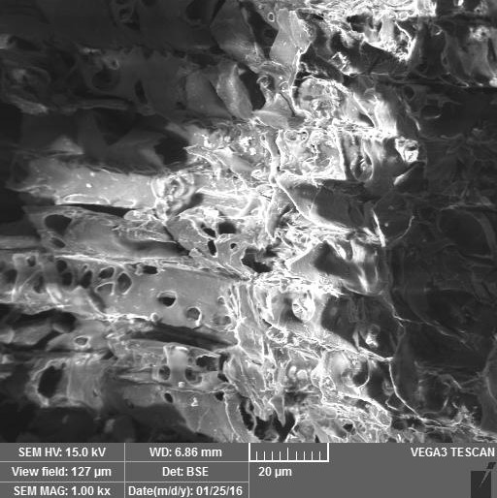

**(c)**

**(b)**

**Figure 4.** The image of SEM sawdust jackfruit size of 20 μm with 1.00 kx magnification on:

1. Powder before the extraction, (b) Powder after the extraction with MAE (Power of 264 W, extraction time for 10 min), (c) Powder after extracted by heat-reflux for 120 min.

In Figure 4 it can be seen that there is damage to the surface of the particles of matter, which is before the extracted (Figure 4a) structural damage visible image of the particle size reduced by mechanical treatment. Particle structures are shown in the horizontal plane. The surface structure of the particles after extraction with MAE shown in Figure 4b. Visible surface structure and surface layer perforated look broke/cracked and peeled. While the picture after extracted by heat reflux (Figure 4c), the visible surface structure is also holey, hollow and cracked.

In general, damage to the surface structure after extracted by MAE can be caused by the polar molecules of materials when exposed to microwave radiation will experience more rapid rotation (movement oscillation and collided) and generates heat energy (Mandal et al., 2007). This is what causes the cell walls cracked/broken or formed hole/cavity penetrates into the surface of the material.

**(a)**

**(b)**

**Alkaline**

**Acid**

**Neutral**

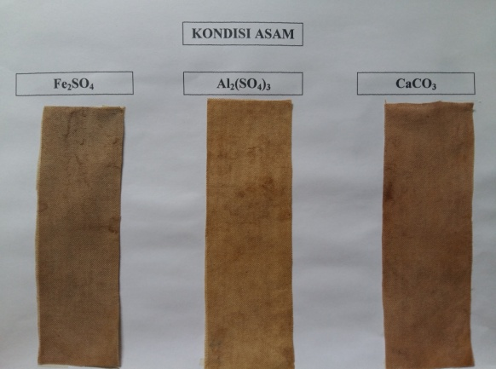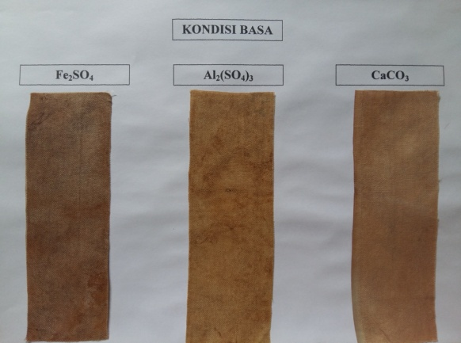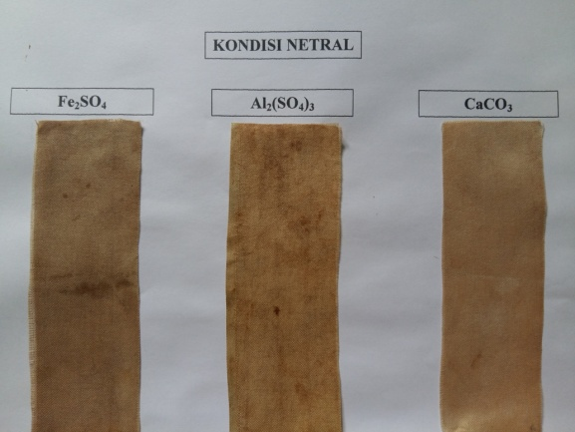

**Figure 5.** Results of dyeing using natural dyes from Jackfruit wood powder with alum fixator under acidic conditions, neutral and alkaline: **(a)** The extract dyes from Jackfruit wood, **(b)** Textile dyes (Naphtol brown)

Figure 5a. shows the fabric has been dyed with natural dyes and produces a brown color, either in acid, neutral or alkaline. Whereas the results shown in Figure 5b for synthetic textile dyes (naphthol brown) show a light brown color. In general, coloring quality using natural dyes tends to have more dominant color strength than synthetic color.

**CONCLUSION**

Extraction of natural dyes from jackfruit wood waste has been successfully performed using MAE. The results showed that the optimum extraction time of 30 minutes with the acquisition yield of 3.14%. Meanwhile, heat-reflux extraction, the optimum time required is 180 minutes with the acquisition of optimum yield of 3.50%. The identification of pigments with phytochemical screening test shows the presence of pigment tannin, flavonoid, and quinone on the extract dyes. In FTIR spectrometry test, it is identified that there is a functional group of the chromophore such as carbonyl groups (C=O) and ethylene group (C=C). Group of auxochrome, hydroxyl (-OH).

The results of SEM analysis showed that the structural failure of the material after extraction with reflux method and MAE (formed holes, cracks and chipped). The damage occurred in a short time (10 minutes) by the method of MAE.

The coloring application using natural dyes on white cotton fabric produces a brown color and shows the strength of color more dominant than synthetic dyes that produce light brown.

**ACKNOWLEDGEMENT**

This work was financially supported by Ministry of Technology Research and Higher Education of Indonesia (1523/K9/KT.03/2017).

REFERENCES

Ali, S., Hussain, T., Nawaz, R. 2009. Optimization of alkaline extraction of natural dye from Henna Leaves and its dyeing on cotton by exhaust method. Journal of Cleaner Production. 17:61-66.

Chen, Y., Xie, M.Y., Gong, X.F. 2007. Microwave assisted extraction used for the isolation of total triterpenoid saponins from *Ganoderma atrum*. Journal of Food Engineering. 81:162-170.

Gala, S., Sumarno, S., Mahfud, M*.,* 2018. Microwave-assisted Extraction of Natural Dyes from *Coleus atropurpureus* Leaves: The Effect of Solvent. MATEC Web of Conferences. 156 : 06011

Karabegovic, I.V., Stojicevic, S.S., Velickovic, D.T., Nokolic, N.C., Lazic, M.L. 2012. Optimization of Microwave-Assisted Extraction of Cherry Laurel *(Prunus laurocerasus L.)* Fruit Using Response Surface Methodology. World Academy of Science, Engineering and Technology*.* 71:351-356

Leitner, P., Fitz-Binder, C., Mahmud-Ali, A., Bechtold, T. 2012. Production of a concentrated natural dye from Canadian Goldenrod *(Solidago Canadensis)* extracts. Dyes and Pigments. 91:1416-1421.

Mandal, V., Mohan, Y., Hemalath, S. 2007. Microwave Assisted Extraction an Innovative and PromisingExtraction Tool for Medicinal Plant Research. Pharmacognosy Reviews. 1(1):7-18.

Marka, S., Talari, S., Penchala, S., Rudroju, S., Nanna, R.S., 2013. Preliminary Phytochemical Analysis of Leaf, Stem, Root and Seed Extracts of *Arachis hypogaea* L. International Journal of Pharmaceutical Sciences Review and Research*.* 22:134-139.

Metaxas, A.C. 1996, Foundations of Electroheat: A unified Approach, Wiley, New York.

Qadariyah, L., Gala, S., Widoretno, D.R, Kunhermanti, D., Bhuana, D.S., Sumarno, Mahfud, M., 2017. Jackfruit (Artocarpus heterophyllus lamk) wood waste as a textile natural dye by micowave-assisted extraction method. AIP Conference Proceedings, 1840:100007.

Rosyida, A. and Zulfiya, A. 2013. Pewarnaan Bahan Tekstil dengan Menggunakan Ekstrak Kayu Nangka dan Teknik Pewarnaannya untuk Mendapatkan Hasil yang Optimal. Jurnal Rekayasa Proses. 7(2):52-58. (in Indonesian)

Selvam, R.M., Athinarayanan, G, Nanthini, A.U.R., Singh, A.J.A., Kalirajan, K., Selvakumar, P.M. 2015. Extraction of natural dyes from Curcuma longa, Trigonella foenum graecum and Nerium oleander, plants and their application in antimicrobial fabric. Industrial Crops and Products. 7:84-90.

Sinha, K., Saha, P.D., Datta, S. 2012. Response surface optimization and artificial neural network modeling of microwave assisted natural dye extraction from pomegranate rind. Industrial Crops and Products*.* 37:408– 414.

Sinha, K., Saha, P.D., Datta, S. 2013. Modeling of microwave-assisted extraction of natural dye from seeds of *Bixa orellana* (Annato) using response surface methodology (RSM) and artificial neural network (ANN). Industrial Crops and Products. 41:165 –171.

Supratman, U. 2010. Elusidasi Struktur Senyawa Organik, Publisher Widya Padjadjaran, Bandung. (in Indonesian)

Umale, S. and Mahanwar P.A., 2012. Extraction of colorant from leaves of Terminalia catappa using Non conventional technique. International Journal of Basic & Applied Sciences IJBAS-IJENS*.* 12:79-88.

Vazquez, M.F.B., Comini, I.R., Martini R.E., Nunez M.S.C., Bottini, S., Cabrera J.L. 2014. Comparisons between conventional, ultrasound-assisted and microwave-assisted methods for extraction of anthaquinones from *Heterophyllaea pustulata* *Hook f.* (*Rubiaceae*). Ultrasonics Sonochemistry*,* 21, 478–484.

Xiao, W., Han, L., Shi, B. 2008. Microwave-assisted extraction of flavonoids from *Radix Astragali*. Separation and Purification Technology. 62:614–618.