COPYRIGHT TRANSFER AGREEMENT FORM

Manuscript Title : Impact of International Sports Event on Local Businesses: Insight from the Stallholders and Official Partners of the 2018 Asian Games
Name of Principal Authors : Mohamad Dian Revindo
Address of Principal Authors : Universitas Indonesia, Jl. Salemba Raya IV Gedung Ali Wardhana, RW.5, Kenari, Kec. Senen, Kota Jakarta Pusat, DKI Jakarta 10430
Email Address : revindo.md@gmail.com
Telephone number : 081380940560

- I hereby declare that I have submitted to the Jurnal Ekonomi dan Kebijakan for the above manuscript in original and no part has been plagiarized.
- I, in consideration of the acceptance of the above work for publication, do hereby assign and transfer to the Jurnal Ekonomi dan Kebijakan, Development Economics Department Universitas Negeri Semarang all of the rights, title, and interest in and to the copyright of the above titled work in its current form, including online supporting material (data supplements) submitted with the work, and in any form subsequently revised for publication and/or electronic dissemination, including translations to another language. I agree to the fact that any attempt to reproduce the text or figures may require their kind permission.

Print or Type Name and Title of Author
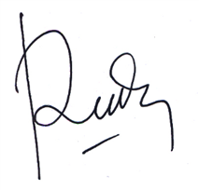
Signature Date: 18 April 2022
(When there is more than one author, only one signature will suffice.)

