 | 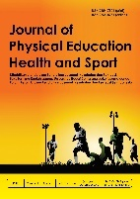  JPEHS3 (2) (2016)  Journal of Physical Education, Health and Sport  http://journal.unnes.ac.id/nju/index.php/jpehs
THE EFFECTIVENESS OF JOGGING SPRINT COMBINATION TRAINING ON STUDENTS 'FAT LEVELS

I Gusti Putu Ngurah Adi Santika¹, I Kadek Yudha Pranata², Rifqi Festiawan³

Pendidikan Jasmani Kesehatan dan Rekreasi, FKIP, Universitas PGRI Mahadewa Indonesia¹²
Fakultas Ilmu-Ilmu Kesehatan Universitas Jenderal Soedirman, Indonesia³

Info Artikel  ____________________  Sejarah Artikel:  Diterima September 2016  Disetujui Oktober 2016  Dipublikasikan November 2016  ____________________  Keywords:  Jogging, Sprint, Kadar Lemak |  | Abstrak  ____________________________________________________________  Pada saat ini remaja cenderung kurang melakukan olahraga sebagai aktivitas rutin karena perkembangan teknologi yang cenderung membuat para remaja lebih berkutat pada gadget. Dengan malas bergerak dan asupan makan secara terus menerus akan menimbun kadar lemak dalam tubuh. Berdasarkan hal tersebut perlu dilakukan latihan yang bertujuan menurunkan tingkat kadar lemak tubuh yaitu dengan latihan jogging sprint combination. Sampel penelitian ini berjumlah 24 orang yang terbagi atas 2 kelompok yaitu kelompok perlakuan dan kelompok kontrol. Design penelitian ini adalah Experimental Randomize Pres-Test and Post-Test Group Design. Hasil penelitian diperoleh bahwa terjadi penurunan tingkat kadar lemak tubuh pada pelatihan jogging sprint combination dengan rerata penurunan tingkat kadar lemak tubuh 6,7% atau sebesar (23,26%). Kesimpulan dari penelitian ini adalah pelatihan jogging sprint combination dapat menurunkan tingkat kadar lemak tubuh siswa putra kelas X MIPA SMA Negeri 2 Tabanan.  Abstract  ____________________________________________________________  At this time teenagers tend to do less exercise as a routine activity due to technological developments that tend to make teenagers more engaged in gadgets. By being lazy to move and continuous intake of food will accumulate fat levels in the body. Based on this, it is necessary to do exercises that aim to reduce the level of body fat, namely the jogging sprint combination. The research sample consisted of 24 people divided into 2 groups, namely the treatment group and the control group. The research design was Experimental Randomize Pres-Test and Post-Test Group Design. The results showed that there was a decrease in the level of body fat levels in the jogging sprint combination training with an average decrease in the level of body fat levels by 6.7% or by (23.26%). The conclusion of this study is that the jogging sprint combination training can reduce the level of body fat levels male student X MIPA public senior high school number 2 Tabanan.  © 2016 Universitas Negeri Semarang
 Alamat korespondensi:  E-mail: ngurahadisantika@gmail.com |  |  | ISSN 2354-8231 (online)  ISSN 2354-7901 (cetak)

introduction

Sport is a systematic process in the form of all activities or efforts that can encourage developing and fostering physical potential (Santika, 2015). This was confirmed by Khairuddin (2017) which says that sports as a person's physical and psychological activity are useful for maintaining and improving the quality of one's health after exercising. Based on the above opinion, we should keep exercising whatever the conditions are in order to maintain the health of our bodies.
At this time teenagers tend to do less exercise as a routine activity due to technological developments that tend to make teenagers more engaged in gadgets (Utomo, Junaidi, & Rahayu, 2012). The same thing was also expressed by Sukendra (2015) who say that children's addiction to gadgets can have a negative impact on health. The things that are caused include radiation, sleep disturbances at night, making children tend to prefer to be quiet / just sit without activity for hours. With the tendency for children to be addicted to gadgets, they are lazy to move and lazy to exercise. While playing gadgets is also accompanied by irregular and healthy eating such as snacking on snacks that are high in fat levels, the child's metabolism is disturbed and prone to increasing body fat levels.
We must fight high levels of fat among teenagers by implementing a healthy lifestyle interspersed with exercise (Santika, 2016). There are many risks of health problems that can occur in children or adolescents who are obese (Utomo et al., 2012). Exercise must be done regularly in order to reduce body fat levels. with normal levels of body fat levels, the activities carried out will run well and smoothly. With a healthy body, youth creativity will develop to carry out positive activities.
Based on observations made at public senior high school number 2 Tabanan, especially male class X MIPA, it shows that the average level of student body fat levels is at a high level with an average body fat level of 30.76% (Santika, 2019). The grouping of body fat level status is based on Omron's norms (Omron, 2008).

Table 1. Norms of Body Fat Levels (Omron, 2008)

Gender | Low | Normal | A little high | High
Man | <10% | 10-20% | 21-25% | >25%
Woman | <20% | 20-30% | 31-35% | >35%

This is a concern for students and our future generations who are already struggling with gadgets in their daily lives and forgetting about sports as an activity that must be carried out to balance the daily routine of students.
Fat or what we are familiar with (lipids) are hygrophobic organic substances that are difficult to dissolve (Fox, 1998). According to Lalarni (2015) fat is a group of organic bonds consisting of the elements Carbon (C), Hydrogen (H), and Oxygen (O), which are soluble in certain solvents. However, fat can dissolve in organic solvents such as columnoform, ether and benzene. Fat in the body is fat in the form of triglycerides, which is the result of fat metabolism (Hadi, 2013). Not only fatty food sources, but protein and carbohydrate food sources can also form triglycerides. With this, the level of body fat levels must be lowered by doing sports through intensive and measured training.
Based on the above background, the researchers conducted a study entitled the effectiveness of the jogging sprint combination training to the level of student body fat levels. The formulation of the problem in this study is how big is the effect of giving the jogging sprint combination exercise on decreasing the level of student body fat levels? The aim that the researcher wants to achieve in this case is to determine the impact of decreasing the level of student body fat levels through the jogging sprint combination exercise.
The term jogging was first known in England in the 17th century (Gobejar, 2016). Jogging is one of the most popular forms of cardio exercise and is cheap and easy, making it one of the most popular forms of cardio training and is cheap and easy, so it can be done by anyone, anytime. (Nala, 2016). The jogging sprint combination is a combination of jogging and sprint activities that are performed alternately at certain intervals. The jogging sprint combination is related to the hollow sprint, which is the use of two sprints with a period between the hollow speed indentation and jogging or walking. (Swtiawan, 2013). In the jogging sprint combination exercise, there will be a combination of aerobic activity, in this case obtained from jogging and anaerobic activity obtained from sprints.

METHOD

The research carried out was an experimental quantitative research with the experimental design randomize pres-test and post-test group design (Sugiyono, 2013).

O1
O2

S
P

O3
O4

Figure 1. Research design

Information :

P : Population
S : Sample
O1 : Control Group Initial Measurement with Body Fat Monitor HBF-306 (400 m Jogging Exercise)
O2 : Final Control Group Measurement using Body Fat Monitor HBF-306 (400 m Jogging Exercise)
O3 : Initial Measurement of the Treatment Group with the Body Fat Monitor HBF-306 (400 m Jogging Sprint Combination Exercise)
O4 : Final Treatment Group Measurements using Body Fat Monitor HBF-306 (400 m Jogging Sprint Combination Exercise)

This research was conducted from May - June 2020 at 16.00 WITA in the Dauh Pala Tabanan field. This training is held for 6 weeks with the frequency of this training being 4 times a week, namely on Monday, Wednesday, Friday and Saturday in accordance with health protocols. The population of this research was the students of class X IPA male of public senior high school number 2 Tabanan, totaling 127 people. Of the 127 people, a sample met the inclusion criteria with the following provisions: 1) having the status of Class X MIPA students of public senior high school number 2 Tabanan, 2) Male. 3) Status of Body Fat Level is at High level, 4) Willing to attend training as many as 26 people.
From 32 samples who meet the inclusion criteria, they will be filtered again using the Pocock formula (Pocock, 2008). The pocock formula is a sample search formula used for research where the sample is doing exercises. The pocock formula requires the researcher to conduct preliminary research or prior observation at the research site. Following are the results of the calculation of the pocock formula:

2(σ²)
n = ꬵ(α,β)
(μ2 – μ1)²

Figure 2. Pocock formula (Pocock, 2008)

Information :

n : Number of Samples
σ : Standard Deviation
μ2 : Average Body Fat Levels expected after training
μ1 : Mean Body Fat Levels of preliminary research / preliminary observations
ꬵ(α,β) : 10,5 (Table of Value)

Known :

σ : 1,6072
μ2 : 28,6068%
μ1 : 30,7600%
ꬵ(α,β) : 10,5

Answer :

2(σ²)
n = ꬵ(α,β)
(μ2 – μ1)²

2(1,6072²)
n = 10,5
(28,6068 – 30,7600)²
5,1661
n = 10,5
(-2,1532)²

5,1661
n = 10,5
4,6362

54,2440
n =
4,6362

n = 11,7

The provisions in the Pocock formula are that if the resulting number has a decimal fraction from 0.5 and above then it is rounded to 1, then the 11.7 obtained is rounded to 12. Given that this research is an experimental study that lasted quite a long time, namely for 8 weeks, then The researcher is obliged to provide a backup sample to avoid dropouts such as: 1) the sample is sick, 2) the sample is injured during training, 3) the sample has an accident. Researchers often forget this, therefore researchers are obliged to provide backup samples, with the aim that our pure samples remain intact until the end of the study. The reserve research is given 20% of the number of samples produced by the pocock formula, so that the number (20% x 12 = 2.4) is rounded to 2. Then the total number of samples per group becomes (12 + 2 = 14 people). So the total sample including the reserve sample is 28 people for 2 groups. So that 32 samples who meet the inclusion criteria will have 4 people left because only 28 people were taken who took part in the training. Remember that the backup sample task is only to maintain the integrity of the pure sample size, the backup sample does not count in data analysis.
The data analysis used in this study included: 1) descriptive analysis to analyze the mean, SB, minimum and maximum levels of body fat levels, 2) data normality test with the Shapiro Wilk Test which aims to determine the normality of data levels of body fat levels in each of them. treatment and control groups respectively, 3) the homogeneity test with Levene's Test aims to find the homogeneity of data on body fat levels in the treatment and control groups, 4) the t-paired test was used to analyze the mean changes in the results of body fat levels between before and after training in each Each group and 5) T-Independent Test was used to analyze the mean changes in body fat levels between the two groups pre and post.

RESULTS AND DISCUSSION

The first step to take is to test the normality and homogeneity of the data we have so that we know whether we will enter a parametric or non-parametric test. If the p value normality test is greater than 0.05 (p>0.05), then proceed to the parametric test. Meanwhile, if the p value normality test is less than 0.05 (p<0.05), then the next process is continued to the non-parametric test. The following is the table for the normality and homogeneity of the data in each group :

Table 2. Normality and Homogeneity Test

Measurement of Body Fat Levels | Normality Test  (Saphiro Wilk-Test) |  | Homogeneity Test  (Levene-Test)  p value
Measurement of Body Fat Levels | Treatment Group  p value | Control Group  p value | Homogeneity Test  (Levene-Test)  p value
Initial Measurement | 0,57 | 0,09 | 0,52
Final Measurement | 0,28 | 0,52 | 0,62

Information :

Treatment Group : Jogging Sprint Combination Training 400 m
Control Group : Jogging Training 400 m

Based on the results of the data normality test with the Shapiro Wilk-test on the level of body fat levels before and after training in the treatment group and the control group, it shows that the data in the two groups has a p value greater than 0.05 (p>0.05). Normally distributed data. In the homogeneity test with the levene-test, it shows that the data on the level of body fat content in the treatment group and the control group are said to be homogeneous because the p value is greater than 0.05 (p>0.05). Thus the data can be tested using a parametric test to determine whether there is an increase or decrease in the results of the research variables.
Paired t-test to compare the mean levels of body fat levels before and after training in the treatment group and the control group based on measurements using the HBF-306 Fat Monitor tool. From the two groups, the mean test for differences in levels of body fat before and after training was carried out which can be presented in table 3 below :

Table 3. Test of Average Differences in Body Fat Levels
Before and After Training

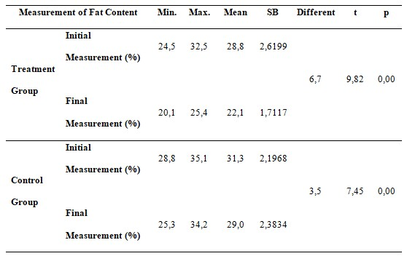

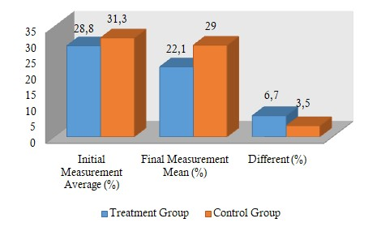

Figure 3. Graph of Average Test of Differences in Body Fat Levels
Before and After Training

Based on the table and graph above, it shows that the difference in the mean level of body fat levels in the treatment group and the control group before and after training using the HBF-306 Fat Monitor tool shows that the p value is less than 0.05 (p<0.05). So that this value states that the jogging sprint combination training and jogging training can significantly reduce the level of body fat levels. Based on the graph in Figure 3, it can be seen that based on the difference in the mean produced, it shows that the jogging sprint combination training reduces body fat levels higher than jogging training.

Table 4. Test Data on the Difference of Treatment Effects between Groups with
Independent T-Test in Determining the Final Result of Measurement
Levels of Body Fat Levels

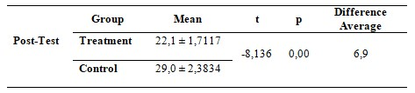

The different test from the results of measuring body fat levels using the HBF-306 Fat Monitor tool can be seen from the mean difference after training in each group as in Table 4. Based on Table 4, it was found that the mean difference in post-test results between the treatment group and the control was 6.9% with p value less than 0.05 (p<0.05). This shows that there is a significant difference in the post-test results between the treatment group and the control group.
Furthermore, the percentage change in the results of measuring the level of body fat levels after training for 2 months in the two experimental groups is presented in table 5.

Table 5. Percentage Change in Body Fat Levels After Training

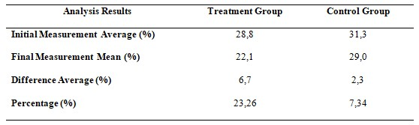

To more clearly the paired group mean in the two groups can be seen from the following graph :

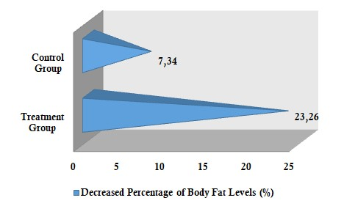

Figure 4. Graph of Percentage Decrease in Body Fat Levels After Training

Based on the average percentage change in body fat levels using the HBF-306 Fat Monitor tool after six weeks of training in table 5, it shows that the average percentage of decreased body fat levels in the jogging sprint combination training is greater than jogging training. Thus it can be said that research in the treatment group (jogging sprint combination training) resulted in a decrease in the level of body fat levels greater than the control group (jogging training).

DISCUSSION
Based on the results obtained from the jogging sprint combination exercise, with an average reduction in fat levels of 6.7% or (23.26%) then if we compare it with other relevant research results such as: research on jogging exercise for 30 minutes Santika (2015) which resulted in an average decrease in body fat levels by 0.8% or (3.8%), the jogging sprint combination training had a better impact in reducing body fat levels.
This is because the exercise carried out in the jogging sprint combination combines aerobic and anaerobic exercises. With this combination, the body's performance increases and the energy intake needed is greater. With the large amount of energy intake when doing the jogging sprint combination exercise, the body takes energy from body fat, so that body fat will be eroded and reduced.

CONCLUSIONS AND SUGGESTIONS

Based on the results of the data analysis and discussion that has been done, it can be concluded that the jogging sprint combination training can reduce the level of body fat levels of male students of class X MIPA public senior high school number 2 Tabanan. It is recommended to trainers and people who want to reduce their level of body fat to use the jogging sprint combination as an alternative in reducing body fat levels.

BIBLIOGRAPHY

Fox, E. L. (1998). The Physiological, Basic For Exercise and Sport. New York : Brown & Benehmark Publisher
Gobejar. (2016). Pengertian Kebugaran Jasmani, Jogging, Sejarah Jogging, Otot-Otot, serta Peregangan. Available from : http://blogcadiak.blogspot.co.id/2016/09/pengertian-kebugaran-jasmani-joging.html, accesed tanggal 6 Nopember 2020
Hadi, A. (2013). Pengertian, Fungsi, dan Metabolisme Lemak. Available from : http://www.softilmu.com/2013/07/pengertian-dan-fungsi-lemak.html, accesed tanggal 6 Nopember 2020
Khairuddin. (2017). Olahraga Dalam Pandangan Islam. Jurnal Olahraga Indragiri, 1(1), 1-14. https://ejournal.unisi.ac.id/index.php/joi/article/view/196
Lalarni, H. K. (2015). Pengaruh Senam Jantung Sehat Seri V Terhadap Kebugaran dan Lemak Tubuh pada Anggota Posyandu Lansia Amrih Sehat Kec. Bergas Semarang. Semarang : Jurusan Ilmu Keolahragaan Fakultas Ilmu Keolahragaan Universitas Negeri Semarang
Nala, I. G. N. (2016). Prinsip Pelatihan Fisik Olahraga. Denpasar : Udayana University Press
Omron. (2008). Body Fat Monitor HBF-306. Healtcare
Pocock, S. J. (2008). Clinical Trial, A Practical Approach, Cichestes. New York : John Wiley & Sons
Santika, I. G. P. N. A. (2015). Hubungan Indeks Massa Tubuh (IMT) Dan Umur Terhadap Daya Tahan Umum (Kardiovaskuler) Mahasiswa Putra Semester II Kelas A Fakultas Pendidikan Olahraga Dan Kesehatan IKIP PGRI Bali Tahun 2014. Jurnal Pendidikan Kesehatan Rekreasi, 1(1), 42-47. Retrieved from https://ojs.ikippgribali.ac.id/index.php/jpkr/article/view/6
Santika, I. G. P. N. A. (2016). Pengukuran Tingkat Kadar Lemak Tubuh Melalui Jogging Selama 30 Menit Mahasiswa Putra Semester IV FPOK IKIP PGRI Bali Tahun 2016. Jurnal Pendidikan Kesehatan Rekreasi, 2(1), 89-98. Retrieved from https://ojs.ikippgribali.ac.id/index.php/jpkr/article/view/165 (Original work published June 30, 2016)
Santika, I. G. P. N. A. (2019). Pengukuran Tingkat Kadar Lemak Tubuh SMA Negeri 2 Tabanan Tahun 2019. Denpasar : FPOK IKIP PGRI Bali
Setiawan, W. (2013). Jogging Olahraga Ringan yang Bermanfaat. Available from : http://kotabiru.blogspot.co.id/2013/07/tips-jogging-untuk-dapatkan-manfaat.html, accesed tanggal 6 Nopember 2020
Sugiyono. (2013). Cara Mudah Menyusun : Skripsi, Tesis, dan Disertasi. Bandung : ALFABETA
Sukendra, D. M. (2015). Efek Olahraga Ringan Pada Fungsi Imunitas Terhadap Mikroba Patogen : Infeksi Virus Dengue. 5(2). https://journal.unnes.ac.id/nju/index.php/miki/article/view/7890
Utomo, G. T., Junaidi, S., & Rahayu, S. (2012). Latihan senam aerobik untuk menurunkan berat badan. Journal of Sport Science and Fitness, 1(1), 6–10. https://journal.unnes.ac.id/sju/index.php/jssf/article/view/205

