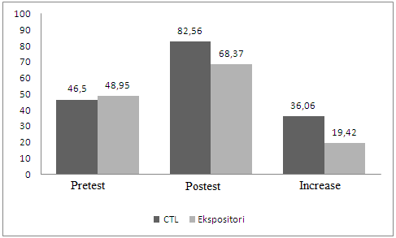

Figure 1: Mean value of Critical Thinking Skills

