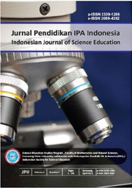JPII 5 (2) (2016) 247-255

Jurnal Pendidikan IPA Indonesia

http://journal.unnes.ac.id/index.php/jpii

IMPROVEMENT OF PROBLEM-SOLVING SKILL AND PHYSICS CONCEPT MASTERY ON TEMPERATURE AND HEAT TOPICS

Wartono Wartono¹, John Rafafy Batlolona^{2*}, Muhammad Nur Hudha³, Inocencia Mesu Kasa³
Department of Physics, Faculty of Mathematics and Natural Sciences Universitas Negeri Malang, Indonesia.
Physics Education Study Programme, Postgraduate Student Unversitas Negeri Malang, Indonesia.
Department of Physics, Faculty of Mathematics and Natural Sciences Universitas Kanjuruhan, Indonesia
Jln Semarang No 5 Malang 65145, 081343314474, johanbatlolona@gmail.com

DOI: 10.15294/jpii.v5i2.6004
Accepted: August 15th 2016. Approved: September 4th 2016. Published: October 2016

ABSTRACT

This work aimed to know the improvement of problem-solving and physics concept mastery by using the learning model of Hints and Peer Interaction Learning (HPIL) on temperature and heat topics. This research used mixed method research method combining the quantitative and qualitative research. The number of the sample used in this research was 22 students of one of Senior High Schools in Malang. The instruments used were 25 numbers consisting of five numbers of essay item for the problem-solving skill and 20 numbers for the reasoning multiple choices items for the concept mastery. The data were analyzed by using paired sample t-test with the significant level of 5%. The research results showed that there was an improvement of problem-solving skill from 40.68% to 74.77% after doing the treatment and an improvement of concept mastery from 0.48% to 0.72% after doing treatment. Thereby, the HPIL model can be recommended to improve the student’s problem-solving skill and physics concept mastery.

Keywords: hints and peer interaction learning, problem-solving skill, concept mastery

© 2016 Science Education Study Program FMIPA UNNES Semarang

INTRODUCTION

Physics is one of the subjects considered difficult by the student so far. It is a modern learning of which purpose is to make the students can learn effectively and by using their knowledge to analyze the situation regarding physics. Besides, physics is one of science branches trying to describe how the nature works by using mathematics language. This case includes universal law and the relationship between physical phenomena (Argaw et al., 2017). Although the formulation looks simple, the application based on the physical phenomena is a problem for the students (Leinonen, 2013). The future challenge or the modern learning demands the students to not only master the concept but also develop the thinking skill. One of the thinking skills that can be developed is a problem-solving skill needed in the 21st century.
PSS is one thing highlighted in student’s learning and seen as a fundamental part of science learning in the school (Gok, 2010). This case is because physics is closely related to the daily life of which the topic scope is always based on the problem (Viennot& Decamp, 2016). PSS helps the student to think, and then solve the problem based on the relevant theory and concept. Physics problem-solving effectively demands the student to identify, determine, and solve the problem by using logic, literature-based, and creative thinking (Hedge & Meera, 2012). The problem-solving skill consists of some skills related each other such as reasoning, planning, and decision making (Greiff et al, 2014). The problem-solving skill demands the student to connect their knowledge to solve and find a solution of certain problem (Hafizah, 2014). A solution is needed to solve a certain problem by using knowledge, capability, and understanding got by the students (Lin, 2010). In those processes, the students will get a deep understanding about the topic field, knowledge construction, new understanding and they can make a decision (Rohanum, 2013). The students’ success in understanding certain problem starts from building a description of the problem to find a proper solution (Reif, 1998). This case is done by interpreting a certain problem into a simpler model by summarizing the core concepts or key concepts needed to describe a certain problem.
Connecting concept to the phenomena needs concept mastery in understanding the physics concept. The students develop the concept mastery when they combine the new knowledge and their own understanding (Aktan, 2013). In this process, the prior knowledge often collaborates with the new knowledge to build a better concept. In the physics learning process, the concept mastery is very significant. Anderson &Krathwohl (2001) state that by concept mastery, the students can improve their intellectual capability, solve the problem they face and find a meaningful learning. Generally, the purpose of physics learning is to make the students have the skill to be able to improve their knowledge, have skill and attitude that can be a provision to continue their study to the higher education level and develop the knowledge and technology (BSNP, 2006)
One of the physics concepts that need a concept mastery and problem-solving skill is the topic of temperature and heat. The topic of temperature and heat is close to the daily life. However, the students are hard to explain the phenomena scientifically. Such topic is one of the abstract topics in physics subject learning(Ornek et al.,2008). The topic of temperature and heat is a rich of concepts correlating each other including some parts of which understanding is overlapping (Leiononen, 2013). For example, explaining the heat as an energy moving from certain object to another object is a result of temperature change (Young & Freedman, 2004) and connecting two concepts namely energy and temperature. Therefore, the complete concept mastery is necessary. The students’ success in mastering the concept is not about how to answer correctly and systematically but how the students understand the physical process of a certain problem (Mc.Dermott, 1991). The fact happening in the field is the learning only focuses more on the mathematics calculation than the physics concept mastery in problem-solving (Gaigher et al., 2007). When the students are low in solving the problem, they may less understand a certain topic being discussed (Hobden, 1999;Maloney, 1994). Therefore, a research is needed to identify the students’ problem-solving skill and concept mastery on the topic of temperature and heat.
The concept mastery cannot be reached only by using traditional learning (Mc.Dermott, 2001), and thus certain learning model supporting the student’s concept mastery on the topic of temperature and heat is urgently required. In this work, one of the solutions proposed by the researcher to improve the students’ problem-solving skill and concept mastery is applying HPIL (Hints and Peer Interaction Learning)modelin the learning process. HPIL is expected can improve the problem-solving skill and mastery concept of heat since HPIL applies a more effective learning giving hints to the students before doing an evaluation as the student activation and doing peer interaction as the student discussion with their matesto compare the students’ understanding through a discussion. HPIL model is a new model developed by Risto Leinonen in his research entitled overcoming students’ misconceptions concerning thermal physics with the aid of hints and peer interaction during lecture course.In that research, HPIL was used since the model can significantly enhance the concept mastery and qualitative problem-solving(Rao & DiCarlo, 2009).Thereby, this research aimed to uncover the improvement of problem-solving skill and physics concept mastery on temperature and heat topics by applying a learning model of Hints and Peer Interaction Learning (HPIL).

METHOD

General Background of Research

This research used a mixed method combining the quantitative and qualitative (Creswell, 2013). The research design used in this research was embedded experimental model.

Sample of Research

The population used in this research was one of Senior High Schools in Malang City with the sample of 22 students. The sample selection was done to get the data by simple random sampling technique that was lottery. The topics taught were temperature and heat.

Instrument and Procedures
Instruments were in the form of test item consisting of 25 numbers including five numbers of essay item for the problem-solving skill and 20 numbers of reasoning multiple choices items for the concept mastery. This research was conducted to measure the problem-solving skill. The problem-solving skills consist of four indicators; they are identifying the problem, planning the problem-solving, applying the problem-solving, and checking the adapted answer (Taale, 2011). The data of problem-solving skill were measured by using an essay test based on a rubric of the topic of heat and its move.

Data Analysis
Data analysis consists of quantitative and qualitative analysis. Quantitative analysis included normality test, hypothesis test, N-Gain, D-Effect Size. The normality test used Kolmogrov Smirnov while the hypothesis test used paired sample-test. The qualitative data analysis obtained from the processing the data of students’ concept mastery was by analyzing the reason written by the students when they finished the pre-test and post-test.

RESULT AND DISCUSSION

Result

Learning Implementation

This study aimed to improve the problem-solving skill and physics concept mastery by implementing Hints and Peer Interaction Learning(HPIL)model. The steps of the learning included such activities as pre-introduction, introduction, key activity, and closing activity. The core activity consisted of individual working, hints and peer interaction.The description of problem-solving skill data can be seen in table 1. The description of problem-solving skill data can be seen in Table 1.

Table1. Description of Problem-Solving Skill

Statistical Description | Pre-Test | Post-Test
The number of student | 22 | 22
Mean | 40,68 | 74,77
Maximum score | 50 | 95
Minimum score | 30 | 60

Based on Table 1, the statistical description of the mean of pre-test of students’ problem-solving skill in the experiment class was 40.68 with the total number of the student was 22 and the mean of post-test of problem-solving skill in the experiment class was 74.11 with the total number of the student was 22. Based on the description of problem-solving skill data, the comparison of the mean of problem-solving skill in the pre-test and post-test is shown in the following Figure 2.

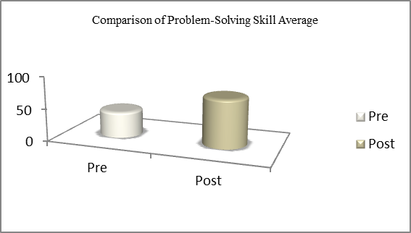

Figure 2. Comparison of Problem-Solving Skill Average

Based on Figure 2, there is a difference of student’s mean of problem-solving skill in pre-test (before using Hints and Peer Interaction Learning Model) and post-test using Hints and Peer Interaction Learning Model. From the figure, we can conclude that the mean score of problem-solving skill using Hints and Peer Interaction Learningmodel was higher than before using Hints and Peer Interaction Learning model. The data of physics concept mastery are presented in Table 2.

Table 2. Description of Concept Mastery Data

Understanding Degree | Average (%)
Understanding Degree | Pre-Test | Post-test
Understanding the concept | 0.48 | 0.72
Misconception | 0.18 | 0.08
Not understand | 0.33 | 0.2

Based on Table 2, the average score of students mastering the concept increased from 0.48 to 0.72, the average of students’ misconception decreased from 0.18 to 0.08, while the average of students who did not understand the concept decreased from 0.33 to 0.2 after treatment.
Based on the description of concept mastery data, the comparison of the average of concept mastery in pre-test and post-test can be shown in Figure 3.

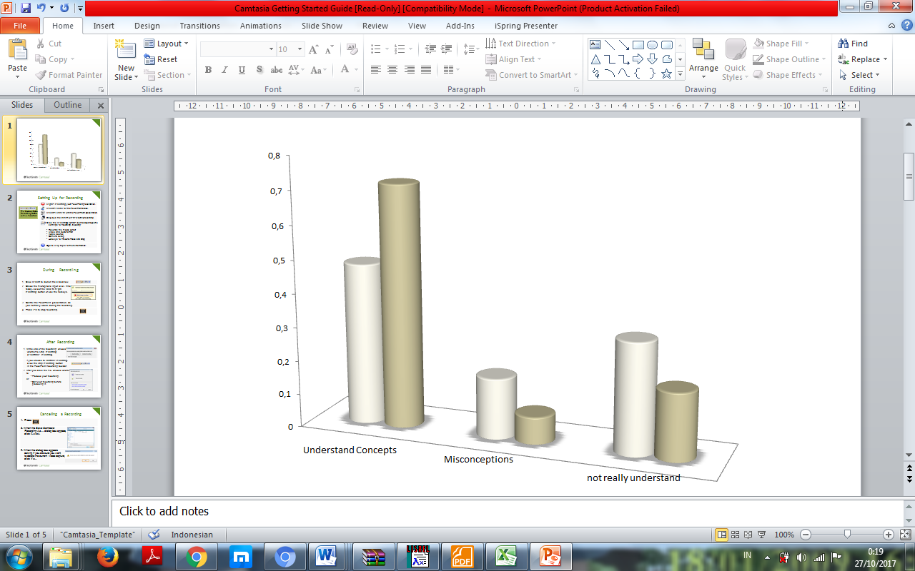

Figure 3. Comparison of Concept Mastery Average

Based on Figure 3, there was a difference of the average of understanding the concept, misconception, and do not understand the concept when pre-test (before using Hints and Peer Interaction Learning model)and post-test using Hints and Peer Interaction Learning model. From the figure above, we can take a conclusion that the mean score of concept mastery using Hints and Peer Interaction Learningmodel was higher than before using Hints and Peer Interaction Learning model.Before doing the hypothesis test, the analysis pre-requirement test was done first in the form of hypothesis test. The result of normality test of problem-solving skill and concept mastery was distributed normally. The results of hypothesis test of this research are presented in Table 3.

Table 3. The Result of Hypothesis Test of Problem-Solving Skill

Pair Pre and Post
Sig_{counting} | 0,00
Sig_{table} | 0,05

Based on the analysis result, the problem-solving skill showed Sig_{counting}<Sig_{table} (0,00< 0,05), so that we can conclude that H₀ was rejected and H₁ was accepted. This case showed that the problem-solving skill increased by using Hints and Peer Interaction Learning model.
Meanwhile, the analysis of N-Gain score used to know the increase in pre-test and post-test was in the low category with the score of 0.34. To know the difference strength, the pre-test and post-test were in the moderate effect category with the score of 0.70. Subsequently, the data of hypothesis test of concept mastery are presented in Table 4.

Table 4.The Result of Hypothesis Test of Concept Mastery

Pair Pre and Post
Sig_{counting} | 0,00
Sig_{table} | 0,05

Based on the analysis result, the concept mastery showed Sig_{counting}<Sig_{table} (0,00< 0,05), so that we can conclude that H₀was rejected and H₁ was accepted. This case showed that the concept mastery increased by using Hints and Peer interaction Learning model. Meanwhile, the analysis of N-Gain value used to know the increase in pre-test and post-test was in low category with the score of 0.23. To know the difference strength, the pre-test and post-test were in the moderate effect category with the score of 0.26.

Discussion

The result of problem-solving skill in this research showed the increase in the physics problem-solving skill after using Hints and Peer Interaction Learning(HPIL) model proven by the increase in the mean of pre-test and post-test from 40.68 to 74.77. The increase in the problem-solving skill in this research was categorized as low since the score of N-gain was 0.34. The problem-solving skill of pre-test and post-test was based on the N-Gain score was normalized at the moderate category with the score range of 0.34. The previous research also proved that the improvement of the students’ problem-solving skill was at the low category because the students were still difficult in solving the physics problem (Pol et al., 2008).Meanwhile, calculating the difference strength between pre-test and post-test was by using D-Effect Size. From this research, we can see that the difference strength between pre-test and post-test was at the category of strong enough effect with the range of 0.70. This case was because the difference of students’ pre-test and post-test scores increased insignificantly. Another thing that caused that problem was the limited time in doing pre-test and post-test. From five questions given, the students were more skillful in doing the calculation item than the concept item. The analysis results state that Hints and Peer Interaction Learning model can be used to improve the students’ problem-solving skill proven by the analysis ofsig_{counting}<sig_{table} (0,000 < 0,005). The results of this research were similar to the previous research reporting that Hints and Peer Interaction Learning can improve the qualitative problem-solving skill and concept mastery significantly (Leinonen et al., 2013).
The improvement of Hints and Peer Interaction Learningmodel is a new development of learning developed by RistoLeinonen. In his research entitled Overcoming students misconceptions concerning thermal physics with the aid of hints and peer interaction learning during lecture course’, there are some phases of Hints and Peer Interaction Learning. The first phase is Individual Working. In this step, the students do the diagnostic test individually. This phase is used to encourage the students to implement the topic that has been taught and the homework session. After that, a hints phase is planned to state whether the hints related to the physical topic can improve the students’ concept mastery. In the hints phase, the teacher gives a guide in the form of concept and formulation and the last is Peer Interaction phase; the students are asked to compare their answers to their partner and discuss. From such activities, there will be an interaction between the peers in sharing the idea based on the answer of everybody so that there will be an interaction to build a new knowledge and students’ problem-solving process (Thurston et al., 2007). Therefore, basically, in the learning process, the students in the group are expected to be heterogeneous meaning that the students having much more knowledge can share their knowledge to the ones having a little knowledge.
The results of concept mastery skill data were obtained from the reasoning multiple choices item. The data analysis result showed that the students’ concept mastery increased after they were given treatment. From the multiple choices test given in pre-test and post-test, the students who understood the concept increased from 0.48 to 0.72, the students who underwent misconception decreased from 0.18 to 0.08, and the students who did not understand the concept decreased from 0.33 to 0.2. These cases showed that the level of concept mastery increased after giving the treatment. The Hints and Peer Interaction Learning also can improve the student’s concept mastery. This case is proven by the analysisof sig_{counting}<sig_{table} (0,000 < 0,005). The results of this research were similar to the previous research stating that Hints and Peer Interaction Learningcan improve the qualitative problem-solving skill and the concept mastery significantly (Leinonen et al., 2013).The increase in the problem mastery in pre-test and post-test based on the normalized N-Gain score was at a low category. The improvement of the problem mastery in pre-test and post-test based on the normalized N-Gain score was at the low category with the range of 0.23; this research result was similar to the previous research reporting that the improvement of students’ problem solving skill was at a low category (Pol et al., 2008). Meanwhile, to measure the difference strength between pre-test and post-test was by using D-Effect Size calculation. From this research, we found that the difference strength in pre-test and post-test was categorized as moderate effect with the range of 0.26. This case was because the difference of pre-test and post-test scores increased insignificantly. Another factor was time management in doing pre-test and post-test. The goal of the students’ concept mastery improvement is to make the students have better knowledge when they are in the higher level of carrier, and increase the students’ critical thinking skill and creative thinking (Saprudin et al., 2017)

CONCLUSION

Based on the discussion explained before, we can draw a conclusion that there was an increase in students’ problem-solving in class X of Senior High School in Malang on the topic of temperature and heat after the students were taught by using Hints and Peer Interaction Learning (HPIL) model. Thereby, HPIL model can be recommended to improve the students’ problem-solving skill and physics concept mastery. The further research is expected can see the other aspects such as the students’ conceptual change (mental model), creative and critical thinking related to physics learning by using HPIL method.

REFERENCES

Anderson, L.R. & Krathwohl, D.R. (2001). Taxonomy for learning teaching and assesing: a revision of bloom’s taxonomy of educational objectivities. New York: Longman.
Argaw, A. S., Haile, B., Ayalew, A. T., & Kuma, S. G. (2017). The effect of problem based learning (pbl) instruction on students’ motivation and problem solving skills of physics. EURASIA Journal of Mathematics Science and Technology Education, 13(3), 857-871.
Cresswell, J. W. dan Clark, P. (2013). Designing and conducting mixed method research. California: Sage Publication, Inc.
Gaigher, E., Rogan, J. M & Braun M. W. H. (2007). Exploring the development of conceptual understanding through structured problem- solving in physics. International Journal of Science Education, 29(9), 1089-1110.
Gok, T & Silay, I. (2010). The effect of problem solving strategies on student’s achievment, attitude and motivation. Latin- America Journal of Phisics Education Research, 4(1), 7-21.
Greiff, S., S. Wustenberg, B. Csapo, A. Demetriou, J. Hautamaki, A. C. Graesser, and R. Martin. (2014). Domain-general problem solving skills and education in the 21st century. Educational Research Review, 13,74-83.
Hafizah, E. (2014). Pengaruh Anchored Instruction Terhadap Penguasaan Konsep dan Pemecahan Masalah Fisika SMA Kelas X. Malang: PPS UM.
Hegde, B. & Meera, B.N. (2012). How do they solve it? an insight into the learner’s approach to the mechanism of physics problem solving. Physics Education Research, 8, (010109), 1-9.
Hobden, P.A. (1999). The context of problems tasks in school physical science. Doctoral Dissetation, University of Natal,Durban, South Africa.
Leinonen, R., Asikainen, M. A., & Hirvonen, P. E. (2013). Overcoming student’s misconceptions concerning thermal physics with the aid of hints and peer interaction during a lecture course. Physics Education Research, 9, (020112), 1-22.
Leionen, R. (2013). Improving the learning of thermal physics at university. Finland: University of Eastern Finland. Dissertation in Forestry and Natural Sciences No 124.
Lin, S. Y., &Singh. 2010. Uuuuuuuuuuuusing analogy to solve a three-step physics problem. Physics Education Research Conference, 1289, 29-32
Maloney, D. P. (1994). Research On Problem Solving: Physics New York. Macmilan.
McDermort, L, C. (1991). Pre-service and in-service teachers’ meatcognitive knowledge about problem solving strategies. Teaching and Teacher Education, 25, 76-82.
Pol, J., Harskamp, E. G., Suhre, C. J. M., &Goedhart, M. J. (2008). The effect of hints and model answers in a student-controlled problem-solving program for secondary physics education, Journal Science Education Technology, 17, 410-425.
Rao, S.P., &Dicarlo, S.E. (2000). Peer instructions improves perfomance on quizzes. Advances in Physiology Education, 24 (1), 51-55.
Reif, F. (1981). Teaching problem solving: A scientific approach. The Physics Teachers, 19, 310.
Rohanum, E. (2013). Pengaruh Authenti Problem Based Learning Terhadap Kemampuan Pemecahan Masalah Fisika Ditinjau dari Kemampuan Awal Peserta Didik MAN Malang. Malang : Pps UM.
Saprudin, S., Liliasari, L., Prihatmanto, A. S. 2017. Pre-service physics teachers’ concept mastery and the challenges of game development on physics learning. IOP Conf. Series: Journal of Physics: Conf. Series, 895(012109), 1-5.

Thurston, A., Van de Keere, K., Topping, K. J., Kosack, W., Gatt, S., Marchal, J., Mestdagh, N., Schmeinck, D., Sidor, W., &Donnert, K. (2007). Peer learning in primary school science: Theoretical perspectives and implications for classroom practice. Electronic Journal of Research in Educational Psychology, 5(3), 477-496.
Viennot, L& Decamp N. (2016). Godevelopment of conceptual understanding and critical attitude:towardasystemic analysis of the survival blanket. European Journal of Physics, 37(015702), 1-28.
Young, H.P. & Freedman, R. A. (2004). University Physics With Modern Physics,11th edition. San Francisco: Pearson.

Apendix

Example of Assessment Rubric of Problem-Solving
Question | Answer | Score | Descriptor
A copper of which mass is 0.3 kg is heated until the temperature of 100 ⁰C. Itis put into a container containing 0.1 kg of water at the temperature of 20 ⁰C. The specific heat of the copper and water is 920 J/kg K and 4200 J/kg K, respectively. Which object that receives the heat and release the heat? Give your reason! | Receiving the heat: 0,1 kg water; the temperature is 20 ⁰C Releasing the heat: 0,3kg copper; the temperature is 100 ⁰C  Reason: if two substances or more mix, the substance that has a lower temperature will tend to absorb/receive the heat; while the substance that has a higher temperature will tend to release the heat. There will be a release and reception of the heat until reaching the balance temperature. | 4 | Determining the concept, principle, equation, and physics law that is suitable for the problem correctly and completely.
 |  | 3 | Determining the concept, principle, equation, and physics law that is suitable for the problem but it is less complete and less correct.
 |  | 2 | Determining the concept, principle, equation, and physics law but it is less appropriate for the problem and less complete and less correct.
 |  | 1 | Do not determine the concept, principle, equation, and physics law that is suitable for the problem.

Example of Concept Mastery Question
Question | Answer
- Pay attention to the picture below !!!  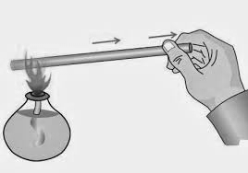  One of the steel tips is heated. What will happen to the steel molecules after the heating process?  - The steel molecules will be hot  - The steel molecules will move in the same direction with the heat transfer  - The distance of the steel molecules will be longer  - The steel molecules will shift to the heat source | - The steel molecules vibrate faster when the steel temperature increases.  - The steel molecules still do not move when the steel temperature increases

