DESIGN AND CHARACTERIZATION OF LOW-COST SENSORS FOR AIR QUALITY MONITORING SYSTEM

Rizki Rumantri, M. Yusup Nur Khakim*,Iskhaq Iskandar
Departement of Physics, Faculty of Mathematics and Natural Sciences, Sriwijaya University

In this study, low-cost sensors for air quality monitoring system have been characterized and designed. These sensors are applied in a monitoring system and installed at Sriwijaya University, which is vulnerable to the impacts of forest fires in the surrounding area. This monitoring system will provide information especially for the university community to determine the level of air quality on campus. In this research the researchers focussed on the characterization and design of system sensor that aimed to get the best configuration of low-cost sensors namely MQ-7, Sharp GP2Y1010AU0F and own-designed smoke sensor to have high reliability and effectiveness to be applied to monitoring systems. The test results showed that the sensors have good response and sensitivity. Therefore, it can be applied to the monitoring system to provide information about the level of particle concentration, carbon monoxide and smoke which meet the needs of low-cost monitoring systems.

© 2018 Science Education Study Program FMIPA UNNES Semarang

Keywords: air quality;arduino; carbon monoxide;particulate; sensor

INTRODUCTION

An air quality level depends on balanced gas compositions in the air. According to Indonesian Air Pollutant Standard Index (ISPU) there are some pollutants affecting the air quality, such as particulate matter (PM), carbon monoxide gas (CO), sulfur dioxide (SO₂), nitrogen dioxide (NO₂), ozon (O₃). If one of this pollutant exceeds their threshold, it could influence human health(Goldstein, 2008; Brook et al., 2010; Goudarzi et al., 2014; Guo et al., 2014). As a developing country, Indonesia has an air pollution problem, not only from industry and vehicle emission, but also from a forest fire. The forest fire in 2015 burnt 2.6 million hectares (Purnomo et al., 2017) and became a source of various type air pollutant (Pribadi & Kurata, 2017).
Sriwijaya University is one of the universities that directly affected the land and forest fires. This is because the location is surrounded by peat lands where the fire disaster occurs. In addition to financial losses, the haze that occurs also disrupts health and campus activities. Therefore, a monitoring system is needed that can provide information and warnings about the level of air quality.
The monitoring system of air quality levels is required not only for precaution but also for awareness to protect and keep our air clean. Unfortunately, in the market most of the monitoring system is expensive and difficult to maintain(Kumar et al., 2015). The recent emergence of low-cost sensors allows us to build a low-cost system that can be a solution for air pollution management. Although the ability may not as good as expensive measurement devices, the sensors can be an alternative for wide application in air quality level measurement. In this study, low-cost sensors are characterized to build an air quality monitoring system. The system has basic measurements for air quality level including carbon monoxide gas and particulate matter. The monitoring system is installed at Sriwijaya University and will be used as an early warning system related to bad air quality level for students and people who live in Sriwijaya University.

METHODS

Monitoring System Design

This air quality monitoring system consists of a microcontroller with 3 sensors namely carbon monoxide sensor, particulate matter sensor, and smoke sensor. This system is also equipped with a data logger to store measurement data and LCD to display the level of air quality. The block diagram of the air quality monitoring system is shown in Figure 1.

Arduino board
(microcontroller)
Carbon Monoxide
sensor

Particulate
sensor
Smoke
Sensor
LCD
Display
Datalogger
GPRS
Modem
Sensors

Output Devices

Figure 1. Block diagram air quality monitoring system

Arduino is used as a processing and controlling device. In addition 10 bits of analog to digital converter (ADC) integrated on arduino is used to convert analog signals from the sensors into physical quantities as measurement data. The data will be displayed on the LCD display, stored in the data logger and sent to the website via GPRS modem.

Particulate and smoke Sensor

Exhaust gas emissions from fossil-fueled vehicles contribute to particulate matter levels in the air (Gentner et al., 2017; McDonald et al., 2015). Particulate measurements are important because the effects of particulate exposure could affect human health even if exposed for a long time(Brook et al., 2010; Guo et al., 2014; K. H. Kim et al., 2015; Turner et al., 2011; Wallwork et al., 2017).
There is low-cost optical based particulate sensor available on the market such as PPD42NS (Shinyei Inc.) and DSM501A (Samyoung Inc.). However GP2Y1010AU0F (Sharp Corp.) has better performance(Wang et al., 2015). Sharp GP2Y1010AU0F is an optical-based sensor, which is used to detect dust or particulate matter in the air. This sensor consists of a phototransistor and infrared led, it has a compact size and simple to apply in a wide application. This sensor can detect particulate concentration in mg/m³. In addition, we also design smoke sensors with simple components consisting of infrared LED and photodiodes. This sensor is used to detect smoke concentration from a safe level of danger.

Carbon Monoxide Sensor

Carbon monoxide gas is a pollutant that is harmful to humans(Goldstein, 2008; Goudarzi et al., 2014; Levy, 2015), this gas is colorless and odorless, most of it comes from vehicle exhaust (Gentner et al., 2017; McDonald et al., 2015). Measuring the level of carbon monoxide gas is very important considering this pollutant is a common contaminant in the air.
There are several low-cost carbon monoxide sensors; the easier one to find in the market is MQ-7. This sensor also has been widely used in several studies(Bakri et al., 2015; Guohua et al., 2012; Kim et al., 2014; Tian et al., 2017).It has good sensitivity, long life and simple wiring circuit. From manufacturer technical data, this sensor can detect carbon monoxide concentration from 20 to 2000ppm. However, the output signal of this sensor is still in the form of a voltage that needs to be calibrated and converted to concentration in ppm unit. The structure and configuration of the MQ-7 gas sensor can be seen in Figure 2. The sensor consists of a micro AL₂O₃ ceramic tube, a sensitive layer of tin dioxide (SnO₂) and Nickel-Chromium alloys as a heater coil. This sensor has 6 pins, 4 pins for signal and electrodes, 2 pins for heating coils.

Figure 2. The structure of MQ-7 Sensor (Hanwei electronics co., ltd)

Sensor Characterization

Characterization of sensors is done to get the conversion value of the sensors output signal in the form of a voltage into the physical quantity that will be used in the algorithm of the monitoring system program.
Many studies have evaluated and characterized the Sharp GP2Y1010AU0F sensor comprehensively(Li & Biswas, 2017; Marinov et al., 2017; Wang et al., 2015). In this study, we use Sharp GP2Y1010AU0F technical data and linear regression of the characteristic graph of the sensor to be able to determine the conversion of the sensor signal in the form of voltage into mg / m³.
For calibrating the MQ-7 sensorb esides technical data, we used a Dekko FM-7910 carbon monoxide meter as a reference. There are many methods and algorithms that have been developed and studied in calibrating low-cost gas sensors (Spinelle et al., 2015), but in this study we use a simple method with the linearity of the gas concentration as measured against the response given by the sensor. By finding sensor resistance in different carbon monoxide gas concentration and curve fitting method we will get the polynomial equation to determine carbon monoxide gas concentration in part per million (ppm) unit.

Measurement chamber

Sensors are placed on the measurement chamber in order to protect sensors from the directly open environment. The design of the measurement chamber is shown in Figure 3.Exhaust fan is applied to make air circulation in the chamber and to enhance data quality of sharp GP2Y1010AU0F(Wang et al., 2015). Besides as a sensor housing, in this experiment the chamber is used as the sensor characterization and test.

CO Sensor
Smoke Sensor
Exhaust fan

Air flow
PM Sensor

16 cm
10 cm
7 cm

Figure 3.Measurement chamber design

Sensor testing is done by exposing the sensor with a pollutant source through the measuring chamber to find out the response and sensitivity of the sensor. Especially for the MQ-7 sensor, the test is carried out on the measuring tube because the measurement is carried out with a predetermined concentration.

RESULT AND ANALYSIS

Particulate and Smoke Sensor Characterization

According to Sharp GP2Y1010AU0F technical data, this sensor works with a pulse-driven wave to turn infrared LED on and off. In one cycle for 10 ms (i.e. 0.32 ms to turn infrared LED on and then 9.68 ms to turn the LED off). This sensor has a sampling time of 0.28 ms when the LED is on.

Figure 4.Sharp GP2Y1010AU0F Characteristic
(Sharp Corp.).

From characteristic in Figure 4, the sensor has a linear relation between output and input i.e., particulate matter concentration of 0 – 0.5 mg/m³ as inputs resulting in the output voltage of 0,6-3.5 volt. Therefore, this linear regression for the relationship between particulate concentrations with sensor signal output can be obtained by using Equation (1).

$x=0,16y-0,1$ (1)

where x is particulate concentration and y is the sensor signal voltage. However, the Equation (1) has been limited to calculate sensor signal voltage up to 3,5 volt for easy unit conversion. Anyways 3,5 volt is represented 0.5 mg/m³ of particulate concentration which is danger level according to standard pollutant index in Indonesia (ISPU).

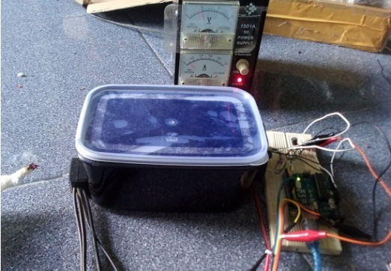
Smoke
Measurement chamber
Power Supply
Arduino

Figure 5.Particulate and smoke sensor test process

To ensure sensor has the same characteristic with Figure 4, Sharp GP2Y1010AU0F is tested with smoke from burning paper and the test result (Figure 6) shows output voltage of this sensor increases along with higher particulate concentration. Meanwhile, it has the output voltage between 0.5 volt to 0.85 volts in the clean air this can be caused by the lowest detection limit of the sensor, besides that the maximum output voltage is 3,77 volt when it is exposed. This means that the sensor has good sensitivity and same characteristic as Figure 4.
The designed smoke sensor was placed on measurement chamber and was exposed directly to smoke for obtaining minimum and maximum voltage outputs of the sensor (Figure 5).At the time of testing, there is an error signal reading this is because the infrared ray smoke sensor bounces off the chassis that result in inconsistent measurement. Due to scattering reflection being able to disturb sensor sensitivity, this chamber uses a black color case to absorb infrared light.
This sensor works with 5 volt voltage power supply, however from the test result voltage signal output is about 0,53 - 2,04 volt. This range is divided into three levels i.e., (<1 volt) for safe level,(1 – 1,5 volt) for warning level, and ( >1,5 volt)for danger level. From the testing, we show that the characteristic of the designed smoke sensor is comparable to the commercial sensor (sharp GP2Y1010AU0F) as shown in Figure 6. It also showed a good sensitivity to smoke exposure.
The designed smoke sensor has a lower measurement limit compared to sharp GP2Y1010AU0F due to differences in sensor manufacturing. The smoke sensor is not equipped with a focusing lens and signal amplifier. This is because the smoke sensor is only designed to detect smoke.

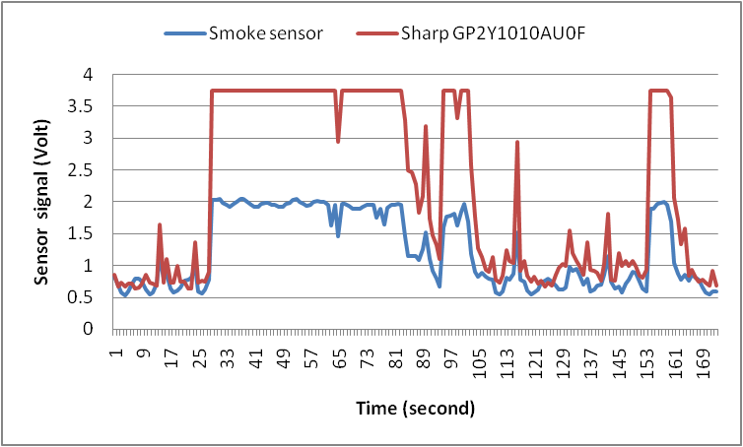

Figure 6.Particulate and smoke sensor test result.

In its application the signal pin (pin 5) and LED signal (pin 3) of the sharp GP2Y1010AU0F sensor will be connected to the analog and digital arduinopin, while the smoke sensor Analog out pin (Ao) is connected to the arduino analog input pin (A1). in detail the wiring of the particulate sensor and the smoke sensor is shown in Figure 7.a.

Carbon Monoxide Sensor Characterization

In this research we used the MQ-7 sensor in default manufacturer circuit with resistance load (RL) about 1 KΩ, although on recommended technical data between 5KΩ-47KΩ, it is intended that in replacement of components do not need to modify the circuit. Before calibrating the sensor, it kept preheating over 48 hours according to the technical data. This sensor has two heating cycles that are high and low heating with alternating work.
The sensor has supplied with 5 volt power for 60 seconds during the high heating cycle and the sensor takes air sample for measuring carbon monoxide concentration. Otherwise, when low heating cycle, the sensor is supplied by 1,4 volts power for 90 seconds and surface resistance of the sensor resulting from the sampled air can be measured. The carbon monoxide concentration can be determined from the sensor resistance changes. Because this sensor requires 350mW of power consumption while the arduino cannot provide enough current, an external power source that is controlled by the driver circuit is needed. The design of the driver circuit is shown in Figure 7.b.
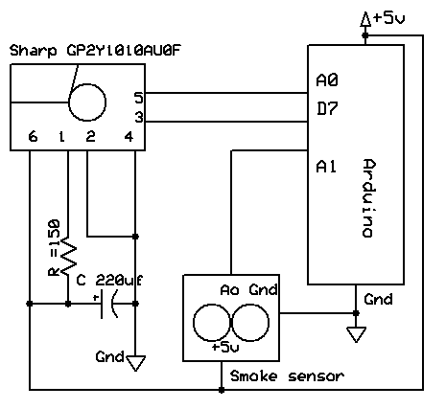
(a)
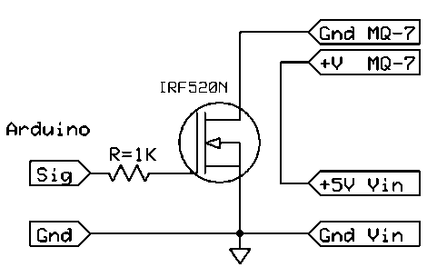
(b)
Figure 7. (a) Particulate and smoke sensor wiring (b) driver circuit of the MQ-7 sensor

The signal pin is connected to the microcontroller which will provide the pulse width modulation (PWM) signal so that the driver will supply the voltage based on the given signal. In this case, when the signal provided by the microcontroller of 0.5 volts then the driver will supply the sensor with a voltage of 1.4 volts, but when the signal is given a voltage of 5 volts then the driver will supply the sensor with full voltage (5 volts).
According to MQ-7 technical data, there are several parameters that must be known for calibrating the MQ-7 sensor. That is output signal sensor voltage (VRL), the surface resistance of the sensor (Rs), sensor resistance at 100ppm CO in the air (Ro), load resistance (RL) and sensor working voltage (Vc). Typical sensitivity characteristics of the MQ-7 for several gases are illustrated by the relationship between the resistance sensor ratio at various concentrations of gases (Rs) with the resistance sensor at 100ppm CO in the clean air (Ro) to the concentration of carbon monoxide gas.
From the characteristic Rs/Ro value will be 1 in 100 ppm gas carbon monoxide concentrations and it is a reference to convert the output voltage to ppm unit. So the relationship between Rs/Ro ratios with carbon monoxide concentration in ppm can be written as Equation 2.

Rs/Ro = 1 = 100ppm CO (2)

Unfortunately Ro value is not clearly mentioned in technical data but the relationship between Rs and RL is described in Equation 3.

$Rs/RL=\frac{(Vc-VRL)}{VRL}$ (3)

Load resistance (RL) of the sensor in this research is 1 kilo Ohm as manufacture circuit default, so that Rs can be determined by using Equation 4.

Rs = ($\frac{Vc}{VRL}$-1) RL (4)

So to determine the value of Ro then the sensor should be tested to get the value of Rs when the concentration of Carbon monoxide gas is 100ppm.
In testing and calibrating process, sensor and reference measurement device are placed on measurement tube which has connected to motorcycle muffler. Motorcycle exhaust gas is used as a carbon monoxide source. Calibrating process is shown in Figure 8.

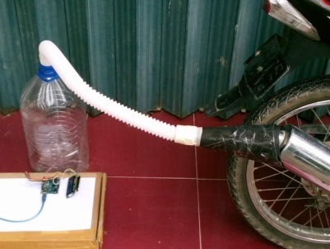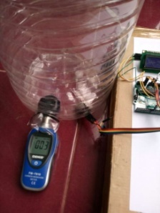
MQ-7
Reference Device
Measurementtube

Figure 8. Testing and Calibrating process of MQ-7 Sensor.

From our test, the sensor output decreased from 0.85 and stable to 0.75 volts in clean air and open environment (Figure 14.a). Meanwhile, sensor output increased up to 2,15 volt when exposure by motorcycle exhaust gas (Figure 14.b). These results indicate that the sensor has a good response to carbon monoxide gas.

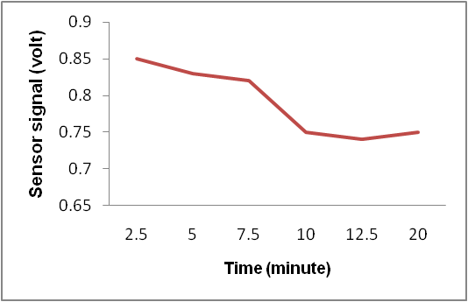
(a)
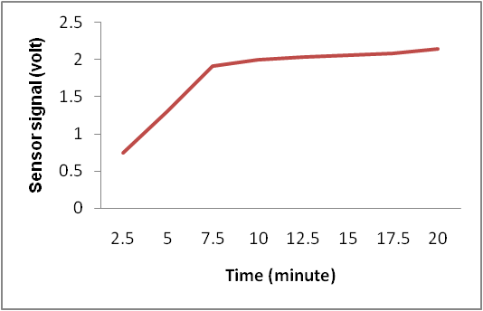
(b)
Figure9.Sensor MQ-7 sensitivity test result (a) in clean air (b) exposed by motorcycle gas emission

The second test was conducted to find the relationship between the sensor resistance values (Rs) of changes in carbon monoxide gas concentration.
When exposed by motorcycle exhaust gas, Rs value is decreasing along with higher carbon monoxide concentration as shown in Figure 10.a.According to Equation (2), Ro value can be obtained from Rs value at 100 ppm carbon monoxide, from test result Rs value at 100 ppm carbon monoxide is 1,7KΩ as we can conclude that Ro value is also 1,7KΩ, where Ro is the value of the sensor resistance when the concentration of carbon monoxide gas is 100 ppm.
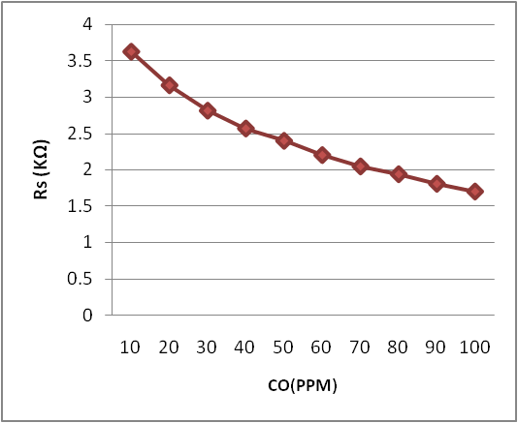
(a)
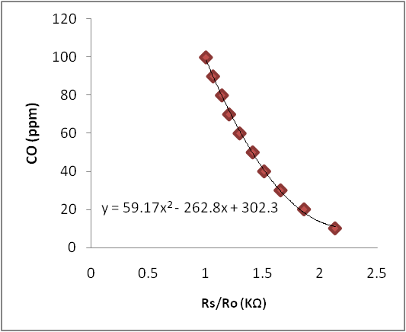
(b)

Figure 10.Mq-7 test result (a) relationship between Rs with CO concentration.(b) Rs/Ro and CO gas concentrations.
However, from the technical data of the MQ-7 Rs value at 100ppm the concentration of carbon monoxide gas should be between 2-20KΩ. This could be due to the difference in RL value used, the researcher uses RL of 1 kilo ohm which is the default of the sensor manufacturer circuit. Other than that, the measurement uncertainty factor due to the influence of various parameters can also make the carbon monoxide gas measurement results less precise (Spinelle et al., 2015). In this case, for samples of motor vehicle exhaust compositions which also contain various hydrocarbon compounds and various nitrogen oxides (NOx)(McDonald et al., 2015) are possible to influence the measurement of carbon monoxide.
With Ro value from the test, Rs/Ro ratio for another CO concentration can be obtained using Equation (2), Rs/Ro values from test result can be seen at Figure 10.b. Rs/Ro is decreased with higher carbon monoxide concentration, and match with sensor characteristic.
By using curve fitting method for Rs/Ro ratio in different CO gas concentration, we can get polynomial equation y = 59.17x² - 262.8x + 302.3, with x is Rs/Ro and y is carbon monoxide concentration in ppm. This equation can be used to determining various CO gas concentrations in ppm unit.

CONCLUSION

Low-cost sensors system for real time monitoring system has been designed and characterized. From the experiment, an MQ-7 sensor with factory default circuit configuration is able to detect carbon monoxide gas concentration with good sensitivity. Other than that from the test show the similarity of sensor characteristics of the test result with factory technical data which shows the relationship between Rs/Ro with carbon monoxide gas concentration in ppm. So the polynomial equation obtained can be used to determine the concentration of carbon monoxide gas. As a particulate sensor, although Sharp GP2Y1010AU0F less accurate in detecting particles <0,2mg/m³, this sensor has good sensitivity and can detect dust or particle concentration up to 0,5 mg/m³. Moreover, the smoke sensor has a good sensitivity to smoke so that the sensor is capable of warning when forest fire happens in the surrounding area. According to ISPU in danger level the concentration of carbon monoxide and particulate matter is about 34 ppm and 0,42 mg/m³, respectively. This indicates that the sensors meet the minimum requirements for air quality measurement and can be applied to the air quality monitoring system to be installed at Sriwijaya University.

REFERENCES

Bakri, N. A. M., Al Junid, S. A. M., Razak, A. H. A., Idros, M. F. M., & Halim, A. K. (2015). Mobile Carbon Monoxide Monitoring System Based on Arduino-Matlab for Environmental Monitoring Application. In IOP Conference Series: Materials Science and Engineering (Vol. 99, No. 1, p. 012009). IOP Publishing.

Brook, R. D., Rajagopalan, S., Pope III, C. A., Brook, J. R., Bhatnagar, A., Diez-Roux, A. V., ... & Peters, A. (2010). Particulate Matter Air Pollution and Cardiovascular Disease: An Update to the Scientific Statement from the American Heart Association. Circulation, 121(21), 2331-2378.

Gentner, D. R., Jathar, S. H., Gordon, T. D., Bahreini, R., Day, D. A., El Haddad, I., ... & Goldstein, A. H. (2017). Review of Urban Secondary Organic Aerosol Formation from Gasoline and Diesel Motor Vehicle Emissions. Environmental science & technology, 51(3), 1074-1093.

Goldstein, M. (2008). Carbon Monoxide Poisoning. Journal of Emergency Nursing, 34(6), 538-542.

Goudarzi, G., Geravandi, S., Vosoughi, M., javad Mohammadi, M., & sadat Taghavirad, S. (2014). Cardiovascular Deaths Related to Carbon monoxide Exposure in Ahvaz, Iran. Iranian Journal of health, Safety and environment, 1(3), 126-131.

Guo, S., Hu, M., Zamora, M. L., Peng, J., Shang, D., Zheng, J., ... & Molina, M. J. (2014). Elucidating Severe Urban Haze Formation in China. Proceedings of the National Academy of Sciences, 111(49), 17373-17378.

Guohua, H., Lvye, W., Yanhong, M., & Lingxia, Z. (2012). Study of Grass Carp (Ctenopharyngodon Idellus) Quality Predictive Model Based on the Electronic Nose. Sensors and Actuators B: Chemical, 166, 301-308.

Kim, J. Y., Chu, C. H., & Shin, S. M. (2014). ISSAQ: An Integrated Sensing Systems for Real-Time Indoor Air Quality Monitoring. IEEE Sensors Journal, 14(12), 4230-4244.

Kim, K. H., Kabir, E., & Kabir, S. (2015). A review of the Human Health Impact of Airborne Particulate Matter. Environment international, 74, 136-143.

Kumar, P., Morawska, L., Martani, C., Biskos, G., Neophytou, M., Di Sabatino, S., ... & Britter, R. (2015). The Rise of Low-Cost Sensing for Managing Air Pollution in Cities. Environment international, 75, 199-205.

Levy, R. J. (2015). Carbon Monoxide Pollution and Neurodevelopment: A Public Health Concern. Neurotoxicology and teratology, 49, 31-40.

Li, J., & Biswas, P. (2017). Optical Characterization Studies of a Low-Cost Particle Sensor. Aerosol and Air Quality Research, 17(7), 1691-1704.

Marinov, M. B., Hensel, S., Ganev, B., & Nikolov, G. (2017, September). Performance Evaluation of Low-Cost Particulate Matter Sensors. In Scientific Conference Electronics (ET), 2017 XXVI International (pp. 1-4). IEEE.

McDonald, B. C., Goldstein, A. H., & Harley, R. A. (2015). Long-Term Trends in California Mobile Source Emissions and Ambient Concentrations of Black Carbon and Organic Aerosol. Environmental Science & Technology, 49(8), 5178-5188.

Pribadi, A., & Kurata, G. (2017, January). Greenhouse Gas and Air Pollutant Emissions From Land and Forest Fire in Indonesia during 2015 based on Satellite Data. In IOP Conference Series: Earth and Environmental Science (Vol. 54, No. 1, p. 012060). IOP Publishing.

Purnomo, H., Shantiko, B., Sitorus, S., Gunawan, H., Achdiawan, R., Kartodihardjo, H., & Dewayani, A. A. (2017). Fire Economy and Actor Network of Forest and Land Fires in Indonesia. Forest Policy and Economics, 78, 21-31.

Spinelle, L., Gerboles, M., Villani, M. G., Aleixandre, M., & Bonavitacola, F. (2015). Field Calibration of a Cluster of Low-Cost Available Sensors for Air Quality Monitoring. Part A: Ozone and Nitrogen Dioxide. Sensors and Actuators B: Chemical, 215, 249-257.

Tian, X., Lei, J., & Du, L. (2017). Design of CO Concentration Detector Based on Infrared Absorption Method. Chemical Engineering Transactions, 62, 733-738.

Turner, M. C., Krewski, D., Pope III, C. A., Chen, Y., Gapstur, S. M., & Thun, M. J. (2011). Long-Term Ambient Fine Particulate Matter Air Pollution and Lung Cancer in a Large Cohort of Never-Smokers. American journal of respiratory and critical care medicine, 184(12), 1374-1381.

Wallwork, R. S., Colicino, E., Zhong, J., Kloog, I., Coull, B. A., Vokonas, P., ... & Baccarelli, A. A. (2017). Ambient Fine Particulate Matter, Outdoor Temperature, and Risk of Metabolic Syndrome. American journal of epidemiology, 185(1), 30-39.

Wang, Y., Li, J., Jing, H., Zhang, Q., Jiang, J., & Biswas, P. (2015). Laboratory Evaluation and Calibration of Three Low-Cost Particle Sensors for Particulate Matter Measurement. Aerosol Science and Technology, 49(11), 1063-1077.

