LETTER OF STATEMENT
No: 25/JPII/R.A./2018

Sutarto1 , Indrawati*2 , J. Prihatin3 , P. A. Dwi4
I hereby declare that the article:
title : GEOMETRICAL OPTICS PROCESS IMAGE-BASED WORKSHEETS FOR ENHANCING STUDENTS’ HIGHER-ORDER THINKING SKILLS AND SELF-REGULATED LEARNING

authors : 1. Sutarto
2. Indrawati
3. J. Prihatin
4. P. A. Dwi
is APPROVED to be published in JPII for December 2018 Issue.
Hereby this statement is made truthfully and to be used accordingly.

Semarang, 24 December 2018
First Author,
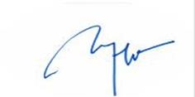
(Sutarto)

