LETTER OF STATEMENT
No: 25/JPII/R.A./2018

I hereby declare that the article:
title : Resistor Value Checker Kit for Educational Purpose

authors : 1. Nurul Nazirah M. I. M.
2. Zaliza H.
3. Irdayanti M. N.
4. Mohd Azlan M. H.
5. Nur Syafiqah I.

is APPROVED to be published in JPII for March 2019 Issue.
Hereby this statement is made truthfully and to be used accordingly.

Semarang, July 1, 2019
First Author,
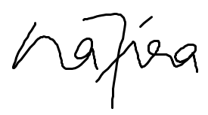
(NURUL NAZIRAH MOHD
IMAM MA’AROF)

