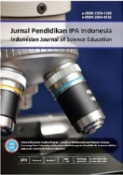JPII 5

**JurnalPendidikan IPA Indonesia**

[http://journal.unnes.ac.id/index.php/jpii](http://journal.unnes.ac.id/index.php/)

**EFFECTIVENESS OF PEDAGOGICAL COMPETENCE:**

**A DEVELOPMENT MODEL THROUGH ASSOCIATION OF**

**BIOLOGY TEACHERS’ FORUM**

**ABSTRACT**

The results of teacher competency test (TCT) performed by the Centre of Human Resource Development on Education and Education Quality Assurance has indicated less effectiveness of a certification program. The association of biology teachers’, calledMGMP board, is also known as a forum of biology teachers with a strategic role in increasing teachers’ professionalism in carrying out their duties as professional teachers through discussion, trainings, workshops, as well as other activities. The main objectives of the present study were to describe the mechanism of pedagogical competence development activities for biology teachers in a post-certification program through MGMP forum and to identify the characteristics of the activities of biology MGMP, which could cover materials, impacts, constraints, and solutions. The research method was of survey type and the data collection instruments were a list of questions, polling, and a questionnaire. The respondents included the head of LPMP Central Java, education officers of Surakarta, principals, biology MGMP board, as well as biology teachers, selected through purposive sampling method. The data consisted of primary and secondary ones while the data analysis technique was of qualitative descriptive type. The results of this study revealed that the mechanisms and the procedures of activities to develop the pedagogical competence of biology teachers in the post-certification program in Surakarta through MGMP were: MKKS or coordinators of biology MGMP initiate coordination with district education office, biology MGMP conducts a gathering to devise programs and activities for a year with guidance from supervisor and MGMP board, MKKS (association of school principles networking) or coordinators of MGMP authorize devised programs and activities, implementation of needs-based activities, determination of resource persons, and evaluation to obtain feedback for programs and activities of subsequent years. Furthermore, characteristics of activities based on the priority were: review of Graduate Competency Standard (GCS); preparation of final exam exercises and national exam try-out, and analysis of previous national exam; preparation of student worksheets, preparation of modules, preparation of lesson plan (LP), comprehension of learning materials, enrichment of laboratory materials; workshop of classroom action research (CAR), and preparation of incidental materials. The outcomes or works produced by biology teachers after carrying out the activities were: final exam exercise, national exam try-out and GCS, syllabus and RPP, learning methods and appraisal instruments, CAR proposal, as well as modules/teaching materials/props. The constraints encountered in the implementation of the activities were: funding issues, unstructured and discontinuous programs, complexity of providing resource persons, absence of guidance and supervision, and lack of teacher’s awareness. Meanwhile, several solutions to overcome the constraints in order to support the effectiveness of the activities were: comprehension of biology learning materials, enrichment of laboratory materials, collaboration with universities, CAR follow-up, more structured and continuous programs and activities, as well as supervision and guidance from supervisors.

© 2018 Science Education Study Program FMIPA UNNES Semarang

**Keywords:** Pedagogical Competence, Biology Teacher, Development Model, Post-Certification, Profesional Teacher

**INTRODUCTION**

Competence along with professionalism in teachers and lecturers as instructed in the Law No. 14 of 2005 have not been realized, as indicated by the high number of teachers with low competence in spite of successfully passing a teacher certification program. It can certainly have implications on quality of education and eventually lead to low educational quality in general. There are a total number of 332 individuals out of 565 biology teachers in Surakarta, Central Java, Indonesia, who have passed a certification program through direct scheme for certification, portfolio, or professional education and training for teachers (Anif, 2013).

In fact; the low competence of biology teachers, particularly in terms of professional competences, was reinforced by the results of the Initial Competency Test (ICT) of biology teachers who attended a certification program in 2012. The results showed the national average score of 42.25 from a range of 1-100, with the highest score of 80.0 and the standard deviation of 10.1 as illustrated in the graph below.

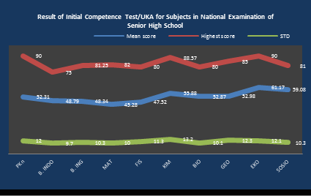

Figure 1. Results of teachers’ competence test in the 2012 teacher certification program (Anif, 2013)

As an attempt to improve the quality of education in Indonesia, a continuous post-certification program for teachers is required, particularly in terms of teacher competence development. To ensure its success, a feasible teacher competence development model can be devised based on pedagogical aspects. Thus, a potential alternative development model for biology teachers can be implemented through MGMP.

Continuous education and training for teachers in a post-certification program is also an effort to enhance competence and professionalism in teachers, which is of utmost importance as claimed by Kunter et al. (2013) in which quality of current education must be assisted by professionalization of teachers (educators), particularly in the context of the current situations wherein various issues should be encountered in the implementation of education, including: (1) development of science and technology, (2) global competition for graduates, (3) regional autonomy, and (4) implementation of curriculum.

The challenge of improving competence and professional development of teachers is also continuous and dynamic. To face and also to cope with future challenges, adaptive skill is a must (Yassin & Razak, 2017) and critical thinking is of significance (Forbes, 2018). Moreover, adaptation is done through implementation of various approaches or models, including one which is carried out through the MGMP forum to improve biology teacher professionalism although it is still low (31%) (Anif, 2013).

Increasing professional competence in biology teachers only with the ability to continuously adapt will not be able to solve the given problem. Therefore, a strategy to improve pedagogical competence is needed through the MGMP forum. Using this forum, biology subject teachers will try to carry out self-evaluation together with their peers.

At least, there were three reasons to conduct the present study. Firstly, most of biology teachers had low professional competence. It could be shown by the results of the ICT, in which their average score was 55,88 while the lowest score was 15,2. These data indicated that teachers’ professional competence was still poor.

The second reason was the absence of a model for improving biology teachers’ competence. Most of the teachers were supposed to improve their competence by doing some programs developed individually. There was also no qualified model used by biology teachers to increase their professional competence.

Finally, the role of biology teacher MGMP was still very weak. MGMP as the central organization for improving teachers’ competence had very limited activities to support improving their activities. Most of the activities were still daily programs; i.e. the role of this association was not strong enough.

Besides, the main objectives of this research were to describe the mechanism of pedagogical competence development activities for biology teachers in a post-certification program through MGMP forum and to identify the characteristics of the activities of biology MGMP; which could cover materials, impacts, constraints, and solutions.

**METHOD**

The research method of the present study was of survey type and the data collection instruments were a list of questions, polling, and a questionnaire. The respondents or the informants included the head of LPMP Central Java, the head of Education Office of Surakarta, principals, biology MGMP board, as well as biology teachers. The selection procedure of the respondents was in accordance with the study by (Parmin at al, 2015;, 2017) in which data sources in qualitative study were people along with their behaviours, events, archives, documents, and other objects. The statistical population of this study included 332 teachers, while the sample was 116 using purposive sampling method. The inclusion criteria for sample selection were obtaining official biology teacher certification by respondents, distribution of teachers among regencies, and proportion of public and private biology tearchers. The data collection instruments were tried out to know the levels of validity and reliability of this instrument.

The determination of informants as data sources was done through purposive sampling method. It was based on the understanding that researchers will select informants who are assumed to comprehend research problems and make them reliable as data sources. The specific characteristics of the purposive sampling method were: (1) temporary design, (2) snowball sampling, (3) adjustability, and (4) data saturation (Hartini et al, 2018; Parmin et al., 2017). The informants were required to provide well-founded information, both verbal and document-based, related to teachers’ competence development in post-certification activities (Van der Lans, et al, 2015). It should be noted that learning experience is also of utmost importance in a learning process for biology. This experience must be always developed through various laboratory simulations (Setiawan, 2015) and problem-solving activities (Syukri et al, 2018) to optimize learning outcomes (Khasanah & Widoretno, 2017). This is not enough only based being certified by teachers.

The data consisted of primary and secondary ones. The primary data were in the form of verbal and non-verbal or behaviours of respondents or informants related to teacher competence development model in the post- certification program. The secondary data were obtained from related documents including laws, government regulations, ministerial regulations, guidebooks, technical manuals, principal work plan, MGMP work plan, and so on.

Basically; data analysis technique used in this study was of qualitative descriptive type which was strengthened by the Constant Comparative Method (CCM) technique. It was conducted to analyze the data obtained from the survey linked to the aspects of procedure, materials, planning, implementation, evaluation, implementation time, and other elements involved in the implementation of activities to develop the pedagogical competence of biology teachers through MGMP.

**RESULTS AND DISCUSSION**

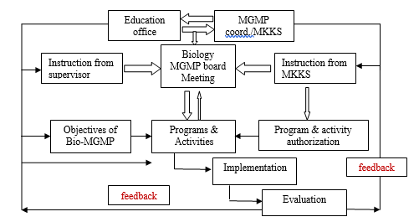The results of the present study revealed the mechanisms and the procedures of biology MGMP activities that were primarily oriented towards the pedagogical competence development of biology teachers in the post-certification program as shown in Fig. 2. The mechanisms and the procedures included planning for evaluation and follow-up as feedback that became the basis for the development of subsequent activities.

Figure 2. Mechanisms and procedures of pedagogical competence development of biology teachers through MGMP in Surakarta

The mechanisms and procedures of competency development activities through MGMP as illustrated in Fig. 2 entailed several stages, namely: (1) school principal working group (MKKS) or coordinators of biology MGMP initiate coordination with district/city education office; (2) biology MGMP conducts a gathering to devise programs and activities for a year, carried out prior to instruction or guidance from supervisors and coordinators of MGMP; (3) MKKS or coordinators of MGMP authorize devised programs and activities; (4) coordinators of MGMP implement needs-based activities and determine resource persons; and (5) coordinator and the management conduct an evaluation to obtain feedback for program and activities in subsequent year.

It should be noted that the mechanisms and procedures for the activities of the pedagogical competence development of biology teachers are carried out through the preparation of Biology MGMP programs and activities. They are carried out through a working meeting attended by all members, administrators, and coordinators of MGMP. The programs discussed and devised in the meeting are verified and implemented on a collaborative basis in order to achieve the objectives (Purwoko, Andayani, Muntar, & Diartha, 2017). Prior to the implementation, the program is authorized by the coordinators and even enacted by the Education Office for particular districts. In terms of the components of the activities, they are generally divided into four, that is: academic (professional and pedagogical competence development), routine, incidental, and social programs.

Based on the education management, the work plan process of biology MGMP has been feasible in accordance with the management function. The ability to manage learning is also of importance in the learning process (Anwar, et al, 2013). Therefore, management is recognized as a technique of coordinating various activities that have been prepared together to achieve the goals of the members. Based on this principle, education management functions to lead toward achievement of the program and goals of the organization.

The function of education management, according to (Isdaryanti, et al, 2018) and (Peniati, et al., 2013) includes planning, organizing, directing, and controlling (Sukaningtyas et al, 2014) (Susilo et al, 2018). Meanwhile, six functions of education management have been proposed (Sumarni & Semarang, 2016); (Li, 2017);(Anwar et al., 2013); namely: planning, organizing, mobilizing, coordinating, directing, and supervising. Hanggraeni (2011) also confirmed that management is a process that runs effectively and efficiently if an organization implements its management functions properly and appropriately. Furthermore, the function of management is associated with the initial and crucial part that leads to the effectiveness of other management functions.

The present study found the characteristics of activity in the context of materials based on priority followed by improvement of biology teacher pedagogy. In this respect, the improvement of biology teacher pedagogy competencies through MGMP in Surakarta in terms of aspects of materials in a row and based on the priorities were illustrated in Table 1 including (1) GCS review; (2) preparation of National Examination exercises and questions, followed by try-out; (3) preparation of student worksheets; (4) preparation of module; (5) preparation of learning tools (lesson plan, syllabus, and other learning tools); (6) comprehension of learning materials; (7) enrichment of laboratory materials; (8) CAR workshop; and (9) preparation of incidental materials. The program is also adjusted to teachers’ needs to achieve the targets of national examinations in the field of biology subjects (Isdaryanti et al., 2018).

**Table 1. Activities for improving pedagogical competence of biology teachers through MGMP during 2011-2016**

|  |  |  |
| --- | --- | --- |
| **No.** | **Activity Materials** | **Achievements** |
| 1. | Surgery for GCS (‘Standar Kompetensi Lulusan’/GCS) | 95% |
| 2. | Making grid and state exam  (Ujian Negara/UN) questions then performing a try-out | 98% |
| 3. | Making LKS | 85% |
| 4. | Module-making | 84% |
| 5. | Preparation of learning devices (making RPP, syllabus, and other learning devices) | 65% |
| 6. | Deepening of learning materials | 45% |
| 7. | Deepening of laboratory materials | 40% |
| 8. | Classroom Action Research (CAR) Workshop | 55% |
| 9. | Other incidental materials | 87 |

The present study revealed that the program was dominated by routine activities, particularly those related to the review as well as preparation of final exam and National Exam exercise, try-out, and LKS. Activities specifically programmed to improve the pedagogical competence in teachers were relatively rare, including SKKD analysis and preparation of module, syllabus, lesson plan, and appraisal instrument. The high percentage of routine and pragmatic activities as indicated in this study was relevant to the findings demonstrating the works produced by teachers in the post-MGMP activities. The works were also in the form of final exam, National Examination and LKS, syllabus and RPP, learning methods and evaluation tools, PTK proposals, as well as teaching materials or modules. The proportion of those works was further illustrated in the following Figure.



Based on Fig. 3, the works generated by biology teachers were dominated by exercises and LKS. They were also in accordance with the work plan devised by MGMP in which routine activities involved preparation of final exam, review of GCS, preparation of National Examination exercises, and practical programs whose benefits were directly noticeable. The work that had the second highest percentage level was syllabus and RPP. It was also used as a reference and then directly implemented when teachers conducted learning activities. The third highest percentage level was in the form of learning methods and evaluation instruments. Similar to the syllabus and the RPP, the works of learning methods and evaluation instrument were used as a reference in teaching and evaluation. Furthermore, the works ranked the fourth and the fifth were the ones related to PTK proposals and teaching materials or modules, respectively.

Figure 3. Percentage of works produced by biology teachers in MGMP forum in Surakarta

The findings of this study revealed that the program and the activities of teacher competence development had been primarily performed based on members’ pragmatic needs; hence, the types of activities were dominated by the routine category providing practical benefits (Peniati et al., 2013);(Purwoko, et al., 2017); (Hartini et al., 2018). Consequently, teachers relatively preferred routine activities as priority. Several activities that became of priority programs were the review of GCS and the preparation of final exam and National Exam exercises, try-out, and LKS. Meanwhile, activities programmed to support professional competence for biology teachers included reinforcing, mastering, and enriching learning materials that were relatively low (10%), even absent in several MGMPs. They might presume that such activities were less practical to the development of teacher competence as a whole. Instead, they preferred activities with temporary benefits that could simultaneously reduce their workloads, particularly related to the requirement to make appraisal instruments for students.

The assessment of a task that provides practical benefit for teachers is considered as a part of individual behaviour in an organization. In this regard, Kunter et al. (2013) suggested that individual behaviour in organizations is human behaviour or actions or attitudes that can be measured or observed. Such individual behaviours potentially form collective ones, in order to achieve common goals. Individual behaviours can be also personal and subjective due to diverse interests among members even though they are intended to reach organizational goals. Furthermore, Hanggraeni (2011) shed light on three factors contributing to individual behaviours in an organization: (1) biographical characteristics; (2) ability; and (3) learning. The first characteristic is linked to a personality within an individual, i.e., age and gender. The second one relates to the capacity of an individual to perform a task. Learning is also associated with the process of learning as a task by an individual, which becomes an experience and behaviour to attain organizational goals.

The subjectivity of teachers in terms of conducting activities in biology MGMP and inclination towards pragmatic ones as the consequence of the absence of a false perception of teacher professional development have been similarly discussed by (Handayani & Brodjonegoro, 2015; Leksono,et al, 2013), (Richmond & Floden, 2018) who examined Japanese teachers considering the best model to improve teacher competence and professionalism. For three years, they finally found that the model employed needed to be instigated by teachers’ understanding about their duties, rights, and obligations and how to implement them to improve and develop their professionalism as teachers (Parmin et al., 2017; Sharif et al., 2018).

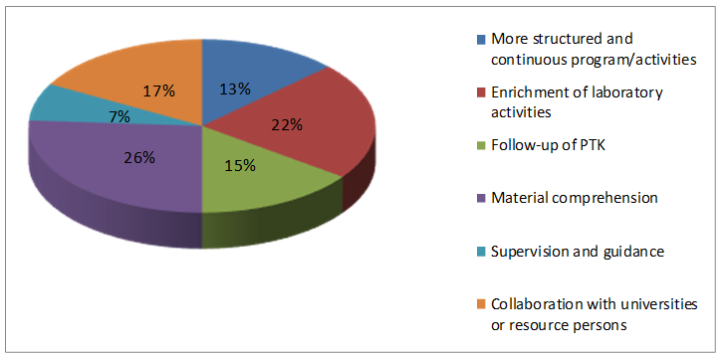Teacher professionalism is highly related to teacher competence, or professional teacher must be supported by the four required competencies. Thus, teacher competence can be assessed from the level of professionalism in terms of completing tasks while teacher professionalism can be assessed through performance or its outcome. Meanwhile, Mathis stated that the appraisal of employees’ and teachers’ performance could generally cover five aspects: (1) outcome quantity, (2) process quality, (3) punctuality, (4) presence, and (5) team work skill. The performance of an employee/teacher can be also affected by several factors including rewards.

Figure 5. Solutions from biology MGMP board to support the effectiveness of activities

Another factor that is not less substantial in terms of the implementation of the biology MGMP activities is motivation, both internal and external. As the leader in the class, teacher must possess vast motivation to realize the objectives of education (Rubini, et al, 2016). In this respect, Danim (2010) asserted that self-motivation meant strength, encouragement, need, enthusiasm or psychological mechanism that could encourage leaders (including teachers) to achieve particular achievements in accordance with the desired content standards and outcomes.

The activities in the pedagogical competence development of biology teachers in the post- certification program through MGMP could also have several characteristics as demonstrated in Fig. 4 below.

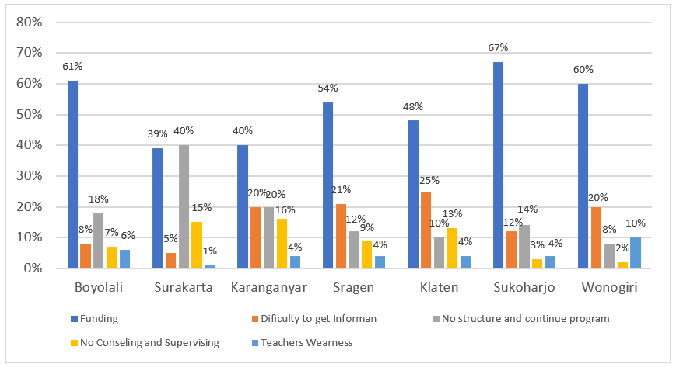

Figure 4. Main constraints in the activities of teacher competence development through biology MGMP

In general, there were five problems encountered by biology MGMPs in Surakarta including; (1) funding issues, (2) unstructured and discontinuous program, (3) difficulty to provide resource persons, (4) absence of guidance and supervision, and (5) teacher awareness. In addition to the constraints, the present study revealed several solutions to support the effectiveness of the teacher competence development program, particularly pedagogical competence, proposed by the MGMP board including (1) a more structured and continuous program, (2) comprehension of learning materials, (3) enrichment of laboratory materials, (4) follow-up for PTK activities; (5) collaboration with universities; and (6) regulations about program funding. The details were presented in Fig. 5 below.

Fig. 5 showed that the solutions proposed by MGMP board were mainly about comprehension of biology learning materials, followed by enrichment of laboratory activities. These two activities were highlighted by MGMP board, and they even became of priority activities since such activities carried out by all MGMPs in Surakarta had not reflected efforts to improve pedagogical competence on a proportional basis.

Basically, Fig. 4 demonstrated constraints or problems encountered by the biology MGMPs while Fig. 5 presented the solutions proposed by the biology MGMP board of Surakarta to overcome the problems. There was a high relevance of the two figures; hence, it was expected that the implementation of the solutions could support the effectiveness and the efficiency of the activities of teacher competence development through MGMP.

Fig.5 showed one of the efforts made for improving professional competence of the biology teachers through laboratory enrichment. These findings indicated that the mastery of biology teaching materials had not become the main factor. Therefore, it needed enrichment of laboratory materials and also empowerment of biology teachers (Anif, 2018).

Furthermore, it was observed that the constraints or the problems had stemmed from lack of understanding and awareness among teachers on their titles as professionals. The professional title and also the professional allowance could also bring high implications and consequences at the same time; namely, the awareness to continuously improve professionalism that could have an impact on students’ achievements and eventually a positive effect on their quality of education in general. It was in accordance with the mandate of Law No. 14 of 2005, specifically Article 20, in which one of the obligations of professional teachers is to improve and develop academic quality and competencies on a continuous basis in line with the development of science, technology, and art.

The obligations of a professional teacher as mandated in the law should be interpreted as a commitment to raise teacher’s awareness to carry out strategic duties and roles of teachers in realizing this nation into a dignified one through continuous development of the quality of education as teacher leadership (Allen, 2018) and provide formative feedback using student ratings of teaching acts (Chokchai & Pupat, 2018).

Conceptually, professional teachers are those who have four competencies and can also demonstrate them through their performance (Brodjonegoro, 2015)(Parmin et al., 2017). Musfah (2011) also suggested three aspects of teacher performance; i.e. (1) professional skills, (2) social skills, and (3) personal skills. Professional skills include teachers’ competence to carry out the learning process.

Meanwhile, the data in Fig. 5 showed solutions to the problems encountered by biology MGMP, which was mainly about the comprehension of biology learning materials by 26%. It was emphasized by the MGMP board, since the activities conducted by all MGMPs in Surakarta did not reflect efforts to develop professional competence through a structured and continuous material comprehension.

The second level was the enrichment of laboratory materials, which was by 22%. Such an activity also became a priority due to its apparent relationship with the first program of material comprehension. So far, only few of biology MGMP activities have directly supported professional competence development through the enrichment of laboratory materials as subject matter knowledge across teacher career cycle (Nixon et al, 2018). It has been only conducted by several MGMPs, and not in the form of a continuous program.

Furthermore, collaboration with universities is assumed to be significant by 19%. The forms of activities include accessibility of resource persons and teacher internships in the contest of laboratory. These activities are also considered as academic recharging that should be performed to improve teacher competencies, particularly professional competence (Parmin et al., 2017; Purwoko et al., 2017). In this respect, studies were conducted on teacher professional development using resource persons from teachers to teachers and by teachers. Nevertheless, under certain conditions, it involved resource persons from university as a companion. A coaching model was also used in which a teacher was considered as an object, a senior teacher, and a team of resource persons from universities made up of a peer coaching. The findings revealed that the team of resource persons from university could play a role in assisting and providing support and material reinforcement throughout the process (Leksono et al., 2013; Nunik Iswardhani & Djukri, 2015).

Subsequently, the follow-up of PTK became a priority with 18%. The biology MGMP board was fully aware that PTK training activities were limited to socialization; hence, many teachers had not been able to make a proper PTK proposal. Moreover, there was an absence of follow-up from research activities based on devised proposals to preparation of scientific journal articles as the study results. Meanwhile, scientific articles became a requirement for promotion. Therefore, the follow-up of PTK is a priority for the professional competence development of teachers (Suastra et al., 2017).

One of the functions of PTK activities was to develop instructional methods and modules (Arifin, 2010). It is expected that the activities will enhance the knowledge and skills of teachers in association with the development of instructional methods or models and teaching materials (Normand & Kohn, 2011; Suastra et al., 2017; Susilo et al., 2018). Furthermore, Arifin (2010**)** argued that the skills to perform PTK for the development of teaching materials were linked to teachers’ ICT skills. Hence, teachers are required to master information and technology in order to be able to access online-based resources or materials (Wiyanto et al., 2014).

Moreover, Choudhary and Bhardwaj (2011**)** emphasized ICT mastery as a major component in improving and developing teacher professional competence. ICT also has an important role in advancement of education since teachers are able to transform ICT knowledge to students, and eventually students will apply the knowledge to complement the materials conveyed in the classroom (Parmin et al., 2015). Moreover, students will be attracted to have a new and fresh atmosphere which stimulates them to be more active and independent (Rubini et al., 2018).

In this regard, Liakopoulou (2011) conducted a study on teachers with a specific subject; namely, professional competence development of teachers using the Internet. The findings indicated that most teachers had experience, even mastery of computer and the Internet. The use of computer and the Internet can also bring positive effect to learning activities and student exams. This model can successfully spur students’ mastery of computer and the Internet for learning in class as well as enjoying the process (Ibrahim & Othman, 2017).

The findings of this study showed that supervision by the MGMP coordinators as the representative of the MKKS was less optimal. Similarly, the school principal had not carried out this function. In fact, the participation of biology teachers in MGMP activities is recognized as an effort to improve and develop teacher competencies as a whole, in which it is highly expected to bring positive impact on the quality of education and ultimately have implications for the achievement of students as desired by schools.

Furthermore, the activities of competence development for biology teachers in the post- certification program through MGMP involved resource persons. The data showed that the resource persons as the facilitators in the activities were mostly mentors, LPMP members, and biology teachers who met the criteria and had profound competence, both from internal and external institutions. Despite the fact that some MGMPs had invited resource persons from universities, the portion was relatively small. Moreover, universities as the center of science and technology development had great liability to realize welfare in society through knowledge (Cochran-Smith & Lytle, 1999). Therefore, initiation to establish collaboration and partnerships for building the nation by developing the best education system and elevating the quality of education as the challenge of the future is a must.

The model employed to improve professional competence of biology teachers has not been significant. Up to now, the model has been only used for a short term. The novelty of this study was presenting a new model based on an initial competence testing enrichment and empowerment of laboratory practicum materials. Therefore, it can be used as an alternative for improving professional competence in biology teachers.

**CONCLUSION**

Continuing development of professional biology teachers and strengthening laboratory materials are of the most effective models to improve competence in biology teachers in schools that are not supported by adequate laboratories and also have implications for low quality of professional biology teachers.

The mechanisms and procedures of activities to develop pedagogical competence of biology teachers in the post-certification program in Surakarta Residency have also devised MGMP program and activities. They cover the MKKS or coordinators of biology MGMP initiate coordination with the District Education Office. Biology MGMP also conducts a gathering to devise programs and activities for a year and the MKKS or coordinators of MGMP authorize the devised programs and activities, the implementation of needs-based activities, and the evaluation to obtain feedback.

The characteristics of program and activities based on the priority were review of GCS, preparation of final exam exercises and national exam try-out, analysis of previouss national exam, preparation of student worksheets, preparation of modules, preparation of lesson plan/RPP, comprehension of learning materials, enrichment of laboratory materials, workshop of CAR, as well as preparation of incidental materials. The outcomes or works produced by biology teachers after carrying out successive activities were finnal exam exercise, national exam try-out, and GCS of 45%, syllabus and RPP of 39%, learning methods and appraisal instruments of 10%, CAR proposal of 5%, and modules/teaching materials/props of 2%.

The constraints encountered in the implementation of the activities were funding issues, unstructured and discontinuous programs, complexity of providing resource persons, absence of guidance and supervision, and lack of teachers’ awareness. Meanwhile, several solutions were formulated to support the effectiveness of the activities; namely, comprehension of biology learning materials, enrichment of laboratory materials, collaboration with universities, PTK follow-up, more structured and continuous programs and activities, as well as supervision and guidance from supervisors.

**REFERENCES**

.