LETTER OF STATEMENT
No: 25/JPII/R.A./2019

I hereby declare that the article:
title : The Developmennt Of PBL-Based Worksheets Integrated With Green Chemistry and Ethnoscience To Improve Student Thinking Skills

authors : 1. Sudarmin
2. L. Zahro
3. Rr. Sri Endang Pujiastuti
4. Rayandra Asyhar
5. Zaenuri
6. Asfia Rosita
is APPROVED to be published in JPII for September 2019 Issue.
Hereby this statement is made truthfully and to be used accordingly.

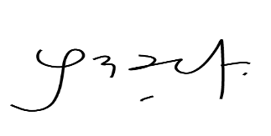
Semarang, 29 Desember 2019
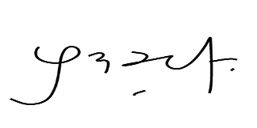

[Sudarmin]

