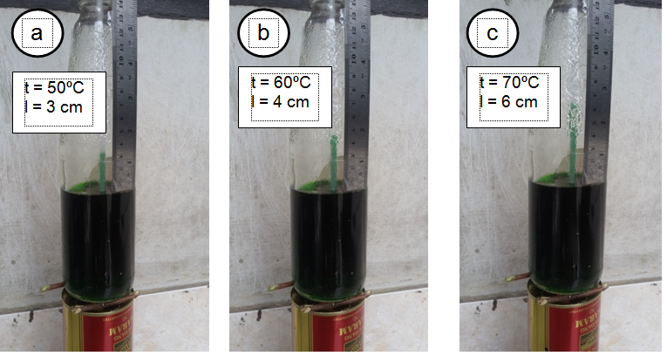
Figure 1. The scientific instrument in liquid expansion concept at different temperatures.

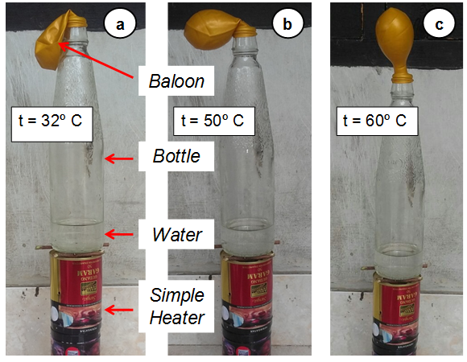
Figure 2. The simple scientific instrument in gaseous expansion concept: (a) Initial condition of gas inside balloon (at 32ºC); (b) Increase in gas indicated by partially inflated balloon (at 50º C), and (c) Balloon inflated more (at 60ºC).

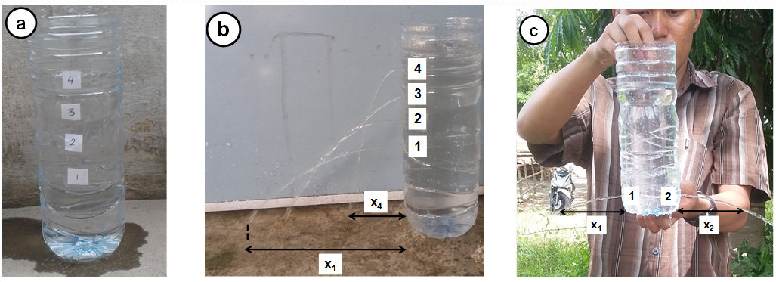
Figure 3. Scientific instrument for pressure on the liquid: (a) design of instrument; (b) experiment showing the liquid pressure at a vertical point; and (c) experiment showing the liquid pressure at a horizontal point.

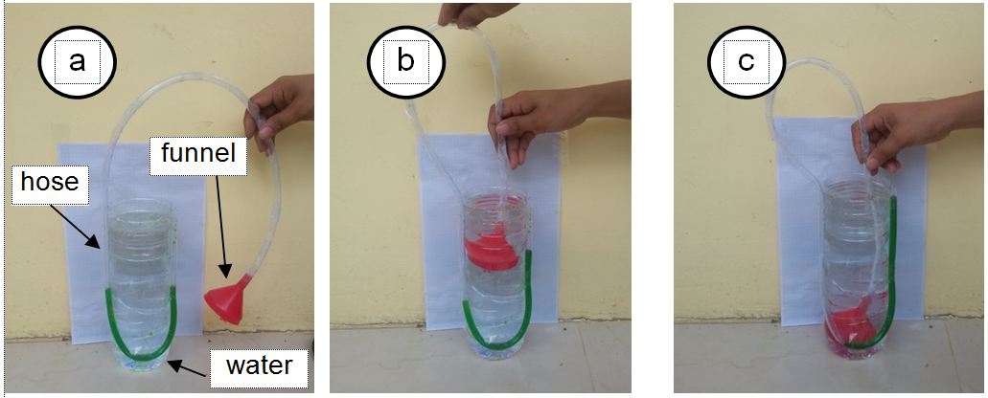
Figure 4. Scientific instrument for detecting pressure in the liquid: (a) initial condition; (b) liquid pressure near the surface; and (c) liquid pressure at the bottom of the bottle.

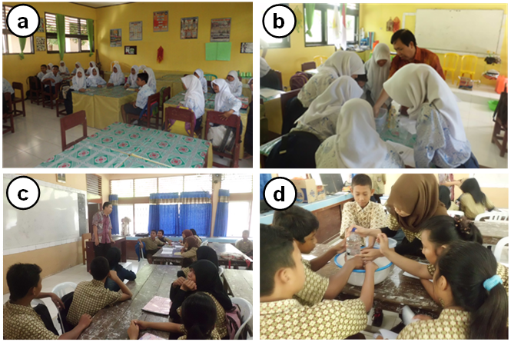
Figure 5. Implementation of learning with the use of scientific instruments: (a) Teacher organised the students into a small group, (b) The teacher demonstrates the use of simple science media, (c) Students used the simple science media for the experiment, (d) Discussion between teacher and the students.

