LETTER OF STATEMENT
No: 25/JPII/R.A./2019

I hereby declare that the article:
title : Ethno-science Pedagogic in Chemistry Learning to Develop Scientific Literacy
authors : 1. Citra Ayu Dewi
2. Yusran Khery
3. Sudarmin
is APPROVED to be published in JPII for June 2019 Issue.
Hereby this statement is made truthfully and to be used accordingly.

Semarang, Juni 26, 2019
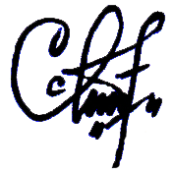
First Author,

(Citra Ayu Dewi)

