

JPII 7 (1) (2018)
Jurnal Pendidikan IPA Indonesia

http://journal.unnes.ac.id/index.php/jpii

APPROACHING THE UNDERSTANDING OF THERMAL PHENOMENA USING 7E LEARNING CYCLE

Abstract
Conceptual understanding is often a problem in science learning, and this has become the focus of science education experts including in Indonesia. Lately, ten articles in Indonesia and six articles in other countries have discussed the model of 7E Learning Cycle. It was mentioned that this model is able to increase the understanding of learners’ concept. This research is aimed to reveal the effectiveness of physics learning using 7E Learning Cycle model after being reviewed with control classes in improving students' understanding of temperature and heat concepts. The research design is quasi-experimental with non-equivalent control group design. The sample was senior high school students. Objective test in the form of multiple choices equipped with reason was employed as the instrument to collect the data. Based on the data analysis, it was obtained that the value of Effect Size was as much as 0.5 with the medium category. It can be concluded, then, that the use of 7E Learning Cycle learning model is effective to improve learners’ understanding of temperature and heat concepts.
Keywords: Conceptual understanding; Direct Learning; 7E Learning Cycle model

INTRODUCTION
The outcome of the physics learning process, among others, is to enable the students to understand the relevance of physics concepts so that the students can apply the knowledge in their daily life(Husein, Herayanti, & Gunawan, 2015; Latifah et al., 2019; Pratiwi & Supardi, 2014). Students' inability to connect one concept to another is a common problem occurring in physics classes(Anwar et al., 2019; Tanti, Jamaluddin, & Syefrinando, 2017). Students are more likely to memorize than to understand the concepts (Saregar, Diani & Kholid, 2017). In this case, physics teachers should emphasize the students’ understanding of the concepts (Lestari & Rahayu, 2015; Wahyuningsih, 2014) based on the knowledge acquired in the previous level to the next (Wekke, 2017; Widayanti, Yuberti, Irwandani, & Hamid, 2018). The use of varied learning model is needed(Saregar, Latifah, & Sari, 2016) in order to be an intermediary so that the material taught could be understood by students(Pitan & Atiku, 2017; Wekke et al., 2017; Widayanti & Yuberti, 2018; Yıldırım & Akamca, 2017). Furthermore, at the final stage, it is expected to increase the students’ mastery of the concepts (Saregar, 2016).
There are various types of constructivism learning models such as problem-solving learning model, mind mapping, and 7E learning cycle. In this research, the 7E Learning Cycle model was selected since it provides opportunities for students to build their knowledge (Febriana, Wartono & Asim, 2014).
7E Learning Cycle model is the improvement of the 5E Learning Cycle model (Ghaliyah, Bakri, & Siswoyo, 2015). The cycles of the applied learning model are emphasized in the understanding of the scientific physics concepts and correcting the knowledge misconception. Furthermore, it is also expected to be able to enhance the students’ memorization process that is focused on the knowledge and knowledge transfer (Yerdelen & Ali, 2016). The model of the learning cycle Approach (LCA) is a model that is deemed effective for physics students (Olaoluwa & Olufunke, 2015). It can help them to elaborate their understanding toward certain aspects in scientific research (Hodson, 2012). One of the physics materials that is considered quite difficult for students to understand is temperature and heat(Sayyadi, Hidayat, & Muhardjito, 2016).
The constructivism basis of the 7E Learning Model possesses some weaknesses and strengths. One of the notable strengths of the 7E Learning Cycle is that it could make the students active since the students are thinking maximally to acquire the knowledge. On the other hand, the weakness of7ELearning Cycle is the length of time needed in its application since the students are trained to explore their knowledge, and they are also given enough freedom to express their ideas. In order to minimize the weakness of this model, proper preparation is certainly needed by the teacher acting as a facilitator (Rosalina Rawa, Sutawidjaja & Sudirman, 2016).
The previous researchers showed that the Learning Cycle could be used to improve students’ understanding (Nurmalasari, Kade & Kamaluddin, 2014). It can also be used to improve students’ learning achievement (Sumiyati, Sujana & Djuanda, 2016). To understand a concept means to be able to express the material having been learned into a simplified version to overcome the problems of the interconnected concept. The cognitive process of concepts understanding consists of interpreting, modeling, classifying, summarizing, predicting, comparing, and explaining (Setyawati, Candiasa & Yudana, 2016). One of the factors that determine the outcome of the learning process is the students’ achievements measured by how much they are able to master the learning material (Parasamya & Wahyuni, 2017).
There are some distinctions between this research and the previous ones. Firstly, there is an elaboration of each of the seven prescribed stages of the 7E Learning Cycle model implementation exposing the students’ level of understanding presented in the discussion. In addition, there is the use of different learning materials, namely temperature and heat which is very suitable for the object of measuring concept understanding(Kambouri-Danos, Ravanis, Jameau, & Boilevin, 2019). Then, the learning circumstances where the subjects of this research study are also relatively different.
Learning cycle is a learning model centered on learners (Yerdelen & Ali, 2016). Learning cycle consists of a series of stages of activities organized in such a way that learners can master the competencies that must be achieved in learning with an active role(Ngalimun, 2014; Ratiyani, Wachju Subchan, & Slamet Hariyadi, 2014). Learning cycle in the classroom practice focuses on the experience and knowledge of the early learners(Ghaliyah et al., 2015), based on the opinions, it can be concluded that the model of learning cycle centered on learners so that learners can actively find their own concept. In order for the learners’ concept can be well-organized, an organized procedure is needed.
The development of learning cycle model has been developed from learning cycle 3e (Exploration, Explanation, Elaboration), learning cycle 5e (Engagement, Exploration, Explanation, Elaboration, and Evaluation), and learning cycle 7e (elicit, engage, explore, explain, elaborate, extend, and evaluate). The latest development is the learning cycle 7e.
Some studies suggest that learning cycle 7e can foster motivation and learning achievement (Febriana et al., 2014; Sumiyati et al., 2016), improve language comprehension (Yerdelen & Ali, 2016) effective to achieve goals quickly(Bozorgpouri, 2016), improve the ability of mathematical connections(Rosalina Rawa et al., 2016), and foster conceptual understanding (Nurmalasari et al., 2014).
In some of the research results, understanding of concepts is very important in learning because, with the concept mastery of the materials, the hardest problem can be solved easily (Alan & Afriansyah, 2017; Suroso, 2016). Many learners do not give good results in learning. Learners are not aware of efficient and effective ways of learning because they only try to memorize lessons. Though physics is not a material to memorize, but requires reasoning and understanding the concept (Lestari & Rahayu, 2015). As a result, if given a test, learners will have difficulty (Yolanda, Syuhendri, & Andriani, 2016). Therefore, understanding the concept is needed by every learner; by understanding the concept, it is expected for the learners to get good learning outcomes.
The results of the earlier quantitative and qualitative research on the understanding of the thermal concepts and phenomena show that the majority of children do not master the concepts of heat and temperature and the related phenomena even after receiving formal instruction on these subjects. By analyzing this bibliographic spectrum, we can specify some constant and strong obstacles in the reasoning and explanations of students.
There is a confusion between the concepts "heat" and "temperature," and often they think that temperature is a measure of the heat, temperature is an intrinsic property of matter, they are hot and cold objects by nature, the warm and the cold d are two separate entities, all materials if they are placed long in an environment with a temperature given, will reach the same temperature, confusion with the meaning of words like 'heat', 'heat flow' or 'heat capacity', mixing hot and cold water lead to correct qualitative judgements but incorrect quantitative judgements,difficulty explaining how a thermometer works (Gönen & Kocakaya, 2010; Harrison, Grayson, & Treagust, 1999; Kampeza, Vellopoulou, Fragkiadaki, & Ravanis, 2016; Ravanis, 2013; Tytler, 2000)

METHOD
Design of Study
The design used in this research was Quasi-experimental with Nonequivalent Control Class Design(Sugiyono, 2014; Tanti et al., 2017). The research was conducted at the X Science 1 and X Science 2 class of SMAN 1 Kotabumi North Lampung. The study was implemented in three phases (pre-test, teaching interventions in an experimental group and a control group and post-test). The data of the study consisted of student’s responses to objective tests in the form of multiple choices equipped with the reason for the answers. The pre-test took place X weeks before the teaching interventions, and the post-test were held X weeks after the intervention.

Participants
The sampling technique employed was Cluster Sampling (Arikunto, 2010). The sample of the study consisted of X subjects, X male and X female (age 15-16; average age X years). The children were attending public secondary classes with similar socio-economic characteristics and were randomly divided into two groups of X children each, thus forming the experimental class (hereafter E.C.) and control class (hereafter C.C.) respectively.

Teaching Interventions
The Experimental Class
The learning stage of 7E Learning Cycle model can be seen in Figure 1:
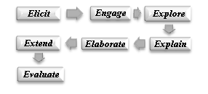
Figure 1. The Stages of 7E Learning Cycle Model.

The Researchers applied the seven stages of 7E Learning Cycle model during the teaching and learning activity. The first stage was Elicit to raise the student's initial knowledge by asking questions as displayed in Figure 2 below;
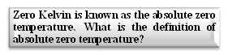
Figure 2. The first Stage: Elicit.

The students responded enthusiastically when they were given such a question. They were willing to present the answer in front of the class. Thus, it brought about the impact of active classroom atmosphere at the beginning of the learning process.
The second stage was to Engage. It was involving the students with the surrounding events related to the temperature material by carrying out the demonstration as displayed in Figure 3.
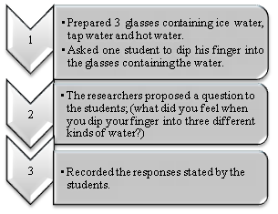
Figure 3. The Second Stage: Engage.

The results of the demonstration were able to stimulate the students in order to answer each question of the demonstration. Besides, it could attract students' attention to focus on the learning process.
The third stage was to Explore. This was the stage of collecting information. The procedure can be seen in the following figure 4,
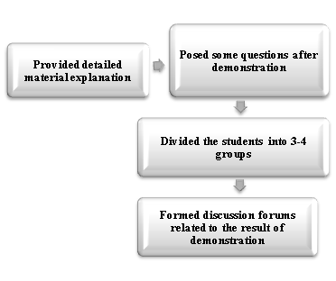
Figure 4. The Third Stage: Explore.

It was expected that based on the information-gathering stage the students were able to understand the material in detail.
The fourth stage was to Explain. The students were required to explain the results of the discussion by using their way to understand the material indicating the level of student’ understanding, has appeared in the following figure 5,
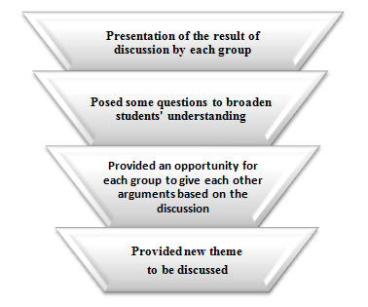
Figure 5. The Fourth Stage: Explain.

The fifth stage was Elaborate. Elaborate was the proficiency stage for the researcher and the students to connect previously learned concepts with daily life. It can be seen in Figure 6.
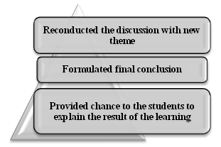
Figure 6. The Fifth Stage: Elaborate.

In this stage, the students re-conducted the discussion to acquire new findings in order to overcome different problems and concepts and to produce the conclusion that was correct and clear.
The sixth stage was to Extend. The result of the students’ findings was extended to enable the students to be more active and interested in searching for new concepts as displayed in Figure 7.
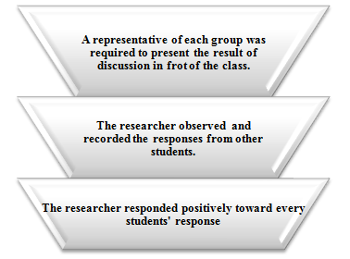
Figure 7. The sixth Stage: Extend.

The seventh stage was to Evaluate. The students were given opportunities to conclude everything related to the material that had been studied. Then, an evaluation was carried out in order to gain a deeper understanding of the concept of the temperature material by giving the task to the students. One of the conceptual understanding problems can be seen in the following figure 8:
Look at the following Images:
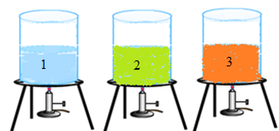
The three images above are liquid which are heated with the same amount of heat. If the density of each liquid is different, namely ρ1 <ρ 2 <ρ 3, then the correct statement regarding the temperature rise is...
- Figure 1 has the fastest temperature rise
- Figure 2 has the fastest temperature rise
- Figure 3 has the fastest temperature rise
- Figure 1 has the lowest temperature rise
- Figure 2 has the lowest temperature rise
Reason:………………………

Figure 8. The Seventh Stage: Evaluate.

In the final step of the seventh stage, the researcher conveyed information about the next material that will be studied so that the students should learn before the material is delivered.
The learning process through the 7E Learning Cycle model requires time accuracy considering its numerous stages. Time is one of the key factors in implementing this learning model. Furthermore, to achieve the learning objectives, this learning model should be done in complete seven stages, if only two stages were done or skipping even a stage, then the implementation of this learning model will not be optimum.

The control classes
The learning process in the control class was conducted using Direct Learning Model which is commonly used by physics teachers. The students responded passively and only listened to the researcher explained. It resulted in a lack of understanding of the concepts of the material; consequently, the students were having difficulty in solving some of the physics problems on temperature and heat materials.

The research questions
Based on the research design presented, we formulated two research questions.
With the first research question, we ask if the students of the experimental class (who took part in a 7E teaching intervention) would be able to better understand the thermal concepts and phenomena, compared to the children in the control class (who participated in a Direct Learning Model.
With the second research question, we ask we ask whether students of both groups progress after the two didactic interventions.

Data analysis
Research Instrument and its development the students’ understanding of the concepts were measured through pre-test and post-test using objective test in the form of multiple choices equipped with the reason for the answers. Each test consisted of 15 items. Since the original version of the tests was the only multiple-choice format, then modification was carried out by asking the students to provide a reason for choosing the answer.
To investigate the effectiveness of learning toward the students’ understanding of the concepts, the Effect Size test was used. Effect Size is a measurement to determine the effect of one variable on another. Effect Size can be counted using a particular formula(Cohen, 1998), and further explanation of it is also available(Hake, 1998; Saregar et al., 2016).
$$d=\frac{m_{A}-m_{B}}{{\left[\frac{\left({sd}_{A}^{2}+{sd}_{B}^{2}\right)}{2}\right]}^{1/2}}$$
Definition:
d | = effect size
m_{A} | = mean gain of the experimental class
m_{B} | = mean gain of control class
sd_{A} | =standard deviation of experimental class
sd_{B} | = standard deviation of control class

The value of Effect Size can be seen in Table 1, as follows:

Table 1. Effect Size Criteria.
Effect Size | Category
d < 0.2 | Low
0.2 ≤ d < 0.8 | Average
d ≥ 0.8 | High

RESULT AND DISCUSSION
The data display of pre-test and post-test score recapitulation of the control and experimental class can be seen in table 2 below,

Table 2. The Pre-Test and Post-Test Score of the Control and Experimental Class
Indicator of Concept Understanding | Pretest |  |  |  | Posttest
Indicator of Concept Understanding | Experimental Class* |  | Control Class** |  | Experimental Class* |  | Control Class**
Indicator of Concept Understanding | Highest Score | Lowest Score | Highest Score | Lowest Score | Highest Score | Lowest Score | Highest Score | Lowest Score
Interpreting | 69 | 70 | 40 | 41 | 95 | 83 | 72 | 62
Modeling | 72 | 70 | 37 | 40 | 94 | 80 | 70 | 63
Predicting | 72 | 69 | 35 | 30 | 89 | 82 | 65 | 60
Explaining | 70 | 67 | 30 | 32 | 90 | 80 | 66 | 61
Classifying | 64 | 65 | 31 | 29 | 97 | 79 | 62 | 58
Comparing | 62 | 64 | 28 | 28 | 94 | 78 | 68 | 59
Summarizing | 60 | 64 | 30 | 31 | 92 | 78 | 66 | 57
The Highest and Lowest Total Score | 469 | 469 | 231 | 231 | 651 | 560 | 469 | 420
The Highest and Lowest Average Score | 67 | 67 | 33 | 33 | 93 | 80 | 67 | 60
Total Score | 1.986,4 |  | 1.880 |  | 3.113,2 |  | 2.820
Number of Students | 40 |  | 40 |  | 40 |  | 40
Total Average Score | 49,66 |  | 47 |  | 77,83 |  | 70,5
*Learning cycle 7e model | **Conventional model

The pretest and posttest shown in Table 2 were measured through a multiple-choice test of concept understanding (example figure 8). The scores measured in this study are cognitive scores ​​according to the blooms’ taxonomy that includes cognitive 2, 3, 4 and 5 (C2, C3, C4, C5). There are seven indicators of understanding the concept applied in this study. Table 2 shows that the results of the concept of understanding tests in each indicator change. On the test of understanding the concepts (interpreting), the highest and lowest scores in the experimental class and the control class experienced an increase, both as a result of pretest and posttest. However, the highest and lowest scores ​​in the experimental class are higher compared to the scores ​​in the control class.
On the concept understanding test (modeling), the highest and lowest scores ​​in the experimental class and the control class experienced an increase, both the results of the pretest and posttest. However, the highest and lowest scores ​​in the experimental class are higher than the scores ​​in the control class.
On the concept understanding test (predicting), the highest and lowest scores in the experimental class and the control class experienced an increase, both the results of the pretest and posttest. However, the highest and lowest scores ​​in the experimental class are higher than the scores ​​in the control class.
On the concept understanding test (explaining) the highest and lowest scores in the experimental class and the control class experienced an increase, both the results of the pretest and posttest. However, the highest and lowest scores ​​in the experimental class are higher than the scores ​​in the control class.
On the concept understanding test (classifying) the highest and lowest scores in the experimental class and the control class experienced an increase, both the results of the pretest and posttest. However, the highest and lowest scores ​​in the experimental class are higher than the scores ​​in the control class.
On the concept understanding test (comparing) the highest and lowest scores in the experimental class and the control class experienced an increase, both the results of the pretest and posttest. However, the highest and lowest scores ​​in the experimental class are higher than the scores ​​in the control class.
On the concept understanding test (summarizing) the highest and lowest scores in the experimental class and the control class experienced an increase, both the results of the pretest and posttest. However, the highest and lowest scores ​​in the experimental class are higher than the scores ​​in the control class.
In general, the results of concept understanding tests on each indicator experienced an increase in both the experimental class and the control class. However, before applying the learning cycle 7e model, there was no significant difference in the understanding of the concepts of the experimental class students. However, after the implementation of the learning cycle 7e model, the scores of the experimental class were significantly improved. Based on the results of the analysis of each student's answers, the understanding of their concepts had not been trained when answering the conceptual understanding questions in the form of multiple choices when they choose the answer (figure 9). In contrast to the results after applying the learning cycle 7e model and the conventional model, there are significant differences in the understanding of the concepts in the experimental class and the control class. In the experimental class, the answer is more appropriate than the control class (figure 10).

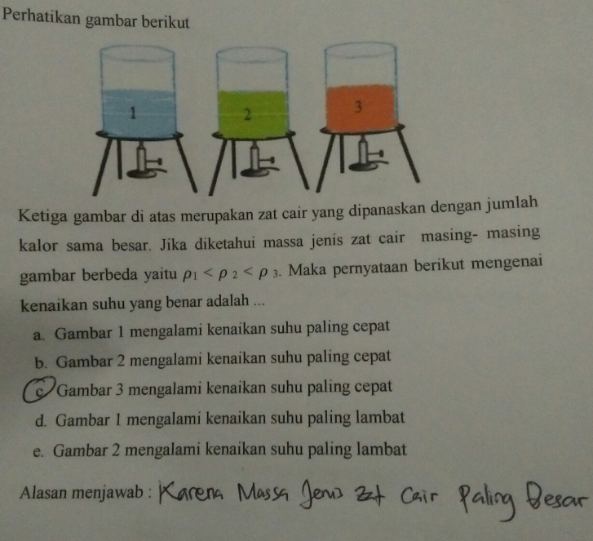 | 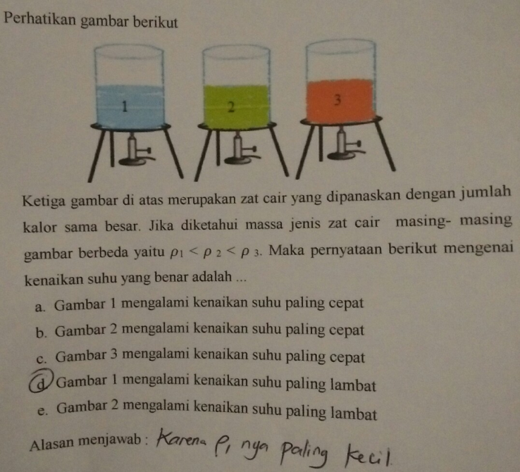
- Learning Cycle 7e Model | - Conventional Model
Figure 9. Before the Application of Learning Cycle 7e and the Conventional Model

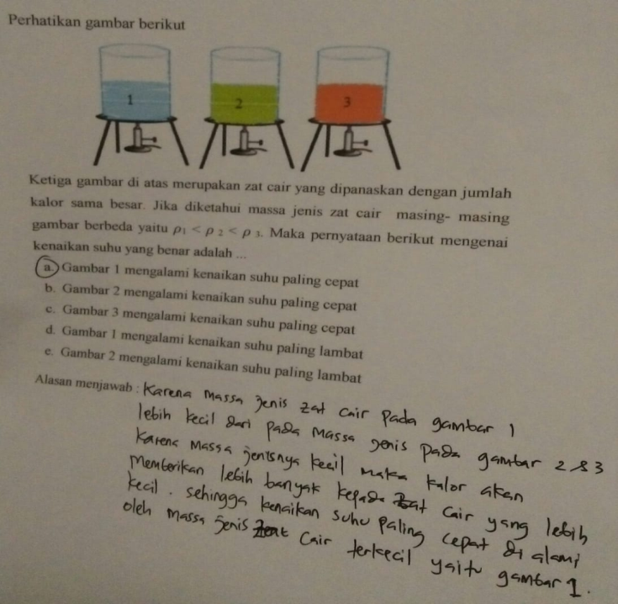 | 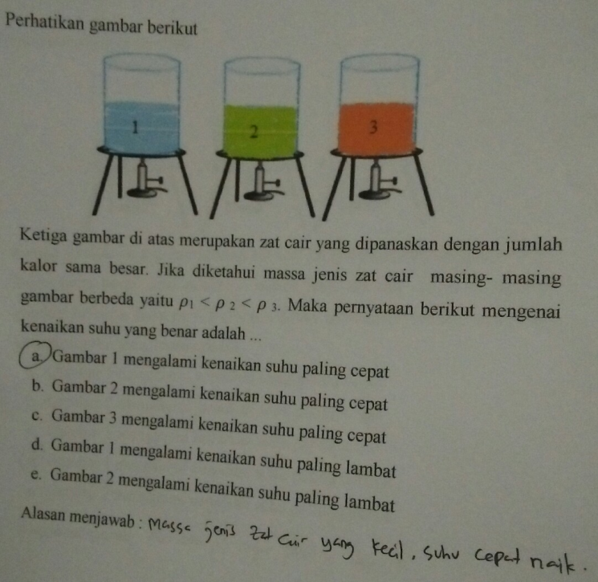
- Learning Cycle 7e Model |  | - Conventional Model
Figure 10. After the Application of Learning Cycle 7e and the Conventional Model

In addition to the results of cognitive scores, the management of learning is also the key to the successful implementation of the learning model. The following is the explanation of the learning management in this study.

Learning Management
The scoring percentage given by the physics teacher while the researcher was applying the learning model can be seen in the following figure 11:
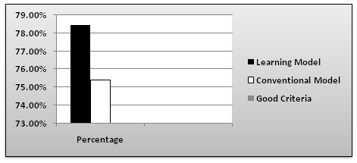
Figure 11. Graphic Percentage of Learning Management.

Based on figure 11, the gain percentage shows that the learning management through 7e Learning Cycle was 78.46% compared to the conventional learning amounting 75.38%. The percentage falls into satisfying criteria. Improvement can occur because the teacher applied the learning cycle 7e systematically. In the class that the learning cycle 7e model was applied, the teacher started the lesson by eliciting knowledge and involving students through engaging demonstrations. In the class that the conventional model was applied, the teacher started the lesson by psychologically preparing the students through stories without demonstrations or involving the students.
The core activity in learning cycle 7e model begins with the grouping to discuss the continuation of the demonstration by changing the object of the demonstration and discussion finding solutions to the questions given by the teacher (explore). Then each group conducts a presentation by explaining the results of the discussion (explain), the teacher gives feedback to each group to expand the discussion material in the group through question and answer between groups (elaborate & extend). In the class that applies conventional models, the core activity begins with the teacher explaining the material then the teacher forms a group to observe events related to the material in daily life. Then students are asked to communicate the material through assignments.
The closing activity in the learning cycle 7e model is ended by asking each group to conclude the results of the discussion and the teacher concludes the overall results of the discussion. The closing activity in the conventional model is ended by giving homework.
Based on the description of learning management, the learning cycle 7e model is a student-centered model. The teacher only acts as a facilitator in learning while the conventional model is still a teacher-centered model. The curriculum in Indonesia is the 2013 curriculum which emphasizes student-centered learning. In addition, other countries such as Finland, England, the United States, and other developed countries also implement student-centered learning which is more effective than teacher-centered learning.
The effectiveness of the application of the learning model is analyzed with effect size formula. Further description is shown in Table 3.

Table 3. The Result of Effect Size.
Class | Mean Gain | Standard Deviation | Effect Size | Category
Experiment | 28,17 | 36,64 | 0,5 | Average
Control | 23,50 | 137,72 | 0,5 | Average

Table 3 shows that the gain of effect size is 0.5 in the average category. This shows that the use of the 7E Learning Cycle model could effectively improve students' understanding of concepts in Physics subjects.
Based on the recapitulation of the post-test scores, both the experimental and the control class of the students' conceptual understanding have increased significantly. This might be caused by the fact that the7E Learning Cycle model has such distinctive characteristics that the students not only listen to the teachers but can also play an active role in exploring and enriching their understanding of the concepts learned.
The importance of understanding the concept of learning in school requires researchers to use various ways to analyze and improve understanding of concepts, including: increasing mastery of concepts through interactive multimedia (Husein et al., 2015), improving understanding of concepts through 7e learning cycle for junior high school students (Nurmalasari et al., 2014), improving understanding of concepts by utilizing PhET Simulation (Saregar, 2016), increasing understanding of concepts through the application of guided inquiry learning model (Setyawati et al., 2016), increasing understanding of concepts through the application of experiential learning models (Wahyuningsih, 2014) and understanding analysis of concepts through TTCI and CRI instruments (Yolanda et al., 2016).
This study supports Nurmalasari’s research that the learning cycle 7e model can improve concept understanding. In the Nurmalasari study, the learning cycle 7e model was applied to the junior high school students, but in this study, it was applied to senior high schools students. It means that the learning cycle 7e model can improve concept understanding to both junior and senior high school students
The findings of this study indicate that the use of the learning cycle model 7e was able to improve the mastery of the concept of the learners effectively. In this paper, the procedures of the learning cycle model 7e in the classroom are discussed in detail and thoroughly.

CONCLUSION
In short, it can be concluded that the use of 7E Learning Cycle Model is effective in improving students’ conceptual understanding. In other words, the learning process through 7E Learning Cycle Model was more effective compared to the conventional model in improving the students’ concept understanding, especially on temperature and heat subject matte.

REFERENCES
Alan, U. F., & Afriansyah, E. A. (2017). Kemampuan Pemahaman Matematis Siswa Melalui Model Pembelajaran Auditory Intellectualy Repetition Dan Problem Based Learning. Jurnal Pendidikan Matematika, 11(1), 68–78.
Anwar, C., Saregar, A., Yuberti, Zellia, N., Widayanti, Diani, R., & Wekke, I. S. (2019). Effect Size Test of Learning Model ARIAS and PBL : Concept Mastery of Temperature and Heat on Senior High School Students. EURASIA Journal of Mathematics, Science and Technology Education, 15(3), 1–9. https://doi.org/https://doi.org/10.29333/ejmste/103032
Arikunto, S. (2010). Prosedur Penelitian Suatu Pendekatan Praktik. Jakarta: Rineka Cipta.
Bozorgpouri, M. (2016). No TitleThe Study of Effectiveness of Seven-Step (7E) Teaching Method in The Progress of English Learning in Students Shiraz City. The Turkish Online Journal of Design, Art and Communication, TOJDAC Jul(July), 341–346.
Cohen, J. (1998). Statistical Power Analysis for The Behavioral Sciences (2nd ed.). Hillsdale, NJ: Lawrence Erlbaum Associates.
Febriana, E., Wartono, & Asim. (2014). Efektivitas Model Pembelajaran Learning Cycle 7E Disertai Resitasi terhadap Motivasi dan Prestasi Belajar Siswa Kelas XI MAN 3 Malang. Jurnal Online Universitas Negeri Malang, 2(1), 1–13.
Ghaliyah, S., Bakri, F., & Siswoyo. (2015). Pengembangan Modul Elektronik Berbasis Model Laerning Cycle 7E pada Pokok Bahasan Fluida Dinamik untuk Siswa SMA Kelas XI. Prosiding Seminar Nasional Fisika (E-Journal) SNF2015, 149–154.
Gönen, S., & Kocakaya, S. (2010). A CROSS-AGE STUDY: A Cross-Age Study on the Understanding of Heat and Temperature. Eurasian J. Phys. Chem. Educ (Vol. 2).
Hake, R. R. (1998). Interactive-engagement Versus Traditional Methods : A Six-thousand-student Survey of Mechanics Test Data for Introductory Physics Courses. American Journal of Physics, 66(64), 64–74.
Harrison, A. G., Grayson, D. J., & Treagust, D. F. (1999). Investigating a grade 11 student’s evolving conceptions of heat and temperature. Journal of Research in Science Teaching, 36(1), 55–87. https://doi.org/10.1002/(SICI)1098-2736(199901)36:1<55::AID-TEA5>3.0.CO;2-P
Hodson, D. (2012). Learning Science, Learning About Science, Doing Science: Different Goals Demand Different Learning Methods. International Journal of Science Education, 36(15), 2537.
Husein, S., Herayanti, L., & Gunawan. (2015). Pengaruh Penggunaan Multimedia Interaktif terhadap Penguasaan Konsep dan keterampilan Berpikir kritis Siswa pada materi Suhu dan kalor. Jurnal Pendidikan Fisika Dan Teknologi, I(3), 221–225.
Kambouri-Danos, M., Ravanis, K., Jameau, A., & Boilevin, J.-M. (2019). Precursor Models and Early Years Science Learning: A Case Study Related to the Water State Changes. Early Childhood Education Journal, 1–14. https://doi.org/10.1007/s10643-019-00937-5
Kampeza, M., Vellopoulou, A., Fragkiadaki, G., & Ravanis, K. (2016). The expansion thermometer in preschoolers’ thinking. Journal of Baltic Science Education, 15(2), 185–193.
Latifah, S., Irwandani, I., Saregar, A., Diani, R., Fiani, O., Widayanti, W., & Deta, U. A. (2019). How the Predict-Observe-Explain ( POE ) learning strategy remediates students ’ misconception on Temperature and Heat materials ? How the Predict-Observe-Explain ( POE ) learning strategy remediates students ’ misconception on Temperature and Heat materia. In Seminar Nasional Fisika (SNF) 2018 (pp. 1–6). IOP Conf. Series: Journal of Physics: Conf. Series 1171. https://doi.org/10.1088/1742-6596/1171/1/012051
Lestari, P. A. S., & Rahayu, S. (2015). Profil Miskonsepsi Siswa Kelas X SMKN 4 Mataram pada Materi Pokok Suhu , Kalor , dan Perpindahan Kalor. Jurnal Pendidikan Fisika Dan Teknologi, I(3), 146–153.
Ngalimun, N. (2014). Strategi dan Model Pembelajaran. Yogyakarta: Aswaja Pessindo.
Nurmalasari, R., Kade, A., & Kamaluddin. (2014). Pengaruh Model Learning Cycle Tipe 7E Terhadap Pemahaman Konsep Fisika Siswa Kelas Vii SMP Negeri 19 Palu. Jurnal Pendidikan Fisika Tadulako (JPFT), 1(2), 2–7.
Olaoluwa, A. M., & Olufunke, T. B. (2015). Relative Effectiveness of Learning-Cycle Model and Inquiry-Teaching Approaches in Improving Students ’ Learning Outcomes in Physics. Journal of Education and Human Development, 4(3), 169–180. https://doi.org/10.15640/jehd.v4n3a18
Parasamya, C. E., & Wahyuni, A. (2017). Upaya Peningkatan Hasil Belajar Fisika Siswa melalui Penerapan Model Pembelajaran Problem Based Learning (PBL). Jurnal Ilmiah Mahasiswa (JIM), 2(1), 42–49.
Pitan, O. S., & Atiku, S. O. (2017). Structural determinants of students’ employability: Influence of career guidance activities. South African Journal of Education, 37(4), 1–13. https://doi.org/10.15700/saje.v37n4a1424
Pratiwi, N. W., & Supardi, Z. A. I. (2014). Penerapan Model Pembelajaran Learning Cycle 5E pada Materi Fluida Statis Siswa Kelas X SMA. Jurnal Inovasi Pendidikan Fisika (JIPF), 3(2), 143–148.
Ratiyani, I., Wachju Subchan, & Slamet Hariyadi. (2014). Pengembangan Bahan Ajar Digital dan Aplikasinya dalam Model Siklus Pembelajaran 5E (Learning Cycle 5E) Terhadap Aktivitas dan Hasil Belajar (Siswa Kelas VII Di SMP Negeri 10 Probolinggo Tahun Pelajaran 2012/2013). Pancaran, 3(1), 79–88.
Ravanis, K. (2013). Mental representations and obstacles in 10-11 year old children’s thought concerning the melting and coagulation of solid substances in everyday life. Preschool and Primary Education, 1(0), 130. https://doi.org/10.12681/ppej.38
Rosalina Rawa, N., Sutawidjaja, A., & Sudirman. (2016). Pengembangan Perangkat Pembelajaran Berbasis Model Learning Cycle-7E pada Materi Trigonometri untuk Meningkatkan Kemampuan Koneksi Matematis Siswa. Jurnal Pendidikan: Teori, Penelitian, Dan Pengembangan, 1(6), 1042–1055.
Saregar, A. (2016). Pembelajaran Pengantar Fisika Kuantum dengan Memanfaatkan Media PhET Simulation Dan LKM Melalui Pendekatan Saintifik : Dampak Pada Minat Dan Penguasaan Konsep Mahasiswa. Jurnal Ilmiah Pendidikan Fisika Al-Biruni, 5(1), 53–60. https://doi.org/10.24042/jpifalbiruni.v5i1.105
Saregar, A., Diani, R., & Kholid, R. (2017). Efektivitas Penerapan Model Pembelajaran ATI (Aptitude Treatment Interaction) Dan Model Pembelajaran TAI (Team Assisted Individualy) : Dampak Terhadap Hasil Belajar Fisika Siswa. Jurnal Pendidikan Fisika Dan Keilmuan, 3(1), 28–35.
Saregar, A., Latifah, S., & Sari, M. (2016). Efektivitas Model Pembelajaran CUPs: Dampak Terhadap Kemampuan Berpikir Tingkat Tinggi Peserta Didik Madrasah Aliyah Mathla’ul Anwar Gisting Lampung. Jurnal Ilmiah Pendidikan Fisika Al-Biruni, 5(2), 233–243. https://doi.org/10.24042/jpifalbiruni.v5i2.123
Sayyadi, M., Hidayat, A., & Muhardjito. (2016). Pengaruh Strategi Pembelajaran Inkuiri Terbimbing dan Terhadap Kemampuan Pemecahan Masalah Fisika pada Materi Suhu dan Kalor Dilihat dari Kemampuan Awal Siswa. Jurnal Inspirasi Pendidikan, 6(2), 352–364.
Setyawati, N. W. I., Candiasa, M., & Yudana, I. M. (2016). Pengaruh Model Pembelajaran Inkuiri Terbimbing terhadap Pemahaman Konsep dan Keterampilan Proses Sains Siswa Kelas XI IPA SMA Negeri 2 Kuta Kabupaten Bandung. E-Journal PGSD Universitas Pendidikan Ganesha, 4(1), 1–10.
Sugiyono. (2014). Metode Penelitian Kuantitatif Kualitatif dan R & D. Bandung: Alfabeta.
Sumiyati, Y., Sujana, A., & Djuanda, D. (2016). Penerapan Model Learning Cycle 7E Untuk Meningkatkan Hasil Belajar Siswa pada Materi Proses Daur Air. Jurnal Pena Ilmiah, 1(1), 354–360.
Suroso. (2016). Analisis Kesalahan Siswa dalam Mengerjakan Soal-soal Fisika Termodinamika pada Siswa SMA Negeri 1 Magetan. JEMS (Jurnal Edukasi Matematika Dan Sains), 4(1), 8–18.
Tanti, T., Jamaluddin, J., & Syefrinando, B. (2017). Pengaruh Pembelajaran Berbasis Masalah terhadap Beliefs Siswa tentang Fisika dan Pembelajaran Fisika. Jurnal Ilmiah Pendidikan Fisika Al-Biruni, 6(1), 23–36. https://doi.org/10.24042/jpifalbiruni.v6i1.603
Tytler, R. (2000). A comparison of year 1 and year 6 students’ conceptions of evaporation and condensation: dimensions of conceptual progression. International Journal of Science Education, 22(5), 447–467. https://doi.org/10.1080/095006900289723
Wahyuningsih, D. (2014). Motivasi Belajar dan Pemahaman Konsep Fisika Siswa SMK dalam Pembelajaran Menggunakan Model Experiental Learning. Jurnal Pembelajaran Fisika, 3(1).
Wekke, I. S. (2017). Arabic Learning Material of Higher Education Muslim Community North Sulawesi. Dinamika Ilmu, 17(2), 175–189.
Wekke, I. S., Yandra, A., & Hamuddin, B. (2017). Learning Strategy in Class Management: A Reflection from Manado Case. Journal IOP Conference Series: Earth and Environmental Science, 97(1), 1.
Widayanti, & Yuberti. (2018). Pengembangan Alat Praktikum Sederhana Sebagai Media Praktikum Mahasiswa. JIPFRI (Jurnal Inovasi Pendidikan Fisika Dan Riset Ilmiah), 2(1), 21–27. https://doi.org/10.30599/jipfri.v2i1.161
Widayanti, Yuberti, Irwandani, & Hamid, A. (2018). Pengembangan Lembar Kerja Praktikum Percobaan Melde Berbasis Project Based Learning. Jurnal Pendidikan Sains Indonesia, 6(1), 24–31. https://doi.org/10.24815/jpsi.v6i1.10908
Yerdelen, D. S., & Ali, E. (2016). The Impact of The Metacognitive 7E Learning Cycle on Students’ Epistemological Understandings. Education Journal, 24(2), 605.
Yıldırım, G., & Akamca, G. Ö. (2017). The effect of outdoor learning activities on the development of preschool children. South African Journal of Education, 37(2), 1–10. https://doi.org/10.15700/saje.v37n2a1378
Yolanda, R., Syuhendri, & Andriani, N. (2016). Analisis Pemahaman Konsep Siswasma Negeri Se- Kecamatan Ilir Barat I Palembang Pada Materi Suhu Dan Kalor Dengan Instrumen TTCI dan CRI. Jurnal Inovasi Dan Pembelajaran Fisika, 3(1), 86–99.

