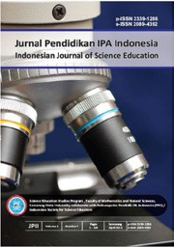JPII 5 (2) (2016) 247-255

Jurnal Pendidikan IPA Indonesia

http://journal.unnes.ac.id/index.php/jpii

MERRY GO ROUND TECHNIQUE AND STUDENTS’ PHYSICS COGNITIVE LEARNING OUTCOMES ON WORK AND ENERGY TOPIC

John Rafafy Batlolona*, Wartono², Ari June Wilyanto Tyas Nenohai³,
Irfan Yurdabakan⁴
¹Teacher Professional Education Study Program, Pattimura University, Ambon, Indonesia
²Physics Education Study Program, Faculty of Science and Technology, Universitas Kanjuruhan Malang, Malang, Indonesia
³Physics Education Study Program, Faculty of Mathematics and Natural Sciences, Universitas Negeri Malang, Malang, Indonesia
⁴Buca Faculty of Education, Dokuz Eylul University, Buca, İzmir, Turkey

corresponding author: johanbatlolona@gmail.com
DOI: 10.15294/jpii.v5i2.6004
Accepted:August 15th2016.Approved: September 4th2016. Published: October 2016

ABSTRACT

This study aims to apply the merry go round technique by using inquiry learning models on student physics learning achievement This study was designed using a quasi-experimental design with a sample of 74 students. The instrument developed was 30 questions about the topic of work and energy. The results show the value that the experimental class has the highest value of 85.27 when compared to the control class only able to reach 77.56. The test results of the learning physics achievement hypothesis were t_{count} (3,295) > t_{table} (1,666), indicating that there were differences in physics learning achievement of students who use inquiry training learning models with merry go round technic than students who study conventionally.

Keywords: inquiry training, merry go round, cognitive learning outcomes

© 2016 Science Education Study Program FMIPA UNNES Semarang

INTRODUCTION

Looking at education at this time, is still improving itself with more human learning patterns. There are several problems in the world of education in Indonesia, including the low quality of graduates and the absorptive capacity of graduates in the work world. Therefore, the government tries to always innovate in reviewing and updating the existing curriculum. One of the things that can be improved is the high school graduates' competency standards which are expected to have dimesnions of factual, conceptual, procedural, and metacognitive with respect to science, technology, arts, culture and humanities (Krathwohl, 2002). The current curriculum used by the Indonesian state is the 2013 curriculum which emphasizes the scientific approach. The scientific approach is designed in such a way that the students' talents and interests can emerge well and facilitate students in learning activities by constructing the concepts, laws, and principles of a learning material (Bigozzi, Tarchi, Fiorentini, Falsini, & Stefanelli, 2018) . The scientific approach that is carried out in the learning process is strengthened by experimental or research-based learning models. Therefore, current learning in Indonesia must follow the existing rhythm. One learning model that can facilitate students to improve the quality of student knowledge is inquiry (Wartono, Hudha, & Batlolona, 2018).
Inquiry is a process of scientific inquiry carried out to find answers (Harlen, 2014); (van Uum, Verhoeff, & Peeters, 2016). Inquiry means students are involved in asking questions, seeking information to making conclusions (Helmreich & Krog, 2018). Inquiry learning model emphasizes more for students to be able to think high-level and analytical to look for and find their own definitive answers to a problem that is questioned through an investigation (Hong et al., 2019). Inquiry provide more opportunities for students to make many questions that lead to scientific discoveries in an effort to build new concepts and knowledge (Arsal, 2017).
One of the things that causes low student physics learning outcomes to date is the selection of inappropriate learning models (Le, Janssen, & Wubbels, 2018);(Cooper, Downing, & Brownell, 2018). Another thing that indicates students' low cognitive learning outcomes are lack of understanding of concepts (Karagiannopoulou & Entwistle, 2019). Inquiry learning emphasizes active learning and is expected not to be teacher-centered so that students can obtain knowledge in the form of material based on the experience gained (Saunders-Stewart, Gyles, & Shore, 2012). In addition, the inquiry model provides more experience directly and interacts in the learning process.

Inquiry learning has a relationship with the merry go round (MGR) cooperative type, because students can experiment to improve creativity, learning is more active in contributing ideas in their groups so that the quality of learning in the classroom can be improved. Recently, research in inquiry and merry go round learning on work and energy topics is still limited. Previous research has still developed merry go round on the topic of inertia moment (Van Hook, Lark, Hodges, Celebrezze, & Channels, 2007), circular motion (Bagge & Pendrill, 2002), molecular (Friedrich, 2011) so that this paper presents something different. The MGR technique has characteristics, where group members get the opportunity to contribute and listen to thoughts or ideas from other members (Gillies & Boyle, 2010). Some of the advantages of merry go round techniques are increasing more positive learning activities, the time it takes for teachers to be more efficient, increasing critical thinking and creative so that they are able to answer the problems given, fostering patience (Ahmadi & Besançon, 2017). The merry go round technique can develop students' patience to wait their turn to ask questions. In addition to the technique of merry go round, learning activities oriented to the inquiry learning model of training. So the focus of this paper tells of collaborating MGR and inquiry learning training models in improving students' learning outcomes in physics.
Training inquiry learning models can provide experience in conducting experiments for each student. Meanwhile, MGR techniques can help students remember the learning that has been learned and communicate new ideas or findings obtained during learning to other groups. So the use of MGR techniques in learning models can help teachers in the learning. In addition, improving memory, communication skills and understanding of material in students can be improved by using an inquiry training learning model with the technique of MGR. Difficulties in learning physics become things that need to be considered as an effort to succeed in learning, if learning is successful, it is expected that learning outcomes will also increase. Learning outcomes are a success that has been achieved by someone after carrying out the learning process activities so that there is a change in behavior (De Hei, Admiraal, Sjoer, & Strijbos, 2018).
As for some physics topics that are still considered difficult such as mechanics, electricity, magnetism, thermodynamics, waves, and optics (McDermott & Redish, 1999), dynamic electricity (Turgut, Gürbüz, & Turgut, 2011), Force (Martín-Blas, Seidel, & Serrano-Fernández, 2010). work and energy (Bezen, Bayrak, & Aykutlu, 2016), quantum mechanics (Krijtenburg-Lewerissa, Pol, Brinkman, & Van Joolingen, 2017). Training inquiry learning models have suitability in the learning process on work and energy topics. At the stage of confrontation with the problem, the teacher gives examples of applications or phenomena in everyday life. Through the provision of real phenomena occurring in their lives, students will look for reasons why it happened, and then students make the temporary reasons become hypotheses in the implementation of the experiment that will be carried out next . Inquiry training learning models can provide direct experience in the learning process, while merry go round techniques can provide opportunities for students to communicate their new findings or ideas to other groups and can improve their memory in the material being studied. The aim of research was to determine differences in learning outcomes on work and energy topic from students who learned to use inquiry training learning models with merry go round techniques.

METHOD

General Background of Research

The research was conducted using a quasi-experimental research. After knowing the results, the experimental class was given learning using an inquiry training model with merry go round techniques and control classes which were given learning with conventional learning models. After both classes have carried out teaching and learning activities, the two classes are given a posttest to find out the achievements of the two classes. The study was conducted for 5 months for data collection to analysis.

Sample of Research

The sample of this research was all tenth grade science students of high school 1 in Batu-Malang city consisting of 6 classes (74 students). The sample in this research was taken using random sampling technique. The selected sample is tenth grade science students 5 as an experimental class that receives treatment learning using a training inquiry learning model with merry go round technique and tenth grade science students 2 is selected as a control class, which is treated in the form of conventional learning models. The number of samples was 74 people, with 37 experimental classes and 37 control classes. Students' academic abilities are at a moderate level. The location of the school is in a mountainous area that has relatively cold temperatures

Instrument and Procedures
Physical learning achievement test instruments consisting of 30 multiple choice questions. Before the two instruments are used, validation was done by the lecturer validator. Then, empirical validation was done to students who had obtained work and energy material. The results of empirical validation obtained 21 valid items from 20 items. Test questions consist of questions about physics concepts about work and energy. Question categories are the level of analysis developed in physics students at the University of Colorado. The test instrument for this study was a multiple choice question. Trial the field before the research was conducted, it was necessary to measure validity, reliability, level of difficulty, and differentiation of items about instruments of learning achievement physics. After the test items were tested then standardization of instruments was carried out testing empirical validity, reliability, level of difficulty and differentiation question.

Data Analysis
Of the 21 valid items used for making pretest and posttest questions. Then proceed to calculate the value of reliability to be able to know the stability of the instrument. The results of the reliability test of valid items are 0.788 so that the bias can be concluded that the question instrument has a high reliability value. This valid question is used in conducting research. After testing for normality and reliability, different levels of difficulty and power are tested. Based on the test of the difficulty level, it was obtained 2 items are difficult criteria, 3 items are moderate criteria and 16 items are easy criteria. Meanwhile, for the distinguishing test, it was obtained 2 items with bad criteria, 8 questions with sufficient criteria and 11 questions with good criteria. The data obtained from the research were pretest values ​​that showed the students 'initial ability and posttest scores which showed students' physics learning achievement. Then the analysis was done using the analysis prerequisite test consisting of normality test and homogeneity test with a significance level of 5%. Hypothesis testing using t-test to determine whether there are differences in the achievement of the experimental class and the control class.

RESULT AND DISCUSSION

Result

The results of students' physics learning achievement were shown on the results of the pretest and posttest that had been analyzed quantitatively. The difference from the acquisition of physics learning achievement from the two classes with different treatments is then compared and discussed in theory and the real results that exist in the field. The following is an explanation of the results of the research that has been obtained. Pre-test is used to be able to find out the initial abilities of both research classes. The acquisition of pretest data from both classes was then analyzed. The results of pretest data analysis are shown in table 1.

Table1. The Pre-Test Results Data of Different Class
Class | The number of students | The Lowest value | The Highest Value | Average
Experiment | 37 | 30 | 80 | 46.62
Control | 37 | 30 | 75 | 45.81

The low pretest mean scores in both classes due to lack of learning related to work and energy materials. In addition, based on the results obtained in the field, the learning that has been done so far has not been fully implemented. As a result, there was no intensive guidance through learning conducted by the teacher; finally some students just stare to find value without knowing the basic concepts that exist.
In addition, the learning pattern carried out by students make them cannot fully understand the whole material that will be taught or are being taught. Thus, the students had lack knowledge of the material being tested. Therefore, efforts to improve student learning achievement can be done using learning methods that make students active, so that information about the material can be understood by students.
After the two classes were treated according to the study design, the two classes got posttest to determine the students' physics learning achievement and the influence of the treatment given to each class. The results of posttest data analysis are shown in table 2.

Table1. The Post-Test Results Data of Different Class
Class | The number of students | The Lowest value | The Highest Value | Average
Experiment | 37 | 55 | 95 | 85.27
Control | 37 | 50 | 100 | 77.56

The data that has been obtained is then analyzed using the prerequisites analysis, namely the normality test and homogeneity test. After conducting the prerequisite analysis test then a hypothesis test is carried out to determine student achievement in the different class as shown in table 3.

Table 3. Prerequisite Analysis Results of Hypothesis Analysis
Test Aspect |  | Calculate Value | Table Value | Level of Significance | Category
Normality | Experiment | 0.136 | 0.145 | 5% | Normal
(Liliefors) | Control | 0.115 | 0.145 | 5% | Normal
Homogenity (Fisher) |  | 1.55 | 1.74 | 5% | Homogen

Research hypothesis testing is carried out after the prerequisite test which consists of normality test and homogeneity test in the different class on the posttest value. The results of the normality test and homogeneity test on the students' posttest scores indicate that the data obtained is normally distributed and homogeneous, the research hypothesis test used is the t test as shown in table 4.

Table 4. Hypothesis Test
Class | N | ̅ | Level of Significance | tcount | ttabe
Experiment Class | 37 | 85,27 | 5% | 3.295 | 1.666
Control Class | 37 | 77,56 | 5% | 3.295 | 1.666

The results of the analysis showed that tcount > t_{table} = 3.295> 1.666, thus H0 was rejected and Ha received the full analysis can be seen in Appendix 24 page 237. So it can be concluded that the experimental class students' physics learning achievement using inquiry training learning model with more techniques MGR higher. The difference from the mean value indicates the influence of the learning process carried out in the different class. Combined with the merry go round technique, the inquiry inquiry training model provides experience directly from the implementation of the experiment. While the merry go round technique provides opportunities for students to be able to share new knowledge and here students are trained to have the ability to convey ideas or opinions to other groups. Furthermore, from the existing process data, the results of the students' answers show that students are able to give good answers to merry go round techniques, as shown in table 5.

Table 5. Student Answers of Work and Energy Questions
Questions | Answers | Cognitive Aspect
A ball with mass of 2 kg falls freely from position A as shown.  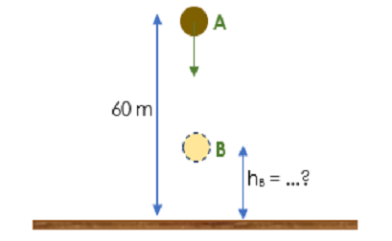  When it reaches B, the kinetic energy is 2 times of its potential energy. Calculate the height of point B from the ground surface!  a. 15 m  b. 20 m  c. 45 m  d. 60 m  e. 80 m | By using law mechanical energy conservation, then | C3
  EM_{A} | = EM_{B}
  Ep_{A} + Ek_{A} | = Ep_{B} + Ek_{B}
  Ep_{A} + Ek_{A} | = Ep_{B} + 2Ep_{B}
  Ep_{A} + Ek_{A} | = 3Ep_{B}
  mgh_{A} + $\frac{1}{2}$ mv_{A}² | = 3mgh_{B}
  Gh_{A} + $\frac{1}{2}$ mv_{A}² | = 3gh_{B}
  (10)(6) + 0 | = (3)(10) h_{B}
  30h_{B} | = 600
  h_{B} | = $\frac{600}{30}$ = 20 m
If we push the eraser in a way like (a), (b) and (c). The most effective way in order to eraser can be easily moved successively is (assume the given force is equal)...  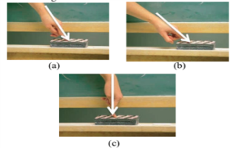  - (a) ; (b) ; (c)  - (b) ; (a) ; (c)  - (c) ; (b) ; (a)  d. (c) ; (a) ; (b)  e. (b) ; (c) ; (a) | The greatest effort occurs when the angle formed between the force F and the plane when it meets  W = F.cos θ . s  Where the value of θ = 0 or angle has the same direction to the force given which will produce the greatest effort. When the value θ = 0, it is the most effective way to move the eraser. So the most effective way to move the eraser is by the way  (b) ; (a) ; (c) | C4
Three identical object are thrown from the top of a building with the same initial speed, as in the following figure.  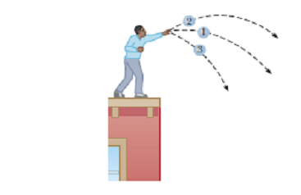  The first object is thrown horizontally, the second object is thrown by forming an angle above the horizontal, and the third is thrown by forming an angle bottom the horizontal. Then the speed of the three object when touching the ground is ...  - v3 is faster than v1 and v  - v1 is faster than v2 and v3  - v2 is faster than v1 and v3  - v3 and v2 faster v1  e. v₁= v₂ = v₃ | The three balls when thrown have the same kinetic energy as the system  ball-Earth and all three balls are also have the same change in a review of gravitational potential energy. So that according to the law of conservation  mechanical energy: Em_{a} = Em_{b}, then  all three balls will also have the same speed when touching the ground.v₁= v₂ = v₃ | C4

Learning with the inquiry training model with merry go round technique shows the results that through this learning model student learning achievement and students' understanding of concepts increases. Examples can be taken such as the work on students' pretest and posttest questions. When working on pretest questions for questions number 11, 12, 13 almost all students answered incorrectly, because students did not understand the relationship between work and kinetic energy. Example problem number 12:
"Reza went to school on a wooden bicycle and he pedaled his bicycle with a force of F and made a work as big as W. When Reza saw a truck crossing the road that was a distance s from his position, Reza had to reduce the speed to ½ v, then what Reza had to do so that the speed of the bike decreases to ½ v is? "
In the above problem, almost all students answered that the speed of the bike was reduced to ½, the given force must also reduce ½ of the initial force, students did not understand the concept of kinetic energy relations. Where the relationship with kinetic energy states that total effort on a moving object is equal to its kinetic energy. The results of students' answers are not completely correct. This is due to students not yet accustomed to developing knowledge in the inquiry process.

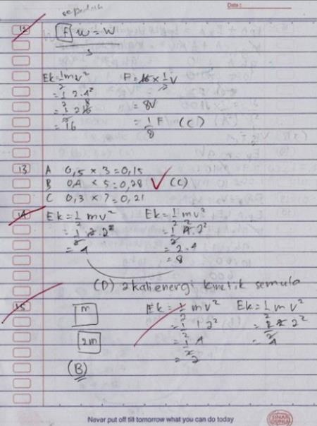

Figure 1. Results of Students' Answers At The Pre-Test

However, after receiving treatment in the form of applying inquirty training learning models with merry go round technique, most of the students have answered correctly and there are even some students’ answer sheets that are given reasons and complete explanations as in Figure 2.

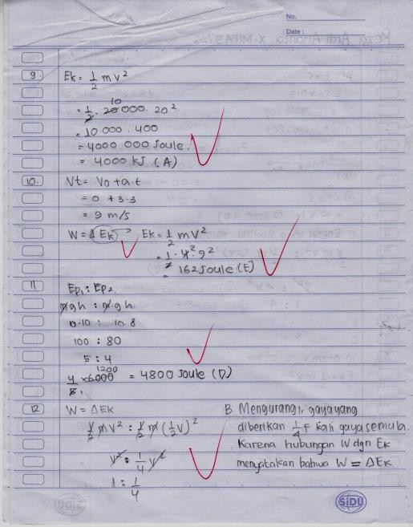
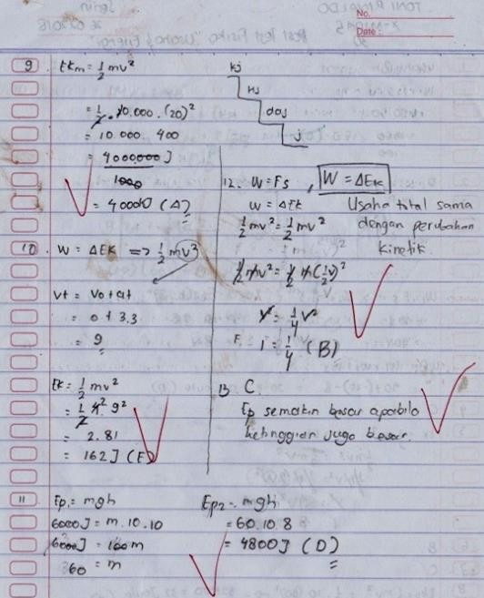

Figure 2. Results of Students' Answers To Post-Test Activitie

Discussion

The use of inquiry training (teacher) learning (student) models with merry go round techniques can help students to understand and comprehend remember the learning process of the material that has been learned, especially through the phenomena shown at the beginning which are able to stimulate students' thinking at the beginning of learning. Figure 2 shows the student answer sheets that answer correctly on problem number 12. Students in the experimental class who get inquiry-based learning through inquiry inquiry training models make them more active and able to develop their abilities so as to make learning more meaningful (Chi, 2009). Meaningful learning itself can occur when students are able to connect between real experiences, previous knowledge and new discoveries and finally be able to apply them (Agra et al., 2019). By involving cognitive, it can trigger attention and willingness to exert effort in order to be able to understand a concept in an effort to improve learning outcomes better (Chi & Wylie, 2014).
Inquiry training learning model increases learning motivation and understanding of students' physics concepts, mastery of experimental class physics concepts that are taught with inquiry training models are also higher when compared to control classes that are taught with conventional learning models (Crawford, 2000). In addition, the application of inquiry training learning models is proven to improve student learning outcomes(Yakar & Baykara, 2014).
An inquiry training learning model with a MGR technique can train students to be responsible for themselves and the group. Each student will get the same burden, because at the time of discussion each student must be able to convey their new ideas or findings in an experiment that will activate the course of the discussion properly. The results of this study illustrate that the use of inquiry training learning models with merry go round techniques can provide a good contribution to the implementation of learning activities in schools, especially towards improving students' physics learning achievement.
These findings are supporting the opinion of which states that the MGR technique is a type of learning that accustoms students to working according to democratic notions and provides opportunities for students to develop a deliberative and responsible attitude and respect the opinions of others. The procedure provides sufficient time to construct knowledge effectively and meaningfully.
This is because the inquiry training learning model with the merry go round technique has many advantages compared to the usual learning methods in the classroom. The use of inquiry training learning models with MGR techniques provides many benefits for students. This can be seen from the results of the learning achievement of the students of senior high school 1 in Batu city who study with the inquiry training learning model with merry go round technique higher than students who learn to use the usual learning methods in the classroom.
Students who have understood the material through the inquiry process will be able to solve physics problems. Students in the experimental class who get inquiry-based learning through inquiry training models make them more active and able to develop their abilities so as to make learning more meaningful(Chi, 2009). Education itself can occur when students are able to connect between real experiences, previous knowledge and new discoveries and finally be able to apply them (Owens & Tanner, 2017). Inquiry-based learning through the training inquiry model also emphasizes how students learn with cognitive processes so that students achieve scientific concepts and skills (Darling-hammond et al., 2019). By involving cognitive, it can trigger attention and willingness to exert effort in order to be able to understand a concept in an effort to improve learning outcomes better..

CONCLUSION

Based on the results of the research that has been done, it can be concluded that there are differences in students' physics learning achievement on the subject matter of work and energy material from students who learn using inquiry training learning models with merry go round techniques with students learning with conventional learning models. The implication of this study is to provide information for learners to be able to reconstruct learning that is centered to communicate new findings or ideas to others and can improve their memory in the material being studied. The limitation of this study was in its exploration that only explores student activities at pretest and posttest, so it is expected that the next study can take more attention in improving the merry go round technique at each meeting and every topic so that learning is better.

REFERENCES

Agra, G., Formiga, N. S., Oliveira, P. S. de, Costa, M. M. L., Fernandes, M. das G. M., & Nóbrega, M. M. L. da. (2019). Analysis of the concept of Meaningful Learning in light of the Ausubel’s Theory. Revista Brasileira de Enfermagem, 72(1), 248–255.
Ahmadi, N., & Besançon, M. (2017). Creativity as a Stepping Stone towards Developing Other Competencies in Classrooms. Education Research International, 2017, 1–9.
Arsal, Z. (2017). The impact of inquiry-based learning on the critical thinking dispositions of pre-service science teachers. International Journal of Science Education, 39(10), 1326–1338.
Bagge, S., & Pendrill, A.-M. (2002). Classical physics experiments in the amusement park. Physics Education, 37(6), 507–511.
BEZEN, S., BAYRAK, C., & AYKUTLU, I. (2016). Physics Teachers’ Views on Teaching the Concept of Energy. Eurasian Journal of Educational Research, 16(64), 109–124. https://doi.org/10.14689/ejer.2016.64.6
Bigozzi, L., Tarchi, C., Fiorentini, C., Falsini, P., & Stefanelli, F. (2018). The influence of teaching approach on students’ conceptual learning in physics. Frontiers in Psychology, 9(DEC), 1–14.
Chi, M. T. H. (2009). Active-Constructive-Interactive: A Conceptual Framework for Differentiating Learning Activities. Topics in Cognitive Science, 1(1), 73–105.
Chi, M. T. H., & Wylie, R. (2014). The ICAP Framework: Linking Cognitive Engagement to Active Learning Outcomes. Educational Psychologist, 49(4), 219–243.
Cooper, K. M., Downing, V. R., & Brownell, S. E. (2018). The influence of active learning practices on student anxiety in large-enrollment college science classrooms. International Journal of STEM Education, 5(1).
Crawford, B. A. (2000). Embracing the essence of inquiry: New roles for science teachers. Journal of Research in Science Teaching, 37(9), 916–937.
Darling-hammond, L., Flook, L., Cook-harvey, C., Barron, B., Flook, L., Cook-harvey, C., … Barron, B. (2019). Implications for educational practice of the science of learning and development. Applied Developmental Science, 0(0), 1–44.
De Hei, M., Admiraal, W., Sjoer, E., & Strijbos, J. W. (2018). Group learning activities and perceived learning outcomes. Studies in Higher Education, 43(12), 2354–2370.
Friedrich, B. (2011). A molecular merry-go-round. Physics Today, 64(6), 66–67. https://doi.org/10.1063/1.3603927
Gillies, R. M., & Boyle, M. (2010). Teachers’ reflections on cooperative learning: Issues of implementation. Teaching and Teacher Education, 26(4), 933–940.
Harlen, W. (2014). Helping children’s development of inquiry skills. Inquiry in Primary Science Education (IPSE), 1, 5–19.
Helmreich, J. E., & Krog, K. P. (2018). Ordinary Least Squares and Quantile Regression: An Inquiry-Based Learning Approach to a Comparison of Regression Methods. Primus, 28(3), 206–222.
Hong, J. C., Tsai, C. R., Hsiao, H. S., Chen, P. H., Chu, K. C., Gu, J., & Sitthiworachart, J. (2019). The effect of the “Prediction-observation-quiz-explanation” inquiry-based e-learning model on flow experience in green energy learning. Computers and Education, 133, 127–138.
Karagiannopoulou, E., & Entwistle, N. (2019). Students’ learning characteristics, perceptions of small-group university teaching, and understanding through a “meeting of minds.” Frontiers in Psychology, 10(MAR). https://doi.org/10.3389/fpsyg.2019.00444
Krathwohl, D. R. (2002). A revision of Bloom’s taxonomy of educational objectives : An overview. Theory Into Practice, 41(4), 212.
Krijtenburg-Lewerissa, K., Pol, H. J., Brinkman, A., & Van Joolingen, W. R. (2017). Insights into teaching quantum mechanics in secondary and lower undergraduate education. Physical Review Physics Education Research, 13(1).
Le, H., Janssen, J., & Wubbels, T. (2018). Collaborative learning practices: teacher and student perceived obstacles to effective student collaboration. Cambridge Journal of Education, 48(1), 103–122.
Martín-Blas, T., Seidel, L., & Serrano-Fernández, A. (2010). Enhancing Force Concept Inventory diagnostics to identify dominant misconceptions in first-year engineering physics. European Journal of Engineering Education, 35(6), 597–606.
McDermott, L. C., & Redish, E. F. (1999). Resource Letter: PER-1: Physics Education Research. American Journal of Physics, 67(9), 755–767.
Owens, M. T., & Tanner, K. D. (2017). Teaching as brain changing: Exploring connections between neuroscience and innovative teaching. CBE Life Sciences Education, 16(2), 1–9.
Saunders-Stewart, K. S., Gyles, P. D. T., & Shore, B. M. (2012). Student Outcomes in Inquiry Instruction: A Literature-Derived Inventory. Journal of Advanced Academics, 23(1), 5–31.
Turgut, Ü., Gürbüz, F., & Turgut, G. (2011). An investigation 10thgrade students’ misconceptions about electric current. Procedia - Social and Behavioral Sciences, 15, 1965–1971.
Van Hook, S., Lark, A., Hodges, J., Celebrezze, E., & Channels, L. (2007). Playground Physics: Determining the Moment of Inertia of a Merry-Go-Round. The Physics Teacher, 45(2), 85–87.
van Uum, M. S. J., Verhoeff, R. P., & Peeters, M. (2016). Inquiry-based science education: towards a pedagogical framework for primary school teachers. International Journal of Science Education, 38(3), 450–469.
Wartono, W., Hudha, M. N., & Batlolona, J. R. (2018). How are the physics critical thinking skills of the students taught by using inquiry-discovery through empirical and theorethical overview? Eurasia Journal of Mathematics, Science and Technology Education, 14(2).
Yakar, Z., & Baykara, H. (2014). Inquiry-based laboratory practices in a science teacher training program. Eurasia Journal of Mathematics, Science and Technology Education, 10(2), 173–183.

*Address Correspondence: E-mail: johabatlolona@gmail.com

