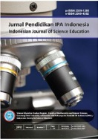
JPII 5 (2) (2016) 247-255

JurnalPendidikan IPA Indonesia

http://journal.unnes.ac.id/index.php/jpii

The Effectiveness of Socio-Scientific Issues in Gadget to Increase Generation Z’s Scientific Literacy

W. Widodo¹, E. Sudibyo¹, Suryanti², D.A.P Sari¹, Inzanah³, B. Setiawan⁴
¹Natural Science Department, Faculty of Mathematics and Natural Science, Universitas Negeri Surabaya
²Elementary Education Department, Faculty of Education,
Universitas Negeri Surabaya
³Graduate of the Postgraduate of Science Education,Universitas Negeri Surabaya
⁴Student of Department of Education and Human Potentials Development. National Dong Hwa University. Taiwan

