LETTER OF STATEMENT
No: 28/JPII/R.A./2020

I hereby declare that the article:
title : Developing a Conceptual Model of Learning Analytics in Serious Games for
STEM Education

authors : 1. Nadia Akma binti Ahmad Zaki
2. Nor Zuhaidah binti Mohamed Zain
3. Noor Anida Zaria Mohd Noor
4. Haslinda Hashim
is APPROVED to be published in JPII for September 2020 Issue.
Hereby this statement is made truthfully and to be used accordingly.

Semarang, [20th September 2020]
First Author,

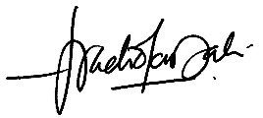
[Nadia Akma binti Ahmad Zaki]

