LETTER OF STATEMENT
No: 30/JPII/R.A./2021

I hereby declare that the article:
Title : SCIENCE TEACHERS ABILITIES IN INTEGRATING POPULATION AND ENVIRONMENTAL EDUCATION WITH SCIENCE SUBJECTS OF JUNIOR HIGH SCHOOL IN MAMASA REGENCY, INDONESIA

authors : 1. Mithen
2. Onesius
3. A. Arfandi
4. Raeny
5. Rahmansah
is APPROVED to be published in JPII for March 2021 Issue.
Hereby this statement is made truthfully and to be used accordingly.

Semarang, 25 Maret 2021
First Author,
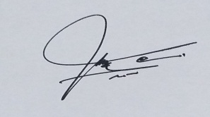
M I T H E N

