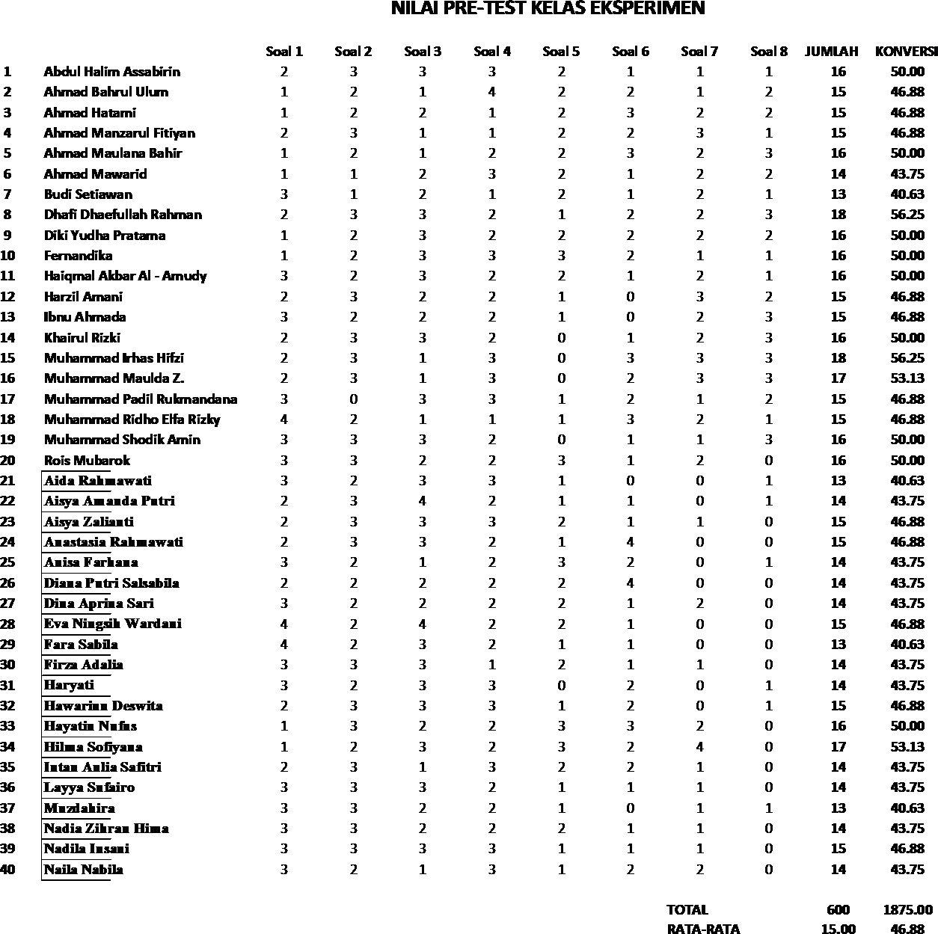
Data Penelitian
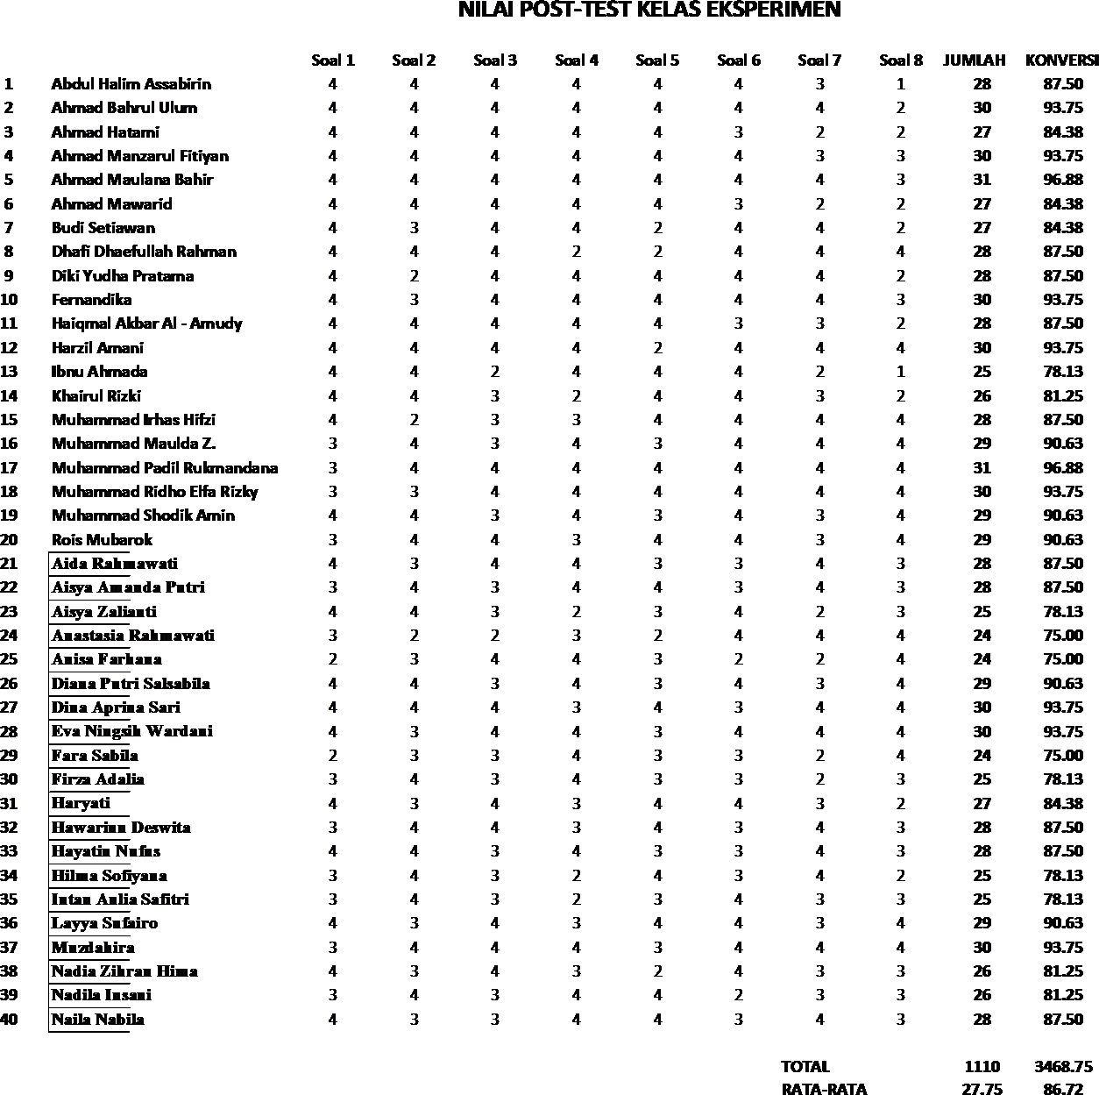

NILAI PRE-TEST KELAS KONTROL

Soal 1 Soal 2 Soal 3 Soal 4 Soal 5 Soal 6 Soal 7 Soal 8 JUMLAH KONVERSI
1 Ahmad Sopyan Maulana 2 2 2 2 2 1 1 2 14 43.75
2 Ahmad Wajdi 1 2 1 3 2 2 1 2 14 43.75
3 Alfa Syahril 2 2 1 1 2 2 2 2 14 43.75

4
Al-Hariri
5 Anas Rulloh
6
Ardian
2 3 2 1 2 2 3 1 16 50.00
1 2 1 2 2 2 2 3 15 46.88
2 2 2 3 2 1 2 2 16 50.00

7 Fikri Hidayatullah 3 2 2 2 2 3 2 2 18 56.25
8 Fitian Hawazi 1 3 3 2 3 2 2 3 19 59.38
9 Haeril Umam 2 1 3 2 1 2 1 2 14 43.75
10 1 2 2 3 3 2 1 1 15 46.88
Haikal
11 Lalu Galang Septian H. 2 3 1 2 2 3 1 1 15 46.88
12 Mahendra Pratama 3 2 1 2 1 3 2 2 16 50.00
13 Muhamad Sawal 2 3 2 1 2 2 2 2 16 50.00
14 Muhammad Afrilia Ilhami 3 2 2 1 2 2 1 2 15 46.88
15 Muhammad Fahmi F. 2 1 2 3 2 1 2 2 15 46.88
16 Muhammad Fauzi 1 2 3 3 2 1 2 2 16 50.00
17 Muhammad Fibriyan M. 3 2 1 2 2 3 1 2 16 50.00
18 Muhammad Haikal R. 1 3 2 1 3 2 1 2 15 46.88
19 Muhammad Irsyad 2 1 3 2 1 1 2 2 14 43.75
20 Muzayyan 2 2 1 1 2 2 1 2 13 40.63
21 Anisa Ramadani 3 2 1 2 1 2 2 1 14 43.75
22 Anissa 1 2 2 3 1 1 2 1 13 40.63
- Ayu Rizkia Lestari 2 1 2 1 2 2 1 2 13 40.63
- Baiq Al-Asri Latin Sani 1 2 2 1 1 2 1 3 13 40.63

- Dina Hasdiana
2 2 3 2 1 1 2 1 14 43.75

26 Dina Rosanti 3 1 2 2 1 2 2 2 15 46.88

27 Dinda Silvayanti
2 3 2 3 1 2 1 2 16 50.00

28 Edistia Putri 2 3 2 1 1 2 2 2 15 46.88
29 Equeena Princessila H.K 1 2 2 3 1 2 2 1 14 43.75
30 Fitri Ramdaniati 2 1 2 3 2 1 2 1 14 43.75
31 Fitriani 3 2 1 1 2 1 2 3 15 46.88

32 Gina Napsah
2 1 2 2 1 2 1 2 13 40.63

33 Halida Zumrotin 2 1 2 3 2 1 2 1 14 43.75
34 Hamdalah 1 3 2 1 3 2 1 2 15 46.88
35 Hulifia Meylinar 2 3 2 3 1 1 2 2 16 50.00
36 Huliza 2 3 1 2 2 1 2 1 14 43.75
37 Ilma Yanti 3 2 3 1 2 2 1 2 16 50.00
38 Lina Sabrina 2 3 2 1 2 3 2 1 16 50.00
39 Mariyatul Qibtiyah 2 3 1 2 1 2 2 1 14 43.75
40 Maulida Hasanah M. 3 1 2 2 1 2 2 1 14 43.75

TOTAL | 594.00 | 1856.25
RATA-RATA | 14.85 | 46.406

NILAI POST-TEST KELAS KONTROL

Soal 1 Soal 2 Soal 3 Soal 4 Soal 5 Soal 6 Soal 7 Soal 8 JUMLAH KONVERSI
1 Ahmad Sopyan Maulana 2 3 4 3 3 2 4 3 24 75.00
2 Ahmad Wajdi 3 4 3 2 3 4 2 3 24 75.00
3 Alfa Syahril 2 3 4 3 2 4 3 2 23 71.88

4
Al-Hariri
5 Anas Rulloh
6
Ardian
3 3 4 3 3 2 3 3 24 75.00
4 3 2 3 2 3 4 3 24 75.00
3 2 3 4 3 4 3 3 25 78.13

7 Fikri Hidayatullah 4 2 4 3 3 4 4 2 26 81.25
8 Fitian Hawazi 3 4 3 4 3 3 3 4 27 84.38
9 Haeril Umam 3 2 3 2 4 2 3 2 21 65.63
10 2 3 3 3 2 2 3 2 20 62.50
Haikal
11 Lalu Galang Septian H. 4 3 2 3 3 2 4 2 23 71.88
12 Mahendra Pratama 3 4 2 3 2 4 3 2 23 71.88
13 Muhamad Sawal 4 2 3 3 4 2 3 3 24 75.00
14 Muhammad Afrilia Ilhami 4 3 3 2 4 3 2 3 24 75.00
15 Muhammad Fahmi F. 3 3 4 2 3 2 3 4 24 75.00
16 Muhammad Fauzi 4 3 3 2 4 3 3 3 25 78.13
17 Muhammad Fibriyan M. 3 2 2 4 2 2 3 3 21 65.63
18 Muhammad Haikal R. 3 3 2 3 3 4 3 3 24 75.00
19 Muhammad Irsyad 4 3 4 3 3 4 3 4 28 87.50
20 Muzayyan 3 4 3 3 4 3 3 4 27 84.38
21 Anisa Ramadani 3 4 3 3 2 2 3 2 22 68.75
22 Anissa 4 3 2 3 3 3 2 3 23 71.88
- Ayu Rizkia Lestari 2 3 3 4 3 2 2 3 22 68.75
- Baiq Al-Asri Latin Sani 3 2 2 3 2 4 3 2 21 65.63

- Dina Hasdiana
3 4 3 3 2 2 3 3 23 71.88

26 Dina Rosanti 3 2 4 3 2 3 4 2 23 71.88

27 Dinda Silvayanti
4 3 3 2 3 3 3 4 25 78.13

28 Edistia Putri 3 3 4 4 3 3 3 3 26 81.25
29 Equeena Princessila H.K 3 3 3 2 3 2 3 2 21 65.63
30 Fitri Ramdaniati 2 2 3 1 2 3 4 3 20 62.50
31 Fitriani 3 4 3 2 2 3 2 3 22 68.75

32 Gina Napsah
3 4 2 3 2 3 3 4 24 75.00

33 Halida Zumrotin 4 2 3 3 3 2 3 4 24 75.00
34 Hamdalah 2 3 4 3 2 3 2 4 23 71.88
35 Hulifia Meylinar 3 2 4 3 3 2 4 3 24 75.00
36 Huliza 3 4 3 3 2 3 4 3 25 78.13
37 Ilma Yanti 3 3 2 3 2 2 3 2 20 62.50
38 Lina Sabrina 4 3 3 4 3 3 3 4 27 84.38
39 Mariyatul Qibtiyah 3 2 3 3 2 3 3 3 22 68.75
40 Maulida Hasanah M. 4 3 3 3 2 2 3 3 23 71.88

TOTAL | 941 | 2940.63
RATA-RATA | 23.53 | 73.52

