LETTER OF STATEMENT
No: 31/JPII/R.A./2021

I hereby declare that the article:
title : ANALYSIS OF STUDENTS’ CRITICAL THINKING SKILLS IN TERMS OF GENDER USING SCIENCE TEACHING MATERIALS BASED ON THE 5E LEARNING CYCLE INTEGRATED WITH LOCAL WISDOM

authors : 1. A. Ramdani
2. A. W. Jufri
3. Gunawan
4. M. Fahrurrozi
5. M. Yustiqvar
is APPROVED to be published in JPII for June 2021 Issue.
Hereby this statement is made truthfully and to be used accordingly.

Mataram, 10 Juni 2021
First Author,
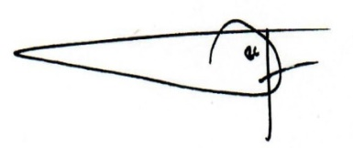
[Agus Ramdani]

