LETTER OF STATEMENT
No: 25/JPII/R.A./2021

I hereby declare that the article:
title : THE VALIDATION OF DIGITAL ANALYSIS TOOL-ASSISTED REAL-WORLD INQUIRY (DIGITA-RI) AS A MODIFICATION OF THE INQUIRY-BASED LEARNING MODEL IN THE DIGITAL AGE

authors : 1. Sabar Nurohman
2. Widha Sunarno
3. Sarwanto
4. Sri Yamtinah

is APPROVED to be published in JPII for September 2021 Issue.
Hereby this statement is made truthfully and to be used accordingly.

Semarang, 18 September 2021
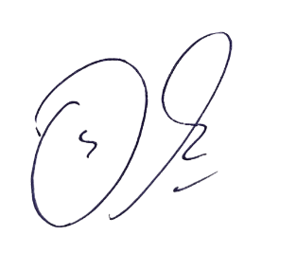
First Author,

Sabar Nurohman

