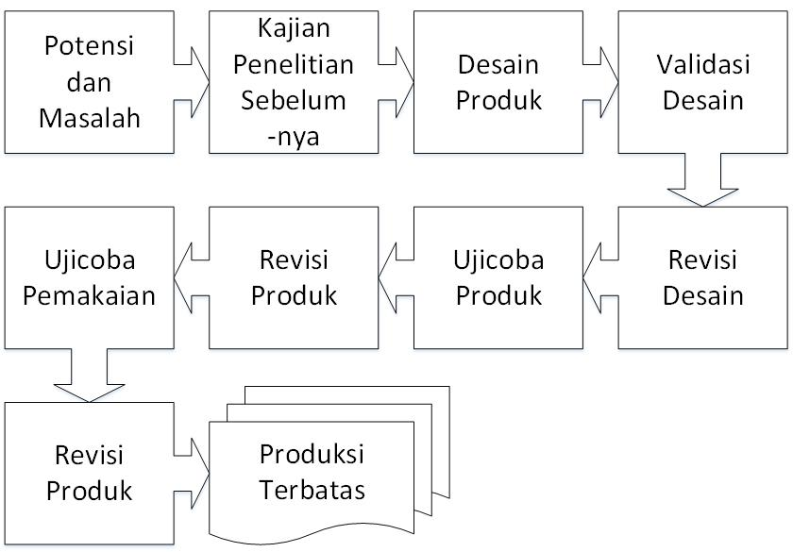
- Desain penelitian

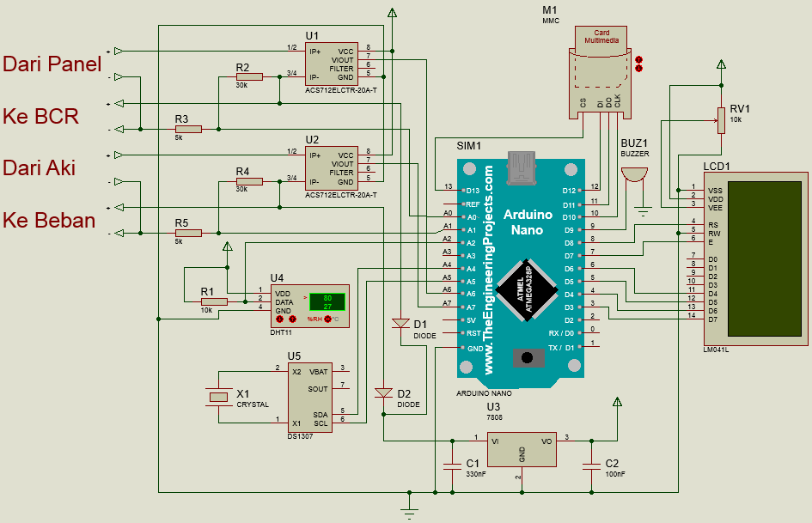
- Skema rangkaian data logger panel surya

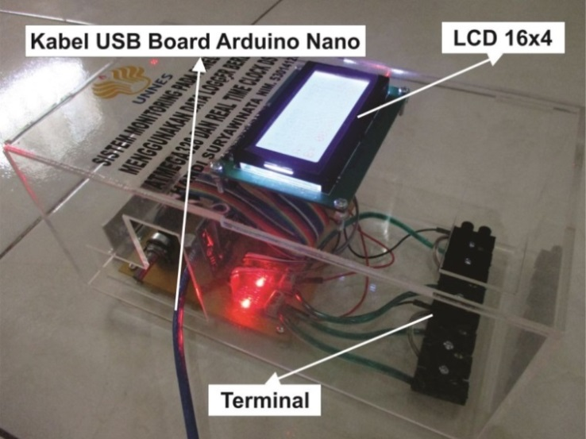
- Sistem monitoring panel surya
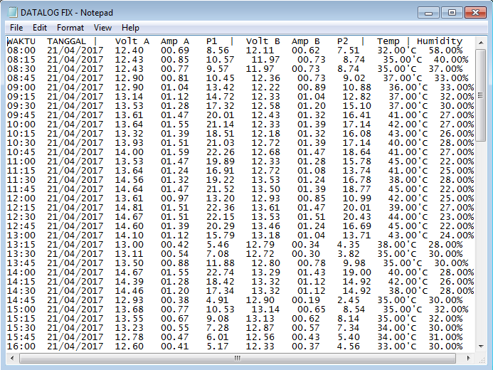
- File data yang tersimpan di Micro SD

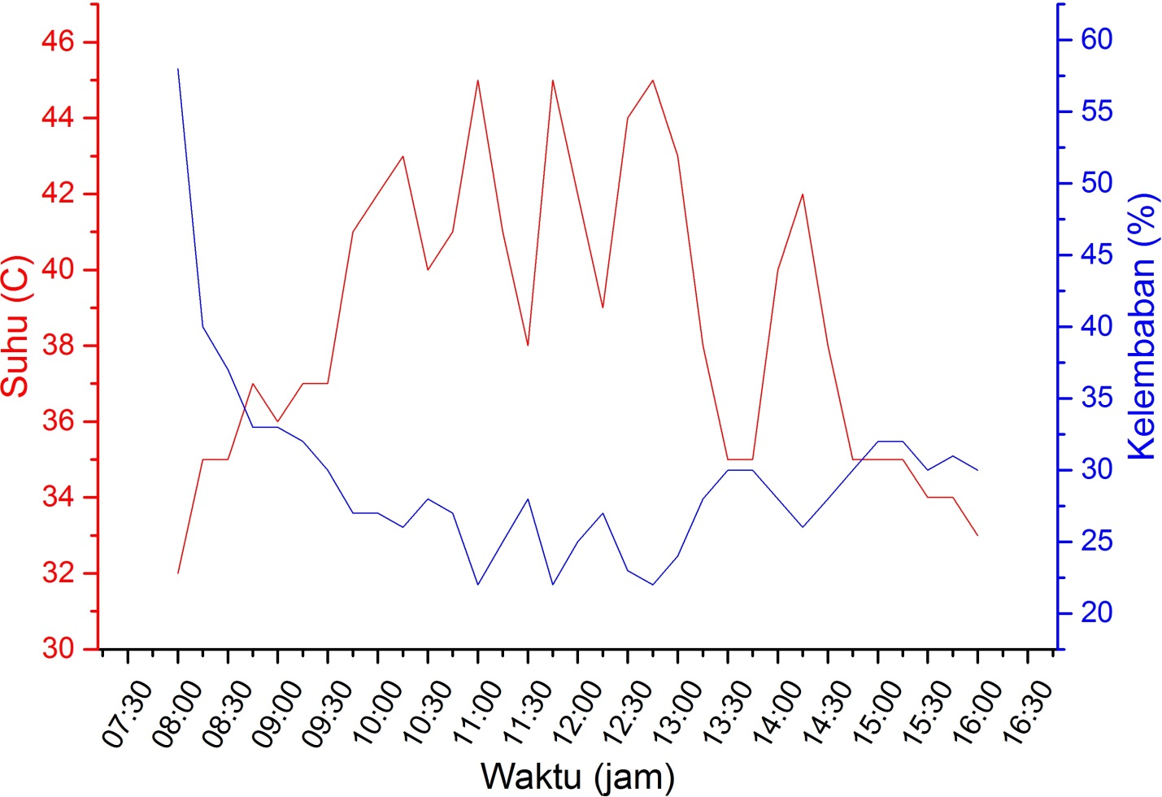
- Grafik perbandingan suhu terhadap kelembaban
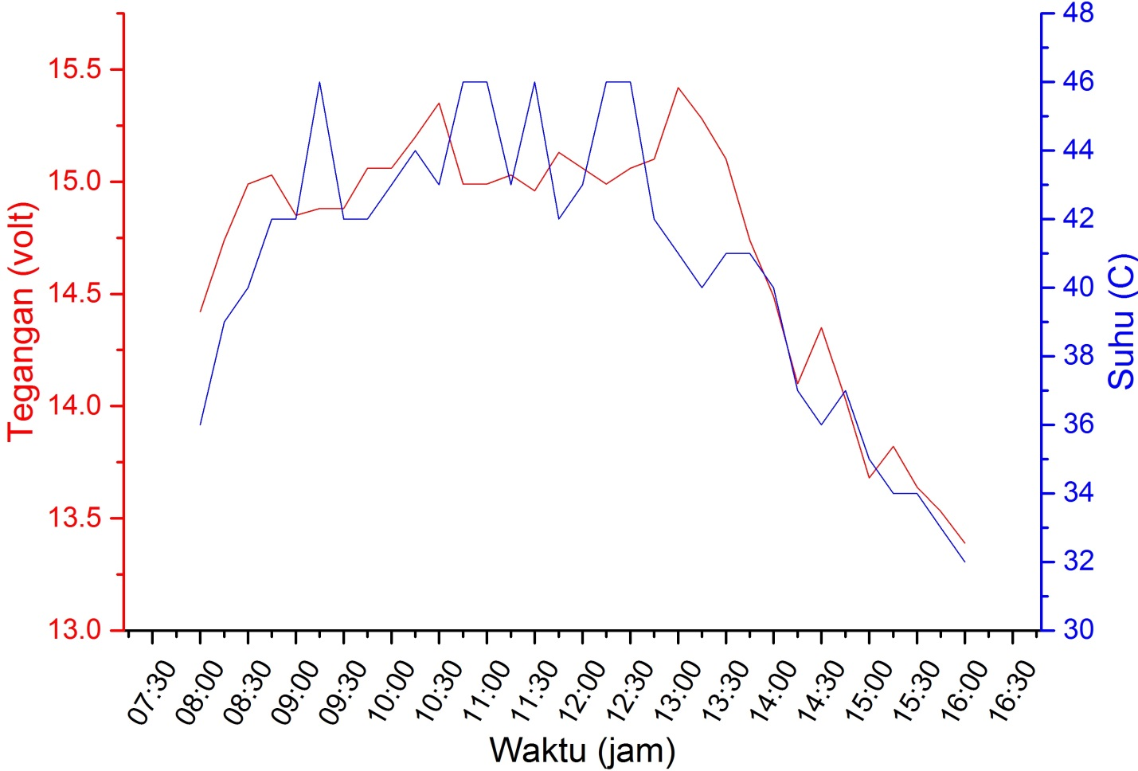
- Grafik perbandingan suhu terhadap tegangan
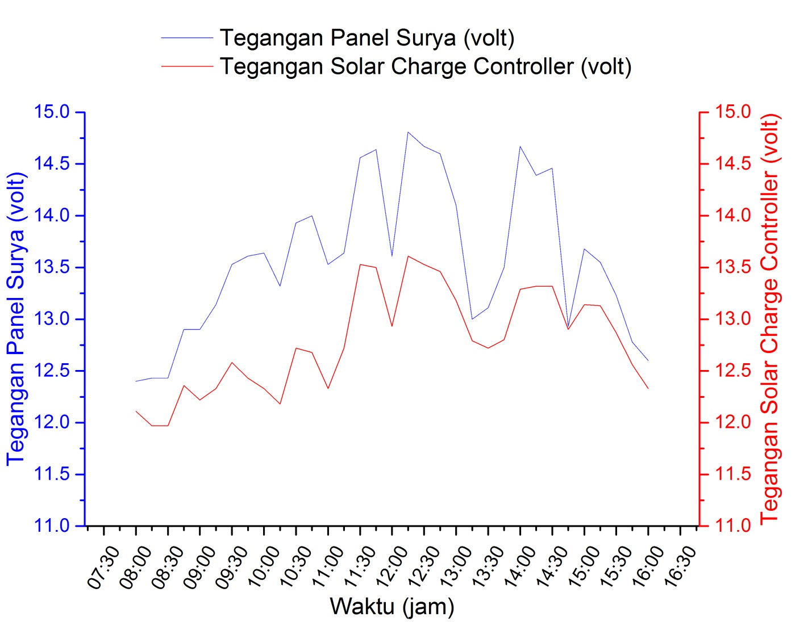
- Grafik perbandingan tegangan dari panel surya terhadap output solar charge controller
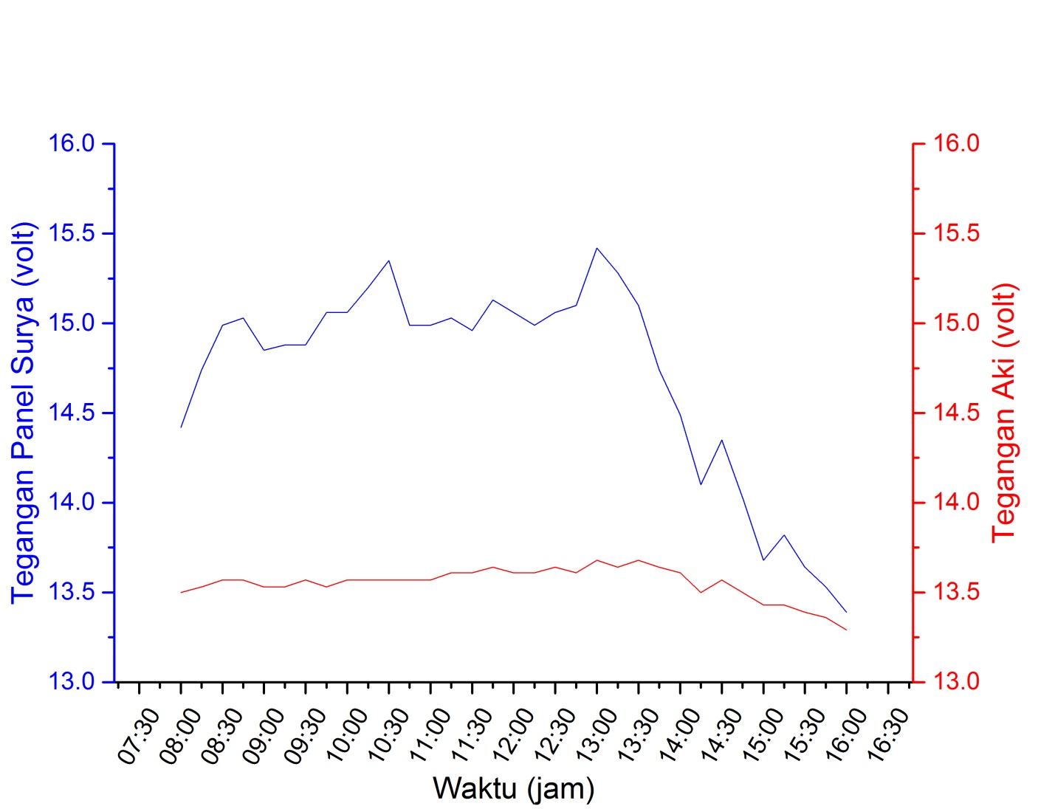
- Grafik perbandingan tegangan dari panel surya terhadap output aki
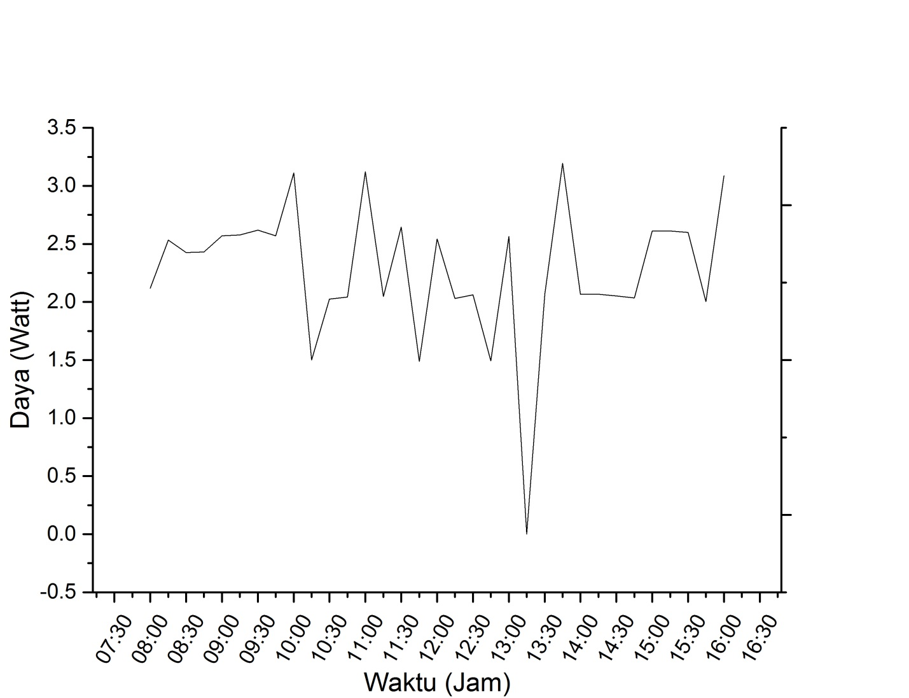
- Grafik daya baterai

Data penelitian selama 3 hari:
Data Hasil Implementasi Sistem Monitoring Panel Surya Hari Pertama
JAM | TANGGAL | Output Panel Surya |  |  | Output Solar Charge Controller |  |  | Suhu  (˚C) | Kelembaban  (%)
 |  | Volt A | Amp A | Watt A | Volt B | Amp B | Watt B
8:00 | 21/04/2017 | 12.40 | 0.69 | 8.56 | 12.11 | 0.62 | 7.51 | 32.00 | 58.00
8:15 | 21/04/2017 | 12.43 | 0.85 | 10.57 | 11.97 | 0.73 | 8.74 | 35.00 | 40.00
8:30 | 21/04/2017 | 12.43 | 0.77 | 9.57 | 11.97 | 0.73 | 8.74 | 35.00 | 37.00
8:45 | 21/04/2017 | 12.90 | 0.81 | 10.45 | 12.36 | 0.73 | 9.02 | 37.00 | 33.00
9:00 | 21/04/2017 | 12.90 | 1.04 | 13.42 | 12.22 | 0.89 | 10.88 | 36.00 | 33.00
9:15 | 21/04/2017 | 13.14 | 1.12 | 14.72 | 12.33 | 1.04 | 12.82 | 37.00 | 32.00
9:30 | 21/04/2017 | 13.53 | 1.28 | 17.32 | 12.58 | 1.20 | 15.10 | 37.00 | 30.00
9:45 | 21/04/2017 | 13.61 | 1.47 | 20.01 | 12.43 | 1.32 | 16.41 | 41.00 | 27.00
10:00 | 21/04/2017 | 13.64 | 1.55 | 21.14 | 12.33 | 1.39 | 17.14 | 42.00 | 27.00
10:15 | 21/04/2017 | 13.32 | 1.39 | 18.51 | 12.18 | 1.32 | 16.08 | 43.00 | 26.00
10:30 | 21/04/2017 | 13.93 | 1.51 | 21.03 | 12.72 | 1.39 | 17.68 | 40.00 | 28.00
10:45 | 21/04/2017 | 14.00 | 1.59 | 22.26 | 12.68 | 1.47 | 18.64 | 41.00 | 27.00
11:00 | 21/04/2017 | 13.53 | 1.47 | 19.89 | 12.33 | 1.28 | 15.78 | 45.00 | 22.00
11:15 | 21/04/2017 | 13.64 | 1.24 | 16.91 | 12.72 | 1.08 | 13.74 | 41.00 | 25.00
11:30 | 21/04/2017 | 14.56 | 1.32 | 19.22 | 13.53 | 1.24 | 16.78 | 38.00 | 28.00
11:45 | 21/04/2017 | 14.64 | 1.47 | 21.52 | 13.50 | 1.39 | 18.77 | 45.00 | 22.00
12:00 | 21/04/2017 | 13.61 | 0.97 | 13.20 | 12.93 | 0.85 | 10.99 | 42.00 | 25.00
12:15 | 21/04/2017 | 14.81 | 1.51 | 22.36 | 13.61 | 1.47 | 20.01 | 39.00 | 27.00
12:30 | 21/04/2017 | 14.67 | 1.51 | 22.15 | 13.53 | 1.51 | 20.43 | 44.00 | 23.00
12:45 | 21/04/2017 | 14.60 | 1.39 | 20.29 | 13.46 | 1.24 | 16.69 | 45.00 | 22.00
13:00 | 21/04/2017 | 14.10 | 1.12 | 15.79 | 13.18 | 1.04 | 13.71 | 43.00 | 24.00
13:15 | 21/04/2017 | 13.00 | 0.42 | 5.46 | 12.79 | 0.34 | 4.35 | 38.00 | 28.00
13:30 | 21/04/2017 | 13.11 | 0.54 | 7.08 | 12.72 | 0.30 | 3.82 | 35.00 | 30.00
13:45 | 21/04/2017 | 13.50 | 0.88 | 11.88 | 12.80 | 0.78 | 9.98 | 35.00 | 30.00
14:00 | 21/04/2017 | 14.67 | 1.55 | 22.74 | 13.29 | 1.43 | 19.00 | 40.00 | 28.00
14:15 | 21/04/2017 | 14.39 | 1.28 | 18.42 | 13.32 | 1.12 | 14.92 | 42.00 | 26.00
14:30 | 21/04/2017 | 14.46 | 1.20 | 17.35 | 13.32 | 1.12 | 14.92 | 38.00 | 28.00
14:45 | 21/04/2017 | 12.93 | 0.38 | 4.91 | 12.90 | 0.19 | 2.45 | 35.00 | 30.00
15:00 | 21/04/2017 | 13.68 | 0.77 | 10.53 | 13.14 | 0.65 | 8.54 | 35.00 | 32.00
15:15 | 21/04/2017 | 13.55 | 0.67 | 9.08 | 13.13 | 0.62 | 8.14 | 35.00 | 32.00
15:30 | 21/04/2017 | 13.23 | 0.55 | 7.28 | 12.87 | 0.57 | 7.34 | 34.00 | 30.00
15:45 | 21/04/2017 | 12.78 | 0.47 | 6.01 | 12.56 | 0.43 | 5.40 | 34.00 | 31.00
16:00 | 21/04/2017 | 12.60 | 0.41 | 5.17 | 12.33 | 0.37 | 4.56 | 33.00 | 30.00
RATA-RATA |  | 13.58 | 1.07 | 14.69 | 12.78 | 0.97 | 12.40 | 38.55 | 29.42

Data Hasil Implementasi Sistem Monitoring Panel Surya Hari Kedua
JAM | TANGGAL | Output Panel Surya |  |  | Output Aki |  |  | Suhu  (˚C) | Kelembaban  (%)
 |  | Volt A | Amp A | Watt A | Volt B | Amp B | Watt B
8:00 | 2/05/2017 | 14.42 | 1.08 | 15.57 | 13.50 | 0.11 | 1.49 | 36.00 | 29.00
8:15 | 2/05/2017 | 14.74 | 1.28 | 18.87 | 13.53 | 0.19 | 2.57 | 39.00 | 26.00
8:30 | 2/05/2017 | 14.99 | 1.51 | 22.63 | 13.57 | 0.00 | 0.00 | 40.00 | 24.00
8:45 | 2/05/2017 | 15.03 | 1.51 | 22.70 | 13.57 | 0.11 | 1.49 | 42.00 | 22.00
9:00 | 2/05/2017 | 14.85 | 1.43 | 21.24 | 13.53 | 0.15 | 2.03 | 42.00 | 22.00
9:15 | 2/05/2017 | 14.88 | 1.43 | 21.28 | 13.53 | 0.15 | 2.03 | 46.00 | 20.00
9:30 | 2/05/2017 | 14.88 | 1.51 | 22.47 | 13.57 | 0.00 | 0.00 | 42.00 | 21.00
9:45 | 2/05/2017 | 15.06 | 1.47 | 22.14 | 13.53 | 0.15 | 2.03 | 42.00 | 22.00
10:00 | 2/05/2017 | 15.06 | 1.47 | 22.14 | 13.57 | 0.15 | 2.04 | 43.00 | 20.00
10:15 | 2/05/2017 | 15.20 | 1.51 | 22.95 | 13.57 | 0.00 | 0.00 | 44.00 | 20.00
10:30 | 2/05/2017 | 15.35 | 1.39 | 21.34 | 13.57 | 0.23 | 3.12 | 43.00 | 20.00
10:45 | 2/05/2017 | 14.99 | 1.51 | 22.63 | 13.57 | 0.15 | 2.04 | 46.00 | 19.00
11:00 | 2/05/2017 | 14.99 | 1.47 | 22.04 | 13.57 | 0.15 | 2.04 | 46.00 | 19.00
11:15 | 2/05/2017 | 15.03 | 1.47 | 22.09 | 13.61 | 0.11 | 1.50 | 43.00 | 20.00
11:30 | 2/05/2017 | 14.96 | 1.39 | 20.79 | 13.61 | 0.15 | 2.04 | 46.00 | 19.00
11:45 | 2/05/2017 | 15.13 | 1.59 | 24.06 | 13.64 | 0.19 | 2.59 | 42.00 | 21.00
12:00 | 2/05/2017 | 15.06 | 1.51 | 22.74 | 13.61 | 0.00 | 0.00 | 43.00 | 20.00
12:15 | 2/05/2017 | 14.99 | 1.47 | 22.04 | 13.61 | 0.19 | 2.59 | 46.00 | 19.00
12:30 | 2/05/2017 | 15.06 | 1.51 | 22.74 | 13.64 | 0.11 | 1.50 | 46.00 | 19.00
12:45 | 2/05/2017 | 15.10 | 1.39 | 20.99 | 13.61 | 0.19 | 2.59 | 42.00 | 21.00
13:00 | 2/05/2017 | 15.42 | 1.55 | 23.90 | 13.68 | 0.23 | 3.15 | 41.00 | 22.00
13:15 | 2/05/2017 | 15.28 | 1.47 | 22.46 | 13.64 | 0.15 | 2.05 | 40.00 | 23.00
13:30 | 2/05/2017 | 15.10 | 1.59 | 24.01 | 13.68 | 0.19 | 2.60 | 41.00 | 22.00
13:45 | 2/05/2017 | 14.74 | 1.39 | 20.49 | 13.64 | 0.15 | 2.05 | 41.00 | 22.00
14:00 | 2/05/2017 | 14.49 | 1.28 | 18.55 | 13.61 | 0.19 | 2.59 | 40.00 | 23.00
14:15 | 2/05/2017 | 14.10 | 0.81 | 11.42 | 13.50 | 0.19 | 2.57 | 37.00 | 25.00
14:30 | 2/05/2017 | 14.35 | 1.04 | 14.92 | 13.57 | 0.11 | 1.49 | 36.00 | 27.00
14:45 | 2/05/2017 | 14.03 | 0.77 | 10.80 | 13.50 | 0.11 | 1.49 | 37.00 | 26.00
15:00 | 2/05/2017 | 13.68 | 0.54 | 7.39 | 13.43 | 0.11 | 1.48 | 35.00 | 27.00
15:15 | 2/05/2017 | 13.82 | 0.73 | 10.09 | 13.43 | 0.15 | 2.01 | 34.00 | 30.00
15:30 | 2/05/2017 | 13.64 | 0.54 | 7.37 | 13.39 | 0.15 | 2.01 | 34.00 | 30.00
15:45 | 2/05/2017 | 13.53 | 0.46 | 6.22 | 13.36 | 0.15 | 2.00 | 33.00 | 30.00
16:00 | 2/05/2017 | 13.39 | 0.38 | 5.09 | 13.29 | 0.15 | 1.99 | 32.00 | 32.00
RATA-RATA |  | 14.71 | 1.26 | 18.67 | 13.55 | 0.14 | 1.85 | 40.61 | 23.09

Data Hasil Implementasi Sistem Monitoring Panel Surya Hari Ketiga
JAM | TANGGAL | Output Solar Charge Controller |  |  | Output Aki |  |  | Suhu  (˚C) | Kelembaban  (%)
 |  | Volt A | Amp A | Watt A | Volt B | Amp B | Watt B
8:00 | 3/05/2017 | 13.11 | 0.00 | 0.00 | 13.23 | 0.16 | 2.12 | 36.00 | 32.00
8:15 | 3/05/2017 | 13.23 | 0.00 | 0.00 | 13.33 | 0.19 | 2.53 | 38.00 | 30.00
8:30 | 3/05/2017 | 13.23 | 0.00 | 0.00 | 13.47 | 0.18 | 2.42 | 38.00 | 30.00
8:45 | 3/05/2017 | 13.40 | 0.15 | 2.01 | 13.50 | 0.18 | 2.43 | 41.00 | 28.00
9:00 | 3/05/2017 | 13.55 | 0.15 | 2.03 | 13.53 | 0.19 | 2.57 | 41.00 | 28.00
9:15 | 3/05/2017 | 13.61 | 0.23 | 3.13 | 13.57 | 0.19 | 2.58 | 42.00 | 27.00
9:30 | 3/05/2017 | 13.53 | 0.15 | 2.03 | 13.78 | 0.19 | 2.62 | 42.00 | 27.00
9:45 | 3/05/2017 | 13.46 | 0.00 | 0.00 | 13.53 | 0.19 | 2.57 | 39.00 | 28.00
10:00 | 3/05/2017 | 13.50 | 0.00 | 0.00 | 13.53 | 0.23 | 3.11 | 42.00 | 27.00
10:15 | 3/05/2017 | 13.50 | 0.00 | 0.00 | 13.64 | 0.11 | 1.50 | 45.00 | 25.00
10:30 | 3/05/2017 | 13.50 | 0.00 | 0.00 | 13.50 | 0.15 | 2.03 | 45.00 | 25.00
10:45 | 3/05/2017 | 13.43 | 0.00 | 0.00 | 13.61 | 0.15 | 2.04 | 46.00 | 25.00
11:00 | 3/05/2017 | 13.57 | 0.00 | 0.00 | 13.57 | 0.23 | 3.12 | 45.00 | 24.00
11:15 | 3/05/2017 | 13.50 | 0.00 | 0.00 | 13.64 | 0.15 | 2.05 | 45.00 | 25.00
11:30 | 3/05/2017 | 14.56 | 1.43 | 20.82 | 13.93 | 0.19 | 2.65 | 46.00 | 25.00
11:45 | 3/05/2017 | 13.50 | 0.69 | 9.32 | 13.53 | 0.11 | 1.49 | 47.00 | 23.00
12:00 | 3/05/2017 | 13.46 | 0.69 | 9.29 | 13.39 | 0.19 | 2.54 | 46.00 | 24.00
12:15 | 3/05/2017 | 13.50 | 0.69 | 9.32 | 13.53 | 0.15 | 2.03 | 45.00 | 24.00
12:30 | 3/05/2017 | 14.28 | 0.69 | 9.85 | 13.75 | 0.15 | 2.06 | 49.00 | 22.00
12:45 | 3/05/2017 | 13.53 | 0.69 | 9.34 | 13.57 | 0.11 | 1.49 | 46.00 | 25.00
13:00 | 3/05/2017 | 13.50 | 0.69 | 9.32 | 13.50 | 0.19 | 2.57 | 46.00 | 24.00
13:15 | 3/05/2017 | 13.71 | 0.69 | 9.46 | 13.43 | 0.00 | 0.00 | 41.00 | 27.00
13:30 | 3/05/2017 | 14.17 | 0.69 | 9.78 | 13.78 | 0.15 | 2.07 | 39.00 | 29.00
13:45 | 3/05/2017 | 14.35 | 0.69 | 9.90 | 13.89 | 0.23 | 3.19 | 42.00 | 28.00
14:00 | 3/05/2017 | 14.07 | 0.69 | 9.71 | 13.78 | 0.15 | 2.07 | 42.00 | 27.00
14:15 | 3/05/2017 | 14.03 | 0.69 | 9.68 | 13.78 | 0.15 | 2.07 | 42.00 | 27.00
14:30 | 3/05/2017 | 14.03 | 0.69 | 9.68 | 13.68 | 0.15 | 2.05 | 42.00 | 27.00
14:45 | 3/05/2017 | 13.85 | 0.69 | 9.56 | 13.57 | 0.15 | 2.04 | 39.00 | 29.00
15:00 | 3/05/2017 | 13.89 | 0.69 | 9.58 | 13.75 | 0.19 | 2.61 | 38.00 | 30.00
15:15 | 3/05/2017 | 13.82 | 0.69 | 9.54 | 13.75 | 0.19 | 2.61 | 38.00 | 31.00
15:30 | 3/05/2017 | 13.71 | 0.69 | 9.46 | 13.68 | 0.19 | 2.60 | 36.00 | 32.00
15:45 | 3/05/2017 | 13.39 | 0.69 | 9.24 | 13.36 | 0.15 | 2.00 | 33.00 | 33.00
16:00 | 3/05/2017 | 13.29 | 0.69 | 9.17 | 13.43 | 0.23 | 3.09 | 34.00 | 34.00
RATA-RATA |  | 13.66 | 0.44 | 6.10 | 13.59 | 0.17 | 2.27 | 41.70 | 27.33

