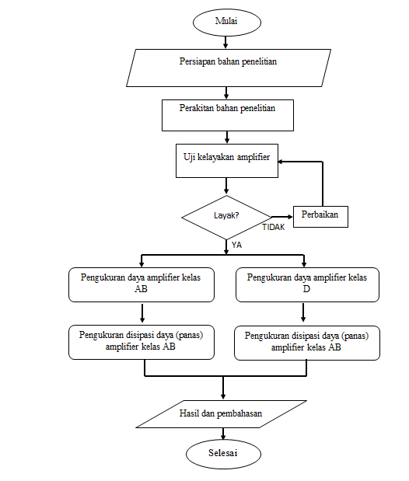

Gambar 1. Desain penelitian

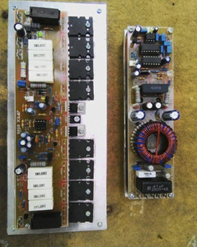

Gambar 2. Hasil perakitan amplifier kelas AB 1000 watt dan kelas D 900 watt



Gambar 3. Instalasi Pengujian *Amplifier*

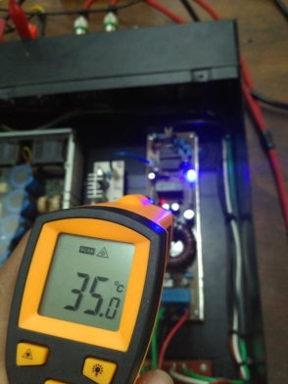

Gambar 6. Pengukuran daya tiap-tiap amplifier

TABEL I. Pengukuran Daya *Amplifier* Kelas AB

|  |  |  |
| --- | --- | --- |
| Daya *output* | Daya *input* | Efisiensi |
| (watt) | V.I (watt) | (%) |
| 1 | 29,16 | 3 |
| 2 | 36,72 | 5 |
| 3 | 44,28 | 7 |
| 5 | 56,16 | 9 |
| 10 | 74,52 | 13 |
| 20 | 105,84 | 19 |
| 40 | 151,2 | 26 |
| 60 | 176,04 | 34 |
| 80 | 210,6 | 38 |
| 100 | 234,36 | 43 |
| 150 | 286,2 | 52 |
| 200 | 309,96 | 65 |
| 250 | 342.36 | 73 |

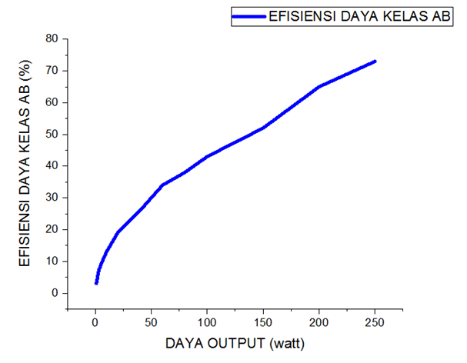

Gambar 7. Grafik efisiensi *audio amplifier* kelas AB

TABEL II**.** Pengukuran Efisiensi Daya *Amplifier* Kelas D

|  |  |  |
| --- | --- | --- |
| Daya *output* | Daya *input* | Efisiensi |
| (watt) | V.I (watt) | (%) |
| 1 | 2,16 | 46 |
| 2 | 4,32 | 46 |
| 3 | 5,4 | 56 |
| 5 | 8,64 | 58 |
| 10 | 15,12 | 66 |
| 20 | 28,08 | 71 |
| 40 | 53,46 | 75 |
| 60 | 76,68 | 78 |
| 80 | 98,28 | 81 |
| 100 | 118,8 | 84 |
| 150 | 174,96 | 86 |
| 200 | 233,28 | 86 |
| 250 | 288,36 | 87 |

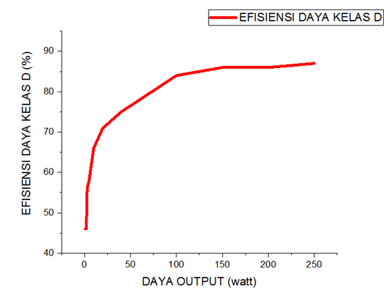

Gambar 8. Grafik efisiensi *audio amplifier* kelas D

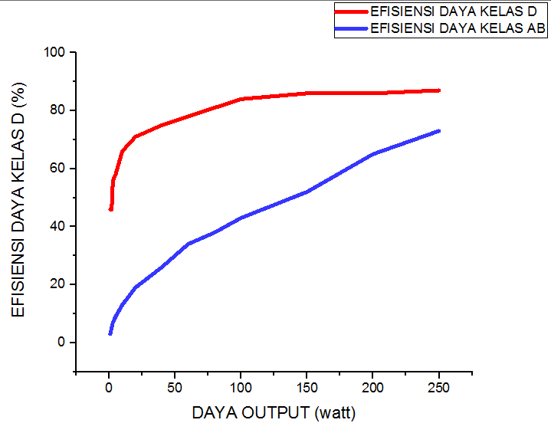

Gambar 9. Grafik efisiensi daya hasil penelitian.

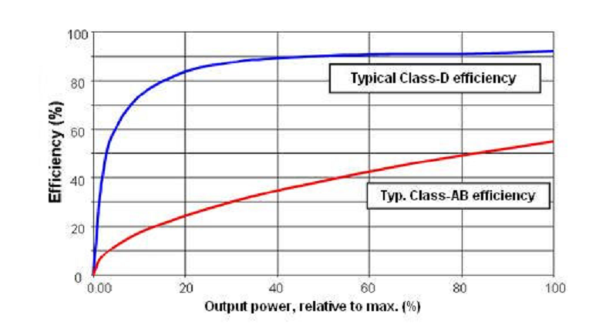

Gambar 10. Grafik perbandingan efisiensi daya audio amplifier kelas D dan AB [3]

TABEL III. Pengukuran Suhu pada *Final Amplifier*

|  |  |  |  |
| --- | --- | --- | --- |
| Menit ke | Suhu amplifier kelas AB | Suhu amplifier kelas D | Suhu Ruangan |
| 0 | 28 | 28 | 27 |
| 10 | 63 | 32 | 27 |
| 20 | 89 | 34 | 27 |
| 30 | 97 | 35 | 27 |
| 50 | 90 | 35 | 27 |
| 80 | 90 | 35 | 27 |
| 120 | 90 | 36 | 27 |

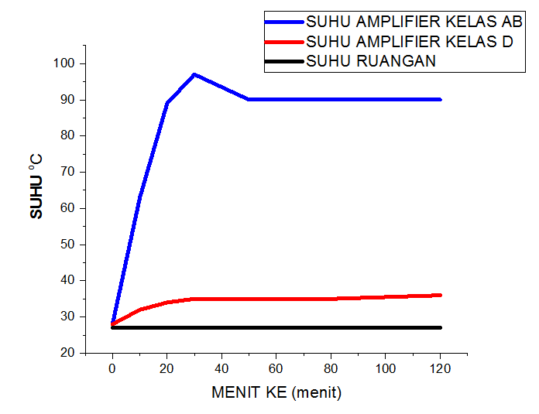

Gambar 11. Grafik suhu tiap-tiap amplifier