VISUAL QUALITY EFFECT ON SUSTAINABILITY IN RAINBOW VILLAGE SEMARANG
Teti Indrawati Wuryaningsih1, Bambang Setioko2, Suzanna Ratih Sari3
Architecture, Faculty of engineering, Diponegoro University.
tetyindravati@gmail.com
Architecture, Faculty of engineering, Diponegoro University.
keliek2000@yahoo.com
Architecture, Faculty of engineering, Diponegoro University.
ratihsaris@yahoo.com

Abstract. Wonosari settlement in Semarang city turned into rainbow village in line with Semarang City Government's goal to beautify the village due to revitalization of Semarang and flowers market. Rainbow village is a complex and dynamic social village, populated by a variety of urbanites, with different religions, incomes, educational and educational backgrounds with generally underprivileged economic levels, providing their own homes, controlling the environment, and trying to getting mutual assistance to improve his life. Rainbow villages have relatively more densely populated buildings, and their inhabitants are livelihoods in the informal sector, spontaneously building so that urban service facilities such as roads, sewerage, sanitation and drainage are inadequate. The design of the city based on the aspects of physical quality, one of which is the visual quality, visual signs are the main features that are physically visible, which can provide attributes to the visual source in a visual system, so that the visual system has a certain quality. The main problem of this research is to see whether there is a significant influence between the visual quality on the sustainability of the settlement environment in the rainbow village, since the sustainability of the rainbow village is very much needed both for the kampong itself and for Semarang city as the embryo of a tourist village inside Semarang city that should be able to continue and not a tourist village for a moment. The method used is quantitative method by using descriptive analysis, weighting using likert scale and linear regression testing, hence the result of this research is visual quality influence to sustainability at rainbow village Semarang visual quality with indicator diversity, dominance, harmony, sequence, uniqueness and vividness combined affect sustainability in Rainbow village. The magnitude of the effect of visual quality of 63.8% on the sustainability of the rainbow villages of Semarang. The remaining 36.2% is influenced by other factors outside the research locus. Based on data processing that has been done, it was found that in general visual quality has an effect on to Sustainability in rainbow village Semarang. The most respondent in giving high respond in visual quality is diversity with mean value 4.26, while seen from sustainability dimension in rainbow village Semarang, social factor with mean value 3.89 is have highest respond value from respondent.

Keywords: visual quality, sustainability, raibow village

PRELIMINARY

Rainbow village is located in Randusari, South Semarang Subdistrict, originally known as Wonosari village, where Semarang government is given a rainbow theme by simultaneous painting and addition of supporting ornaments, with the aim to improve the visual impression of the kampong and become a pilot project as a tourist village in Semarang City is expected to survive and sustainable. Starting from the effort to support the development of Semarang river and revitalization of flower market, then created the idea to beautify the residential area that occupies the Brintik mountain known as Wonosari village on the east side of the flower market segment which is a fairly dense residential area of ​​the building. With the building coloring techniques on the roof, walls, roads and street furniture simultaneously, then created a village with a rainbow theme and then known as Rainbow village Semarang Rainbow village Semarang is located on contoured soil, relatively denser buildings, spontaneously built so that urban service facilities, such as clean water, sanitation, and drainage are inadequate, have a complex and dynamic social system, inhabited by urban residents with a high family system , with different incomes, educational and work backgrounds and at a generally economically disadvantaged level, providing their own homes, controlling the environment, and working to geting mutual assistance to improve their lives for the better.
According to Doxiadis (1968) Settlements are part of a residential environment consisting of more than one housing unit that has infrastructure, facilities, public utilities, and has supporting other functional activities in urban areas or rural areas. Settlements can be defined as a space inhabited by humans. The settlement consists of two basic elements namely container and contents. Containers are in the form of physical buildings houses, infrastructure networks, and nature, while the content in question is in the form of human and public relations in it. The emergence of urban settlement problems raises ideas and concepts about sustainable settlements. A sustainable urban settlement environment should pay attention to three aspects of environmental, social, and economic aspects or so-called triple bottom line (Kuswartodjo, 1997).
The design of the city based on the aspects of physical quality, one of which is the visual quality. Visual signs are the main features that are physically visible, which can attribute to the visual source in a visual system, so that the visual system has certain qualities. Furthermore, it is said that visual quality is a special attribute that exists in a visual system determined by the cultural values and physical properties that can be seen from its formers, such as lines, shapes, textures, colours, scales and spaces that can form diversity, dominance, harmony, continuity, order, uniqueness and unity of a Region (Smardon, 1986).
Current development is a temporary development, with the demands of globalization, Indonesia to follow the development of the era without seeing the future prospects. The development of a society of instant-paced and of origin, consumptive culture has been ingrained in most Indonesian society. In fact, the essence of development is sustainable development that is not partial, instant and skin development. The concept of sustainability is basically the fulfilment of the needs of today's society without neglecting the ability of future generations to meet their needs, as a process of change where resource use, investment direction, development orientation and institutional change are always in development and synergistically reinforce both present and future potential to meet human needs and aspirations (Brundtland 1987 in Budihardjo 2005). While sustainable cities are cities that allow all citizens to meet their needs and improve their welfare, without degrading the condition of the natural environment or the lives of others, in the present and in the future (Girardet, 2004).
The objectives of sustainable urban development include the reduction of space and natural resource use, the rationalization and efficient management of urban material flows, the protection and enhancement of urban health, equitable maintenance of resources and services, and enhancement of cultural and social diversity (EEA, 1995).
Sustainable Tourism or sustainable tourism is expected to be applied to Semarang's rainbow villages, where tourism development and new investment in the tourism sector should not bring adverse impacts and can blend with the existing environment and continue for long periods of time and not for a moment.
Visual quality in Rainbow village is suspected to have an impact on the success and sustainability of Rainbow village as one of the tourist destinations in Semarang City.
Temporary suspicion of changing nuance in the form of painting and the addition of elements visually aimed to improve the quality of the area with the final goal of becoming one of the tourist destinations in Semarang City is expected to make one of the factors that support the rainbow village as a sustainable tourism village, then basically research this is done to determine whether there is influence simultaneously on the visual quality of the sustainability of the rainbow villages of Semarang.

LITERATURE REVIEW

Visual Quality
According to Smardon (1986) quality is the level of excellence, superior in form, distinguishing attributes. Literally visual means can be seen by the sense of sight (eye), while Visual Understanding according to Smardon (1986), visual signs are the main physical features can be seen, which can provide attributes to the visual source and a visual system, so the visual system has a certain quality, it is further said that the visual quality is a special attribute that exists in the visual system that is determined by the cultural values ​​and the physical property of reality. Visual signs are the main features that are physically visible that can attribute to the visual source in a visual system so that the visual system has a certain quality (Smardon, 1986). The visual aspect is so important in the world of architecture that it is mentioned that the architecture is visual art. Because architecture is a work that can be enjoyed with a direct sensation in the eye.
Visual Quality Assessment Theory Smardon (1986) said that the visual value of a region is indicated by the physical quality formed by the relationship or interrelation between the visual elements in a city landscape. Attributes that can show the visual quality in an area include:
- Closure
The driving force of the organization towards spatial order and stability, tends to form an optical unit into a completely closed compact. Faced with a complex optical situation, the viewer seeks to form with the most stable union, or with the least interference with the environment.
- Distinct
resources or activities that are considered unique and as assets of an area. It is usually known as a visual / aesthetic appeal and / or has a distinctive attribute. Diversity and compatibility are characteristics in such resources. Clearly marks landscape or landscape features that are different from others.
- Diversity
Collection of various elements of the pattern and the varying arrangement.
- Domination
One of two distinct parts must clearly dominate the other can be one element is a visual that is highlighted and the other becomes a support background.
- Harmony (Harmony)
The look of all the different parts becomes one. The representation of all the opposite elements (in a work of art) in such a way as to be a pleasant union, generally the task of art is to bring different parts into the whole of the Area, or to make them a component of a larger territory and thereby to excite satisfaction aesthetically, harmony is the main requirement of every art.
- Intactness
The continuity of views and in the broadest sense is free from the obstruction of views. The integrity of the visual conformity between nature and man in building landscapes, and the extent to which the landscape is free from visual encroachment.
- Sequence
The units are arranged in order from one unit to another with certain patterns.
- Uniqueness
Visual sources, visual characters, or rare or unusual visual qualities are found on a regional or national scale.
- Vividness
Beauty is a visually impressive appearance, shaped by the visually striking and attractive elements or units.

Sustainability
According to the Brutland Report at the UN session in 1987, sustainable development or in English is often called sustainable development is a principled development process to meet current needs without sacrificing the needs of future generations. In the World Commission on Environmental Development (WCED) in 1987 it was formulated that the notion of sustainable development is development that seeks to meet the needs of today without diminishing the ability of future generations to meet their needs.
Meanwhile, according to Budiharjo and Sudjarto the definition of sustainable development is a city that in its development able to meet the needs of today's society, able to compete in the global economy by maintaining the harmony of social vitality environment, culture, politics and security defence without neglecting or reducing the ability of future generations in meeting the needs they.
The concept of sustainability is a simple concept, but complex, so that the understanding of sustainability is very multidimensional and multiinterprestasion, but the most prominent and used by many people is sustainable development that carries three dimensions, namely economic, social and environmental, though carrying the same dimension, about the form of linkage between the three dimensions (Lachman, 1997), see figure 1.

Figure 1. Linkage between three dimension as feets of sustainability

In the Sustainable Tourism Charter, emphasizing that tourism should be based on sustainable criteria which in essence are that long-term ecological development must be supported and tourism should be economically and fairly ethically and socially equitable to local communities. In addition, the concept of sustainable development encompasses three components that are interconnected with each other, as follows: First, Ecological Sustainability means that tourism development is not caused by irreversible changes in an existing ecosystem, and a dimension that is generally accepted since the need to protect natural resources from the negative impacts of tourism activities. Second, Social Adaptability, in accordance with the group's ability to absorb tourists without causing disharmony of social relationships, either between members of the community group with tourists, or between members of the group. Third, Cultural Sustainability, in this context assumes that the impact of tourist presence on a tourist destination does not negatively impact the development of local culture, but the existence of that culture must be maintained for future generations. Furthermore, to achieve the goal of sustainable tourism development, it takes two approaches in relation in tourism. (Fitra and Maharani, 2001).

RESEARCH METHODS
The steps in this study are to determine the theory relating to the topic taken and then test it. Go directly to the study field by reviewing directly and conducting a comparative study. Then make a comparison of area activities. Difficulty in obtaining the data, that is the difference of perception and meaning on the individual is not the same in describing the topic taken, the method chosen is a quantitative research method. This method can overcome the verbal descriptions of the environment. (Azwar, 2007) In this method, can be obtained the response of some / sampling which then accumulated so that the collective data appear and then analysed. This method is quantitative based with regression testing. Variables are the object of research, what is the point of attention of a study (Supomo, 1998). Based on the mind-set, variable causality is differentiated into dependent variable (affected variable) and independent (influence variable). The independent variables or influence variables in this study are visual quality based on Grand Theory used (Smardon, 1986) analysed through indicators of diversity, dominance, harmony, sequence, uniqueness and vividness. While the influence variable or influenced variable from this research is Sustainability of rainbow village of Semarang seen from three main elements, that is ecology, economic, and social sector, see table 1.

Table 1. Independet Variabel and Dependent Dimension
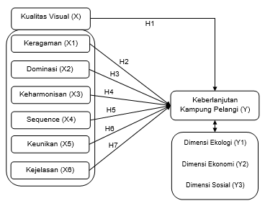

Furthermore, in determining the process of selecting samples, required the existence of the previous classification. The sample is part of the number and characteristics possessed by a population (Sugiyono, 2009). In determining representative samples, exact calculation of sample quantities for a given population must be performed. This is done to avoid difficulties because the population has a character that is difficult to describe (Bungin, 2005). After finding the number of samples that need to be considered is a sampling technique used to collect quantitative data, namely using probability sampling technique. This probability sampling technique using random sampling technique. The samples taken should represent the existing population and the samples taken at random or called random sampling of a heterogeneous population. Because respondents come from different backgrounds and ages who have the same opportunity to provide answers to the questionnaire questions and are expected to provide heterogeneous answers.
Data collection methods are divided on how to obtain:
- Observation
- Questionnaire Technique
- Secondary Data and Information
According to Ghozali (2011), a simple linear regression analysis or single regression analysis is an analytical technique that seeks a functional relationship between one dependent variable and one independent variable. Before performing regression test, normality test is performed to find the variables and sought functional relationship so that it has normal distributed data, so that the data show can be distributed normally then the data can be used in regression analysis to find the influence between independent variables to the dependent variable. The next step is the technique of explanation / meaning.

Results and discussion

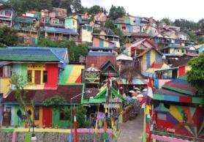
Rainbow Village area of Semarang City is located in the village of Wonosari, Randusari Village, South Semarang District, Semarang City. Located in downtown Semarang near Tugu Muda area or more precisely located on the east side of Jl. Dr. Sutomo consisting of RW 3 and RW 4 Randusari. Physical Rainbow Village is a hill located on the south side of Pandanaran road and east of Dr. Sutomo and known as Mount Brintik, see figure 2 and 3.
Figure 2. Ranbow Village Location
Figure 3. View of Raibow Village
Respondents of this research are 100 people divided into 2 categories: (1) the visitors are visiting people and passing in the research location as many as 50 people and (2) the occupants are the occupants in the research location as many as 50 people. Respondents were randomly selected by their classification, so that respondents could give answers and thoughts that were easy to accept.
Seen the age category, it can be seen from the figure 5 that many respondents dominated by visitors with a relatively young age of less than 30 years as much as 86% it also shows the level of interest of young visitors to enjoy the rainbow village, while viewed from the picture of 3 respondents from occupant categories are more varied, but the most are from ages 41 to 50 years, see figure 6.
In the figure 7 that based on the number of visitor arrivals indicates that many new respondents first visited the rainbow village by 48%, this indicates that visitors of rainbow villages that come more than once are still rare.

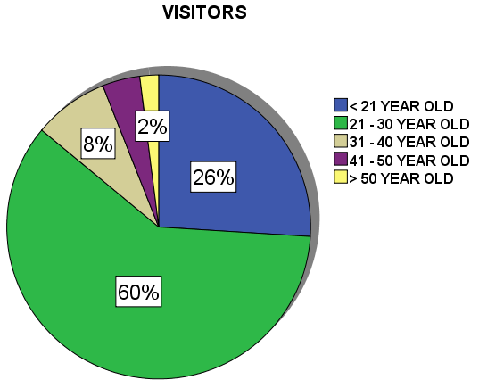
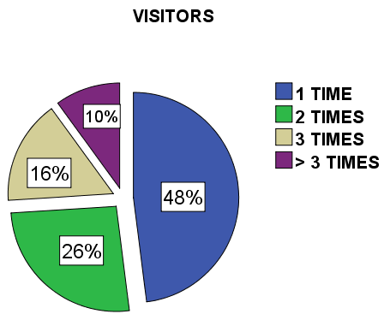

Results and discussion
STATISTICS DEPENDENT VARIABLES: SUSTAINABILITY OF RAINBOW VILLAGE | VAR |  | MEAN
 | 1 | ECOLOGY | 3.354
 | 2 | ECONOMY | 3.768
 | 3 | SOCIAL | 3.899
Seen from table 2, it can be seen the tendency of respondent answer agreed for independent variable visual quality about its diversity with the average value is 4,256 This means that most respondents agreed that rainbow village has visual diversity in the form of its slope, building function, building shape and the roof, the Color of the building and the number of floors of the building.

Table 2. Statistics Mean Independent Variables Visual Quality and Sustainability

INDEPENDENT VARIABLE STATISTICS: VISUAL QUALITY | VAR |  | MEAN
 | 1 | DIVERSITY | 4.256
 | 2 | DOMINATION | 4.046
 | 3 | HARMONY | 3.480
 | 4 | SEQUENCE | 3.843
 | 5 | UNIQUENESS | 3.877
 | 6 | VIVIDNESS | 3.849

Seen from table 2, it can be seen the tendency of respondent to answer agree to dependent variable of sustainability on social dimension with average value is 3,899 it means most of respondent agreed that rainbow village have social sustainability seen from quality of education, skill, health, government and public services, social spaces, low crime rates, high citizenship, and a sense of belonging or a sense of belonging to a high rainbow village, while the ecological dimension has the lowest sustainability value with an average of 3,354.

Multiple Linear Regression Test

Multiple linear regression tests aimed to determine the effect of independent variables on dependent variable, in this study the multiple linear regression test using the T test simultaneously, that is by taking the average Visual Quality seen on the variables of sustainability variables in the rainbow, the result is as follows:

Table 4. Multiple Linear Regression T-Test Results

Model | R | R Square | Adjusted R Square | Std. Error of the Estimate
1 | .713ª | .509 | .477 | .262085322018299

ANOVA^{b}
Model |  | Sum of Squares | df | Mean Square | F | Sig.
1 | Regression | 6.612 | 6 | 1.102 | 16.044 | .000ª
 | Residual | 6.388 | 93 | .069
 | Total | 13.000 | 99
a. Predictors: (Constant), Diversity, Dominance, Harmony, Sequence, Uniqeness, Vividness
b. Dependent Variable: Sustainability

From the output view of SPSS model summary in table 4 adjusted R Square R² is 0.477, this means 47.7% variation Sustainability can be explained by the variation of six independent variables namely diversity, dominance, harmony, sequence, uniqueness and clarity, while the rest (100 % - 47.7% = 52.3%) is explained by other causes outside the model.
Table 4 above shows that the sig value. is 0.000 which means less than 0.05 it shows there is influence on Visual Quality with variables Diversity, Domination, Harmony, Sequence, Uniqueness and Vividness simultaneously or together have significant effect to the sustainability of Raibow Village Semarang. F = 16.044 means that there is a linear relationship between visual quality and rainbow sustainability, and F = 16.044 is bigger than F table = 2,31 means H0 is rejected and H1 accepted.

conclusion
Visual quality in rainbow villages has a strong influence on sustainability in Semarang village of 47.7% the rest of 52.3% is influenced by other factors outside the research locus, see figure 4. From the results of questionnaire processing also obtained the result that rainbow village has the most dominant visual diversity with the mean of 4.256 which is seen from the indicator of the slope of the soil, its building function, the shape of the building and the roof, the colour of the building and the number of storey floors, while viewed from the harmony then the rainbow has the lowest value with a mean of 3.880 seen from the unconformity of the pattern and architectural style, the incompatibility of colour and texture composition, open spaces and parks that are less in tune with the settlements, as well as parking lots for visitors that are not yet available and well ordered.
Rainbow village also has a level of sustainability in social dimension with average value is 3,899 this means rainbow village has good social sustainability seen from quality of education, skill, health, governmental and public service, social space, low crime rate, high sense of belonging, and sense of belonging or sense of having a high rainbow village, while the ecological dimension has the lowest sustainability value with an average of 3.354, which means not yet sustainable because good sustainability value should be between the three dimensions in harmony, there are projecting or left behind.
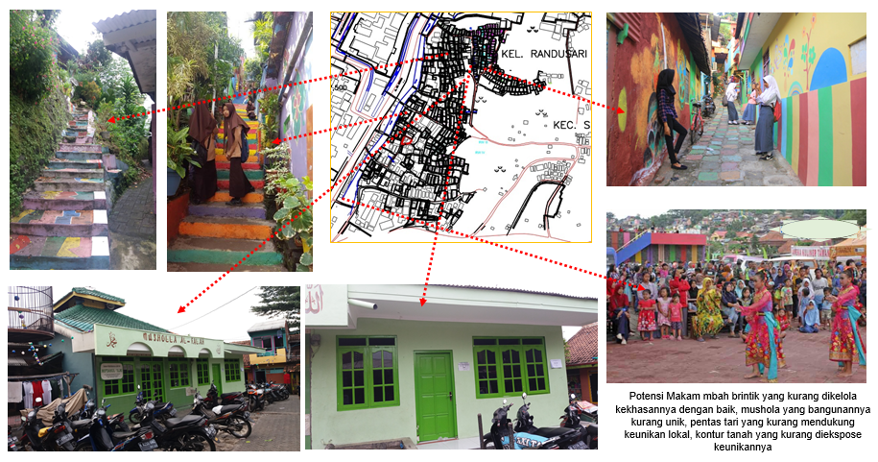

Figure 4. Visual Quality that Affects Sustainability in Rainbow Village Semarang
Recommendations that can be given on the condition of rainbow villages are as follows:
Arrange style and style of architecture to match the existing settlements, Provide socialization of the importance of maintaining the environment by providing sufficient green open spaces, not filled only with house building, so that each house has a garden for greening and beautifying the visual of the house, the use of ecological local materials, and the adequacy of openings / ventilation so as not to need using air conditioners that slightly damage the ozone layer and indirectly damage the nature where the estuary or the main goal is to maintain or improve the visual quality without damaging it in order to continue up to the grandchildren.

References
- Abdilah Fitra dan Leksmono, S Maharani, “Pengembangan Kepariwisataan berkelanjutan”, (Jurnal Ilmu Pariwisata Vol.6, No. 1 Juli 2001)
- Azwar, Saifuddin. 2007. Metode Penelitian. Yogyakarta, Pustaka Pelajar.
- Budiharjo, E dan Sujanto, D., 2005, Kota Berkelanjutan. Bandung, Penerbit Alumni.
- Bungin, B. (2005). Metode Penelitian Kuantitatif: Komunikasi Ekonomi dan Kebijakan Publik Serta Ilmu-ilmu Sosial Lainnya. Jakarta, Gramedia Pustaka.
- Doxiadis, Contantinos A. 1968. Ekistics: An Introduction to the Science of Human Settlements Hutchinson and Co, Ltd, London.
- EEA. Environmental indicators:Typology and overview. Technical report No 25., 1995.
- Ghozali, Imam, 2016, Aplikasi Analisis Multivariate dengan Program IBM SPSS 23. Semarang, Badan Penerbit Universitas Diponegoro.
- Girardet, H., 2004, Cities People Planet: Liveable Cities for a Sustainable City. Ashgate Publishing Ltd, Aldershot.
- Indriantoro, Nur dan Bambang Supomo, 1998. Metodologi Penelitian Bisnis untuk Akuntansi dan Manajemen . Yogyakarta : BPFE.
- Kuswartojo, Tjuk, 2005, Perumahan dan Permukiman di Indonesia. Bandung, Penerbit ITB.
- Lachman, Beth E., 1997, Lingking Sustainable Community activities to pollution prevention : A sourcebook. RAND
- Research Triangle Institute, Desember 2017, Sustainable Cities. Diakses dari www.rti.org/cid/scsummary.ctm.
- Smardon, Richard, 1986, Foundation for Visual, Project Analysis. New York, John Wiley & Son.
- Sugiyono, S., 2009. Metode Penelitian Kualitatif. Bandung, CV Alfabeta.
- UN–Habitat, 2012, Sustainable Housing For Sustainable Cities : A Policy Framework For Developing Countries. Naraobi United Nation Human Settlements Programme (UN-Habitat).
- WCED, 1987, Our Common Future (The Brundtland Report). Oxford: Oxford University Press.

